Lab – Getting Familiar with the Linux Shell
By: Sean Patterson
Part 1: Shell Basics
Step 1: Access the Command Line
- Log on to the CyberOps Workstation VM as the analyst using the password cyberops. The account analyst is used as the example user account throughout this lab
- To access the command line, click the terminal icon located in the Dock, at the bottom of VM screen. The terminal emulator opens.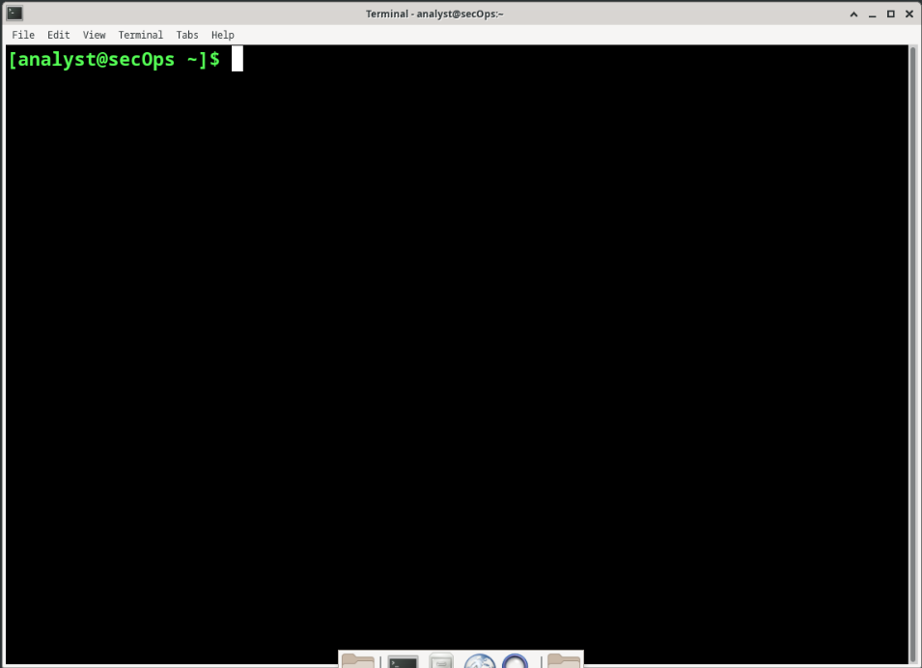
Step 2: Display Manual Pages from the command line
- To learn more about the man page, type: man man
  - Name a few sections that are included in a man page
    - DEFAULTS, OVERVIEW, EXAMPLES, OPTIONS
- Type q to exit the man page
- Use the man command to learn more about the cp command. Type man cp
  - What is the function of the cp command?
    - The function of the cp command is to copy files and directories.
  - What command would you use to find out more information about the pwd command? What is the function of the pwd command?
    - The command you would use to find more information about the pwd command is “man pwd”. The function of pwd is to print name of the current/working directory. 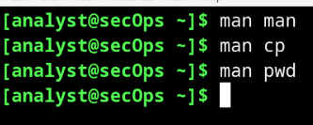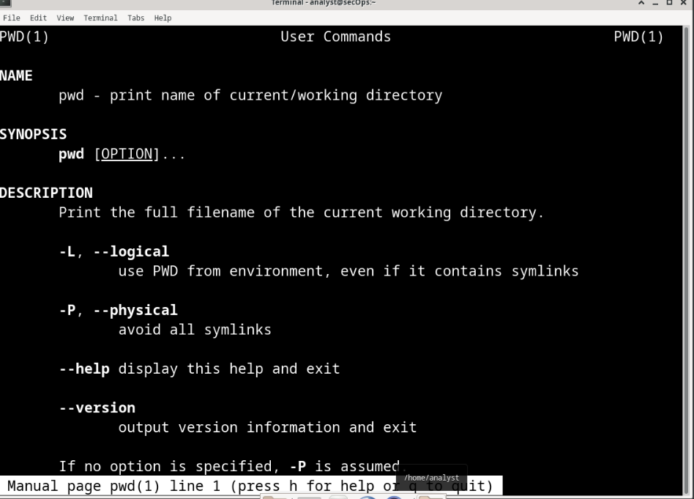
Step 3: Create and change directories
- Type pwd at the prompt
  - What is the current directory?
    - The current directory is /home/analyst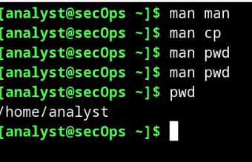
- Navigate to the /home/analyst directory if it is not your current directory. Type cd /home/analyst
- Type ls -l at the command prompt to list the files and folders that are in the current folder. Standing for list, the -l option displays file sizes, permissions, ownership, data of creation and more.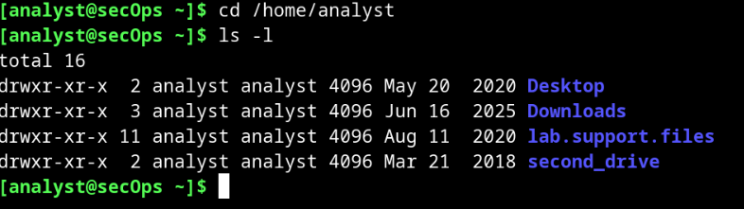
- In the current directory, use the mkdir command to create three new folders: cyops_folder1, cyops_folder2, and cyops_folder3. Type mkdir cyops_folder1 and press Enter. Repeat these steps to create cyops_folder2 and cyops_folder3.
- Type ls -l to verify that the folders have been created.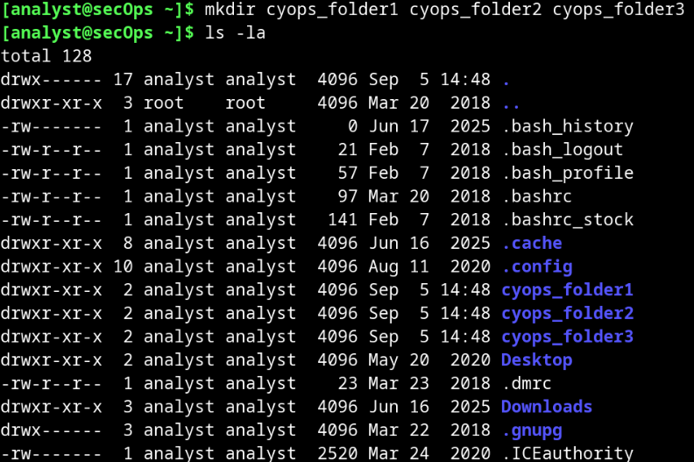
- Type cd /home/analyst/cyops_folder3 at the command prompt and press Enter.
  - What folder are you in now?
    - I am currently in the cyops_folder3
  - Challenge: Type the command cd ~ and describe what happens.
    - Why did this happen?
      - When I use cd ~, I go back to the /home/analyst directory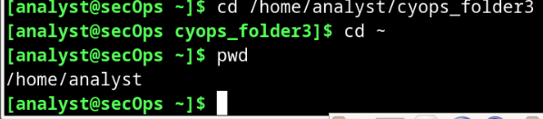
- Use the mkdir command to create a new folder named cyops_folder4 inside the cyops_folder3 folder.
- Use the ls -l command to verify the folder creation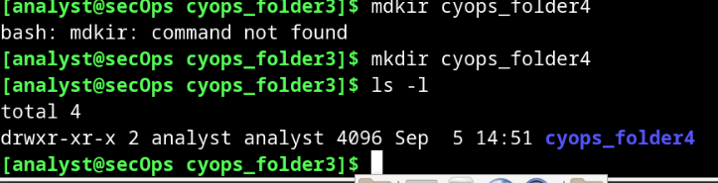
- Up to this point, we have been using full or absolute paths. Absolute path is the term used when referring to paths that always start at the root (/) directory. It is also possible to work with relative paths. Relative paths reduce the amount of text to be typed. To understand relative paths, we must understand the . and .. (dot and double dot) directories. From the cyops_folder3 directory, issue a ls -la:
  - The -a option tells ls to show all files. Notice the . and .. listings shown by ls. These listings are used by the operating system to track the current directory (.) and the parent directory (..). You can see the use of the . and .. when using the cd command to change directories. Using the cd command to change the directory to the . directory incurs no visible directory change as the . points to the current directory itself.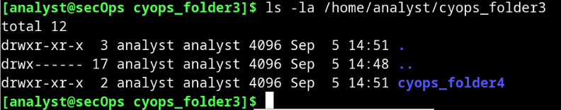
- Change the current directory to /home/analyst/cyops_folder3
- Type cd .
  - What happens?
    - The change directory command with only one dot calls the directory that it is currently in
    - 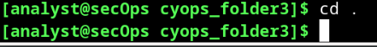
- Change the directory to the .. directory, will change to the directory that is one level up. This directory is also know as the parent directory. Type cd ..
  - What happens?
    - Using the “cd ..” command it goes back into the parent directory that that folder is currently in.
    - 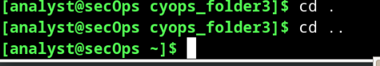
  - What would be the current directory if you issued the cd .. command at [analyst@secOps ~]$?
    - 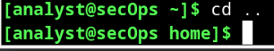
  - What would be the current directory if you issued the cd .. command at [analyst@secOps home]$?
    - 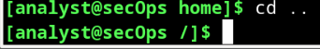
  - What would be the current directory if you issued the cd .. command at [analyst@secOps /]$?
    - 
Step 4: Redirect Outputs
- Use the cd command to change to the /home/analysts/ (~) directory
- Use the echo command to echo a message. Because no output was defined, echo will output to the current terminal window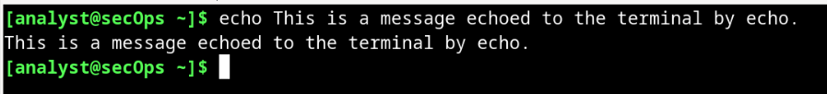
- Use the > operator to redirect the output of echo to a text file instead of to the screen
  - No output was shown. Is that expected? Explain
    - The echoed sentence from the terminal was redirected to the file “some_text_file.txt” instead of the terminal window
    - 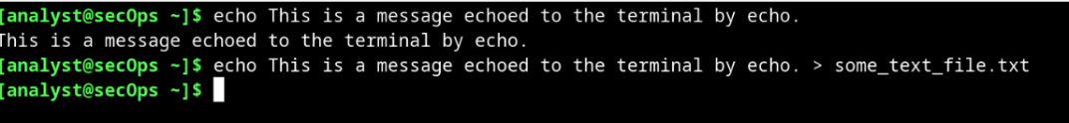
- Notice, that even though the some_text_file.txt file did not exist, prior to the echo command, it was automatically created to receive the output generated by echo. Use the ls -l command to verify if the file was really created. 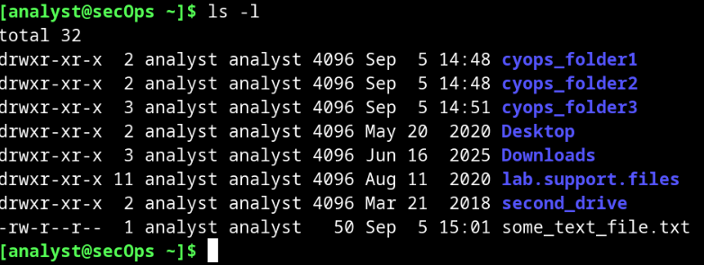
- Use the cat command to display the contents of the some_text_file.txt text file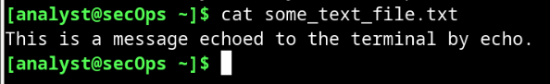
- Use the > operator again to redirect a different echo output of echo to the some_text_file.txt text file
- Once again, use the cat command to display the contents of the some_text_file.txt text file
  - What happened to the text file? Explain
    - You redirected the echo to say a different output but you only used one > operator making it change whatever the echoed version was before. If you used 2 >> operators it would have appended the different echo output after the first echo output.
    - 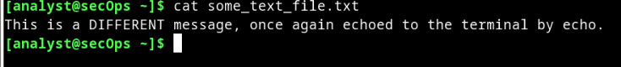
Step 5: Redirect and Append to a Text File
- Similar to the > operator, the >> operator allows for redirecting data to files. The difference is that >> appends data to the end of the referred file, keeping the current contents intact. To append a message to the some_text_file.txt, issue the command below:
  - Echo This is another line of text. It will be APPENDED to the output file. >> some_text_file.txt
- Use the cat command to display the contents of the some_text_file.txt text file yet again
  - What happened to the text file? Explain
    - We used the >> operator to append the new echo to the old echo so it added it to the next line on the text file.
    - 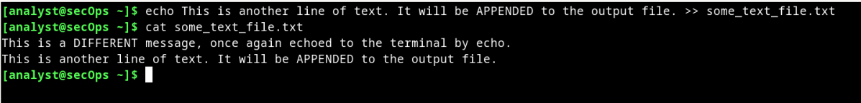
Step 6: Work with hidden files in Linux
- In Linux, files with names that begin with a ‘.’ (single dot) are not shown by default. While dot-files have nothing else special about them, they are called hidden files because of this feature. Examples of hidden files are .file5, .file6, .file7.
- Use ls -l to display the files stored in the analyst home directory
  - How many files are displayed?
    - 32 files are displayed
    - 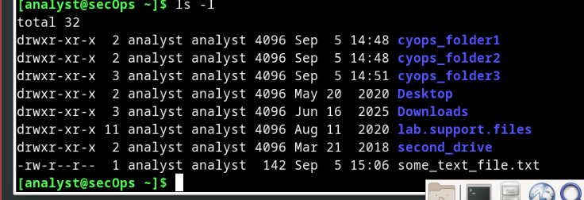
- Use the ls -la command to display all files in the home directory of analyst, including hidden files.
  - How many more files are displayed than before? Explain.
    - 132 files are displayed because most of these files are hidden files
    - 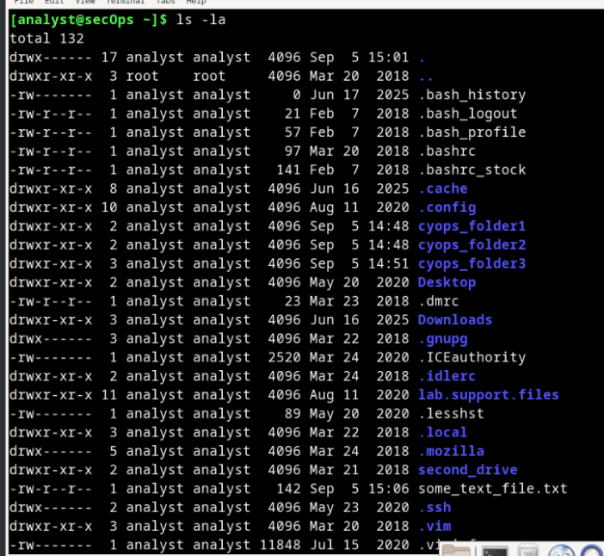
  - Is it possible to hide entire directories by adding a dot before its name as well? Are there any directories in the output of ls -la above?
    - Yes, it is possible to hide entire directories by adding a dot before its name. There are the . and .. directories and many more hidden directories.
  - Give three examples of hidden files shown in the output of ls -la above.
    - .bash_history, .bash_stock, and .ssh
- Type the man ls command at the prompt to learn more about the ls command
- Use the down arrow key (one line at a time) or the space bar (one page at a time) to scroll down the page and locate the -a option used above and read its description to familiarize yourself with the ls -a command
Part 2: Copying, Deleting, and Moving Files
Step 1: Copying Files
- The cp command is used to copy files around the local file system. When using cp, a new copy of the file is created and placed in the specified location, leaving the original file intact. The first parameter is the source file and the second is the destination. Issue the command below to copy some_text_file.txt from the home directory to the cyops_folder2 folder:
    - 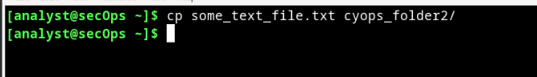
  - Identify the parameters in the cp command above
  - What are the source and destination files? (Use full paths to represent the parameters)
    - The source is the file name. In this case it would be /home/analyst/some_text_file.txt. The destination is the cyops_folder2/ . This is /home/analyst/cyops_folder2/ .
- Use the ls command to verify that some_text_file.txt is now in cyops_folder2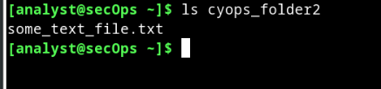
- Use the ls command to verify that some_text_file.txt is also in the home directory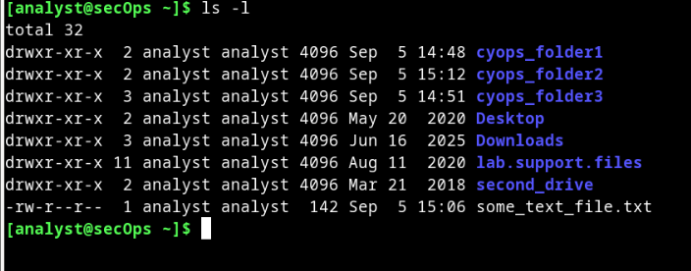
Step 2: Deleting Files and Directories
- Use the rm command to remove files. Issue the command below to remove the file some_text_file.txt from the home directory. The ls command is then used to show that the file some_text_file.txt has been removed from the home directory.
- In Linux, directories are seen as a type of file. As such, the rm command is also used to delete directories but the -r (recursive) option must be used. Notice that all files and other directories inside a given directory are also deleted when deleting a parent directory with the -r option. Issue the command below to delete the cyops_folder1 folder and its contents: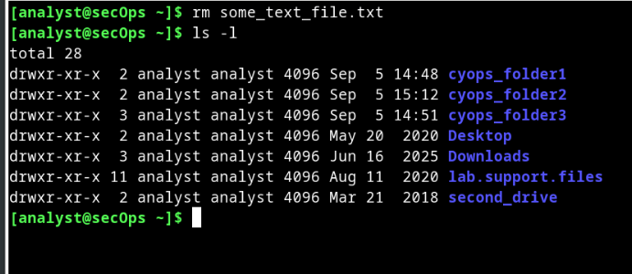
Step 3: Moving Files and Directories
- Moving files works similarly to copying files. The difference is that moving a file removes it from its original location. Use the mv commands to move files around the local filesystem. Like the cp commands, the mv command also requires source and destination parameters. Issue the command below to move the some_text_file.txt from /home/analyst/cyops_folder2 back to the home directory:
  - What command did you use to accomplish the task?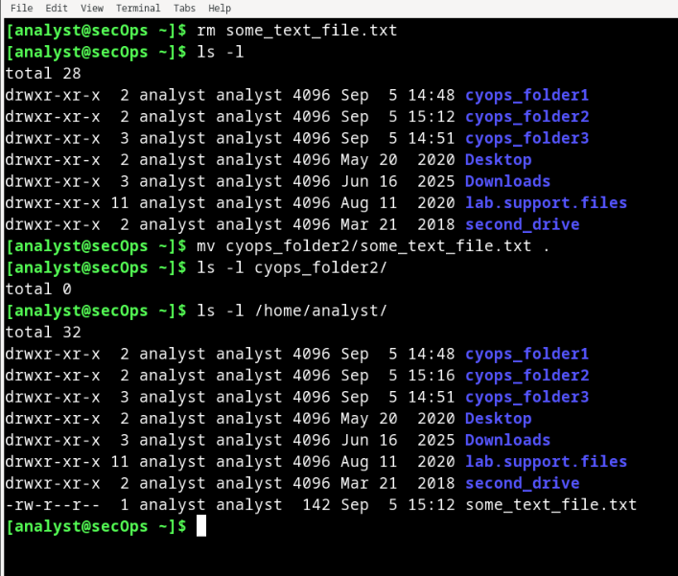

Reflection: What are the advantages of using the Linux command line?
- The advantages of using the Linux command line are efficiency and speed, flexibility, scripting, universality and accessibility. You can do almost anything in Linux command line. For example, you can change the color of the text. You can find hidden files and directories you didn’t even know existed. You can create programming tools to automate certain tasks. Linux can also enhance security.

