Lab- Exploring Processes, Threads, Handles, and Windows Registry
By: Sean Patterson

Part 1: Exploring Processes
Step 2: Explore an active process
c) The Process Explorer displays a list of currently active processes
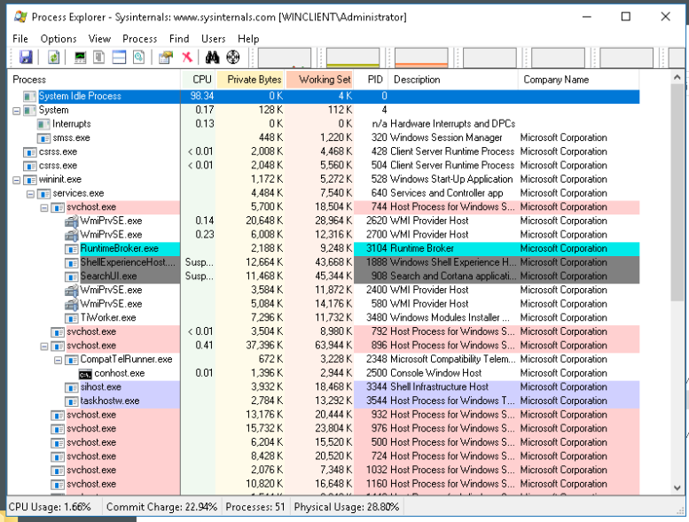
d) To locate the web browser process, drag the Find Window’s Process icon into the opened web browser window. 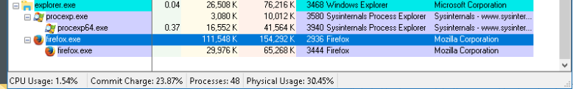
e) The FireFox process can be terminated in the Process Explorer. Right-click the selected process and select Kill Process. Click OK to continue. What happened to the web browser window when the process is killed?
a) When the process was killed the web browser was terminated. 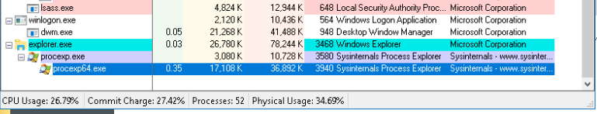
Step 3: Start another process.
b) Drag the Find Window’s Process icon into the Command Prompt window and located the highlighted Command Prompt process in Process Explorer.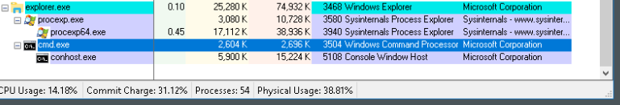
d) Navigate to the Command Prompt window. Start a ping at the prompt and observe the changes under the cmd.exe process. What happened during the ping process?
a) When I used the command “ping 8.8.8.8” into the Command Prompt, the PING.EXE process was started and when it was finished pinging the PING.EXE was killed. 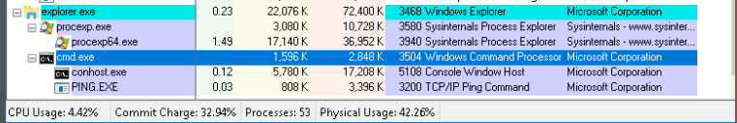
g) Right-click the cmd.exe process and select Kill Process. What happened to the child process conhost.exe?
a) When I killed the process cmd.exe, the conhost.exe process also was killed because the parent process was terminated. 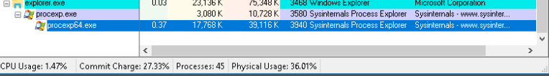

Part 2: Exploring Threads and Handles
Step 1: Explore threads
c) Examine the details of the thread. What type of information is available in the Properties window?
a) The type of information that is available in the Properties window is the individual execution threads that are currently running inside the Command Prompt process. It can have multiple threads because it may be handling multiple console sessions or background tasks. Looking at the threads tab helps you:
- Identify if a thread is stuck or consuming excessive CPU
- See if multiple threads are running for legitimate console sessions
- Detect unusual thread behavior that might indicate a problem or potential compromise
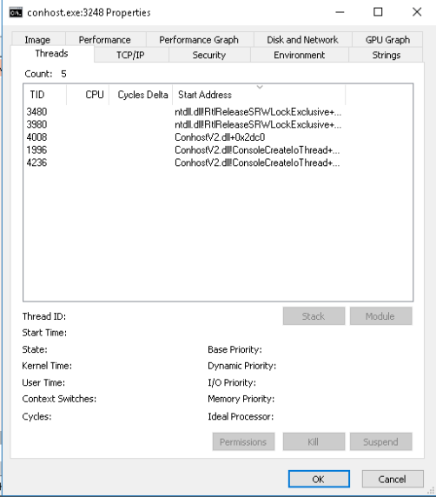

Step 2: Explore Handles
- In the Process Explorer, click View > select Lower Pane View > Handles to view the handles associated with the conhost.exe process. Examine the handles. What are the handles pointing to?
  - The handles point to kernel objects that the process has opened. These handles represent system resources that the process interacts with during execution. Specifically, the handles can point to:
    - Files: These include executable files, configuration files, or temporary files that conhost.exe may read from or write to while running.
    - Registry Keys: Handles to registry keys allow conhost.exe to access configuration settings stored in the Windows Registry, which may include user permissions or system-level settings.
    - Threads: Handles to threads represent the individual execution threads that conhost.exe manages or interacts with, enabling multitasking and process coordination. These handles are essential for the process to function correctly, as they provide controlled access to system resources without directly exposing the underlying kernel objects to the application. By examining these handles, you can gain insight into the resources conhost.exe is using and troubleshoot potential issues related to files access, registry operations, or thread management.
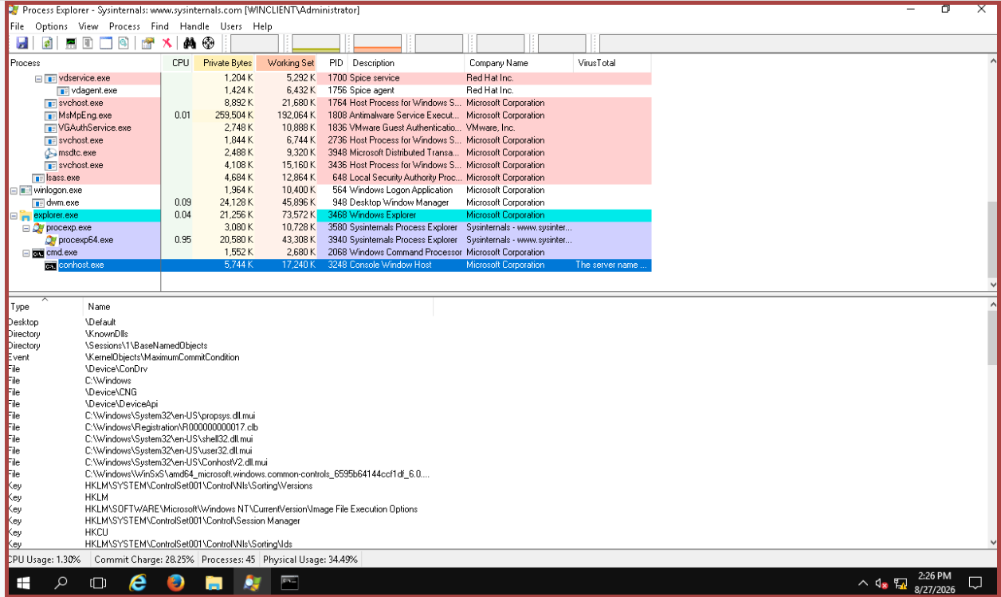
Part 3: Exploring Windows Registry
- Navigate to the EulaAccepted registry key for Process Explorer. Click to select Process Explorer in HKEY_CURRENT_USER > Software > Sysinternals > Process Explorer. Scroll down to locate the key EulaAccepted. Currently, the value for the registry key EulaAccepted is 0x00000001(1).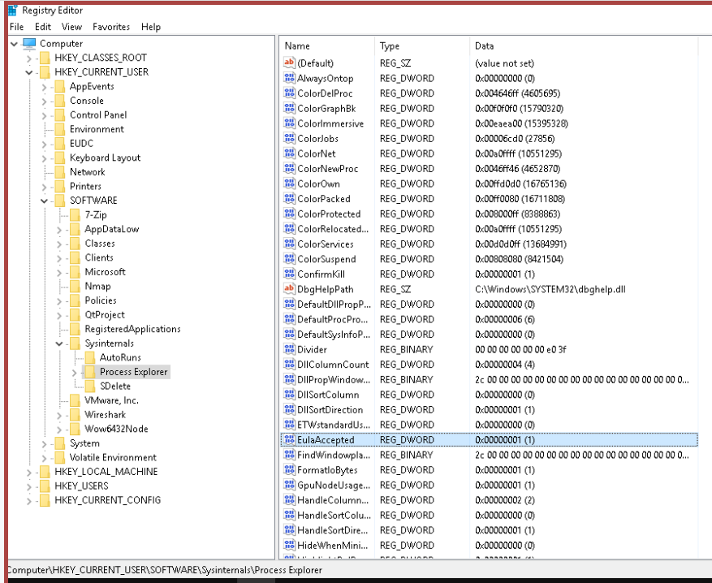

- Change the 1 to 0 for Value data. The value of 0 indicates that the EULA was not accepted. Click OK to continue. What is the value for this registry key in the Data column?
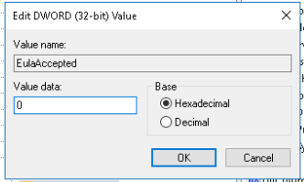
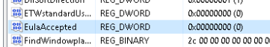

- Open the Process Explorer. Navigate to the folder where you have downloaded SysInternals. Open the folder SysInternalsSuite > Open procexp.exe. When you open the Process Explorer, what did you see?
