HOME PAGE

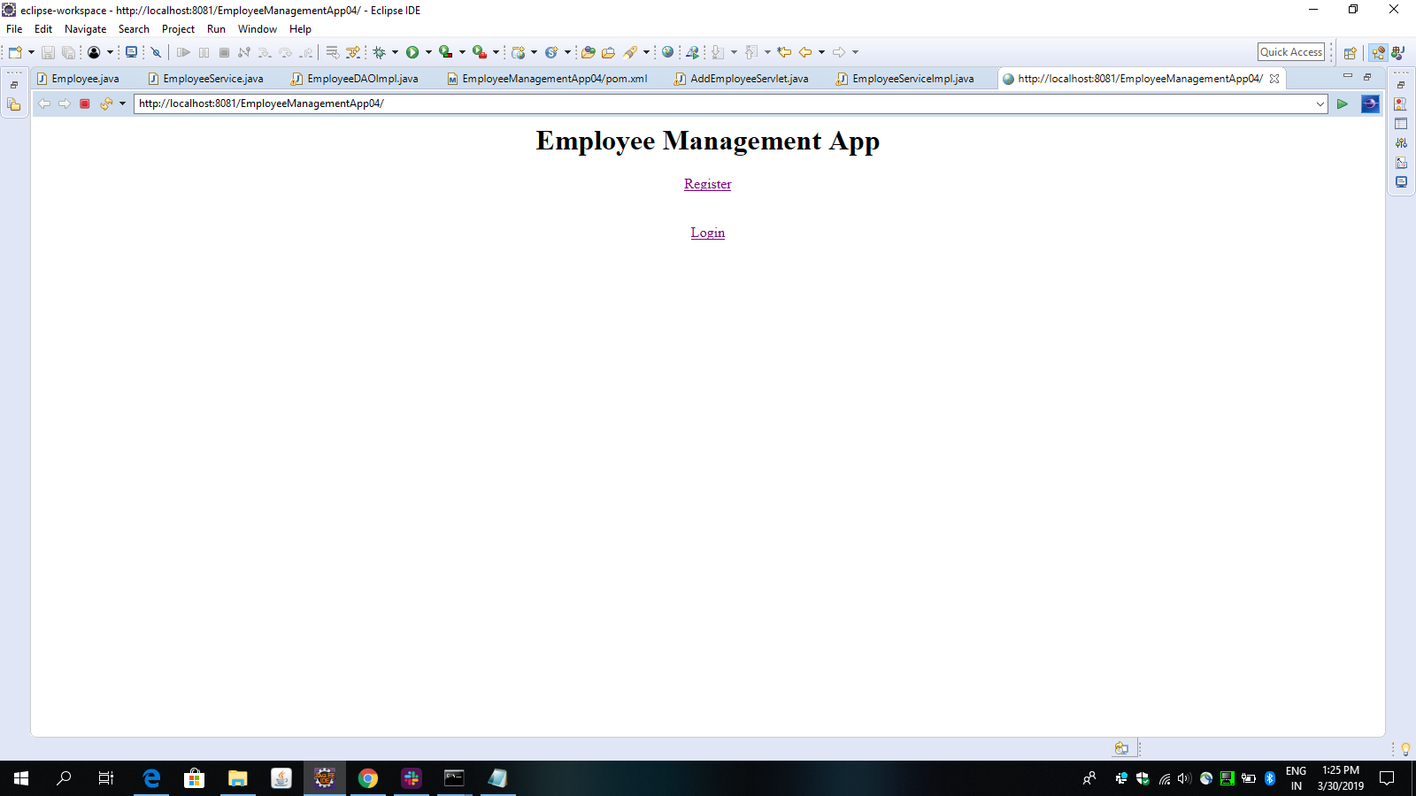

REGISTRATION PAGE

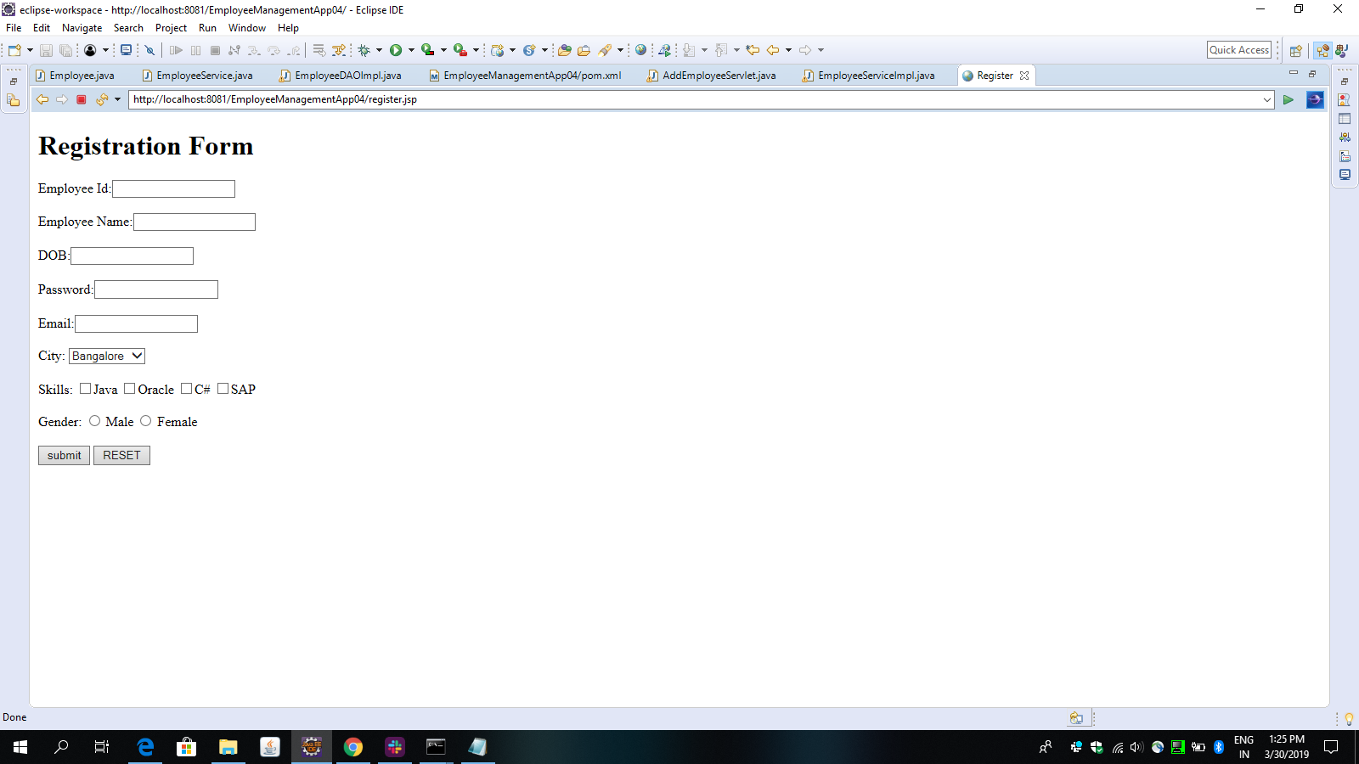

LOGIN PAGE:

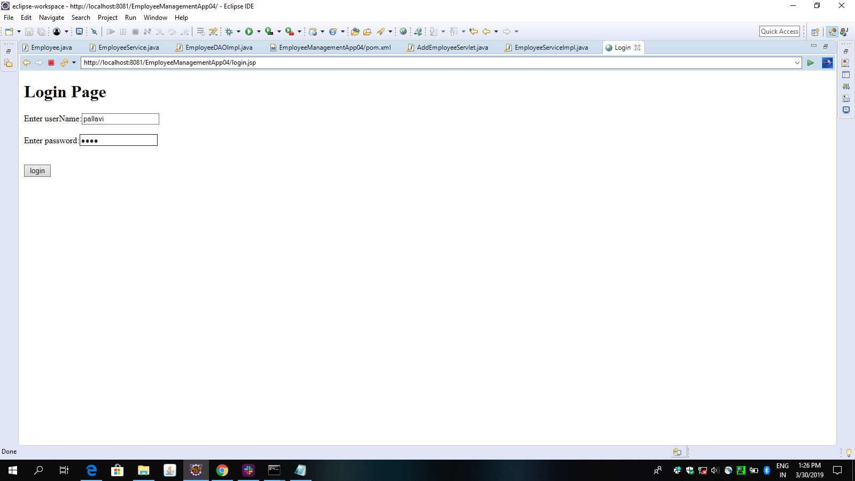

EMPLOYEE LANDING PAGE

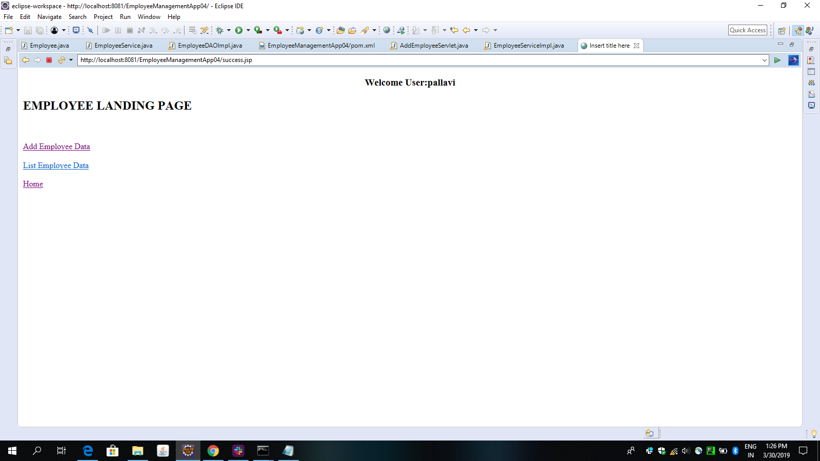

ADD EMPLOYEE PAGE

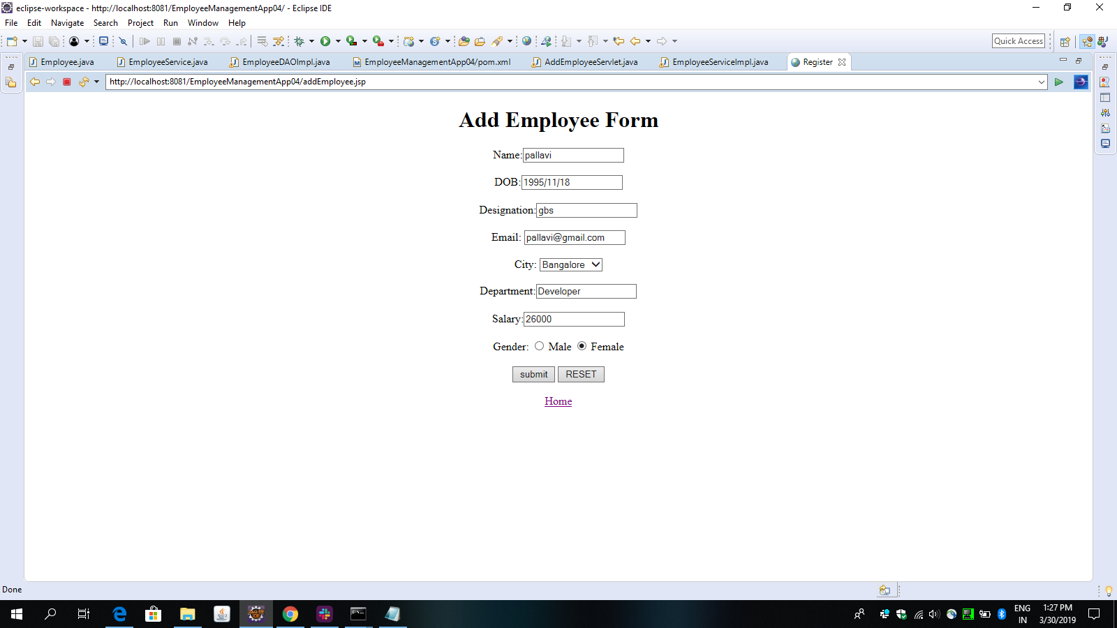

LIST OF EMPLOYEE PAGE

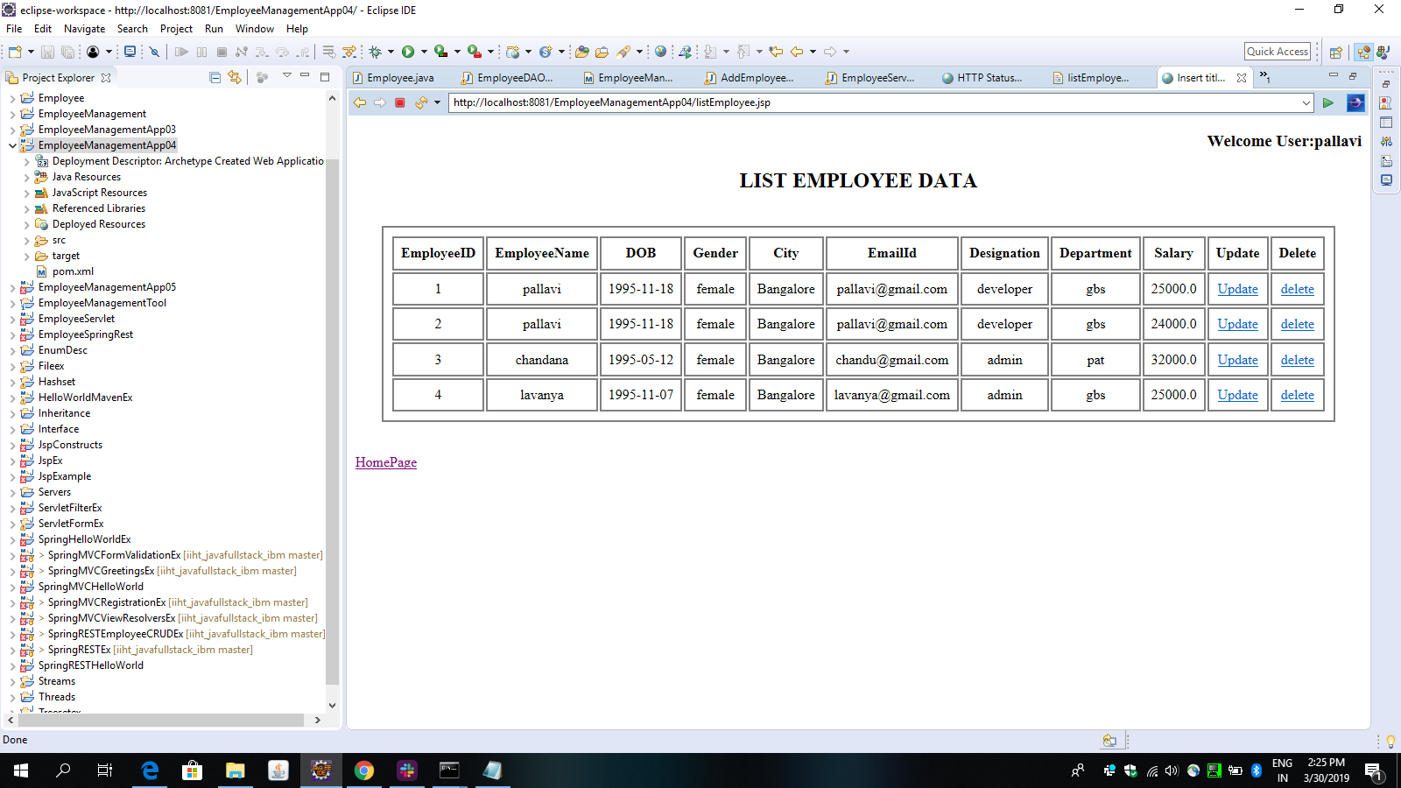

AFTER DELETING THE EMPLOYEE

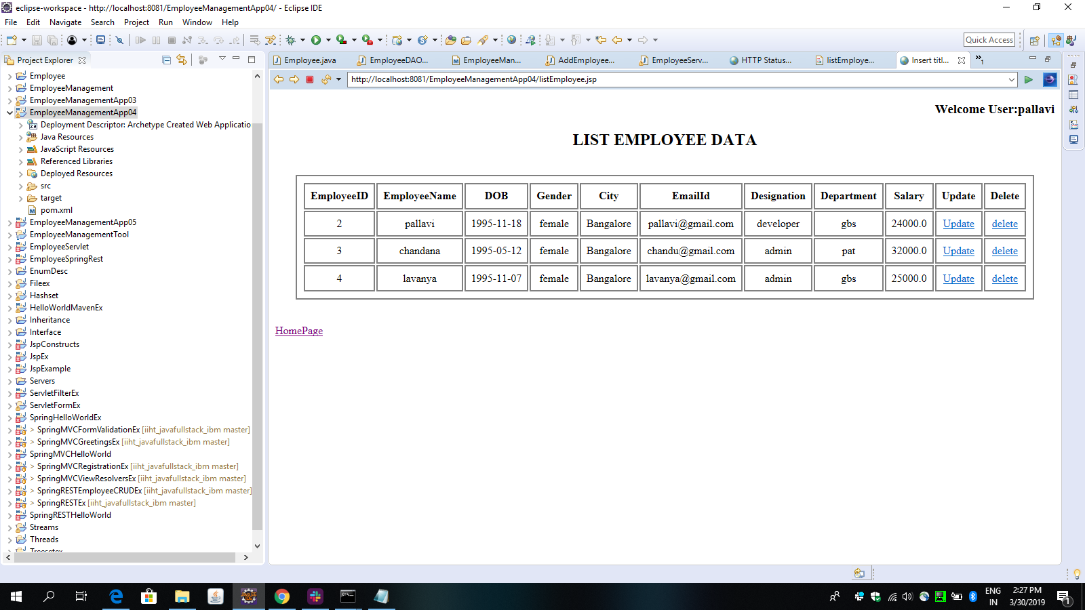

UPDATE EMPLOYEE DETAILS PAGE

