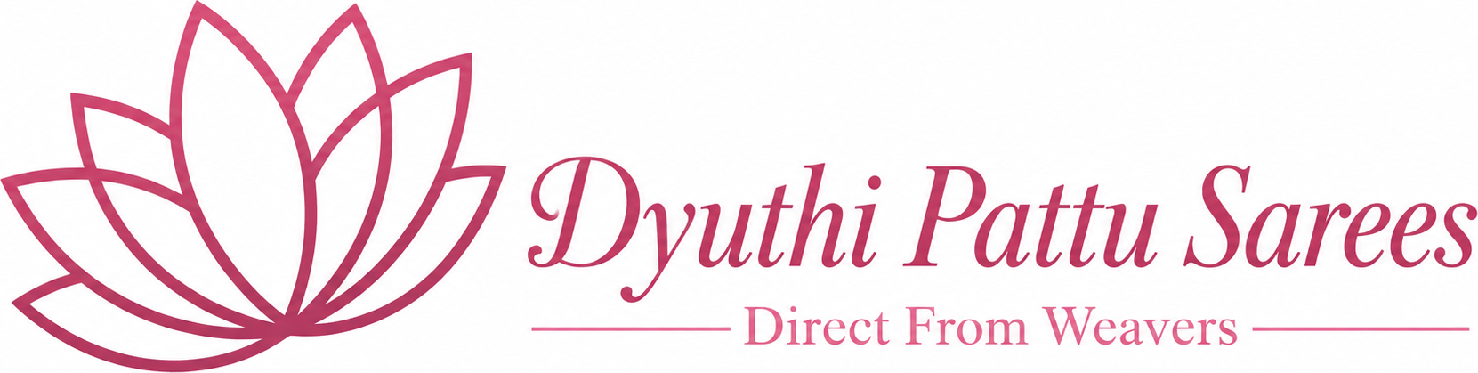
Brand Guidelines
Direct From Weavers
A Legacy Woven in Silk

1. Brand Essence
Dyuthi Pattu Sarees is a premium handloom saree brand sourcing directly from master weavers across India. The brand celebrates authenticity, craftsmanship, and India’s textile heritage with an elegant, traditional yet modern identity.

Brand Pillars
- Authenticity — sourced direct from weavers
- Craftsmanship — time-honoured handloom techniques
- Heritage — celebrating India’s textile traditions
- Premium — refined, elegant, trustworthy

Voice & Tone
- Warm, refined, and heritage-led — never loud or generic.
- Sentence case for UI; storytelling that honours the weaver and the wearer.
- Key lines: “Treasures from Timeless Traditions”, “A Legacy Woven in Silk”, “Direct From Weavers”.

2. Primary Colors
These define the brand’s core identity and should lead every layout.
Name | Hex | Usage
Brand Pink | C2185B | Primary actions, CTAs, active states, accents
Deep Maroon | 4E1E24 | Headings, header text/icons, frame outlines
Hero Maroon | 4A1F1F | Hero / feature section backgrounds
Antique Gold | B8860B | Announcement bar, hero CTA, premium accents

3. Secondary Colors
Supporting tones for backgrounds, text, and decorative detail.
Name | Hex | Usage
Warm Cream | F5EFE6 | Header background, soft section backgrounds
Cream / Ivory | FFF8E7 | Announcement text, light surfaces
Ivory Matting | FBF6EA | Frame backing, matting behind imagery
Antique Gold (text) | F8E7C5 | Hero headings on maroon
Warm Ivory (text) | E8DCC7 | Hero body copy on maroon
Footer Maroon | 3A0D22 | Footer background
Footer Gold | F4C430 | Footer links / accents
Deep Red | A30B2E | Dashboard section headings
Gold (frames) | D4AF37 | Decorative frame motifs, zari detail
Sparkle Gold | F59E0B | Account / profile sparkle icon

4. Typography

Primary Typeface
- Geist (sans-serif) — used across the web app for navigation, body, and UI.

Display / Brand Typeface
- Georgia / serif — used for the logo wordmark and editorial headings to convey heritage.

Usage Rules
- Two weights only: Regular (400) and Bold (500/700). Avoid heavy mid-weights.
- Sentence case for all UI labels and buttons (e.g., “Shop premium sarees”).
- Headings in serif for storytelling sections; sans-serif for functional UI.
- Maintain generous line-height (~1.7) for body copy.

5. Logo Usage Rules

The Mark
The primary logo is the pink lotus symbol with the “Dyuthi Pattu Sarees” wordmark and the “Direct From Weavers” tagline. The lotus is the signature brand symbol and is reused as the active-navigation indicator and as a banner crown motif.

Do
- Keep clear space around the logo equal to the height of the lotus mark.
- Place the logo on light/cream backgrounds for best contrast.
- Use the provided high-resolution file; scale proportionally only.
- Use the lotus alone as an icon/accent where the full lockup won’t fit.

Don’t
- Don’t stretch, skew, rotate, or recolor the logo.
- Don’t place the logo on busy imagery without a solid/ivory backing.
- Don’t add drop shadows, outlines, or effects.
- Don’t recreate the wordmark in a different typeface.

6. Image Style
- Rich, warm, heritage-led imagery — sarees as the hero of every frame.
- Prefer natural light, authentic settings (looms, artisans, traditional interiors).
- Decorative frames use hand-crafted gold/maroon motifs (lotus, scallop, mandala, zari).
- Category cards use a scalloped petal frame with a single deep-maroon outline and a subtle lotus-pink glow on hover.
- Keep backgrounds uncluttered; let texture and weave detail shine.

7. Saree Photography Style
- Shoot the full saree so drape, border, pallu, and body are all visible.
- Use consistent portrait framing (approx. 4:5) for category and product thumbnails.
- Neutral or softly textured backdrops (ivory, cream, warm wood) — never distracting.
- Diffused natural light to render true colours and zari shimmer accurately.
- Include both flat-lay/draped detail shots and on-model shots for context.
- Capture close-ups of weave, border, and motifs to convey craftsmanship.
- Maintain accurate colour — avoid heavy filters that misrepresent the fabric.

8. Instagram Branding

Grid & Aesthetic
- Cohesive warm palette: maroon, gold, cream — consistent with the website.
- Alternate full-saree shots, draped close-ups, and weaver/behind-the-scenes posts.
- Use the lotus mark and gold accents as recurring visual motifs.

Content Pillars
- Product showcases (new arrivals, best sellers, on sale).
- Weaver stories & craftsmanship (“Direct From Weavers”).
- Styling & occasion inspiration (wedding, festival, daily elegance).
- Customer love / testimonials.

Voice & Hashtags
- Captions: warm, heritage-led storytelling; sentence case.
- Signature lines: “Direct From Weavers”, “A Legacy Woven in Silk”.
- Suggested tags: #DyuthiPattuSarees #DirectFromWeavers #HandloomSarees #PattuSarees #HandloomLove #SareeLove.

Profile
- Use the lotus logo as the profile photo on a cream background.
- Bio: brand name + “Direct From Weavers · Handloom sarees · Telangana, India” + website link.
- Free shipping all over India — highlight in bio / story highlights.
— Dyuthi Pattu Sarees · Brand Guidelines —

