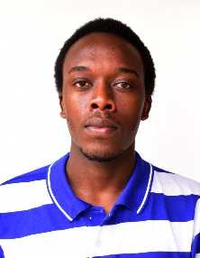IRADUKUNDA PATRICK

KAMONYI DISTRICT

RUNDA SECTOR

RUYENZI CELL

CELL PHONE: +2507892892

EMAIL: [iradukundapatrick001@gmail.com](mailto:iradukundapatrick001@gmail.com)

CAREER OBJECTIVE

I am seeking for company where my experience can not only improve the status of the company but also automate the working process to the best possible one.

PERSONAL INFORMATION

|  |  |
| --- | --- |
| Date of birth: May 05, 1998  Age: 23 | Country of birth: RWANDA  Gender: Male  Occupation: Student |

EDUCATIONAL ATTAINMENT

**Tertiary education**

School: Mount Kenya University

Address: Kicukiro center

School year 2020-2022

School: Strathmore university

Address: Nairobi-Madaraka

School year: 2019-2020

**Secondary education**

School: Petit Seminaire Saint Leon Kabgayi

Address: Muhanga-Kabgayi

School year: 2013-2018

**Elementary school**

School: APAPER

Address: Kicukiro-sonatube

**WORK EXPERIENCE**

IT SUPERVISOR at IN MANUS TUA DOMINE ltd

Duration: 2020-present

Freelancer at numerous occasions.

**LANGUAGE SKILLS**

|  |  |  |  |
| --- | --- | --- | --- |
| **LANGUAGE** | **Not bad** | **good** | **excellent** |
| English |  | **yes** |  |
| French |  | **yes** |  |
| Kinyarwanda |  |  | **Yes** |
| Kiswahili | yes |  |  |
| Latin | yes |  |  |