Project Report: Customer Shopping Behaviour Analysis

1. Project Overview
This project provides an end-to-end analysis of customer purchasing patterns to help a retail business optimize its marketing and operations. By leveraging a dataset of 3,900 customers, the study identifies key revenue drivers across categories, age groups, and subscription statuses.
2. Dataset Summary
- Total Records: 3,900 customers.
- Key Metrics: The average purchase amount is $59.76 and the average review rating is 3.75.
- Categories: Includes Clothing, Accessories, Footwear, and Outerwear.
- Demographics: Includes Gender (Male/Female) and Age Groups (Young, Adult, Middle_Age, Senior).

3. Data Preprocessing & EDA (Python)
The analysis began with data cleaning and feature engineering in a Python Jupyter Notebook.
- Missing Value Imputation: The review_rating column had 37 null values, which were filled using the median rating grouped by category.
- Standardization: Column names were converted to lowercase and spaces were replaced with underscores (e.g., purchase_amount).
- Feature Engineering:
  - Age Grouping: Created an age_group column by segmenting ages into four quartiles: Young, Adult, Middle_Age, and Senior.
  - Frequency Mapping: Converted categorical purchase frequencies into numerical days (e.g., "Weekly" to 7, "Annually" to 365).
- Data Export: The cleaned dataset was saved as clean_data.csv.

4. SQL Business Queries
Business logic was implemented using SQL to extract specific insights:
- Revenue by Gender: Compares total spending between Male and Female segments.
- Subscription Performance:
SQL

-- What is the total revenue generated by male vs female customers?
select gender, sum(purchase_amount) as revenue
from cust
group by gender;
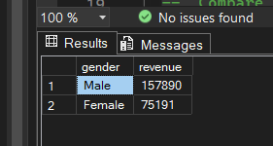

-- which customers used a discount but still spent more than the average purchase amount?
select customer_id, purchase_amount
from cust
where discount_applied = 'Yes' and purchase_amount>(select avg(purchase_amount) from cust);
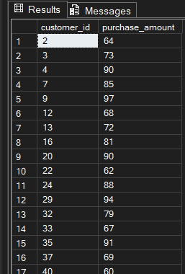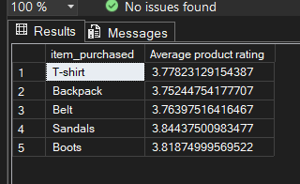

-- Which are the top 5 products with the highest average review rating?
select top 5 item_purchased, avg(review_rating) as 'Average product rating'
from cust
group by item_purchased;


-- Compare the average Purchase Amounts between Standard and Express Shipping?
select shipping_type,
avg(purchase_amount) as Average_purchased_amount
from cust
where shipping_type in ('Standard','Express')
group by shipping_type;
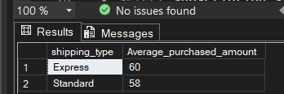

-- Do subscribed customers spend more ? compare average spend and total revenue between subscribers and non-subscriber?
select subscription_status,
count(customer_id) as total_customers,
round(avg(purchase_amount),2) as avg_Spend,
round(sum(purchase_amount),2) as Total_spend
from cust
group by subscription_status;
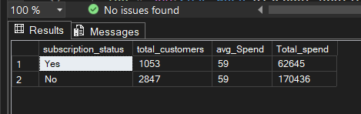

-- Which 5 products have the highest percentage of purchases with discounts applied?
select top 5 item_purchased,
100 * SUM(CASE when discount_applied = 'Yes' Then 1 else 0 end)/count(*) as discounnt_rate
from cust
group by item_purchased
order by discounnt_rate desc;
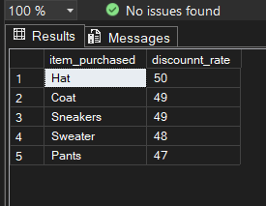

-- Are customers who are repeat buyers( more than 5 previous purchases)also likely to subsribe?
select subscription_status,
count(customer_id) as repeat_buyers
from cust
where previous_purchases > 5
group by subscription_status;
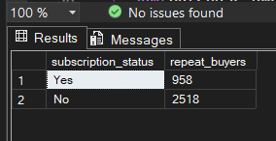

-- What are the revenue contribution of each age group?

select age_group,
sum(purchase_amount) as Revenue_contribution
from cust
group by age_group;
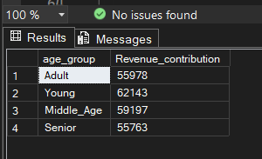

5. Power BI Dashboard Insights
The dashboard visualizes the KPIs and sales distributions:
- Category Leadership: Clothing is the top category, generating $104K in revenue from 1,737 sales.
- Subscription Gap: 27% of customers are subscribed, while 73% are not.
- Demographic Focus: The Young age group represents the largest customer base (1,028) and the highest revenue contribution ($62K).
- Revenue by Group: Middle_Age contributes $59K, while Adults and Seniors both contribute approximately $56K.
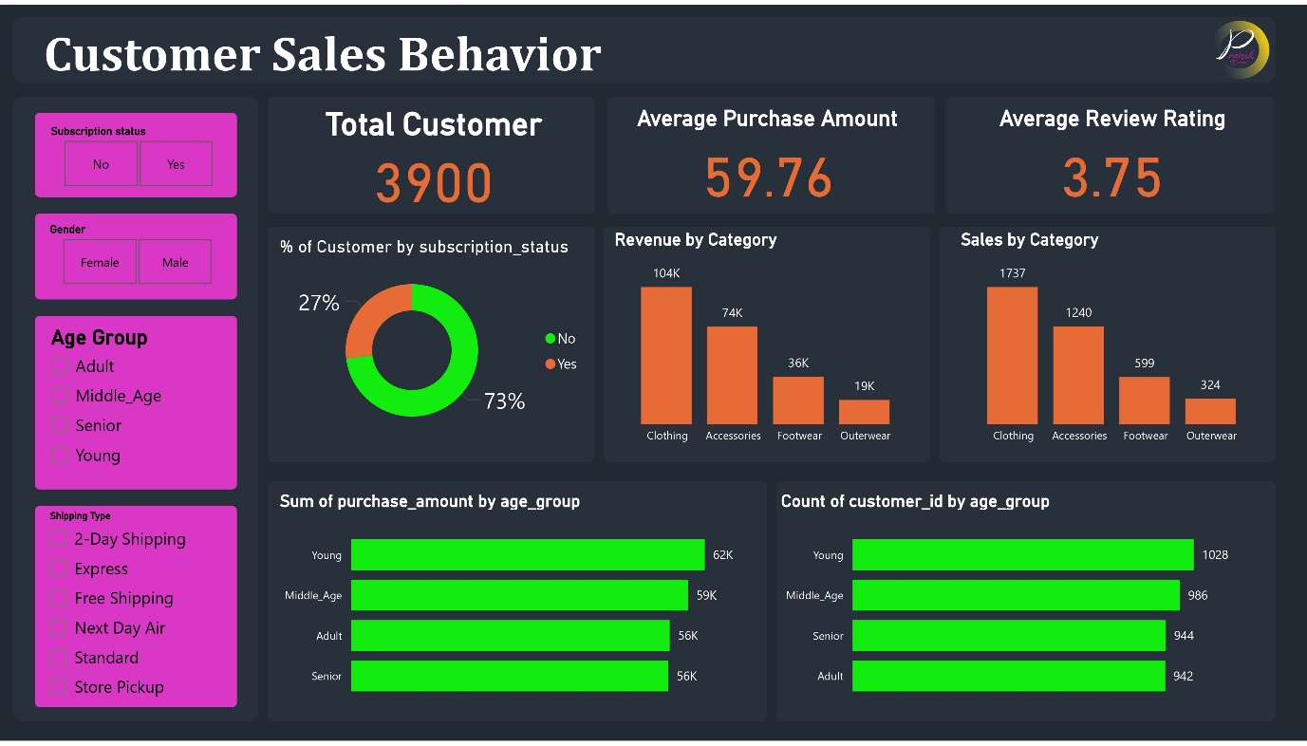

6. Business Recommendations
- Clothing Strategy: Since Clothing drives the most revenue, prioritize inventory and seasonal marketing for this category.
- Subscription Drive: Launch a targeted campaign to convert the 73% of non-subscribers into the loyalty program.
- Youth Marketing: Focus social media marketing on the "Young" segment, as they are the primary revenue drivers.
- Inventory Clearance: Outerwear has the lowest sales volume (324 units); consider bundle offers to increase movement

