**IsPostBack**

Postback is actually sending all the information from client to web server, then web server process all those contents and returns back to the client. Most of the time ASP control will cause a post back (e. g. buttonclick) but some don't unless you tell them to do In certain events ( Listbox Index Changed,RadioButton Checked etc..) in an ASP.NET page upon which a PostBack might be needed.

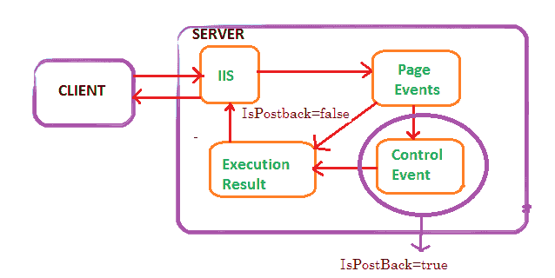

IsPostBack is a property of the Asp.Net page that tells whether or not the page is on its initial load or if a user has perform a button on your web page that has caused the page to post back to itself. The value of the Page.IsPostBack property will be set to true when the page is executing after a postback, and false otherwise. We can check the value of this property based on the value and we can populate the controls on the page.

Is Postback is normally used on page _load event to detect if the web page is getting generated due to postback requested by a control on the page or if the page is getting loaded for the first time.

