RadRichTextBox for Silverlight/WPF

# Overview

RadRichTextBox is a control that offers Microsoft Word-like authoring and editing in your applications using a familiar interface for end users. The experience is enhanced by the support of multilevel bullet and numbered lists, tables, inline and floating images. More advanced options include external and in-document hyperlinks, bookmarks and comments.

The control can preview and edit text in various languages thanks to the Input Method Editor and the Right-to-Left support, which makes it an appropriate choice in a wide range of applications. Even more sweetness is added by the integrated spell-checker and image editor allowing immediate detection and correction of spelling mistakes and in-place tweaking of images.

# MS Word-like Authoring

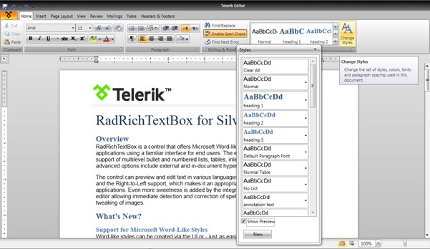

Provide Microsoft Word-like authoring and editing in your applications using a familiar interface for your end users.

# Rich Document Model Support

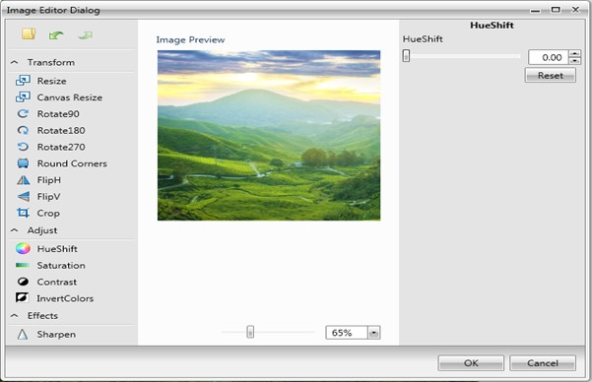Get a more complete rich text editing experience with support for Lists, Tables, Inline and Floating Images, Hyperlinks, Bookmarks and Comments.

# With SpellChecker & Image Editor

With integrated SpellChecker and ImageEditor, provide on-the-fly proofing and tweaking of images, all without leaving the document UI.

# Markup & Navigation

Markup your documents with Word-like comments and enable document navigation with a built-in Bookmark system.

# Import & Export

Import and export to and from Docx, RTF, HTML, XAML and Txt, as well as export to PDF - all without writing a single line of code.

# Document Protection

Define different editing restrictions and enforce them on different parts of the document. Import and export protected documents in the supported file formats.

# VS Wizard

Add a fully featured rich text editor to your solution in under a minute thanks to the click-through interface provided by Visual Studio's wizard.

# Different Views & Printing

Use a standard TextBox-like layout or a Paged view with various sizes and Headers and Footers. Utilize the printing functionality that comes out of the box.

# Mail Merge

Create or open existing templates and fill in different data taken from database, spreadsheet or any other source. Preview the results in the RichTextBox or proceed with exporting.

# RTL and IME

Allow entering text in various languages thanks to the built-in Input Method Editor and Right-to-Left support.

# Intuitive Editing Experience

Provide an intuitive editing experience thanks to the integrated RibbonView, context menus, mini toolbars and dozens of dialogs designed to gear the functionality of the control.

# Performance

Ensure quick loading even of larger documents. Further editing can be performed without significant performance hit due to the built-in UI Virtualization.