**Software Change Request**

**Change Request Initiation:**

Originator: OPC

Date submitted: March-18

System name: UT

Expected launch date: TBC

**Change Type:**

New requirement/~~Requirement Change~~/~~Design Change~~

**Reason:**

Business update

**System Affected:**

UT~~/WM/NFT/MFT/Interface file to other system/WMS/ROD/e-statement/ETL/KB/WebAdmin~~

**Impact to advice:**

~~Yes~~/No

**Impact to statement:**

~~Yes~~/No

**Change Description:**

Return mail handling for UT/WM contact notes Phase one

Requirements

1. [UT]

Existing practice:

The contract notes are printed in this sequence and group altogether.

Print sequences are:

C:\pdf\print\WM\WM contract note 1

C:\pdf\print\WM\WM contract note 2

C:\pdf\print\WM\WM contract note 3

C:\pdf\print\UT contract note 1

C:\pdf\print\UT contract note 2

C:\pdf\print\UT contract note 3

(To IT technical team: put to the mutual fund PC c:\pdf\print and the operator helps to print the contract note. The contract note should be in account sequence.)

Revised practice:

Contract notes and its coversheets are printed with grouping. The contract note should be divided into three groups(local/byhand/oversea).

Print sequences are:

C:\pdf\print\Local\WM\Local coversheet for WM contract note

C:\pdf\print\Local\WM\WM contract note 1

C:\pdf\print\Local\WM\WM contract note 2

C:\pdf\print\Oversea\Oversea coversheet for WM contract note

C:\pdf\print\Oversea\WM\WM contract note 3

C:\pdf\print\Oversea\Oversea coversheet for UT contract note

C:\pdf\print\Oversea\UT contract note 1

By hand coversheet

C:\pdf\print\Byhand\Byhand coversheet for UT contract note

C:\pdf\print\Byhand\UT contract note 2

C:\pdf\print\Byhand\UT contract note 3

(To IT technical team: Put to the mutual fund PC c:\pdf\print and the operator helps to print the contract note and coversheet.)

1. [UT] Generate a coversheet (pdf or text file) by local/oversea/byhand that include the following information

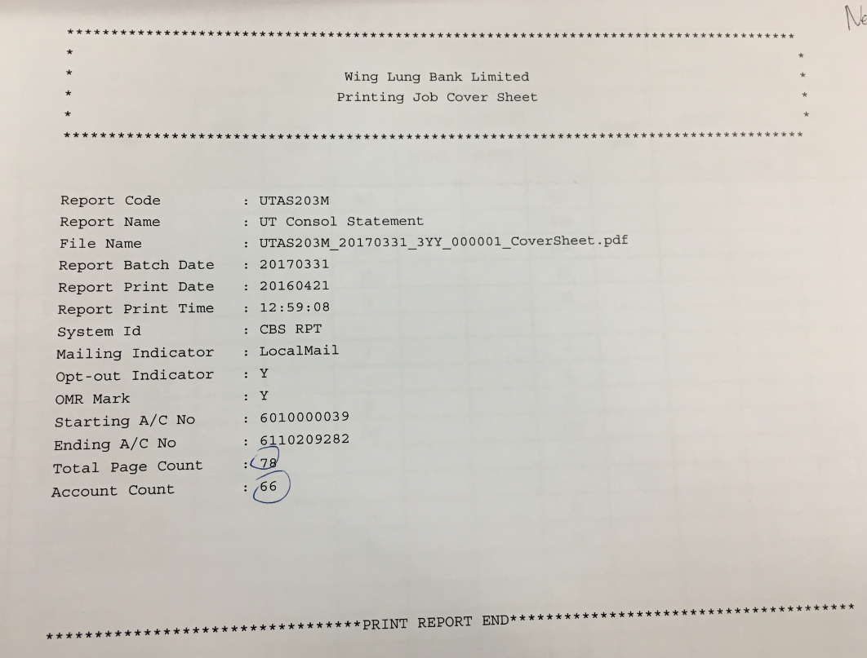

Report code: [Report ID]

Report name: [Report name]

Report file name: [Coversheet file name]

System ID: [UT or WM]

Mailing indicator: [Local/oversea/by hand]

Opt-out indicator: N/A

OMR Mark: N/A

Starting A/C No: [XXXXXXXXXX]

Ending A/C No: [XXXXXXXXXX]

Total page count: [999]

Account Count: [999]

** No handling for opt-out indicator, OMR mark

(To IT technical team: and upload the file to the mutual fund PC c:\pdf\print\)

1. [UT] The mail indicator(byhand/overrsea/local) to be used should rely on the “Customer Profile” and not refer to “Account Profile”.
2. [UT] Contract note with e-statement are needed to handle for local/oversea/byhand. Like C:\pdf\print\Byhand\NOPRINT_PDF\
3. [UT] Contract notes are kept to send to OPC-IOS, OPC-ASS as usual. Directly sending to GAD is not in this phase of development.
4. [UT] Adding new return mail indicator is not in the scope of this phase.
5. [UT] UT statement is not in the scope of this phase.

UAT test plan and cases

1. UT generates the coversheet
2. UT generates the printed pdf and check by hand/local/oversea
3. UT generates the no printed(e-statement) pdf and check by hand/local/oversea

[More test cases can be appended]

** If any further test case is needed, OPC-IOS user could provide it.

Migration verification:

1. [UT] Migrate the program
2. [UT] Update the SQL to add a new field
3. [UT] To UT-IT technical team, please put the path file to be updated here.(e.g. jar/sql/jsp). It is for the migration verification. [To be confirmed]

Production verification:

1. After the program is launched, the IOS/OPC user needs to perform the production verification.

* End of Document -