Recommender Systems - Course Project Report
Cumulative report template - Parts 1, 2, and 3
Team | Group 3
Members | Pau Duch 154980474, seyedali 155021329
For Part 3 track: select one | A / B / C
GitHub repository link | https://github.com/PauDuch/recommender_systems_project.git

How to use this template
- This is one cumulative report. Extend and revise the same document at each project stage.
- Maximum length: 4 pages at Part 1, 8 pages at Part 2, and 12 pages for the final report, excluding references.
- Keep the section headings below. You may add subsections where useful.
- All explanations and justifications requested in the project specification belong in this report.
- The Results Sheet contains the complete standardized numerical record. In the report, include only the tables and figures needed to support your analysis.
- Delete all italic instructional text before the final submission.

1. Part 1 - Data, Protocol and Baselines

1.1 Data characterization
The MovieLens 1M dataset consists of 1,000,209 explicit ratings on a 1–5 scale, with 6,040 unique users across 3,706 rated movies out of a total catalogue of 3,883 titles in movies.dat. The matrix density is 4.47% over rated items and 4.26% against the full catalogue.
Users have on average 165.60 ratings (median: 96.0, std: 192.75, range: 20 to 2,314), with every user having at least 20 ratings.
Items have on average 269.89 ratings (median: 123.5, std: 384.05, range: 1 to 3,428). The rating score distribution has a negative (left) skew (mean: 3.58, median: 4.0, std: 1.12), with 4-star (34.9%) and 5-star (22.6%) ratings comprising over 57.5% of all interactions, therefore most ratings are positive ones.
Non-obvious properties relevant to the experiments:
- Catalogue Incompleteness: Exactly 177 movies in the catalogue (4.56%) have zero interactions in the ratings data, and 114 movies have only a single rating. The log-log rank-interaction plot reveals a steep linear power-law decay, indicating that obviously a tiny list of blockbusters dominates overall consumption while the vast majority of items reside in a highly sparse long tail.
- Extreme Temporal Burstiness: Although the dataset spans 1,038 calendar days (April 2000 to February 2003), over 90.5% of all ratings (904,757 ratings) were entered within the first 8 months (year 2000). Rating volume collapsed to 6.8% in 2001, 2.4% in 2002, and 0.3% in 2003. This extreme burstiness dictates that a single global temporal cutoff cannot be applied without causing catastrophic user attrition in the test set.
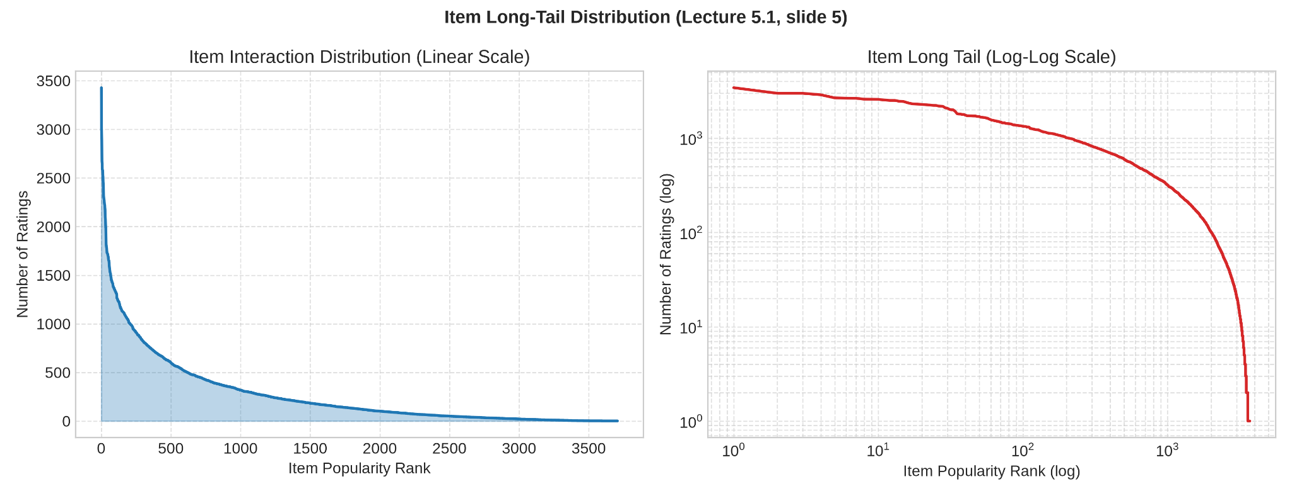
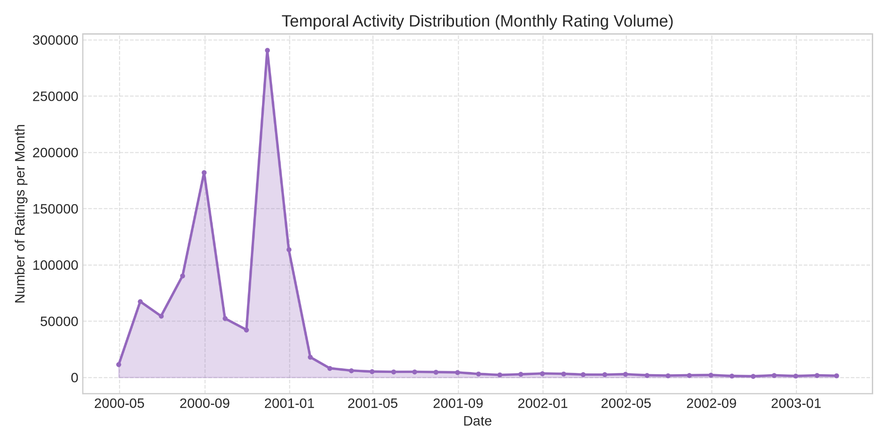
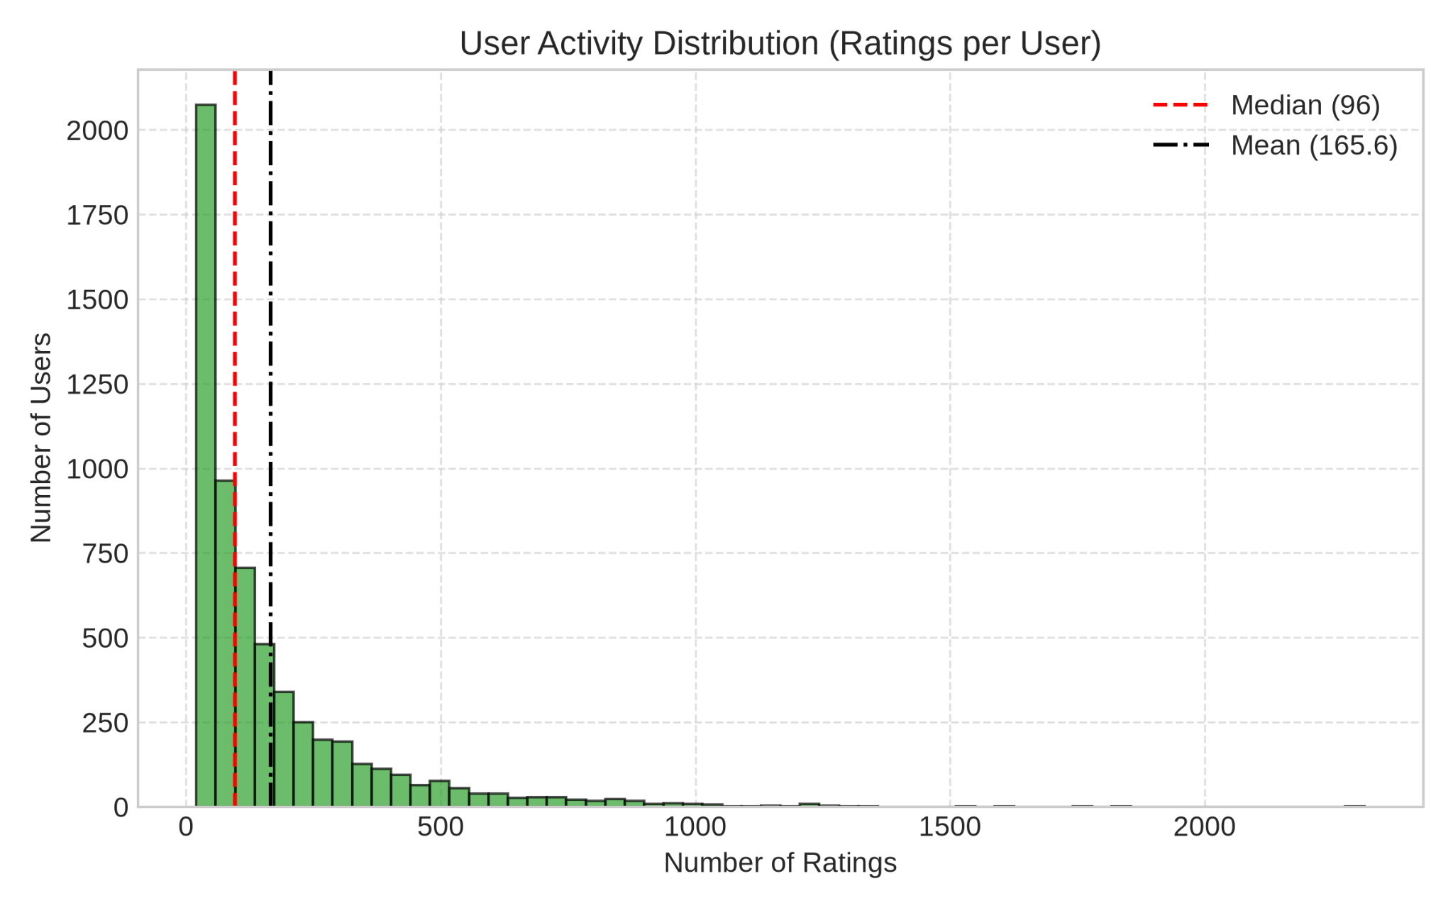

1.2 Preprocessing and feedback treatment
Item Filtering Threshold: We applied a threshold of at least 5 interactions per item. This threshold removed 290 low-activity items and 598 interactions (only 0.060% of total volume), preserving 999,611 interactions (99.940%) across 3,416 unique items. This filtering was necessary as items with fewer than 5 ratings lack sufficient co-occurrence data for computing item-item similarity vectors and would generate problems later on.
User Filtering: No filtering was performed on users as the dataset already enforces a minimum of 20 ratings per users.
Feedback Treatment: MovieLens records explicit 1–5 ratings. For top-10 ranking, ratings were converted to binary positive feedback: interactions with rating >= 4.0 are treated as positive and relevant, while ratings < 4.0 are non-relevant. As mentioned previously, most ratings are 4 and 5, therefore a rating lower than that is not considered a good recommendation.
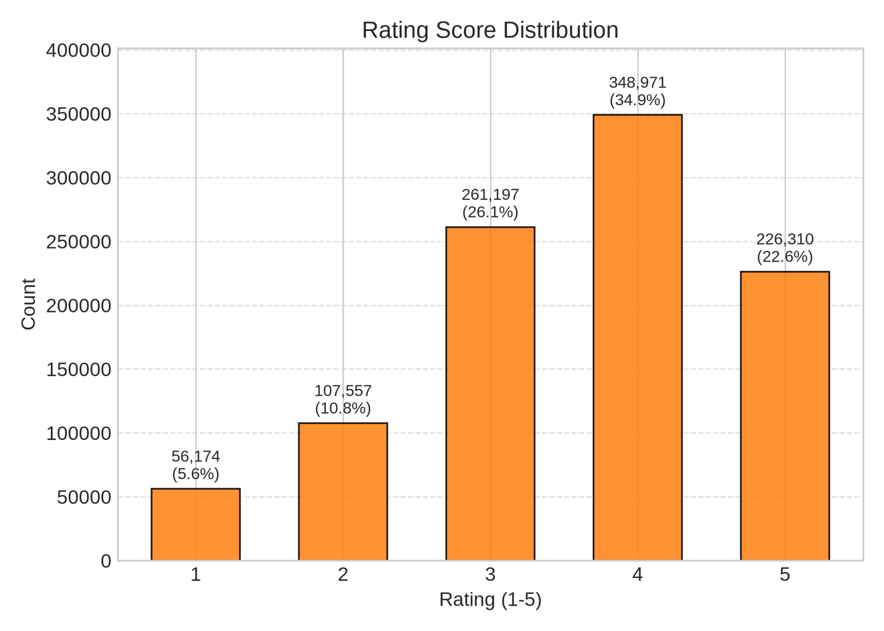

1.3 Train/validation/test split
We implemented a per-user chronological split using an 80% / 10% / 10% ratio:
- Each user's interactions were sorted chronologically by timestamp.
- The earliest 80% of interactions form the Training set (797,275 interactions).
- The subsequent 10% form the Validation set (99,639 interactions) for hyperparameter tuning.
- The final 10% form the Test set (102,697 interactions) for final baseline reporting.
The reason behind this is that a timestamp cutoff wouldn’t perform well in this dataset, due to the previously mentioned fact that most of the ratings occur in the first year. This would result in most users having 0 test interactions. The selected per-user chronological split guarantees that all the users will be evaluated, while at the same time it respects the temporal causality with no future past leakage, and also simulates a realistic behavior over time, predicting future choices.

1.4 Evaluation protocol
For each user, unseen items are ranked against the full catalogue of 3,883 items, strictly excluding movies already rated during training.
We deliberately avoid sampled negative evaluation, which is known to introduce artificial popularity and sampling bias. The recommendation list cutoff is set to K = 10.
Performance is assessed across the user cohort using four standard metrics:
- Precision@10 measures the fraction of recommendations that are relevant (rating >= 4.0)
- Recall@10 measures the coverage of the user's test-set preferences
- NDCG@10 evaluates ranking quality by penalizing relevant items placed at lower ranks via logarithmic discounting (1 / log2(rank + 1)).
- Additionally, catalogue coverage measures the percentage of distinct items in the entire catalogue recommended to at least one user, tracking system-wide diversity and popularity bias.
- A fixed random seed (42) is enforced across all experiments to guarantee full determinism and reproducibility.

1.5 Baseline methods and settings
We implemented two primary baseline architectures: Most Popular and Item-based kNN. For Most Popular, we evaluated three distinct variants:
- All Interactions, which ranks items by total rating count
- Positive Only, which ranks items by the count of ratings >= 4.0
- Damped Average, which ranks items using a Bayesian mean rating with a global prior weight (m = 50) to mitigate low-count noise.
For Item-based kNN, an hyperparameter optimization was conducted strictly on the Validation set across neighborhood sizes k in {10, 20, 50, 100} and two similarity measures: standard Cosine similarity on raw ratings, and Adjusted Cosine (centering ratings by subtracting user means).
As detailed in the Baseline Table in the xlsx, Cosine similarity with k = 100 achieved the best validation performance (NDCG@10 = 0.0831), outperforming smaller neighborhoods by aggregating broader collaborative evidence. While Adjusted Cosine produced significantly higher catalogue coverage (up to 41.02%) by neutralizing blockbuster bias, it suffered a noticeable penalty in ranking accuracy (NDCG@10 = 0.0764). Consequently, Cosine similarity with k = 100 was selected as our primary Item-kNN configuration for final test-set evaluation.
The main command doesn’t run this extra test of the item based knn, only the best configuration, however the code is preserved in the repository and explained how to test it in the readme

1.6 Results and analysis
On the held-out test set, Item-based kNN (k = 100, Cosine) decisively outperforms all Popularity baselines across every ranking metric. Compared to the strongest popularity baseline, personalization yields a +22.0% relative improvement in NDCG@10 and a +45.1% relative gain in Recall@10. This confirms that collaborative preference modeling successfully captures meaningful individual tastes better than just presenting the user the list of usual blockbusters.
Furthermore, our experiments reveal an extreme popularity bias in unpersonalized ranking. The Most Popular baselines achieve only 3.01% to 3.17% catalogue coverage, concentrating all recommendations onto a tiny fraction of blockbusters and permanently burying over 96% of the catalogue. In sharp contrast, Item-based kNN expands catalogue coverage to 31.68%, proving that neighborhood models actively surface niche titles from the long tail while simultaneously elevating ranking accuracy. Clearly a 31% coverage is not enough, however it established a good baseline.
Among the popularity variants, ranking strictly by positive feedback (ratings >= 4.0) slightly edges out all-interaction volume because filtering out low-rated interactions eliminates polarizing movies. Conversely, ranking by damped average rating collapses to an NDCG@10 of 0.0296 and a catalogue coverage of 2.16%. This demonstrates that high average ratings on niche, low-exposure films do not generalize well to general top-10 discovery, where broad appeal remains an essential component of candidate retrieval.

2. Part 2 - Models and Honest Comparison

2.1 Models
Describe the additional models and paradigms. Clearly identify the self-implemented algorithm and explain its implementation.

2.2 Hyperparameter tuning and variability
Describe the validation-only tuning procedure, search spaces/budgets, random seeds, and confidence intervals or statistical testing.

2.3 Overall results
Present and discuss the main comparison. Explain important differences and avoid unsupported claims.

2.4 Disaggregated analysis
Report and interpret results broken down by at least two of the required dimensions: items with few vs. many training interactions, low- vs. high-activity users, popular vs. long-tail items, and early vs. late test period. Define any thresholds used and focus on findings that change or qualify the overall conclusions.

2.5 Sparsity ablation
Report and discuss the 100%, 50%, and 20% training-interaction experiments, including changes in the ranking between models.

3. Part 3 - Beyond Accuracy

3.1 Selected track and motivation
State Track A, B, or C and briefly motivate the selected intervention/extension.

3.2 Method
Describe only your selected track. The Track A/B/C guidance below is provided as instructions; delete the guidance for the two tracks you did not select before submission.

If Track A - Diversity and popularity bias
State the base recommender, selected re-ranking method, genre-vector item representation, trade-off parameter, and exact item-distance measure. Describe how the parameter was swept.

If Track B - Fairness
Define the release-decade provider proxy, report and justify the final decade boundaries and group sizes, state and justify the adopted fairness notion, describe the consumer groups based on MovieLens user attributes, and identify the stage and form of the mitigation.

If Track C - Group recommendations
State the selected synthetic group type and justify the chosen group size (3-5). Describe the three aggregation strategies. Identify which strategy was extended to the sequential scenario and explain how satisfaction is carried forward between recommendation rounds.

3.3 Results and trade-offs
Present the required track-specific results. Track A: report intra-list diversity, catalogue coverage, Gini and calibration error across the parameter sweep, and discuss the accuracy-diversity frontier. Track B: report position-weighted exposure against catalogue share, per-group consumer-side accuracy, and the fairness-performance frontier. Track C: compare group satisfaction, disagreement and minimum member satisfaction across the three aggregation strategies, then analyse how member and group satisfaction develop in the sequential scenario.

3.4 Cost and interpretation
State what is gained, what is lost, and who bears the cost where applicable. Explain what operating choice or strategy you would select and why.

3.5 "One number we cannot explain"
Identify one result you do not fully understand and describe how you would investigate it.

4. Discussion and Conclusions
Summarize the main findings across the project. Discuss limitations, failed approaches where relevant, and what the experiments support.

5. Contribution Statement
For each team member, provide two or three sentences describing their contribution.

6. Use of AI Assistants
State which AI tools were used and for what. If none were used, state that explicitly.
We used an AI assistant Gemini to help structure the Python pipeline architecture, draft clean documentation and code, and mostly to review that we were consistent with the guidelines and what was asked in the project document.

References
List references used in the report. References do not count toward the page limit.

