**Q16 A**

*Open the Q16A file and add your name where appropriate.*

(i) Currently the player's name is hard coded to be “Adventurer”. Change the code so the user is asked for their name. The code should then display the player’s chosen name before running the program for the goblin encounter.

When run, your code might look like the following:

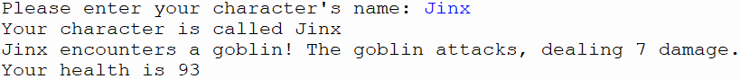

(ii) Currently the goblin can deal a maximum of 12 damage. This is too powerful. Change the code so that the goblin can deal a maximum of 6 damage.

(iii) Create a new function called health_potion. This function should randomly add between 1 and 4 inclusive to the player’s health. It should then print the player's health to the screen.

When run, it should look similar to the code below.

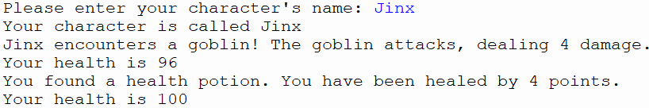

(iv) Create a new function called dragon_encounter similar to the goblin_encounter, but the dragon will always deal 5 damage plus a random number between 1 and 20.

(v) Change the program so that the player chooses between two pathways. One pathway will lead to the dragon encounter and the health potion, the other pathway will lead to the goblin. The resulting code might look similar to below.

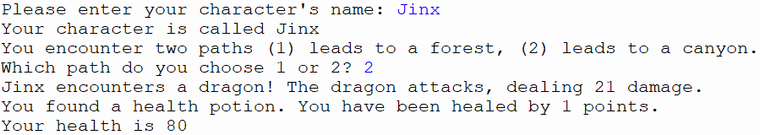

(vi) Change the program so that it validates the user’s choice of path. Use a loop to ensure that the program keeps asking the user to select a path until they enter 1 or 2. When run your code may look similar to below

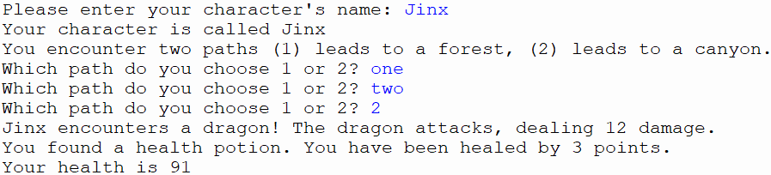

**Q16 (b)**

*Open the Q16B file and add your name where appropriate.*

Write a program that simulates a number guessing game.

* The user should be asked for their name and the computer should confirm the user’s chosen name.
* The user will be asked to enter a number between 0-100 which is compared to a number the program has randomly chosen.
* The user should get 5 attempts.
* The computer should inform the user if their guess was high or low after each attempt.
* A message should be printed telling the user what the random number was if the user uses all their lives or a message of congratulations if they guess correctly.