“BENEPESO: A WEB-BASED BENEFICIARY PROFILING, ELIGIBILITY, AND VERIFICATION SYSTEM FOR PESO PROGRAMS”

A Capstone Project Presented to the
Faculty of the College of Computing and Multimedia Studies at University of Camarines Norte
Daet, Camarines Norte

In Partial Fulfillment of the Requirements
for the Degree of Bachelor of Science
In Information Systems

By:
AGUILAR, PAULO V.
GUERRERO, MARK JESSIE
PALOMARES, JOHN MARWEN
SILO, JAYLO M.

2026
TABLE OF CONTENTS
INTRODUCTION 3
Context of the Study 3
Research Objectives 6
Research Questions 7
Scope and Delimitations 8
Significance of the Study 11
REVIEW OF RELATED LITERATURE AND STUDIES 14
Information Requirements for Employment Profiling, Eligibility, and Verification System 14
Features of Employment Profiling, Eligibility, and Verification System 18
Synthesis of the State-of-the-Art 28
RESEARCH METHODOLOGY 33
Research Design 33
Software Development Methodology 33
Schedule of Activities 37
Sources of Data 41
Population of the Study 42
Data Collection Method 44
Data Analysis 45
Statistical Treatment of Data 47
Ethical Consideration 48

Chapter 1

INTRODUCTION

Context of the Study
As the world becomes more connected, governments are quickly adopting digital tools to provide better, more transparent, and accessible public services. Using information and communication technologies (ICT) has changed how public institutions work, making services faster, data management better, and citizen engagement stronger. Research shows that digital governance helps make public services more efficient by cutting processing times, lowering costs, and increasing transparency and satisfaction among citizens (Putra et al., 2023). Other studies also show that the digital economy and e-governance make public services more effective, especially where digital infrastructure is strong (Zhang et al., 2024).
Along with digital transformation, digital identity has become a key part of modern public services. Digital identity means a unique way to represent people online, allowing secure and accurate access to services. As governments use more digital platforms, having reliable identity checks is more important to keep things fair, avoid duplicate records, and protect personal data. Studies show that digital identity systems are now essential for public services, helping with inclusion, security, and efficient service delivery in many areas (Pöhn & Hommel, 2020). New ideas like self-sovereign identity focus on secure, user-centered management, offering better ways to verify identities while keeping privacy and trust (Wang et al., 2020).
In line with these global trends, digital transformation in public administration plays a vital role in improving the efficiency, transparency, and accessibility of services at the local level. Government offices are increasingly adopting web-based technologies to manage data more effectively, reduce manual processes, and provide faster services to citizens. Digital systems help streamline operations, minimize errors, and ensure that services reach communities in a more convenient and inclusive manner, particularly in geographically dispersed areas. Furthermore, studies on digital public service implementation emphasize that technologies such as electronic identification systems and digital records significantly enhance the effectiveness of service delivery and improve the performance of government personnel (Sari et al., 2023).
At the local government level, offices that handle social welfare, employment, and livelihood programs often deal with large volumes of beneficiary data. Accurate profiling, eligibility checking, and verification are essential to ensure that assistance is distributed fairly and efficiently. However, many municipal offices still rely on manual processes such as spreadsheets, printed lists, and physical records. These traditional methods can lead to delays, data redundancy, difficulty in verification, and increased workload for staff.
In the Municipality of Vinzons, the Public Employment Service Office (PESO) is responsible for implementing employment assistance and livelihood programs such as TUPAD and other related initiatives. One of the major challenges faced by PESO staff is managing beneficiary information and verifying eligibility. Currently, staff manually search through spreadsheets or printed records to check if a person is already registered or qualified for a program. This process is time-consuming and prone to human error. Additionally, beneficiaries are required to personally visit the PESO office to verify their eligibility. For residents from distant barangays, especially island barangays that require boat transportation to reach the municipal center, this creates inconvenience, additional expenses, and time consumption. These difficulties can discourage eligible residents from seeking assistance, resulting in missed opportunities for support. By modernizing the system, the municipality can ensure more equitable access to its programs and services.
This study developed BENEPESO, a web-based beneficiary profiling, preliminary eligibility screening, application management, and verification system for PESO Vinzons. The system organizes program and beneficiary records in a centralized database and provides separate access for the Administrator, PESO Staff, and Registered Applicant or Beneficiary. Residents can submit applications and monitor recorded status online, while authorized PESO personnel review information, record documentary verification, and update program progress. The system is intended to reduce repetitive record searching and unnecessary status-inquiry visits; physical submission and verification of required documents remain part of the office process.
The implementation of web-based beneficiary management systems in government offices has been widely recognized as an effective approach to improving administrative efficiency and public service delivery. Digital platforms not only reduce paperwork and human error but also enhance accessibility and transparency in government processes (Latupeirissa et al., 2024). By adopting such a system, PESO Vinzons demonstrates its commitment to digital transformation, efficient governance, and inclusive service delivery for all residents, including those in geographically isolated barangays.

Research Objectives
The study aims to develop BENEPESO: A Web-Based Beneficiary Profiling, Eligibility, and Verification System for PESO Programs in Vinzons. Specifically, this study aims to:
1. determine the information requirements needed in the development of BENEPESO for managing beneficiary profiles, eligibility records, and program participation of PESO programs in Vinzons
2. determine and implement the features of BENEPESO that support beneficiary profiling, preliminary eligibility screening, application review, requirements verification, program-progress tracking, and historical report generation for authorized PESO personnel; and
3. evaluate BENEPESO through functional testing, including automated checks, and User Acceptance Testing (UAT), guided by selected ISO/IEC 25010:2011 quality characteristics:
a. functional suitability;
b. usability;
c. performance efficiency;
d. security;

Research Questions
The research study aims to develop the BENEPESO: A Web-Based Beneficiary Profiling, Eligibility, and Verification System for PESO Programs in the Municipality of Vinzons, Camarines Norte. Specifically, it sought to answer the following:
1. what information requirements are needed in the development of BENEPESO;
2. What features are needed to support beneficiary profiling, preliminary eligibility screening, requirements verification, program-progress tracking, and historical report generation in BENEPESO?
3. How is BENEPESO evaluated through functional testing and User Acceptance Testing (UAT), guided by the following selected ISO/IEC 25010:2011 quality characteristics?
a. functional suitability;
b. usability;
c. performance efficiency; and
d. security;

Scope and Delimitations
This study focuses on BENEPESO, a web-based beneficiary profiling, preliminary eligibility screening, application management, and verification system for the Public Employment Service Office of Vinzons, Camarines Norte. The implemented system covers three program families: TUPAD, SPES, and MSME Profiling. Program categories contain descriptive information, while dated batches contain schedules, slots, venues, and configured eligibility requirements. Account information, applications, beneficiary details, program participation, requirements review, and reporting records are maintained in a centralized database.
The system supports three user roles: Administrator, PESO Staff, and Registered Applicant or Beneficiary. Registered users can create an account, securely sign in, maintain their own profile, view program batches, submit an online application subject to configured screening rules, and monitor recorded application and program-progress updates. Beneficiary name verification is available only after authentication and is restricted to the user's registered barangay and approved program batches associated with their own application. Results are limited and masked where applicable. A missing search result does not establish eligibility or replace official PESO confirmation.
The Administrator manages program information and batches, reviews staff-submitted batch requests, accepts or rejects applications, and manages staff and user account access. PESO Staff submit batch requests for administrator approval, encode or import beneficiary records, review requirements, and update permitted application details and program-progress information. Both authorized personnel roles can access historical reports, Excel exports, forms and templates, and relevant activity logs. Final application acceptance or rejection and account management are administrator functions. After acceptance, applicants bring physical requirements face to face to the PESO office within the recorded deadline. PESO personnel verify the documents and forward them to DOLE for rechecking. Personnel record applicable receipt, review, resubmission, and progress information in BENEPESO; the DOLE rechecking procedure takes place outside the website.
The implemented scope is limited to PESO programs within the Municipality of Vinzons. Preliminary eligibility screening uses configured rules and information encoded or submitted to the system; it does not authenticate records against DOLE or other national-government databases. Final office decisions and documentary verification remain the responsibility of authorized PESO personnel. Account registration currently requires applicants to be at least 18 years old. Program-specific age limits, sex restrictions, household rules, participation history, and other implemented local screening conditions apply where configured. These implementation rules must be distinguished from general program coverage stated in source forms.
The system does not process payments, transfer funds, distribute financial assistance, or perform job matching. MSME capital, earnings, and accepted payment-method fields are descriptive profiling records rather than transactions processed by the website. Face-to-face requirements submission, PESO document handover to DOLE, and DOLE rechecking are manual office procedures outside the automated website boundary. Pending and active records are processed in the Application module. The Report module provides read-only historical records and exports for rejected applications and approved applications with terminal statuses, including Completed, Exam Failed, Not Qualified, or Cancelled. The system does not provide applicant self-service cancellation or unrestricted public beneficiary searches.

Significance of the Study
The researchers believe that the implementation of BENEPESO: A Web-Based Beneficiary Profiling, Eligibility, and Verification System will provide significant benefits to the following stakeholders:
PESO Staff. This system will help PESO staff as an efficient tool for managing beneficiary information and verifying eligibility for programs such as TUPAD. Instead of manually searching through Excel files and printed records, PESO personnel will be able to use a centralized, searchable database to quickly check whether an individual is already registered, eligible, or has previously participated in a program. This will help reduce processing time, minimize record duplication, and make the verification process more organized. As a result, staff can focus more on implementing programs and providing better services to the public.
Beneficiaries. The system provides online access to available program information, application submission, and recorded status updates. Registered users can maintain their own profile and use restricted beneficiary verification within their barangay and applied program batches. These features are intended to reduce unnecessary trips for information and status inquiries, particularly for residents of remote or island barangays. Accepted applicants still need to follow PESO instructions for physical requirements submission and verification. Any claimed reduction in travel cost, waiting time, or processing time requires supporting evaluation data.
Municipality and Local Government Unit. This system will support the municipality in improving the management and documentation of PESO programs. By having an organized and centralized database, the local government unit can easily monitor beneficiary participation and generate reports for planning and evaluation purposes. The system will also help improve transparency, accountability, and efficiency in the implementation of employment and livelihood programs in Vinzons.
Future Researchers. This study will serve as a useful reference for future researchers who plan to develop web-based systems related to beneficiary management and public service delivery. It can provide ideas, guidance, and insights on how digital technologies can be used to improve administrative processes in government offices and address real-world challenges in managing beneficiary information.

Chapter 2

REVIEW OF RELATED LITERATURE AND STUDIES
This chapter discussed the review of related literature and studies that were relevant to the development of the BENEPESO: A Web-Based Beneficiary Profiling, Eligibility, and Verification System for PESO Programs. The review was organized according to the specific objectives of the study, which included identifying the challenges of the current system, developing the features and functionalities of the proposed system, and determining the level of effectiveness of the developed system using ISO/IEC 25010. The synthesis of the art is also provided to summarize the findings and highlight the gaps addressed by this study.

Information Requirements for Employment Profiling, Eligibility, and Verification System
The development of the BENEPESO system requires a clear understanding of the information and system requirements needed to effectively manage beneficiary profiles, eligibility assessment, and program participation records. In many public service institutions, the lack of integrated digital systems results in inefficiencies in handling beneficiary data and delivering services. According to Riansyah et al. (2025), integrated public service information systems improve government efficiency by enabling better data management, transparency, and accuracy in delivering services. This highlights the importance of developing a system that can organize and manage beneficiary information efficiently, which is one of the main goals of BENEPESO .
Beneficiary profiling is a key requirement for the system. Web-based profiling systems help local governments collect and organize demographic data, making it easier to manage community programs. Varona and Senen (2025) noted that these systems help keep accurate records of people in a community. For BENEPESO, profiling is important for identifying qualified PESO program beneficiaries and keeping records up to date. Melendres and Aranda (2024) also found that web-based information management systems are more efficient for storing, retrieving, and updating citizen data than manual systems, which supports the need for a digital profiling system.
Eligibility verification is another important requirement. Making sure that only qualified people get benefits is a major concern for social programs. The Digital Benefits Network (2025) reported that digital identity systems help government agencies check eligibility before giving public assistance. Beuermann et al. (2025) also said that targeting tools are important for finding eligible beneficiaries, especially when it is hard to measure income or other indicators. This means BENEPESO needs a reliable eligibility verification feature to make sure PESO services go only to those who qualify. Achungura et al. (2024) added that integrated digital systems can check eligibility by using data from different sources, which makes the process more accurate.
Accurate data management is also a critical requirement in developing the system. Maintaining correct and updated beneficiary records ensures that social programs reach the right individuals. Albert et al. (2024) emphasized that accurate beneficiary databases and targeting mechanisms are essential in ensuring that social protection programs effectively reach their intended recipients. However, data-related issues such as bias can affect decision-making. Dietrich et al. (2024) pointed out that data bias may negatively impact the identification of beneficiaries, which can lead to unfair or incorrect eligibility decisions. Therefore, BENEPESO must ensure the use of accurate, reliable, and unbiased data in managing beneficiary information.
In addition to data management, system usability and accessibility are important considerations. Digital government platforms improve service delivery by making services faster and more accessible to citizens (Mao, 2023). Ilieva et al. (2024) also noted that user satisfaction and system usability significantly influence the adoption of e-government services. This means that BENEPESO should be designed with user-friendly features so that PESO personnel can easily navigate and utilize the system. Furthermore, Nookhao and Kiattisin (2023) explained that the success of e-government systems depends on how easily users can understand and adopt the system, reinforcing the importance of usability in system design.
Security is also a major requirement, especially because the system will handle sensitive personal information. Silva et al. (2023) said that online public service systems need strong data security to protect citizen information from unauthorized access. Edu et al. (2023) pointed out that electronic identity systems are important for authenticating users and keeping digital services secure. Pham et al. (2023) added that reliable, secure, and trustworthy management of user data is key for high-quality e-government services. These points show that BENEPESO must have strong security features to protect beneficiary information and keep the system safe.
Moreover, the use of information systems in the public sector has been proven to enhance efficiency and service delivery. Bakar et al. (2024) stated that information systems improve operational efficiency, transparency, and service delivery in government organizations. This supports the idea that implementing a web-based system like BENEPESO can significantly improve the management of beneficiary profiles, eligibility assessment, and program records in PESO offices.
The reviewed literature highlights the importance of developing an integrated, secure, and user-friendly system for managing beneficiary information. The studies consistently show that digital systems improve efficiency, accuracy, and transparency in public service delivery, while also addressing challenges such as data management, eligibility verification, and system usability. Despite these advancements, many public service offices still rely on traditional or fragmented systems, which limit their ability to effectively manage beneficiary data. This gap emphasizes the need for the development of BENEPESO as a web-based beneficiary profiling, eligibility, and verification system that can streamline administrative processes, ensure accurate beneficiary targeting, and improve overall service delivery in PESO programs.

Features of Employment Profiling, Eligibility, and Verification System
The development of BENEPESO aimed to address the inefficiencies of manual beneficiary management by incorporating modern functionalities tailored for local government programs. Ruíz-Ortega et al. (2025) stated that structured eligibility assessment systems help social service agencies efficiently evaluate applicants and determine program qualification. This emphasized the need for an automated verification process within the system to ensure that only qualified individuals were enrolled in PESO programs, minimizing errors and biases. Furthermore, the Digital Benefits Network (2025) noted that digital identity systems help government agencies securely verify the eligibility of individuals before granting access to public assistance programs, reinforcing the necessity of a robust verification module in BENEPESO.
One of the major features required for an effective profiling system was the ability to cross-reference and validate data accurately. Achungura et al. (2024) pointed out that integrated digital systems allow organizations to validate beneficiary eligibility by combining and analyzing information from multiple data sources seamlessly. Similarly, Albert et al. (2024) emphasized that maintaining accurate beneficiary records and targeting mechanisms was crucial in ensuring that social protection programs reached the intended recipients. For PESO offices, these findings reinforced the need for BENEPESO to feature a strict beneficiary profiling and filtering tool that guarantees employment programs and services reach the correct demographic.
Beyond profiling, a critical feature of the proposed system was the integration of real-time monitoring tools to track program implementation effectively. Banerjee et al. (2025) emphasized that web-based dashboards allow organizations to monitor activities in real time and analyze operational performance. This capability was further supported by Rabiei et al. (2024) and Stahlman et al. (2025), who identified that dashboards transform complex datasets into clear, understandable information and present performance indicators effectively. Additionally, Schulze et al. (2023) explained that visual dashboards simplify information through interactive charts, while Katapally and Ibrahim (2023) noted that these tools improve organizational responsiveness. For PESO administrators, these visual and monitoring capabilities were essential to quickly identify trends in beneficiary participation and track overall program progress.
The ability to generate actionable insights from collected data was also a vital feature of the proposed system. Sayogo et al. (2024) stated that information systems enable local governments to analyze program data and support evidence-based decisions. This was reinforced by Sayogo et al. (2023), who emphasized that government information systems improve policy decisions by transforming raw collected data into analytical information. Vahedi et al. (2022) added that dashboards integrate data from multiple sources to support comprehensive monitoring, while Ivanković et al. (2021) stated that effective dashboards must present updated indicators to facilitate timely decision-making. For PESO offices, an automated report generation feature based on these principles would provide administrators with meaningful insights regarding beneficiary information and program outcomes without the burden of manual computation.
To support these features, the system required robust mechanisms for handling data securely and ensuring seamless operation. Bernardo et al. (2024) emphasized that reliable data governance improves the accuracy and trustworthiness of information systems, a principle that Alhassan et al. (2021) echoed, stating that effective data governance ensures the reliability of information. To achieve this, Matlala and Ncube (2024) highlighted the importance of electronic records management, which facilitates the efficient storage and retrieval of digital information. Additionally, Schmitz and Wimmer (2023) stated that integrated digital service architectures enable different system functions to work together seamlessly within public service platforms. This strongly supported the architectural design of BENEPESO, where profiling, eligibility verification, and monitoring must operate as interconnected components within a single, unified system rather than fragmented modules.
The reviewed literature highlighted important features that improve the functionality and efficiency of public service management systems. Studies emphasized that eligibility verification, real-time monitoring, proper data management, and automated report generation help improve administrative processes and program transparency. These features guided the development of BENEPESO to enhance beneficiary profiling, eligibility checking, program monitoring, and overall efficiency in managing PESO operations and services.
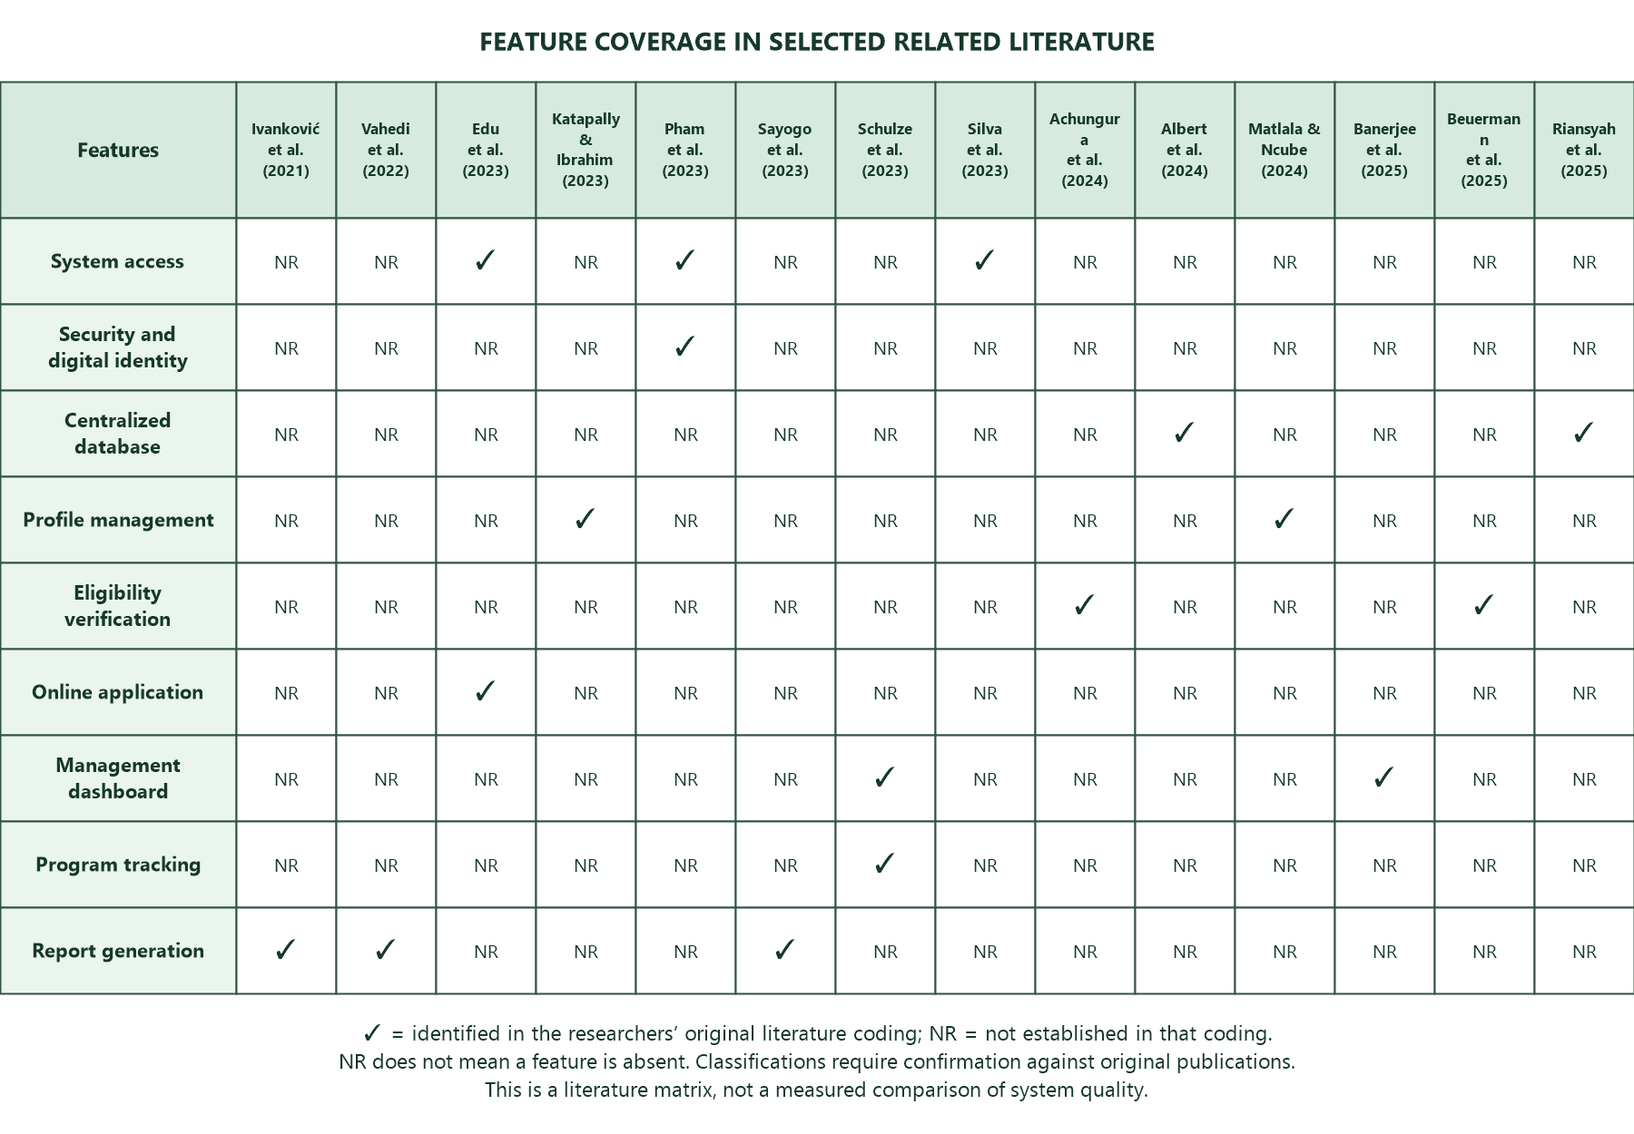
Figure 1 organizes selected related literature according to features discussed in the study. The matrix retains the researchers' feature coding for comparison; a check mark represents a feature identified in the original literature review, while NR means that the feature was not established in that coding. NR must not be interpreted as proof that the feature is absent from a source system. Individual classifications require confirmation against the original publications.

Figure 1. Feature-Coverage Matrix of Selected Related Literature
The matrix provides a structured comparison of the selected literature across system access, security and digital identity, centralized data storage, profile management, eligibility verification, online applications, dashboards, program tracking, and reporting. It is used to organize the review and identify areas for closer investigation rather than to establish that a study or system lacks an unreported feature. Conclusions about a research gap should be based on verified source descriptions and the local operational requirements of PESO Vinzons. The matrix does not constitute a measured comparison of system quality or proof that BENEPESO is superior to the reviewed systems.
Evaluation of Beneficiary Profiling, Eligibility, and Verification Systems
Evaluation of BENEPESO considers both implemented behavior and user experience. Functional testing compares actual results with expected outcomes for defined tasks, while User Acceptance Testing (UAT) assesses whether intended users can complete role-appropriate tasks. The evaluation is guided by the selected ISO/IEC 25010:2011 product-quality characteristics of functional suitability, usability, performance efficiency, and security (International Organization for Standardization [ISO], 2011). Selecting these characteristics does not imply evaluation of the entire standard or ISO certification. Technical test evidence and respondent perceptions should be reported separately.
Adyaputra et al. (2025) found that factors such as functional suitability, usability, security, and performance efficiency play a major role in determining user satisfaction and acceptance. This implies that PESO administrators will evaluate BENEPESO based on how well the system performs its intended functions, how easy it is to use, how efficiently it operates, and how secure it is during actual operation. Similarly, Lusiani and Princes (2024) explained that system effectiveness depends on how well it performs across multiple quality dimensions rather than focusing on a single factor, reinforcing the need for a comprehensive evaluation approach.
Supporting this, Sarwosri et al. (2023) evaluated software quality using the ISO/IEC 25010 model by focusing on functional suitability and performance efficiency. The study applied the Analytical Hierarchy Process (AHP) to determine the weight of each quality characteristic and combined questionnaire-based evaluation with automated response time testing. The results showed that the system achieved acceptable quality levels, indicating that it effectively provides required features and performs efficiently under user demands.
In addition, Llovido et al. (2024) evaluated the usability and performance efficiency of the BOSESKO system using the ISO/IEC 25010 quality model through a combination of manual and automated testing methods. The study used usability surveys and several automated testing tools, including WebPageTest, Google Lighthouse, PageSpeed Insights, Yellow Lab Tools, and Pingdom, to assess the system’s overall quality and efficiency. The findings revealed that the system obtained acceptable usability ratings and satisfactory performance scores for both web and mobile platforms, showing that combining user feedback and automated testing provides a more comprehensive system evaluation.
Furthermore, the study emphasized that software evaluation should not only focus on system functionality but also on usability, accessibility, and performance efficiency to ensure better user experience and system effectiveness. The results also identified areas needing improvement, particularly in system optimization and performance enhancement, which highlighted the importance of continuous testing and evaluation during system development.
In support of this, Keibach and Shayesteh (2022) evaluated multiple software tools using the ISO/IEC 25010 framework through objective experiments. The study assessed systems based on functional suitability, performance efficiency, and usability, demonstrating that ISO/IEC 25010 can be adapted depending on the purpose of evaluation. The findings revealed that no single system fully satisfies all quality requirements, as each tool has its own strengths and limitations in terms of functionality and performance.
Moreover, the study emphasized that many systems experience challenges such as inefficient performance and incomplete functionality, which may require improvements to achieve optimal results. It also highlighted that selecting appropriate quality characteristics is essential, as not all ISO/IEC 25010 attributes are applicable in every system evaluation.
Usability is one of the most important factors in determining system effectiveness. Januhari et al. (2025) highlighted that usability evaluation based on ISO/IEC 25010 helps determine whether a system is effective, efficient, and satisfactory for users. A system with good usability allows users to easily interact with its features and complete tasks without confusion. In the case of BENEPESO, User Acceptance Testing should assess whether PESO personnel can efficiently use the system for profiling beneficiaries, verifying eligibility, and generating reports. Nuzula and Rochimah (2023) also emphasized that systems should effectively support user tasks and organizational processes, further highlighting the importance of usability in system evaluation.
Performance efficiency is another key aspect of system evaluation. Kurniasari and Rochimah (2025) stated that performance efficiency can be measured based on how quickly a system responds to user requests and how effectively it utilizes system resources. A system with poor performance may cause delays and reduce productivity. For BENEPESO, performance efficiency is important to ensure that beneficiary data processing and report generation are completed quickly and without interruptions. This supports the need for performance testing during system evaluation.
Security is also a critical factor in evaluating system effectiveness, especially for systems that manage sensitive information. Fadilah and Rochimah (2023) highlighted that security testing is necessary to identify system vulnerabilities and ensure the protection of sensitive data from unauthorized access. Since BENEPESO will handle confidential beneficiary information, it must implement strong security measures to protect data integrity and privacy. Additionally, Edu et al. (2023) emphasized the importance of secure authentication mechanisms to ensure that only authorized users can access system data.
Furthermore, combining technical evaluation with user-centered assessment strengthens system evaluation. Syahrul et al. (2025) emphasized that integrating ISO/IEC 25010 with user-based evaluation models helps determine whether a system meets both technical standards and user expectations. Similarly, Abello et al. (2025) stated that combining User Acceptance Testing with ISO/IEC 25010 provides a more comprehensive evaluation approach, ensuring that the system is both functional and acceptable to users. Budianto et al. (2025) also noted that integrating multiple evaluation frameworks improves the assessment of system usability, performance efficiency, and organizational applicability.
The reviewed literature supports combining technical checks with user-centered assessment. For BENEPESO, functional test cases should document expected and actual outcomes, performance checks should state the measurement conditions, and scoped security checks should test access and data-protection behavior. UAT ratings describe the perceptions and task experience of participating users; they do not independently prove security or measured response speed. The selected ISO/IEC 25010:2011 characteristics guide this evaluation without establishing certification or complete standards compliance.

Synthesis of the State-of-the-Art
This section presents the similarities and differences among the reviewed studies and explains how they are related to the current research. It highlights the relevance of previous literature in understanding the development of digital public service systems and emphasizes how these studies contribute to the design and evaluation of the BENEPESO system.
Many studies have shown that digital transformation is important for public service systems. Riansyah et al. (2025) and Bakar et al. (2024) found that integrated information systems make government operations more efficient, transparent, and accurate. Mao (2023) also pointed out that digital platforms make services easier to access online. Together, these studies suggest that a web-based system like BENEPESO can help manage beneficiary data better and make PESO program operations more efficient.
Several studies on beneficiary management looked at profiling, data management, and checking eligibility. Varona and Senen (2025) and Melendres and Aranda (2024) showed that web-based profiling systems help keep accurate records. The Digital Benefits Network (2025), Beuermann et al. (2025), and Achungura et al. (2024) discussed how digital identity systems and targeting tools make sure only eligible people get help. Albert et al. (2024) also pointed out that accurate databases are needed so social programs reach the right people. These findings show that BENEPESO should have strong profiling and eligibility verification features.
However, the reviewed studies also identified several challenges related to data management and system implementation. Dietrich et al. (2024) pointed out that data bias can negatively affect beneficiary selection, while Ilieva et al. (2024) and Nookhao and Kiattisin (2023) emphasized that system usability and user acceptance are critical factors in the successful adoption of digital systems. Furthermore, Silva et al. (2023) and Edu et al. (2023) highlighted the importance of data security and user authentication in protecting sensitive information. These challenges indicate that developing a system is not only about functionality but also about ensuring usability, accuracy, and security.
When it comes to system evaluation, several studies supported the use of ISO/IEC 25010 as a framework for assessing software quality. Rojas et al. (2025) and Pratama and Mutiara (2021) explained that ISO/IEC 25010 provides a comprehensive model for evaluating multiple system attributes such as functionality, usability, reliability, performance efficiency, security, compatibility, maintainability, and portability. Adyaputra et al. (2025) and Lusiani and Princes (2024) further emphasized that these quality attributes significantly influence user satisfaction and system effectiveness. Moreover, Syahrul et al. (2025) and Abello et al. (2025) highlighted the importance of combining technical evaluation with User Acceptance Testing to ensure that systems meet both technical standards and user expectations.
The reviewed literature also showed that system effectiveness depends on how well it supports user tasks and organizational processes. Januhari et al. (2025) and Nuzula and Rochimah (2023) emphasized the role of usability in ensuring that systems are easy to use and efficient for users. Meanwhile, Kurniasari and Rochimah (2025) highlighted the importance of performance efficiency in ensuring fast system response and resource utilization. Studies by Nurunnisa et al. (2024) and Suryadi and Sulistiyani (2024) further stressed the need for reliable and accurate system outputs to support decision-making processes. These findings indicate that a successful system must balance multiple quality attributes to achieve overall effectiveness.
In summary, the studies showed that digital systems help manage data, improve efficiency, and make service delivery better in public institutions. They also pointed out that qualities like usability, security, reliability, and performance efficiency are important for system success. Still, there is a gap in having an integrated system made for managing beneficiary profiling, eligibility checks, and program participation in PESO programs.
Although numerous studies highlight the benefits of digital systems in public service delivery, there is still a significant gap in developing a fully integrated system specifically designed for beneficiary profiling, eligibility verification, and program participation within PESO operations. Existing studies often focus on general information systems, digital identity solutions, or standalone beneficiary management tools, but they do not address the specific operational challenges faced by local PESO offices, such as manual record searching, fragmented data storage, and the lack of a centralized verification platform.
Moreover, many systems discussed in previous research are not specifically adapted to the local context of municipalities like Vinzons, where accessibility issues, especially for residents in remote or island barangays, further complicate service delivery. There is also limited integration of key functionalities such as profiling, eligibility checking, monitoring, and reporting within a single unified system, which is essential for improving efficiency and decision-making in PESO programs.
BENEPESO addresses the identified local need through an integrated platform for beneficiary profiles, preliminary screening, application processing, requirements review, program tracking, and historical reporting. Its development is evaluated using functional tests and role-appropriate UAT guided by selected ISO/IEC 25010:2011 characteristics. Statements about achieved improvements in efficiency, accessibility, accuracy, or user satisfaction must be supported by the study's actual evaluation evidence.

Chapter 3

RESEARCH METHODOLOGY
This chapter discusses the methodology used in the design, development, and evaluation of BENEPESO: A Web-Based Beneficiary Profiling, Eligibility, and Verification System. It includes the research design, software development methodology, schedule of activities, sources of data, population of the study, data collection methods, data analysis techniques, statistical treatment of data, and ethical considerations.

Research Design
The researchers used a developmental research design combined with a case study approach to examine the specific challenges faced by the Public Employment Service Office (PESO) of Vinzons in beneficiary profiling, eligibility verification, and data management. The developmental aspect focused on the creation of the web-based system, while the case study approach involved an in-depth analysis of the existing manual processes within the municipality. Interviews and questionnaires were conducted with PESO staff and intended beneficiaries to gather the necessary data for system requirements and evaluation.

Software Development Methodology
The study adopted an iterative and incremental development approach guided by the Rational Unified Process (RUP). RUP organizes development into four phases: Inception, Elaboration, Construction, and Transition (IBM, n.d.). Requirements analysis, design, implementation, and testing may be revisited across iterations. Specific agile practices should be described separately when supported by the team's development records.
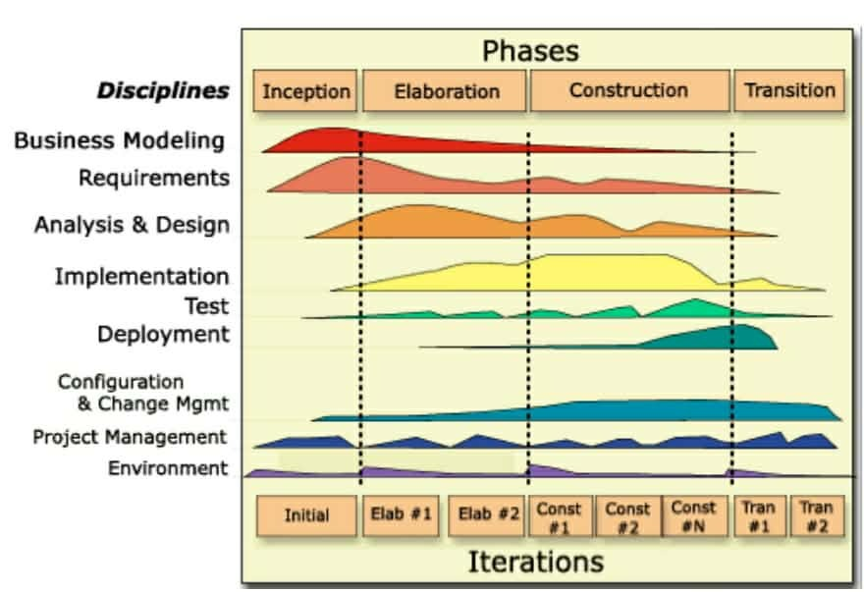
The approach allows requirements and interfaces to be refined through stakeholder feedback and repeated testing. Figure 2 illustrates the four RUP phases and the changing emphasis of development disciplines across iterations. Review and maintenance activities in the project schedule are project-specific activities rather than an additional standard RUP phase.

Figure 2. Rational Unified Process Phases and Disciplines (framework reference: IBM, n.d.)
The Inception Phase concentrated on identifying the scope, objectives, and deliverables of the project. In this phase, the team gathered requirements by interviewing PESO administrators and staff, surveying beneficiaries, and observing the current manual workflows for profiling and verification. Existing documents, such as spreadsheets and printed beneficiary lists for programs like TUPAD, were reviewed to validate the accuracy of the gathered data. These insights helped define the essential system requirements. This process highlighted the main issues in the current system, such as time-consuming manual searching, data redundancy, and the difficulty of verifying eligibility for residents from distant barangays. The phase ended with a clear project plan and a list of prioritized features for BENEPESO, including beneficiary profiling, online eligibility checking, and report generation.
The Elaboration Phase focused on system architecture, information flow, database structure, and interface design. The implemented account, program-batch, beneficiary, requirements-review, and reporting structures guided the database design. Interface prototypes represented the distinct responsibilities of the Administrator, PESO Staff, and Registered Applicant or Beneficiary. The context-level data flow diagram in Figure 3 defines the implemented software boundary and the information exchanged with these users. Detailed database-design artifacts should reflect the current schema and distinguish logical relationships from enforced database constraints.
Figure 3 distinguishes two connected aspects of the service: the information exchanges with the BENEPESO website and the external manual document-verification procedure. The software context shows the Administrator, PESO Staff, and Registered Applicant or Beneficiary. In the office procedure, the applicant submits physical requirements face to face at PESO; PESO personnel verify the documents and forward them to DOLE for rechecking. This external agency review is part of the overall service workflow and is not an automated connection to the DOLE information system.
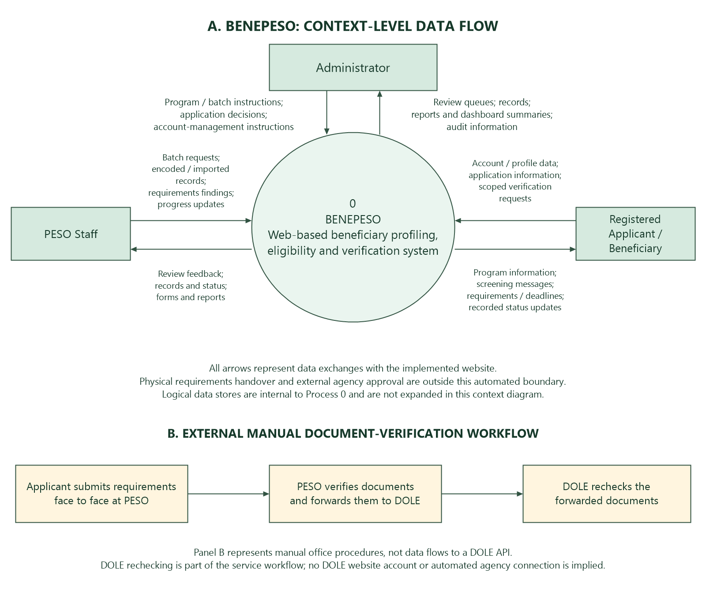

Figure 3. BENEPESO System Context and External Document-Verification Workflow
The Administrator supplies program and batch instructions, application decisions, and account-management instructions and receives review queues, records, summaries, and reports. PESO Staff submit batch requests, encoded or imported application information, requirements-review findings, and permitted progress updates and receive records, review feedback, forms, and reports. Registered applicants and beneficiaries supply account and profile information, applications, and scoped verification requests and receive available-program information, screening messages, requirements instructions, and recorded status updates. The application decision is maintained separately from program progress. BENEPESO stores these records centrally and supports authorized reporting and notifications. Physical requirements are submitted face to face and verified by PESO before being forwarded to DOLE for rechecking. DOLE is therefore an external participant in the office workflow, while website access and recorded updates remain the responsibility of authorized PESO personnel. The diagram does not imply a DOLE login, automated agency API, or a separate DOLE approval status implemented in the website.

Schedule of Activities
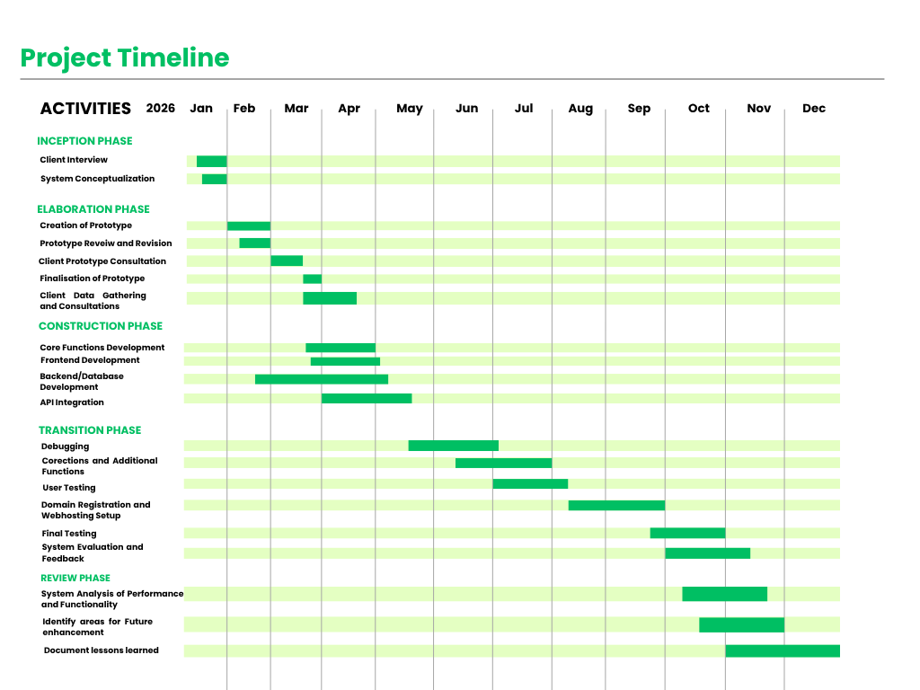
This section presents the activities conducted by the researchers using a Gantt Chart to outline, organize, and monitor the scheduled tasks throughout the duration of the study. The detailed schedule of activities is shown in Figure 4, which provides a visual presentation of the project timeline and the different phases involved in the research. The Gantt Chart also serves as a guide for tracking the progress of each activity and ensuring that all tasks are completed within the planned timeframe.

Figure 4. Schedule of Activities
Figure 4 presents the January–December 2026 project schedule from initial requirements work to review and future maintenance planning. It shows the intended timing of activities and their overlap. The chart should be read as a schedule rather than proof that every activity was completed. Actual completion dates, stakeholder consultations, testing records, and deployment evidence must support any claims of completed work. Activities after October 20, 2026 remain planned unless separately documented.
In January 2026, during the first month of the project, the researchers concentrated on the Inception Phase. This phase involved carrying out interviews with members of the PESO staff, developing concepts for the proposed system, identifying the problems found in the current manual processes, and examining the way spreadsheets and printed beneficiary records were being used. As a result of these activities, the researchers were able to understand the existing workflow, collect the initial system requirements, identify problems such as time-consuming verification and data redundancy, and define the scope and objectives of the BENEPESO system.
The Elaboration Phase took place from January to April 2026, during which the researchers focused their efforts on system analysis, design and the development of a prototype. To show the system processes and the relationships in the database, Data Flow Diagrams (DFD) and Entity-Relationship Diagrams (ERD) were prepared. Initial prototypes for both the administrator and beneficiary interfaces were developed, then reviewed and amended. The team also carried out consultations with clients and gathered data in order to obtain feedback, finalise the prototype, arrange the database structure and determine the core modules of the system.
From February to May 2026 the project reached the Construction Phase. In this phase the core functions of the system together with the frontend, backend and database components were developed. The main user interfaces, the navigation and the layout were created, and for the backend the database setup and the implementation of the key system features were carried out. Integration of the API was also carried out in order to connect the various parts of the system and make sure that the frontend and backend worked together smoothly. The main functions consisted of beneficiary profiling, eligibility checking, data management and report generation. Testing and debugging took place throughout the development process in order to spot errors and enhance the system's functionality.
Transition activities in the schedule include debugging, corrections, additional functions, user testing, hosting preparation, final testing, and system evaluation. The bars indicate the planned windows for these tasks; actual completion and deployment dates should be recorded separately. These activities prepare the system for intended use and provide feedback for corrections. They do not, by themselves, establish that user acceptance or production deployment has been completed.
As of the October 2026 review point, the schedule places the project in final testing and evaluation activities. Any reported results must be drawn from completed test records and actual respondent feedback. Developer smoke tests and regression checks can support technical verification but do not replace UAT conducted with the study's respondents.
The schedule includes review and future maintenance planning from October through December 2026. These are project-specific activities following and overlapping transition work, not a fifth standard RUP phase. Future activities include reviewing functionality and performance, identifying improvements, and documenting lessons learned. Their completion should be reported according to actual records rather than inferred from planned chart bars.

Sources of Data
The study will utilize both primary and secondary sources of data to support the development of the BENEPESO system. The combination of these two sources will allow the researchers to gather firsthand information from key stakeholders regarding the current PESO beneficiary management processes, challenges, and user needs, while also supporting the study with related literature, previous studies, and established standards relevant to web-based beneficiary management systems.
The Primary Data is collected through formal interviews and survey questionnaires with stakeholders such as PESO personnel, beneficiaries, and other individuals involved in PESO program operations. Observations were conducted to understand the current manual processes for employment profiling, eligibility verification, and record management, which use spreadsheets and printed documents.
The Secondary Data will be derived from government publications, online databases, related literature, and related studies on beneficiary management systems, digital governance, web-based information systems, and ISO/IEC 25010 software quality standards.

Population of the Study
To gather and obtain the necessary data for the study, the researchers will utilize the purposive sampling method. This type of sampling intentionally selects participants based on their knowledge, experiences, and involvement relevant to the study. Purposive sampling helps the researchers choose respondents who can provide reliable and meaningful information related to the current beneficiary management processes of the Public Employment Service Office (PESO) in Vinzons. The target population of the study includes PESO personnel, beneficiaries, and other individuals directly involved in PESO program operations.
Through purposive sampling, the researchers will be able to gather data only from respondents who have direct knowledge and experience regarding beneficiary profiling, eligibility verification, and data management within PESO programs. This approach allows the researchers to obtain relevant and trustworthy information from respondents who are actively involved in the processes being studied. These respondents include PESO staff responsible for managing beneficiary records and beneficiaries who experience the current system and services provided by the office.
By using this method, the study will focus on participants who can provide informed responses regarding the functionality, usability, performance efficiency, and security of the proposed BENEPESO system. The information gathered from these respondents will help the researchers evaluate whether the proposed system can effectively improve the management and delivery of PESO programs in Vinzons.
Table 1
The Distribution of Respondents
Respondents | Quantity | Percentage (%)
Admin | 1 | 3.33%
Peso Staff | 9 | 30.00%
Beneficiaries | 20 | 66.67%
TOTAL | 30 | 100%

The respondents of the study consisted of one (1) PESO Administrator, nine (9) PESO staff members, and twenty (20) beneficiaries, as presented in Table 1. They were selected due to their direct involvement and experience in PESO operations and services. Their participation helped evaluate the BENEPESO system in terms of functionality, efficiency, usability, and overall effectiveness from both administrative and user perspectives.

Data Collection Method
To achieve the specific objectives of the study, researchers gathered the necessary information to support the development of BENEPESO: A Web-Based Beneficiary Profiling, Eligibility, and Verification System for PESO Programs in Vinzons. The following paragraphs explain the different methods and procedures used by the researchers in collecting data for the study.
The study used a mix of data-gathering methods to better understand how beneficiary management currently works and to pinpoint the challenges faced in PESO operations. PESO staff and beneficiaries took part in interviews to share their experiences and discuss what features they would want in the BENEPESO system. Surveys were also distributed to collect more responses. Additionally, the research team observed manual processes, like how beneficiary records are managed with spreadsheets and paper documents. These observations revealed problems such as delays, duplicate entries, and trouble managing beneficiary information.
To determine the features and functions of the system, researchers interviewed PESO personnel, beneficiaries, and other individuals involved in PESO program operations. The semi-structured interviews and survey questionnaires helped the researchers understand the current workflow, common problems encountered, and the specific needs of the users. The information gathered served as the basis for designing the BENEPESO system to ensure that it addresses the actual needs of the users and improves the delivery of PESO services.
The evaluation framework combines functional testing, including automated checks where applicable, with User Acceptance Testing (UAT), guided by selected ISO/IEC 25010:2011 characteristics: functional suitability, usability, performance efficiency, and security. Functional tests compare actual behavior against defined expected results. Performance checks require stated conditions and measured outcomes, while security checks examine specific controls and access restrictions. UAT uses tasks appropriate to each role and questionnaire responses to assess user experience and acceptance. Technical findings and user ratings must be reported separately and supported by their corresponding evidence.

Data Analysis
Questionnaire responses are analyzed using a five-point Likert scale from 1 (Strongly Disagree) to 5 (Strongly Agree). Item means summarize respondent perceptions regarding the selected quality characteristics. These ratings are interpreted separately from measured response times, functional test outcomes, and security-check findings. The number of valid responses must be stated for each item, including how missing or not-applicable answers are handled. Means are rounded to two decimal places before applying the interpretation intervals in Table 2.
Table 2
Five-Point Likert Scale and Interval
Likert-Scale Description | Scale | Interval
Strongly Agree | 5 | 4.21 - 5.00
Agree | 4 | 3.41 - 4.20
Neutral | 3 | 2.61 - 3.40
Disagree | 2 | 1.81 - 2.60
Strongly Disagree | 1 | 1.00 - 1.80

Table 2 presents the five-point Likert scale used to evaluate the feedback of the respondents regarding the BENEPESO system. The scale provides the researchers with a clear and organized guide in interpreting the responses by assigning each number to a corresponding level of agreement. This method ensures consistency in data gathering and analysis while helping the researchers better understand the perceptions of the respondents toward the system.
The highest rating in the Likert scale is five (5), interpreted as “Strongly Agree,” with an interval of 4.21–5.00, which indicates a very positive evaluation of the system. A rating of four (4), interpreted as “Agree,” with an interval of 3.41–4.20, indicates positive feedback with minimal concerns or suggestions for improvement. A rating of three (3), interpreted as “Neutral,” with an interval of 2.61–3.40, shows that the respondent neither agrees nor disagrees with the statement being evaluated. Meanwhile, a rating of two (2), interpreted as “Disagree,” with an interval of 1.81–2.60, indicates dissatisfaction or concerns regarding the system. The lowest rating, one (1), interpreted as “Strongly Disagree,” with an interval of 1.00–1.80, reflects strong negative feedback and indicates that major improvements may still be needed in the system.
The use of the Likert scale provides a standardized way of measuring user feedback and allows the researchers to identify trends, determine user satisfaction, and recognize areas that may still need improvement in the proposed system implementation. Through this method, the researchers can analyze and interpret the gathered data more effectively and reliably to support the evaluation of the BENEPESO system.

Statistical Treatment of Data
For each questionnaire item, the frequency-weighted mean is computed using the expression below. W represents the frequency of a rating category, X represents the numerical rating, and N equals the sum of the valid response frequencies for that item. Accordingly, the expression is equivalent to the sum of frequency multiplied by rating divided by the total valid responses. Any aggregation across items or respondent groups should state its weighting method, and excluded or not-applicable responses should be accounted for explicitly.
$$x̄=\frac{Σ(WX)}{N}$$
Where:
$x̄$= Weighted Mean
$Σ =$Summation Symbol
W = Frequency of responses in a rating category
$X =$Score/Rating
N = Total valid responses for the item (sum of frequencies)

Ethical Consideration
This research followed ethical guidelines throughout the data collection and analysis process in the development of the BENEPESO: Beneficiary Profiling, Eligibility, and Verification System. First, the privacy and confidentiality of all participants, including PESO staff, administrators, and beneficiaries, were strictly ensured. Respondents were informed about the purpose of the study, and all personal information was kept confidential. Data gathered from the questionnaires and interviews were used exclusively for research and system development purposes and were securely stored to prevent unauthorized access.
Additionally, maintaining data accuracy and integrity during the analysis was given high importance. All procedures were carefully designed to protect the participants and uphold ethical standards. The researchers ensured that responses to the survey questionnaires were recorded and analyzed honestly, without alteration or bias. The use of accurate, reliable data was essential to drawing valid conclusions that supported the development and implementation of the proposed system. This also helped ensure that the findings truly reflect the actual situation and needs of PESO users.
The research also followed the principle of informed consent. Respondents joined the study voluntarily after learning about their rights, including the option to withdraw at any time without consequences. Only the data needed to meet the study’s goals were collected, and no data was used for other purposes.
Furthermore, the study observed the responsible use of artificial intelligence (AI) tools in supporting the research process. AI technologies were used only as supplementary tools for organizing, refining, and enhancing the presentation of content, while all critical analyses, interpretations, and decisions remained the responsibility of the researchers. The researchers also ensured that all sources of information were properly cited and acknowledged to avoid plagiarism. Proper attribution was strictly followed, and all referenced materials were used in accordance with academic standards to maintain the originality and credibility of the study.
Throughout the research, accountability remained central. The team upheld high ethical standards by handling all data respectfully, confidentially, and accurately. Participants were informed of their roles, and the researchers-maintained integrity in presenting and reporting the findings.

REFERENCES
Abello, L. M., Barba, A. I., Ong, J. V., & Javier, M. A. V. (2025). An innovative test generation and scoring system for accountancy and business management courses. Philippine Journal of Interdisciplinary Research.
Achungura, G., Raza, A., Katre, V., Anand, J. S., Ravishankar, N., & Kelkar, R. (2024). Data integration of health financing systems as a critical enabler for objective-oriented health system reform: A scoping review from India. Health Systems & Reform, 10(3).
Adyaputra, R., Imtihan, K., & Saleh, M. (2025). Assessing user satisfaction of local government websites through ISO 25010 and Technology Acceptance Model (TAM): A SmartPLS and IPMA-based study in Lombok Tengah. Journal of Information and Organizational Sciences.
Albert, J. R. G., Orbeta, A. C., Jr., Melad, K. A. M., & Mahmoud, M. A. (2024). Is the 4Ps targeting and reaching the “right” beneficiaries? An assessment of the veracity of the list of Pantawid Pamilya/4Ps beneficiaries. Philippine Institute for Development Studies.
Alhassan, I., Sammon, D., & Daly, M. (2021). Data governance activities: An analysis of the literature. Journal of Decision Systems.

Bakar, N., et al. (2024). A systematic literature review on the effect of information systems in the public sector. International Journal of Advanced and Applied Sciences.
Banerjee, S., Fullerton, C., Gaharwar, S., & Jaselskis, E. (2025). Strategic web-based data dashboards as monitoring tools. Buildings.
Beuermann, D. W., et al. (2025). Evaluating targeting tools for social programs when income is volatile and unobservable. Journal of Development Economics.
Bernardo, B., Barroso, J., & Santos, V. (2024). Data governance and quality management. Journal of Innovation and Knowledge.
Budianto, A. E., Othman, M. F. I., Mat Ariff, N. A., & Abdul Rashid, I. M. (2025). An integrated framework for improving online counseling system quality: A case study using HOT-FIT, ISO/IEC 25010, and SPBE models. International Journal of Research and Innovation in Social Science.
Department of Information and Communications Technology. (2022). Philippine e-government masterplan 2022. https://dict.gov.ph/egovernment-masterplan/
Dietrich, S., et al. (2024). On the social welfare damage of data biases. Data & Policy.
Digital Benefits Network. (2025). Digital doorways to public benefits: User experiences with digital identity.
Edu, J., Hooper, M., Maple, C., & Crowcroft, J. (2023). An impact and risk assessment framework for national electronic identity systems.
Fadilah, M. D., & Rochimah, S. (2023). Security evaluation of insurance portal agency information system based on ISO/IEC 25010 quality standard utilizing OWASP ZAP. In Proceedings of the 3rd International Conference on Intelligent Cybernetics Technology and Applications.
Ilieva, G., Yankova, T., Ruseva, M., Dzhabarova, Y., Zhekova, V., Klisarova-Belcheva, S., Mollova, T., & Dimitrov, A. (2024). Factors influencing user perception and adoption of e-government services. Administrative Sciences, 14(3), 54.
Ivanković, D., et al. (2021). Features constituting actionable dashboards. Journal of Medical Internet Research.
Januhari, N. N. U., Setyanto, A., Kusrini, K., Utami, E., & Martínez Béjar, R. (2025). Evaluation of e-learning usability based on ISO 25010 with Hofstede’s cultural dimensions as moderation: A PLS-SEM study in higher education. Applied Information System and Management.
Katapally, T., & Ibrahim, S. (2023). Digital dashboards for decision-making in health systems. JMIR Research Protocols.
Karyukin, V., Mutanov, G., Mamykova, Z., Nassimova, G., Torekul, S., Sundetova, Z., & Negri, M. (2022). Development of information systems for monitoring public opinion. Journal of Big Data.
Kurniasari, D. T., & Rochimah, S. (2025). An evaluation model of website testing framework based on ISO 25010 performance efficiency. Indonesian Journal of Electrical Engineering and Computer Science.
Lusiani, S., & Princes, E. (2024). Evaluating the effectiveness of Mobile JKN application in Indonesia: A user-centric approach using the ISO 25010 quality model. Journal of Logistics, Informatics and Service Science.
Mao, Z. (2023). Understanding the role of service quality in government digital services. SAGE Open.
Matlala, M., & Ncube, T. (2024). Electronic records management in digital environments. Records Management Journal.
Melendres, U. M., & Aranda, K. M. (2024). Development and evaluation of a web-based resident information management system. Journal of Computer Studies and Programming.
Moumane, K., Idri, A., & El Aouni, F. (2024). ISO/IEC 25010-based quality evaluation of three mobile applications for reproductive health services in Morocco. Clinical and Experimental Obstetrics & Gynecology.
Nookhao, S., & Kiattisin, S. (2023). Achieving a successful e-government: Determinants of behavioral intention from Thai citizens’ perspective. Heliyon.
Nurunnisa, F., Hamzah, M. L., Angraini, A., & Saputra, E. (2024). Analyzing the quality of web-based scholarship information system using ISO/IEC 25010 standard. In 2024 International Conference on Circuit, Systems and Communication (ICCSC 2024).
Nuzula, M. I. F., & Rochimah, S. (2023). Evaluation of service quality in human resource information systems using the ISO/IEC 25010. In International Seminar on Application for Technology of Information and Communication (iSemantic 2023).
Pham, L., Limbu, Y. B., Le, M. T. T., & Nguyen, N. L. (2023). E-government service quality, perceived value, satisfaction, and loyalty: Evidence from a newly emerging country. Journal of Public Policy.
Pratama, A. A., & Mutiara, A. B. (2021). Software quality analysis for Halodoc application using ISO 25010:2011. International Journal of Advanced Computer Science and Applications.
Rabiei, R., Bastani, P., Ahmadi, H., Dehghan, S., & Almasi, S. (2024). Developing public health surveillance dashboards. BMC Public Health.
Riansyah, R., Elyandi, J., Saskia, D., Sinaga, E., Matondang, A., Padang, R., & Arnita, V. (2025). Development of public service information systems for local government. Formosa Journal of Sustainable Research.
Rojas, H., Cabrera, D. I., & Aminuddin, A. (2025). Mapping the evolution and future directions of ISO/IEC 25010: A bibliometric and thematic analysis. Engineering, Technology & Applied Science Research.
Ruíz-Ortega, D., García-Domingo, M., Fuentes, V., & De la Fuente-Robles, Y. (2025). The impact of prioritisation and eligibility criteria on social services intake processes. Social Sciences.
Sayogo, D., Yuli, S., & Amalia, F. (2023). Critical success factors for data-driven decision-making at local government. JeDEM.
Sayogo, D., Yuli, S., & Amalia, F. (2024). Data-driven decision-making in local governments. Transforming Government: People, Process and Policy.
Schmitz, A., & Wimmer, M. (2023). Framework for interoperable service architecture development. Government Information Quarterly.
Schulze, A., Brand, T., Böhme, K., & Böhm, R. (2023). Digital dashboards visualizing public health data. Frontiers in Public Health.
Silva, J., Ribeiro, D., Ramos, L., & Fonte, V. (2023). A worldwide overview on the information security posture of online public services.
Stahlman, G., Yanovitzky, I., & Kim, M. (2025). Design and application of public health dashboards. Journal of Medical Internet Research.
Suryadi, D. A., & Sulistiyani, E. (2024). Evaluation of information quality using ISO/IEC 25010:2011 (Case research: Menu Harianku application). International Journal of Innovation in Enterprise System.
Syahrul, S., Alifya, N. F. H., Dewi, S. S., & Anandari, D. R. (2025). Evaluating EduTrack system quality using ISO/IEC 25010 and the DeLone and McLean model. Journal of Embedded Systems, Security and Intelligent Systems.
United Nations. (2022). E-government survey 2022: The future of digital government. United Nations Department of Economic and Social Affairs. https://publicadministration.un.org/egovkb/en-us/reports/un-e-government-survey-2022
Vahedi, A., Moghaddasi, H., Asadi, F., Hosseini, A., & Nazemi, E. (2022). Applications and features of data dashboards. Informatics in Medicine Unlocked.
Varona, T., & Senen, P. (2025). Kabataan-Konek: A barangay web-based youth profiling and management system. International Journal of Software and AI Technology.
Wang, F., De Filippi, P., & Wright, A. (2020). Self-sovereign identity in the age of blockchain. Frontiers in Blockchain, 2, Article 28. https://doi.org/10.3389/fbloc.2019.00028
World Bank. (2021). Digital government for development. https://www.worldbank.org/en/topic/digitaldevelopment
Zhang, Y., Liu, X., & Chen, H. (2024). Digital economy and public service efficiency: Evidence from developing countries. Sustainability, 16(11), 5223. https://doi.org/10.3390/su16115223

IBM. (n.d.). Project planning. IBM Documentation. https://www.ibm.com/docs/en/rational-clearquest/10.0.8?topic=settings-project-planning
International Organization for Standardization. (2011). ISO/IEC 25010:2011: Systems and software engineering — Systems and software Quality Requirements and Evaluation (SQuaRE) — System and software quality models. https://www.iso.org/standard/35733.html
APPENDICES
Appendix 1. Use Case Diagram of the Implemented BENEPESO System
This diagram represents implemented authenticated user goals. Related operations are grouped for readability. Face-to-face submission to PESO, PESO verification and forwarding, and DOLE rechecking belong to the overall office workflow outside the software boundary.
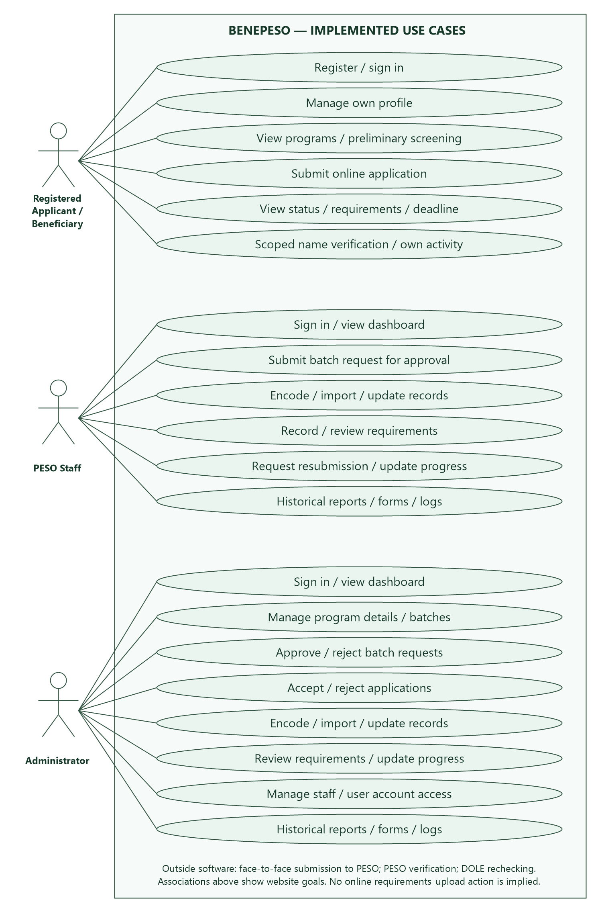
Appendix 2. MSME Registration and Profiling Source Form

Appendix 2. MSME Registration and Profiling Source Form (Continued)
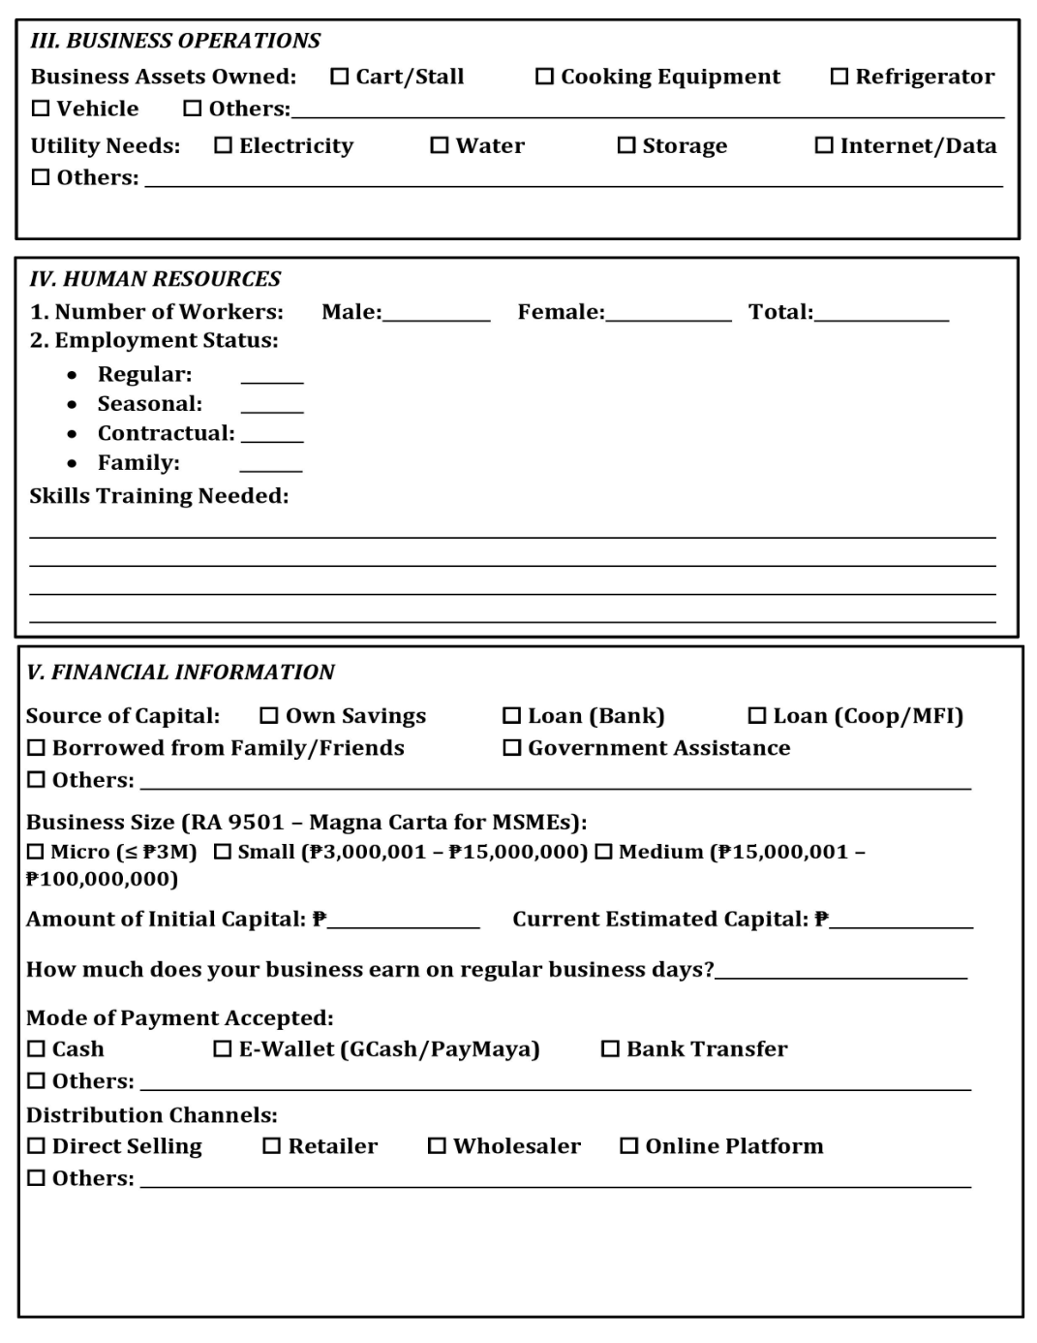
Appendix 2. MSME Registration and Profiling Source Form (Continued)
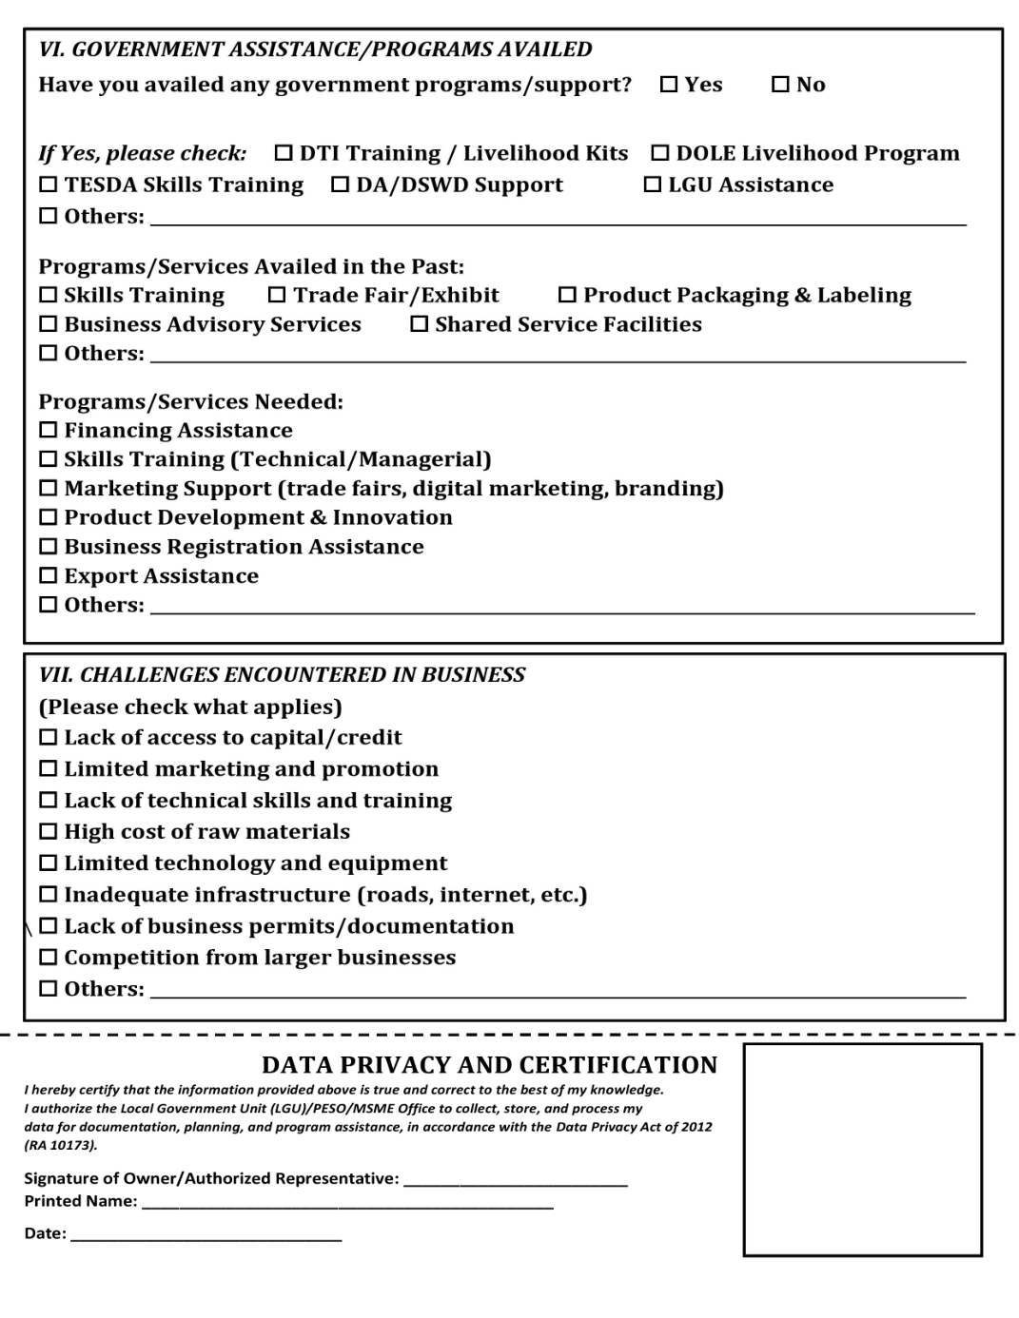
Appendix 3. SPES Application Source Form (Form 2)
Source-form note: The reproduced form states ages 15–30 and shows Regional Office No. 12. The current BENEPESO account-registration limit is 18+, and its SPES master category is configured for ages 18–30. The appropriate local form and any local eligibility restrictions require confirmation by PESO Vinzons. The source form is retained as a reference and is not presented as an exact screenshot of the online interface.

Appendix 4. SPES Oath of Undertaking Source Form (Form 2-A)

Appendix 5. TUPAD Application Source Form
Source-form note: The printed TUPAD form mentions fitness-to-work certification for applicants aged 60 and above. The current BENEPESO checklist requests a fitness certificate based on PWD or work-limitation declarations. These implementation conditions and the source-form instruction require reconciliation with office-approved policy; reproducing the form does not establish that every printed instruction is automated.
