Activity No. 4.2
Hands-on Activity 4.2: Arrays
Course Code: CPE007 | Program: Computer Engineering
Course Title: Programming Logic and Design | Date Performed: 9-11-25
Section: CPE11S1 | Date Submitted: 9-13-25
Name(s): Paula Esguerra | Instructor: Engr. Jimlord Quejado
6. Output
Example of initializing an array:

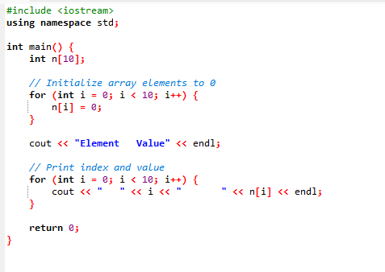
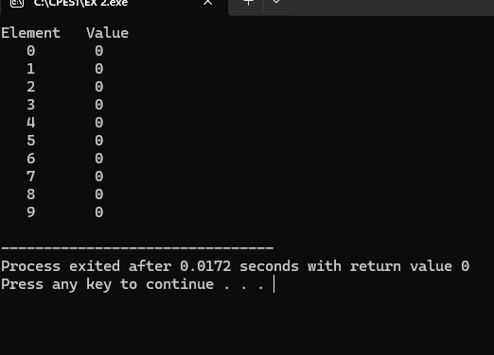

In this array, for loop is used performed in this coding, it is used to shorten the code with the variable i going to 0-9. It declares an integer array n of size 10. Prints a header of “Element and Value”.

Example of initializing an array with a declaration:
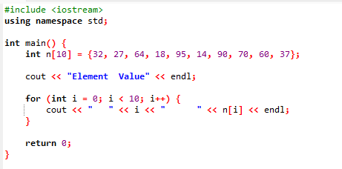
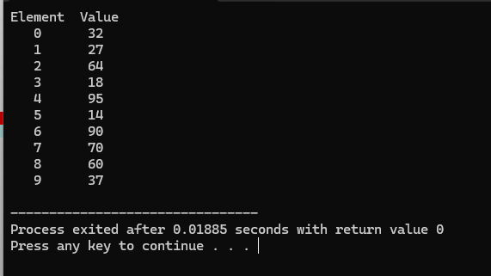

In this array, compared to the one before its Value has value of numbers, which were declared as 32, 27, 64, 18, 1 95, 14, 90, 70, 60, and 37. Also, like no. 1, Element used ‘for loop’ for its contents, ranging from 0 -9 and prints the header as Element and Value.

Example of computing sum of elements of the array:

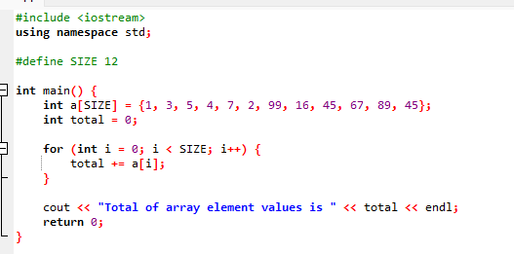
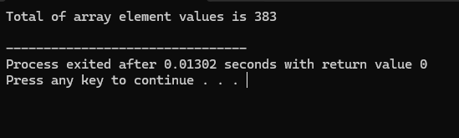

In this array, it is used for computing sum of element values. Then again, the code used for loop to shorten the code, using variable of I, it should be less than the given integer and equals to zero, after than use a code to add everything “+=”. Lastly, print “Total of array element values is ”.

7. Supplementary Activity
- Given the size of an array which is 10, and the elements such as 19, 3, 15, 7, 11, 9, 13, 5, 17 and 1, create a program that will display the following output:

Element Value Histogram
0 19 *******************
1 3 ***
2 15 ***************
3 7 *******
4 11 ************
5 9 *********
6 13 *************
7 5 *****
8 17 *****************
9 1 *
o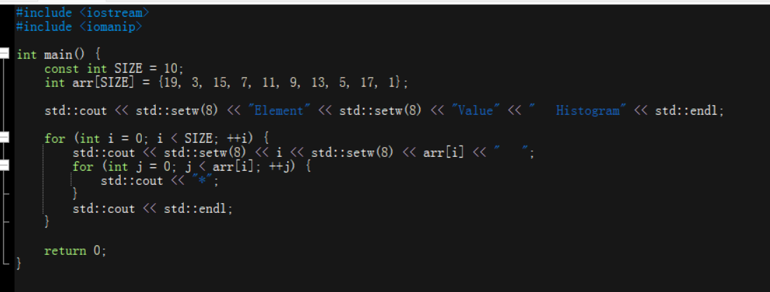
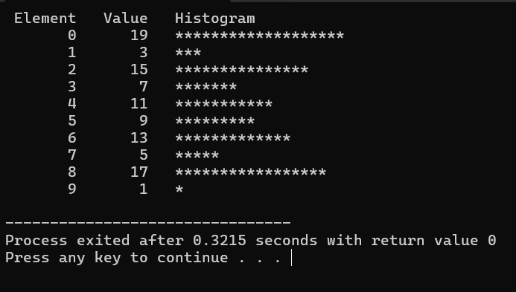

In this array, there are three columns to perform and match the value to the historgram, to perform that, setw are used.

- Given the following data, create a program that summarizes the number of each type. Use array responses for the 40 element array of student’s responses. Such as
int responses[RESPONSE_SIZE] = { 1, 2, 6, 4, 8, 5, 9, 7, 8, 10, 1, 6, 3, 8, 6, 10, 3, 8, 2, 7, 6, 5, 7, 6, 8, 6, 7, 5, 6, 6, 5, 6, 7, 5, 6, 4, 8, 6, 8, 10
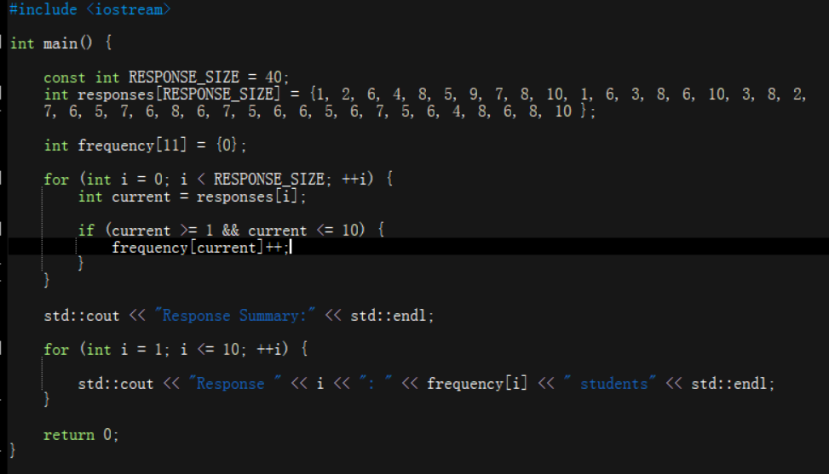
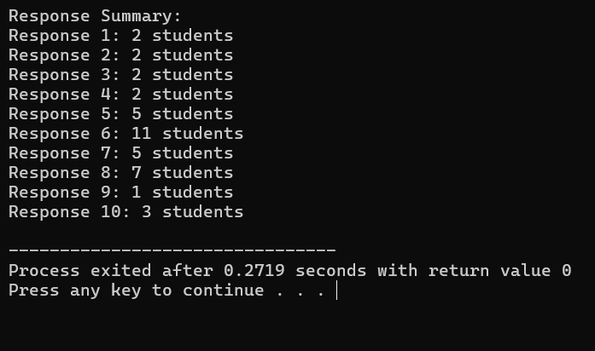
In this array, to know know the code will know have to decision wether ifs a match or not, use the for loop and then, bind values using &&.
8. Conclusion
Even if I’m not accustomed to using array, I don’t my best with understanding array, it can be just a simple array itself, it can be use to sum elements, it can be used to match one’s values and etc. To do this, I must understand the concept and apply them in coding. I must understand for loop, the various prints and also setw.
9. Assessment Rubric

