Hands-on Activity No. 1.1
Using Pseudo-code Statements and Flowchart Symbols
Course Code: CPE 007 | Program: Computer Engineering
Course Title: Programming Logic and Design | Date Performed: 8 | 1 | 25
Section: CPE11S1 | Date Submitted: 8 | 1 | 25
Name(s): Paula Esguerra | Instructor:
6. Output
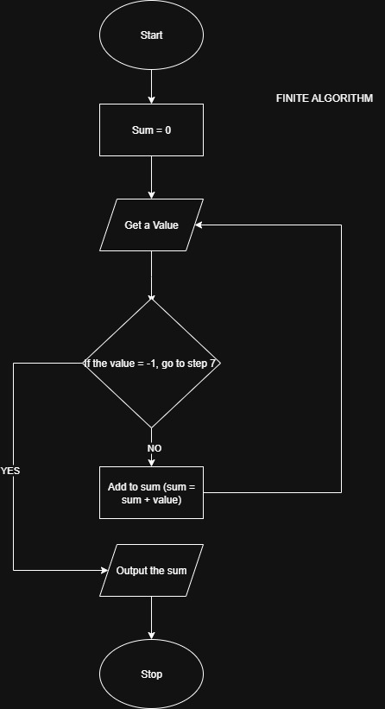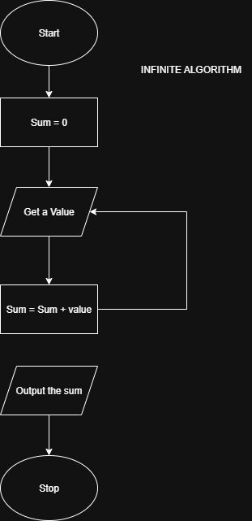
7. Supplementary Activity
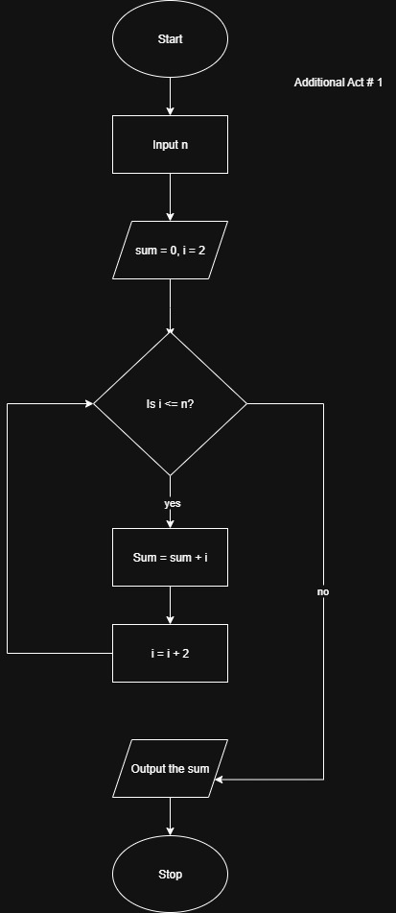
1 . Design an algorithm and the corresponding flowchart for finding the sum of the numbers 2, 4, 6, 8, …, n (output: Algorithm and Flowchart)
Pseudo Code:
start
declare numeric variables i, n, sum
set sum = 0, i = 2
input n
if i less than n, go to step 7
sum = sum + i
i = i+2
output sum
stop

2. Write an algorithm to read 100 numbers and then display the sum.
Pseudo Code:
start
initialize sum = 0
set counter n = 1
repeat steps 5 to 6 while n <= 100
input number
add number to sum (sum = sum + n)
increment counter (n= n + 1)
output sum
stop
3. Write an algorithm to read two numbers then display the largest.
Pseudo Code:
start
input first value
input second value
if first value > second value then
display first value is the largest
else
display second value is the largest
output largest
stop

4. Write an algorithm to read two numbers then display the smallest
Pseudo Code:
start
input first value
input second value
if first value < second value then
display first value is the smallest
else
display second value is the smallest
output smallest
stop
5. Write an algorithm to read three numbers then display the largest.
Pseudo Code:
start
input first value
input second value
input third value
if first value ≥ second value and first value ≥ third value then
display first value is the largest
else if second value ≥ first value and second value ≥ third value then
display second value is the largest
else
display third value is the largest|
output largest
stop
6. Write an algorithm to read 100 numbers then display the largest.
Pseudo Code:
start
set count = 1
input value
set largest = value
input value
if value > largest then
set largest = value
increment count by 1
repeat steps 6 to 8 while count < 100
output largest
stop

8. Conclusion
Some are similar to each other, that’s maybe the reason why I learned but at the same time got lost in the process, There are always the input/output, start, processing and decision. Also, learning pseudo can make doing flowcharts a bit easier to do.
9. Assessment Rubric
