Hands-on Activity 1.1
Using Pseudo-code Statements and Flowcharts Symbols
Course Code: CPE007 | Program: Computer Engineering
Course Title: Data Structures and Algorithms | Date Performed:7/27/2025
Section: CPE11S1 | Date Submitted:8/5/2025
Name(s): Ralph Angelov F. Braganza | Instructor: Engr. Jimlord M. Quejado
Output
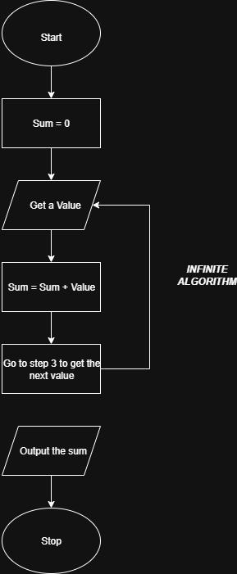
Problem 1: (Infinite Algorithm) The problem with this algorithm is that, some of the steps appear more than once, i.e. step 5 get second number, step 7, get third number, etc. One could shorten the algorithm or flowchart as follows:
Start
Sum=0
Get a value
Sum = sum + value
Go to step 3 to get the next value
Output the sum
Stop
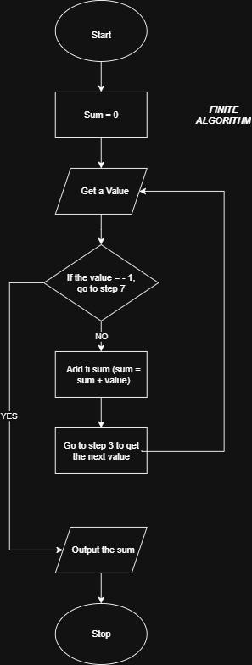
Problem 2: (Finite Algorithm) The new list of numbers is given as 26, 49, 498, 9387, 48962, 1, -1. The value –1 is a unique number since all other numbers are positive. This means that the procedure will stop once -1 is encountered.
Start
Sum=0
Get a value
If the value = -1, go to step 7
Add to sum (sum = sum + value)
Go to step 3 to get the next value
Output the sum
Stop

Supplementary Activity
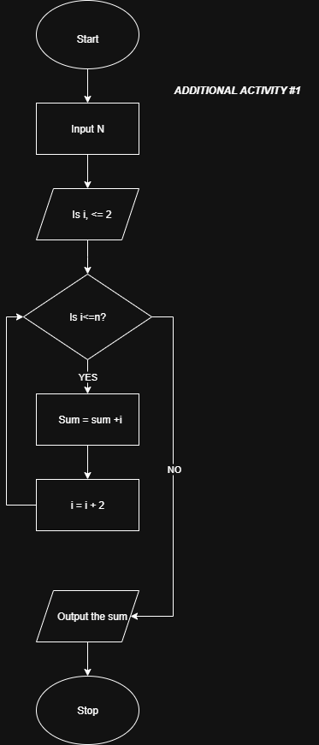
1. Design an algorithm and the corresponding flowchart for finding the sum of the numbers 2, 4, 6, 8, …, n (output: Algorithm and Flowchart)
Pseudo Code:
start
declare numeric variables i, n, sum
set sum = 0, i = 2
input n
if i less than n, go to step 7
sum = sum + i
i = i+2
output sum
stop
2. Write an algorithm to read 100 numbers and then display the sum.
Pseudo Code:
start
initialize sum = 0
set counter n = 1
repeat steps 5 to 6 while n <= 100
input number
add number to sum (sum = sum + n)
increment counter (n= n + 1)
output sum
stop
3. Write an algorithm to read two numbers then display the largest.
Pseudo Code:
start
input first value
input second value
if first value > second value then
display first value is the largest
else
display second value is the largest
output largest
stop
4. Write an algorithm to read two numbers then display the smallest
Pseudo Code:
start
input first value
input second value
if first value < second value then
display first value is the smallest
else
display second value is the smallest
output smallest
stop
5. Write an algorithm to read three numbers then display the largest.
start
input first value
input second value
input third value
if first value ≥ second value and first value ≥ third value then
display first value is the largest
else if second value ≥ first value and second value ≥ third value then
display second value is the largest
else
display third value is the largest|
output largest
stop
6. Write an algorithm to read 100 numbers then display the largest.
start
set count = 1
input value
set largest = value
input value
if value > largest then
set largest = value
increment count by 1
repeat steps 6 to 8 while count < 100
output largest
stop
Conclusion
Some of the algorithms were quite like each other so I was able to translate it to pseudo code easily but others like number 6 and 1 were confusing at first but I think I get the gist of it. I will be completely honest I need to work on my pseudo code more and how to make the pseudo code into a flowchart so I can perform and improve for future task.
Assessment Rubric
