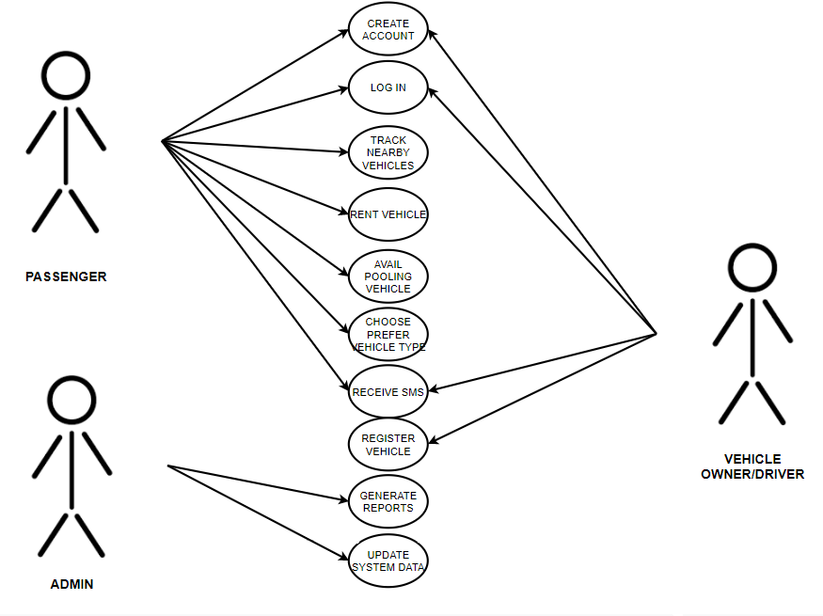 Use case diagram of Pasakay: An Online Land Vehicle Pooling and Rental Services with GPS Technology

**Passenger Entity**: use cases of passenger are create account, login, track nearby vehicle, rent vehicle, avail pooling vehicle, choose prefer vehicle type and receive SMS.

**Admin Entity**: use cases of admin are generate reports and update data system.

**Vehicle owner/Driver Entity**: use cases of vehicle owner/driver are create account, login, register vehicle and receive SMS.