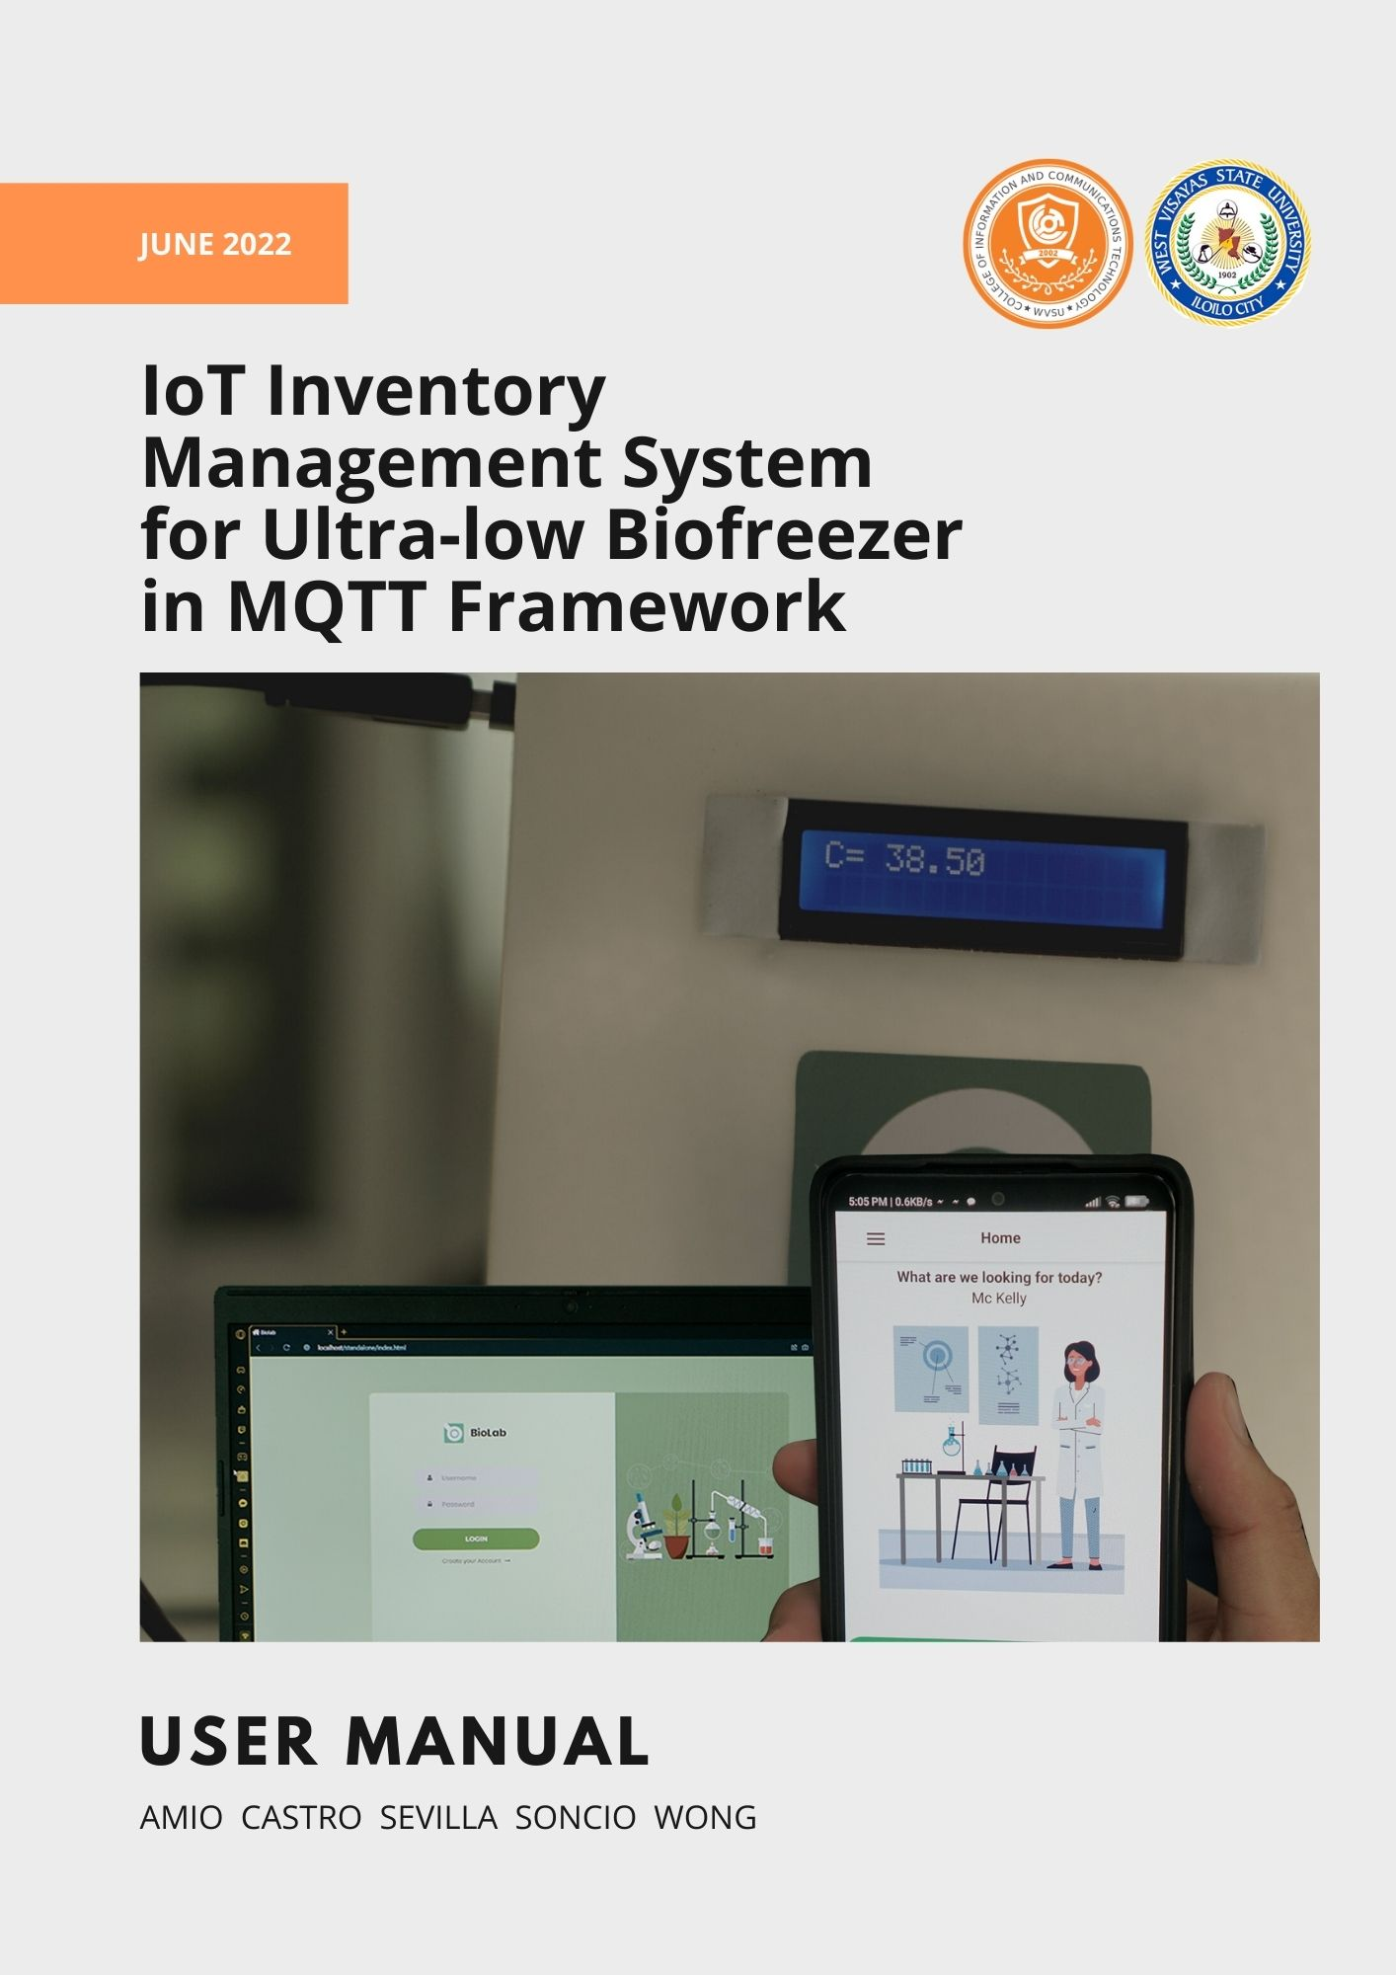

**Bio Lab: An Internet-of-Things Inventory Management System**

**for Ultra-low Biofreezers in MQTT Framework**

User Manual

Amio, Ayrra Jane R.

Castro, Mc Kelly D.

Sevilla, Winston C.

Soncio, Paul Adrian D.

Wong, Jose Mari C.

*June 2022*

**Disclaimer**

This software project and its corresponding documentation entitled “IOT INVENTORY MANAGEMENT SYSTEM FOR ULTRA-LOW BIOFREEZER IN MQTT FRAMEWORK” is submitted to the College of Information and Communications Technology, West Visayas State University, in partial fulfillment of the requirements for the degree, Bachelor of Science in Information Technology. It is the product of our own work, except where indicated text.

We hereby grant the College of Information and Communications Technology permission to freely use, publish in local or international journal/conferences, reproduce, or distribute publicly the paper and electronic copies of this software project and its corresponding documentation in whole or in part, provided that we are acknowledged.

Amio, Ayrra Jane R.

Castro, Mc Kelly D.

Sevilla, Winston C.

Soncio, Paul Adrian D.

Wong, Jose Mari C.

*June 2022*

**Table of Contents**

Disclaimer 2

Table of Contents 3

Getting Started 4

Introduction

System Requirements

Installation

Usage 14

Standalone Web Application and features

Mobile Application and features

Troubleshooting 20

FAQ (Frequently Asked Questions) 21

Contact Details 22

**Getting Started**

**Introduction**

With the increasing number of specimens being stored inside Ultra-Low Biofreezers, the Biological and Physical Sciences Department of the West Visayas State University needs a systematic and reliable way of monitoring inventory and the fluctuation of the temperature inside the biofreezer. Thus, this study aimed to develop an Internet-of-Things Inventory Management System to manage the biospecimen materials in Ultra-low Biofreezers. The system can monitor temperature, store and record data logs inside the biofreezers. It can also generate a record of inventory load in and load outs, fluctuations and manifesto reports.

This User Manual contains all essential information for the user to make full use of the Inventory Management system, graphics and pictures are also provided for the step-by-step instructions.

**System Requirements**

**Windows**

Minimum system requirements

OS: Windows 10 64-bit: Home or Pro (build 19041 or later), Enterprise or Education (build 18363 or later). windows 11 64-bit: Home, Pro, Enterprise, or Education versions.

Processor: 64-bit processor with Second Level Address Translation (SLAT)

Memory: 4.00GB RAM

Recommended specs:

Processor: Intel Core i5-2400s @ 2.5 GHz or AMD FX-6350 @ 3.9 GHz or equivalent

Memory: 8.00GB RAM

**Android**

Minimum system requirements  
  
 OS: Android - Version 7.0 or later

Processor: Snapdragon 435/ HiSilicon Kirin 650/ Mediatek Helio P20/ Exynos 7420.

Memory: 4gb Ram

Recommended specs:

Processor: Snapdragon 888

Memory: 8gb ram

**Installation**

Before using the device, check if you have the following:

List of softwares needed for deployment or testing:

ARDUINO IDE for the IoT device source code.

VSCODE or any IDE suitable or alternative.

MySQL for importing the database.

XAMPP or any suitable environment to serve as a local host or server.

***Installing Node Js-for-backend***

1: Download Node.js Installer

In the web browser, navigate to[*https://nodejs.org/en/download/*](https://nodejs.org/en/download/)*.* Click on the Windows Installer button to download the latest version. At the time this article was written, version 18.0.0 was the latest version. The version used for the study was 16.14.3. The Node.js installer includes the NPM package manager.

2: Install Node.js and NPM from Browser

1. Once the installer finishes downloading, launch it. Open the downloads link in your browser and click the file. Or, browse to the location of the saved file and double-click to launch.
2. The system will ask if you want to run the software *– click Run.*
3. You will be welcomed to the Node.js Setup Wizard *– click Next.*
4. On the next screen, review the license agreement. Click Next if you agree to the terms and install the software.
5. The installer will prompt you for the installation location. Leave the default location, unless you have a specific need to install it somewhere else then – *click Next.*
6. The wizard will let you select components to include or remove from the installation. Again, unless you have a specific need, accept the defaults by clicking Next.
7. Finally, click the Install button to run the installer. When it finishes, click Finish.

3: Verify Installation

1. After installation, open command prompt (or PowerShell), and enter the following:

*node -v*

1. The system should display the Node.js version installed on your system. You can do the same for the NPM using the following code on the command prompt (or PowerShell):

*npm -v*

1. Once both versions are shown, then you will have successfully installed Node JS and NPM.

*npm i expo-cli*

1. To view a project, you must have an Expo CLI server running for that project. Run expo start *[path]* to start running the server. Once it is ready it'll output a URL for your project.

The server will continue running until you close it.

For simulation purposes, do the following:

Go get the Expo app on your Android or iOS device. It's available on the Google Play Store and on the iOS App Store.

***Setting up MySQL Database***

1. Start the MySQL Query Browser.
2. Connect to your Database by entering credentials.
3. Open the Query Editor.
4. Drag and drop or import the sql file into the editor.

*Note: the sql file will be provided along with the software package under the /db folder.*

1. Execute the import.

***For the IoT temperature sensor device***

1. Open the Arduino code file in Arduino IDE.
2. Change the Wi-Fi credentials into the provided establishment Wi-Fi.

*Note: Preferably Globe or Skycable ISP.*

**

1. Upload the code to the IoT device via USB cable.
2. Now, test the device if it connects. It will start showing temperature on screen if the device is working properly.

***For the standalone web***

1. Open XAMPP and turn on *Apache.*
2. Move the following folders to C:\xampp\htdocs

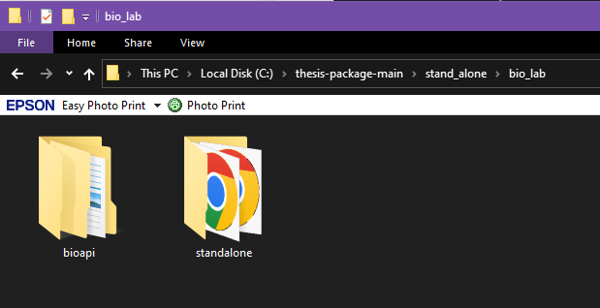

Like this:

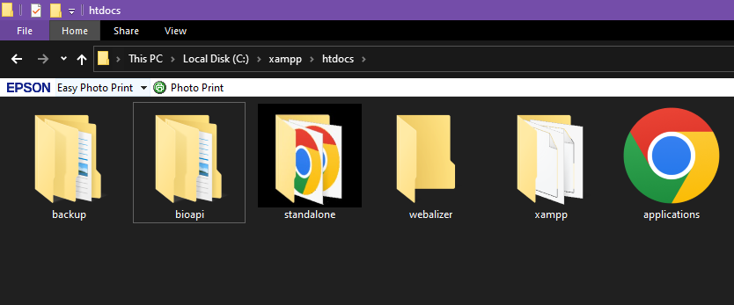

1. Open any web browser and go to *localhost/standalone/index.html* to test.

***For the mobile application,***

***Setting up the connection to ISP***

1. Open the source code for the mobile application in Visual Studio. To open, *shift+right click and open PowerShell window here -* the file folder for the mobile application.

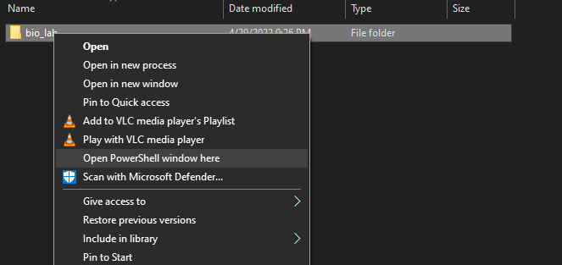

Enter the command *code* . to automatically open the package folder in visual studio.

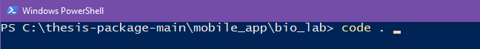

1. Locate the globalvar.js file under the styles folder and change IP according to the localhost IP address.

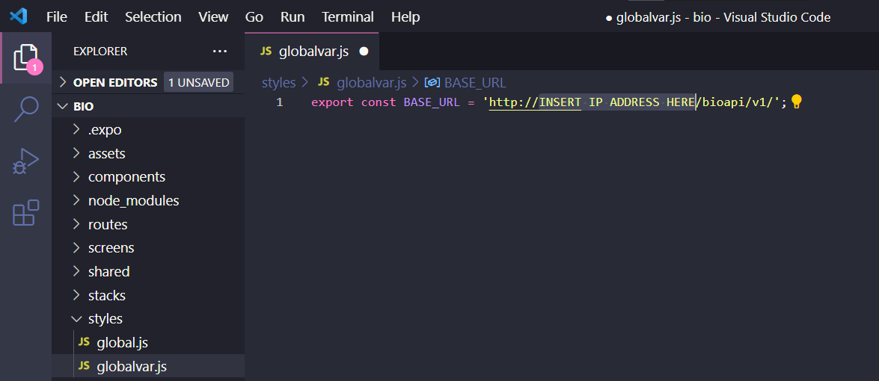

1. To know the IP address, open the command prompt. Type the *ipconfig* and press enter. The IP address will display.

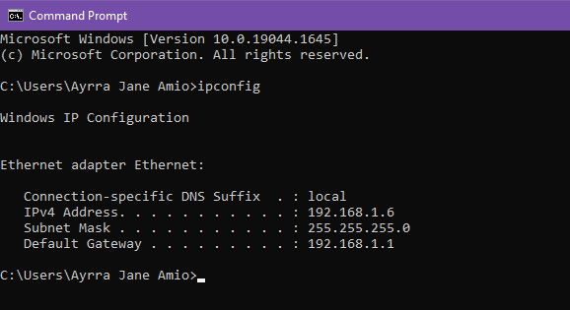

***Exporting to an Android Package Kit (apk) in Visual Studio***

1. Go to the terminal, it can be found at the top. Click “Terminal” then “New Terminal”. Open the package terminal and type the command:

expo ba

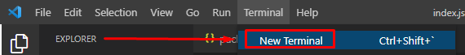

1. Hit enter to build a package to install directly on android devices.

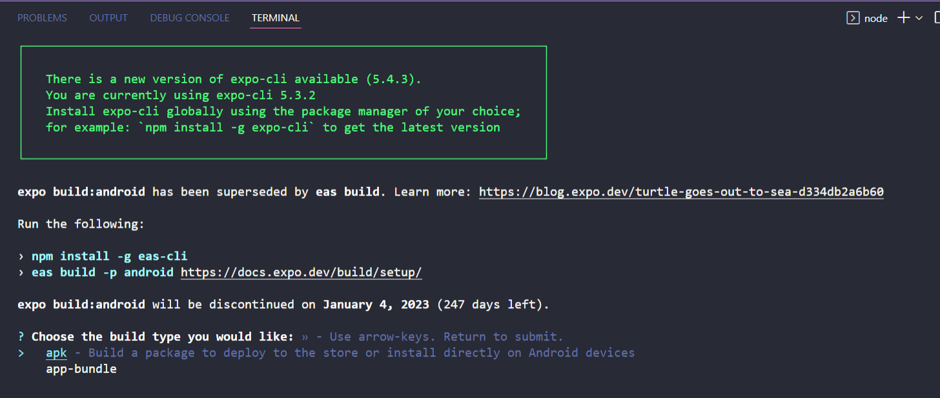

1. Enter “y” for the package to be published and installed.

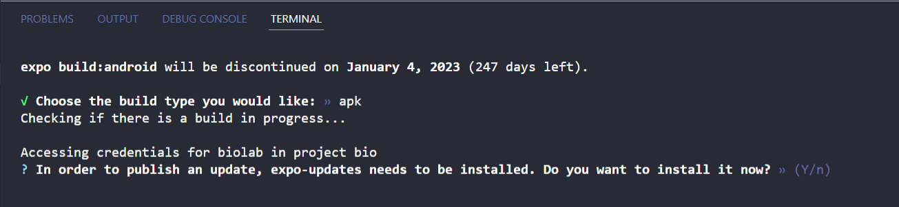

1. Wait for the build to be finished and install the package on an Android device. Connect to the same ISP and try logging in to the admin account to test.

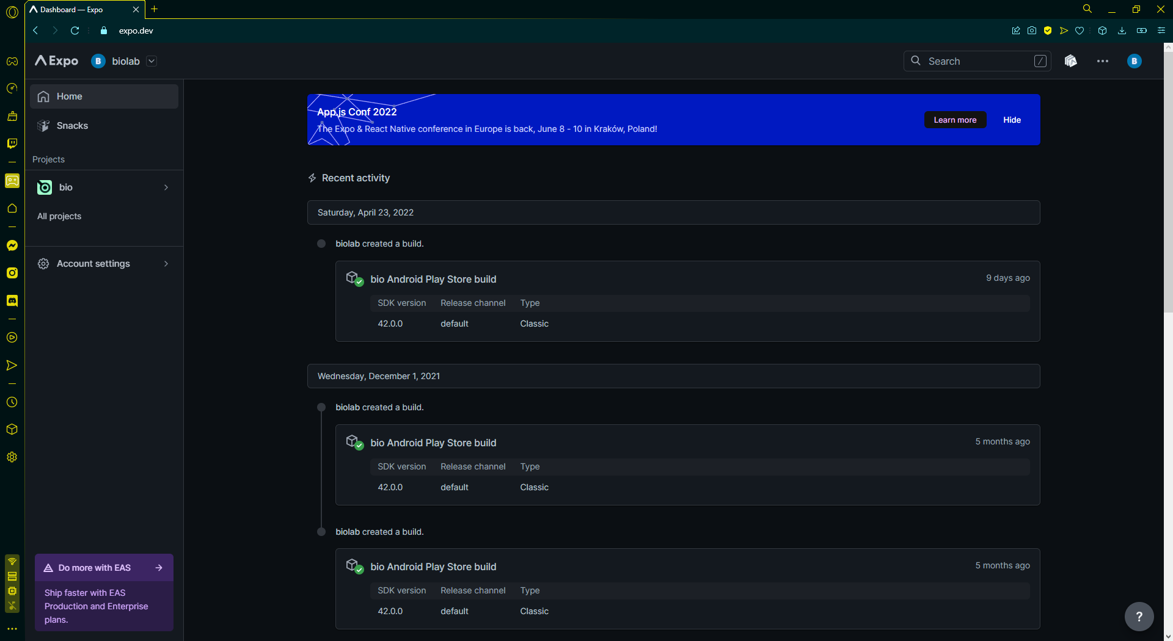

***Setting up the Cayenne MQTT Service***

*The setting up of the Cayenne MQTT Service will only be executed if the admin wants to change the set threshold as the basis for the monitored temperature fluctuation and user notification.*

1. Open Cayenne MQTT in the browser through this link: *https://developers.mydevices.com/cayenne/features/*

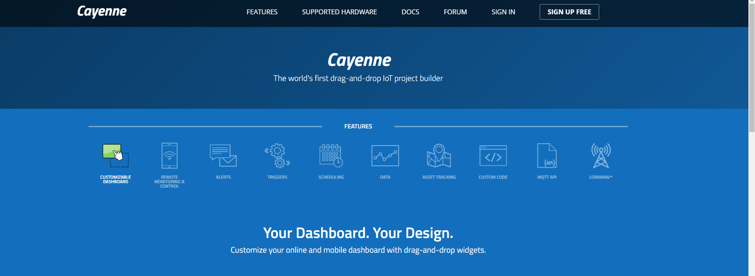

1. Input credentials

*Note: Credentials for Cayenne account will be provided by the IT admin*

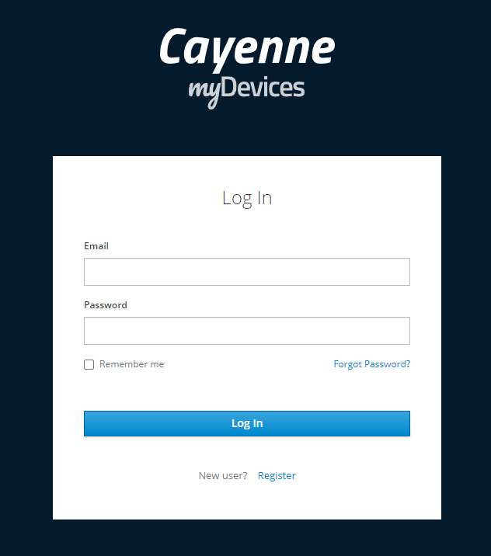

1. Setting threshold for fluctuation. In the dashboard, click “Settings” and select “Trigger”. Currently, the threshold set for determining fluctuation is when the temperature goes higher than 38.50 degrees Celsius.

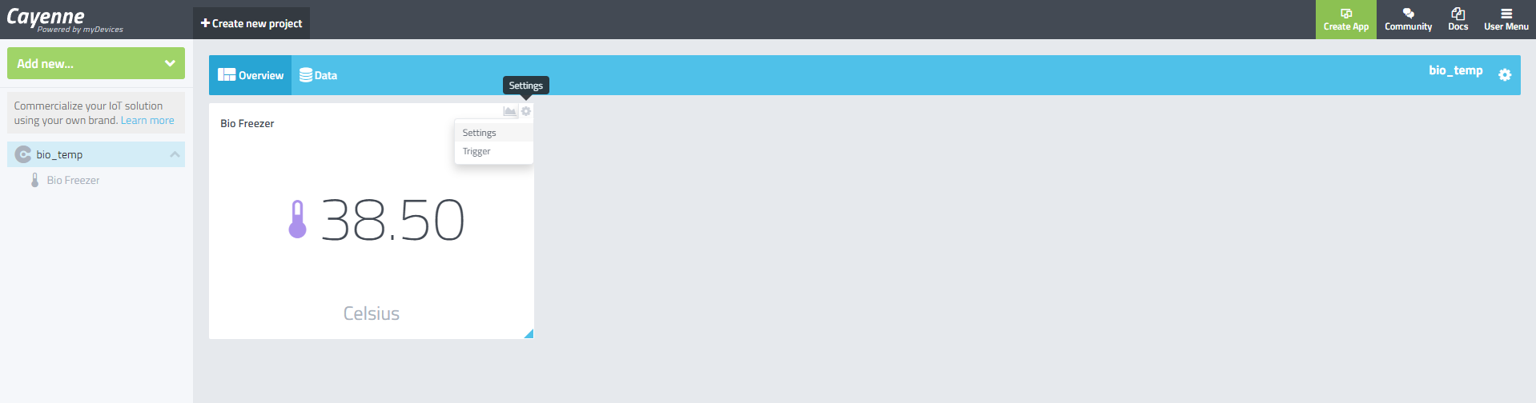

Then in the “if’ section drag the project to the trigger and set the threshold. On the other side, the “then” section.

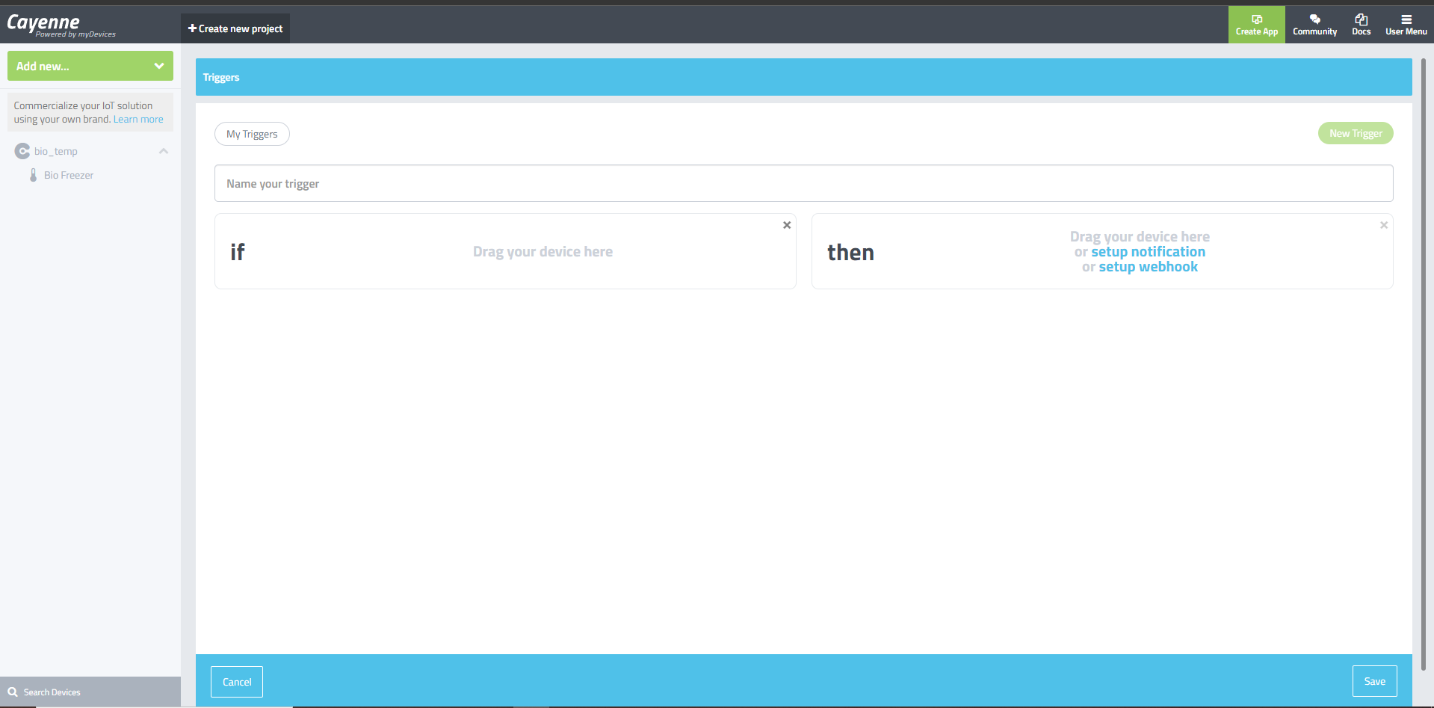

Click “setup notification”, check the “Select All” textbox and then add the custom recipient. After filling all needed and important information click “Save”.

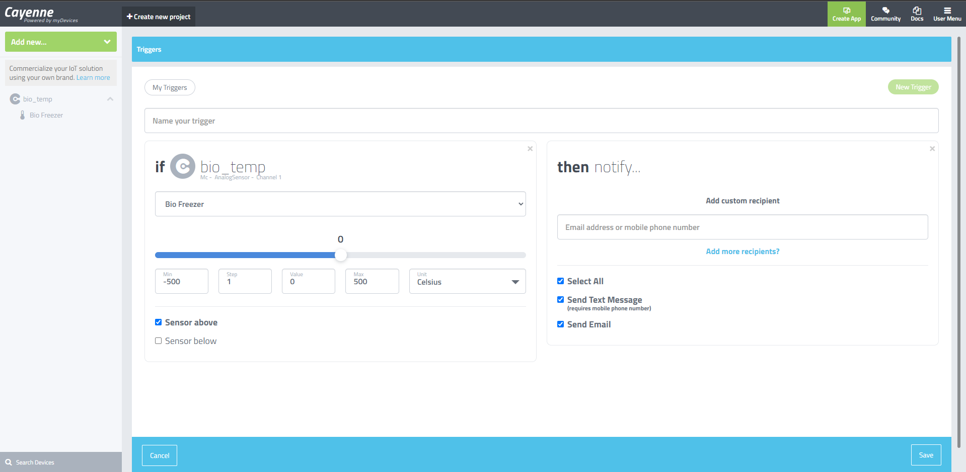

**Usage**

***Setting up the IoT device temperature sensor probe for the monitoring of temperature in the Ultra-low Biofreezers***

1. Place the device near the cold storage and put the sensor probe inside through its designated place at the back or depending where it is located.

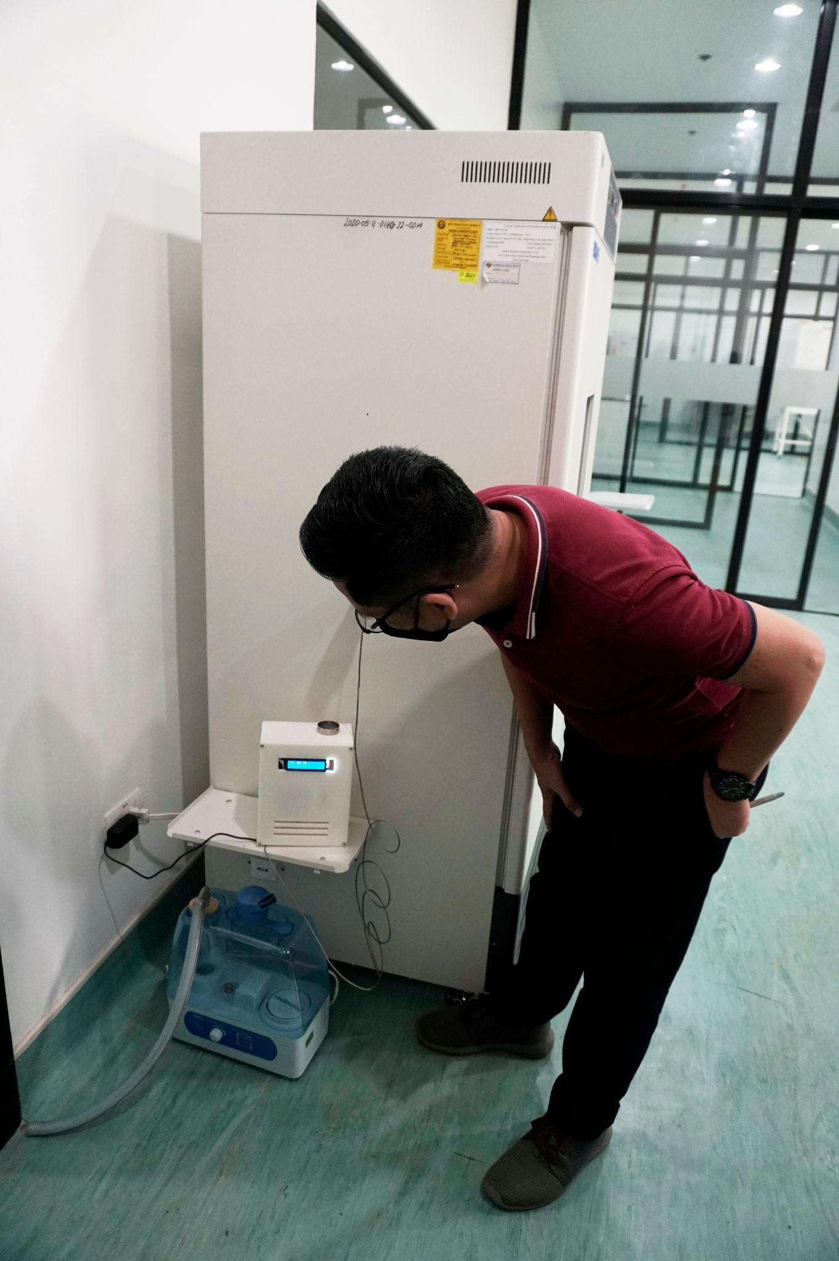

1. Plug the power cord. It will automatically switch on and connect the device to the ISP provided in the Arduino code.

*Note: It is required to connect to a Globe or Skycable Internet*

1. Upon connecting to the ISP, the screen will show the temperature being read inside the cold storage.

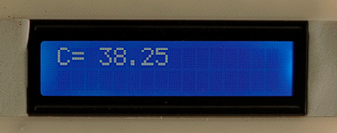

*Note: Device is limited to only read temperatures more than 0 degrees Celsius.*

**Standalone Web App and features:**

Step 1: Open localhost/standalone/index.html

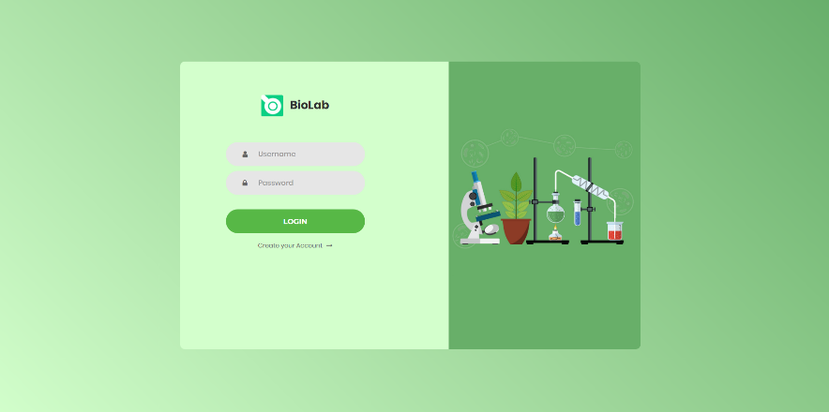

To register co-admins or users, click “create your account” and input the required credentials.

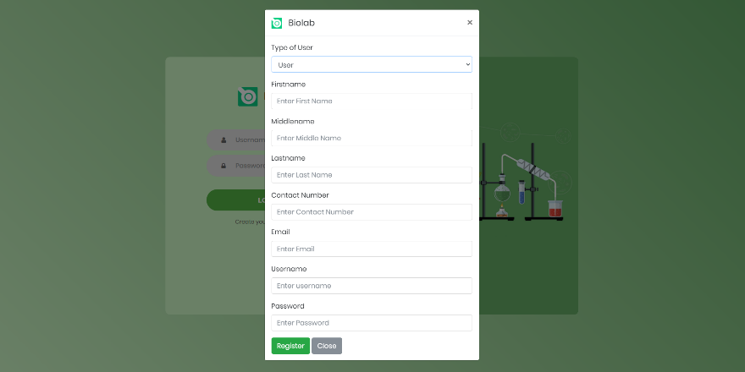

Step 2: Input admin credentials

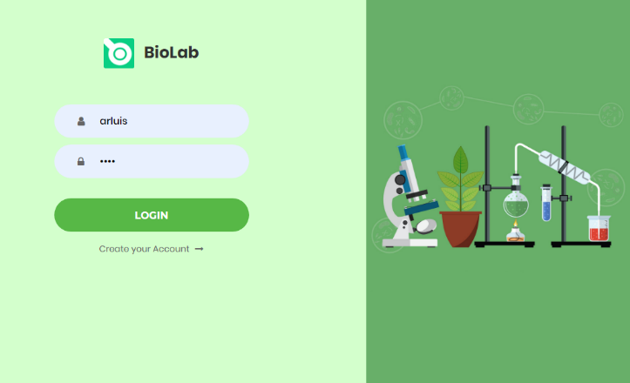

Step 3: Input material description, click “Next”.

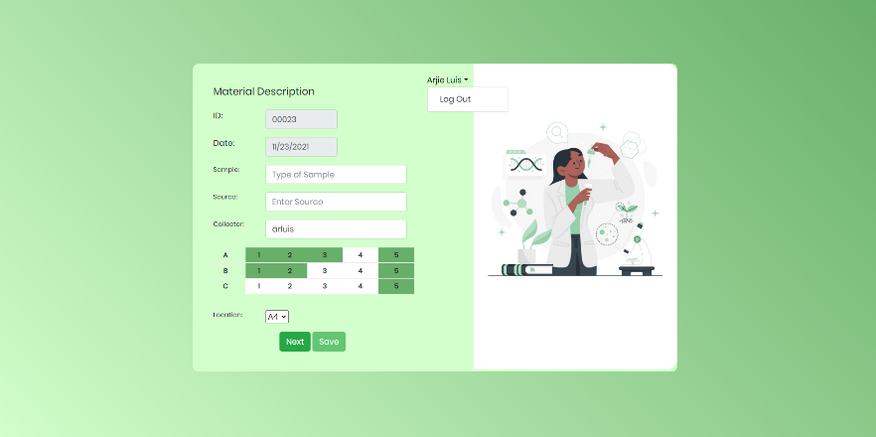

Step 4: Upon confirming material details, click “Save”.

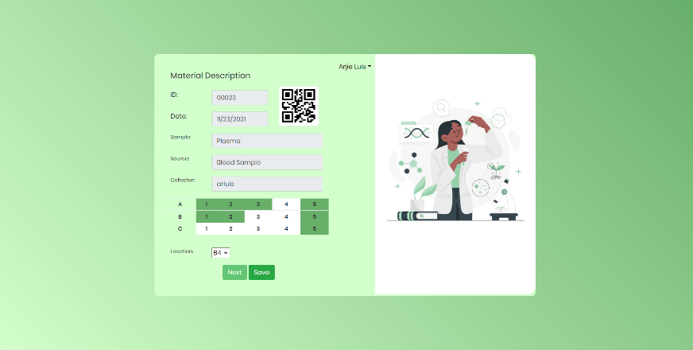

After that, the system will notify that the materials have been added to the database and the “Print” button will appear.

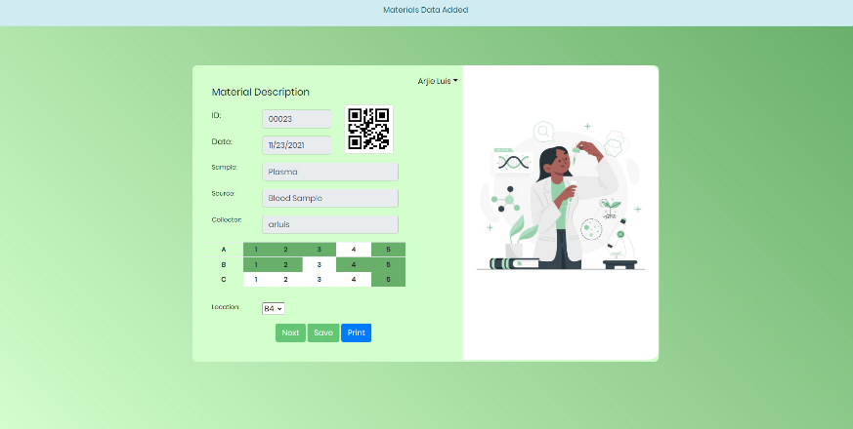

Step 5: To print QR code, click “Print”.

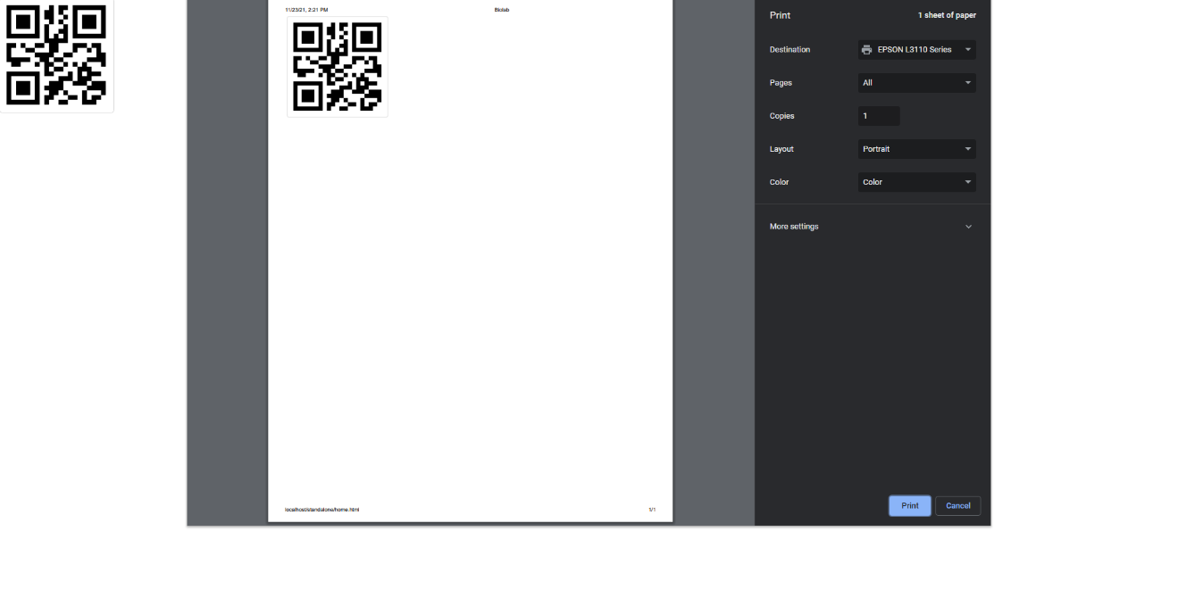

**Mobile App and features:**

Step 1: Download the bio_lab apk to android mobile phone.

Step 2: Open the Bio Lab application. Input credentials.

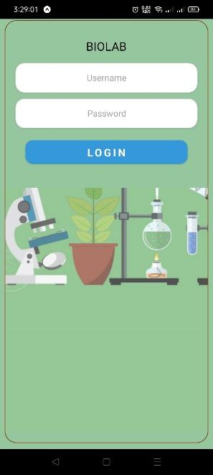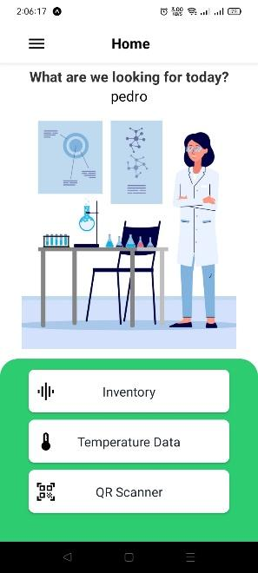

Upon logging in, you will see the main menu of the application where you can choose to view inventory, temperature data and scan QR.

Step 3: In the Inventory page, you will be able to see the materials that are listed inside the biofreezer.

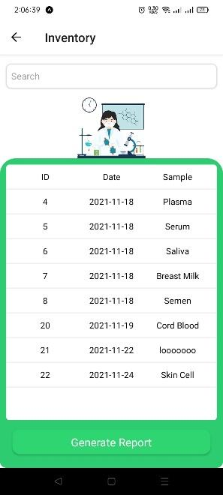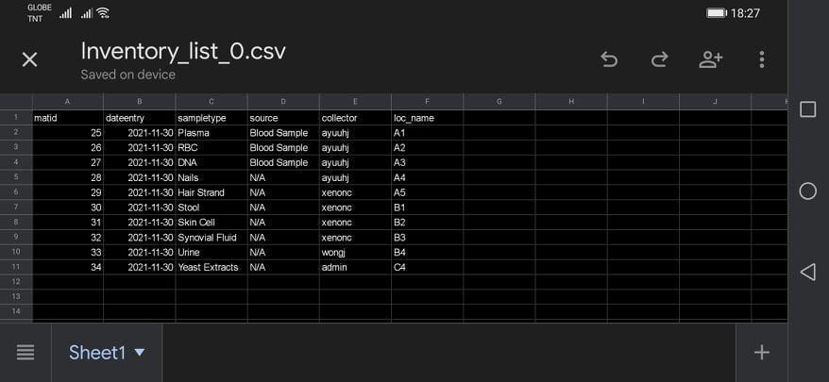

To generate an inventory log report, click “Generate Report” and it will automatically be saved through your phone in csv format.

Step 5: On the other hand, in the temperature page, you will see the real time temperature being monitored in the storage and you can also choose a date of which you want to view the temperature readings.

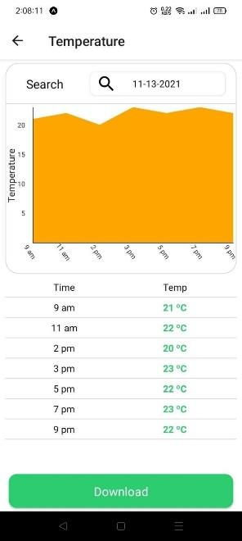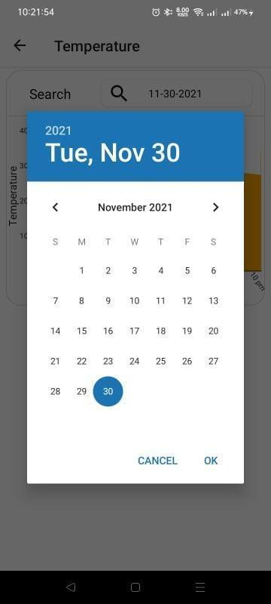

To generate a temperature log report, click “Download” and it will automatically be saved through your phone in csv format.

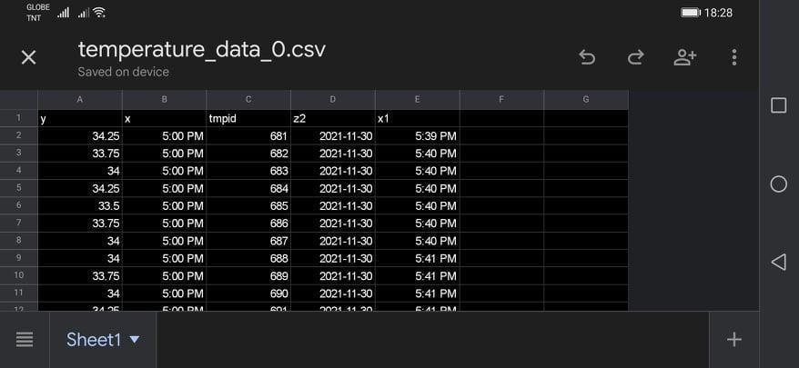

Step 6: Lastly, for the QR Scanner, the mobile camera will open as the user will scan it to a material vial with QR to view material description and choose whether to “load in” or “load out”.

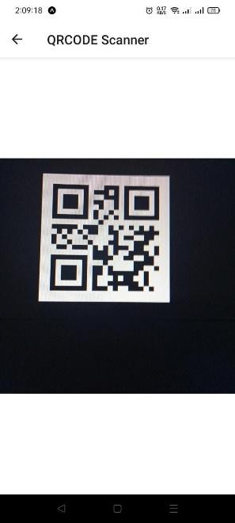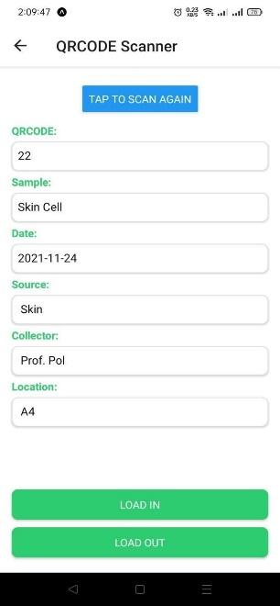

To generate log reports on the material items, only the laboratory head or the admin accounts can access through the inventory page where they can download item load in and out logs in csv format.

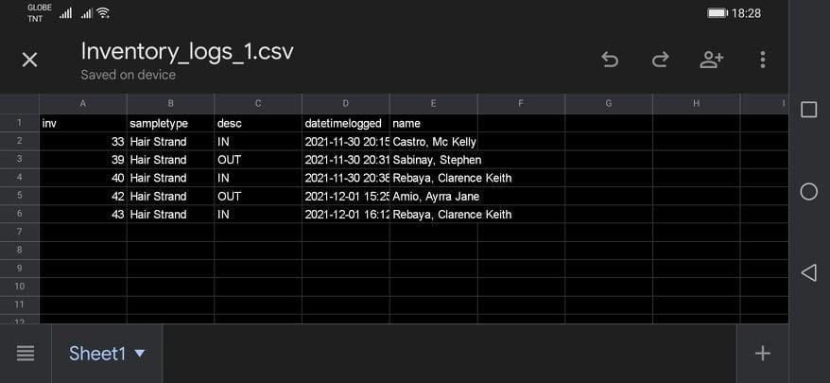

**Troubleshooting**

*Mobile Application not proceeding to main menu after login*

* Always check the localhost web server if it is active and online.

*IoT device not reading temperature*

* Try turning it off and on again, if a problem persists, there might be connectivity problems, contact the IT support.

**FAQ (Frequently Asked Questions)**

**What Is Being Measured?**

- The temperature inside of an Ultra-low Biofreezer is what is being measured and monitored.

**Why Do We Need This Measurement?**

- It is in order to know and regulate the optimal temperature inside these biomedical storage devices. It is highly effective for a wide range of biomedical practices and research.

- The process can have an unintended impact if not executed and implemented properly. Therefore, to avoid their degradation specimen and disruption of critical research, special care and effort are required for their storage and maintenance.

**What is the main use of the system?**

- The main use of the system is (1) to be a functional temperature reading monitoring device designed and integrated with a notification alert system and (2) a functional IoT inventory management system can make a reliable and systematic way to handle these stored specimens

**Do operations depend on having the reading available?**

- Yes, operations do depend on having the readings available coming from the sensor of the device. Once the temperature is read that data is then being collected and can be essential to the laboratory personnel.

**Does it have a temperature control function?**

- No, unfortunately not, the system (device) was designed to capture and monitor the temperature from wherever or whatever storage unit it was intended to.

**Where else can we use this system?**

- The system can be used in any climate-controlled storage.

**How accurate must the readings be?**

- They are many factors that can affect the accuracy of the readings whether it is the environment, quality of the storage unit or even the integrity of the hardware being used but generally in a close to perfect scenarios it should be with a consideration of a small margin of error

**How long must the equipment last before replacement is possible?**

- Depends on what the build quality of the hardware is being used, for example a thermocouple. Generally, in cold temperatures reaching -75° to -100° Aluminum and carbon-steel alloys are suitable enough in these conditions but in hotter conditions titanium is more preferred.

**Contact Details**

**Ayrra Jane R. Amio**

[ajamio@wvsu.edu.ph](mailto:ajamio@wvsu.edu.ph)

+639566706812

**Mc Kelly D. Castro**

[mckcastro@wvsu.edu.ph](mailto:mckcastro@wvsu.edu.ph)

+639076067735s

**Winston C. Sevilla**

winston.sevilla@wvsu.edu.ph

+639491015546

**Paul Adrian D. Soncio**

[pauladrian.soncio@wvsu.edu.ph](mailto:pauladrian.soncio@wvsu.edu.ph)

+639616552028

**Jose Mari C. Wong**

[josemari.wong@wvsu.edu.ph](mailto:josemari.wong@wvsu.edu.ph)

+639458500027

