**Reporting Dashboard for Interrogating Transactional Insurance Data within Applied Relay Broker Management System**

*Project Plan*

Paul Connolly

B00348751

Table of Contents

Introduction 2

Background 2

Project Aim 3

Project Objectives and Activities 3

Objectives 3

Activities 3

Project Lifecycle 4

Project Schedule 5

Project Milestones 5

Work Breakdown Structure 5

Establish a top-level work breakdown structure (WBS) 5

Project Scope 6

Estimate the projects effort for tasks 6

Project Resources 7

Required Knowledge and Skills for the Project 7

Project Data Management 7

Project Stakeholders 8

Stakeholder Register 8

Understand project commitments 9

Works Cited 10

Appendix 11

# Introduction

Project aim is to create a reporting dashboard for insurance brokers using Applied Systems product Applied Relay enabling them to view their transactional data over a given period.

# Background

Applied Systems have operated for over 30 years powering the insurance industry across the USA, Canada, Ireland and the United Kingdom, providing industry leading technology to the insurance industry (Applied Systems, 2017).

In the Irish insurance market, Applied Systems provides insurance brokers with a product called Applied Relay. Applied Relay is a back-office solution enabling brokers to facilitate all needs of their customers (Applied Systems, 2017).

Key features of Applied Relay are (Applied Systems, 2017):

* Leads management
* Automatic Accounts reconciliation
* Policy Administration
* Product Builder
* Account Reconciliation

The current reporting tool in Applied Relay is limited as it is not able to provide its users with graphical representations of the reports it generates.

Reports are generated within Applied Relay and these can be executed on-demand or set-up to run automatically. The reports can be run from a predefined list or the user can generate their own by using the report building tool inside of Applied Relay.

# Project Aim

Aim of the project is to provide insurance brokers in Ireland using Applied Relay, with a secure, web-based dashboard giving them the ability to view graphical reports of their transactional data from Applied Relay.

The reporting dashboard should give insurance brokers a better and more in depth understanding of how their brokerage is functioning. It will give them more informative feedback that is easily understood and will give them the ability to interrogate the data to meet their own needs.

## Project Objectives and Activities

To give the project structure, a list of project objectives and activities have been identified and listed below:

### Objectives

1. Create website for Irish insurance brokers that will graphically represent the transactional data of their business.
2. Create SQL database for storing data that will be reported against.
3. Create service for exporting data from current Applied Relay database to the new database schema.

### Activities

1. Project requirements gathering.
2. Determine database and database tables in Applied Relay that will be used during the data export process.
3. Define user roles on the website.
4. Determine default reports, graphs and statistics to be included on the dashboard.
5. Research best programming languages to use for this project.
6. Design reporting database.
7. Mock-up user interfaces and have them signed off by Project Manager.
8. Build UI and test.
9. Create Windows service or web API for front-end communication and retrieving data from database.
10. Write SQL queries.
11. Test code base in the Windows service/web API.
12. Link front-end and service so data can be retrieved from the database and displayed on the UI.
13. Manually test all aspects of the system. This should be an ongoing process during system development but an all-around test will be done when the project is considered complete.

# Project Lifecycle

Comparison of possible lifecycles

Why have I chosen the one I have?

# Project Schedule

The project is scheduled to run for around 7 months, which breaks down in to estimated periods of 1 month of planning and design, 5 months of development and another month for testing and deployment.

## Project Milestones

The project milestones have been added to the GitHub applied-relay-reporting, available [here](https://github.com/ulster-university/applied-relay-reporting/milestones) and Appendix 1 and Appendix 1.

The milestones selected outline important stages throughout the project and determine points at which significant amounts of work have been completed.

## Work Breakdown Structure

As part of project planning, a Work Breakdown Structure, Appendix 3, has been developed to give an oversight to which project milestones fall in each stage of the Software Development Life Cycle (SDLC).

The SDLC is a process that aims to produce software with the highest quality and with the lowest cost possible in the shortest amount of time (Stackify, 2017).

According to (Stackify, 2017), the advantages of following the SDLC are:

* It allows a high level of management control
* Gives developers a good understanding of what they are trying to build
* An agreement is made upfront on what the project outcome should be
* It sets out an agreed plan on how to reach the proposed goal

# Project Scope

The delivered system should consist of a secure, web-based website that communicates with a server side service and SQL database.

A registered user of the system will be able to login to the site and view data associated to the role they have been assigned. User roles will restrict the reports a user can execute and view.

Users will also be restricted to only viewing data of the company/insurance brokerage they are employed by.

The website will be an interactive dashboard with graphs and statistics showing an insurance brokerages performance over a specified period. As a default this data will be from the previous day’s business but the time period can be changed to show reports for a custom date period.

Users will be able to configure the settings for their dashboard so they can choose which reports and statistics they see on their dashboard by default.

For this project, the data is currently stored in an old database that over time has become disjointed and difficult to work with. To get the data in a more suitable structure for reporting a database schema will be designed as one of the initial tasks on this project. This will be a relational SQL database designed with emphasis on being in a performant structure suitable for reporting.

The project will require a Windows service to be created that will have open endpoints the websites can make requests to for retrieving the data that will be drawn up in graphs and output as statistics on the user interface.

# Estimate the projects effort for tasks

# Project Resources

To ensure delivery of this project, the following required resources have been identified:

* Development computer (PC and/or laptop)
* Microsoft Visual Studio
* Microsoft Visual Studio Code
* SQL server
* Hosting server

## Required Knowledge and Skills for the Project

Programming skills for this project will include development languages:

* C#
  + NCrunch and SpecFlow will be used when testing this code
* SQL

Web development languages include:

* HTML
* CSS
* JavaScript
  + React – a JavaScript library
  + Wallaby – a JavaScript testing library

Development framework

* ASP.NET

## Project Data Management

All data stored in the database is held on a secure server inside of Applied Systems Ireland.

Source code for the project will be held in a private GitHub repository so that it is controlled and versioned. The GitHub repository will be called ‘applied-relay-reporting’.

# Project Stakeholders

## Stakeholder Register

The list below has been identified as the list of interested stakeholders including their expected engagement level throughout the duration of the project.

|  |  |  |  |
| --- | --- | --- | --- |
| **Name** | **Position** | **Project Role** | **Contact Information** |
| Alastair Bell | Managing Director | Project Sponsor | [alastair.bell@appliedsystems.com](mailto:alastair.bell@appliedsystems.com) |
| Michael Harding | Customer Service Director | Senior Manager | [michael.harding@appliedsystems.com](mailto:michael.harding@appliedsystems.com) |
| Alan Matthews | Software Development Manager | Project Manager | [alan.matthews@appliedsystems.com](mailto:alan.matthews@appliedsystems.com) |
| Lee Browne | Team Lead | Team Member | [lee.browne@appliedsystems.com](mailto:lee.browne@appliedsystems.com) |
| Richard Hamilton | Senior Developer | Team Member | [richard.hamilton@appliedsystems.com](mailto:richard.hamilton@appliedsystems.com) |
| Paul Connolly | Software Developer | Lead Developer | [paul.connolly@appliedsystems.com](mailto:paul.connolly@appliedsystems.com) |
| Professor  Colin Turner | Head of School of Engineering | Supervisor | [c.turner@ulster.ac.uk](mailto:c.turner@ulster.ac.uk) |
| Dr Kenneth Adamson | Reader in Computer Science | Supervisor | [k.adamson@ulster.ac.uk](mailto:k.adamson@ulster.ac.uk) |

Communication with the relevant stakeholders will be a mixture of face-to-face meetings, emails and communication via GitHub.

# Understand project commitments

Obtain commitment from relevant stakeholders

# Works Cited

Applied Systems. (2017, 10 28). *About Applied*. Retrieved from Applied Systems website: https://www1.appliedsystems.com/en-ie/about-us/

Applied Systems. (2017, 10 28). *Applied Relay Software for Brokers*. Retrieved from Applied Systems website: https://www1.appliedsystems.com/en-ie/solutions/for-brokers/managing-your-brokerage/applied-relay/

Stackify. (2017, 10 04). *What is SDLC? Understand the Software Development Life Cycle*. Retrieved from Stackify website: https://stackify.com/what-is-sdlc/

# Appendix

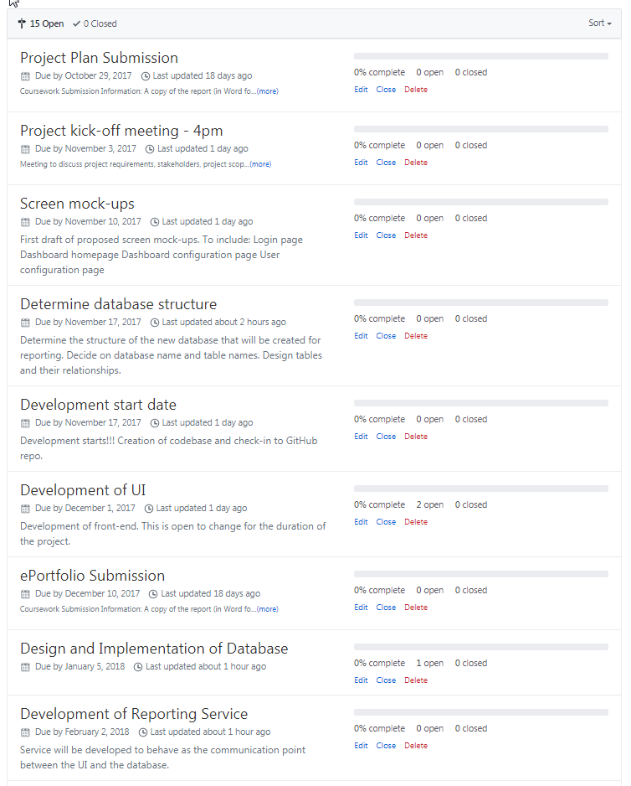

Appendix 1

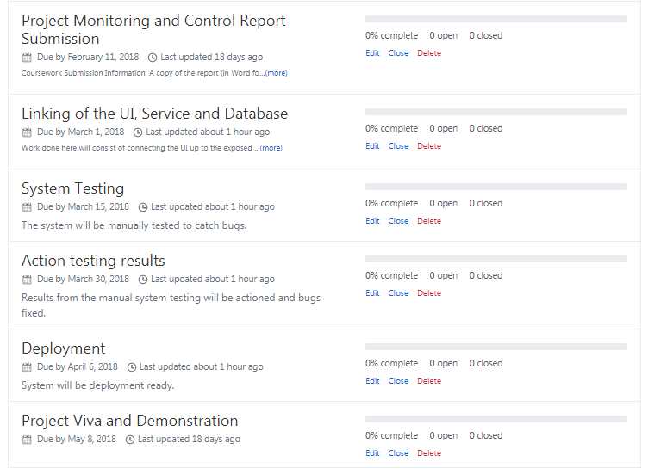

Appendix 2

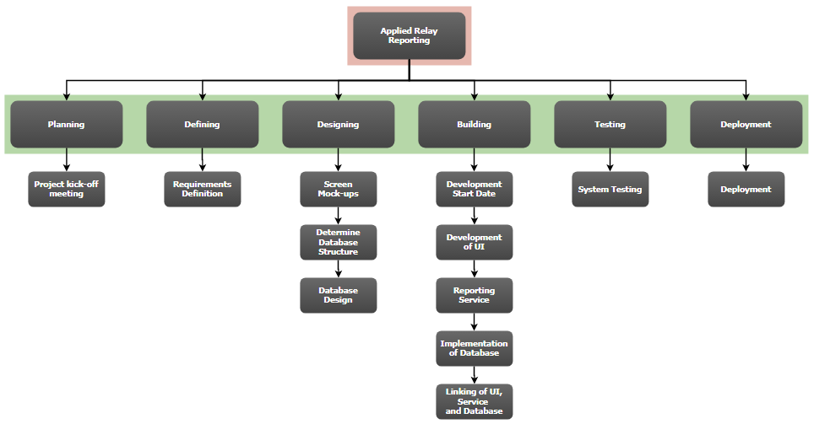

Appendix 3