Abstract

An interim update report detailing project progress in comparison to the initial project plan aims, objectives and project timeline.

Project Monitoring and controlling

B00348751 – Paul Connolly

Contents

Introduction 2

Actual Values vs Project Plan 3

Commitments vs Project Plan 4

Risks vs Project Plan 5

Management of Data vs Project Plan 6

Stakeholder Involvement vs Project Plan 7

Current Project Status Review 8

Progress Review 8

Performance Review 8

Progress Issues 8

Project Accomplishments 9

Issues & Solutions 10

Issues 10

Solutions 10

# Introduction

To assess the current progress of the project against the initial assumptions and estimates made in the project plan, this Project Monitoring and Controlling report will look at the actual results to date compared to predicted progress.

Areas to be evaluated include, commitment to the project, associated risks, project management, stakeholder involvement, project progress and project accomplishments.

Where issues have been encountered the actions taken to address and correct the issues will be detailed.

# Actual Values vs Project Plan

As it stands, this project is estimated to be 3 months behind the proposed schedule of the project plan.

The original project deliverables and their estimated delivery dates have been included in Appendix 1 & Appendix 2 of this report.

To this date the only deliverables that have been delivered on time are the project kick-off meeting and submission of associated project reports.

# Commitments vs Project Plan

From a project perspective; there has been a slight change to the project aim. The original aim of the project in the project plan was ‘to provide insurance brokers in Ireland using Applied Relay, with a secure, web-based dashboard giving them the ability to view graphical reports of their transactional data’ – this how now changed slightly.

The data will now be for the full Irish insurance market to view; i.e. insurance brokers and insurers. This data is to be compliant with an agreement Applied Systems Ireland, formerly Relay Software Ltd., made with the Competition and Consumer Protection Commission in Ireland - <https://www.ccpc.ie/business/enforcement/civil-competition-enforcement/closed-investigations/relay-investigation/>

It means the data displayed on the dashboard will not be specific to any insurer or broker and instead will be an average of top 5 insurance prices for all insurers and brokers up to 6 months historically. After the 6 months, the actual cheapest insurance premium can be shown.

The change in requirement means I will have to rethink how the data is manipulated and displayed but the reports will still be shown on a secure, web-based dashboard.

From a personal point of view, my commitment to getting this project completed on time and to the best of my ability has not changed. I am still fully committed to achieving the aim.

To ensure that this project is completed, I requested gratis time off work to complete the project which was approved. This will give me time to focus on the project without the distraction of my day-to-day work as a developer on the project that I have been assigned to by my employer. The work project also has a first release delivery date of April 2018.

# Risks vs Project Plan

*Monitor risks against those risks identified in the project plan.*

# Management of Data vs Project Plan

*Monitor the management of project data against the project plan.*

# Stakeholder Involvement vs Project Plan

*Monitor stakeholder involvement against the project plan.*

# Current Project Status Review

*Review the project’s progress, performance and issues.*

## Progress Review

## Performance Review

## Progress Issues

# Project Accomplishments

*Review the project’s accomplishments and results at selected milestones.*

# Issues & Solutions

*Analyse issues and determine corrective actions to address them.*

## Issues

## Solutions

# Appendix

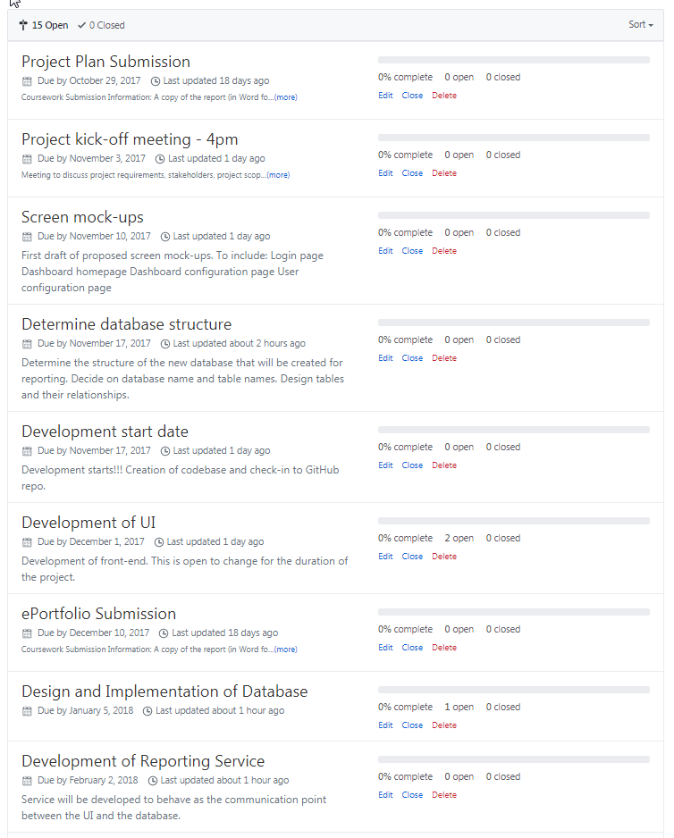

Appendix

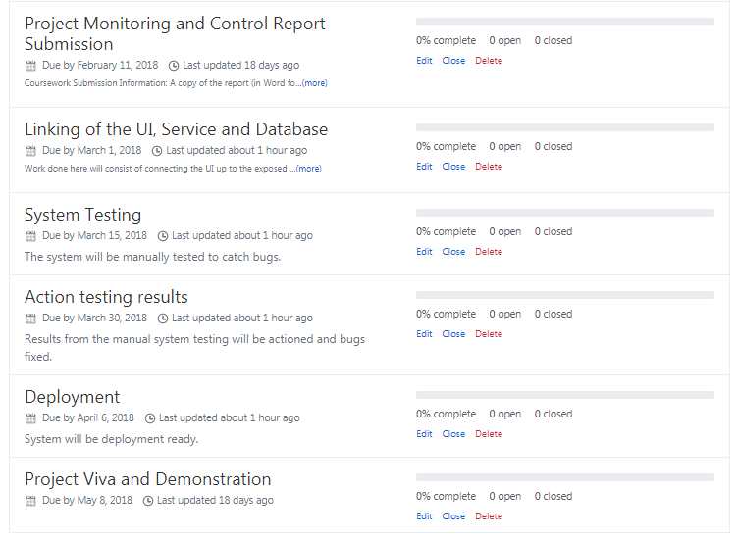

Appendix