Abstract

An interim update report detailing project progress in comparison to the initial project plan aims, objectives and project timeline.

Project Monitoring and controlling

B00348751 – Paul Connolly

Contents

Introduction 2

Actual Values vs Project Plan 3

Commitments vs Project Plan 4

Risks vs Project Plan 5

Management of Data vs Project Plan 7

Stakeholder Involvement vs Project Plan 8

Current Project Status Review 9

Progress Review 9

Performance Review 9

Progress Issues 9

Project Accomplishments 11

Issues & Solutions 12

Appendix 13

# Introduction

To assess the current progress of the project against the initial assumptions and estimates made in the project plan, this Project Monitoring and Controlling report will look at the actual results to date compared to predicted progress.

Areas to be evaluated include, commitment to the project, associated risks, project management, stakeholder involvement, project progress and project accomplishments.

Where issues have been encountered the actions taken to address and correct the issues will be detailed.

# Actual Values vs Project Plan

As it stands, this project is estimated to be 3 months behind the proposed schedule of the project plan.

The original project deliverables and their estimated delivery dates have been included in Appendix 1 & Appendix 2 of this report.

By now, it was expected that the below milestones would have been reached with work completed at each milestone but so far, the only deliverables that have been delivered on time are the project kick-off meeting and submission of associated project reports.

* Project plan submission – Complete
* Project kick-off meeting – Complete
* Screen mock-ups – Outstanding
* Determine database structure – Outstanding
* Development start date – Outstanding
* Development of User Interface – Outstanding
* ePortfolio submission - Complete
* Design and implementation of database – Oustanding
* Development of reporting service – Oustanding
* Project monitoring and controlling report – Complete

From 10 milestones, only 4 have been completed. This leaves the project behind schedule with a lot of work to be completed in the next 10 weeks.

# Commitments vs Project Plan

From a project perspective; there has been a slight change to the project aim. The original aim of the project in the project plan was ‘to provide insurance brokers in Ireland using Applied Relay, with a secure, web-based dashboard giving them the ability to view graphical reports of their transactional data’ – this how now changed slightly.

The data will now be for the full Irish insurance market to view; i.e. insurance brokers and insurers. This data is to be compliant with an agreement Applied Systems Ireland, formerly Relay Software Ltd., made with the Competition and Consumer Protection Commission in Ireland - <https://www.ccpc.ie/business/enforcement/civil-competition-enforcement/closed-investigations/relay-investigation/>

It means the data displayed on the dashboard will not be specific to any insurer or broker and instead will be an average of top 5 insurance prices for all insurers and brokers up to 6 months historically. After the 6 months, the actual cheapest insurance premium can be shown.

The change in requirement means I will have to rethink how the data is manipulated and displayed but the reports will still be shown on a secure, web-based dashboard.

From a personal point of view, my commitment to getting this project completed on time and to the best of my ability has not changed. I am still fully committed to achieving the project aim.

To ensure that this project is completed, I requested gratis time off work to complete the project which was approved. This will give me time to focus on the project without the distraction of my day-to-day work as a developer on the project that I have been assigned to by my employer. The work project also has a first release delivery date of April 2018.

# Risks vs Project Plan

In the project plan, a risk assessment was carried out and a risk register was compiled as shown below in Figure 1.



Figure 1 – Risk Register from Project Plan

Most of the risks identified above where in relation to the actual development of the project.

At this stage the project development has not even started so it is hard to measure the impact of the risks noted in the project plan as they have not had a chance to materialise.

From the risk register, Risk 5 - Scope Creep, is the risk that has posed most of a threat to this project. With the change in requirement it was also suggested by the project sponsor that we add additional functionality so the view of the data could be on a full market level, an insurer level and on a broker level. Due to time constraints I had to push back on this request and state that these additional views on the data may only get added to the system later when the project had been completed and submitted to the university. It was agreed that this was acceptable, and the additional views could be implemented on the system after the university submission.

I decided to build the user interface of this project using React. This was decided because it is a technology I am aware of through my employment and I wanted to improve my skills using it. The lack of skills before starting development means I have had to undertake many hours of learning before starting development on the project. This learning has been done using online tutorials.

The risks that have proven to be obstacles in getting the project started are risks that I could not have predicted when the project plan was written.

These risks are the additional responsibilities I have been given in work when being assigned the role of Scrum Master on my team and the extra hours required to work due to my work-based project being behind schedule.

Becoming Scrum Master means I have had to assign hours at evenings and weekends to expand my knowledge on the role. It has also meant that I have lost development hours in work which are also having to be made up at evenings and weekends. The fact that work demands are taking up time outside of regular work hours means I have had very limited time to work on this project. To help limit the impact of this risk I have started to take shorted lunch breaks in work. This has given me an extra 2.5 hours per week which is time I now use as extra development time in work for work projects. I don’t use up as much time outside of work now and this time is going to be free to develop my university project.

# Management of Data vs Project Plan

With the current development progress, the only data management carried out has been where the project source code is being stored. Although the actual project development has not started, a proof-of-concept/demo system has been developed. In accordance with the project plan, the source code for this demo application has been stored in an online GitHub repository.

To avoid any chance of corruption to “real” data, it is agreed that all my development will be done against a copy of the live database that will be stored on my work development machine. This means the data is stored behind a secure firewall that is managed in compliance with Applied Systems security policies.

# Stakeholder Involvement vs Project Plan

The stakeholder involvement in the project has been as planned.

The key stakeholders have stayed the same and since the start of 2018, I have been holding bi-weekly project catch-up meetings with the stakeholders and these have been instrumental in defining requirements and understanding the type of reports they want to display on the dashboard.

One stakeholder plays less of a role than first anticipated. This stakeholder is the senior developer who was assigned to help and give me guidance on best practices in programming. It has since transpired that I do not need as much of his time as first predicted so he is involved as a stakeholder in a limited capacity.

# Current Project Status Review

## Progress Review

To date, the project is behind schedule by around 3 months with only 40% of predicted work being completed.

With work commitments I have not had the time to work on this project that I thought I would have had.

At this stage, I would have expected to have completed the user interface and the reporting web service with work ongoing to integrate the UI, service and database together. However, currently only a proof-of-concept application has been developed with a UI containing a couple of graphs being populated with dummy, hard-coded data. This can be seen below.

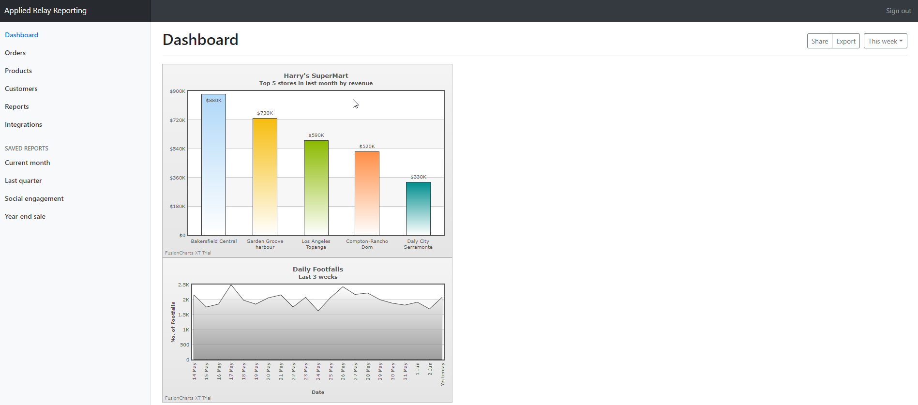

Figure 2 – Proof-of-concept dashboard

Being behind schedule means I have had to adapt the delivery dates on the project milestones, see Appendices 3 and 4 for updated milestones.

## Performance Review

As the project is behind it is safe to say that it has generally not been performing very well.

Enough time has not been available for me to work on this project, so it would be fair to say it is underperforming.

However, for the parts of the project that have been carried out, i.e. meetings and proof-of-concept application, they have been carried out efficiently and effectively.

## Progress Issues

The dangers of being this close to my project delivery date with so few milestones reached and completed is that the project is at serious risk of not being completed on time. Should the project be delivered on time, which it must be, it is possible that some of the expected functionality could be missing.

The main issue that has been holding back my progress on the project is the fact that I am in full-time employment with Applied Systems as a Software Developer and more recently combining that role with becoming a Scrum Master on a development team.

In my current work project, we are also behind schedule and this has meant working overtime at evenings and weekends, thus limiting the time I have to complete this university project.

# Project Accomplishments

To date, the major accomplishment of this project has been to complete a proof-of-concept.

This proof-of-concept has provided a working solution to demonstrate that the technologies I will be using can come together to achieve the overall project aim.

This proof-of-concept has now provided me a good base on which I can build the final solution.

# Issues & Solutions

To date the main issue has been my full-time job taking up too much of the time I had expected would be available for me to work on this project. To solve this problem, I have had to come to an arrangement with my line manager and senior management at Applied Systems that will mean I am not expected to do as much overtime on the work project and I have instead requested that I use this overtime to complete my university project.

As development has not started it is hard to predict what issues may arise but to this point, time-management has been the deciding factor in this project being behind schedule.

As a method to help solve my time-management issue, I plan on making weekly task lists for both work and the university project. This will detail work I want to complete that week and give me realistic targets to achieve each week.

# Appendix

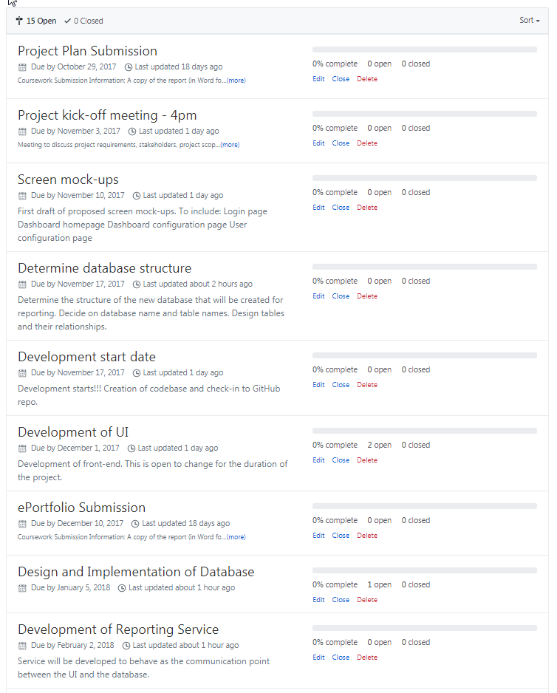

Appendix 1

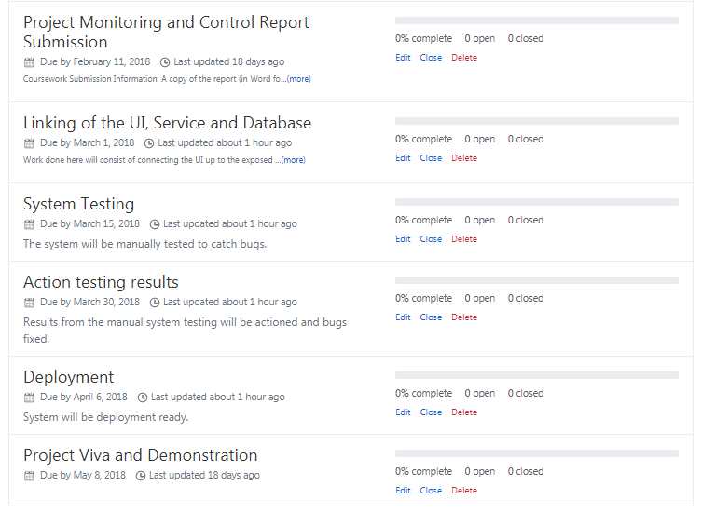

Appendix 2

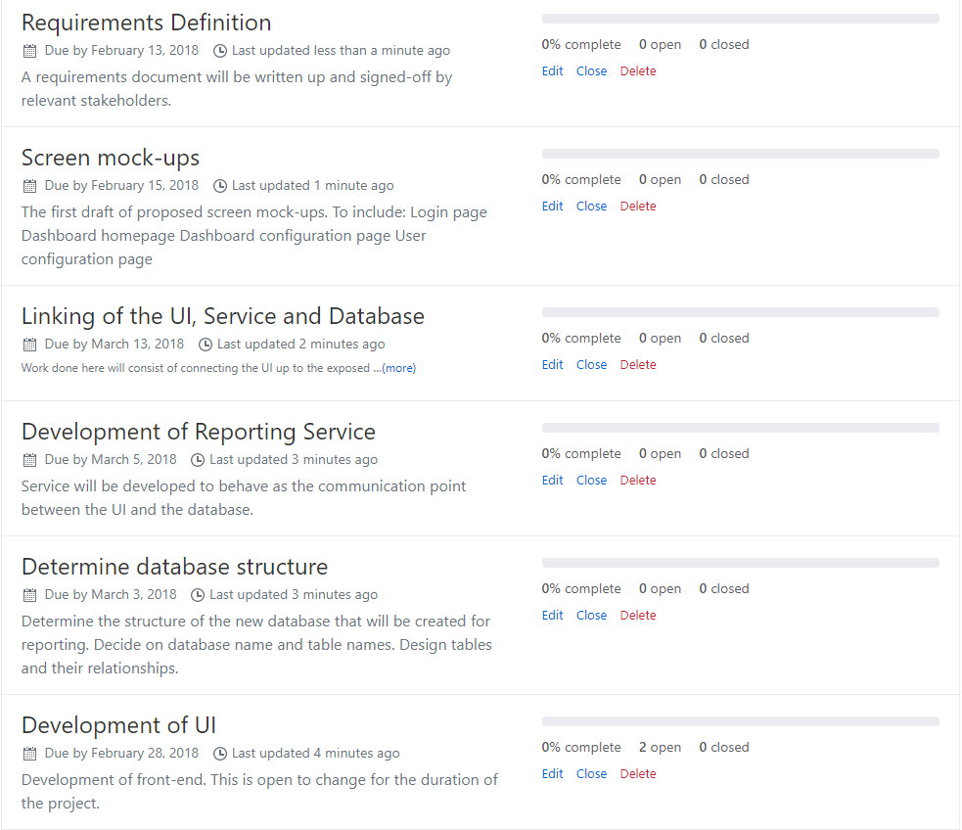

Appendix 3

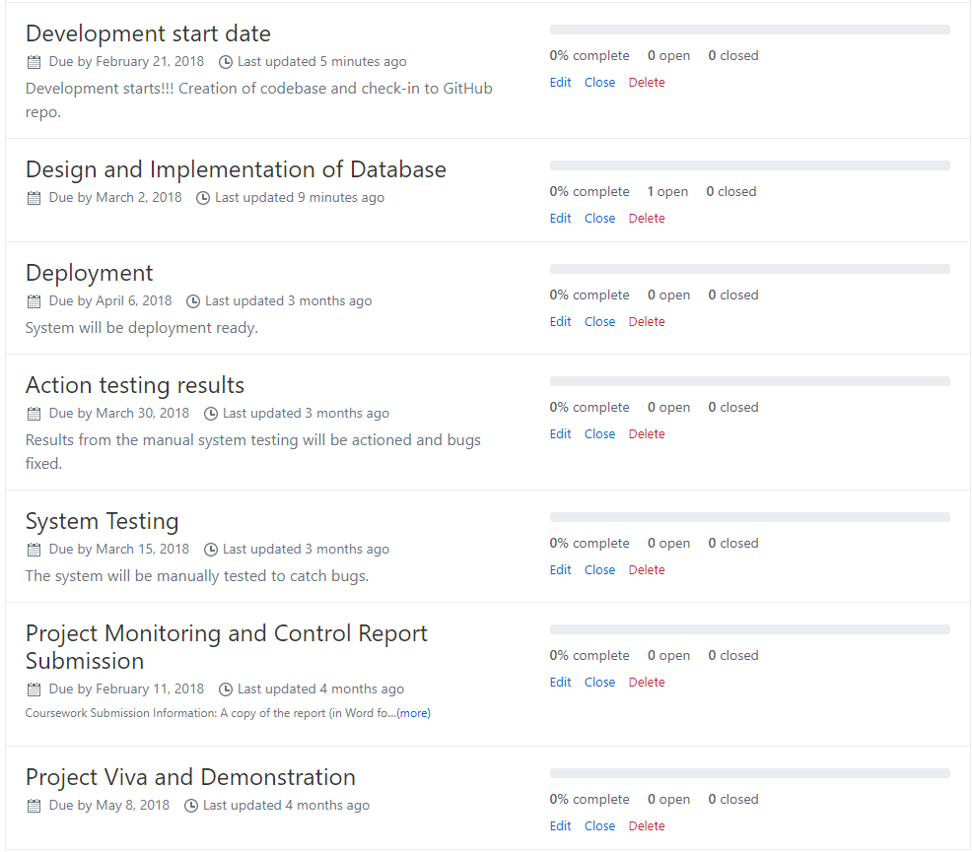

Appendix 4