
Device to Monitor Conditions
for Panic/Anxiety Attacks

Internet of Things Project
Project Proposal

Paul Daly
BEng(H) in Software & Electronic Engineering
Atlantic Technical University
2025/2026

Project Description

Many people experience panic attacks in their lives. A sudden unexpected change in your mind and body. It can be as light as having your mind race and becoming short of breath but for some people, they experience far more debilitating symptoms. For these people, these attacks can be so severe that it disables their body in the short term and can weaken them for several days after. I myself have experienced the lighter cases, and have witnessed my girlfriend experiencing the more severe attacks. Something interesting I thought about during my own attacks was how obvious some of the causes can be and how oblivious we can be until it’s too late. Some of those factors are sound, temperature, where you are and how many people are around you, as well as light and other stimulus for our senses. After an attack these are obvious but are difficult to keep track of in the moment, especially for people who get overwhelmed easily.

For my project, I will be making a device that keeps track of surrounding stimulus, specifically light, heat and humidity, sound, and heartrate, relaying this information to the user and warning them if the conditions are present that they are vulnerable to. It would relay this information using LEDs and an LCD screen. For example, too many people in a room making it quite hot, or a speaker that’s too loud. This would be useful for people with autism who are prone to these kinds of attacks, people performing tasks they are not used to in very social or simply uncomfortable positions, or even children who are adapting to new schools or areas. It could improve these people’s quality of life, allowing them to enjoy places or activities without having to worry so much about their wellbeing.

The device I have in mind would make use of the ESP32 alongside some sensors and LEDs and an LCD screen. The ESP32 would carry the code and the logic, taking in input from the sensors and applying logic to the resulting data, as well as use the outputs to convey that data to the user and the logic to light the LEDS. The LEDs would be used to convey the safety of the current situation, a green one lighting to signify ideal conditions, and a red one which will light if one unsafe condition is met, flashing if 2 or more are met. The LCD screen would scroll through the different readings at a slow pace and show a warning for any reading that is unsafe. The sensors would include the DHT11, a light sensor, a microphone/sound sensor, and possibly a heartrate sensor. The code would be written in C/C++, which would handle the input information and the logic. It would also control the LEDs and LCD screen.

Architecture Diagram

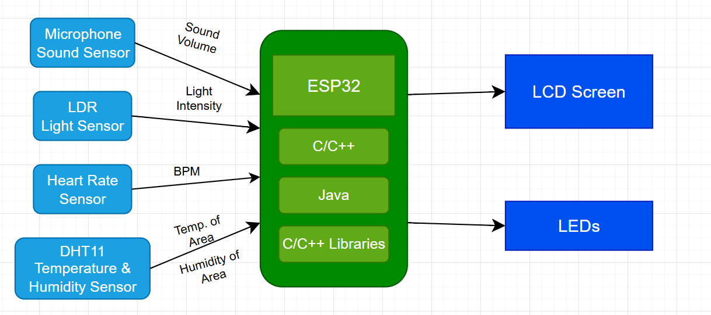

Feasibility

Getting the code to work, catching and fixing bugs, may be challenging. I have experience with some of the sensors and the LCD screen but utilising them together may provide a different kind of challenge. Working with the unfamiliar sensors and figuring out how best to make them work could be tricky and will require some time to be put aside for. Working with the hardware and putting everything together will reveal weaknesses or problems with the code and the parts, this will be something to work through. The temperature sensor may present an issue and must be swapped for a different sensor. The device itself, in practical application, may be difficult to work out an appropriate mounting place. It may inspire fear or discomfort due to the information it relays, which goes against the intent behind the device, which is to put the user’s mind at ease. It may also be relied on too heavily which will cause problems when it inevitably malfunctions or breaks.

Meeting United Nations’ Sustainability Development Goals UN SDGs

3. Good Health & Well-Being: This device has potential to help people in social situations or when engaging in activities, improving their quality of life.
4. Quality Education: This device has potential to improve people’s education, by allowing them to know quickly and easily how they are doing mentally, they can worry less and focus on learning.

Schedule
Two/three weeks on the code
One/two weeks on each sensor
One week on LEDs
One week on LCD screen
One/two weeks getting a board layout for all the hardware
Two weeks putting everything together
Two weeks debugging and fixing any issues

References

[1] | United Nations, “The 17 Goals Sustainable Development,” [Online]. Available: https://sdgs.un.org/goals. [Accessed 27 September 2023].

