This Specific ESP32 Pinout and Info

Sound Sensor Info

Grove LCD 16x2 White on Blue Wiki

Maybe Better LCD Tutorial

Heart Rate Sensor Tutorial
Another HR Sensor Tutorial
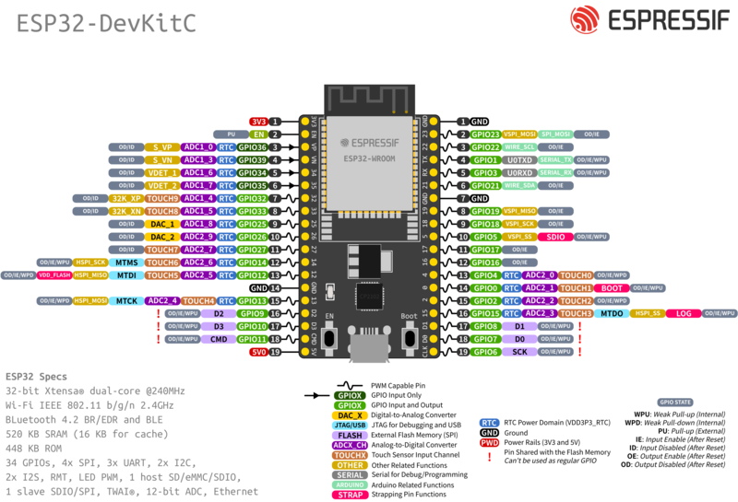
Pinout for LCD Screen (SCL,SDA)
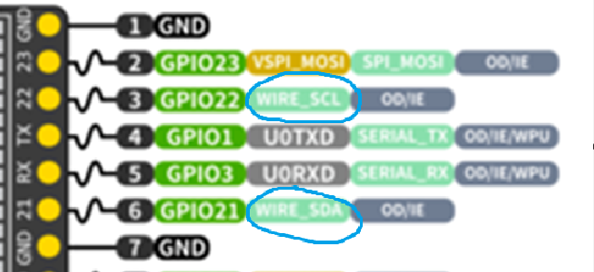

New Sound Sensor INMP 441:
Datasheet
Tutorial for INMP 441

Decoupling (?)
