

|  |
| --- |
| WEB PROJECT  PRESENTATION OF THE SPECIFICATION DOCUMENT |
| NGANKAM Paul-henry  TOUKAM Sonia  ABDULRAHAMAN Faris  NOUMEN Darryl  Academic Year 2022-2023  X2025 PROMOTION |
| 9 May 2022  Group 7 |

Contents

**I.** **PROJECT FRAMEWORK** 3

A. GENERAL PRESENTATION OF THE PROJECT 3

B. NEEDS THE PROTOTYPE MEETS 3

C. PROJECT STAKES 5

D. TEAM PRESENTATION 6

**II.** **FUNCTIONAL SPECIFICATIONS** 7

A. TARGETED FUNCTIONALITIES 7

**III.** **TECHNICAL SPECIFICATIONS** 7

A. TECHNOLOGIES CHOICES 7

**IV.** **MARKETING AND LEGAL ASPECTS** 7

A. BUDGET PRESENTATION 7

1. **PROJECT FRAMEWORK**
2. **GENERAL PRESENTATION OF THE PROJECT**

Nowadays, the conception of dynamic, responsive and ergonomic websites is more and more appreciated and claimed by users. Actually, it is in this context that the BDE of the CESI Engineering School asked for a group of qualified computer engineers to design a website which will facilitate the organization and communication of manifestations within the school and suggest to members some giveaways.

1. **NEEDS THE PROTOTYPE MEETS**

The website to design must satisfy according to the role of the user the needs below :

* **Students**
* Register on the site
* Consult the entire site
* Access the store (without being able to proceed with the purchase)
* **Connected Students**

* Register on an activity suggested by the BDE members
* Access to the suggestions box and vote for the activities suggested by other students
* Propose an activity to the BDE members
* Add photos on registered past events
* Comment and like photos of a past event
* **BDE members**
* Post a manifestation
* Access to the set of manifestations proposed by the students
* Choose a suggested manifestation in the suggestions box
* Access for each proposed manifestation to the list of subscribers and download it under the PDF or CSV extension
* Administrate the photos and comments of the past events section
* **CESI employees**
* Notify BDE members when photos, comments or manifestations are unappropriated
* Access to the site with same rights as students
* Download through a button all the photos posted by students and BDE members
* **Store / Shop**
* BDE members can add, delete or order by categories products
* Students can order via a shopping basket
* Provide a PayPal account to aid transactions
* Display the 3 most ordered articles
* Provide a search and filtering functionality

1. **PROJECT** **STAKES**

This project must address the following issues :

* **Technical issues :**
* Presence of a REST API : accessibility to the database by the other sites
* Use of modern technologies : personalized, stylish and functional website design
* Data Centralization : existence of a common database to all the CESI centres
* Forms and REST API Security : Forms queries must be validated through PHP functionalities and the API protected by an authentication mechanism (tokens)
* **Legal issues :**
* Legal mentions’ Presence : inform users about cookies purpose and general conditions of sale

1. **TEAM PRESENTATION**

1. **FUNCTIONAL SPECIFICATIONS**
2. **TARGETED FUNCTIONALITIES**

The main functionalities of this website are :

* aid the planification and the announcement of the school events
* allow students to get accessed to the BDE online shop

1. **TECHNICAL SPECIFICATIONS**
2. **TECHNOLOGIES CHOICES**

The use of the following technologies is required to carry out the project :

* PHP, HTML, CSS, JAVASCRIPT, AJAX
* The pre-processors LESS or SASS
* The Frameworks Bootstrap, jQuery and Laravel

1. **MARKETING AND LEGAL ASPECTS**
2. **BUDGET PRESENTATION**

The realization or the implementation of this project will need the following budget :

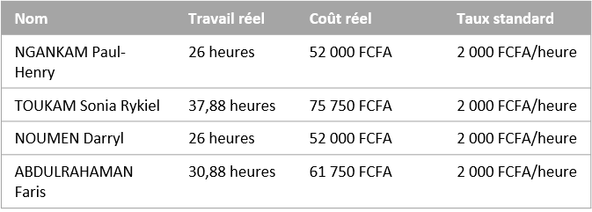

ÉTAT DES COÛTS

RÉPARTITION DES COÛTS

DÉTAILS DES COÛTS

État des coûts pour les ressources de travail.

Répartition des coûts parmi les différents types de ressources.

Détails des coûts pour toutes les ressources de travail.