**Characterization of explosive eruptions based on tephra deposits:**

**plume height, mass eruption rate, erupted volume, eruption classification**

***Costanza Bonadonna, Eduardo Rossi*** *University of Geneva*[*Costanza.Bonadonna@unige.ch*](mailto:Costanza.Bonadonna@unige.ch)*,* [*Eduardo.Rossi@unige.ch*](mailto:Eduardo.Rossi@unige.ch)

**PART I: Determination of plume height and Mass Eruption Rate**

**Objective**: determination of 1) plume height and wind speed with the model Rossi et al. (2018), and of 2) MER with the methods of Wilson and Walker (1987), Mastin et al. (2009) and Degruyter and Bonadonna (2012).

**1.** Please compile an isopleth map based on the document provided and calculate **the height of the plume** (above the vent) and the **wind speed** based on the method of Rossi et al. (2018) using both the nomograms (Fig. 1) and the Matlab script provided. The map represents the largest lithics of the Layer 3 of Cotopaxi volcano (vent height: 5.7 km above sea level). Assume a density of lithics of 2500 kg/m3 and consider an average altitude of sampling above sea level of 3500 m. Before starting, be sure to choose your contour values according to figure 1.

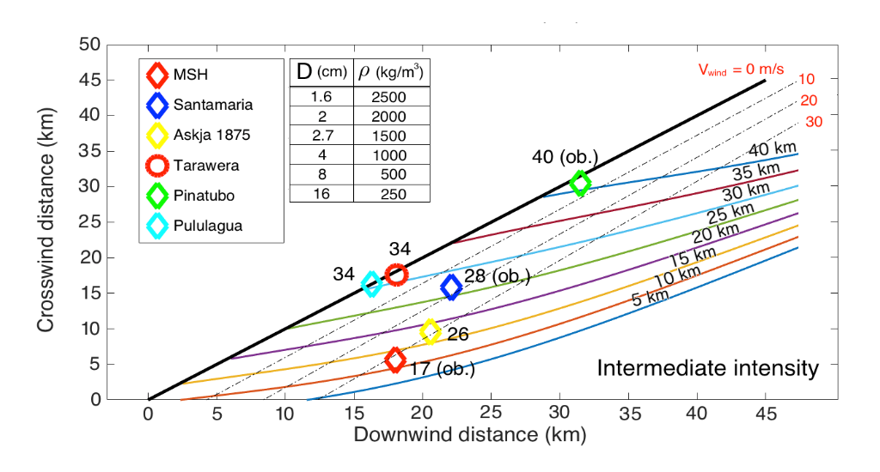

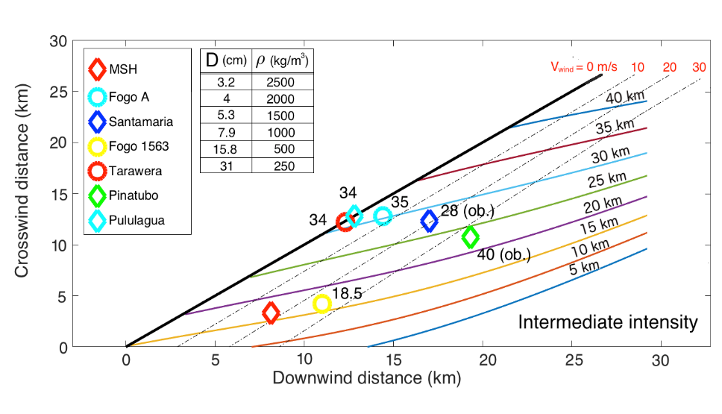

***Figure 1:*** *Nomograms of Rossi et al. (2018) to calculate plume height*

*based on particle diameters of 1.6 and 3.2 cm and a density of 2500 kg/m3.*

Calculate the plume height (km) and wind speed (m/s) as an average value of the results obtained from the different plots considered. Please also indicate the associated variation (i.e. ±(max-min)/2).

🡪Make sure to subtract the average height of sampling from the height obtained with the nomograms in order to derive the height above the vent (i.e. vent height – sampling height)

**2.** The **mass eruption rate** (MER, kg/s) can be related to the plume height above the vent (H, km) using the formula of Wilson and Walker (1987):

 (1)

The DRE **volumetric flow rate** (; m3/s) can be derived with the equation of Mastin et al. (2009) (with H expressed in km above the vent):

 (2)

 can be converted in MER based on a DRE density of 2500 kg/m3.

In order to account for the effect of wind, the MER can be calculated from H above the vent (in m) with the formula of Degruyter and Bonadonna (2012):

****(3)

assuming  = 0.0156 s-1 (average buoyancy frequency across the plume height),  = 8.7 m s-1 (average wind velocity across the plume height),  = 1.2259 kg m-3 (density of the atmosphere), = 45.6525 m s-2 (reduced gravity),  = 0.1 (radial entrainment coefficient) and  = 0.5 (wind entrainment coefficient). Notice that the average wind speed along the plume () is smaller than the wind speed that you have derived with the method of Rossi et al. (2018), which is the maximum wind speed at tropopause.

Calculate the MER using the average value of plume height **above the vent** obtained from previous exercise and the three formulas 1), 2) and 3). Discuss the difference.

**PART II: Erupted volume and eruption classification**

**Objective**: determination of the volume of erupted tephra based on the method of Pyle (1989) and of Bonadonna and Houghton (2005) and classification of the eruption using the method of Pyle (1989)

**1.** Several approaches exist for the calculation of the volume. Here you will use the exponential method with one segment (Pyle 1989) and the power-law method (Bonadonna and Houghton 2005). Figure 2 shows the isopach map for Layer 3, and figure 3 shows the area1/2 vs. thickness plot, with the fits of the different approaches.

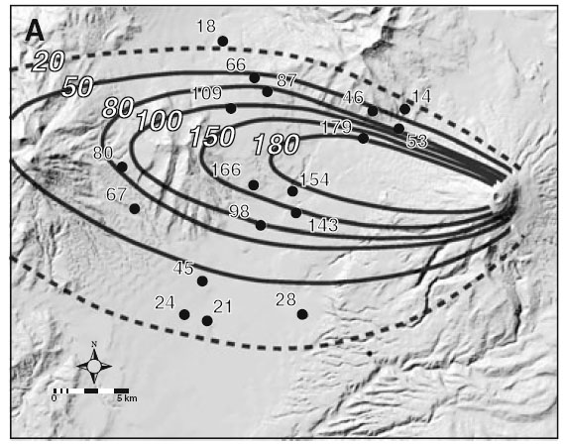

***Figure 2:*** *Isopach map (cm) for Layer 3.*

***Figure 3:*** *Thickness vs. square root of area.*

*Exponential method, 1 segment (Pyle 1989)*

The exponential fit can be described by the following equation:

 (4)

The expression of the volume integral is given by:

, (5)

where *T0* and *bt* are the maximum thickness (intercept) and half-distance thickness respectively, with:

, (6)

where *-k* is the slope of the line segment (i.e. exponent of the equation for the exponential best fit). k is a positive value.

*Power-law method (Bonadonna and Houghton 2005)*

The Power-Law fit can be described by the following equation:

. (7)

The expression of the volume integral is given by:

. (8)

where  and  are the power-law constant and exponent in Eq. (7). C and B are two constants of integration. Here, fix B to 4.6 km, and calculate the volumes with C = 100 km and C = 500 km.

Determine the volume (in km3) using both the exponential method and the power-law method (be careful with units: you need to convert both To and Tpl from “cm” to “km”!)

**2.** Determine the VEI of Layer 3 with figure 4

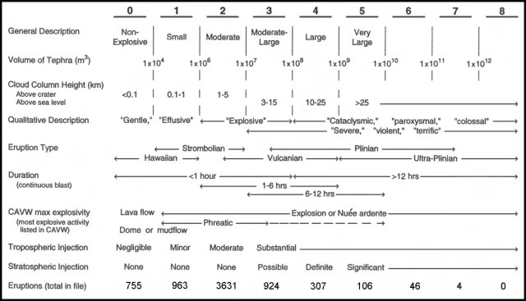

***Figure 4:*** *Boundary parameters for VEI classes (Newhall and Self 1982).*

**3.** Considering a density of the deposit of 700 kg/m3, calculate the eruption duration (in hours and minutes) using the 3 values of volume obtained in exercise 1 Part 2 and the MER obtained with the method of Degruyter and Bonadonna (2012). Discuss the results.

**4.** Using the value of bt calculated in eq. 5 and a value of bc of 2.8 km, use figure 5 and the method of Pyle (1989) to classify the eruption associated with Layer 3.

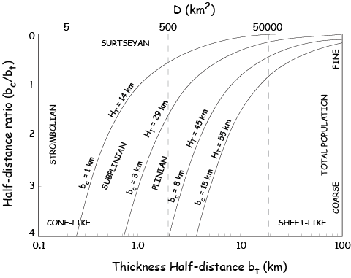

***Figure 5:*** *Classification scheme of Pyle (1989).*

**References:**

Carey SN, Sparks RSJ (1986) Quantitative models of the fallout and dispersal of tephra from volcanic eruption columns. Bulletin of Volcanology 48:109-125

Rossi E, Bonadonna C, Degruyter W (2018) A new strategy for the estimation of plume height from clast dispersal in various atmospheric and eruptive conditions. Earth and Planetary Science Letters 505:1-12 <https://www.sciencedirect.com/science/article/pii/S0012821X18305958?via%3Dihub>

Degruyter W, Bonadonna C (2012) Improving on mass flow rate estimates of volcanic eruptions, Geophysical Research Letters

Mastin, L.G., M. Guffanti, R. Servranckx, P. Webley, S. Barsotti, K. Dean, A. Durant, J.W. Ewert, A. Neri, W.I. Rose, D. Schneider, L. Siebert, B. Stunder, G. Swanson, A. Tupper, A. Volentik, C.F. Waythomas (2009) A multidisciplinary effort to assign realistic source parameters to models of volcanic ash-cloud transport and dispersion during eruptions. Journal of Volcanology and Geothermal Research, 186, Issues 1–2, 10–21.

Newhall CG, Self S (1982) The volcanic explosivity index (VEI)-An estimate of explosive magnitude for historical volcanism. J Geophys Res 87:1231–1238

Pyle, DM (1989) The thickness, volume and grainsize of tephra fall deposits. Bulletin of Volcanology 51(1):1-15

Wilson L, Walker GPL (1987) Explosive volcanic-eruptions .6. Ejecta dispersal in plinian eruptions - the control of eruption conditions and atmospheric properties. Geophysical Journal of the Royal Astronomical Society 89(2):657-679