**Thursday 25/10 afternoon exercise: Calculating flow properties of magma in the conduit**

This exercise is an introduction to fluid dynamics modeling of magma flow within a volcanic conduit during a steady-state eruption. We will use the ‘Conflow’ model to compare different flow properties of three magmas during ascent. This model was developed by Larry Mastin and Mark Ghiorso and available at <https://vhub.org/resources/453/about>

Software Installation

Download CONFLOW.zip from the Exercise 3b Thursday 26 afternoon folder on Chamilo. Also download and read the manual (titled ‘of2000—0209’) within the same folder.

Open the downloaded CONFLOW.zip file and drag the CONFLOW folder to the D: drive. Open it and install it by running Setup.exe. Install this to the D: drive also when prompted.

In the Windows Start Menu, click to run Conflow 1.0.5

Running Conflow

The window below will open. Take some time to familiarise yourself with the options. Specific Melt Compositions are already included for a number of magmas, different ones can be selected in the drop-down box. Note how the different magmas plot on the TAS diagram.

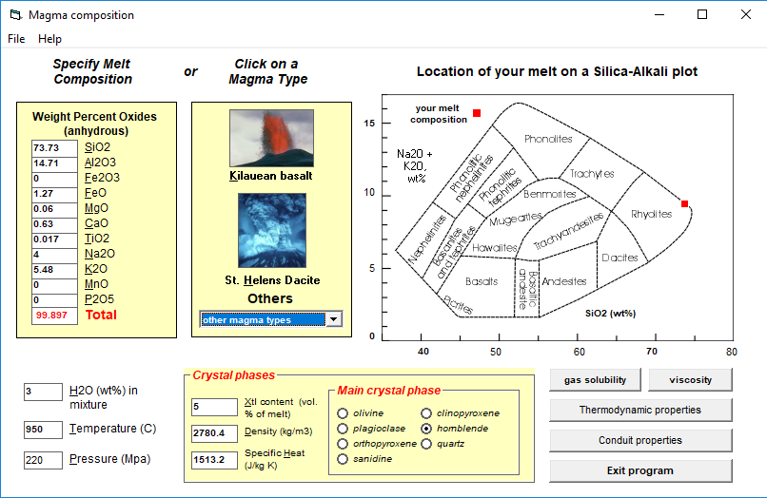

The three magmas we will look at in this exercise are:

1. 1783 Laki tephra
2. 79AD Vesuvius white pumice
3. 550 BP Inyo Rhyolite

To run the model, follow these steps:

1. Select the 1783 Laki tephra from the drop-down box.
2. Click the ‘**Conduit properties**’ button. Make sure conduit diameter is 10m, input pressure is 220 MPa and depth is 8000 m.
3. In the Input Properties window which opens, click the ‘**Browse**’ button and save the output file as 1783Laki.txt to your D: drive.
4. Click the ‘**Run model**’ button. If prompted in the window type y and Enter. Do not close the window once the model is complete.
5. The output can be viewed immediately by clicking the ‘**view output**’ button on the Input Properties window. Clicking the ‘**Plot**’ button will show plots of certain variables.

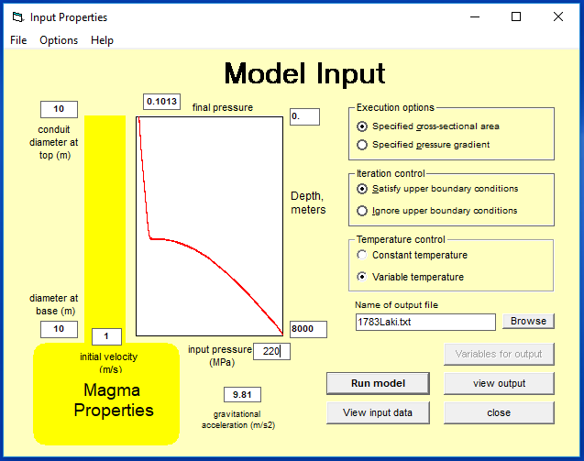

To run the other magmas, close all windows except the main one then select the new magma composition and repeat the above steps, making sure to rename the output file appropriately each time.

*** Make sure the H2O wt%, Temperature and Pressure are the same as the table below ***

|  |  |  |  |
| --- | --- | --- | --- |
|  | **79AD Vesuvius** | **550 BP Inyo Rhyolite** | **1783 Laki Tephra** |
| **H20 (wt%)** | 2.9 | 3.0 | 0.65 |
| **Temperature (°C)** | 875 | 950 | 1140 |
| **Pressure (MPa)** | 26 | 26 | 26 |

The output files can be read in Excel by first running Excel then opening the text file through the File menu (you may need to select all file types to see it). When opening, tick ‘Delimited’ then Next, then tick the ‘Space’ box and Finish. Scroll down to your data and correct the headings of your variables (the units are incorrectly considered separate columns when opening the file).

1. Looking back at your notes, list the most significant physical properties of magma and how they change during ascent.

From the modeling of the 3 magma ascents, fill in the table below and answer the two questions:

|  |  |  |  |
| --- | --- | --- | --- |
| **Magma** | **Main Crystal Phase** | **Viscosity**  **(Pa s)** | **Approx. Fragmentation Depth (m)** |
| **79AD Vesuvius** |  |  |  |
| **550 BP Inyo Rhyolite** |  |  |  |
| **1783 Laki Tephra** |  |  |  |

1. How does the velocity profile change over the depth of the conduit for each magma? What processes are driving these velocity changes?
2. Are the magmas fragmenting during ascent? If so, is there a difference in the depth of fragmentation between the three magmas? Why?

Include with these answers combined plots for each of the 4 variables output (plotting the data first will make it easier to answer these questions). Include legends and titles for axes.

Larry Garver Mastin (2011), "Conflow 1.0.5," https://vhub.org/resources/453. Mastin, L. (2002) Insights into volcanic conduit flow from an open-source numerical model. Geochemistry, Geophysics, Geosystems. Vol 3, Number 7.