# **Exercise: Controls on the viscosity of a magma**

In this exercise we will calculate magma viscosities to investigate how viscosity changes with volatile content, temperature, SiO2 content and crystallinity.

You are given an Excel file with the chemical composition of eruptive material from 9 different eruptions. Compositional data for both the bulk rock and groundmass (equivalent to the melt) are given. Two models for calculating viscosity are provided which you will need to use to complete the table on the following page and answer the questions.

1. Using the TAS diagram below and the spreadsheet titled “Viscosity Exercise Spreadsheet”, plot and list in the table on the first page the bulk rock composition for each eruption.

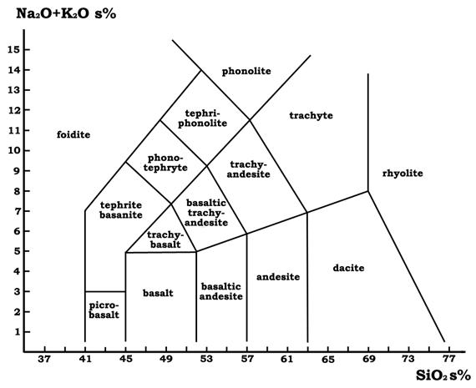

|  |  |  |  |  |  |  |  |
| --- | --- | --- | --- | --- | --- | --- | --- |
| **Eruption** | **Bulk rock**  **composition** | **T**  **(°C)** | **Crystallinity**  **(volume fraction)** | **Max H2O (wt.%)** | **Bulk rock viscosity**  **(Log Pa s)** | **Melt viscosity**  **(Log Pa s)** | **Viscosity including crystallinity**  **(Log Pa s)** |
| Fuego 1974 |  | 1030 | 0.40 | 3.6 |  |  |  |
| Vesuvius 1906 |  | 1050 | 0.40 | 2.0 |  |  |  |
| Astroni-U6 |  | 840 | 0.06 | 2.0 |  |  |  |
| Agnano Monte Spina-B1 |  | 820 | 0.30 | 2.0 |  |  |  |
| Ruapehu 1996 |  | 1100 | 0.42 | 2.0 |  |  |  |
| Mt Spurr Aug 1992 |  | 950 | 0.32 | 2.0 |  |  |  |
| Mt. St. Helens 18/05/1980 |  | 950 | 0.15 | 3.3 |  |  |  |
| Cordón Caulle 2011 – Unit I |  | 900 | 0.05 | 2.4 |  |  |  |
| Askja 1875 phase D |  | 1030 | 0.05 | 3.0 |  |  |  |

1. Using the Compositional Data and Viscosity Model worksheets, enter the bulk rock composition data for each of the eruptions. Fill in the Bulk rock viscosity column in the table. You may need to change the temperature to the value given.
2. Repeat the viscosity calculations for the Groundmass data and fill in the Melt viscosity column. Use the wt.% H2O provided as a maximum value and 0.5wt.% H2O as a minimum to provide a range.
3. Using the Crystallinity Model worksheet, calculate the viscosity when the crystal fraction is also considered (add the appropriate value to your melt viscosity value). Briefly comment on the overall differences between viscosities and why these exist.
4. Using the Ruapehu 1996 bulk rock composition data, plot the viscosity for temperatures from 700°C to 1250°C (use increments of 50°C). Describe the role of temperature on magma viscosity.
5. Using the Ruapehu 1996 bulk rock composition data, plot the viscosity for volatile content of 0.5wt.% H2O to 2.0wt.% H2O (use increments of 0.25wt.%). Describe the role of volatiles on magma viscosity.