AI DATA ANALYTICS LAYER FOR SURVEILLANCE SYSTEMS USING EDGE AI FOR ENERGY MANAGEMENT SYSTEMS
PHASE I REPORT
Submitted by
PAUL JEY SANJITH J (3122233001069)
OVIYAN P S (3122233001067)
THIRSNA S (3122233001309)

in partial fulfillment for the award of the degree of
BACHELOR OF ENGINEERING
in
ELECTRICAL AND ELECTRONICS ENGINEERING

Department of
Electrical and Electronics Engineering
Sri Sivasubramaniya Nadar College of Engineering
(An Autonomous Institution, Affiliated to Anna University)
Rajiv Gandhi Salai (OMR), Kalavakkam - 603 110
NOVEMBER 2026
Sri Sivasubramaniya Nadar College of Engineering
(An Autonomous Institution, Affiliated to Anna University)
BONAFIDE CERTIFICATE
Certified that this project titled “AI DATA ANALYTICS LAYER FOR SURVEILLANCE SYSTEMS USING EDGE AI FOR ENERGY MANAGEMENT SYSTEMS” is the bonafide work of “Paul Jey Sanjith J (3122233001069), Oviyan P S (3122233001067) and Thirsna S (3122233001309)”, who carried out the project work under my supervision.
Certified further that to the best of my knowledge the work reported herein does not form part of any other thesis or dissertation on the basis of which a degree or award was conferred on an earlier occasion on this or any other candidate.

SIGNATURE | SIGNATURE
Dr. V. RAJINI | Dr. RAJESH PANDA
HEAD OF THE DEPARTMENT | SUPERVISOR
Professor and Head | Assistant Professor
Department of Electrical and Electronics Engineering | Department of Electrical and Electronics Engineering
SSN College of Engineering | SSN College of Engineering
Kalavakkam - 603 110 | Kalavakkam - 603 110
Submitted for project viva-voce examination held on ...............................
EXTERNAL EXAMINER | INTERNAL EXAMINER
ABSTRACT
Machines in small and medium machining shops keep drawing power long after they stop cutting. Pumps, fans, lights and compressors run through breaks, material waits and sometimes whole nights. This project develops an edge artificial intelligence layer that uses existing surveillance cameras to detect this waste and act on it, while keeping all video on the device.
In the first phase of the work, an edge node was built on an NVIDIA Jetson Nano running DeepStream with a TensorRT-optimised ResNet10 person detector. The node turns camera frames into a filtered person count and publishes it to a live dashboard. Following feedback from industry experts, the decision layer was then extended from an office room to a manufacturing shop. Operator presence in a region of interest at each machine is combined with machine activity from a current transformer clamp, and a four-state machine moves a machine to standby only when it is both idle and unattended, with a further deep standby for machines that are safe to power down. The same signals control zone lighting, ventilation fans, the conveyor and the compressor.
The electrical effect was evaluated with a stochastic simulation of a reference shop with ten CNC machining centres working two shifts, using the Tamil Nadu HT-I tariff of Rs 7.50 per kWh and Rs 608 per kVA per month. Over 1,000 simulated days the mean energy saving was 8.5 %, with 90 % of days between 6.6 % and 10.6 %, corresponding to 45,295 kWh, Rs 3.47 lakh and 32.2 tonnes of CO2 per year. More than half of the saving came from loads other than the machines. Maximum demand was almost unchanged, so the benefit is a reduction in energy rather than in peak demand. A timer study showed that a three-minute standby timer gives both a higher saving and fewer nuisance standbys than longer timers close to the length of a tea break. The complete installation pays back in about 3.3 months. A measurement and verification plan is proposed for validating these savings on a working shop floor.
Keywords: edge AI, Jetson Nano, idle energy, machine tools, occupancy detection, MSME, energy management, demand charge
ACKNOWLEDGEMENT
We express our sincere gratitude to the management of Sri Sivasubramaniya Nadar College of Engineering for providing the facilities for this project.
We are thankful to Dr. S. Radha, Principal, Sri Sivasubramaniya Nadar College of Engineering, for the support and encouragement extended to us throughout our course of study.
We thank Dr. V. Rajini, Professor and Head, Department of Electrical and Electronics Engineering, for her encouragement and support throughout this work.
We are deeply grateful to our project guide, Dr. Rajesh Panda, Assistant Professor, Department of Electrical and Electronics Engineering, for his guidance and encouragement at every stage of the project.
We thank the project coordinators of the department for organising the reviews and for their timely guidance. We also thank the review panel, the laboratory staff, and our families and friends for their constant support.
PAUL JEY SANJITH J
OVIYAN P S
THIRSNA S
TABLE OF CONTENTS
CHAPTER NO. | TITLE | PAGE NO.
 | ABSTRACT | iii
 | LIST OF TABLES | ix
 | LIST OF FIGURES | x
 | LIST OF SYMBOLS AND ABBREVIATIONS | xi
1 | INTRODUCTION | 1
 | 1.1 GENERAL | 1
 | 1.2 ENERGY USE IN INDIAN MANUFACTURING | 2
 | 1.3 IDLE ENERGY IN MACHINE SHOPS | 3
 | 1.4 NEED FOR THE STUDY | 4
 | 1.5 OBJECTIVES OF THE STUDY | 5
 | 1.6 SCOPE AND LIMITATIONS | 5
 | 1.7 ORGANISATION OF THE REPORT | 6
2 | LITERATURE REVIEW AND RESEARCH GAP | 7
 | 2.1 INTRODUCTION | 7
 | 2.2 ENERGY CONSUMPTION OF MACHINE TOOLS | 7
 | 2.3 SWITCHING IDLE MACHINES TO STANDBY | 8
 | 2.4 THERMAL AND PROCESS CONSTRAINTS | 9
 | 2.5 VISION-BASED OCCUPANCY SENSING | 10
 | 2.6 CURRENT-BASED MACHINE MONITORING | 11
 | 2.7 OTHER IDLE LOADS IN A FACTORY | 12
 | 2.8 STANDARDS AND CONTROL PATHS | 12
 | 2.9 RESEARCH GAP | 13
3 | SYSTEM ARCHITECTURE | 15
 | 3.1 OVERVIEW | 15
 | 3.2 DESIGN PRINCIPLES | 16
 | 3.3 SENSING INPUTS | 17
 | 3.4 ZONES AND REGIONS OF INTEREST | 17
 | 3.5 SIGNAL CONDITIONING | 18
 | 3.6 MACHINE STATE MACHINE | 19
 | 3.7 MULTI-LOAD ACTIONS | 21
 | 3.8 ADVISORY AND AUTOMATIC MODES | 21
 | 3.9 SAFETY CONSIDERATIONS | 22
 | 3.10 PRIVACY AND WORKER ACCEPTANCE | 22
4 | IMPLEMENTATION OF THE EDGE NODE | 24
 | 4.1 HARDWARE | 24
 | 4.2 SOFTWARE STACK | 25
 | 4.3 PIPELINE | 26
 | 4.4 LIVE DETECTION AND DASHBOARD | 27
 | 4.5 EXTENSION FOR THE SHOP FLOOR | 28
 | 4.6 PERFORMANCE CONSIDERATIONS | 29
5 | ELECTRICAL ENERGY MODELLING | 30
 | 5.1 APPROACH | 30
 | 5.2 MACHINE POWER MODEL | 30
 | 5.3 SHARED LOADS | 31
 | 5.4 OPERATIONS MODEL OF THE REFERENCE SHOP | 32
 | 5.5 BASELINE AND CONTROLLED OPERATION | 33
 | 5.6 ENERGY, DEMAND AND COST | 34
 | 5.7 PERFORMANCE INDICATORS | 35
 | 5.8 MODEL CHECKS | 35
6 | SIMULATION RESULTS AND DISCUSSION | 36
 | 6.1 OVERVIEW OF THE STUDIES | 36
 | 6.2 S1: ONE MACHINE OVER ONE SHIFT | 36
 | 6.3 S2: WHOLE SHOP CUMULATIVE ENERGY | 38
 | 6.4 S3: SAVINGS BY LOAD TYPE | 39
 | 6.5 S4: LOAD-DURATION CURVE, LOAD FACTOR AND MAXIMUM DEMAND | 40
 | 6.6 S5: MONTE-CARLO ROBUSTNESS | 41
 | 6.7 S6: SENSITIVITY ANALYSIS | 43
 | 6.8 S7: TIMER STUDY | 44
 | 6.9 S8: PAYBACK PER NODE | 46
 | 6.10 S9: GENERALITY, OFFICE AND FACTORY | 47
 | 6.11 DISCUSSION | 48
7 | ECONOMICS, STANDARDS AND DEPLOYMENT ROADMAP | 50
 | 7.1 COST OF A DEPLOYMENT | 50
 | 7.2 STANDARDS AND CONTROL PATHS | 51
 | 7.3 MEASUREMENT AND VERIFICATION PLAN | 52
 | 7.4 DEPLOYMENT ROADMAP | 53
 | 7.5 BENCH DEMONSTRATION | 54
8 | CONCLUSION AND FUTURE WORK | 55
 | 8.1 CONCLUSIONS | 55
 | 8.2 CONTRIBUTION TO SUSTAINABLE DEVELOPMENT GOALS | 56
 | 8.3 FUTURE WORK | 57
 | APPENDIX 1 MODEL ASSUMPTIONS | 58
 | APPENDIX 2 EDGE NODE PROBE AND FILTER | 60
 | APPENDIX 3 BENCH DEMONSTRATION | 62
 | REFERENCES | 63
LIST OF TABLES
TABLE NO. | TITLE | PAGE NO.
1.1 | Key figures for the Indian manufacturing context | 3
1.2 | Objectives of the project and their status | 5
2.1 | Summary of related work | 13
3.1 | Sensing inputs for machine k and zone j | 17
3.2 | Machine states, conditions, power and action | 20
3.3 | Control rules for shared loads | 21
4.1 | Edge node hardware | 24
4.2 | DeepStream pipeline elements | 26
5.1 | Power assumptions for model v2 | 31
5.2 | Events in each machine shift | 33
5.3 | Tariff and emission inputs | 34
6.1 | Mean daily saving by load type over 1,000 days | 40
6.2 | Electrical indices on the reference day | 41
6.3 | Headline results over 1,000 simulated days | 42
6.4 | Sensitivity of the annual saving (150 days per case) | 44
6.5 | Effect of the standby timer T1 (150 days per value) | 45
7.1 | Indicative cost of the installation for the reference shop | 50
7.2 | Standards and protocols relevant to deployment | 51
8.1 | Mapping to Sustainable Development Goals | 56
A3.1 | Parts for the bench demonstration | 62
LIST OF FIGURES
FIGURE NO. | TITLE | PAGE NO.
3.1 | System architecture with implementation status | 16
3.2 | Reference machining shop with zones, machine regions of interest and cameras | 18
3.3 | Machine state machine with transition conditions | 20
4.1 | Prototype bench set-up with the Jetson Nano edge node | 25
4.2 | Live person detection on the Jetson Nano | 27
4.3 | Live energy dashboard in the office configuration | 28
6.1 | Activity, operator presence and power of machine M1 over the first shift | 37
6.2 | Cumulative energy of the shop on the reference day | 38
6.3 | Energy by load type on the reference day, baseline and controlled | 39
6.4 | Load-duration curve of the shop on the reference day | 40
6.5 | Distribution of the daily energy saving over 1,000 simulated days | 42
6.6 | One-at-a-time sensitivity of the annual saving | 43
6.7 | Effect of the standby timer T1 on saving and on nuisance and false standbys | 45
6.8 | Simple payback against the number of machines covered by one node | 47
6.9 | Saving of the same edge layer in an office room and in a machining shop | 48
LIST OF SYMBOLS AND ABBREVIATIONS
SYMBOL | DESCRIPTION
a_k(t) | Activity of machine k (1 when cutting), from CT current
o_k(t) | Operator presence in the region of machine k, after filtering
n_j(t) | Person count in floor zone j
P(t) | Active power, kW
E | Energy, kWh
Δt | Simulation time step, s
T1, T2 | Standby and deep standby timers, min
MD | Maximum demand over a 15-minute interval, kVA
CD | Contract demand, kVA
PF | Power factor
LF | Load factor
IER | Idle-energy ratio
EF | Grid emission factor, kg CO2 per kWh
c_E, c_D | Energy charge (Rs/kWh) and demand charge (Rs/kVA/month)
α_u, λ_leak, β | Compressor unloaded fraction, leak demand and demand per cutting machine

ABBREVIATION | EXPANSION
BEE | Bureau of Energy Efficiency
CEA | Central Electricity Authority
CNC | Computer Numerical Control
CT | Current Transformer
DPDP | Digital Personal Data Protection
FP16 | 16-bit floating point
HT | High Tension
HVAC | Heating, Ventilation and Air Conditioning
IPMVP | International Performance Measurement and Verification Protocol
MQTT | Message Queuing Telemetry Transport
MSME | Micro, Small and Medium Enterprises
NILM | Non-Intrusive Load Monitoring
OPC UA | Open Platform Communications Unified Architecture
PAT | Perform, Achieve and Trade
PyDS | Python bindings for DeepStream
ROI | Region of Interest
TNERC | Tamil Nadu Electricity Regulatory Commission
VMC | Vertical Machining Centre

CHAPTER 1

INTRODUCTION

1.1 GENERAL
Walk through any small machining unit in an industrial estate around Chennai during the lunch break and you will hear it before you see it. The operators have gone to the canteen, but most of the machines are still humming. Coolant pumps circulate oil that nobody is using, chip conveyors crawl along with nothing on them, the hydraulic power packs hold pressure, and the high-bay lights over the bays stay on. The same thing happens, in smaller doses, many times in every shift: while an operator walks to the stores for raw material, while a crane is awaited, while a setter checks a drawing, or while a breakdown waits for the maintenance fitter.
None of this energy goes into making a part. It is the cost of keeping a machine ready. In a large plant with an energy cell, some of it is managed by habit and by maintenance checklists. In a micro, small or medium enterprise (MSME), it is usually nobody's job.
This project started with a narrower question. In the first three reviews we built an edge computing node that watches a camera feed, counts people, and turns that count into a stable occupancy signal for building energy management. We applied it to an office room and modelled the effect on air conditioning and lighting. At Review 3 the industry experts on the panel accepted the work but pushed it in a new direction. Factories, they said, use far more electricity than offices, and idle machines waste a large share of it. They also asked us to use the camera intelligence for more than air conditioning. This report is our response to that feedback. It keeps the hardware we built, extends the decision layer to a machining shop, and quantifies the result in electrical terms.

1.2 ENERGY USE IN INDIAN MANUFACTURING
Industry is the largest consumer of electricity in India. Data from the Central Electricity Authority show that industrial consumers accounted for about 42 % of total electricity consumption in 2023-24, well ahead of the domestic sector at about 24 % (CEA 2025a). A large part of this demand sits in MSME clusters. According to TERI, roughly 200 energy-intensive MSME clusters account for about a quarter of the country's energy use, with an estimated saving potential of around 15 %.
The large energy-intensive plants are covered by the Perform, Achieve and Trade (PAT) scheme of the Bureau of Energy Efficiency, which has delivered verified savings; the first cycle alone saved 8.67 Mtoe against a target of 6.69 Mtoe. Most machining MSMEs, however, are far too small to be designated consumers under PAT. They buy power on high-tension (HT) or low-tension industrial tariffs, they rarely have sub-metering, and the person who pays the electricity bill is often the owner, who has no way of knowing which machine consumed what.
The tariff structure matters for this work. In Tamil Nadu, the HT-I industrial tariff that applies from July 2025 has two parts: an energy charge of Rs 7.50 per kWh and a demand charge of Rs 608 per kVA per month, billed on the higher of the recorded maximum demand and 90 % of the contract demand (TNERC 2025). A saving in kWh therefore reduces the bill directly, while a saving in demand reduces it only if it lowers the monthly peak.
Table 1.1 Key figures for the Indian manufacturing context
Quantity | Value | Source
Industry share of electricity consumption, 2023-24 | about 42 % | CEA (2025a)
Share of line energy used for machining (automotive line) | 14.8 % | Gutowski et al. (2005)
Compressed air share of plant electricity | about 10 %, over 30 % at some sites | US DOE (2003)
Tamil Nadu HT-I tariff from July 2025 | Rs 7.50/kWh and Rs 608/kVA/month | TNERC (2025)
Grid emission factor, 2024-25 | 0.710 kg CO2/kWh | CEA (2025b)

1.3 IDLE ENERGY IN MACHINE SHOPS
A computer numerical control (CNC) machine is not a single load. Besides the spindle and feed drives that actually remove metal, it carries a set of auxiliary units: coolant pumps and chillers, a hydraulic unit, lubrication, a chip conveyor, cabinet cooling fans, the control system and lighting. Many of these run at near constant power whenever the machine is switched on, regardless of whether it is cutting.
This is why the energy that actually goes into cutting is often a small share of the total. A widely cited survey of an automotive machining line found that only 14.8 % of the input energy was used for the machining itself, with the remaining 85.2 % going to auxiliary and constant loads (Gutowski et al. 2005). Later reviews report that idle, standby and auxiliary states can take up to 80 % of the energy of a machine tool, depending on how busy the machine is. The lower the utilisation, the larger the share of energy that is spent simply waiting.
Machines are only part of the picture. Compressed air typically uses about 10 % of the electricity in an industrial facility, and much more at some sites (US DOE 2003). Lighting, extraction fans and conveyors in a shop are usually switched on at the start of the shift and switched off at the end, whether or not anyone is in the bay.

1.4 NEED FOR THE STUDY
Switching idle machines to standby is not a new idea. Several scheduling studies have shown that turning off under-used machines during long idle periods saves a significant amount of energy (Mouzon et al. 2007), and machine builders now ship standby modes. The difficulty on a real shop floor is deciding when to use them. A timer that sends a machine to standby after a fixed time without a part cannot tell the difference between an operator who has walked away for twenty minutes and an operator who is standing at the machine measuring a component. The first case is waste. The second is normal work, and interrupting it annoys the operator, who will then simply disable the feature.
Most Indian factories already have CCTV cameras on the shop floor for security. If the video from those cameras can be turned into a reliable signal of whether an operator is at a machine, the standby decision can be made with context, and the same signal can also drive lights, fans, conveyors and the compressor. Because the processing happens on a small edge computer next to the camera, no video has to leave the premises, which addresses the privacy concern that workers and unions rightly raise about camera analytics.
What was missing in our earlier work, and in the literature we reviewed, was a quantified answer to three questions. How much energy would such a system actually save in a typical Indian machining shop? Would it reduce the electricity bill, including the demand charge? And can it be done safely, without stopping machines that should not be stopped?

1.5 OBJECTIVES OF THE STUDY
The objectives of the project, and their status at the time of writing, are listed in Table 1.2. We use three status labels throughout the report. IMPLEMENTED means built and running on our hardware. MODELLED means evaluated by simulation with stated assumptions. FUTURE means designed but not yet built.
Table 1.2 Objectives of the project and their status
No. | Objective | Status
1 | Detect people in real time on a Jetson Nano edge node | IMPLEMENTED
2 | Convert detections into a stable presence signal | IMPLEMENTED
3 | Extend sensing to machine and zone regions with current-based activity | MODELLED
4 | Design a safe machine state machine with advisory and automatic modes | MODELLED
5 | Quantify energy, cost (energy and demand), demand, load factor and CO2 for a reference shop | MODELLED
6 | Test robustness, sensitivity and the choice of standby timer | MODELLED
7 | Define the integration and measurement path | FUTURE

1.6 SCOPE AND LIMITATIONS
The reference case for the study is a small machining shop with ten CNC vertical machining centres, a compressor, a conveyor line, high-bay lighting and extraction fans, working two shifts a day. The office room studied in Review 3 is retained as a second application to show that the same edge layer works in both settings.
Thermal processes such as furnaces, heat treatment and injection moulding barrels are outside the automatic control scope. They may receive advisory alerts, but the system never switches them. The edge node may request standby; it never starts a machine.
The person detector, filter and dashboard run on real hardware. The machine-level control and all energy and cost figures in this report are modelled. We have not measured savings on a working shop floor, and the report does not claim measured savings anywhere.

1.7 ORGANISATION OF THE REPORT
Chapter 2 reviews the literature on machine tool energy states, switch-off policies, vision-based occupancy sensing and current-based machine monitoring, and identifies the research gap. Chapter 3 presents the system architecture, the machine state machine and the rules for shared loads. Chapter 4 describes the edge node as built. Chapter 5 develops the electrical model of the reference shop, including the tariff and demand calculation. Chapter 6 presents and discusses the simulation results. Chapter 7 covers the economics, the relevant standards and a deployment roadmap. Chapter 8 concludes the report and outlines future work.
CHAPTER 2

LITERATURE REVIEW AND RESEARCH GAP

2.1 INTRODUCTION
The problem sits at the meeting point of three bodies of work that rarely cite each other. Production engineers have studied how much energy machine tools use in different operating states and when it pays to switch them off. Building researchers have shown that cameras and deep learning can detect occupants and save HVAC energy. Signal processing researchers have shown that current measurements can reveal what a machine is doing without opening its controller. This chapter reviews each strand in turn, then looks at the other idle loads in a factory and at the standards that govern control and verification. It closes with the gap that this project addresses.

2.2 ENERGY CONSUMPTION OF MACHINE TOOLS
Gutowski, Dahmus and Thiriez (2006) collected the specific electrical energy requirements of a wide range of manufacturing processes and showed that the energy per unit of material processed is not constant, as many life cycle tools assume. It falls steeply as the process rate rises, because a large part of the power drawn is needed just to keep the equipment running. In an earlier survey of production systems in Japan, Europe and the United States, Gutowski et al. (2005) reported that in an automotive machining line only 14.8 % of the energy reached the actual machining process.
Kara and Li (2011) turned this observation into an empirical model. They expressed the specific energy consumption of turning and milling as a constant plus a term inversely proportional to the material removal rate. The second term represents the fixed power of the machine spread over its output. When the material removal rate drops to zero, as it does whenever the machine is waiting, the whole fixed power becomes waste.
Li, Zein, Kara and Herrmann (2011) looked specifically at this fixed energy consumption, which keeps the machine in a ready state. They pointed out that the behaviour of machine tools in standby had not been studied in depth and evaluated improvement strategies on six machines covering different processes. The keynote paper by Denkena et al. (2020) in the CIRP Annals later surveyed machine-side and process-side measures for metal-cutting machine tools, from efficient drives and hydraulics to operating strategies, and named retrofitting of existing machines as an open research question.
Some idea of the magnitudes comes from industry. In a worked example published by Heidenhain (2011), a machining centre milling an aluminium housing drew a mean total power of about 13 kW during roughing, of which about 5.1 kW was needed only for conditioning and pumping the cooling lubricant. Mori et al. (2011) at DMG Mori showed that changing cutting conditions and synchronising spindle acceleration with the feed axes can reduce the energy per part. These are machine-side measures. They make a running machine more efficient but do nothing about a machine that is switched on and not running.

2.3 SWITCHING IDLE MACHINES TO STANDBY
Mouzon, Yildirim and Twomey (2007) were among the first to treat idle energy as a scheduling problem. They showed that a significant amount of energy can be saved when non-bottleneck machines, which are under-used by definition, are turned off during idle periods that are long enough. They also pointed out the catch: switching a machine off and on again costs energy and time, so a short idle period is better left alone. The break-even idle time depends on the machine.
Squeo, Frigerio and Matta (2019) refined this idea for CNC machining centres. Instead of switching the whole machine off, their policy moves individual components through several sleeping states as the idle time grows, using time thresholds. On a five-axis machining centre this gave significantly better savings than single-state policies. The structure of their policy, with a short threshold for a light standby and a longer one for a deeper state, is close to what we adopt in Chapter 3.
All of these policies decide on the basis of time since the last part. They assume that a machine with no part is idle. They have no way of knowing whether an operator is setting up the next job, inspecting a part, or has left the area.

2.4 THERMAL AND PROCESS CONSTRAINTS
The main argument against aggressive switch-off is thermal stability. Spindles, ball screws and machine structures expand as they warm up, and a precision machine is usually run for a warm-up period before accurate work begins. Fraunhofer IPK reports that up to 75 % of the geometric errors of machine tools can be traced to thermally induced displacement. Experiments reported at euspen have shown that putting the spindle cooling unit into standby during non-machining periods saves energy but also shifts spindle temperature and displacement, so the saving has to be weighed against accuracy.
For the design of an automatic system, this means that not every machine should be treated alike. A general-purpose machine making roughing cuts can tolerate a deeper standby. A precision machine may only tolerate a light standby with thermal control still running, and should be left to a human decision. Process equipment such as furnaces or injection moulding barrels should not be switched by an external system at all.

2.5 VISION-BASED OCCUPANCY SENSING
The building energy literature provides strong evidence that cameras can sense occupants reliably. Tien et al. (2021) trained a Faster R-CNN model to detect both occupancy and equipment use from a camera in an office. They reported an overall accuracy of 97.32 % for occupancy and 80.80 % for equipment use, and estimated through building simulation that the internal gains assumed in a schedule-based model were substantially higher than the detected ones. Choi et al. (2022) developed deep vision-based occupancy counting and used the counts for ventilation control, and Zhang et al. (2024) compared deep learning models for occupancy detection in buildings with high occupancy, showing a trade-off between accuracy and processing speed.
The energy effect of occupancy-based control has been measured in the field. Kong et al. (2022) ran a side-by-side experiment and reported weekly HVAC energy savings of 17 to 24 % with more than 80 % occupant satisfaction. Lin et al. (2023) evaluated an occupancy-based HVAC control system in an office building and, using a calibrated model, projected an annual whole-building saving of 6.1 %. Occupancy-based lighting control has an even longer record. A meta-analysis of 240 savings estimates from 88 studies found average savings of about 24 % for occupancy sensors (Williams et al. 2012).
The factory floor is harder than an office. Operators work close to machines and are often partly hidden by guards, fixtures or the machine itself. Work on indoor worker localisation in industrial settings has reported that a deep learning detector found a walking operator in only about two thirds of the frames. A practical system therefore needs temporal filtering and, ideally, a second sensor.

2.6 CURRENT-BASED MACHINE MONITORING
Non-intrusive load monitoring (NILM) infers the state of individual loads from current and voltage measurements. Gebbe (2019) applied it to machines in manufacturing and estimated the energy demand of individual loads from aggregate measurements with an accuracy of 85 % or better for most loads in two case studies. Suzuki, Kohmoto and Ogatsu (2017) monitored several manufacturing machines with a single current sensor using a factorial hidden Markov model, and noted that household NILM models do not transfer directly because industrial machines behave in more complex ways. Deep learning has also been used to recognise operating states of machine tools such as starting, standby and cutting from power data.
For our purposes, a current transformer (CT) clamp on each machine feeder is enough. It tells us reliably whether the machine is cutting, because spindle current rises sharply under load, but it cannot tell us whether a person is present. That is exactly the information the camera provides.

2.7 OTHER IDLE LOADS IN A FACTORY
Compressed air deserves special mention. The US Department of Energy sourcebook on compressed air systems estimates that compressed air generation takes about 10 % of the electricity in a typical industrial facility and 30 % or more at some sites, and that system improvements can save 20 to 50 % of that electricity (US DOE 2003). Leaks are a large part of the waste: a poorly maintained plant may lose 20 to 30 % of compressor output to leaks, and these leaks continue whenever the system is pressurised, including breaks and idle periods.
Lighting, extraction fans and conveyors are simple on and off loads. Their savings depend almost entirely on how often the area they serve is empty. We found no peer-reviewed figures for idle conveyor or fan energy in Indian machine shops, so these loads are modelled with stated assumptions in Chapter 5.

2.8 STANDARDS AND CONTROL PATHS
Several standards define how a system like ours would connect to real equipment and how its savings would be verified. ISO 14955-1 (2017) gives a design methodology for energy-efficient machine tools and describes their energy-using functions. PROFIenergy, a profile of PROFINET maintained by PROFIBUS and PROFINET International, lets a controller send standard pause commands so that devices enter predefined low-power modes during planned and unplanned breaks. OPC UA and Modbus TCP give vendor-neutral access to machine data and to meters, relays and drives, while MQTT 5.0 (OASIS 2019) is a lightweight publish and subscribe protocol for telemetry. On the management side, ISO 50001 (2018) defines an energy management system, ISO 50006 (2014) explains how to set baselines and energy performance indicators, and ISO 50015 (2014) covers measurement and verification of savings. These are discussed again in Chapter 7.

2.9 RESEARCH GAP
Table 2.1 summarises the main strands of related work. Switch-off policies for machine tools decide on time alone and do not know whether anyone is at the machine. Vision-based occupancy systems know where people are but have been applied almost entirely to buildings. Current-based monitoring knows what a machine is doing but not who is around it, and stops at monitoring rather than control.
Table 2.1 Summary of related work
Work | Sensing | Decision | Limitation for this problem
Mouzon et al. (2007) | Schedule and time | Switch off idle machines | No knowledge of operator presence
Squeo et al. (2019) | Time since last part | Multi-level sleep states | No knowledge of operator presence
Tien et al. (2021); Choi et al. (2022) | Camera | Building HVAC and ventilation | Applied to buildings only
Kong et al. (2022); Lin et al. (2023) | Occupancy sensors | HVAC control | Applied to buildings only
Gebbe (2019); Suzuki et al. (2017) | Current (NILM) | Monitoring only | No operator context, no control
This work | Camera regions and machine current on an edge node | Machine standby and shared loads, advisory or automatic | Modelled; field validation planned

We did not find any reported system that combines camera-based operator presence with current-based machine state on an edge device and uses the result to decide standby for machines and switching for shared loads, with an explicit safety whitelist. This project addresses that gap. Because the work is still at the modelling stage for the factory, our contribution is a complete design and a quantified estimate of its electrical effect, built on top of a working edge node.
CHAPTER 3

SYSTEM ARCHITECTURE

3.1 OVERVIEW
The system is organised in three layers, shown in Figure 3.1. The first layer is the edge node that we built and tested in Phase I: a camera feeds an NVIDIA Jetson Nano, which runs a person detector and produces a filtered person count. The second layer is new. It adds regions of interest around each machine and each floor zone, a current measurement on each machine, a state machine per machine, and a set of rules for the shared loads. This layer is modelled in the present work. The third layer covers the connections to real equipment and to metering, which are planned.
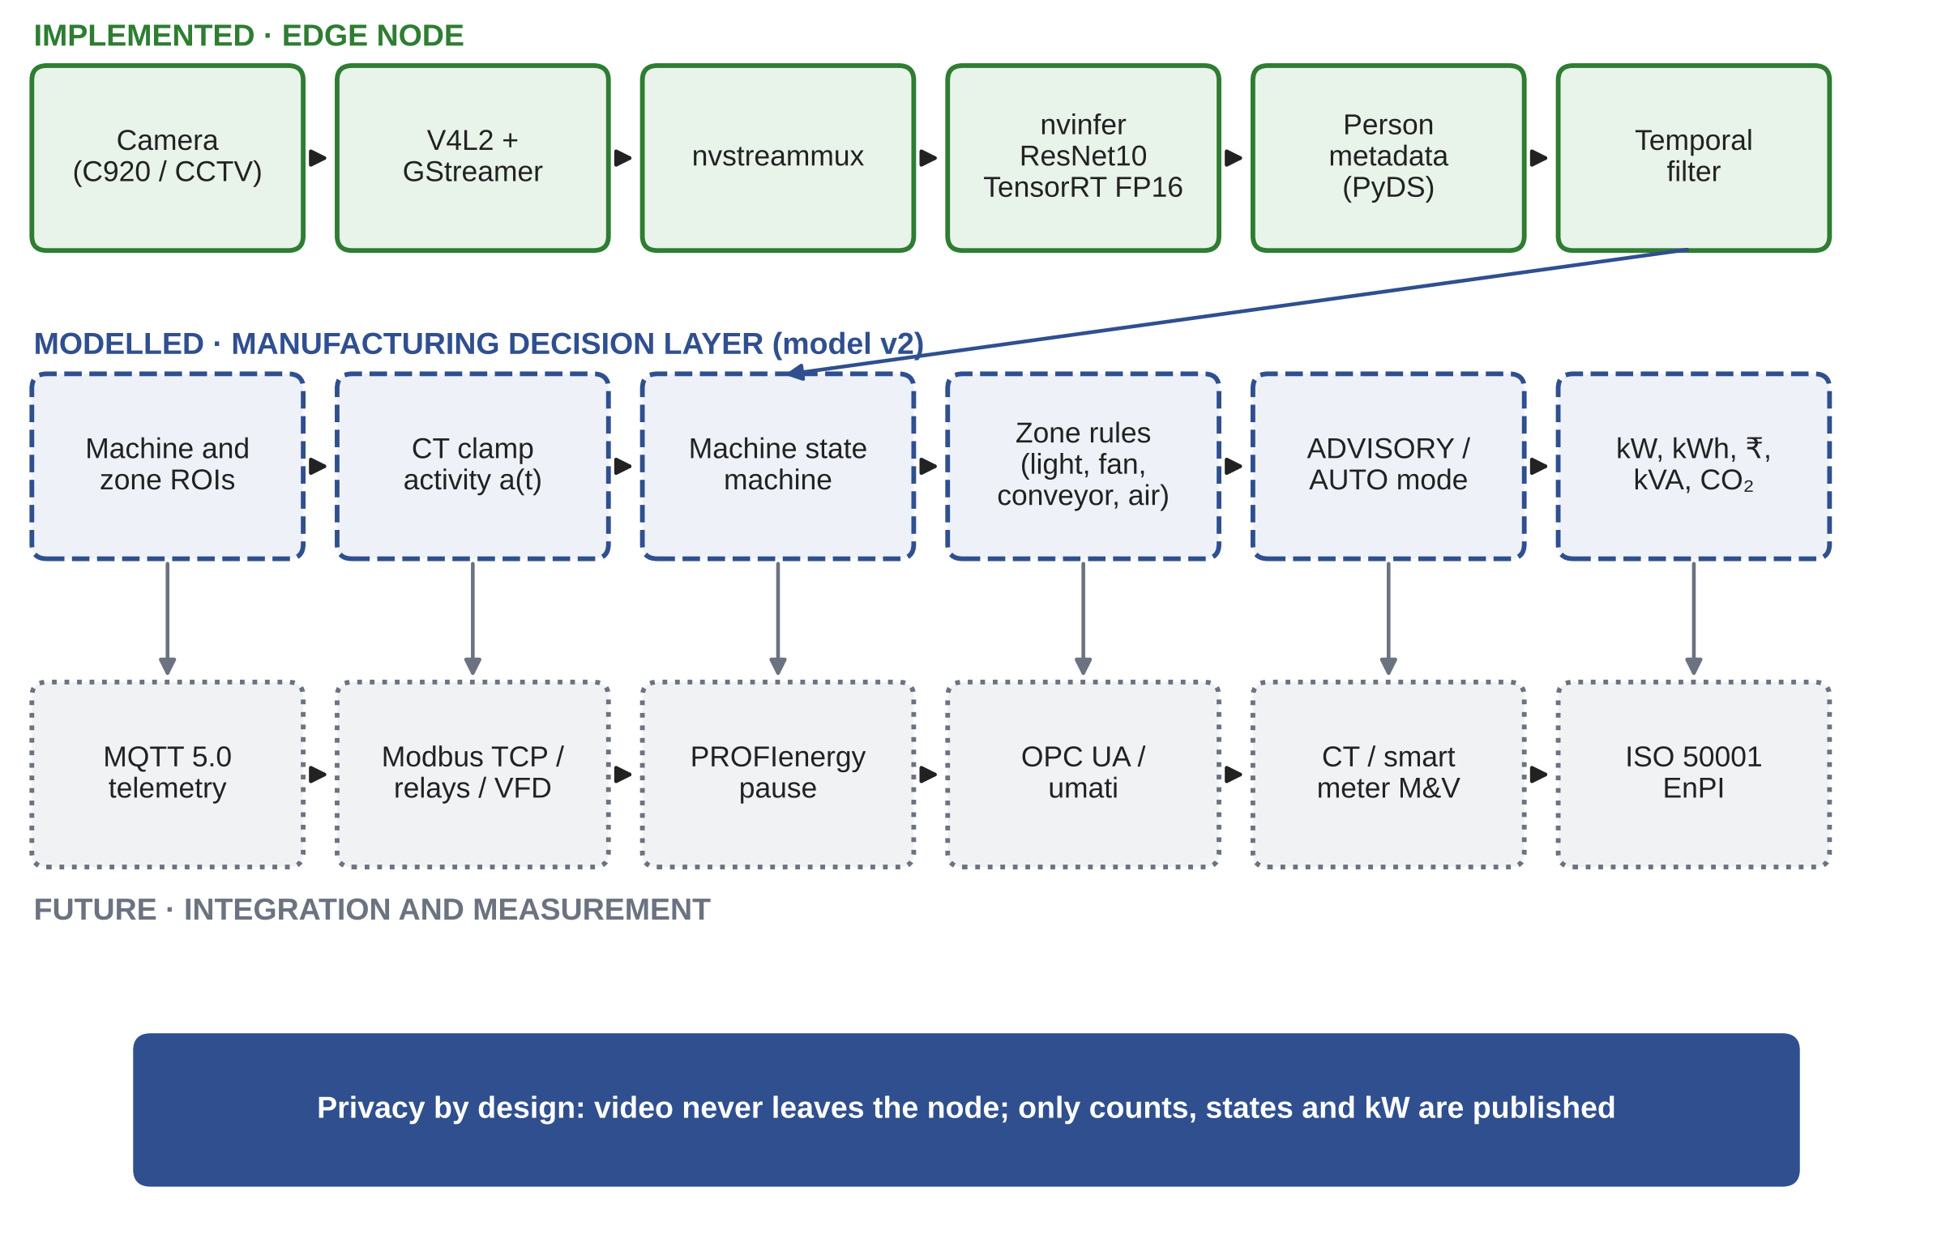
Figure 3.1 System architecture with implementation status
The most important design decision is that the hardware already built is kept and extended, not replaced. The person detector does not change when the node moves from an office to a shop floor. What changes is the interpretation of its output: instead of one count for a room, the node reports presence inside several small regions, one per machine, and a count per zone.

3.2 DESIGN PRINCIPLES
Four principles guided the design.
• Sense, do not guess. A machine is put in standby only when two independent signals agree that it is idle and unattended.
• Fail towards production. If any signal is missing or uncertain, the machine stays as it is. Saving energy must never cost output.
• Never start anything. The node may request standby or switch off a light, but restarting a machine is always an operator action.
• Keep video on the device. Only counts, states and power values leave the node.

3.3 SENSING INPUTS
Table 3.1 lists the signals used for each machine k and each zone j. The camera gives operator presence o_k(t) in the region of interest drawn in front of each machine, and a person count n_j(t) for each floor zone. A CT clamp on the supply to each machine gives the activity signal a_k(t), which is 1 when the measured current exceeds a threshold that separates cutting from idling.
Table 3.1 Sensing inputs for machine k and zone j
Signal | Meaning | Source | Status
o_k(t) | Operator present in the region of machine k | Camera, per-region person count | Detector IMPLEMENTED, regions MODELLED
a_k(t) | Machine k cutting | CT clamp current above threshold | MODELLED
n_j(t) | Persons in floor zone j | Camera, per-zone person count | Count IMPLEMENTED, zones MODELLED

The two sensors complement each other. On a machining centre with a closed enclosure, the camera cannot see whether the spindle is turning, but the current makes it obvious. On the other hand, the current is the same whether the operator is standing at the machine or has gone for tea. By combining them, the node can separate an idle machine that is attended, which is normal work, from one that is idle and abandoned, which is waste.

3.4 ZONES AND REGIONS OF INTEREST
Figure 3.2 shows the layout of the reference shop used in this study. Ten machines are arranged in three zones. Zones 1 and 2 hold six general-purpose machines, and zone 3 holds four precision machines. A fourth zone covers the aisle, stores and inspection area. Each machine has a rectangular region of interest on the floor in front of it, where the operator normally stands. With existing CCTV cameras mounted high on the columns, one camera can cover about four machines.
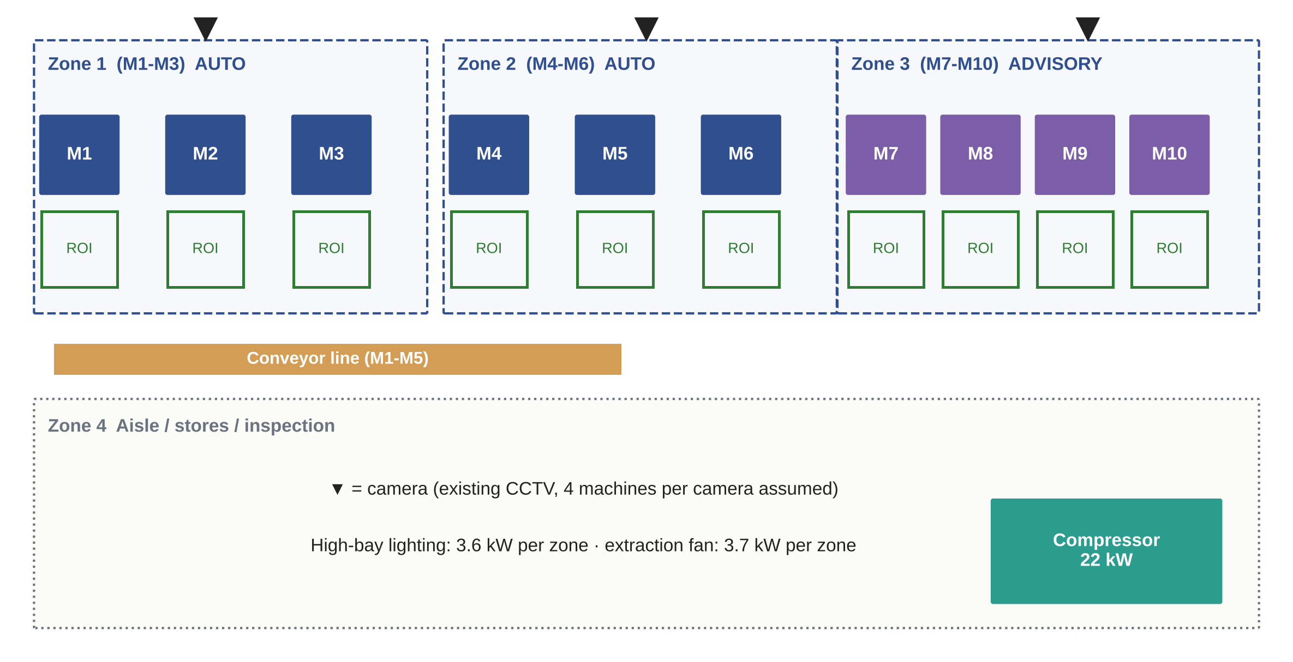
Figure 3.2 Reference machining shop with zones, machine regions of interest and cameras
In DeepStream, these regions are defined as polygons in the configuration of the nvdsanalytics plugin. For each frame, the plugin reports which detected persons have their reference point inside each region, so the probe function receives per-region counts directly.

3.5 SIGNAL CONDITIONING
Raw detections flicker. A person who turns sideways or is partly hidden behind a guard can disappear for a few frames, and a reflection can occasionally be detected as a person. In Phase I we showed that a simple asymmetric persistence filter removes almost all of this chatter: on a simulated office day it reduced the number of state changes from 2,633 to 9 and kept the room in the correct state 99.1 % of the time. The same idea is used here, with timings suited to a shop floor:
o_f : 0 → 1 after t_rise of presence; 1 → 0 after t_fall of absence (3.1)
a_f : 0 → 1 when I_k > I_th; 1 → 0 after 30 s with I_k < I_th (3.2)
Here t_rise is 10 s and t_fall is 60 s. Presence is accepted quickly, so that a returning operator is served at once, but absence is accepted only after a full minute, so that an operator who bends down or steps behind the machine is not treated as gone. For the current signal, a cycle start is accepted at once and a stop only after 30 s, so that the short pauses within a machining cycle, such as tool changes, are not mistaken for idling.

3.6 MACHINE STATE MACHINE
Each machine is described by a four-state machine, shown in Figure 3.3 and summarised in Table 3.2. In PROCESSING the machine is cutting. In IDLE-ATTENDED it is not cutting but an operator is present, for example during loading, measuring or a tool change; nothing is done. When the machine is idle and nobody is present, a timer starts. After T1 the machine enters STANDBY, in which the coolant pump, chip conveyor, hydraulic unit and work lamp are switched off while the control and thermal management stay on. If the machine remains unattended beyond T2, and only if it is on the whitelist, it moves to DEEP STANDBY, in which only the control remains powered.
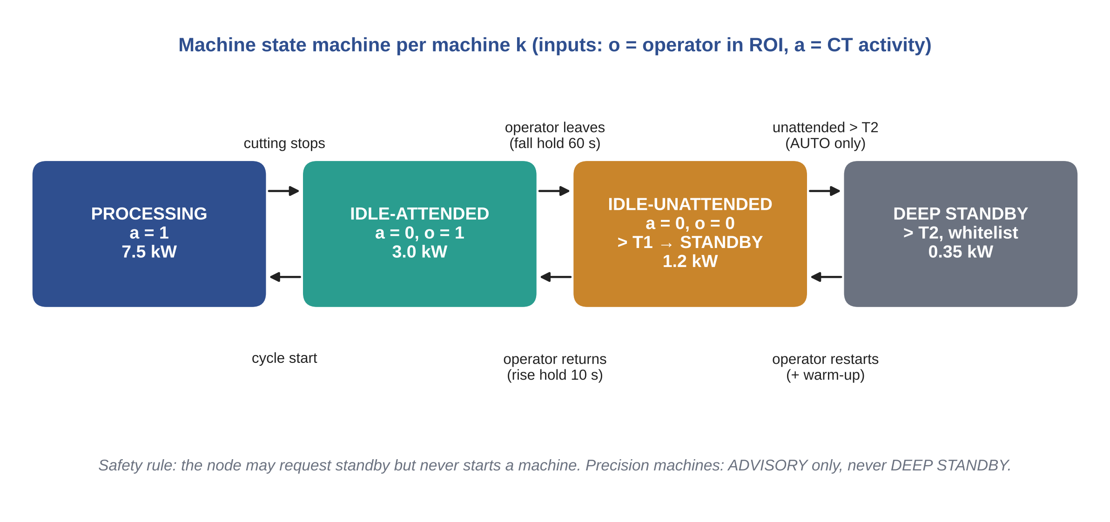
Figure 3.3 Machine state machine with transition conditions
Table 3.2 Machine states, conditions, power and action
State | Condition | Power (kW) | Action
PROCESSING | a = 1 | 7.5 | None
IDLE-ATTENDED | a = 0 and o = 1 | 3.0 | None
IDLE-UNATTENDED | a = 0 and o = 0 for more than T1 = 3 min | 1.2 in standby | Advisory alert, or automatic standby if whitelisted
DEEP STANDBY | Unattended for more than T2 = 30 min, whitelisted only | 0.35 | Automatic deep standby; restart by operator with warm-up

The timer values are not arbitrary. We first used T1 = 5 min, as suggested by the scheduling literature, and then tested a range of values in simulation. As shown in Chapter 6, a timer close to the length of a tea break causes many standby events that end only a few minutes later, which annoys operators without saving much. A shorter T1 of 3 min gave both a higher saving and fewer nuisance events, so it was adopted. T2 is set at 30 min, long enough that a deep standby normally covers a meal break, a long material wait, a breakdown or an unattended night.
Leaving DEEP STANDBY is not free. A machine that has cooled down needs a warm-up before precision work. The model charges a warm-up of 10 min at 4 kW every time a machine leaves deep standby, so that the reported saving is net of this penalty.

3.7 MULTI-LOAD ACTIONS
The second request from the expert panel was to use the camera intelligence for more than HVAC. The zone counts and machine states produced by the node are enough to drive several other loads, using the simple rules in Table 3.3.
Table 3.3 Control rules for shared loads
Load | Baseline | Rule with the edge node | Mode
Conveyor (2.2 kW) | Runs all shift | Stop when no line machine has cut for 2 min | Automatic
Compressor (22 kW) | Runs all shift | Stop and isolate when the whole shop has been idle for 5 min | Automatic
High-bay lighting (3.6 kW per zone) | On all shift | Dim to 10 % when the zone has been empty for 2 min | Automatic
Extraction fan (3.7 kW per zone) | On all shift | Off when the zone is empty and no machine in it has cut for 5 min | Automatic

Each rule has a hold time to avoid switching a load on and off repeatedly. High-bay lights are dimmed to 10 % rather than switched off, so that the aisle is never dark. The compressor is stopped only when the whole shop has been idle for five minutes, which in practice means common breaks and the end of the shift; this also removes the leak load during those periods, since a pressurised system leaks whether or not anyone is using air.

3.8 ADVISORY AND AUTOMATIC MODES
The node can operate in two modes. In ADVISORY mode, which is the default for any new installation, it does not switch anything. It shows an alert on the supervisor's dashboard, for example that machine 7 has been unattended for six minutes and is costing a stated amount per hour, and leaves the decision to a person. In AUTO mode, the node sends a command through a relay, a Modbus coil, a drive stop input or, on PROFINET machines, a PROFIenergy pause command.
AUTO mode is allowed only for loads on a whitelist. In the reference shop, the six general-purpose machines and all the shared loads are whitelisted. The four precision machines are advisory only, and even when a supervisor acts on an alert, they are sent only to the light standby state and never to deep standby. In the model, we assume that a supervisor acts on 60 % of advisory alerts, after a delay of three minutes.

3.9 SAFETY CONSIDERATIONS
The node is not part of any safety function of the machine. It only requests transitions into lower power states that the machine builder already provides, and it never requests a start. A standby request is not sent while a cycle is in progress, because the activity signal would show the machine as active. Furnaces, heat treatment equipment, injection moulding barrels and any process where interrupting power would damage the product or create a hazard are excluded from automatic control entirely.

3.10 PRIVACY AND WORKER ACCEPTANCE
Camera analytics on a shop floor will be read by workers as surveillance unless the design proves otherwise. In our design, video is processed on the Jetson in real time and discarded. Nothing is recorded. The only outputs are counts per region, machine states and power values. The detector finds people, not faces, and no identity is attached to any count. India's Digital Personal Data Protection Act, 2023 allows certain processing for employment purposes but requires that data be limited to its stated purpose; keeping the output to anonymous counts used only for energy control is consistent with this. In a deployment we would also recommend clear signage and discussion with the workers' committee, and a written commitment that the data will not be used to assess individual operators.
CHAPTER 4

IMPLEMENTATION OF THE EDGE NODE

4.1 HARDWARE
The edge node was built around an NVIDIA Jetson Nano Developer Kit with 4 GB of memory. The Nano has a quad-core ARM Cortex-A57 processor and a 128-core Maxwell GPU, which is enough to run a small detection network at useful frame rates while drawing only a few watts. For development we used a Logitech C920 USB webcam; in a factory, the same pipeline would take the RTSP stream from an existing CCTV camera instead. The components and their costs are listed in Table 4.1, and the bench set-up is shown in Figure 4.1.
Table 4.1 Edge node hardware
Item | Specification | Cost (Rs)
NVIDIA Jetson Nano Developer Kit | 4 GB, quad-core ARM A57, 128-core Maxwell GPU | 13,000
Camera | Logitech C920 USB (existing CCTV in a factory) | 1,300
Storage | 64 GB microSD card | 700
Power supply | 5 V, 4 A barrel jack | 500
Cooling | Heatsink with fan | 600
Networking and miscellaneous | Wi-Fi module, cables | 1,400
Total |  | 17,500

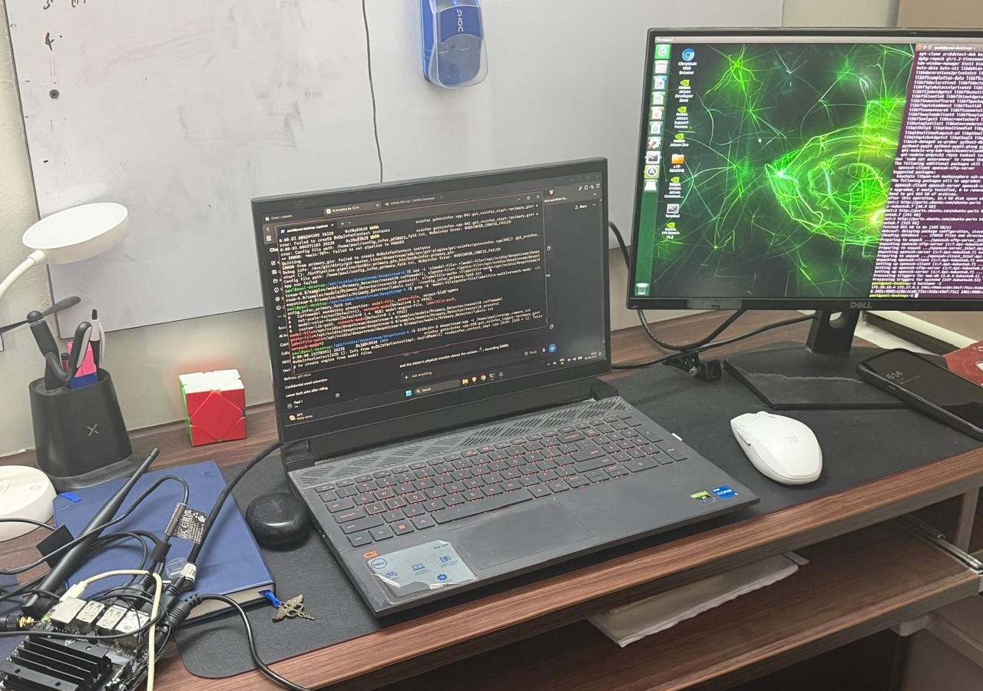
Figure 4.1 Prototype bench set-up with the Jetson Nano edge node
The node is powered from a 5 V, 4 A supply through the barrel jack, which allows the Nano to run in its 10 W mode. A heatsink with a fan keeps the module cool during continuous inference. For energy accounting we use a rated budget of 12.5 W for the node, including the camera, which is conservative for this configuration.

4.2 SOFTWARE STACK
The software runs on JetPack 4.6 with the NVIDIA DeepStream SDK 6.0.1. DeepStream is built on GStreamer and provides hardware-accelerated plugins for decoding, batching, inference and tracking. We used its Python bindings, PyDS, to read the inference results inside the pipeline. The detector is the ResNet10-based four-class detector supplied with DeepStream as a reference model, of which only the person class is used.
The model is converted into a TensorRT engine with 16-bit floating point (FP16) precision the first time the pipeline runs, and the engine file is cached for later runs. FP16 roughly halves memory traffic compared with 32-bit precision and runs efficiently on the Nano's GPU, with negligible loss of accuracy for this kind of detector.

4.3 PIPELINE
The pipeline is summarised in Table 4.2. Frames from the camera are read through V4L2 by the GStreamer source element, converted to the format the GPU expects, and passed to nvstreammux, which forms batches. The nvinfer element runs the TensorRT engine and attaches the detections to each frame as metadata. A probe function attached downstream reads this metadata in Python.
Table 4.2 DeepStream pipeline elements
Stage | Element | Function
Capture | v4l2src (rtspsrc for CCTV) | Read camera frames
Batching | nvstreammux | Form batches in GPU memory
Inference | nvinfer with ResNet10, TensorRT FP16 | Detect persons
Regions | nvdsanalytics (factory extension) | Count persons per region of interest
Metadata | PyDS probe | Read detections, apply filter
Output | live_state.json | Publish state once a second

The probe function walks through the object metadata of each frame and counts the objects of the person class whose confidence exceeds the threshold set in the nvinfer configuration file. The raw count is passed to the temporal filter described in Section 3.5. Once a second, the filtered count, the resulting state and the modelled power are written to a small JSON file, live_state.json, which is read by the dashboard. The core of the probe function and the filter is listed in Appendix 2.
Writing a small file once a second, rather than sending every detection, keeps the interface between the vision code and the rest of the system simple. Any other program, whether a dashboard, an MQTT client or a controller, only needs to read one file with a fixed structure.

4.4 LIVE DETECTION AND DASHBOARD
Figure 4.2 shows a frame from the live pipeline with the detected person marked, and Figure 4.3 shows the dashboard. The dashboard displays the current count, the operating state, the set-point and lighting state for the office application, and the modelled power and energy compared with the scheduled baseline, together with the corresponding cost and CO2. The power and energy values on the dashboard are computed from the state using the model in Chapter 5. They are not measured, and the dashboard labels them as modelled.

Figure 4.2 Live person detection on the Jetson Nano
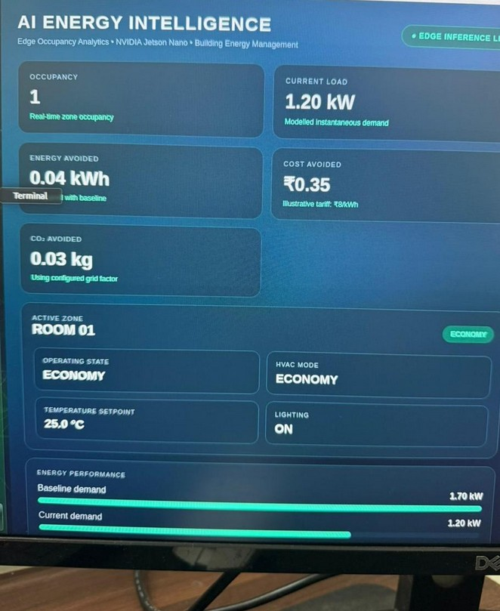
Figure 4.3 Live energy dashboard in the office configuration
In the office configuration, the node was able to follow people entering and leaving the room in real time, and the filtered state changed smoothly without the flicker seen in the raw count. This confirmed the behaviour predicted by the filter study in Phase I.

4.5 EXTENSION FOR THE SHOP FLOOR
Moving from the office to the shop floor requires three additions, none of which changes the existing pipeline.
The first is region-level presence. The nvdsanalytics plugin is inserted after nvinfer, with one region of interest per machine and one per zone defined in its configuration file. The probe then reads per-region counts instead of a single frame count.
The second is the activity input. For each machine, a split-core CT such as the SCT-013 is clamped on one phase of the supply. Its output is read either by an ADS1115 16-bit analogue to digital converter on the Jetson's I2C bus, for a few machines, or by a Modbus energy meter with several CT inputs, for a full shop. A machine is taken as active when its current exceeds about 30 % of its cutting current.
The third is the action output. For loads under automatic control, the node drives a relay module or writes to a Modbus input and output module. Lighting zones are dimmed through their drivers, fans and conveyors through contactors, and the compressor line through an isolation valve and the compressor's own remote stop input. Machines that support PROFIenergy would instead receive a pause command over PROFINET.

4.6 PERFORMANCE CONSIDERATIONS
The person detector processes each frame independently, so the main performance limits are the frame rate per camera and the end-to-end delay from a person leaving a region to the state changing. Neither is critical for this application. The temporal filter already waits 60 s before accepting an absence, and the standby timer adds three more minutes, so a detection delay of even a second has no practical effect on the energy result. The frame rate only needs to be high enough to catch an operator walking into a region, which a few frames per second will do.
What matters more is the error rate of the detector under factory conditions: operators partly hidden by machine guards, workers wearing helmets and coveralls, and poor lighting in some bays. In the simulation, we account for this by assuming a 10 % chance of missing a present person in any frame and adding occlusion periods in which an operator is present but not seen at all. Measuring the actual precision, recall, frame rate and power of the node on a shop floor is part of the planned next step described in Chapter 7.
CHAPTER 5

ELECTRICAL ENERGY MODELLING

5.1 APPROACH
Since the factory part of the system has not been installed on a real shop floor, its effect is estimated with a simulation model, called model v2 to distinguish it from the office model of Review 3. The model generates the activity of every machine and operator in a reference shop over a full day, runs the same decision logic that the edge node would run, and computes the electrical power of every load at every time step, both with and without the node. Comparing the two gives the energy saving, the change in maximum demand and the change in cost.
The model is written in Python and uses a time step of 10 s, which is short compared with any event that matters for energy, such as a tea break or a material wait. All input values are kept in a single assumptions file, listed in Appendix 1, and a fixed random seed makes every result reproducible. Every number quoted in Chapter 6 is produced by this code and written to a results file; none is typed in by hand.

5.2 MACHINE POWER MODEL
Each machine k is in one of the states defined in Chapter 3 at each time step, and its power is taken from that state:
P_k(t) = P_state( s_k(t) ) (5.1)
The values used for a vertical machining centre are listed in Table 5.1. There is no published measurement of state powers for a typical Indian MSME machine, so these are engineering assumptions chosen to be consistent with the literature: a mean cutting power of 7.5 kW sits comfortably below the 13 kW reported for roughing on a larger machining centre (Heidenhain 2011), and an idle power of 40 % of the cutting power reflects the large fixed share described in Chapter 2. Because these values matter, the idle power ratio is varied from 25 % to 55 % in the sensitivity study.
Table 5.1 Power assumptions for model v2
Load | Value | Basis
Machine, cutting | 7.5 kW | Assumed; below the 13 kW roughing example of Heidenhain (2011)
Machine, idle | 3.0 kW | Assumed, 40 % of cutting; varied 25 to 55 %
Machine, standby / deep standby | 1.2 / 0.35 kW | Assumed
Warm-up after deep standby | 4.0 kW for 10 min | Assumed
Compressor | 22 kW, unloaded 30 %, leak 25 % | Leak within US DOE (2003) range
Conveyor | 2.2 kW | Assumed
Lighting per zone | 3.6 kW | Assumed, 24 LED fittings of 150 W
Fan per zone | 3.7 kW | Assumed
Power factor | 0.90 | Assumed

5.3 SHARED LOADS
The power drawn by the whole shop is the sum of the machine powers and the shared loads:
P_shop = Σ_k P_k + P_comp + P_conv + Σ_j ( P_light,j + P_fan,j ) (5.2)
The compressor is modelled as a 22 kW screw compressor with load and unload control. Its load fraction f depends on the air demand of the machines that are cutting plus a constant leak demand, and in the unloaded state it still draws a fraction of its full power:
P_comp = P_full [ f + (1 - f) α_u ], f = min(1, λ_leak + β N_proc) (5.3)
Here P_full is the full-load power, alpha_u the unloaded power fraction (0.30), lambda_leak the leak demand as a fraction of capacity (0.25, within the 20 to 30 % range reported by the US DOE), beta the air demand per cutting machine (0.06 of capacity) and N_proc the number of machines cutting. The conveyor is a 2.2 kW drive. Each of the four zones has 3.6 kW of LED high-bay lighting, equivalent to twenty-four 150 W fittings, and one 3.7 kW extraction or ventilation fan.

5.4 OPERATIONS MODEL OF THE REFERENCE SHOP
The value of the edge node depends entirely on how often machines stand idle and whether anyone is with them. To capture this, every machine shift is generated as a random sequence of events, summarised in Table 5.2. Machining cycles have random lengths with a mean of 12 min, separated by two-minute loading gaps during which the operator is present. On top of this, each shift contains a set-up period at the start, two tea breaks, a lunch break and a changeover at the end, as well as random material waits, tool changes, breakdowns and short absences of the operator. In the baseline, 30 % of machines are left switched on overnight, which reflects a common situation in small shops where the last shift does not always power down every machine.
Table 5.2 Events in each machine shift
Event | Model | Operator
Machining cycle | Exponential, mean 12 min, with 2 min loading gaps | Present
Set-up at shift start | 10 min | Present
Tea breaks | 15 min at 2 h and 6 h into the shift | Absent
Meal break | 30 min at 4 h into the shift | Absent
Material wait | Poisson, 1.5 per shift; lognormal, median 15 min | Absent with probability 0.7
Tool change | Poisson, 2.0 per shift; mean 8 min | Present
Breakdown | Probability 0.08 per shift; 45 to 120 min | Absent with probability 0.6
Short absence | Poisson, 3.0 per shift; mean 5 min | Absent
Left on overnight (baseline) | Probability 0.3 per machine | Absent

The camera itself is also modelled imperfectly. In any frame, a present operator is missed with a probability of 10 %, the same assumption used in Phase I, and a false detection appears with a probability of 0.2 %. In addition, each operator is fully hidden from the camera twice per shift on average, for a random period with a mean of 90 s. These occlusion periods are what can cause a false standby, and they are an important input to the timer study in Chapter 6.

5.5 BASELINE AND CONTROLLED OPERATION
The baseline represents the shop as it runs today. Machines are switched on for the whole shift and draw idle power whenever they are not cutting. Lights, fans, the conveyor and the compressor run for the whole of both shifts. Machines left on overnight idle until the next morning.
In controlled operation, the same random events are replayed, but the decision logic of Chapter 3 is applied using the filtered camera signal and the current signal. Using the same events for both cases means the difference between them is due only to the control, not to a different day.

5.6 ENERGY, DEMAND AND COST
Energy is obtained by summing power over the time steps, and the saving is the difference between baseline and controlled energy:
E = Σ_t P(t) Δt (5.4)
E_saved = E_base - E_ctrl (5.5)
Industrial meters record maximum demand as the highest average apparent power over a demand interval, taken as 15 min. With n time steps in each interval b and a plant power factor PF, the maximum demand in kVA is
MD = max_b [ (1/n) Σ_(t in b) P(t) ] / PF (5.6)
The monthly bill under the TNERC two-part tariff is then
C_month = E c_E + max( MD, 0.9 CD ) c_D (5.7)
where c_E is the energy charge, c_D the demand charge and CD the contract demand. The tariff and emission inputs are listed in Table 5.3. The contract demand of 130 kVA is an assumption that places the baseline maximum demand close to the contract value, which is typical of a shop that has sized its connection to its load.
Table 5.3 Tariff and emission inputs
Item | Value | Source
Energy charge c_E | Rs 7.50 per kWh | TNERC (2025), HT-I
Demand charge c_D | Rs 608 per kVA per month | TNERC (2025), HT-I
Billing demand | Higher of recorded MD and 90 % of CD | TNERC (2025)
Contract demand CD | 130 kVA | Assumed
Emission factor EF | 0.710 kg CO2 per kWh | CEA (2025b), 2024-25
Working days | 300 per year | Assumed

5.7 PERFORMANCE INDICATORS
Three further indicators are reported. The load factor compares average and peak power:
LF = P_avg / P_peak (5.8)
The idle-energy ratio is the share of the total shop energy that is used by machines while they are not cutting. It is a simple energy performance indicator in the sense of ISO 50006, and it is the quantity that the edge node is designed to reduce:
IER = E_idle / E_total (5.9)
Finally, the avoided emissions follow from the grid emission factor published by the Central Electricity Authority, 0.710 kg CO2 per kWh for 2024-25 (CEA 2025b):
CO2 = E_saved × EF (5.10)

5.8 MODEL CHECKS
Before using the model, we checked it in three ways. First, with the standby timers set longer than a day and advisory compliance set to zero, the controlled machine energy equals the baseline machine energy to within rounding, which confirms that the two cases are computed on exactly the same events. Second, the office case of Review 3 was recomputed from its state durations and gives the same 17.0 and 13.8 kWh per day as before. Third, the time series of individual machines were inspected by eye, as in Figure 6.1 in Chapter 6, to confirm that standby occurs only when the machine is idle and the filtered presence signal is absent.
CHAPTER 6

SIMULATION RESULTS AND DISCUSSION

6.1 OVERVIEW OF THE STUDIES
All results in this chapter are MODELLED, using model v2 as described in Chapter 5. Nine studies were run. Studies S1 to S4 look at a single reference day in detail: one machine, the whole shop, the split between load types, and the shape of the load curve. Study S5 repeats the day 1,000 times with different random events to test how robust the saving is. Studies S6 and S7 examine the sensitivity of the result to the main assumptions and to the choice of standby timer. Study S8 looks at payback, and S9 compares the factory with the office case of Review 3.

6.2 S1: ONE MACHINE OVER ONE SHIFT
Figure 6.1 shows the first shift of machine M1, a general-purpose machine under automatic control, on the reference day. The top panel shows when the machine was cutting, the middle panel shows operator presence, both true and as seen by the filtered camera signal, and the bottom panel shows the power drawn with and without the node.
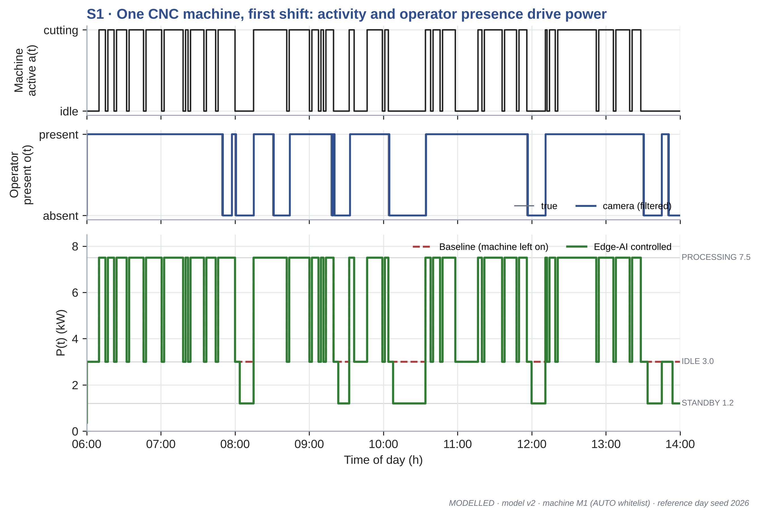
Figure 6.1 Activity, operator presence and power of machine M1 over the first shift
For most of the shift the two power curves lie on top of each other. The machine alternates between cutting at 7.5 kW and short idle gaps at 3.0 kW while the operator loads the next part, and the node correctly leaves these gaps alone because the operator is present. The curves separate only during the tea breaks at about 08:00 and 12:00, the meal break at about 10:00, a short absence before 09:30 and the end-of-shift changeover. In each case the operator leaves, the filtered presence drops after a minute, and three minutes later the machine drops to its 1.2 kW standby. When the operator returns, the machine goes back to idle and then to cutting.
Over this shift, the energy of M1 fell from 45.6 kWh to 43.4 kWh, a reduction of 4.9 %. This is a modest figure, and it is meant to be. A busy machine with a present operator offers little to save during the shift, and the system is designed not to interfere with it. The large savings come from the longer unattended periods, as the following studies show.

6.3 S2: WHOLE SHOP CUMULATIVE ENERGY
Figure 6.2 shows the cumulative energy of the whole shop over the reference day, including all ten machines and the shared loads. The two curves stay close during productive hours and pull apart during breaks, at the end of each shift, and overnight, where machines that were left on in the baseline drop to deep standby under control.
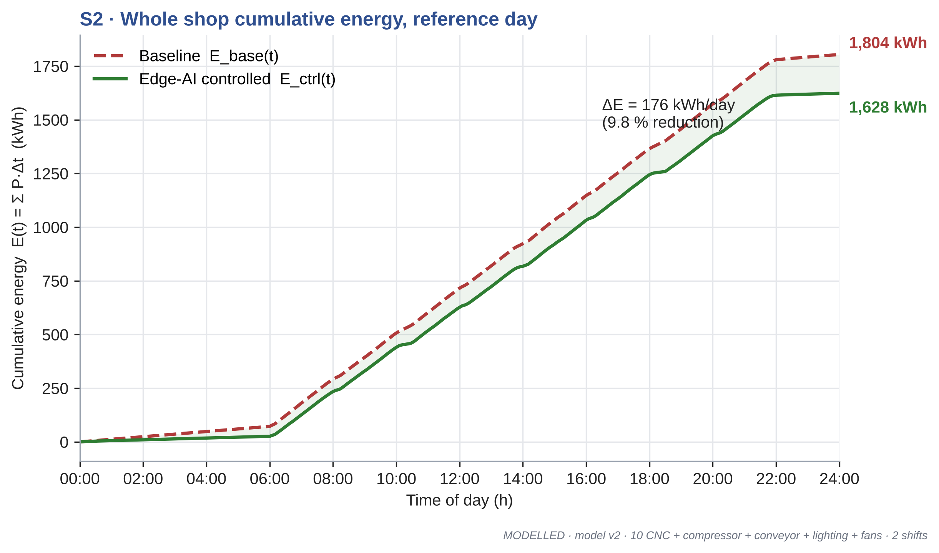
Figure 6.2 Cumulative energy of the shop on the reference day
On the reference day, the shop used 1,804 kWh in the baseline and 1,628 kWh with the edge node, a saving of 9.8 %. This is a single sample. As Section 6.6 shows, the average over many days is somewhat lower, and it is the average that we use as the headline result.

6.4 S3: SAVINGS BY LOAD TYPE
Figure 6.3 breaks the energy of the reference day down by load type. Machines dominate the bill, using a little over half of the shop's energy, followed by the compressor, the fans and the lighting.
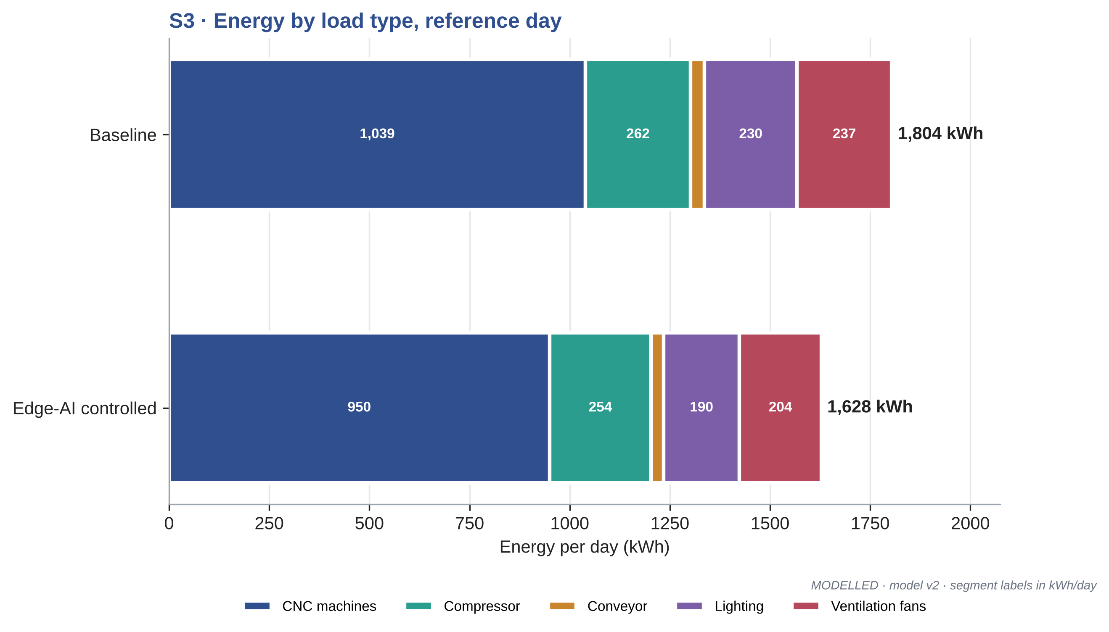
Figure 6.3 Energy by load type on the reference day, baseline and controlled
The pattern of savings is different from the pattern of use. Averaged over 1,000 simulated days, the daily saving is 68.5 kWh from the machines, 38.2 kWh from lighting, 31.2 kWh from the fans, 9.1 kWh from the compressor and 4.2 kWh from the conveyor, as listed in Table 6.1. Machines give the largest absolute saving. Lighting and fans give the largest percentage saving on their own consumption, because whole zones are often empty during breaks and on the aisle side of the shop. The compressor saving is small because it can be stopped only when the entire shop is idle.
Table 6.1 Mean daily saving by load type over 1,000 days
Load | Saving (kWh per day)
CNC machines | 68.5
Compressor | 9.1
Conveyor | 4.2
Lighting | 38.2
Ventilation fans | 31.2
Total | 151

This result directly answers the second point raised by the expert panel. The same camera signal that controls machine standby also drives lighting, ventilation, the conveyor and the compressor, and together these shared loads account for more than half of the total saving.

6.5 S4: LOAD-DURATION CURVE, LOAD FACTOR AND MAXIMUM DEMAND
Figure 6.4 shows the load-duration curve of the shop for the reference day, with the power values sorted from highest to lowest. The electrical indices are summarised in Table 6.2.
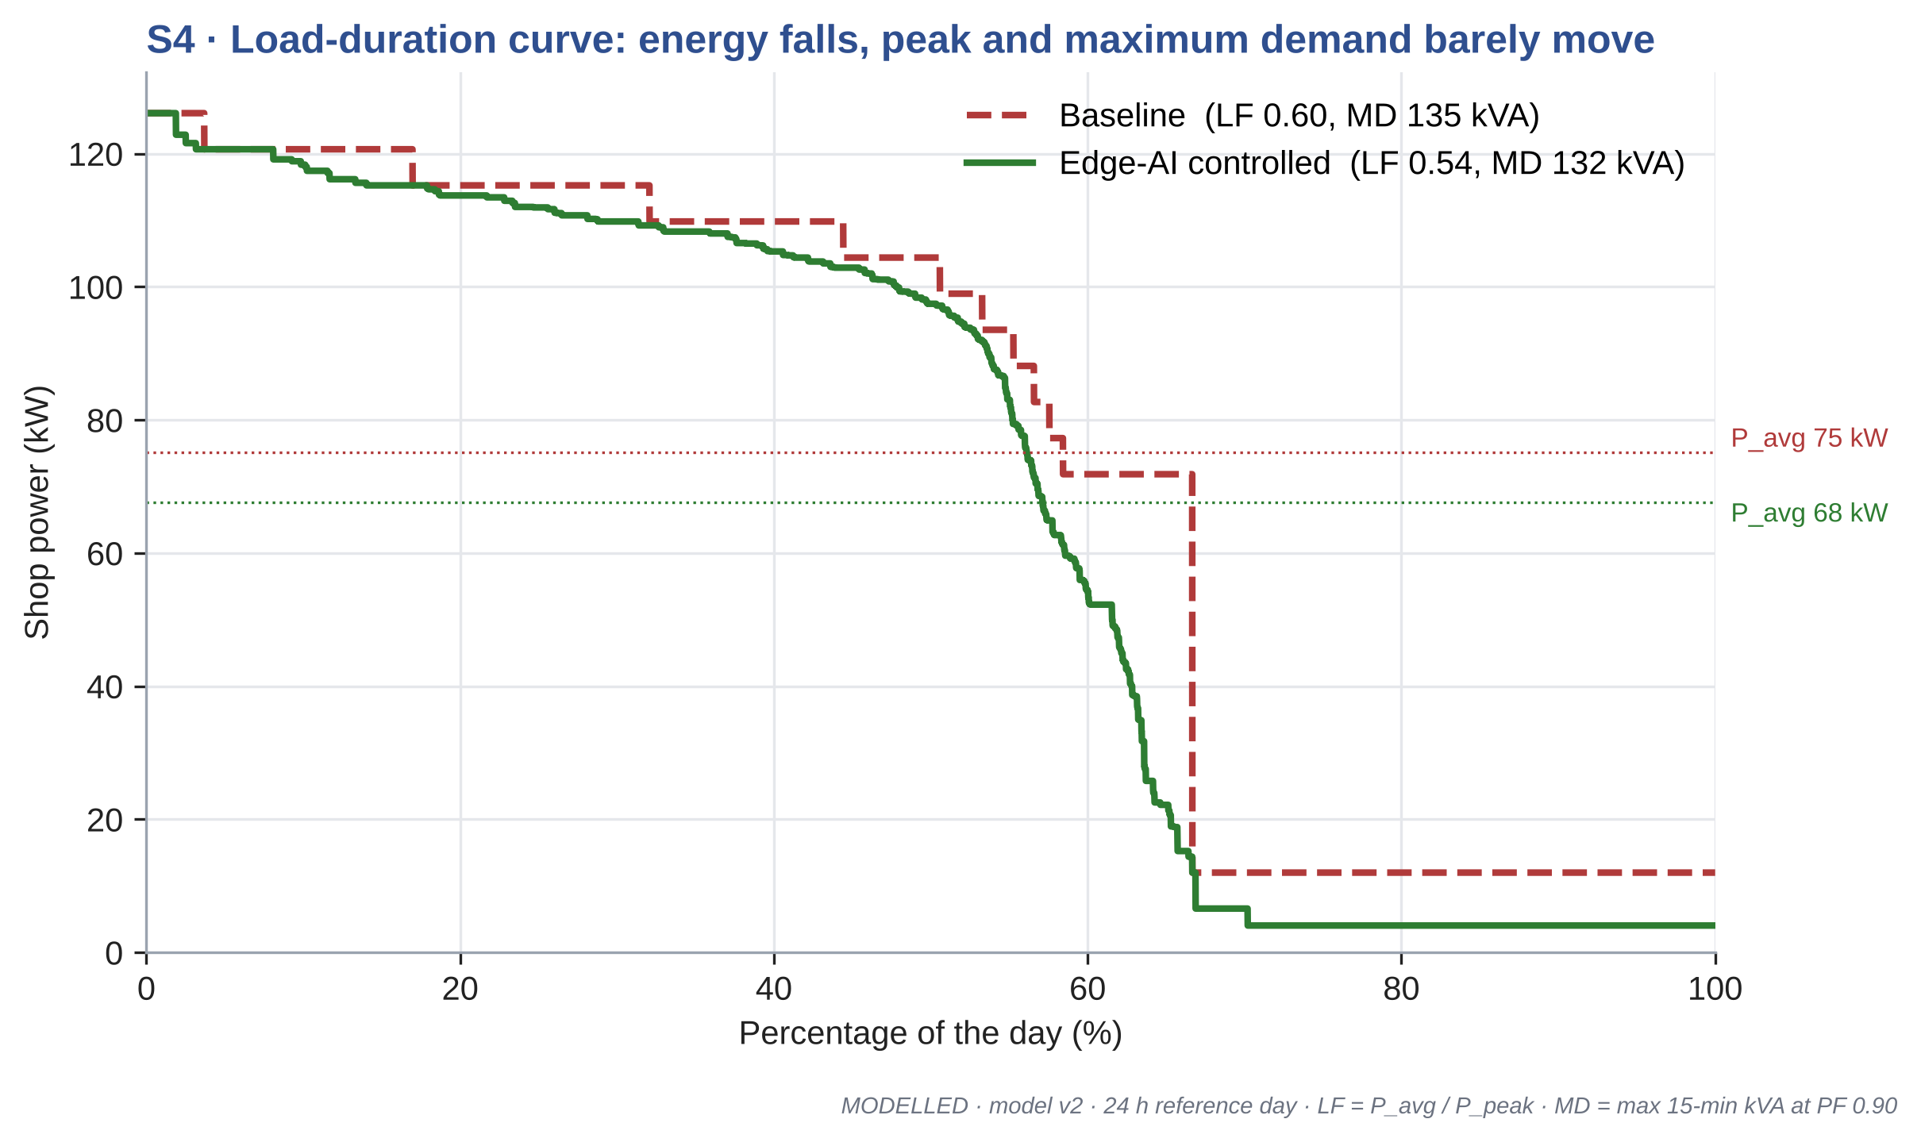
Figure 6.4 Load-duration curve of the shop on the reference day
Table 6.2 Electrical indices on the reference day
Index | Baseline | Controlled
Average power (kW) | 75.2 | 67.6
Peak power (kW) | 126.1 | 126.1
Load factor | 0.60 | 0.54
Maximum demand, 15 min (kVA) | 135.3 | 132.0

The upper part of the curve, which covers the hours when most machines are cutting, is almost unchanged. The difference lies in the middle and lower part: the controlled curve falls away earlier and settles at a much lower level overnight. Average power falls from 75.2 kW to 67.6 kW, while the peak stays at 126.1 kW. As a result, the load factor falls from 0.60 to 0.54.
The maximum demand barely moves, from 135.3 kVA to 132.0 kVA on the reference day and from 134.4 to 133.2 kVA on average. This is expected. The highest 15-minute demand occurs when most machines are cutting at the same time, which is exactly when the node does nothing. We therefore claim an energy saving, not a demand saving, and the demand charge component of the saving in the next section is correspondingly small. A lower load factor is not a problem in itself here; it simply reflects lower consumption with the same connected load. Reducing the peak would need a different feature, such as staggering machine restarts after lunch, which we list as future work.

6.6 S5: MONTE-CARLO ROBUSTNESS
A single day can be lucky or unlucky. To see how much the saving depends on the particular events of one day, the simulation was repeated for 1,000 days, each with its own random material waits, tool changes, breakdowns, operator absences, occlusions and overnight decisions. Figure 6.5 shows the distribution of the daily saving.
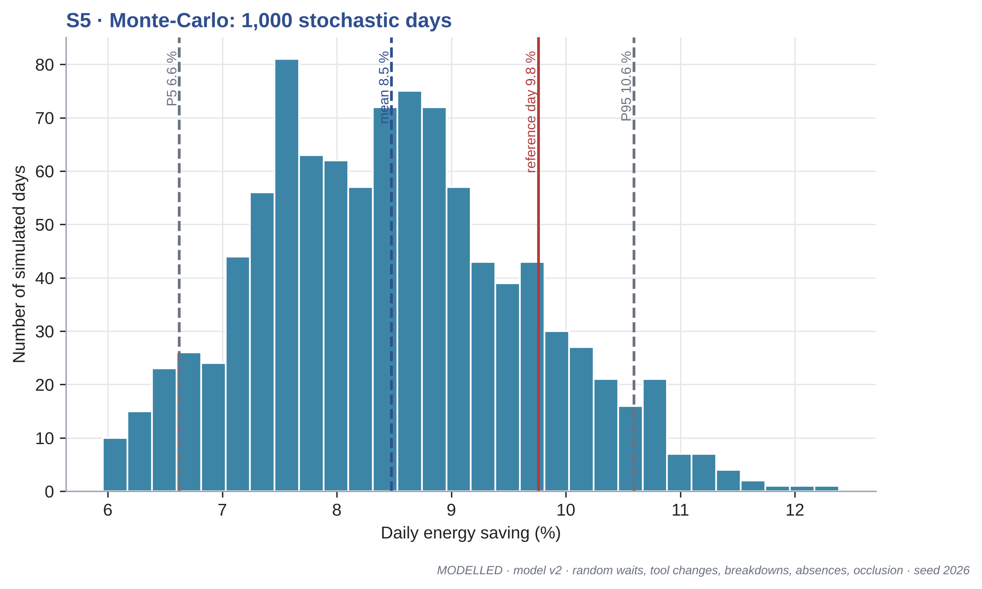
Figure 6.5 Distribution of the daily energy saving over 1,000 simulated days
The mean saving is 8.5 %, with a median of 8.4 %, and 90 % of days fall between 6.6 % and 10.6 %. The saving was positive on 100.0 % of the simulated days. The reference day, at 9.8 %, lies in the upper part of the distribution, which is why we use the Monte-Carlo mean rather than the reference day for the headline figures in Table 6.3.
Table 6.3 Headline results over 1,000 simulated days
Quantity | Value
Mean shop energy, baseline to controlled | 1,778 to 1,627 kWh per day
Mean saving (5th to 95th percentile) | 8.5 % (6.6 to 10.6 %)
Days with a positive saving | 100.0 %
Energy avoided | 45,295 kWh per year
Cost saving: energy, demand, total | Rs 339,710, Rs 7,098, Rs 346,808 per year
CO2 avoided | 32.2 t per year
Idle-energy ratio | 13.9 % to 11.0 %
Mean maximum demand | 134.4 to 133.2 kVA
Nuisance standbys | 0.30 per machine-shift

Over a year of 300 working days, the mean saving corresponds to 45,295 kWh, which at the TNERC HT-I tariff is worth Rs 339,710 in energy charges and Rs 7,098 in demand charges, a total of Rs 346,808 per year. The avoided emissions are 32.2 tonnes of CO2 per year. The idle-energy ratio of the shop falls from 13.9 % to 11.0 %.
The percentage saving is lower than the 18.8 % found for the office in Review 3. This is not a weakness of the factory case. A machining shop is busy for most of the shift, so the fraction of time available for saving is smaller, but the loads are so much larger that the absolute saving, about 151 kWh per day, is nearly fifty times that of the office room.

6.7 S6: SENSITIVITY ANALYSIS
Several inputs to the model are assumptions. To see which of them matter, each was varied on its own between a low and a high value while the others were held at their reference values, using 150 simulated days for each case. The results are shown as a tornado chart in Figure 6.6 and in Table 6.4.
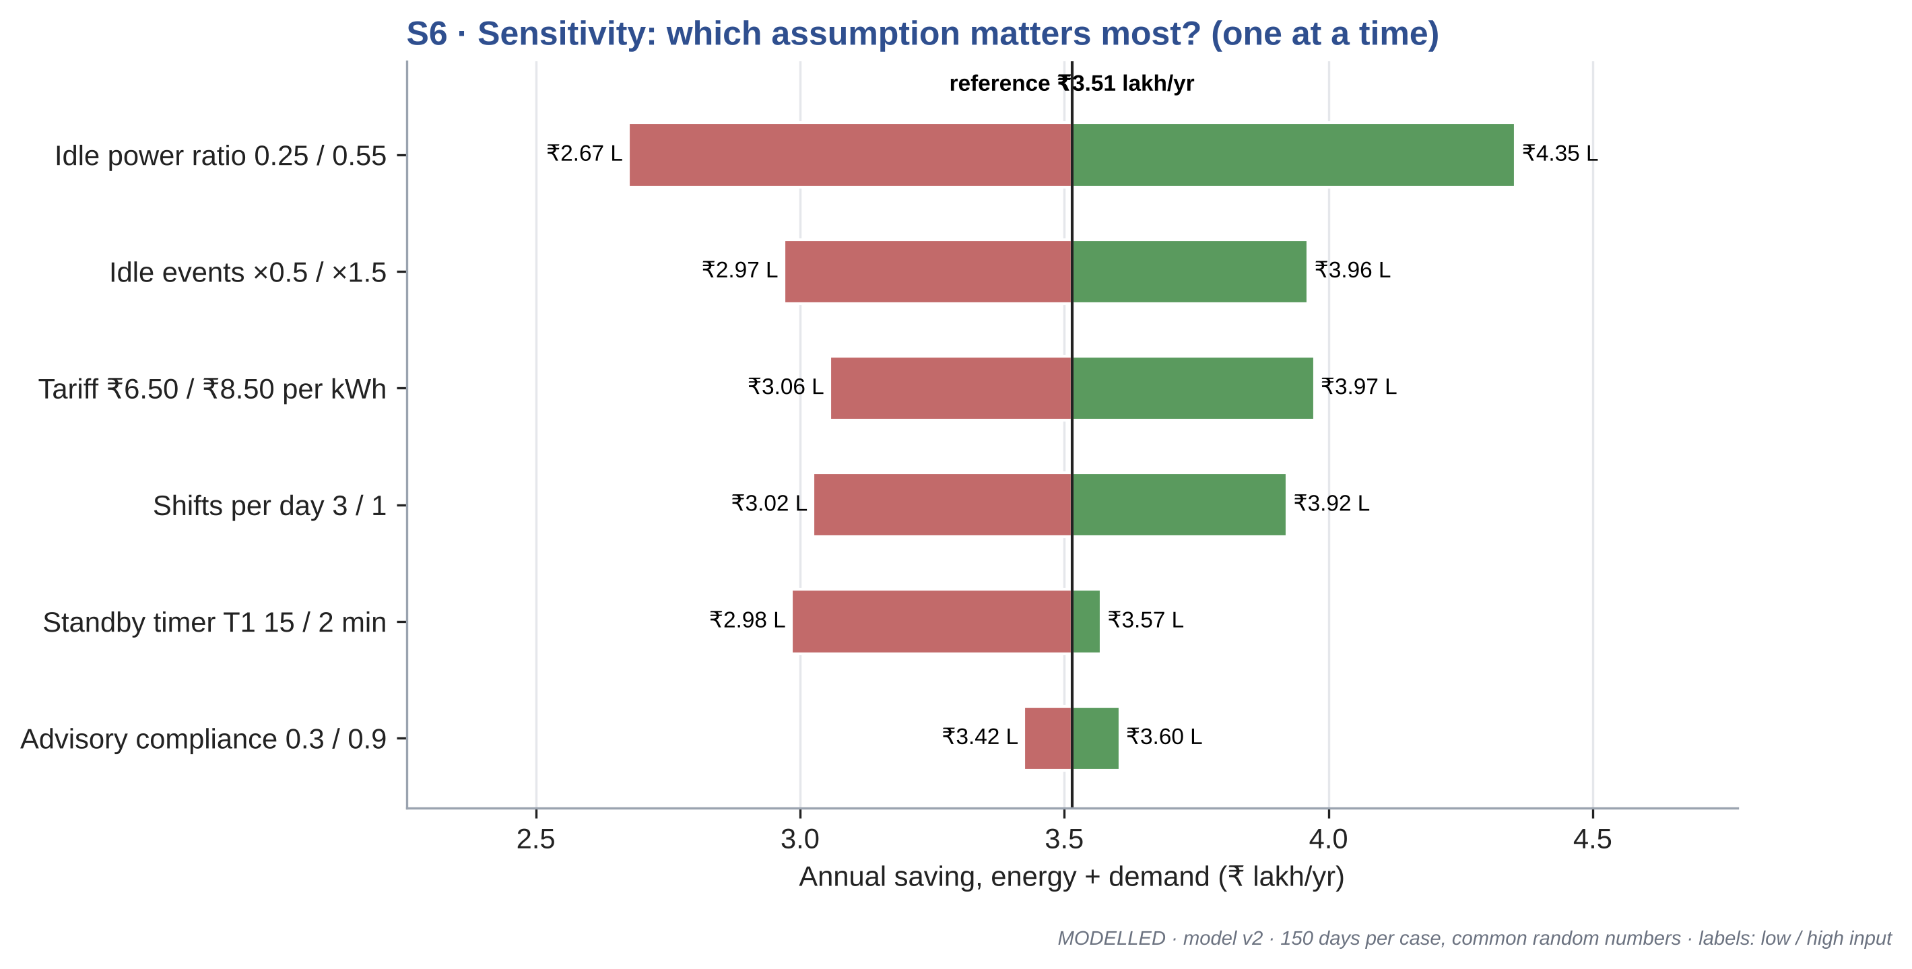
Figure 6.6 One-at-a-time sensitivity of the annual saving
Table 6.4 Sensitivity of the annual saving (150 days per case)
Input (low / high) | Saving at low input (Rs/yr) | Saving at high input (Rs/yr)
Idle power ratio 0.25 / 0.55 | 267,494 | 435,406
Idle events x0.5 / x1.5 | 296,894 | 396,144
Tariff Rs 6.50 / Rs 8.50 per kWh | 305,580 | 397,319
Shifts per day 3 / 1 | 392,169 | 302,462
Standby timer T1 15 / 2 min | 298,316 | 356,980
Advisory compliance 0.3 / 0.9 | 342,338 | 360,488
Reference case over the same 150 days: Rs 351,450 per year.

The idle-to-cutting power ratio of the machines matters most. If idle power is only 25 % of cutting power, the annual saving falls to Rs 267,494; at 55 % it rises to Rs 435,406. The frequency of idle events comes next: halving the material waits, breakdowns and machines left on overnight reduces the saving to Rs 296,894, and increasing them by half raises it to Rs 396,144. The tariff simply scales the result. The number of shifts also matters. A three-shift shop saves more, Rs 392,169, because it has three sets of breaks and changeovers and its lights, fans and compressor run around the clock. A single-shift shop saves less, Rs 302,462, even though the machines left on overnight stand idle for longer, because only a minority of machines are left on and the shared loads run for only eight hours.
The practical conclusion is that the two inputs with the largest influence are both properties of the real shop, the idle power of its machines and how often they stand idle, and both can be measured cheaply with CT clamps before any control is installed. That measurement should be the first step of any deployment.

6.8 S7: TIMER STUDY
The standby timer T1 is the main design parameter of the system. A short timer saves more energy but risks putting a machine to sleep just before the operator returns. A long timer avoids this but misses many short idle periods. To quantify this trade-off, T1 was varied from 1 to 30 min. Two kinds of unwanted event were counted. A nuisance standby is one in which the operator or the machine becomes active again within five minutes of the standby starting. A false standby is one that starts while the operator is actually present but hidden from the camera. The results are plotted in Figure 6.7 and listed in Table 6.5.
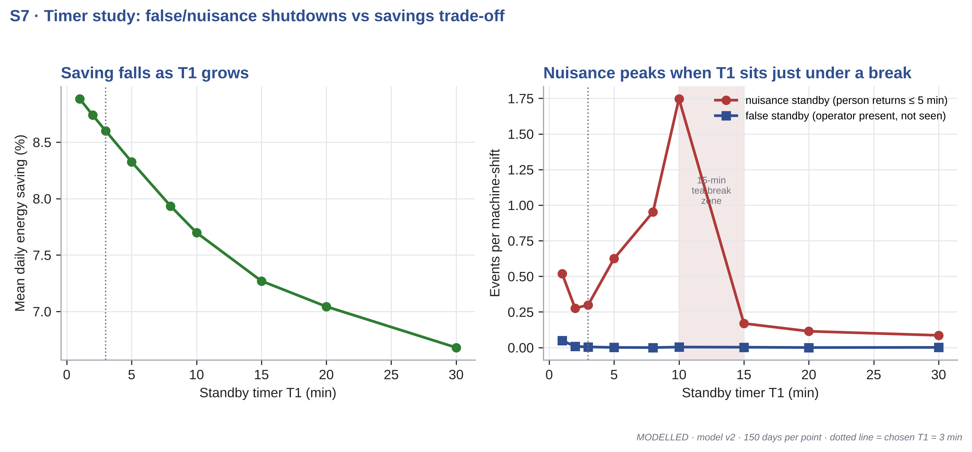
Figure 6.7 Effect of the standby timer T1 on saving and on nuisance and false standbys
Table 6.5 Effect of the standby timer T1 (150 days per value)
T1 (min) | Saving (%) | Nuisance per machine-shift | False standby per machine-shift
1 | 8.88 | 0.52 | 0.049
2 | 8.74 | 0.28 | 0.008
3 | 8.60 | 0.30 | 0.004
5 | 8.33 | 0.62 | 0.001
8 | 7.93 | 0.95 | 0.000
10 | 7.70 | 1.75 | 0.003
15 | 7.27 | 0.17 | 0.002
20 | 7.04 | 0.11 | 0.000
30 | 6.68 | 0.09 | 0.001

The saving falls steadily as T1 grows, from 8.88 % at 1 min to 6.68 % at 30 min. The nuisance rate, however, does not fall steadily. It is low at 2 to 3 min, rises to a peak of 1.75 events per machine-shift at 10 min, and then drops sharply above 15 min. The reason is the tea break. With T1 at 10 min, a machine goes to standby ten minutes into a fifteen-minute break, and the operator returns a few minutes later, so almost every tea break produces a nuisance event. With T1 at 3 min, the same break produces a standby that lasts twelve minutes, which saves energy and is not a nuisance.
False standbys are rare at every setting except the shortest. At T1 = 1 min, an operator hidden behind a machine guard for a minute or two can be taken as absent, giving 0.05 false standbys per machine-shift. At 3 min this falls to 0.004.
On this basis we chose T1 = 3 min. Compared with the 5 min we started with, it gives a higher saving (8.60 % against 8.33 %) and about half the nuisance events (0.30 against 0.62 per machine-shift). The study also suggests a simple improvement: since breaks happen at known times, the node could send a planned pause command at the start of each scheduled break, rather than waiting for the timer at all.

6.9 S8: PAYBACK PER NODE
The cost of a node depends on how many machines it serves, since each machine needs a CT clamp but the Jetson, power supply and input and output module are shared. Figure 6.8 shows the simple payback against the number of machines covered by one node, using the average saving per machine of Rs 34,681 per year and subtracting the cost of the node's own electricity.
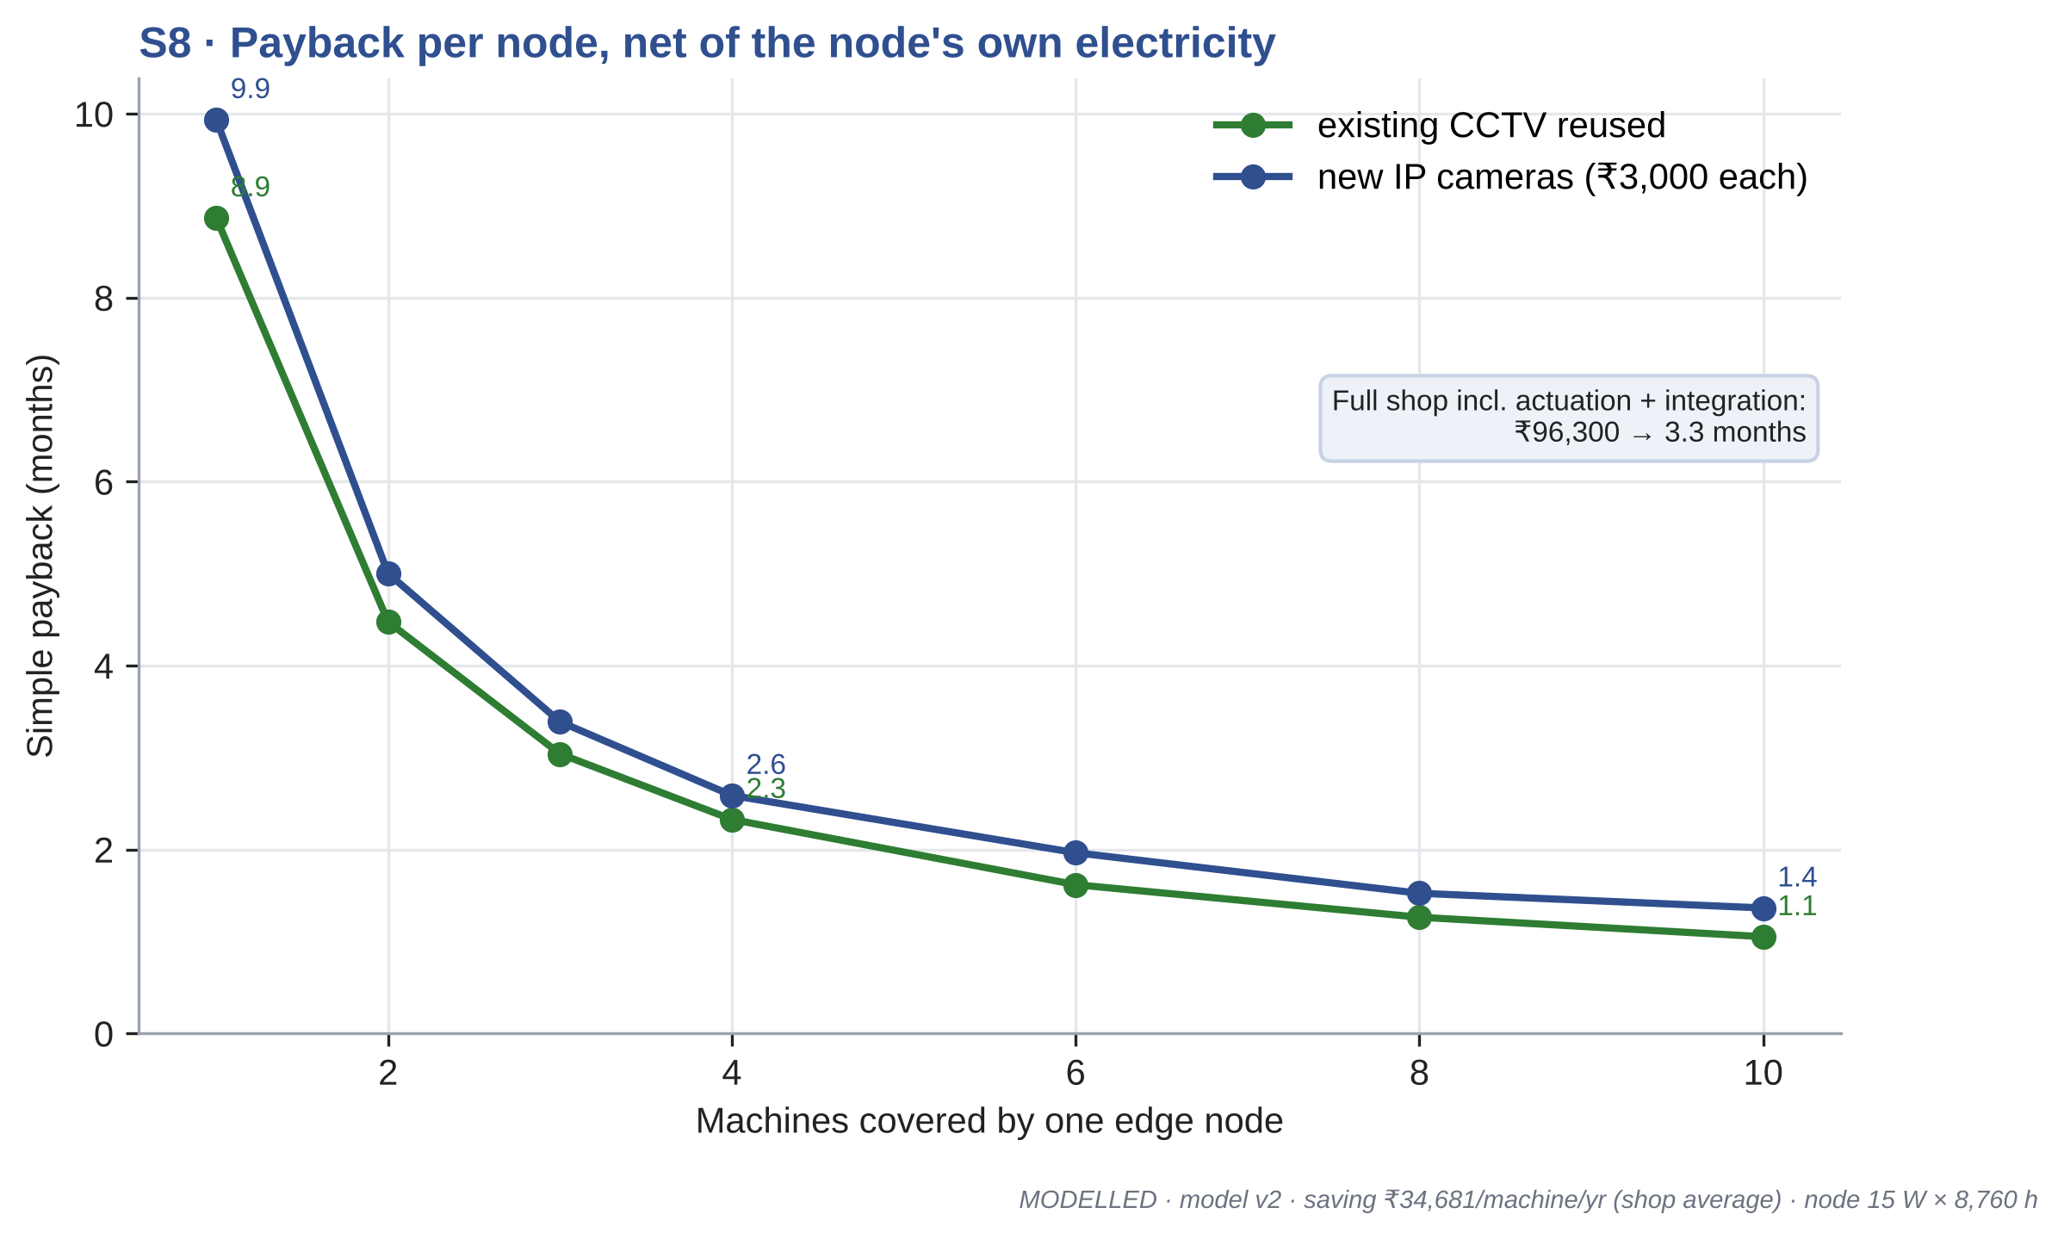
Figure 6.8 Simple payback against the number of machines covered by one node
With existing CCTV cameras, a node serving a single machine pays back in 8.9 months, one serving four machines in 2.3 months, and one serving ten machines in 1.1 months. These figures cover only the node and its sensors. A complete installation for the reference shop, including dimming interfaces for the lighting zones, contactors for the fans, the conveyor interlock, a compressor isolation valve and the cost of wiring and commissioning, comes to Rs 96,300, and pays back in 3.3 months. If new IP cameras have to be installed, the cost rises to Rs 105,300 and the payback to 3.7 months.
The node's own electricity, 131 kWh per year, is only 0.29 % of the energy it saves. The prices used are indicative retail prices and are listed in Chapter 7.

6.10 S9: GENERALITY, OFFICE AND FACTORY
Figure 6.9 places the two applications side by side. In the office room of Review 3, occupancy control reduced energy from 17.0 to 13.8 kWh per day, a saving of 18.8 %, or 1,168 kWh per year. In the machining shop, the saving is 8.5 %, but in absolute terms it is about 151 kWh per day.
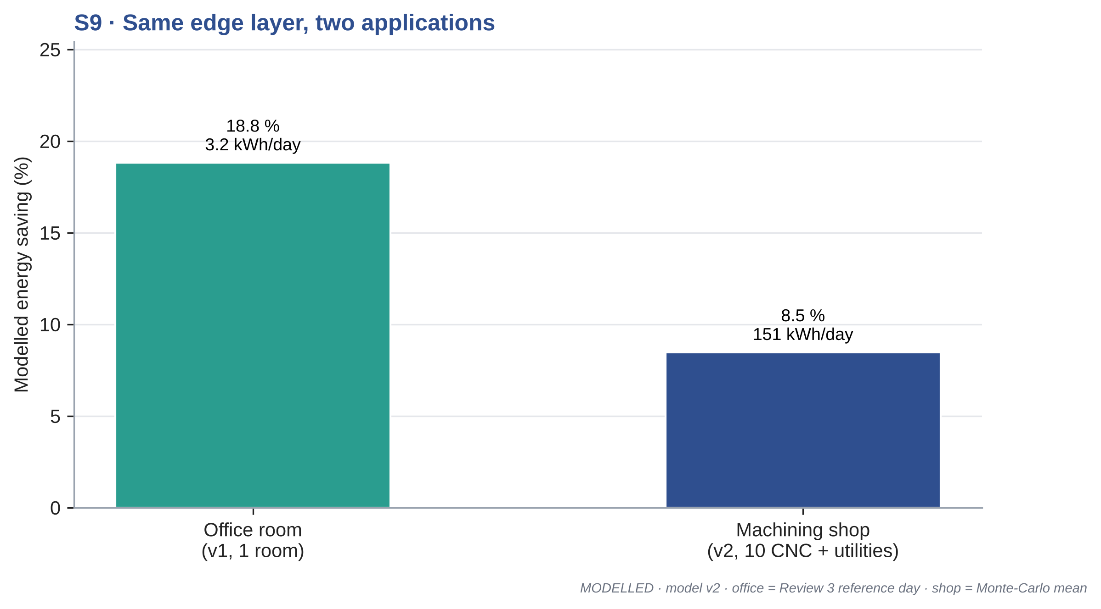
Figure 6.9 Saving of the same edge layer in an office room and in a machining shop
Recomputing the office economics with the same method as the factory exposed one correction to Review 3. The payback of 22.5 months reported there used the gross saving. Subtracting the electricity used by the node itself, which is 12.5 W running all day, reduces the annual saving from Rs 9,344 to Rs 8,468, and the payback becomes 24.8 months. The difference is small, but the corrected value is the one that should be quoted.

6.11 DISCUSSION
The results support three conclusions. First, the edge node can reduce the energy of a small machining shop by a meaningful amount, about 8.5 % on average, without interfering with productive work, because it acts only when a machine is both idle and unattended. Second, a substantial part of the saving comes from loads other than the machines themselves, which justifies treating the camera as a sensor for the whole shop rather than for one machine at a time. Third, the saving is an energy saving, not a demand saving.
The result compares reasonably with the literature, given the differences in setting. Building studies with occupancy control report savings between about 6 % for whole buildings (Lin et al. 2023) and 17 to 24 % for HVAC alone (Kong et al. 2022). Our factory figure is at the lower end in percentage terms, which is consistent with a busy workplace, but large in absolute terms.
The limitations should be stated plainly. The state powers of the machines, the frequency of idle events, the shared load ratings and the hardware prices are assumptions, not measurements. The sensitivity study shows which of them matter most. The camera error model is based on our office experience and on published industrial detection rates, not on measurements in a factory. And the reference shop is a single, stylised example; a forging unit, a fabrication shop or a plastics plant would behave differently. Each of these limitations points to a specific measurement, and those measurements form the next stage of the work.
CHAPTER 7

ECONOMICS, STANDARDS AND DEPLOYMENT ROADMAP

7.1 COST OF A DEPLOYMENT
The cost of equipping the reference shop is broken down in Table 7.1. The edge computer itself is a small part of the total. Most of the money goes into the interfaces that let the node act on the shared loads, such as dimming interfaces for the lighting zones and contactors for the fans, and into wiring and commissioning. Where the shop already has CCTV cameras covering the machines, no new cameras are needed; if not, one IP camera for every four machines adds about Rs 3,000 each.
Table 7.1 Indicative cost of the installation for the reference shop
Item | Quantity | Cost (Rs)
Jetson Nano with power supply, storage and enclosure | 1 | 16,300
Relay or Modbus input and output module | 1 | 3,500
CT clamps | 10 | 6,000
CT interface (ADC or Modbus meter) | 1 | 2,500
Installation sundries | 1 | 2,000
Lighting zone dimming interfaces | 4 | 24,000
Fan contactors | 4 | 12,000
Conveyor interlock and compressor isolation valve | 1 | 5,000
Wiring, integration and commissioning | 1 | 25,000
Total, with existing CCTV |  | 96,300
Indicative retail prices, October 2026.

The simple payback of the complete installation is
Payback = 12 C_inst / ( S_yr - E_node c_E ) months (7.1)
where C_inst is the installed cost, S_yr the annual saving, E_node the annual energy used by the node and c_E the energy charge. For the reference shop this gives 3.3 months with existing cameras and 3.7 months with new cameras. Even if the saving turned out to be only half of the modelled value, for example because the machines have a lower idle power than assumed, the payback would still be well under a year. This margin is the main economic argument for the system: the investment is small compared with the electricity bill of even a small machining unit, which in the baseline case is about Rs 40.0 lakh a year in energy charges alone.

7.2 STANDARDS AND CONTROL PATHS
Table 7.2 lists the standards and protocols that a real deployment would rely on, and the role each would play. They fall into two groups: those that let the node talk to equipment, and those that define how the savings should be managed and proven.
Table 7.2 Standards and protocols relevant to deployment
Standard | Purpose | Role in this work
ISO 14955-1:2017 | Design method for energy-efficient machine tools | Reference for machine energy states
PROFIenergy (PROFINET) | Standard pause and standby commands | Automatic control of PROFINET machines
OPC UA / umati | Vendor-neutral machine data | Machine state from the controller
Modbus TCP | Register access to meters, relays and drives | CT meters and switching of shared loads
MQTT 5.0 | Publish and subscribe telemetry | Node to dashboard and plant systems
ISO 50001:2018 | Energy management system | Framework for the node in a plant
ISO 50006:2014 | Baselines and performance indicators | Idle-energy ratio as an indicator
ISO 50015:2014, IPMVP | Measurement and verification | Proving the savings (Option B)

On the equipment side, the simplest path is a relay or a Modbus input and output module, which works with any load that has a contactor or a remote stop input. This is enough for lighting, fans, the conveyor and the compressor. For machines, a direct connection is better. PROFIenergy allows a controller to tell a PROFINET machine to enter a pause mode that its builder has defined, so the machine itself decides which units to switch off and how to come back. OPC UA, and the machine tool companion specification published by umati, would let the node read the machine's own state, which could later replace or confirm the CT signal.
On the management side, the node fits naturally into an energy management system under ISO 50001. The idle-energy ratio defined in Chapter 5 is a suitable energy performance indicator in the sense of ISO 50006, because it is easy to measure, easy to explain to a shop owner and directly affected by the control.

7.3 MEASUREMENT AND VERIFICATION PLAN
The savings in this report are modelled. Before they can be claimed for a real shop, they must be measured. We propose a plan based on Option B of the International Performance Measurement and Verification Protocol (IPMVP), retrofit isolation with measurement of all parameters, which is consistent with ISO 50015.
• Install CT clamps on every machine feeder and on the feeders for the compressor, lighting and fans, logged at one-minute intervals.
• Run the node in ADVISORY mode with alerts hidden for two weeks. This records the baseline while also logging what the node would have done.
• Switch to AUTO mode for the whitelisted loads for a further two weeks.
• Normalise both periods by production, as kWh per part, and by operating hours, then compare. Report the idle-energy ratio before and after.
The baseline period also gives the two inputs that the sensitivity study identified as most important, the real idle power of each machine and the real frequency of idle periods, so the model can be recalibrated before the AUTO period begins.

7.4 DEPLOYMENT ROADMAP
We see deployment in five steps, each of which reduces risk before the next.
• Step 1, bench demonstration: a small fan or motor acts as the machine, with a current sensor and a relay, to show the complete chain from operator absence to switching. The parts cost about Rs 1,000 beyond the existing node, and the plan is given in Appendix 3.
• Step 2, one machine in a partner MSME in advisory mode, to measure detection accuracy under real conditions and the real idle power.
• Step 3, automatic control of shared loads, which carry no risk to product quality.
• Step 4, automatic standby for whitelisted machines, with operator feedback collected on nuisance events.
• Step 5, integration with the plant's systems through MQTT and, where available, PROFIenergy or OPC UA, with verified savings reported under ISO 50015.

7.5 BENCH DEMONSTRATION
For the final review, the full chain can be shown on the bench with the existing Jetson. A 12 V fan stands in for the machine, an INA219 sensor measures its current, and a relay switches it. A desk in front of the camera is defined as the operator region. When the operator sits at the desk with the fan running, the state is PROCESSING. When the fan is stopped but the operator stays, the state is IDLE-ATTENDED and nothing happens. When the operator walks away, a timer shortened to 30 s for the demonstration counts down, the relay opens and the dashboard shows the energy and rupees avoided rising. When the operator returns, the fan is restarted only by pressing a resume button, which shows that the node never starts a load on its own. Switching to ADVISORY mode and repeating the sequence shows an alert instead of an action.
CHAPTER 8

CONCLUSION AND FUTURE WORK

8.1 CONCLUSIONS
This project set out to turn an ordinary surveillance camera into a source of energy intelligence. In Phase I we built an edge node on an NVIDIA Jetson Nano that detects people in real time with a TensorRT-optimised ResNet10 detector, converts the detections into a stable occupancy signal with a temporal filter, and shows the result on a live dashboard, with no video leaving the device. That node is implemented and working.
Following the feedback of the industry experts at Review 3, we extended the decision layer from an office room to a machining shop. The extension combines operator presence from the camera with machine activity from a current clamp, so that a machine is put into standby only when it is both idle and unattended. A four-state machine with a short standby timer and a longer deep standby timer handles the machines, and a set of zone rules handles lighting, fans, the conveyor and the compressor. Precision machines are kept in advisory mode, and the node never starts any load.
For a reference shop with ten CNC machines working two shifts, the simulation gives a mean energy saving of 8.5 %, with 90 % of days between 6.6 % and 10.6 %. This corresponds to 45,295 kWh, Rs 3.47 lakh and 32.2 tonnes of CO2 per year. The complete installation, including the interfaces to the shared loads, pays back in about 3.3 months. More than half of the saving comes from loads other than the machines, which confirms that the camera is most useful as a sensor for the whole shop. The maximum demand is almost unchanged, so the benefit is an energy saving rather than a demand saving.
The timer study produced a result we did not expect at the start. The nuisance rate of the standby timer is worst when the timer is a little shorter than a standard tea break, and a shorter timer of three minutes is better on both energy and nuisance than the five minutes we first proposed. Finally, recomputing the office case with the same method corrected its payback from 22.5 to 24.8 months once the node's own electricity is included.
The objectives set in Chapter 1 have been met at the level stated for each: the edge node is implemented, the factory extension is designed and modelled, and the integration and measurement path is defined.

8.2 CONTRIBUTION TO SUSTAINABLE DEVELOPMENT GOALS
The work relates to four of the United Nations Sustainable Development Goals, as summarised in Table 8.1.
Table 8.1 Mapping to Sustainable Development Goals
Goal | Contribution
SDG 7: Affordable and clean energy | Reduces avoidable electricity use in factories
SDG 9: Industry, innovation and infrastructure | Adds edge AI to existing camera infrastructure in MSMEs
SDG 12: Responsible consumption and production | Lowers the energy used per part produced
SDG 13: Climate action | Avoids about 32.2 t CO2 per year for one shop (modelled)

8.3 FUTURE WORK
The next steps follow directly from the limitations identified in Chapter 6.
• Measure the idle power of real machines and the frequency of idle periods in a working MSME, using CT clamps in advisory mode, and recalibrate the model.
• Build and run the bench demonstration with a current sensor and a relay, and measure the detection accuracy, frame rate, delay and power consumption of the node.
• Retrain or fine-tune the detector on factory images, with helmets, coveralls and partial occlusion by machine guards.
• Add a demand-limiting function that staggers machine restarts after common breaks, so that the system can also reduce the maximum demand charge.
• Use known break times to send planned pause commands, through PROFIenergy where available, instead of relying only on the standby timer.
• Integrate with plant systems through MQTT, Modbus and OPC UA, and verify the savings under ISO 50015.

APPENDIX 1 MODEL ASSUMPTIONS
The complete input file of model v2 is reproduced below. Every value used in Chapters 5 and 6 is read from this file.
meta:
model: "model v2"
seed: 2026
dt_s: 10
days_per_year: 300
mc_days: 1000
shop:
n_machines: 10
whitelist_auto: [0, 1, 2, 3, 4, 5]
precision_advisory: [6, 7, 8, 9]
zones:
- [0, 1, 2]
- [3, 4, 5]
- [6, 7, 8, 9]
- []
conveyor_line: [0, 1, 2, 3, 4]
shifts: [[6, 14], [14, 22]]
machine_power_kw:
processing: 7.5
idle: 3.0
standby: 1.2
deep_standby: 0.35
warmup_kw: 4.0
warmup_min: 10
other_loads_kw:
conveyor: 2.2
compressor_full: 22.0
compressor_unload_frac: 0.30 # ASSUMED unloaded power fraction
compressor_leak_frac: 0.25
compressor_demand_per_proc_machine: 0.06
lighting_per_zone: 3.6
lighting_dim_frac: 0.10
fan_per_zone: 3.7
power_factor: 0.90
operations:
cycle_proc_min: 12
load_unload_min: 2
setup_start_min: 10
tea_breaks_h: [2, 6]
tea_min: 15
lunch_h: 4
lunch_min: 30
changeover_min: 15
material_wait_rate: 1.5
material_wait_median_min: 15
material_wait_sigma: 0.6
material_wait_p_absent: 0.7
tool_change_rate: 2.0
tool_change_min: 8
breakdown_prob: 0.08
breakdown_min: [45, 120]
breakdown_p_absent: 0.6
short_absence_rate: 3.0
short_absence_min: 5
night_left_on_prob: 0.30
aisle_busy_mean_min: 6
aisle_empty_mean_min: 10
detection:
miss_prob: 0.10
false_pos_prob: 0.002
occlusion_rate: 2.0
occlusion_mean_s: 90
rise_hold_s: 10
fall_hold_s: 60
ct_off_hold_s: 30
control:
T1_min: 3
T2_min: 30
advisory_compliance: 0.6
advisory_delay_min: 3
conveyor_hold_min: 2
compressor_hold_min: 5
light_hold_min: 2
fan_hold_min: 5
nuisance_window_min: 5
tariff:
energy_rs_per_kwh: 7.50
demand_rs_per_kva_month: 608
contract_demand_kva: 130
billing_floor_frac: 0.90
days_per_month: 25
carbon:
ef_kg_per_kwh: 0.710
node:
jetson_rs: 13000
psu_sd_enclosure_rs: 3300
relay_io_modbus_rs: 3500
ct_per_machine_rs: 600
ct_interface_rs: 2500
camera_rs: 3000
machines_per_camera: 4
install_misc_rs: 2000
node_power_w: 15
node_hours_per_year: 8760
site_actuation:
lighting_zone_rs: 6000
fan_contactor_rs: 3000
conveyor_compressor_rs: 5000 # conveyor interlock + line isolation solenoid valve
integration_rs: 25000

APPENDIX 2 EDGE NODE PROBE AND FILTER
The listing below shows the PyDS probe function attached to the DeepStream pipeline, the per-region counting and the asymmetric presence filter of Section 3.5.
import json, os, time
import pyds
from gi.repository import Gst

PERSON_CLASS_ID = 2 # ResNet10 reference detector: car, bicycle, person, roadsign
RISE_S, FALL_S = 10, 60 # asymmetric persistence filter (Section 3.5)

class PresenceFilter:
"""Accept presence after RISE_S seconds, absence after FALL_S seconds."""

def __init__(self, rise=RISE_S, fall=FALL_S):
self.rise, self.fall = rise, fall
self.state, self.since = 0, None

def update(self, raw, now):
if raw == self.state:
self.since = None
return self.state
if self.since is None:
self.since = now
hold = self.rise if raw > self.state else self.fall
if now - self.since >= hold:
self.state, self.since = raw, None
return self.state

filters = {} # one filter per region of interest
last_write = 0.0

def osd_sink_pad_buffer_probe(pad, info, u_data):
global last_write
buf = info.get_buffer()
batch_meta = pyds.gst_buffer_get_nvds_batch_meta(hash(buf))
l_frame = batch_meta.frame_meta_list
now = time.time()
while l_frame is not None:
frame_meta = pyds.NvDsFrameMeta.cast(l_frame.data)
counts = {}
# per-region person counts written by nvdsanalytics
l_user = frame_meta.frame_user_meta_list
while l_user is not None:
user_meta = pyds.NvDsUserMeta.cast(l_user.data)
if user_meta.base_meta.meta_type == pyds.nvds_get_user_meta_type(
"NVIDIA.DSANALYTICSFRAME.USER_META"):
fmeta = pyds.NvDsAnalyticsFrameMeta.cast(user_meta.user_meta_data)
counts = dict(fmeta.objInROIcnt)
l_user = l_user.next
# whole-frame person count (office mode)
n, l_obj = 0, frame_meta.obj_meta_list
while l_obj is not None:
obj = pyds.NvDsObjectMeta.cast(l_obj.data)
if obj.class_id == PERSON_CLASS_ID:
n += 1
l_obj = l_obj.next
counts["frame"] = n
state = {}
for roi, c in counts.items():
f = filters.setdefault(roi, PresenceFilter())
state[roi] = f.update(1 if c > 0 else 0, now)
if now - last_write >= 1.0:
with open("live_state.json.tmp", "w") as fh:
json.dump({"t": now, "raw": counts, "present": state}, fh)
# atomic replace so the dashboard never reads a half-written file
os.replace("live_state.json.tmp", "live_state.json")
last_write = now
l_frame = l_frame.next
return Gst.PadProbeReturn.OK

APPENDIX 3 BENCH DEMONSTRATION
The bench demonstration shows the complete chain from operator absence to switching on the existing edge node, using a small fan as the machine. The parts are listed in Table A3.1.
Table A3.1 Parts for the bench demonstration
Part | Quantity | Approximate cost (Rs)
Jetson Nano and C920 camera (existing) | 1 | 0
12 V DC fan with 12 V, 2 A adapter | 1 | 450
INA219 current and power sensor | 1 | 250
Opto-isolated 5 V relay module | 1 | 120
Jumper wires, terminal block and board | 1 set | 200
Total |  | 1,020
The software changes are small. The probe counts persons inside a region drawn around the desk, the INA219 is read twice a second over I2C and the fan is taken as running when its current exceeds about 30 % of its running value. The state machine of Chapter 3 runs with the standby timer shortened to 30 s, and a GPIO pin drives the relay. The dashboard gains a machine card with the state, the countdown and live counters of energy and rupees avoided.
The demonstration runs in five steps. With the operator seated and the fan running, the state is PROCESSING; with the fan stopped and the operator present, it is IDLE-ATTENDED and nothing happens. When the operator leaves, the countdown runs, the relay opens and the avoided energy counter starts to rise. The fan restarts only when the returning operator presses the resume button. In advisory mode the same sequence produces only an alert.

REFERENCES
1. Central Electricity Authority (2025a), 'All India Electricity Statistics: General Review 2025', Ministry of Power, Government of India, New Delhi.
2. Central Electricity Authority (2025b), 'CO2 Baseline Database for the Indian Power Sector, User Guide Version 21.0', Ministry of Power, Government of India, New Delhi.
3. Choi H., Lee J., Yi Y., Na H., Kang K. and Kim T. (2022), 'Deep vision-based occupancy counting: experimental performance evaluation and implementation of ventilation control', Building and Environment, Vol. 223, 109496.
4. Denkena B., Abele E., Brecher C., Dittrich M.-A., Kara S. and Mori M. (2020), 'Energy efficient machine tools', CIRP Annals - Manufacturing Technology, Vol. 69, No. 2, doi:10.1016/j.cirp.2020.05.008.
5. Gebbe C. (2019), 'Nonintrusive load monitoring for machines used in manufacturing', arXiv preprint arXiv:1912.01500, Fraunhofer IGCV, Augsburg.
6. Government of India (2023), 'The Digital Personal Data Protection Act, 2023', Act No. 22 of 2023, Ministry of Law and Justice, New Delhi.
7. Gutowski T., Dahmus J. and Thiriez A. (2006), 'Electrical energy requirements for manufacturing processes', Proc. 13th CIRP International Conference on Life Cycle Engineering, Leuven, pp. 623-628.
8. Gutowski T., Murphy C., Allen D., Bauer D., Bras B., Piwonka T., Sheng P., Sutherland J., Thurston D. and Wolff E. (2005), 'Environmentally benign manufacturing: observations from Japan, Europe and the United States', Journal of Cleaner Production, Vol. 13, No. 1, pp. 1-17.
9. HEIDENHAIN (2011), 'Aspects of energy efficiency in machine tools', Technical Information, Dr. Johannes Heidenhain GmbH, Traunreut.
10. ISO (2014a), 'ISO 50006:2014 Energy management systems: Measuring energy performance using energy baselines and energy performance indicators', International Organization for Standardization, Geneva.
11. ISO (2014b), 'ISO 50015:2014 Energy management systems: Measurement and verification of energy performance of organizations', International Organization for Standardization, Geneva.
12. ISO (2017), 'ISO 14955-1:2017 Machine tools: Environmental evaluation of machine tools, Part 1: Design methodology for energy-efficient machine tools', International Organization for Standardization, Geneva.
13. ISO (2018), 'ISO 50001:2018 Energy management systems: Requirements with guidance for use', International Organization for Standardization, Geneva.
14. Kara S. and Li W. (2011), 'Unit process energy consumption models for material removal processes', CIRP Annals - Manufacturing Technology, Vol. 60, No. 1, pp. 37-40.
15. Kong M., Dong B., Zhang R. and O'Neill Z. (2022), 'HVAC energy savings, thermal comfort and air quality for occupant-centric control through a side-by-side experimental study', Applied Energy, Vol. 306, 117987.
16. Li W., Zein A., Kara S. and Herrmann C. (2011), 'An investigation into fixed energy consumption of machine tools', Proc. 18th CIRP International Conference on Life Cycle Engineering, Braunschweig, pp. 268-273.
17. Lin G., Casillas A., Sheng M. and Granderson J. (2023), 'Performance evaluation of an occupancy-based HVAC control system in an office building', Energies, Vol. 16, No. 20, 7088.
18. Mori M., Fujishima M., Inamasu Y. and Oda Y. (2011), 'A study on energy efficiency improvement for machine tools', CIRP Annals - Manufacturing Technology, Vol. 60, No. 1, pp. 145-148.
19. Mouzon G., Yildirim M.B. and Twomey J. (2007), 'Operational methods for minimization of energy consumption of manufacturing equipment', International Journal of Production Research, Vol. 45, No. 18-19, pp. 4247-4271.
20. NVIDIA Corporation (2021), 'DeepStream SDK 6.0.1 Developer Guide', NVIDIA, Santa Clara.
21. OASIS (2019), 'MQTT Version 5.0', OASIS Standard, 7 March 2019.
22. PROFIBUS and PROFINET International (2024), 'PROFIenergy: energy management for PROFINET devices', Technology description, PI, Karlsruhe.
23. Squeo M., Frigerio N. and Matta A. (2019), 'Multiple sleeping states for energy saving in CNC machining centers', Procedia CIRP, Vol. 80, pp. 144-149.
24. Suzuki R., Kohmoto S. and Ogatsu T. (2017), 'Non-intrusive condition monitoring for manufacturing systems', Proc. 25th European Signal Processing Conference (EUSIPCO), Kos.
25. Tamil Nadu Electricity Regulatory Commission (2025), 'Tariff Order No. 6 of 2025', TNERC, Chennai, 30 June 2025.
26. Tien P.W., Wei S., Calautit J.K., Darkwa J. and Wood C. (2021), 'A computer vision-based occupancy and equipment usage detection approach for reducing building energy demand', Energies, Vol. 14, No. 1, 156.
27. U.S. Department of Energy (2003), 'Improving compressed air system performance: a sourcebook for industry', Industrial Technologies Program and Compressed Air Challenge, Washington DC.
28. Williams A., Atkinson B., Garbesi K., Page E. and Rubinstein F. (2012), 'Lighting controls in commercial buildings', LEUKOS, Vol. 8, No. 3, pp. 161-180.
29. Zhang Y., Calautit J.K., Tien P.W., Wu Y. and Wei S. (2024), 'Deep learning models for vision-based occupancy detection in high occupancy buildings', Journal of Building Engineering, Vol. 98, 111355.

