AI DATA ANALYTICS LAYER FOR SURVEILLANCE SYSTEMS USING EDGE AI FOR ENERGY MANAGEMENT SYSTEMS
PHASE I REPORT
Submitted by
PAUL JEY SANJITH J (3122233001069)
OVIYAN P S (3122233001067)
THIRSNA S (3122233001309)
in partial fulfillment for the award of the degree of
BACHELOR OF ENGINEERING
in
ELECTRICAL AND ELECTRONICS ENGINEERING

Department of
Electrical and Electronics Engineering
Sri Sivasubramaniya Nadar College of Engineering
(An Autonomous Institution, Affiliated to Anna University)
Rajiv Gandhi Salai (OMR), Kalavakkam - 603 110
NOVEMBER 2026
Sri Sivasubramaniya Nadar College of Engineering
(An Autonomous Institution, Affiliated to Anna University)
BONAFIDE CERTIFICATE
Certified that this Report titled “AI DATA ANALYTICS LAYER FOR SURVEILLANCE SYSTEMS USING EDGE AI FOR ENERGY MANAGEMENT SYSTEMS” is the bonafide work of “Paul Jey Sanjith J (3122233001069), Oviyan P S (3122233001067) and Thirsna S (3122233001309)” who carried out the project work under my supervision.
Certified further that to the best of my knowledge the work reported herein does not form part of any other thesis or dissertation on the basis of which a degree or award was conferred on an earlier occasion on this or any other candidate.

SIGNATURE | SIGNATURE
[NAME OF HOD] [TEAM TO FILL] | Dr. RAJESH PANDA
HEAD OF THE DEPARTMENT | SUPERVISOR
Professor and Head | Professor
Department of Electrical and Electronics Engineering | Department of Electrical and Electronics Engineering
SSN College of Engineering | SSN College of Engineering
Kalavakkam - 603 110 | Kalavakkam - 603 110
Submitted for project viva-voce examination held on ...............................
EXTERNAL EXAMINER | INTERNAL EXAMINER
ABSTRACT
Writing notes (target about 350 to 450 words)
• Max 2 pages, TNR 14, double spacing (set the final text to 14 pt, double line spacing).
• Problem: machines, compressors, fans and high-bay lights in Indian MSME factories keep drawing power when no part is being cut and no operator is present.
• What exists: the Jetson Nano edge node (DeepStream, TensorRT FP16, ResNet10) that turns a camera feed into a filtered person count. IMPLEMENTED.
• What is new: machine ROIs + CT activity sensing + a four-state machine state machine with T1/T2 timers, ADVISORY vs AUTO modes, and zone rules for lights, fans, conveyor and compressor. MODELLED.
• Key numbers (Monte-Carlo, 1,000 days): mean saving 8.5 % (P5 6.6 %, P95 10.6 %), 45,295 kWh/yr, Rs 346,808/yr, 32.2 t CO2/yr, full-shop payback 3.3 months.
• Honest limits: maximum demand barely changes (134.4 to 133.2 kVA); savings are modelled, not measured.
• End with keywords: edge AI, Jetson Nano, idle energy, machine tools, occupancy, MSME, energy management.
[TEAM TO WRITE]
ACKNOWLEDGEMENT
Writing notes (target about 150 to 200 words)
• Max 1 page, double spacing. Thank: Chairman/President, Principal, HOD EEE, guide Dr. Rajesh Panda, review panel and the industry experts whose Review 3 feedback led to the manufacturing extension, lab staff, families.
• Student names typed in capitals at the bottom right, with signatures above.
[TEAM TO WRITE]
TABLE OF CONTENTS
In Word: right-click the field below and choose Update Field after the final edit. Reformat into the Annexure III table layout (CHAPTER NO. | TITLE | PAGE NO.) before printing.
Right-click and choose Update Field
LIST OF TABLES
Right-click and choose Update Field
LIST OF FIGURES
Right-click and choose Update Field
LIST OF SYMBOLS AND ABBREVIATIONS
a_k(t) | Machine activity of machine k (1 = cutting), from CT current
o_k(t) | Operator presence in the ROI of machine k (camera, filtered)
n_j(t) | Person count in floor zone j
P(t) | Instantaneous active power, kW
E | Energy, kWh
Δt | Simulation time step, s
T1, T2 | Standby and deep-standby timers, min
MD | Maximum demand, kVA (15-min block)
CD | Contract demand, kVA
PF | Power factor
LF | Load factor
IER | Idle-energy ratio (energy performance indicator)
EF | Grid CO2 emission factor, kg/kWh
c_E, c_D | Energy charge (Rs/kWh) and demand charge (Rs/kVA/month)
BEE | Bureau of Energy Efficiency
CEA | Central Electricity Authority
CNC | Computer Numerical Control
CT | Current Transformer
DPDP | Digital Personal Data Protection (Act, 2023)
EnMS | Energy Management System
EnPI | Energy Performance Indicator
FP16 | 16-bit floating point
HT | High Tension (supply category)
IPMVP | International Performance Measurement and Verification Protocol
M&V | Measurement and Verification
MQTT | Message Queuing Telemetry Transport
MSME | Micro, Small and Medium Enterprises
NILM | Non-Intrusive Load Monitoring
OPC UA | Open Platform Communications Unified Architecture
PAT | Perform, Achieve and Trade
PyDS | Python bindings for DeepStream
ROI | Region of Interest
TNERC | Tamil Nadu Electricity Regulatory Commission
VMC | Vertical Machining Centre

CHAPTER 1

INTRODUCTION

1.1 GENERAL
Writing notes (target about 250 words)
• Industry used about 42 % of India's electricity in FY 2023-24 (CEA General Review 2025) [CHECK Table 1.4].
• Machine tools: only 14.8 % of input energy went to actual cutting in a studied automotive line; 85.2 % to auxiliary and constant loads (Gutowski et al. 2005/2006, secondary citation, check primary).
• Fixed or readiness load keeps running when the machine waits for material, the operator is away, or during breaks.
• Our Phase I work (Reviews 1 to 3) built an edge node that turns a camera into an occupancy signal; experts asked us to apply it to factories and to loads beyond HVAC.
Sample paragraph (rewrite fully in your own words; do not paste):
A machining centre does not stop drawing power when it stops cutting. Coolant pumps, hydraulics, chip conveyors and spindle cooling keep running while the operator fetches material or takes a break. Studies of production lines report that only a small share of the electricity reaches the cutting process itself. In a typical Indian machining shop this idle load is paid for at the full industrial tariff and adds to the plant's carbon footprint.
[TEAM TO WRITE]
Table 1.1 Context numbers used in this report
Quantity | Value | Source
Industry share of India's electricity, FY 2023-24 | about 42 % | CEA (2025) via ORF
Machining share of line energy (automotive line) | 14.8 % | Gutowski et al. (2005)
Compressed air share of plant electricity | about 10 % (30 % or more at some sites) | US DOE (2003)
TN HT-I industrial tariff from 1 July 2025 | Rs 7.50/kWh + Rs 608/kVA/month | TNERC (2025)
Grid emission factor FY 2024-25 | 0.710 kg CO2/kWh | CEA (2025) v21.0

1.2 NEED FOR THE STUDY
Writing notes (target about 250 words)
• Machines are often left powered through breaks, material waits, breakdowns and even overnight.
• Existing switch-off policies use only a timer since the last part (Mouzon et al. 2007; Squeo et al. 2019); they do not know if an operator is standing at the machine.
• Most Indian factories already have CCTV. Adding an edge analytics layer reuses that sensor at low cost.
• HT bills charge both energy (kWh) and maximum demand (kVA), so both must be analysed.
[TEAM TO WRITE]

1.3 OBJECTIVES OF THE STUDY
Table 1.2 Objectives and status
No. | Objective | Status
1 | Detect people live on a Jetson Nano edge node | IMPLEMENTED
2 | Convert detections into a stable presence signal | IMPLEMENTED
3 | Extend to machine and zone ROIs with CT-based activity sensing | MODELLED
4 | Design a safe machine state machine with ADVISORY and AUTO modes | MODELLED
5 | Quantify kWh, Rs (energy and demand), kVA, load factor and CO2 for a reference MSME shop | MODELLED
6 | Test robustness, sensitivity and timer trade-offs | MODELLED
7 | Define the integration (PROFIenergy, Modbus, MQTT) and M&V path | FUTURE

1.4 SCOPE AND LIMITATIONS
Writing notes (target about 150 words)
• In scope: 10-machine CNC shop, compressor, conveyor, lighting, extraction fans, 2 shifts; office room kept as a second case.
• Out of scope: furnaces, moulding barrels and any thermal process (advisory only); no automatic restart of machines.
• All savings are MODELLED; measured validation is FUTURE work. State this clearly.
[TEAM TO WRITE]

1.5 ORGANISATION OF THE REPORT
Writing notes (target about 150 words)
• One or two lines per chapter (Chapters 2 to 8).
[TEAM TO WRITE]
CHAPTER 2

LITERATURE REVIEW AND RESEARCH GAP

2.1 ENERGY USE OF MACHINE TOOLS IN NON-PRODUCTIVE STATES
Writing notes (target about 500 words)
• Gutowski, Dahmus and Thiriez (2006): specific energy is not constant; process rate is the main driver.
• Kara and Li (2011): SEC = C0 + C1/MRR; the fixed term C1 is spread over output, so idle time inflates it.
• Li, Zein, Kara and Herrmann (2011): fixed (readiness) energy is under-studied; six machines assessed.
• Denkena et al. (2020) CIRP keynote: machine and process measures; retrofitting is an open question.
• Mori et al. (2011): DMG Mori cut energy by changing cutting conditions and synchronising spindle and feed acceleration.
• Heidenhain (2011): example machining centre 13 kW mean roughing; 5.1 kW just for coolant conditioning and pumping.
[TEAM TO WRITE]

2.2 SWITCHING IDLE MACHINES TO STANDBY
Writing notes (target about 450 words)
• Mouzon, Yildirim and Twomey (2007): turn off under-used machines when idle time exceeds a break-even value.
• Squeo, Frigerio and Matta (2019): several sleep states per component on a 5-axis machining centre.
• Thermal warm-up limits: Fraunhofer IPK (up to 75 % of geometric errors are thermal); euspen studies on cooler standby.
• Link to our design: T1 (standby) and T2 (deep standby), whitelist, warm-up penalty charged in the model.
[TEAM TO WRITE]

2.3 VISION-BASED OCCUPANCY AND MACHINE-STATE SENSING
Writing notes (target about 450 words)
• Tien et al. (2021): Faster R-CNN detects occupancy (97.3 %) and equipment use (80.8 %) in an office.
• Hu et al. (2023), Choi et al. (2022), Calautit et al. (2024): camera-based counting for buildings (from Review 3).
• Kong et al. (2022): 17 to 24 % HVAC savings side by side; Lin et al. (2023): 6.1 % projected whole-building saving.
• Industrial worker localisation detects walking operators in about two-thirds of frames: occlusion is real, so filter + second sensor.
[TEAM TO WRITE]

2.4 CURRENT-BASED MACHINE MONITORING (NILM)
Writing notes (target about 300 words)
• Gebbe et al. (2019): NILM for manufacturing machines, 85 % or better for most loads.
• Suzuki, Kohmoto and Ogatsu (2017): one current sensor, several machines, factorial HMM.
• Machine-tool operating-state recognition from power data with deep learning (Sensors 2022): cutting, starting, standby.
[TEAM TO WRITE]

2.5 OTHER IDLE LOADS IN A FACTORY
Writing notes (target about 250 words)
• Compressed air: about 10 % of plant electricity, leaks 20 to 30 % of output in poorly maintained plants, improvements save 20 to 50 % (DOE 2003).
• Lighting: occupancy sensors save about 24 % on average (Williams et al. 2012).
• Conveyors and extraction fans: no specific source found; values are labelled assumptions.
[TEAM TO WRITE]

2.6 RESEARCH GAP
Table 2.1 Summary of related work and the gap
Work | Sensing | Decision | Gap for our problem
Mouzon et al. (2007) | Schedule / time | Turn off idle machines | No presence sensing
Squeo et al. (2019) | Time since last part | Multi-level sleep | No presence sensing
Tien et al. (2021) | Camera (office) | HVAC / plug loads | Buildings only
Kong et al. (2022); Lin et al. (2023) | Occupancy sensors | HVAC control | Buildings only
Gebbe et al. (2019); Suzuki et al. (2017) | Current (NILM) | Monitoring only | No operator context, no action
This work | Camera ROI + CT current on an edge node | Machine standby + zone loads, ADVISORY/AUTO | Fills the gap (modelled)

Writing notes (target about 150 words)
• One paragraph stating the gap: no reported system fuses camera operator presence and current-based machine state on an edge node to drive standby decisions for machines and shared loads with a safety whitelist.
[TEAM TO WRITE]
CHAPTER 3

SYSTEM ARCHITECTURE

3.1 OVERVIEW
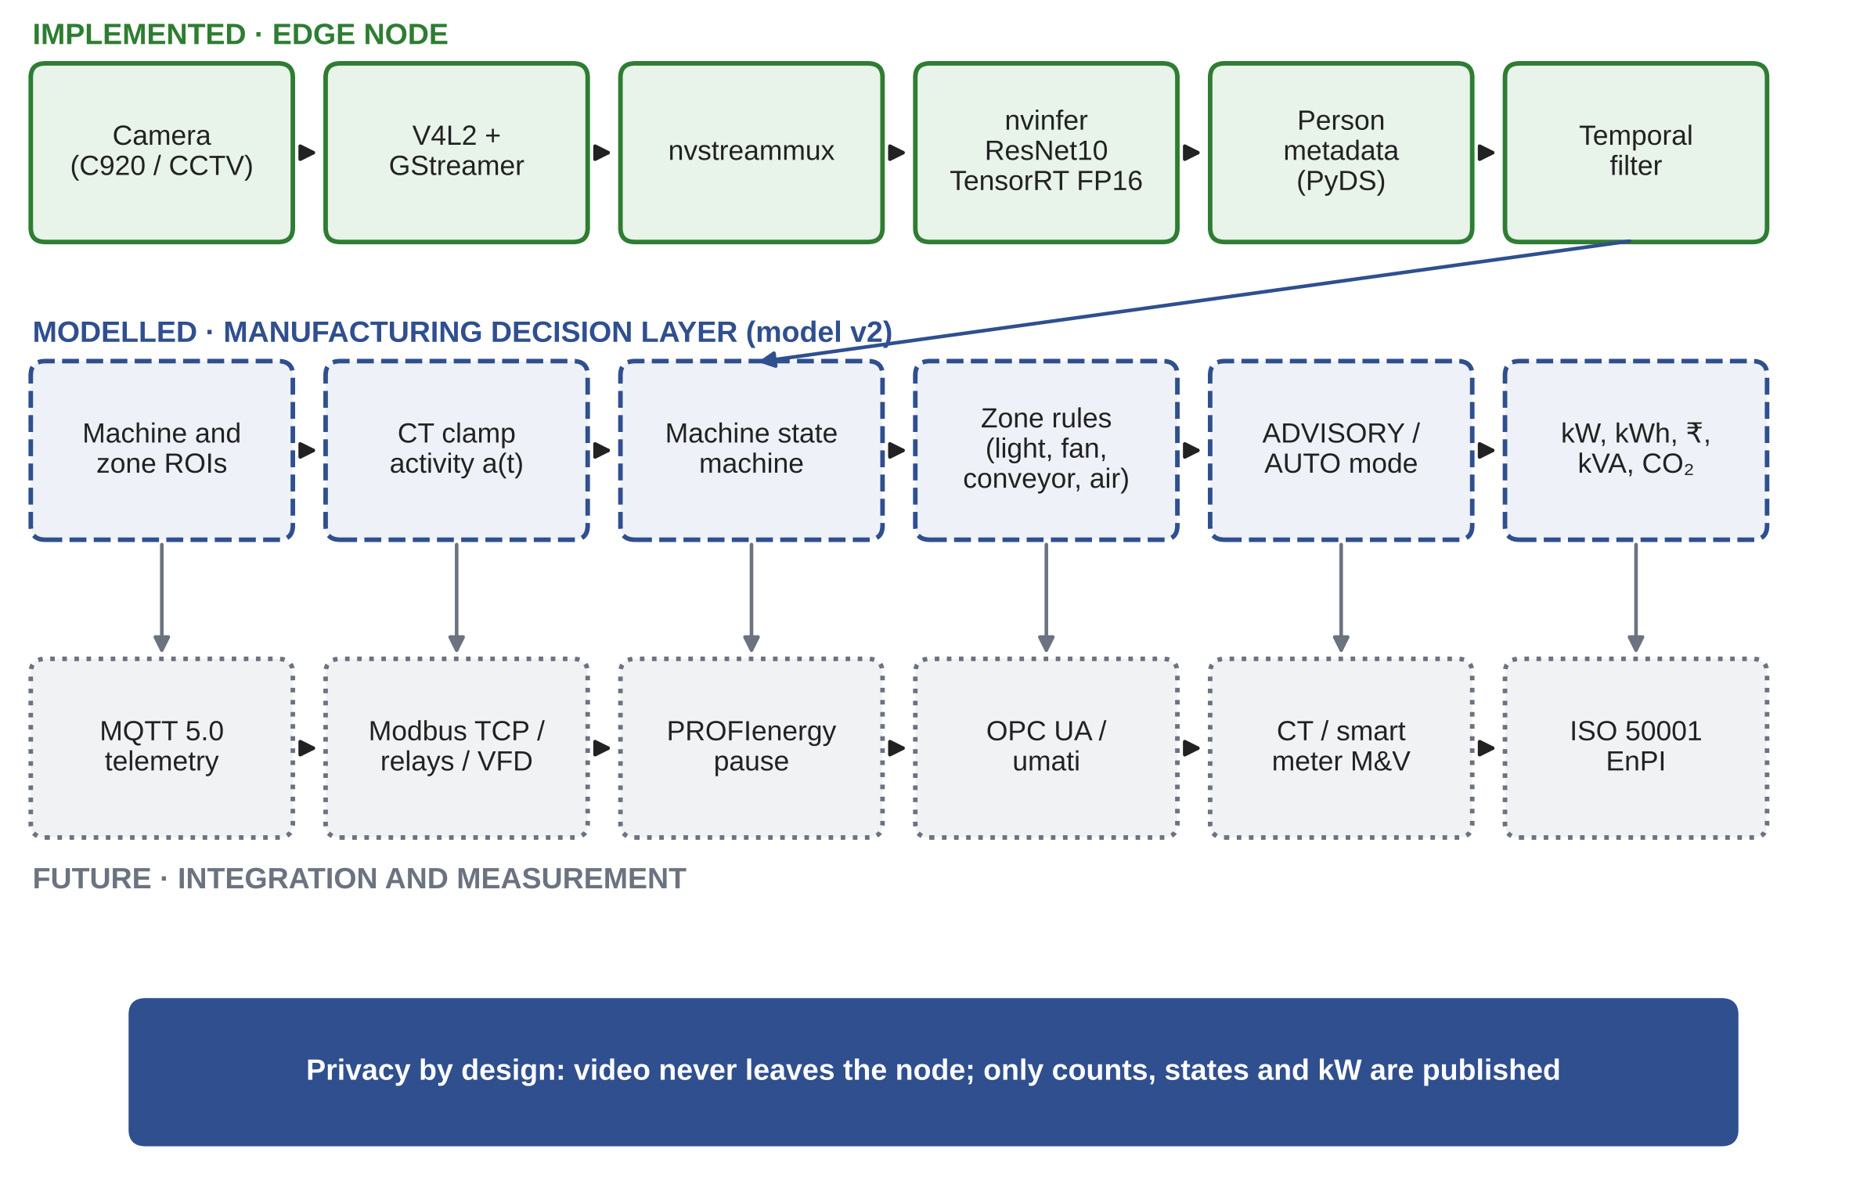
Figure 3.1 System architecture with implementation status
Writing notes (target about 300 words)
• Walk through the three rows of Figure 3.1. Stress: the implemented pipeline is kept and extended, not replaced.
• Only metadata leaves the node.
[TEAM TO WRITE]

3.2 ZONES AND REGIONS OF INTEREST
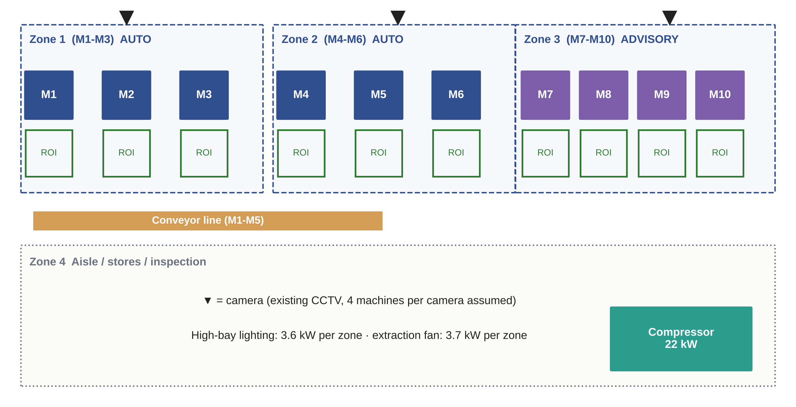
Figure 3.2 Reference machining shop with zones, machine ROIs and cameras
Writing notes (target about 250 words)
• Each machine has an operator ROI drawn in front of it (nvdsanalytics polygon).
• Zones 1 to 3 hold machines; Zone 4 is the aisle, stores and inspection area.
• Zone 3 holds precision machines, so it runs in ADVISORY mode.
[TEAM TO WRITE]

3.3 SIGNAL CONDITIONING (TEMPORAL FILTER)
The presence signal from the detector is passed through an asymmetric persistence filter, kept from Phase I:
o_f(t) = 1 if raw presence held for t_rise = 10 s; o_f(t) = 0 if absence held for t_fall = 60 s (3.1)
a_f(t) = 1 if I_k(t) > I_th; a_f(t) = 0 only after I_k(t) < I_th for 30 s (3.2)
Writing notes (target about 200 words)
• Explain why rise is short (serve the operator fast) and fall is long (do not sleep a machine when the operator bends down or is briefly hidden).
• Phase I result to quote: 2,633 to 9 state changes per day, 99.1 % time in correct state (office, model v1).
[TEAM TO WRITE]

3.4 MACHINE STATE MACHINE
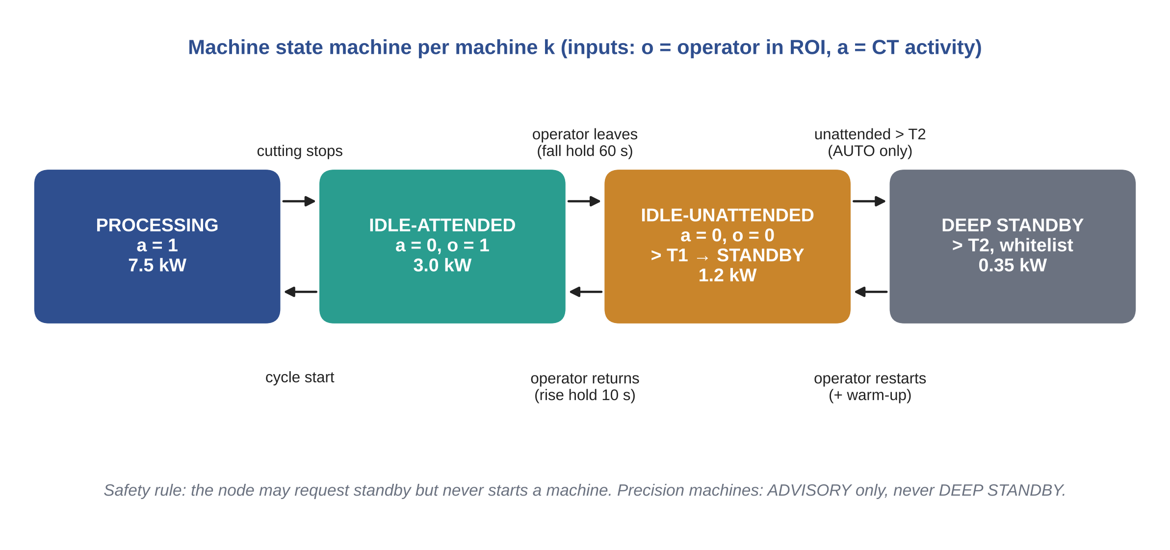
Figure 3.3 Machine state machine with transition conditions
Table 3.1 Machine states, conditions, power and action
State | Condition | Power (kW) | Action
PROCESSING | a = 1 | 7.5 | None
IDLE-ATTENDED | a = 0, o = 1 | 3.0 | None (set-up, measuring, tool change)
IDLE-UNATTENDED | a = 0, o = 0 for more than T1 = 3 min | 1.2 (standby) | ADVISORY alert; AUTO standby if whitelisted
DEEP STANDBY | unattended more than T2 = 30 min and whitelisted | 0.35 | AUTO deep standby; operator restarts with warm-up
Power values are ASSUMED for a vertical machining centre (Chapter 5).

3.5 MULTI-LOAD ACTIONS
Table 3.2 Rules for shared loads
Load | Baseline | Rule with edge node | Mode
Conveyor (2.2 kW) | Runs whole shift | Stop when no line machine processing for 2 min | AUTO
Compressor (22 kW) | Runs whole shift | Stop and isolate when whole shop idle for 5 min | AUTO
High-bay lighting (3.6 kW per zone) | All on in shift | Dim to 10 % when zone empty for 2 min | AUTO
Extraction fan (3.7 kW per zone) | On in shift | Off when zone empty and no machine processing for 5 min | AUTO

3.6 ADVISORY AND AUTOMATIC MODES
Writing notes (target about 300 words)
• ADVISORY default: dashboard alert with machine, minutes unattended, kW and Rs per hour lost; supervisor decides.
• AUTO only on a whitelist; never furnaces, moulding barrels, heat treatment, or a machine with a cycle in progress.
• Node never restarts a machine; operator presses Resume (machinery safety principle).
[TEAM TO WRITE]

3.7 PRIVACY AND WORKER ACCEPTANCE
Writing notes (target about 250 words)
• Process on device, publish counts and states only, no face recognition, no image storage.
• DPDP Act 2023: purpose limitation and minimisation; core provisions due by May 2027 [CHECK].
• Signage and works-committee consent; use data for energy, not for appraisals.
[TEAM TO WRITE]
CHAPTER 4

IMPLEMENTATION OF THE EDGE NODE

4.1 HARDWARE
Table 4.1 Edge node hardware (IMPLEMENTED)
Item | Specification | Cost (Rs)
NVIDIA Jetson Nano Developer Kit | 4 GB, 128-core Maxwell GPU | 13,000
Camera | Logitech C920 USB (existing CCTV in deployment) | 1,300
Storage | 64 GB microSD | 700
Power supply | 5 V / 4 A | 500
Cooling | Heatsink + fan | 600
Networking and misc. | Wi-Fi, cabling | 1,400
Total |  | 17,500

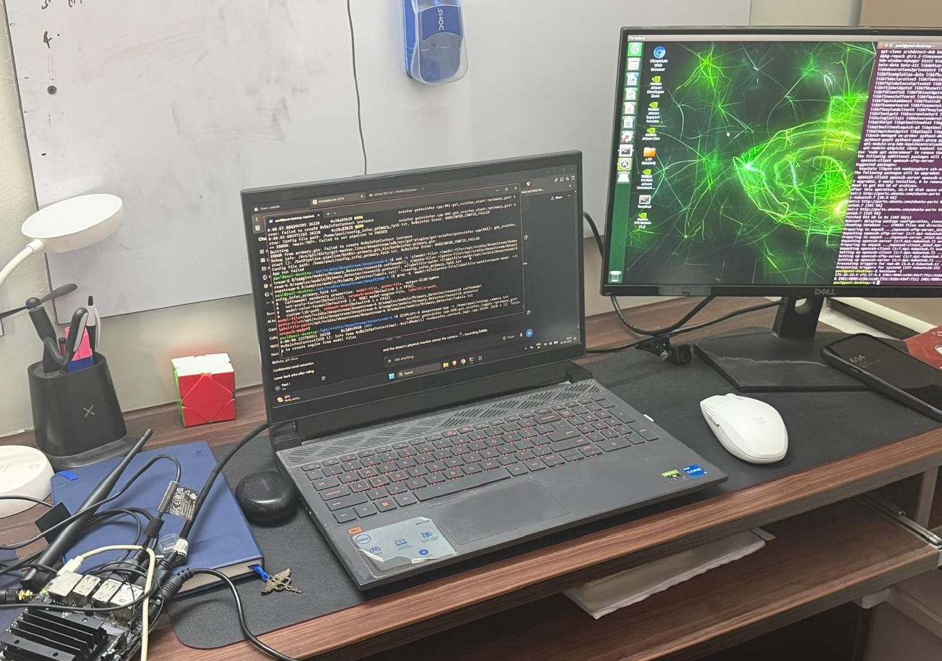
Figure 4.1 Prototype bench set-up with Jetson Nano and live output

4.2 SOFTWARE PIPELINE
Table 4.2 DeepStream pipeline elements
Stage | Element | Function
Capture | v4l2src / GStreamer | Read camera frames
Batching | nvstreammux | Form GPU batches
Inference | nvinfer (ResNet10, TensorRT FP16) | Detect persons
Metadata | PyDS probe | Read object metadata, count persons
Filtering | Python | Rise/fall persistence filter
Output | live_state.json | State and load for dashboard

Writing notes (target about 600 words)
• Describe each stage in your own words with the config file names you used. Insert short code excerpts in Appendix 3.
• Add the TensorRT engine build step and why FP16 suits the Nano.
[TEAM TO WRITE]

4.3 LIVE DETECTION AND DASHBOARD
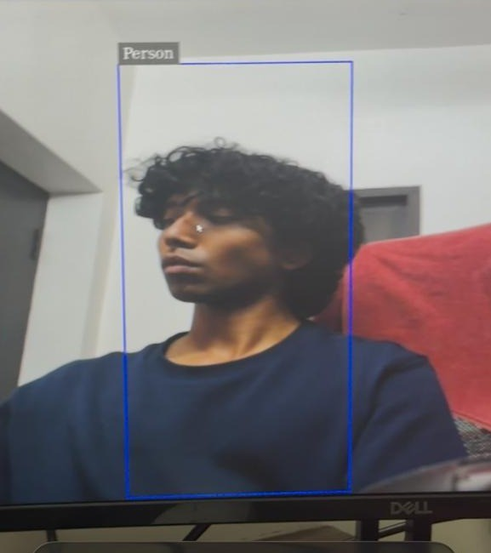
Figure 4.2 Live person detection on the Jetson Nano
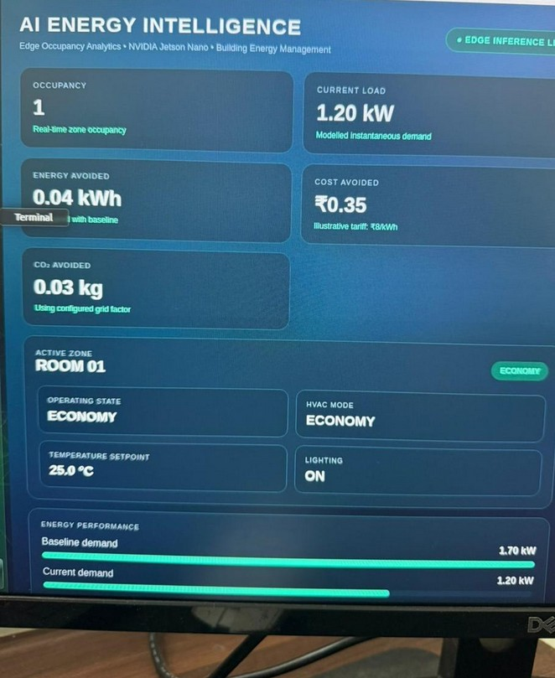
Figure 4.3 Live energy dashboard (office mode)
Writing notes (target about 300 words)
• Explain the dashboard fields. State that the kW and Rs values shown are modelled from state, not metered.
[TEAM TO WRITE]

4.4 EXTENSION FOR THE FACTORY (PLANNED)
Writing notes (target about 300 words)
• nvdsanalytics ROI config per machine; INA219/SCT-013 + ADS1115 activity input; relay output; mode switch.
• Point to the bench demo plan (Appendix 4).
[TEAM TO WRITE]

4.5 MEASUREMENTS TO REPORT
[TEAM TO MEASURE AND FILL] FPS, end-to-end latency, Jetson input power (USB meter), precision and recall on 200 labelled frames.
CHAPTER 5

ELECTRICAL ENERGY MODELLING

5.1 MACHINE POWER MODEL
Each machine k is in one state s_k(t) at every time step; its power is taken from the state table:
P_k(t) = P_state( s_k(t) ) (5.1)
P_shop(t) = Σ_k P_k(t) + P_comp(t) + P_conv(t) + Σ_j [ P_light,j(t) + P_fan,j(t) ] (5.2)
Table 5.1 Power assumptions (model v2)
Load | Value | Basis
CNC processing | 7.5 kW | ASSUMED, consistent with 13 kW roughing example (Heidenhain 2011)
CNC idle | 3.0 kW | ASSUMED 40 % of processing; swept 0.25 to 0.55
CNC standby / deep standby | 1.2 / 0.35 kW | ASSUMED
Warm-up after deep standby | 4.0 kW for 10 min | ASSUMED
Compressor | 22.0 kW, unload 30 %, leak 25 % | Leak range from DOE (2003)
Conveyor | 2.2 kW | ASSUMED
Lighting per zone | 3.6 kW | ASSUMED 24 x 150 W LED
Fan per zone | 3.7 kW | ASSUMED
Power factor | 0.90 | ASSUMED

5.2 COMPRESSOR MODEL
P_comp = P_full [ f + (1 - f) α_u ], f = min( 1, λ_leak + β N_proc ) (5.3)
Writing notes (target about 150 words)
• α_u: unloaded fraction; λ_leak: leak demand; β: air demand per processing machine; N_proc: machines processing.
[TEAM TO WRITE]

5.3 ENERGY, DEMAND AND COST
E = Σ_t P(t) Δt (5.4)
E_saved = E_base - E_ctrl (5.5)
MD = max_b [ (1/n) Σ_(t in b) P(t) ] / PF (5.6)
C = E c_E + max( MD, 0.9 CD ) c_D (5.7)
LF = P_avg / P_peak (5.8)
IER = E_non-processing / E_total (5.9)
CO2 = E_saved × EF (5.10)
Table 5.2 Tariff and emission inputs
Item | Value | Source
Energy charge c_E | Rs 7.50/kWh | TNERC T.O. No. 6 of 2025, HT-I
Demand charge c_D | Rs 608/kVA/month | TNERC T.O. No. 6 of 2025, HT-I
Billing demand | max(recorded, 90 % of CD) | TNERC
Contract demand CD | 130 kVA | ASSUMED
Emission factor | 0.71 kg CO2/kWh | CEA v21.0, FY 2024-25
Working days | 300 per year | ASSUMED

5.4 OPERATIONS MODEL OF THE REFERENCE SHOP
Table 5.3 Shift events per machine (stochastic model)
Event | Model | Operator
Machining cycle | exponential, mean 12 min; load/unload 2 min | present
Start-of-shift set-up | 10 min | present
Tea breaks | 15 min at +2 h and +6 h | absent
Lunch | 30 min at +4 h | absent
Material wait | Poisson 1.5/shift, lognormal median 15 min | absent with p = 0.7
Tool change | Poisson 2.0/shift, mean 8 min | present
Breakdown | p = 0.08/shift, 45 to 120 min | absent with p = 0.6
Left on overnight | p = 0.3 per machine | absent

Writing notes (target about 250 words)
• Detector model: 10 % per-sample miss (as Phase I), 0.2 % false positive, occlusion bursts 2 per shift with mean 90 s.
• Time step Δt = 10 s, fixed seed 2026, all inputs in assumptions.yaml (Appendix 1).
[TEAM TO WRITE]
CHAPTER 6

SIMULATION RESULTS AND DISCUSSION
All results in this chapter are MODELLED (model v2). Numbers are generated by the code in Appendix 2.

6.1 S1: ONE MACHINE OVER ONE SHIFT
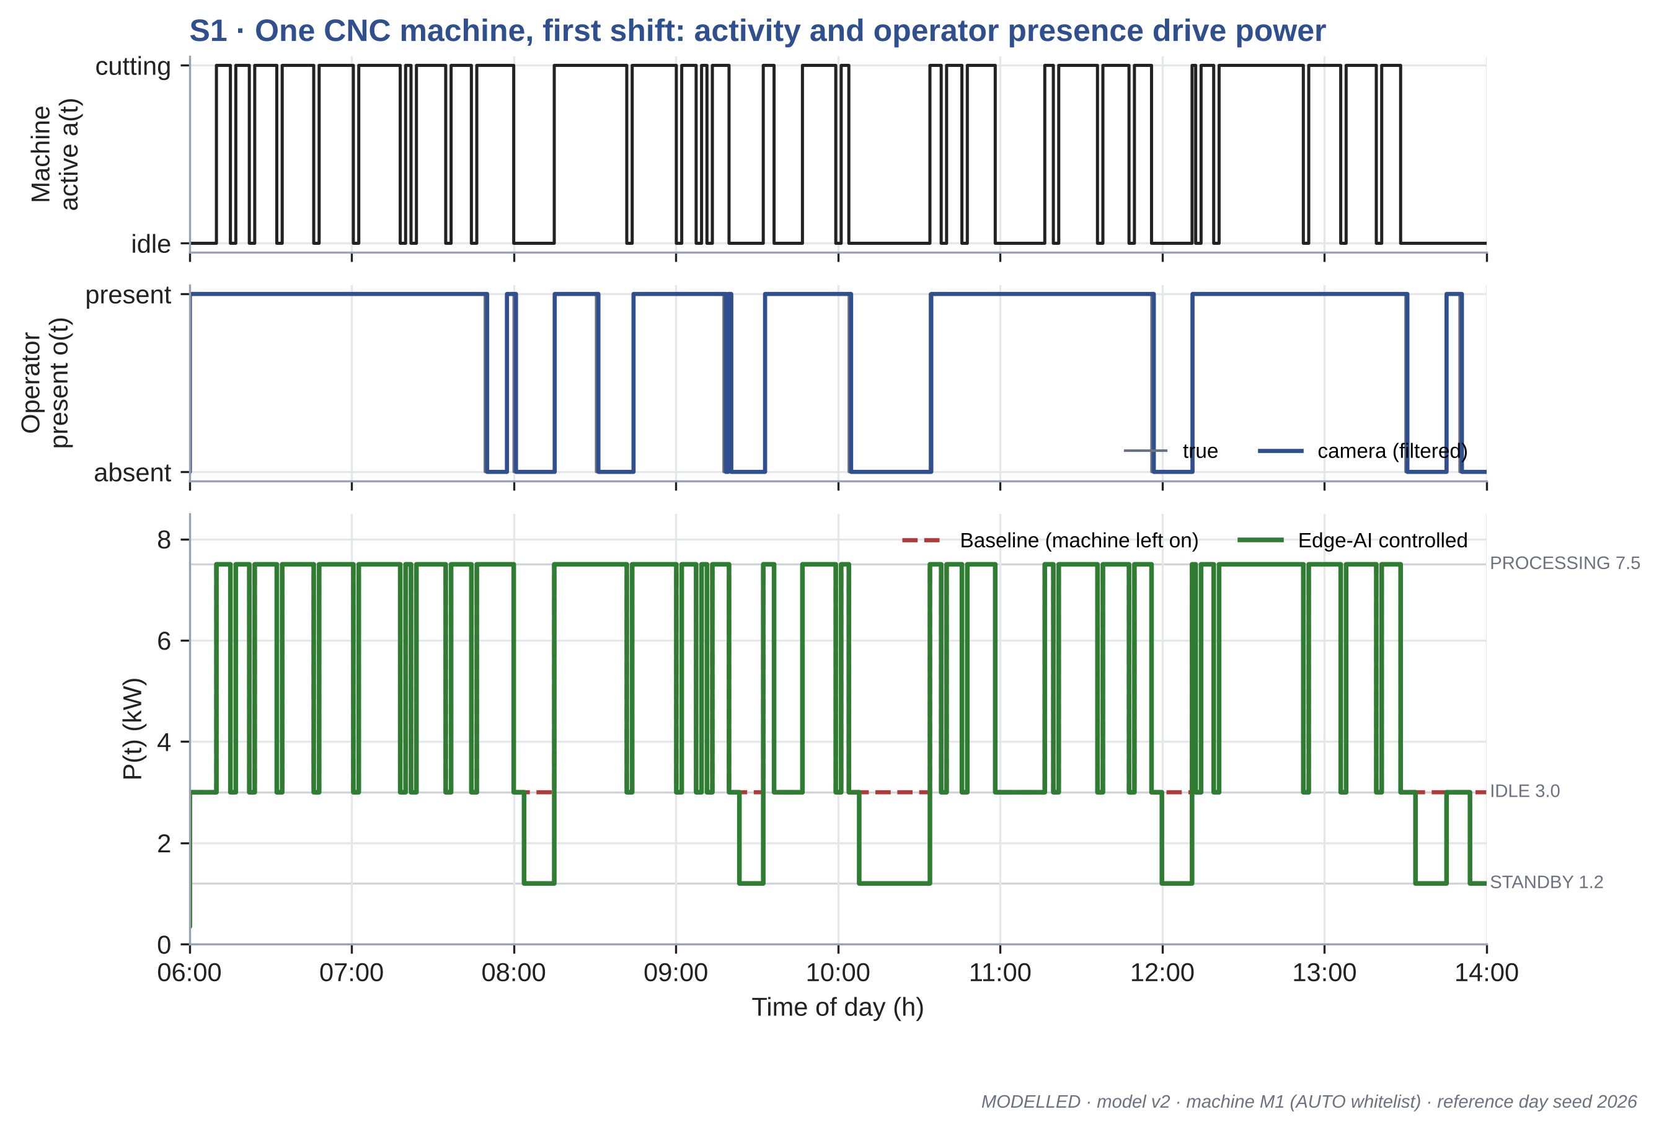
Figure 6.1 Activity, operator presence and power of one machine over one shift
Writing notes (target about 250 words)
• Machine M1: 45.6 to 43.4 kWh in the shift (4.9 %).
• Point to the standby dips during tea break, lunch and material waits; idle-attended periods are left alone.
[TEAM TO WRITE]

6.2 S2: WHOLE SHOP CUMULATIVE ENERGY
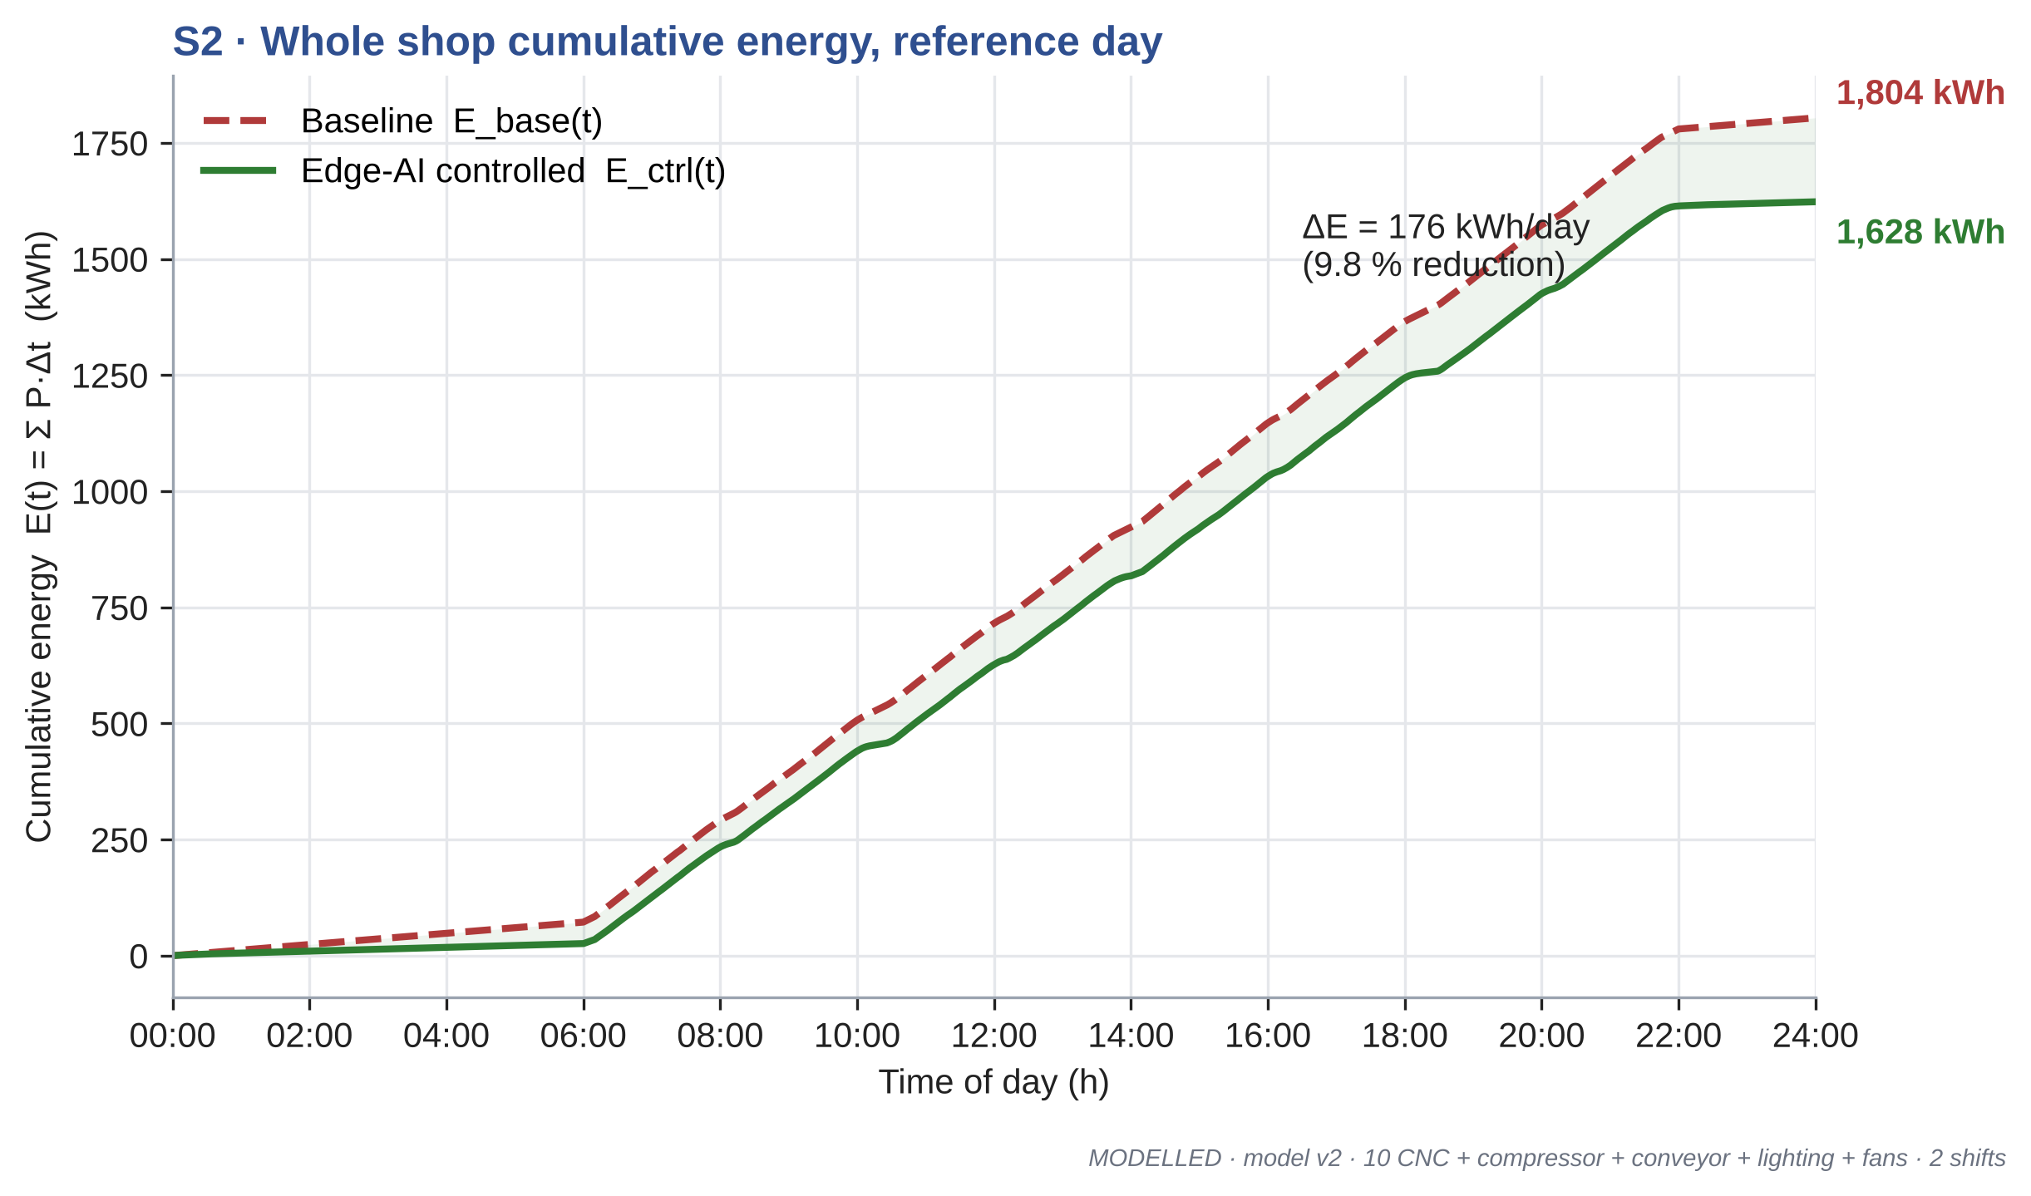
Figure 6.2 Cumulative energy of the shop on the reference day
Writing notes (target about 200 words)
• Reference day: 1,804 to 1,628 kWh (9.8 %).
• Quote the Monte-Carlo mean (8.5 %) as the headline; the reference day is one sample.
[TEAM TO WRITE]

6.3 S3: SAVINGS BY LOAD TYPE
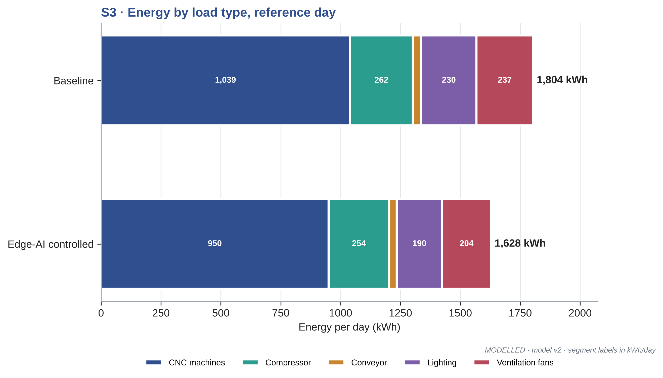
Figure 6.3 Energy by load type, baseline and controlled
Table 6.1 Mean daily saving by load type (Monte-Carlo)
Load | Saving (kWh/day)
CNC machines | 68.5
Compressor | 9.1
Conveyor | 4.2
Lighting | 38.2
Ventilation fans | 31.2

Writing notes (target about 250 words)
• Machines give the largest absolute saving; lighting and fans the largest percentage. The same camera drives all of them, which answers the experts' second point.
[TEAM TO WRITE]

6.4 S4: LOAD-DURATION CURVE, LOAD FACTOR AND MAXIMUM DEMAND
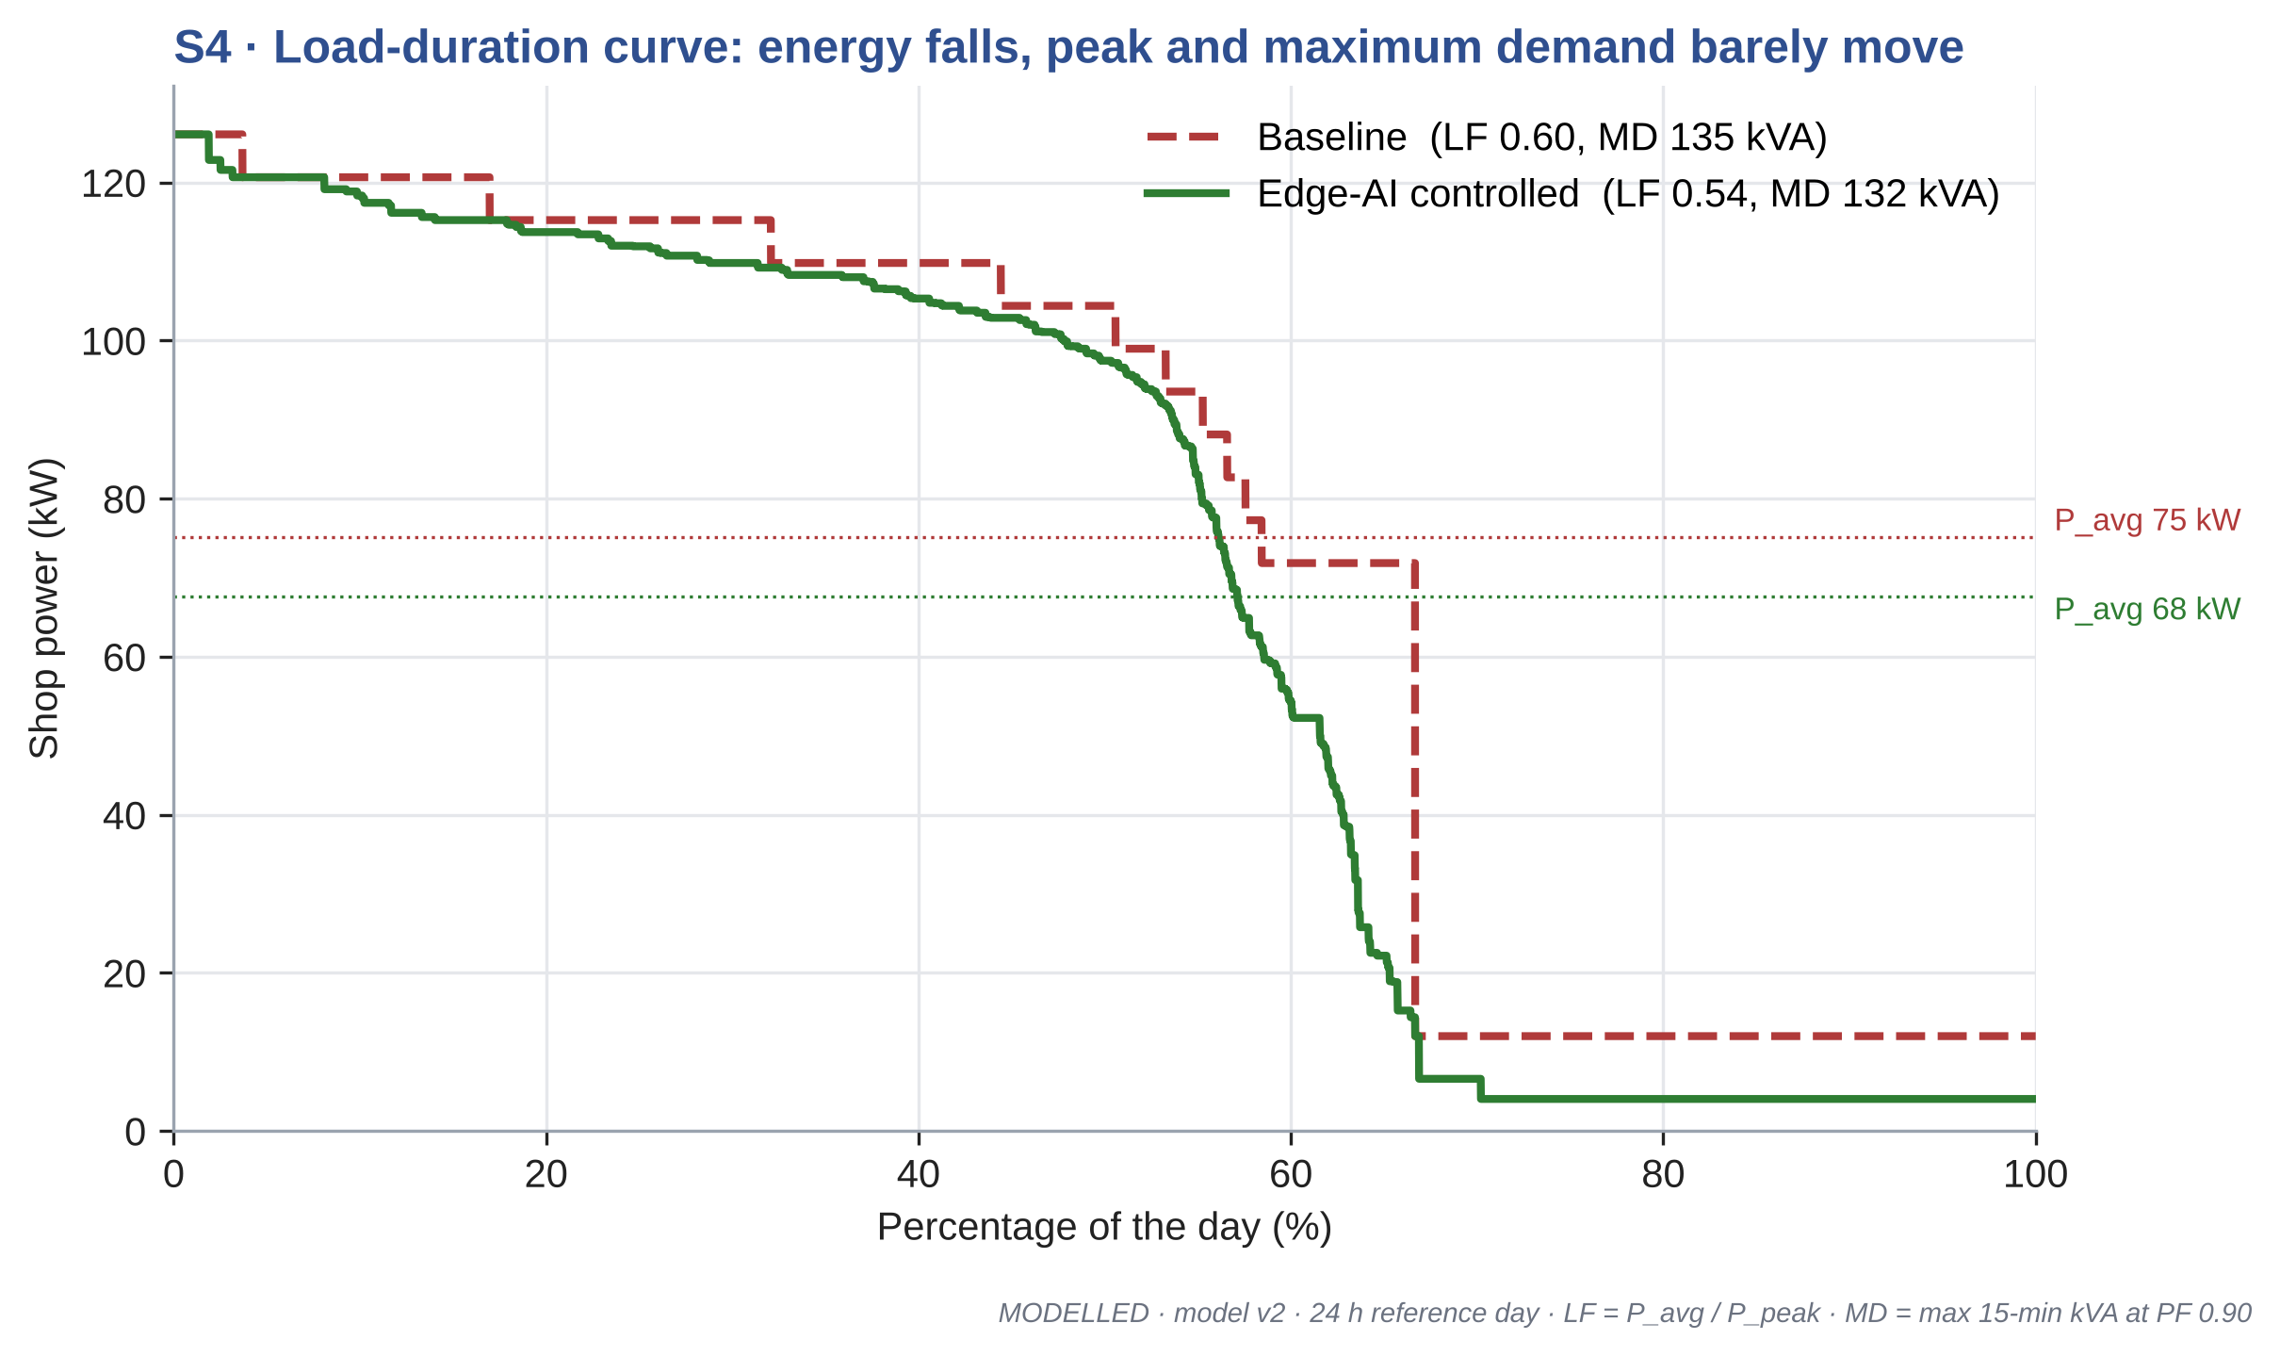
Figure 6.4 Load-duration curve of the shop
Table 6.2 Electrical indices (reference day)
Index | Baseline | Controlled
Average power (kW) | 75.2 | 67.6
Peak power (kW) | 126.1 | 126.1
Load factor | 0.60 | 0.54
Maximum demand, 15 min (kVA) | 135.3 | 132.0

Writing notes (target about 300 words)
• Honest claim: energy falls; peak and MD hardly change because the peak occurs when all machines cut together. Load factor falls since average falls and peak stays.
• Demand saving is therefore small (Table 6.4); a demand-limiting feature is future work.
[TEAM TO WRITE]

6.5 S5: MONTE-CARLO ROBUSTNESS
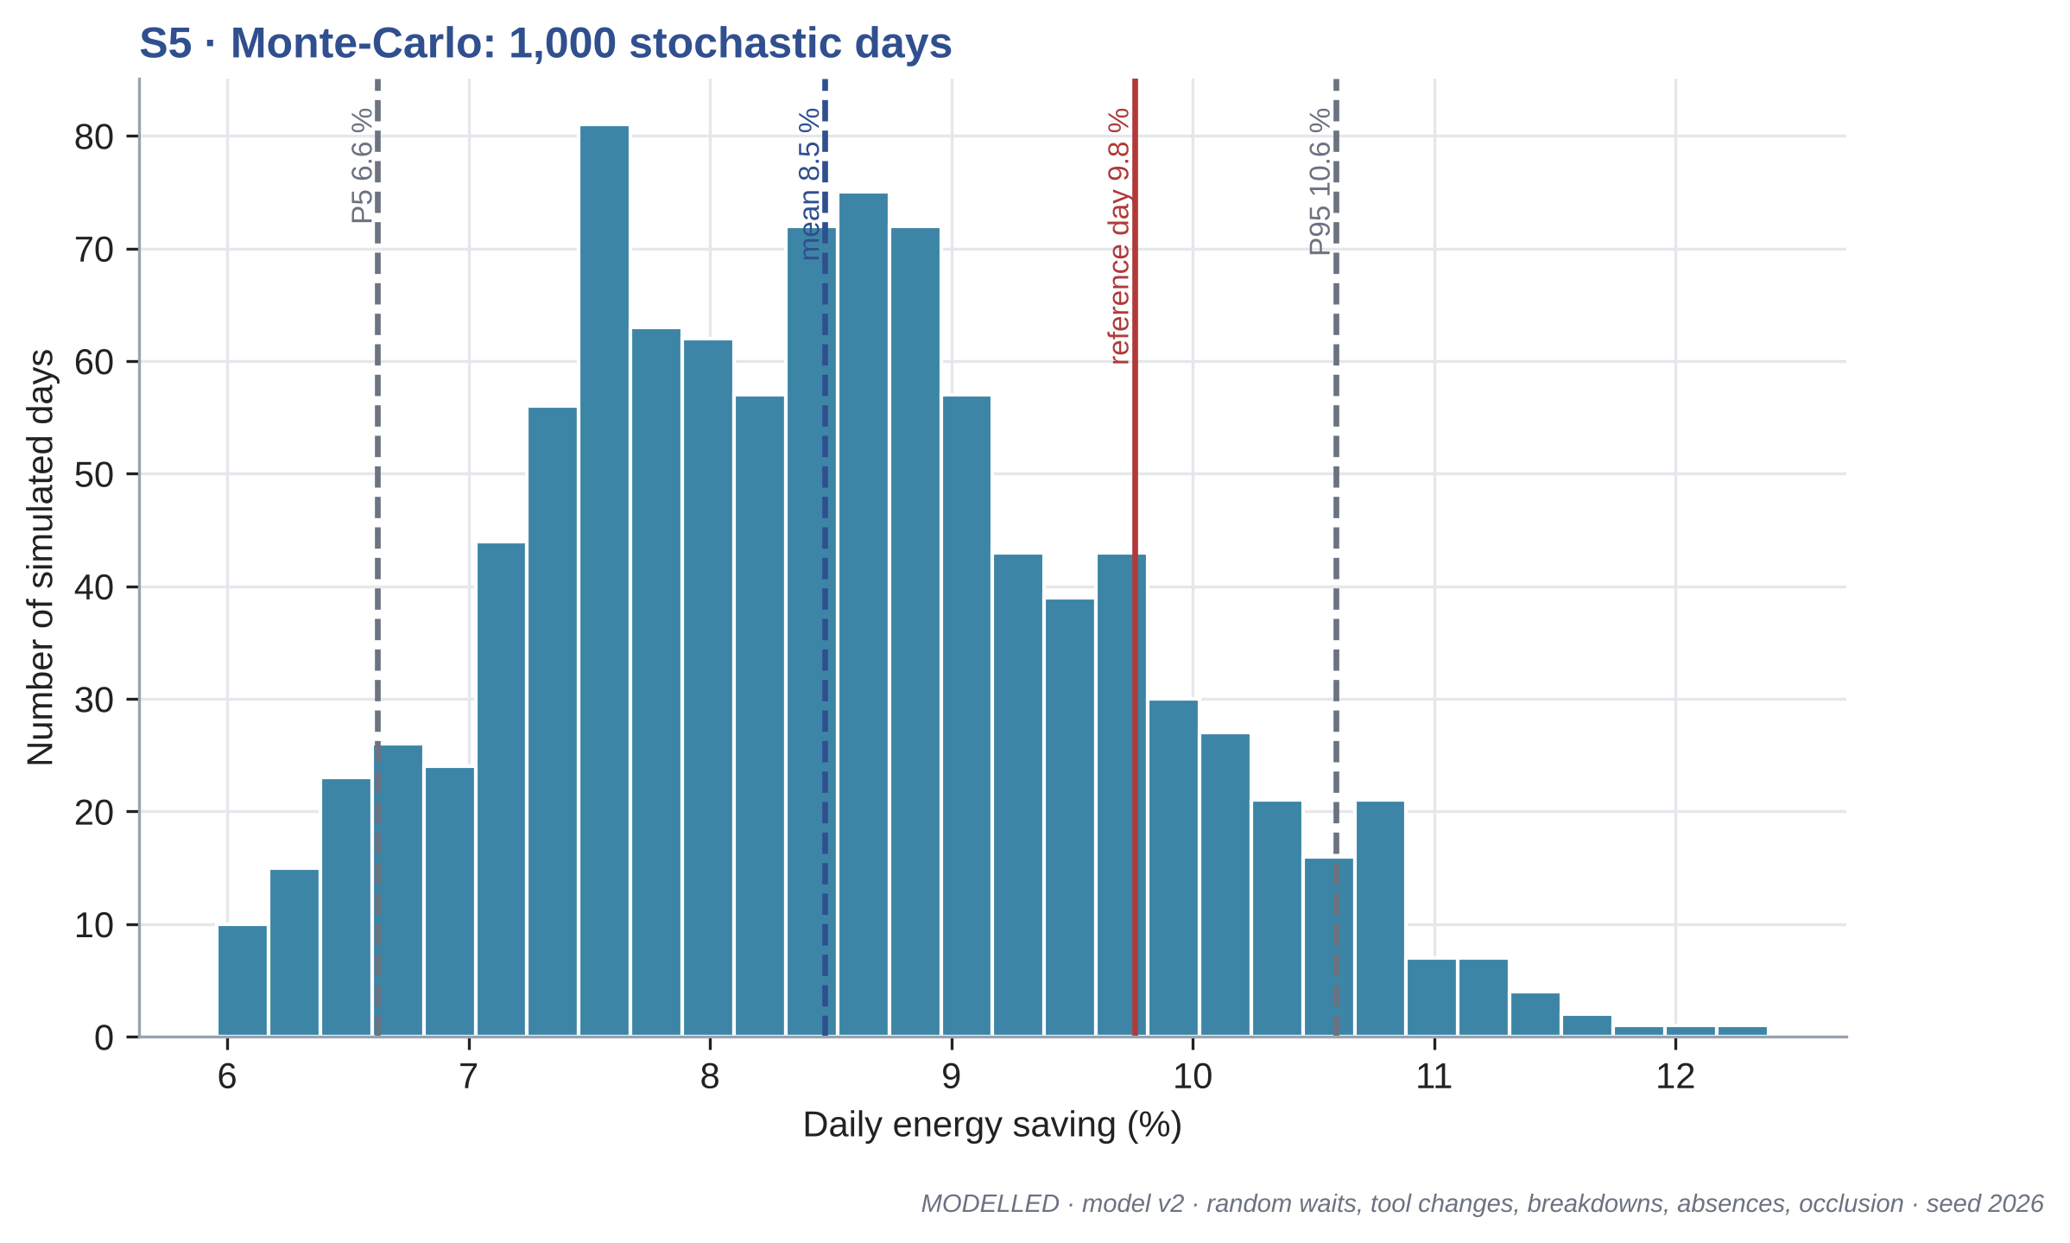
Figure 6.5 Distribution of daily saving over 1,000 simulated days
Table 6.3 Headline results (Monte-Carlo)
Quantity | Value
Mean shop energy, baseline to controlled | 1,778 to 1,627 kWh/day
Mean saving (P5 / P95) | 8.5 % (6.6 / 10.6 %)
Days with positive saving | 100.0 %
Energy avoided | 45,295 kWh/yr
Cost saving, energy / demand / total | Rs 339,710 / Rs 7,098 / Rs 346,808 per year
CO2 avoided | 32.2 t/yr
Idle-energy ratio (EnPI) | 13.9 % to 11.0 %
Mean maximum demand | 134.4 to 133.2 kVA

6.6 S6: SENSITIVITY ANALYSIS
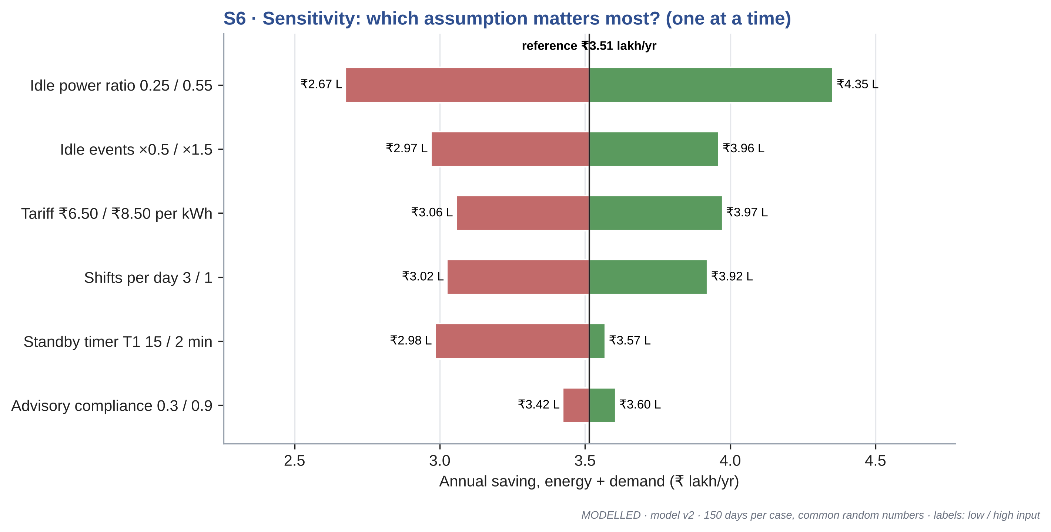
Figure 6.6 One-at-a-time sensitivity of the annual saving
Writing notes (target about 300 words)
• The idle-to-processing power ratio matters most, followed by the number of idle events and the tariff.
• These are the two numbers that must be measured on a real machine (CT clamp) before deployment.
• Advisory compliance matters little here because only 4 of 10 machines are advisory.
[TEAM TO WRITE]

6.7 S7: TIMER STUDY (FALSE AND NUISANCE STANDBY)
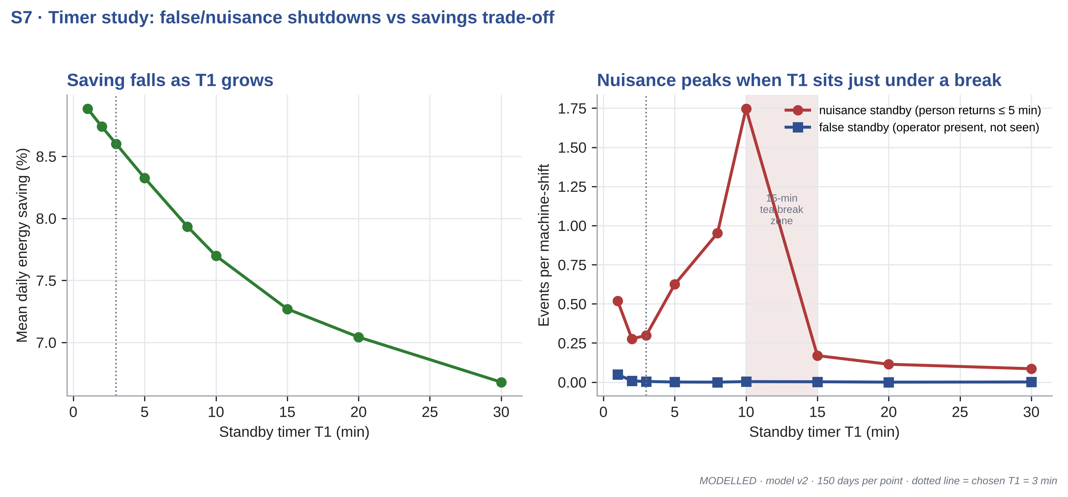
Figure 6.7 Timer T1 versus saving and nuisance or false standby events
Table 6.4 Timer study results
T1 (min) | Saving (%) | Nuisance per machine-shift | False standby per machine-shift
1 | 8.88 | 0.52 | 0.049
2 | 8.74 | 0.28 | 0.008
3 | 8.60 | 0.30 | 0.004
5 | 8.33 | 0.62 | 0.001
8 | 7.93 | 0.95 | 0.000
10 | 7.70 | 1.75 | 0.003
15 | 7.27 | 0.17 | 0.002
20 | 7.04 | 0.11 | 0.000
30 | 6.68 | 0.09 | 0.001

Writing notes (target about 350 words)
• Key engineering result: nuisance standbys peak when T1 sits just under the 15-min tea break; T1 = 3 min gives more saving and fewer nuisance events than 5 to 10 min.
• Very short T1 (1 min) raises false standbys when an operator is briefly hidden.
• Recommendation: T1 = 3 min, plus a planned pause command at the start of scheduled breaks (PROFIenergy).
[TEAM TO WRITE]

6.8 S8: PAYBACK PER NODE
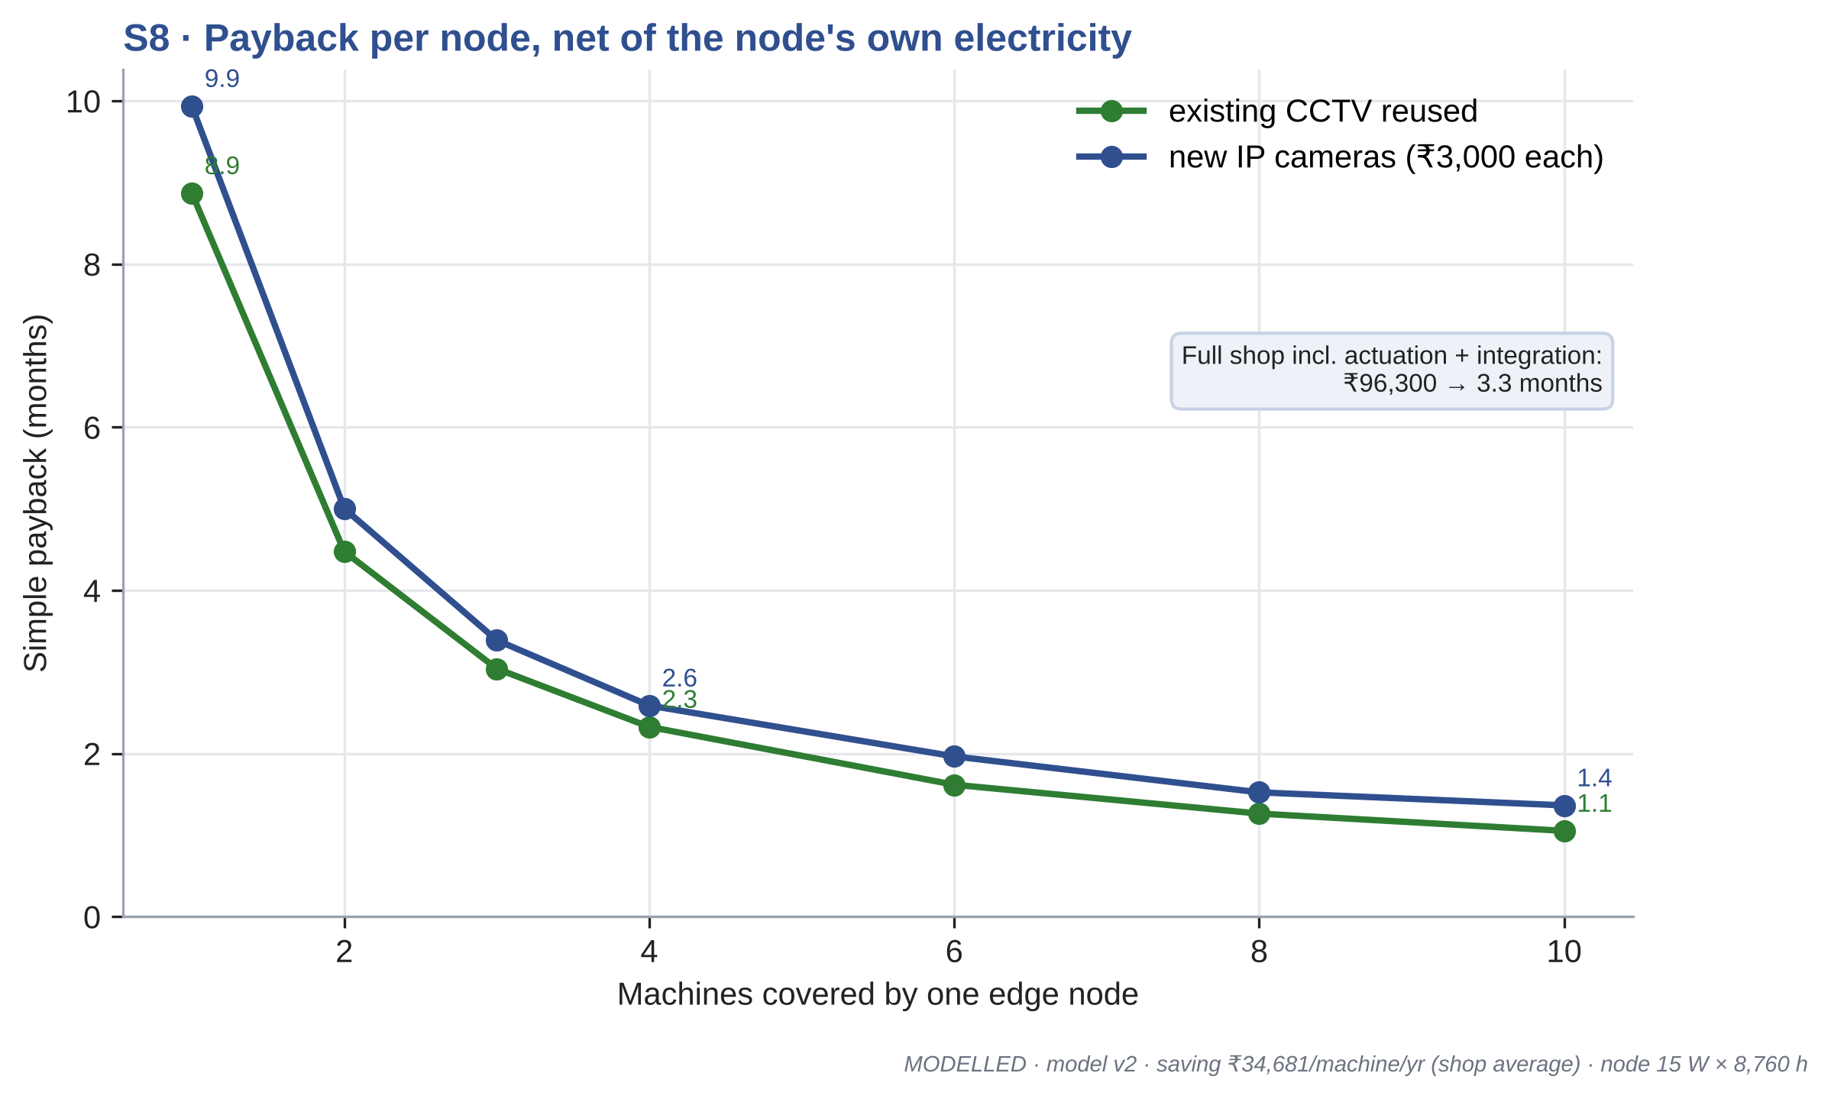
Figure 6.8 Simple payback versus machines covered per edge node
Writing notes (target about 250 words)
• Full shop, including actuation and integration: Rs 96,300, payback 3.3 months (CCTV reused); Rs 105,300 and 3.7 months with new cameras.
• The node's own electricity is 131 kWh/yr, 0.29 % of the saving.
• Payback is short because one node serves many machines and shared loads; prices are indicative.
[TEAM TO WRITE]

6.9 S9: GENERALITY, OFFICE CASE
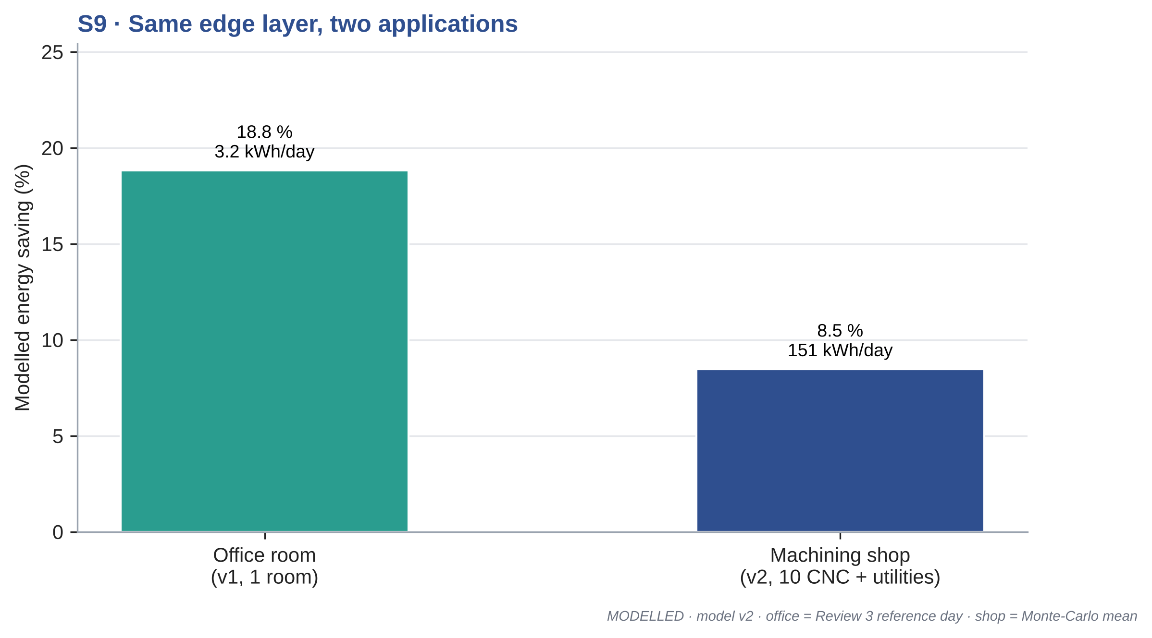
Figure 6.9 Same edge layer applied to an office room and a machining shop
Writing notes (target about 200 words)
• Office (model v1): 18.8 %, 1,168 kWh/yr; payback corrected from 22.5 to 24.8 months once the node's own load is subtracted.
• The factory saving in percent is lower because machines are busy most of the shift, but the absolute saving is far larger.
[TEAM TO WRITE]

6.10 DISCUSSION
Writing notes (target about 500 words)
• Compare with literature: building studies 6 to 24 %; our factory figure is lower in percent but large in kWh.
• Limitations: assumed powers, synthetic events, no measured data, single shop type.
• What would change the answer: measured idle power ratio and real idle-event logs.
[TEAM TO WRITE]
CHAPTER 7

ECONOMICS, STANDARDS AND DEPLOYMENT ROADMAP

7.1 COST OF A DEPLOYMENT
Table 7.1 Indicative cost for the 10-machine shop (CCTV reused)
Item | Qty | Cost (Rs)
Jetson Nano + PSU, SD, enclosure | 1 | 16,300
Relay / Modbus I/O module | 1 | 3,500
CT clamps | 10 | 6,000
CT interface (ADC / Modbus meter) | 1 | 2,500
Installation misc. | 1 | 2,000
Lighting zone dimming interface | 4 | 24,000
Fan contactors | 4 | 12,000
Conveyor interlock + compressor isolation valve | 1 | 5,000
Integration and commissioning | 1 | 25,000
Total |  | 96,300
Indicative retail prices, October 2026 (ASSUMED).

7.2 STANDARDS AND CONTROL PATHS
Table 7.2 Standards and their role
Standard | What it does | Use in this work
ISO 14955-1:2017 | Design method for energy-efficient machine tools | Reference for machine energy states
ISO 14955-2 | Measurement of energy supplied to machine tools | Future M&V of machine kW
PROFIenergy (PI) | PROFINET pause and standby commands | AUTO path for PROFINET machines
OPC UA (IEC 62541) / umati | Vendor-neutral machine data model | Second source of machine state
Modbus TCP | Register read/write for meters, VFDs, relays | CT meter and relay I/O
MQTT 5.0 | Lightweight publish/subscribe | Node to dashboard / SCADA
ISO 50001:2018 | Energy management system | Where the node sits in an EnMS
ISO 50006:2014 | Baselines and EnPIs | Idle-energy ratio as EnPI
ISO 50015:2014 / IPMVP | Measurement and verification | M&V plan (Option B)

7.3 MEASUREMENT AND VERIFICATION PLAN
Writing notes (target about 400 words)
• IPMVP Option B (retrofit isolation): CT on each machine and on compressor and lighting feeders.
• Baseline period 2 weeks with node in ADVISORY-only logging; reporting period 2 weeks AUTO.
• Normalise by parts produced (kWh/part) and by shift hours; report IER before and after.
[TEAM TO WRITE]

7.4 DEPLOYMENT ROADMAP
Writing notes (target about 300 words)
• Step 1 bench demo (Appendix 4); Step 2 one machine in a partner MSME (ADVISORY); Step 3 zone loads AUTO; Step 4 whitelist machines AUTO; Step 5 MQTT/SCADA integration.
[TEAM TO WRITE]
CHAPTER 8

CONCLUSION AND FUTURE WORK

8.1 CONCLUSIONS
Writing notes (target about 400 words)
• Restate each objective with its status and one number.
• Headline: 8.5 % modelled energy saving, 45,295 kWh/yr, Rs 346,808/yr, 32.2 t CO2/yr for a 10-machine shop.
• Honest: energy, not peak demand; modelled, not measured.
[TEAM TO WRITE]

8.2 MAPPING TO SUSTAINABLE DEVELOPMENT GOALS
Table 8.1 SDG mapping
SDG | Link
SDG 7 Affordable and clean energy | Cuts avoidable electricity use in factories
SDG 9 Industry, innovation and infrastructure | Adds edge AI to existing CCTV in MSMEs
SDG 12 Responsible consumption and production | Lower energy per part produced
SDG 13 Climate action | 32.2 t CO2/yr avoided per shop (modelled)

8.3 FUTURE WORK
Writing notes (target about 300 words)
• Measure idle power ratio and idle events on real machines; replace assumptions.
• Bench demo with CT and relay; then a pilot in an MSME.
• Demand-limiting: stagger restarts after lunch to cut MD.
• PROFIenergy and OPC UA integration; detector retraining for factory PPE and occlusion.
[TEAM TO WRITE]

APPENDIX 1 MODEL ASSUMPTIONS
Full listing of sim_v2/assumptions.yaml (single spaced):
# sim_v2 assumptions. Every value is either SOURCED (ref id from 03_RESEARCH_FINDINGS.md)
# or ASSUMED (engineering estimate, swept in sensitivity S6 where it matters).
meta:
model: "model v2"
seed: 2026
dt_s: 10 # time step (s)
days_per_year: 300 # ASSUMED: 6-day week, holidays removed
mc_days: 1000

shop: # Reference Indian MSME machining shop (ASSUMED layout)
n_machines: 10
whitelist_auto: [0, 1, 2, 3, 4, 5] # general-purpose machines: AUTO standby + deep standby
precision_advisory: [6, 7, 8, 9] # precision machines: ADVISORY only, never deep standby
zones: # machine index lists per floor zone; zone 3 = aisle/stores/inspection
- [0, 1, 2]
- [3, 4, 5]
- [6, 7, 8, 9]
- []
conveyor_line: [0, 1, 2, 3, 4]
shifts: [[6, 14], [14, 22]] # hours; 2-shift baseline (swept 1/3 in S6)

machine_power_kw: # per CNC vertical machining centre
processing: 7.5 # ASSUMED, consistent with N6 (13 kW roughing on a larger VMC)
idle: 3.0 # ASSUMED: 40 % of processing; fixed/aux load (N1-N4); swept 0.25-0.55
standby: 1.2 # ASSUMED: coolant pump, chip conveyor, hydraulics, lamp off
deep_standby: 0.35 # ASSUMED: CNC control only
warmup_kw: 4.0 # ASSUMED: warm-up cycle power after deep standby
warmup_min: 10 # ASSUMED (N22: thermal stability needs warm-up)

other_loads_kw:
conveyor: 2.2 # ASSUMED
compressor_full: 22.0 # ASSUMED 22 kW screw compressor, load/unload
compressor_unload_frac: 0.30 # ASSUMED unloaded power fraction
compressor_leak_frac: 0.25 # SOURCED range N9 (20-30 % of output, poorly maintained)
compressor_demand_per_proc_machine: 0.06 # ASSUMED fraction of capacity
lighting_per_zone: 3.6 # ASSUMED 24 x 150 W LED high-bay per zone
lighting_dim_frac: 0.10 # ASSUMED aisle-safety level when zone empty
fan_per_zone: 3.7 # ASSUMED one 3.7 kW extraction / ventilation fan per zone
power_factor: 0.90 # ASSUMED plant PF for kVA

operations: # per machine per shift (ASSUMED; scaled together in S6 "idle events")
cycle_proc_min: 12 # mean machining cycle
load_unload_min: 2 # operator present, machine idle
setup_start_min: 10 # start-of-shift set-up (attended idle)
tea_breaks_h: [2, 6] # hours after shift start
tea_min: 15
lunch_h: 4
lunch_min: 30
changeover_min: 15 # end of shift: 5 attended + 10 unattended
material_wait_rate: 1.5 # Poisson events / shift
material_wait_median_min: 15
material_wait_sigma: 0.6 # lognormal sigma
material_wait_p_absent: 0.7 # operator leaves (stores, crane)
tool_change_rate: 2.0
tool_change_min: 8 # exponential mean
breakdown_prob: 0.08 # per machine-shift
breakdown_min: [45, 120]
breakdown_p_absent: 0.6
short_absence_rate: 3.0
short_absence_min: 5 # exponential mean
night_left_on_prob: 0.30 # machine left powered (idle) overnight in baseline
aisle_busy_mean_min: 6 # zone 3 occupied spells
aisle_empty_mean_min: 10 # zone 3 empty spells

detection: # camera + filter (v1 values kept)
miss_prob: 0.10 # per-sample miss (v1 assumption)
false_pos_prob: 0.002
occlusion_rate: 2.0 # bursts / operator-shift where operator present but not visible
occlusion_mean_s: 90
rise_hold_s: 10
fall_hold_s: 60
ct_off_hold_s: 30

control:
T1_min: 3 # unattended -> standby (chosen from S7 timer study)
T2_min: 30 # unattended -> deep standby (whitelist only)
advisory_compliance: 0.6 # fraction of alerts acted on (ASSUMED, swept)
advisory_delay_min: 3
conveyor_hold_min: 2
compressor_hold_min: 5
light_hold_min: 2
fan_hold_min: 5
nuisance_window_min: 5 # standby counted "nuisance" if person/activity returns within this

tariff: # TN HT-I (N16-N18)
energy_rs_per_kwh: 7.50
demand_rs_per_kva_month: 608
contract_demand_kva: 130 # ASSUMED
billing_floor_frac: 0.90
days_per_month: 25

carbon:
ef_kg_per_kwh: 0.710 # CEA v21 (N20)

node: # indicative prices (ASSUMED, Oct 2026 retail)
jetson_rs: 13000
psu_sd_enclosure_rs: 3300
relay_io_modbus_rs: 3500
ct_per_machine_rs: 600
ct_interface_rs: 2500
camera_rs: 3000 # per IP camera if CCTV not reusable
machines_per_camera: 4
install_misc_rs: 2000
node_power_w: 15
node_hours_per_year: 8760

site_actuation: # full-shop actuation hardware + labour (ASSUMED indicative)
lighting_zone_rs: 6000 # contactor / 0-10 V dimming interface per zone
fan_contactor_rs: 3000 # per zone fan
conveyor_compressor_rs: 5000 # conveyor interlock + line isolation solenoid valve
integration_rs: 25000 # wiring, PLC/Modbus mapping, commissioning

office_v1: # S9: Review 3 office room, kept for generality
powers_kw: {Unoccupied: 0.30, Economy: 1.20, Comfort: 1.70, HighDemand: 2.00}
hours: {Unoccupied: 2, Economy: 2, Comfort: 4, HighDemand: 2}
baseline_kw: 1.70
baseline_h: 10
tariff: 8.0
days: 365
node_cost: 17500
node_w: 12.5

APPENDIX 2 SIMULATION CODE EXCERPT
def simulate(cfg, n_days=1, seed=None, keep_series=False, data=None):
seed = cfg["meta"]["seed"] if seed is None else seed
if data is None:
data = gen_days(cfg, n_days, seed)
A, O, ON, Z4, shift, rng = data["A"], data["O"], data["ON"], data["Z4"], data["shift"], data["rng"]
D, M, T = A.shape
dt = cfg["meta"]["dt_s"]
h = dt / 3600.0
mp, ol, ctl = cfg["machine_power_kw"], cfg["other_loads_kw"], cfg["control"]
st = lambda m: _steps(cfg, m)

Of = detect_and_filter(cfg, O, rng)
Af = off_hold(A, max(1, cfg["detection"]["ct_off_hold_s"] // dt))

white = np.zeros(M, bool)
white[cfg["shop"]["whitelist_auto"]] = True
T1, T2 = st(ctl["T1_min"]), st(ctl["T2_min"])
adv_delay = st(ctl["advisory_delay_min"])
nuis_win = st(ctl["nuisance_window_min"])

# ---- baseline machine power
Pm_base = np.where(ON == 1, np.where(A == 1, mp["processing"], mp["idle"]), 0.0)

# ---- controlled machine state machine
Pm_ctrl = np.zeros((D, M, T), np.float32)
state_ctrl = np.zeros((D, M, T), np.int8) if keep_series else None
timer = np.zeros((D, M), np.int32)
in_deep = np.zeros((D, M), bool)
sb_entry = np.full((D, M), -1, np.int64)
comply = np.zeros((D, M), bool)
warm_kwh = np.zeros(D)
n_standby = np.zeros(D)
n_nuisance = np.zeros(D)
n_false = np.zeros(D) # standby entered while operator truly present
for t in range(T):
on, af, of = ON[:, :, t] == 1, Af[:, :, t] == 1, Of[:, :, t] == 1
active = af | of
unatt = on & ~active
newly = unatt & (timer == 0)
comply = np.where(newly, rng.random((D, M)) < ctl["advisory_compliance"], comply)
timer = np.where(unatt, timer + 1, 0)
# leaving standby/deep
was_sb = sb_entry >= 0
leaving = was_sb & active
n_nuisance += (leaving & ((t - sb_entry) <= nuis_win)).sum(1)
warm_kwh += (leaving & in_deep).sum(1) * mp["warmup_kw"] * mp["warmup_min"] / 60.0
sb_entry = np.where(leaving | ~on, -1, sb_entry)
in_deep = np.where(leaving | ~on, False, in_deep)

in_shift = shift[t] == 1
sb_white = unatt & white[None, :] & (timer > T1)
sb_adv = unatt & ~white[None, :] & comply & (timer > T1 + adv_delay) & in_shift
sb = sb_white | sb_adv
deep = unatt & white[None, :] & (timer > T2)
entering = sb & (sb_entry < 0)
n_standby += entering.sum(1)
# false standby: operator truly present for the last 30 s but not seen by the camera
n_false += (entering & (O[:, :, max(0, t - 3):t + 1].min(2) == 1)).sum(1)
sb_entry = np.where(entering, t, sb_entry)
in_deep = in_deep | deep

# physical power follows the true machine activity; the node only changes idle draw
P = np.where(A[:, :, t] == 1, mp["processing"], mp["idle"])
P = np.where(sb, mp["standby"], P)
P = np.where(deep, mp["deep_standby"], P)
P = np.where(on, P, 0.0)
Pm_ctrl[:, :, t] = P
if keep_series:
s = np.where(af, PROC, np.where(of, IDLE_ATT, IDLE_UNATT))
s = np.where(sb, STANDBY, s)

APPENDIX 3 EDGE NODE CODE EXCERPTS
[TEAM TO INSERT] DeepStream config (nvinfer, nvdsanalytics ROI), PyDS probe function, temporal filter, dashboard JSON writer. Keep to about 2 pages.

APPENDIX 4 BENCH DEMONSTRATION PLAN
Goal: show, live on the existing Jetson, the full chain operator leaves → timer → IDLE-UNATTENDED → action → kWh and ₹ update.
Fallback if hardware fails: replay a recorded live_state.json log through the same dashboard (keep a screen recording too).
1. Bench set-up
[C920 camera] ──USB──► [Jetson Nano] ── GPIO / USB ──► [Relay module] ──► 230 V or 12 V "machine"
▲ │
└── ADS1115 (I²C) ◄── burden + SCT-013 CT ◄─────┘ (current = activity)
Desk = "workstation ROI"; small fan / drill / DC motor = "machine"
Two options for the "machine" (pick one; Option A is safer in a viva hall):
Option | Machine | Sensing | Switching | Safety
A (recommended) | 12 V DC motor or 12 V fan from a 12 V 2 A adapter | INA219 current sensor (I²C) | 5 V relay on 12 V side | No mains on the bench
B | 230 V table fan (≈ 50 W) on a plug board | SCT-013-030 CT + ADS1115 | 5 V relay with opto + mains-rated enclosure, or a smart plug with power reading and local API | Mains: enclosed, fused, checked by lab staff
2. Parts and cost (indicative, Oct 2026)
Part | Qty | ₹ (approx.)
Jetson Nano + C920 (already owned) | 1 | 0
12 V DC fan or motor + 12 V 2 A adapter | 1 | 450
INA219 current/power sensor breakout | 1 | 250
1-channel 5 V relay module (opto-isolated) | 1 | 120
Jumper wires, terminal block, small board | 1 set | 200
*(Option B only)* SCT-013-030 CT | 1 | 650
*(Option B only)* ADS1115 16-bit ADC | 1 | 300
*(Option B only)* enclosure, fuse, plug board | 1 | 600
Total Option A | | ≈ ₹1,020
Total Option B | | ≈ ₹2,570
3. What the team must code (small)
1. ROI presence: in the existing PyDS probe, count persons whose bbox centre lies inside a desk ROI polygon (or enable nvdsanalytics ROI filtering). Output o(t).
2. Activity: read INA219 at 2 Hz; a(t) = I > I_th (I_th ≈ 30 % of running current).
3. State machine: port the v2 rules: rise hold 10 s, fall hold 60 s, T1 = 30 s in demo (scaled down from 3 min so the panel can see it), T2 = 90 s demo.
4. Action: in AUTO mode toggle the relay GPIO to cut the "machine"; in ADVISORY mode only show a red banner "Machine 1 unattended: standby recommended".
5. Energy counters: integrate measured P (from INA219: V × I) for controlled; integrate "machine left on" power for baseline; show kWh, ₹ (× 7.50) and CO₂ (× 0.710) live.
6. Dashboard: add a machine card: state chip (PROCESSING / IDLE-ATTENDED / IDLE-UNATTENDED / STANDBY), timer countdown, mode switch (ADVISORY/AUTO).
Rule kept in demo: the node never restarts the machine; the operator presses a "Resume" button.
4. Demo script (≈ 90 s inside the 10-minute talk)
1. Operator sits at desk, fan running → PROCESSING.
2. Operator stops the fan with a switch but stays → IDLE-ATTENDED (no action).
3. Operator walks away → countdown 30 s → IDLE-UNATTENDED → relay opens (AUTO) → power drops on dashboard; kWh/₹ "avoided" counter starts rising.
4. Operator returns → presses Resume → PROCESSING.
5. Switch mode to ADVISORY → repeat step 3 → only an alert appears (precision-machine behaviour).
5. What to measure during the demo week (fills FUTURE items honestly)
- Detector precision/recall on 200 labelled desk frames (person in ROI vs not).
- Jetson FPS and end-to-end latency (frame → state change).
- Jetson input power with a USB power meter (replace the 12.5 W rated figure).
- False-standby count over a 1-hour session with normal desk movement.
Label all of these MEASURED (bench) in the report; savings remain MODELLED.

REFERENCES
1. Calautit J.K. et al. (2024), Journal of Building Engineering [CHECK full citation from Review 3 source].
2. Central Electricity Authority (2025), 'All India Electricity Statistics, General Review 2025', Ministry of Power, Government of India, New Delhi.
3. Central Electricity Authority (2025), 'CO2 Baseline Database for the Indian Power Sector, User Guide Version 21.0', Ministry of Power, Government of India, New Delhi.
4. Choi H. et al. (2022), Building and Environment, Vol. 223, 109496 [CHECK full author list and title].
5. Denkena B., Abele E., Brecher C., Dittrich M.-A., Kara S. and Mori M. (2020), 'Energy efficient machine tools', CIRP Annals - Manufacturing Technology, Vol. 69, No. 2, pp. [CHECK].
6. Gebbe C. et al. (2019), 'Nonintrusive load monitoring for machines used in manufacturing', arXiv:1912.01500 [CHECK full author list].
7. Government of India (2023), 'The Digital Personal Data Protection Act, 2023', Act No. 22 of 2023, New Delhi.
8. Gutowski T., Dahmus J. and Thiriez A. (2006), 'Electrical energy requirements for manufacturing processes', Proc. 13th CIRP Int. Conf. on Life Cycle Engineering, Leuven, pp. 623-628.
9. Gutowski T., Murphy C., Allen D., Bauer D., Bras B., Piwonka T., Sheng P., Sutherland J., Thurston D. and Wolff E. (2005), 'Environmentally benign manufacturing: observations from Japan, Europe and the United States', Journal of Cleaner Production, Vol. 13, No. 1, pp. 1-17.
10. HEIDENHAIN (2011), 'Aspects of energy efficiency in machine tools', Technical Information, Dr. Johannes Heidenhain GmbH, Traunreut.
11. Hu S. et al. (2023), IEEE Internet of Things Journal, Vol. 10, No. 1, pp. 597-608 [CHECK title].
12. ISO (2014), 'ISO 50006:2014 Energy management systems - Measuring energy performance using energy baselines and energy performance indicators', International Organization for Standardization, Geneva.
13. ISO (2014), 'ISO 50015:2014 Energy management systems - Measurement and verification of energy performance of organizations', ISO, Geneva.
14. ISO (2017), 'ISO 14955-1:2017 Machine tools - Environmental evaluation of machine tools - Part 1: Design methodology for energy-efficient machine tools', ISO, Geneva.
15. ISO (2018), 'ISO 50001:2018 Energy management systems - Requirements with guidance for use', ISO, Geneva.
16. Kara S. and Li W. (2011), 'Unit process energy consumption models for material removal processes', CIRP Annals - Manufacturing Technology, Vol. 60, No. 1, pp. 37-40.
17. Kong M., Dong B., Zhang R. and O'Neill Z. (2022), 'HVAC energy savings, thermal comfort and air quality for occupant-centric control through a side-by-side experimental study', Applied Energy, Vol. 306, 117987.
18. Li W., Zein A., Kara S. and Herrmann C. (2011), 'An investigation into fixed energy consumption of machine tools', Proc. 18th CIRP Int. Conf. on Life Cycle Engineering, Braunschweig, pp. 268-273.
19. Lin G., Casillas A., Sheng M. and Granderson J. (2023), 'Performance evaluation of an occupancy-based HVAC control system in an office building', Energies, Vol. 16, No. 20, 7088.
20. Mori M., Fujishima M., Inamasu Y. and Oda Y. (2011), 'A study on energy efficiency improvement for machine tools', CIRP Annals - Manufacturing Technology, Vol. 60, No. 1, pp. 145-148.
21. Mouzon G., Yildirim M.B. and Twomey J. (2007), 'Operational methods for minimization of energy consumption of manufacturing equipment', International Journal of Production Research, Vol. 45, No. 18-19, pp. 4247-4271.
22. NVIDIA (2021), 'DeepStream SDK 6.0.1 Developer Guide', NVIDIA Corporation, Santa Clara.
23. OASIS (2019), 'MQTT Version 5.0', OASIS Standard, 7 March 2019.
24. PROFIBUS and PROFINET International (2010), 'PROFIenergy - Technical specification for PROFINET', PI, Karlsruhe [CHECK version].
25. Squeo M., Frigerio N. and Matta A. (2019), 'Multiple sleeping states for energy saving in CNC machining centers', Procedia CIRP, Vol. 80, pp. 144-149.
26. Suzuki R., Kohmoto S. and Ogatsu T. (2017), 'Non-intrusive condition monitoring for manufacturing systems', Proc. 25th European Signal Processing Conf. (EUSIPCO), Kos, pp. [CHECK].
27. Tamil Nadu Electricity Regulatory Commission (2025), 'Tariff Order No. 6 of 2025', TNERC, Chennai, 30 June 2025.
28. Tien P.W., Wei S., Calautit J.K., Darkwa J. and Wood C. (2021), 'A computer vision-based occupancy and equipment usage detection approach for reducing building energy demand', Energies, Vol. 14, No. 1, 156.
29. U.S. Department of Energy (2003), 'Improving compressed air system performance: a sourcebook for industry', DOE Industrial Technologies Program and Compressed Air Challenge, Washington DC.
30. Williams A., Atkinson B., Garbesi K., Page E. and Rubinstein F. (2012), 'Lighting controls in commercial buildings', LEUKOS, Vol. 8, No. 3, pp. 161-180 [CHECK].

