**COMPSCI5018 MSc IT+ Project**

Essay: An investigation into the viability of botting in Runescape for the IT+ Project

By

Paul Smith

Student ID: 3070332s

Student E-mail: [3070332s@student.gla.ac.uk](mailto:3070332s@student.gla.ac.uk)

Contents

1. Overview 2

2. What is Botting? 3

3. What is Runescape? 4

3.1. Oldschool Runescape (2007scape) 5

3.2. Runescape Private Servers (RSPS) 5

3.3. Lost City (2004scape) 5

4. Runescape Botting 6

4.1. Oldschool Runescape Botting 6

5. Botting for IT+ Project 7

5.1. Project Aims 7

5.2. Project Scoping 8

5.3. Project Requirements 8

5.4. Ethical Concerns 10

5.5. Safeguards 11

6. References 12

7. Appendices 13

1. Overview

The author must complete an IT+ Project which involves producing a Software artefact. This software artefact will be a bot for Runescape. Sections 1-4 cover contextual information for the game and botting. The structure of the essay is as follows: (2) covers what botting is, why people bot, how people bot; (3) covers what Runescape is, the author’s summary of the game, the different versions of the game; (4) covers Botting within Runescape, botting within Old School Runescape; (5) covers initial project scoping, aims, requirements for Botting, potential ethical concerns and safeguards.

1. What is Botting?

Amazon definition of botting: “… an automated software application that performs repetitive tasks over a network. It follows specific instructions to imitate human behavior but is faster and more accurate. A bot can also run independently without human intervention. For example, bots can interact with websites, chat with site visitors, or scan through content. While most bots are useful, outside parties design some bots with malicious intent. Organizations secure their systems from malicious bots and use helpful bots for increased operational efficiency” [AWS].

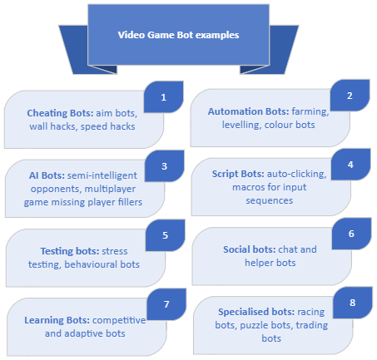Game botting: bots can “…automatise malicious tasks obtaining some rewards with respect to other game players (the game user increases personal benefits and popularity with low effort)” [].

1. What is Runescape?

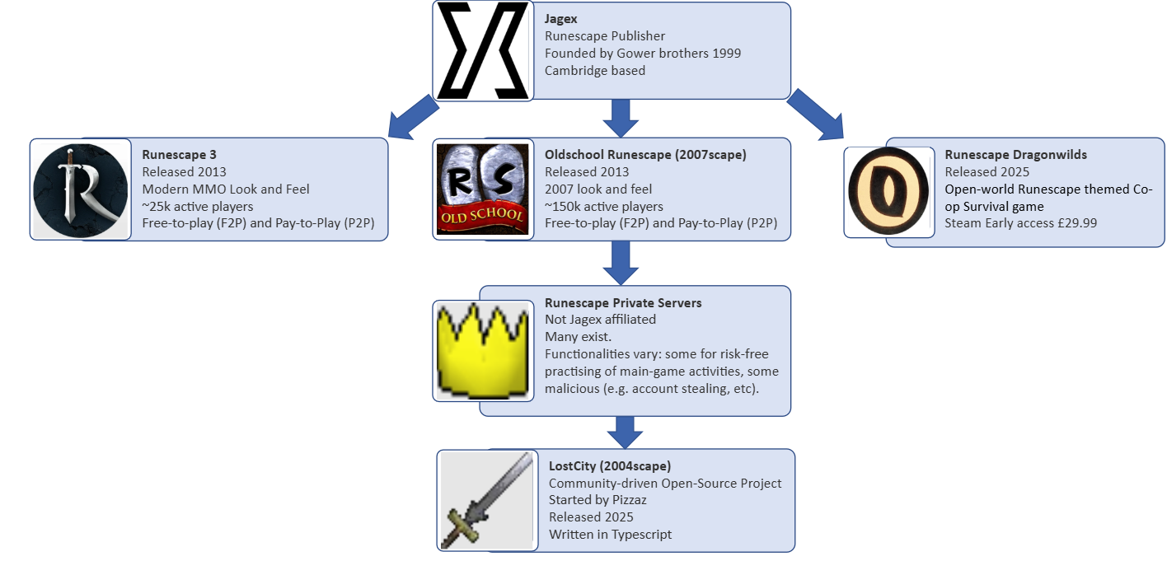

|  |  |  |
| --- | --- | --- |
| **Runescape Versions** | | |
| **Version** | **Launched** | **Status** |
| DeviousMUD | 1999 | Defunct |
| Runescape Classic | 2001 | Defunct |
| Runescape 2 | 2004 | Defunct 2013 |
| Oldschool Runescape | 2013 | Live |
| Runescape 3 | 2013 | Live |
| Runescape Private Servers (various) | Various | Various |
| LostCity (a Private Server) | 2025 | Live |

Runescape is a fantasy massively multiplayer online role-playing game (MMORPG). Jagex originally launched Runescape in 2001. Various versions have existed throughout the years (see Runscape versions table). The versions of the game we are concerned with (Oldschool Runescape) is a tile-based and predominantly point-and-click to iteract game.

Runescape is a fantasy massively multiplayer online role-playing game (MMORPG). It was developed and released by the publisher Jagex originally in 2001 (the name comes from the ‘Java’, ‘game’ and ‘experts’). The original version (AKA ‘Runescape Classic’, ‘RSC’, ‘Classic’) is no longer available (see appendix ), now being officially replaced by Runescape 3 (AKA RS3) and OldSchool Runescape (AKA OSRS, 2007scape, OldSchool, OS, Runescape). The game is a tile-based game where players mainly interact by clicking on screen. This is less true for the former which has integrated key-binding functionalities to make it more appealing to players of other MMORPGs like World-of-WarCraft (WOW). This essay focuses on the latter. Due to rampant microtransactions (see appendix Squeel of Fortune) being added to RS3 in 2012, unpopular game mechanic overhauls (see appendix for the Evolution-of-Combat), players were leaving the game in droves, the community had an appetite for an earlier version of the game without these updates, and so in February 2013, Jagex re-released a back-up version of Runescape from 2007. The focus of this essay will be Oldschool Runescape and LostCity.

* 1. Oldschool Runescape (2007scape)

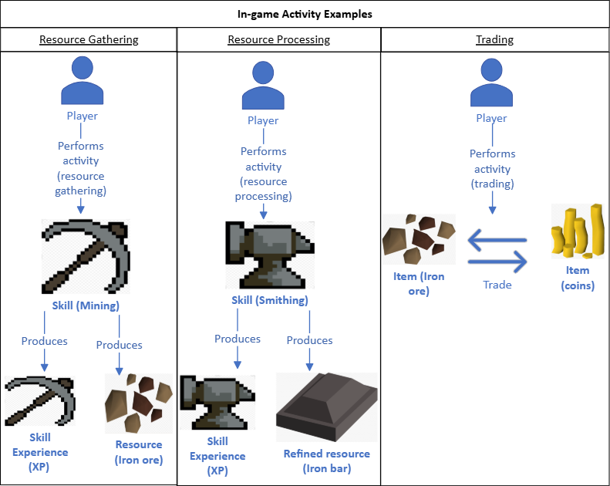Oldschool Runescape is an older version of Runescape released per popular demand by the community, using a back-up from 2007 during March 2013. This version does not have the “game-bar” and “key-binding” features of the main game. With the exception of integrity updates (those deemed critical to the game), game updates are polled to the community and must receive 75% of votes in favour to be implemented. Some game activities worth noting include: killing monsters (PVMing), killing other players (PVPing), training skills (skilling), completing quests (questing), and money-making. Levelling all 23 skills from 1 to the maximum 99 is expected to take upwards of thousands of hours.

* 1. Runescape Private Servers (RSPS)

These are unauthorised attempts to recreate versions of the game. They are run by third-parties. RSPS first emerged when players wanted to customise their playing experience. For instance, play the same game from an earlier time, play the game with higher experience rates, add custom content, etc. The Jagex position is that RSPS infringe upon their intellectual property and where they deem appropriate take legal action, particularly among those RSPS run for profit since this directly competes with their Runescape games. RSPS come with potential security risks, e.g. they may pose as an RSPS but be a front for phishing or account hijacking.

* 1. Lost City (2004scape)

Lost City is a “free, open-source, community-run project” focusing on restoring the game from 2004. The game allows players to play on Lost City servers, or download the source code and host their own server. The “server was written from scratch after many hours of research and Peer review. Everything… is completely and transparently open source.”

1. Runescape Botting

Botting within Runescape is define as: “Macroing, botting, or autoing is the act of using third-party software to perform automated tasks. A macro operates by automating user input to the game. A simple macro may just move the cursor to a certain position and perform a click while more advanced ones may interact with the game client directly; as technology advances, botting methods as well as their countermeasures have evolved from simple macros to utilising machine learning. The terms macroer, autoer, botter or bot usually refer to players who use such programs”[].

Botting timeline:

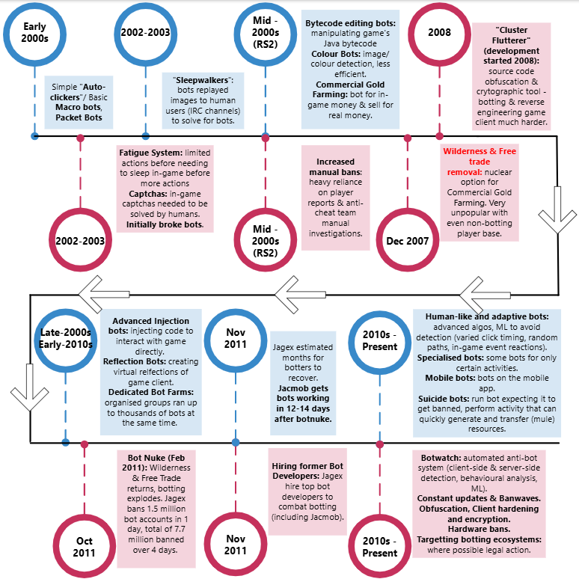

* 1. Oldschool Runescape Botting

1. Botting for IT+ Project
   1. 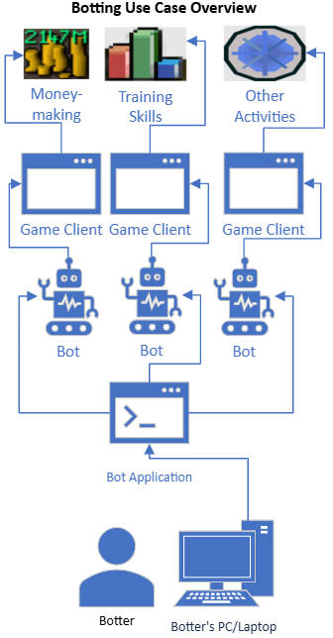Project Aims
2. Produce a Minimum Viable Product (MVP).
3. Determine how to measure success.
4. Determine if there’s any benchmarks for bots & APIs.

Project Timeline

* 1. Project Scoping

* 1. Project Requirements

Project Sprint Plan Timeline

Project Overview

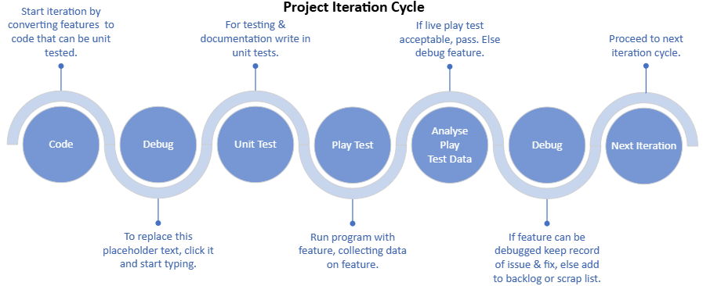

APIs Explored

|  |  |  |
| --- | --- | --- |
| API | Description | Decision |
| RuneLite | Java-based |  |
| DreamBot | Java-based |  |
| OSBot API | Java-based |  |
| TriBot | Java-based |  |
|  |  |  |

Libraries Explored

|  |  |  |
| --- | --- | --- |
| Libraries | Description | Decision |
| OpenCV |  |  |
| Tesseract OCR |  |  |
| PyAutoGUI |  |  |
| Numpy |  |  |
| Tensorflow |  |  |
| Pillow (PIL Fork) |  |  |
| Sqlite3 |  |  |
| Pandas |  |  |
| Matplotlib/ Seaborn |  |  |
| Altair |  |  |
| Java AWT |  |  |
| OpenCV (Java) |  |  |
| SQLite JBDC Driver |  |  |
|  |  |  |
|  |  |  |
|  |  |  |
|  |  |  |
|  |  |  |
|  |  |  |

Frameworks Explored

|  |  |  |
| --- | --- | --- |
| Frameworks | Description | Decision |
| RuneLite Plugin Development Framework |  |  |
| DrameBot Framework |  |  |
| OSBot Framework |  |  |
| Tribot Scripting Framework |  |  |
| Custom Bot Framework |  |  |
|  |  |  |
|  |  |  |
|  |  |  |
|  |  |  |
|  |  |  |

Toolkits Explored

|  |  |  |
| --- | --- | --- |
| Toolkit | Description | Decision |
| WASP Scripts |  |  |
| SIMBA |  |  |
| DreamBot |  |  |
| OSMB |  |  |
|  |  |  |

* 1. Ethical Concerns

A number of ethical concerns around botting can be raised. Broadly these concerns would fall into categories of for and against botting. Examples arguments:

1. Using bots shallows achievements:
   1. Botting players who would otherwise put in 1000 hours of manually grinding away at a task to achieve the satisfaction at the end will no longer
   2. Genuine players have their genuine achievements ‘shallowed’ or ‘inflated’ through others using bots, disincentivising genuine players to pursue goals.
2. Playing with bots is bad for the game experience:
   1. Playing with bots won’t have the same level of interaction as would playing with genuine players.
   2. Playing with bots ‘crowds-out’ in-game non-instanced activities.
   3. Playing with bots become stale.
3. Bots are bad for the game state:
   1. Bots (especially bot farms), have the potential to flood the game with resources, inflating the economy.
   2. Bots potentially damage the intellectual property of the company (game economy).
4. Bots are an economical solution:
   1. Players play this game with their free-time, of which they only have so much. Bots allow them to make more use of their time.
   2. Bots potentially allow players to allocate time away from tedious, dull in-game tasks, instead focusing towards they are interested in (maybe ones bots haven’t yet been developed for).
   3. Safeguards

The author has obtained and will proceed with the explicit understanding of his supervisor that the development of any botting scripts is not intended for malicious purposes.

The author understands that the development of bots is to proceed with the goal of having learned something through this 12-week process.

1. References

Botting Definitions

<https://aws.amazon.com/what-is/bot/>

<https://dl.acm.org/doi/pdf/10.1145/3102254.3102263>

<https://oldschool.runescape.wiki/w/Botting>

Official Runescape sources:

[1] <https://play.runescape.com/>

[2] <https://oldschool.runescape.com/launcher#_ga=2.26562621.1410479580.1750164561-1696873367.1750164559>

<https://oldschool.runescape.com/>

<https://www.jagex.com/>

Runescape Community sources:

<https://oldschool.runescape.wiki/>

<https://oldschool.runescape.wiki/w/Project_Zanaris>

<https://oldschool.runescape.wiki/w/Code_of_Conduct>

<https://legal.jagex.com/docs/terms/terms-and-conditions>

<https://2004.lostcity.rs/>

<https://github.com/LostCityRS/Server>

Runescape Community population sources:

<https://www.misplaceditems.com/rs_tools/graph/>

<https://mmo-population.com/game/runescape>

Runescape Gold sites

Runescape Botting sites

Runescape & Venezuelans

<https://www.npr.org/transcripts/1018915121>

<https://www.investmentmonitor.ai/tech/gaming-venezuela-runescape-wages-digital/>

Jagex and the Botting arms Race:

<https://www.pcgamer.com/runescape-bot-nuking-event-bans-1-5-million-bots-in-one-day/>

<https://www.youtube.com/watch?v=VZHalHeWer8>

1. Appendices

Appendix A – Dreambot Scripts online store screenshot:

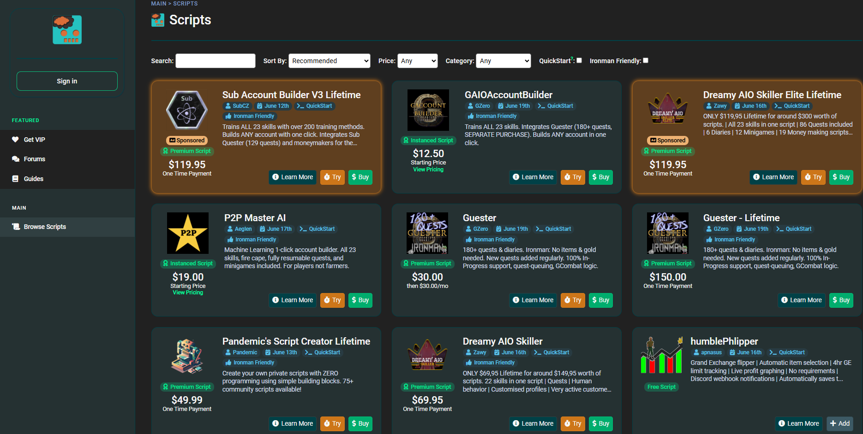

Obtained 20/06/2025 from: <https://sdn.dreambot.org/scripts>

Appendix B – Wasp Scripts online store screenshot:

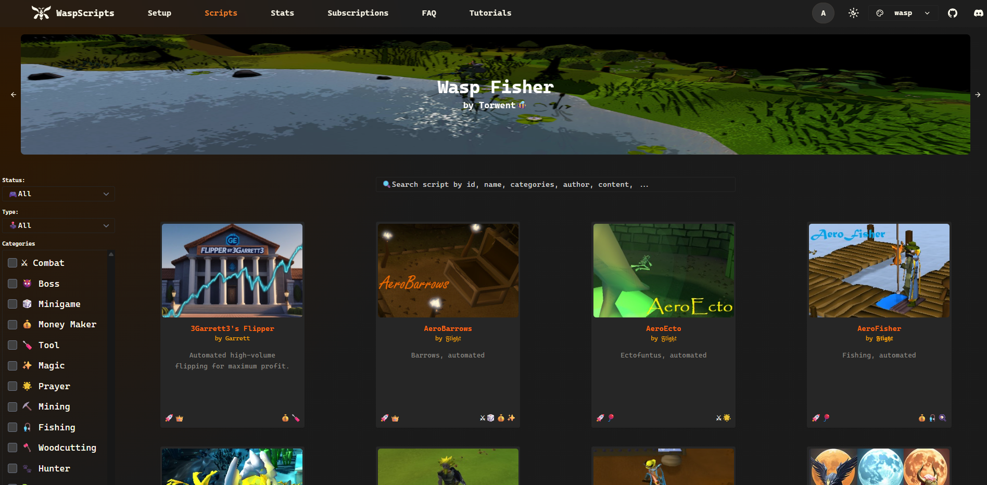

Obtained 20/06/2025 from: <https://waspscripts.com/scripts>

Appendix C – Runemate Scripts online store screenshot:

Obtained 20/06/2025 from: <https://www.runemate.com/store>