
Index:
- Introduction.
- Features.
- How to play.
- Goals.
- Credits.
- Story.

PLEASE NOTE THIS IS A ROUGH DRAFT AND NOTHING IS FINAL, IT IS A WORK IN PROGRESS.
If an error or inconsistency is found please contact me so I may correct it. Paul.wortmann@gmail.com

1. Introduction:

Frost and Flame is a 2D isometric action role playing game, in a similar style and inspired by great games like the Diablo series, NOX and Fallout (1,2).

2. Features:

4 Random dungeon generation algorithms:
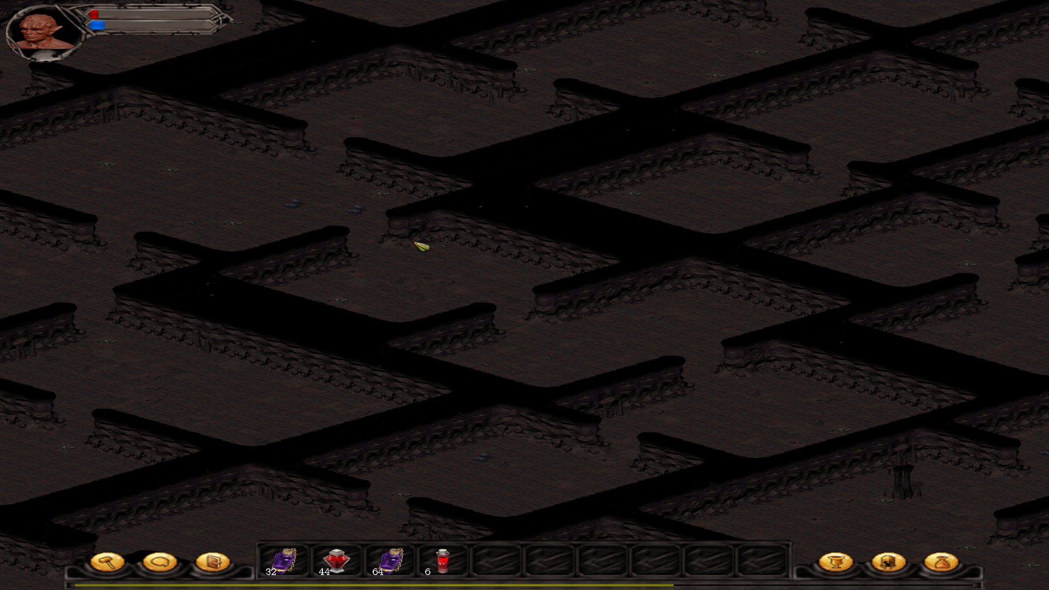 | A random dungeon generator based on a recursively dividing BSP tree. Great for generating dungeons with closely joined rooms.
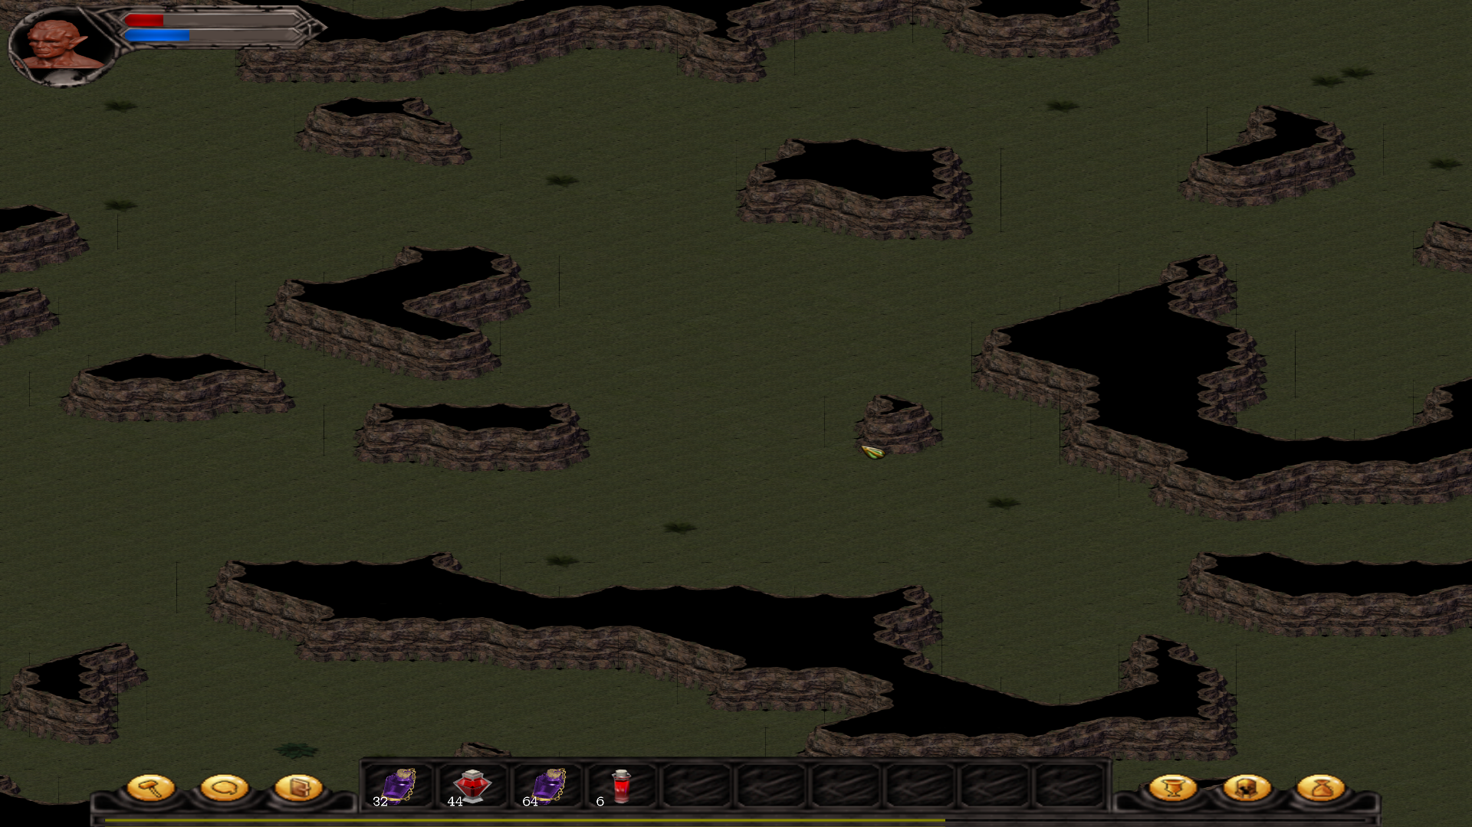 | A random dungeon generator based on cellular automata. Perfect for generating cave like maps, as well as outdoor maps.
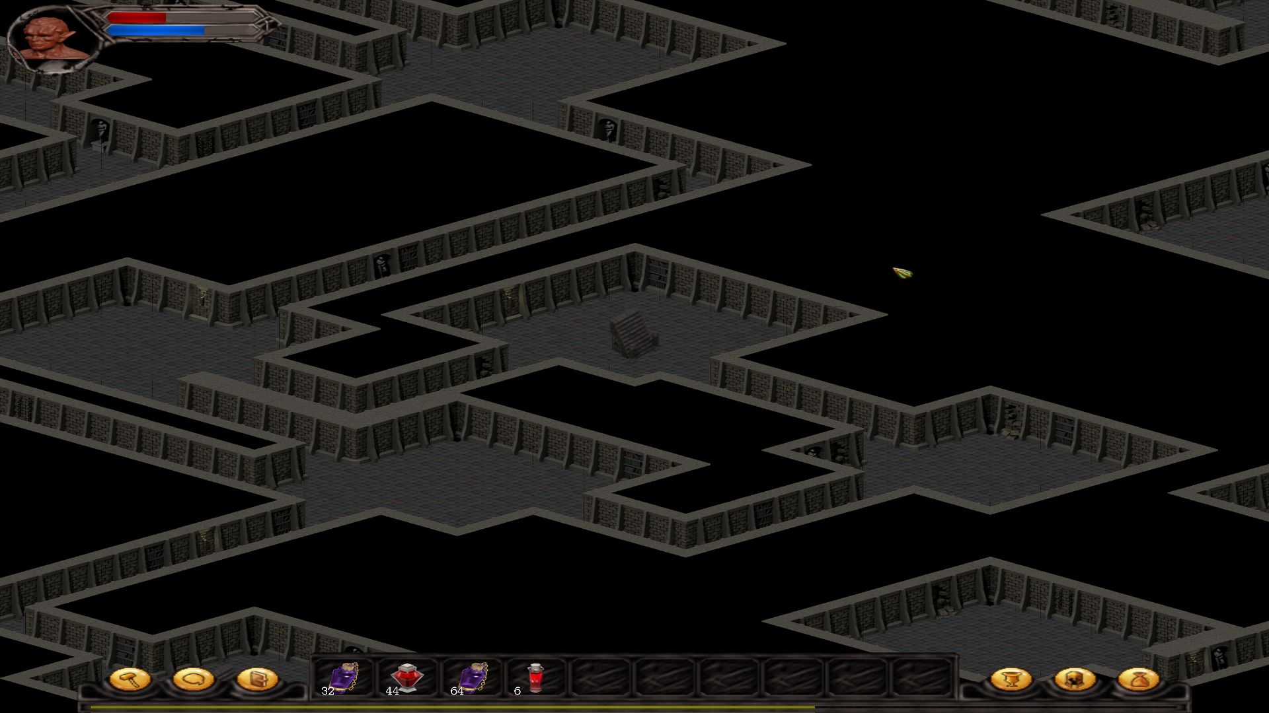 | A random dungeon generator that builds rooms in random circles and then connects them with passages, this algorithm generates some nice looking dungeon maps.
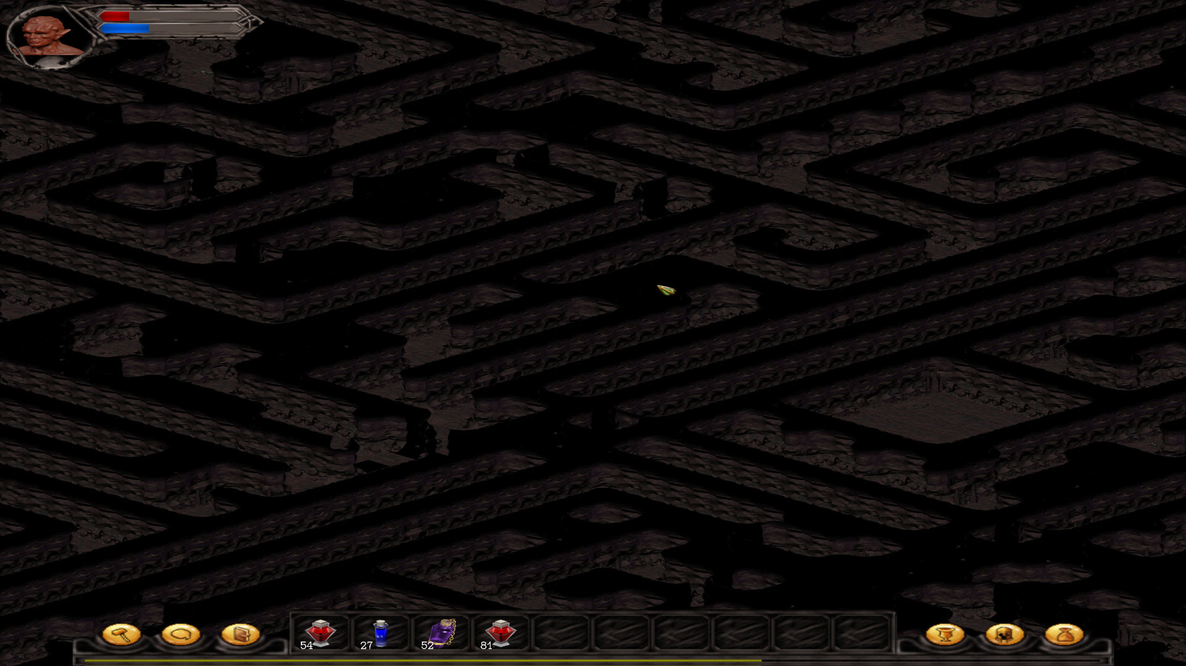 | A random dungeon generator that uses a recursive algorithm to generate maps with perfect mazes.

Currently there are 3 tile sets available, and can used interchangeably with any of the above maps.

Flexible UI system:
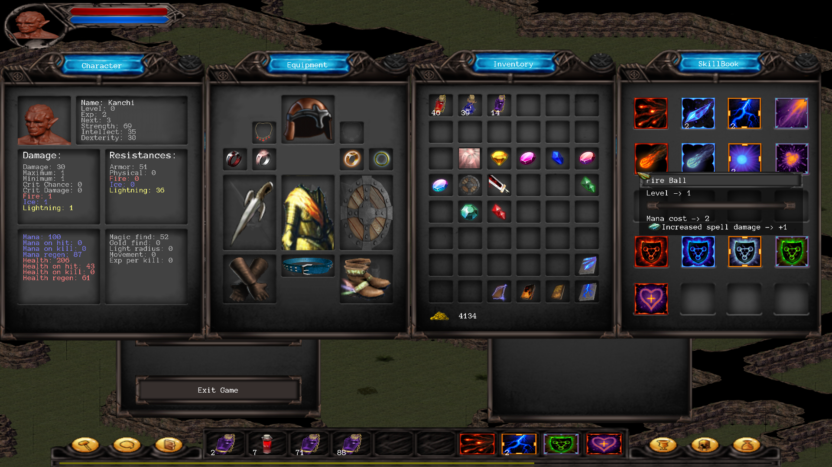

Extensive item system:
Random item generation:
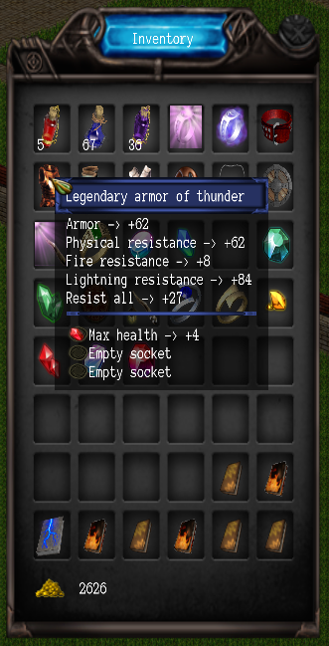
Gems:
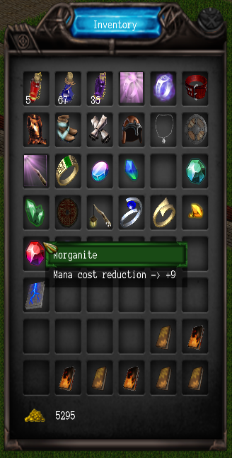 | 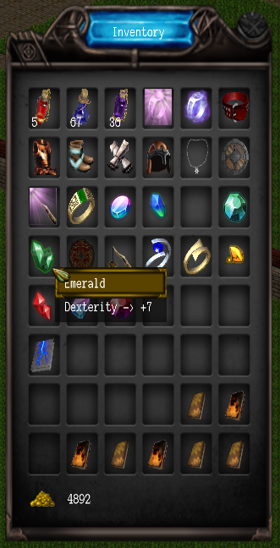
Consumable items:
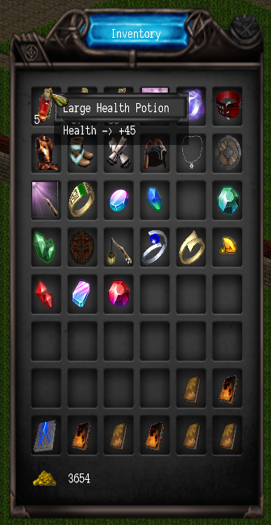 | 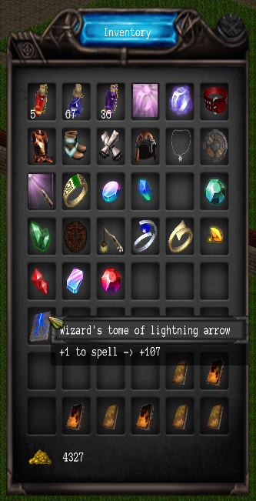 | 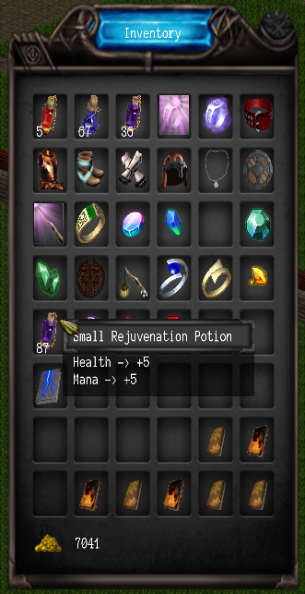

3. How to play:

Mouse:
Left click | Move / Use item.
Right click | Equip item.

Keyboard key assignment:
1-9 | Action bar → use item / cast spell.
Escape | Display the Main menu.
Q | Display the Quest log.
B | Display the Skill book.
C | Display the Character overview.
E | Display the player Equipment.
I | Display the player Inventory.
Space | Close all windows.

Developer keys: (will be removed in final game.)
A | Generate a random dungeon, type 0.
S | Generate a random dungeon, type 1.
D | Generate a random dungeon, type 2.
F | Generate a random dungeon, type 3.
G | Generate a random dungeon, type 4.
H | Generate a random dungeon, type 5.
J | Generate a random dungeon, type 6.

4. Goals:

5. Credits:

A lot of art has been used under permissive licenses, as the game is in development, and a specific art direction has not been decided this list has not yet been implemented.
The current art used in Frost and flame is to be considered place holder art for the time being, it may be used in the final game, but currently I am undecided on this matter.
I do plan on populating this credits section with currently used art in the future.
To see the credits for the currently used art, please see the credits.txt file.
A lot of art used is from the awesome site of http://opengameart.org/
If you find an inconsistency, or art without a credit given, please contact me so that I may correct it as soon as possible. Paul.wortmann@gmail.com

