Li Pok Yin
CDAS4999

A troubleshooting copilot for deploying ML workloads – Context Rot

Abstract
Large language models (LLMs) are considered as the most trending topics worldwide. After the publishing of GPT3 (Brown et al., 2023), tech giants like Google and Meta are leveraging all their available resources to evolve in the artificial intelligence field. Currently, LLMs have reached expert level in programming and mathematics. Therefore, learning programming with LLMs seems promising for beginners. However, researchers like Hong (Hong et al., 2025) and Wang (Wang et al., 2025) suggest that the performance of LLMs dropped significantly when the context window size increase. This research aims to remedy the problem of performance degradation due to long context window with the approach of cropping previous conversation. So that the context window will be shortened without affecting the performance of LLMs.

Introduction
Large context windows are one of the trends of current AI development because they could include more detail and lead to better response. Google first introduced a 1 million tokens context window with Gemini 1.5 in 2024 (Team Gemini et al., 2024). Later, LLMs like Qwen (Yang et al., 2025), Claude Opus also published their 1M token version LLMs. The current open sources and widely used LLM with largest context window is Llama 4 Scout and it has reached 10 million tokens (Meta-llama/Llama-4-Scout-17B-16E · Hugging Face, 2025). All these models score almost perfect in the Needle in a Haystack (NIAH) test. Aroundample, Gemini 1.5 get around 99.7% recall score in NIAH which prove LLMs work well with large context window (Team Gemini et al., 2025).

However, this benchmark does not reflect use cases in real life. Hong suggested that there is always some distractors within the long context window (Hong et al., 2025). After adding one distractor into the haystack, the performance of LLM starts dropping when the input reaches ten thousand tokens. In the worst case, the accuracy dropped from nearly 100% to 40% when the input token size reached 1 million. This proves the context becomes ‘rotten’ in a much faster rate than what LLMs providers claim. The effective context window that can reliably handle information without being easily disrupted by distractors is around 100,000 tokens. So that, it is important to suppress the context window especially in LLM chatbot in order to make sure that LLMs does not degrade with increasing context window.

To build a troubleshooting copilot for deploying ML workloads, there are requirements that have to be met. The first one is performance with long context window. Since the final product should be an Open-domain dialogue system (also known as chatbot), it should have the ability to memorize the information provided from users like users’ code, hardware, model choices, hyperparameters and so on (Wu et al., 2022; Zhang et al., 2022). Moreover, machine learning workloads often involve coding, and beginners frequently resort to copying and pasting entire scripts. This practice can significantly increase the required context window size. Therefore, context rot will be an important issue during building our chatbot. Another important requirement is code cohesion. The best practice in answering coding questions is to have minimal change on user provided code. Therefore, it is important to train our chatbot to feed least token to LLM but still have minimal change on the script.

A novel approach is suggested by Wang (Wang et al., 2025) which is to recursively summarize the chat history. They summarize the previous chat session history into a message. Then for the new session, they summarize the current session history and the previous message as a new message and then feed it to LLM. This approach ensures a lifelong chatbot and also remedies the problem of context rot, around 3% increase in BLEU score on text-davinci-003 compared to traditional LLM chatbot. However, we believe recursive summarizing is too greedy on suppressing the context window since it will lose many useful information each summarizing. Therefore, we need another method to suppress the context window but include more detail in order to strike a balance between having all user’s information and minimizing context window.

Our approach is to use cropping instead of summarizing. The difference between cropping and summarizing is that summarizing will rephrase the content in order to suppress the content into minimum size. However, cropping will only delete the content that is not related or useful for future conversations. Therefore, cropping will preserve all the code, model parameters, users’ hardware information but summarize only leave a brief message to describe what the code does and what the user’s purpose is. Our approach solves the problem of code cohesion and enhances answer consistence compared to the summarizing approach introduced by Wang.

2. Related work

2.1 Transformer model and Generative Pre-Trained Transformers (GPT)
Transformer model was first introduced in one of the most important papers “Attention is all you need” (Vaswani et al., 2017). Vaswani suggested a self-attention mechanism in order to model the relationship between every token from users, predicting the next word in the sequence given the previous ones. Transformers perform really well in sequence-to-sequence tasks like translation and sound to text. Later, GPT was released by OpenAI which proposed a decoder-only transformer model that targeted more natural language processing tasks like storytelling and question answering (Radford et al., 2018). Instead of considering every token in original transformer model, GPT only considers previous tokens which allow the model to finish generative tasks. Nowadays, GPT models usually integrate with chatbot interface due to its excellent performance in question answering.

2.2 Context Rot
Chroma, which is one of the most popular vector-based database providers, conduct several experiments on how context influences the performance of LLM response and brings some valuable insights. The first experiment mentioned above related the size of context window. Needle in a Haystack benchmark is used in this experiment. LLM received a question and been asked to find the correct answer from the haystack. One or more distractors (which is a sentence that looks similar to the correct answer) are added in the haystack. In Fig 1, when the input length increases from 1,000 to 1,000,000 tokens, accuracy drops by approximately 10%, 25%, and 30–40% under conditions with no distractor, one distractor, and four distractors, respectively. These results show that context is highly vulnerable to distractors, which is frequently encountered in chatbot interactions. Further investigations are made and it has found out that the main reason led to wrong response is that there is absence of response instead of choosing the distractor.

Another experiment worth mentioning is about the continuity of context. Two variants are compared. One is the natural flow of ideas and the other is to shuffle all the ideas and reorder into the haystack, so it does not follow logical progression. It was found that the average accuracy of 18 models is around 5% higher when the context is shuffled. This suggests a potential positive relationship between discontinuous context and accuracy.
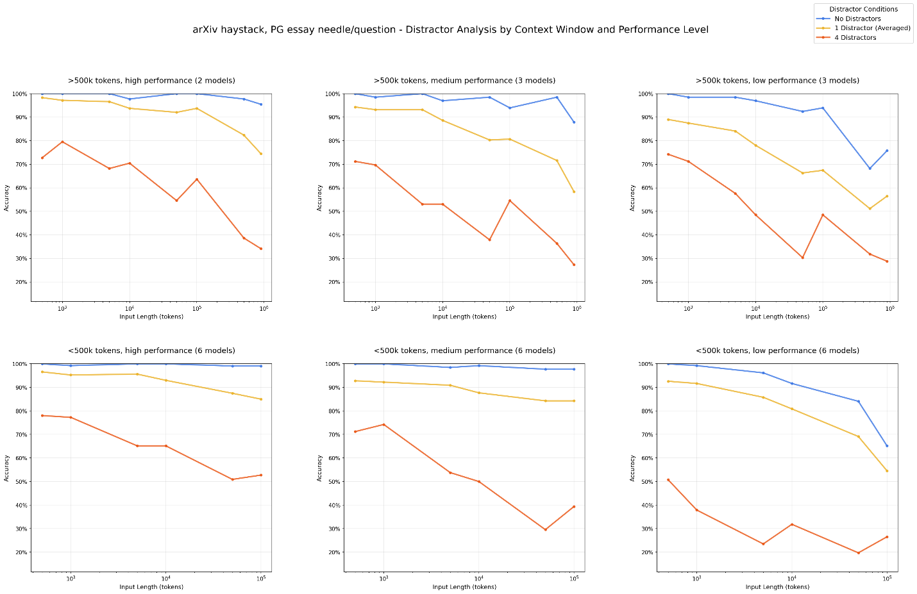
Fig. 1 Result of Context Rot experiments (Hong et al.,2025)

2.3 Recursively summarizing enables long-term dialogue
The concept of Context Rot and Context engineering were just introduced last year. Therefore, there are not many solutions or strategies for remedy Context Rot. Recursively summarizing chat history is one of the novel techniques in context engineering. In Fig 2, it shows the architecture introduced by Wang (Wang et al., 2025). It aims to maintain a real-time memory that concludes all the past sessions’ chat history. What differs from our approach is that we will only suppress and feed the message within a single chat session and we will not suppress a message more than once because we believe each suppression led to loss of information.
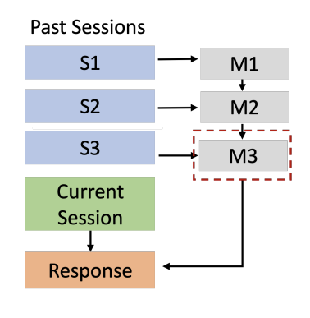
Fig. 2 Architecture of recursively summarizing chat history (Wang et al., 2025)

Approach Overview
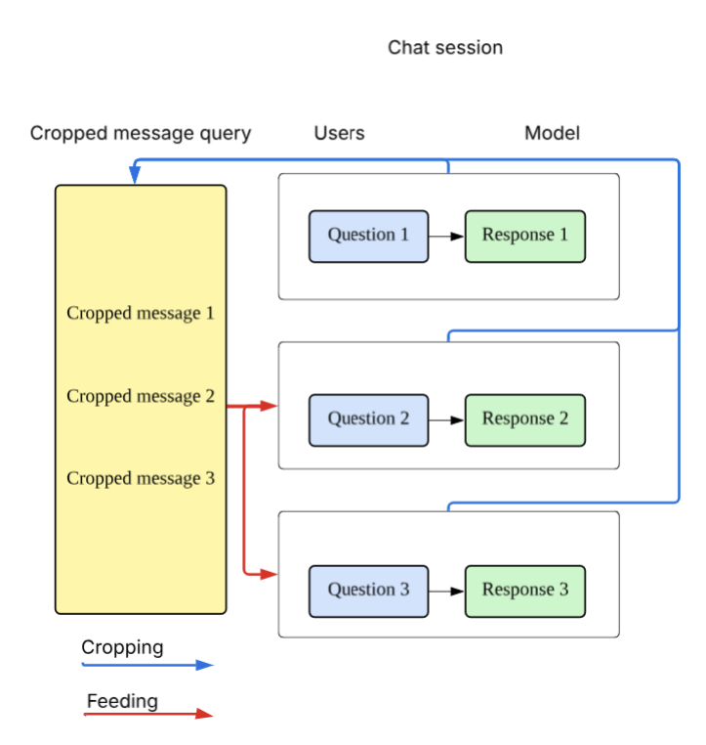
Fig. 3 Architecture of our approach
We use “cropping” as our suppression method. The idea of cropping comes from cropping an image. There are two important characteristics for cropping which differ from summarizing. First, we cannot rephrase or alter the content which is similar to cropping an image we could only get the exact part of an image. To crop a message, we are only allowed to extract or delete. Besides, cropping is allowed to choose what to keep and what to delete, but summarizing cannot. For example, we could ask LLM to delete the introduction and keep code snippets in order to enhance to performance of the chatbot. This could be shown in the coding question below.

The most important thing to decide is what is needed to feed to LLM as a chatbot. Therefore, the question is what information does LLM need to answer the following questions. First, we observe what does a LLM responses contain. In most cases, LLM responses usually contain an introduction, some important points which each contain a statement, explanation and example, use cases, other related concepts and a conclusion. Obviously, introduction and conclusion are not useful for follow up questions since any useful information contain in these two paragraphs should also be contained in those main paragraphs. In each point, explanation usually is the longest part since LLM are expert in explaining abstract concepts. However, feeding the explanation part to LLM as reference for following questions does not make sense because we may consider the explanation are the knowledge that LLM already has and LLM do not need this part for future questions. We just need to keep the statement and the example (usually contain some code) of the point so that LLM knows what the conversation is about. Therefore, cropping the explanation away is a more effective way to suppress the context window.

Our chatbot has a similar structure to the traditional chatbot LLM. A traditional chatbot uses a message query to store all questions and responses. After user asks a question, LLM generates a response as usual. However, after LLM response, it will ask the LLM to suppress the previous question and answer by cropping. Then we pass the suppressed context to the chatbot for reference. However, we will not suppress cropped messages more than once to pursue a lifelong chatbot. This is because we believe each suppression increases the chance of loss of information. Therefore, users still need to start a new chat session when the context window meet its limit instead of having a lifelong single session.

Algorithm: Generating response with dataset using cropped-based LLM chatbot
Crop = function(Question, Response){
Message = cropping prompt + Question + Response
Return LLM(Message)
}
// Initialized message query
Message = []
for i 1 to N do
Response = LLM(Message, Question)
Output response
Cropped_message = Crop(Question, Response)
// remove the question in message query, prevent duplication (The question is already in the cropped message)
Message.pop()
Message.append(Cropped_message)

Experiment
This experiment aims to prove two hypotheses:
1. Our approach generates better responses than the baseline (Summarizing).
2. Suppression ratio of our approach is significantly lower than 1 which indicates that the context window is significantly smaller than traditional chatbot.

4.1 Dataset
We use MT-Bench dataset, which is one of the most recognized datasets for evaluating conversational LLM. (Zheng et al., 2023). MT-Bench is a dataset that evaluates the ability of chatbot to memorize chat history for answering future questions. It aims to compare the performance of memorizing between two chatbot. This dataset has total 80 test cases related to 8 categories which are writing, roleplay, reasoning, math, coding, extraction, stem and humanities. Each test case involves two questions which the second question required the first question or the first response of LLM.

To further analyze the performance of two chatbots in coding question, we use Microsoft/NextCoderDataset-Conversational (Aggarwal et al., 2025) to generate coding related response for evaluation. This dataset is a synthetic dataset generated with GPT-4o and Llama-3.3-70B-Instruct for training coding LM. It contains around 57k samples, and we chose 100 samples of data for our project due to our limited computation power.

4.2 Baseline
We use the idea of recursively summarizing the chat history that introduced by Wang (Wang et al., 2025) and build a chatbot that summarize the previous question and answer after each response and only feed the summarized content to LLM. The primary objective of this evaluation is to demonstrate that context cropping superiorly preserves salient information compared to summarization. To isolate the impact of these two suppression techniques, we use the same structure as our chatbot and focus one a single chat session instead of using Wang’s original architecture in order to focus on the difference between cropping and summarizing.

4.3 Metrics
First, we consider using BLEU (Papineni et al., 2002) score and BERT (Zhang et al., 2020) score for evaluation. BLEU score is an n-gram precision score which could be understood as how many words or sequences of words in our approach also appear in the baseline. Bertscore is a metric using Bert model (Devlin et at., 2019) to find the similarities between our approach and the baseline. However, we find that both BLEU score and Bertscore does not reflect the ability of memorizing. This is because there is an important assumption for these two metrics which is the content of baseline should be the ground truth and is expected to be better than our approach. However, our target is to prove our approach generates better responses than the baseline. Therefore, using BLEU and Bert scores are not appropriate. This will still lead to very low BLEU and Bert score even our chatbot’s performance is better.

Therefore, we use LLM-as-a-judge for evaluation. We use Deepseek v3.1 as the LLM judge and use deepeval library for evaluation. Moreover, we use a default metric Turn Relevancy from deepeval and a self-defined metric memorizing ability metric using threshold 0.7 to further investigate the memorizing ability or the chatbot. (Please reference Table A.3 for the prompt for memorizing ability metric.)

For coding questions, we will add one more self-defined metric – code cohesion metric. To build a copilot for teaching ML questions, the response performance on coding related questions is very important. There are some requirements for coding questions related to memorizing ability on top of the memorizing ability metric we have so we create a new metric for coding questions. We expected the response of LLM to make minimal changes instead of writing new code. Also, the variable name and coding habit must strictly follow the user provided code. (Please reference Table A.4 for the prompt for Code cohesion metric.) However, the LLM-judged score is inconsistent with deepseekv3.1. Therefore, we use gpt-oss-safeguard-120b in Amazon Bedrock for coding question and the result are more consistent.

5. Experiment result

5.1 Result overview
Table 1 shows the median pass rates of test cases with MT-bench dataset under cropping and summarizing, evaluating with Turn relevancy metric and Memorizing ability metric in 5 runs. The data suggests that both summarizing and cropping achieve high score on turn relevancy. This implies both chatbot generate relative responses. However, there is a significant performance difference between two methods in terms of memorizing ability. The chatbot using cropping is 14.6% higher than the chatbot using summarizing in memorizing ability metric which suggests that summarizing may lead to severe information loss in chat history.

Table 1 Pass rate of different methods with different metrics using MT-bench
Method | Turn Relevancy | Memorizing Ability
Cropping | 0.925 | 0.8125
Summarizing | 0.899 | 0.7000

5.2 Memorizing ability in different categories
Then, we further investigate on the memorizing ability between two strategies in different types of questions. As shown in Table 2, the cropping-based approach significantly outperforms the summarization-based method in the Writing and Extraction categories, while maintaining a marginal lead in Roleplay and Math. We believe the reason behind it is that for writing and extraction questions, the useful information is much longer. To answer the second question for writing and extraction, it requires the chatbot to remember the whole story and paragraph for extraction respectively.

Conversely, math and roleplay questions rely on shorter useful information, like a short math function. The performance gap between two chatbot is smaller compared to writing and roleplay questions. Furthermore, stem and humanities questions are more dependent on the stem and humanities knowledge of the LLM itself instead of chat history. So that both cropped-based chatbot and summarized-based chatbot pass all the test cases in these two fields. These results suggest a possible positive correlation between the magnitude of the performance gap and the volume of task-essential information required for the response.

Table 2 Pass rate of memorizing ability metric in different categories using MT-bench
Method | Writing | Roleplay | Reasoning | Math | Coding | Extraction | Stem | Humanities
Cropping | 0.9 | 0.8 | 0.8 | 0.9 | 0.9 | 0.5 | 1 | 1
Summarizing | 0.4 | 0.6 | 0.9 | 0.7 | 0.9 | 0.2 | 1 | 1

5.3 Memorizing ability on coding questions
As mentioned above, our chatbot values the memorizing ability on coding questions. The pass rate of memorizing ability on coding questions for both chatbots is 90%. It seems the memorizing ability on coding questions are the same. However, if we add the coding cohesion metric. Our approach gets 30 percentage points higher than the baseline in pass rate. A comparative analysis reveals cropping maintains the full detail of code snippets and user specifications, whereas summarization often filters out critical technical details in favor of high-level descriptions. For example, one of the test cases ask “A binary tree is full if all of its vertices have either zero or two children. Let B_n denote the number of full binary trees with n vertices. Implement a function to find B_n.” and “What if the problem changed from a binary tree to a ternary tree?”. Using cropping, LLM uses same method in two responses which is memorized recursion but the summarize-based chatbot just generates new script and use two different methods instead of referencing previous code snippets since the code snippets are not fed to the chatbot.
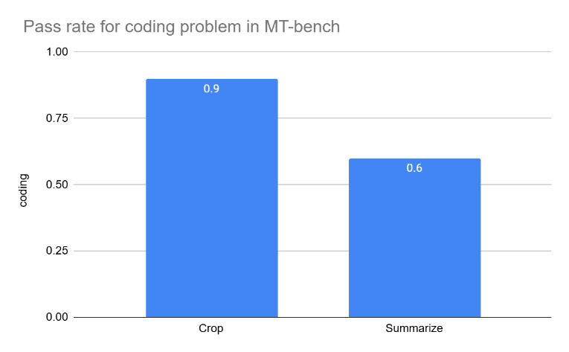
Fig. 4 Bar chart of pass rate of coding problem in mt-bench
However, mt-bench dataset only has 10 coding questions. We, therefore, use a subset of NextCoder-Conversational dataset from Microsoft to further evaluate the performance of two chatbots on coding question. We crafted a new prompt that asks LLM to keep code snippets and user purpose from user during cropping (Please see Table A.5 for the prompt). Our approach achieves a 20% increase in pass rate compared to summarizing. To conclude, cropping is significantly better than summarizing in coding problems.
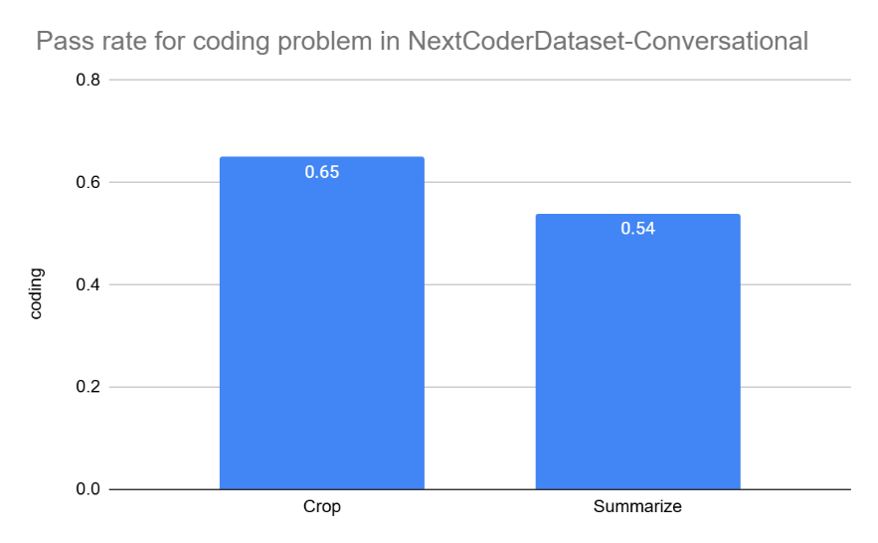
Fig. 5 Pass rate on coding problem in NextCoderDataset-Conversational

5.4 Suppression ratio
Before experiment, we expected the suppression ratio of cropping should be between 1 and the suppression ratio of summarizing. This is because cropping preserves more information than summarizing. However, the result is different from our expectations. The suppression ratio of cropping and summarizing in mt-bench are 0.59 and 0.83 respectively, which is a 24-percentage points difference. From Table 3, it shows both chatbot cannot preserve useful information for the second question, but the summarized message is longer than the cropped message. This is because when we ask LLM to summarize, it implies that the summarized message should be easy to understand for humans. Therefore, the summarized message waste tokens to explain the task in the first question but actually did not provide more useful information compared to cropping. This implies summarizing has the problem of feeding unnecessary tokens to LLM.
message
Table 3 An example that demonstrates the cropped and summarized messages
Question: Given these categories - Literature, History, Science, and Art. Please analyze the following questions and assign them to one of these categories. In your response, refrain from uttering any extraneous words. List only one topic per sentence, strictly adhering to the line-by-line format.\n1. Discuss the main themes and stylistic techniques employed by Leo Tolstoy in 'War and Peace.' How do they align with the wider social context of 19th-century Russia?\n2. Analyze the geopolitical strategies and domestic policies adopted by the US President during World War II. How did these actions shape the post-war international order?\n3. Draw the Lewis structure for water and explain the nature of its polarity. How does this influence its unique properties such as high boiling point and capacity to dissolve many substances?\n4. Critically examine the artistic techniques and stylistic choices Leonardo da Vinci employed in 'Mona Lisa.' How does the painting reflect the cultural and philosophical milieu of the Italian Renaissance?
Model: Literature\n History\n Science\n Art
Summarized message: User provided four sample questions and asked to assign each to one of the categories Literature, History, Science, Art; the assistant returned the corresponding labels: Literature, History, Science, Art.
Cropped message: 1. Literature 2. History 3. Science 4. Art
Second question: Amend your earlier answer by mentioning a person who is most relevant to each point.

However, we believe the above results do not reflect normal use cases because the model responses are short. Therefore, we also calculated the suppression ratio in NextCoderDataset-Conversational. The number of tokens of the response may reach 4000. The suppression ratio of cropping and summarizing are around 0.41 and 0.17 respectively. This shows the suppression ratio of summarizing is smaller, but cropping is still suppressing the context window size significantly because user could ask at least double numbers of questions within the same effective context window compared to traditional chatbot without any suppression technique.

Limitation
The current limitation of the cropping-based approach is its inability to identify the most useful content. Because LLMs are optimized for summarization rather than cropping. In Table 3, the cropping method exhibited a selective data loss by retaining categorical labels while removing the original user queries, thereby proving currently LLM still has huge room for improvement in its cropping technique. Supervised fine-tuning and prompt engineering would be a possible solutions in identifying and retaining 'task-critical' segments within the context window.

Conclusion
This paper proposed a new method for suppressing the context window size in LLM chatbot. Our experiment successfully shows that cropping would be a more appropriate method in shortening the context size compared to summarizing. Our research may provide some insights into context engineering and introduce the problem of context rot.

Future work

Integrate with RAG
Future iterations of this research will explore the integration of history cropping with Retrieval-Augmented Generation (RAG) to facilitate a truly lifelong chatbot architecture. By combining the cropped chat history after each session with the vector-based database and integrating the latency-aware utility function and selectively reranking. We believe that using this approach to build a troubleshooting copilot on ML workloads could remedy some biggest challenges in building chatbot and outperform most existing LLM chatbots in terms of context engineering.
Appendix
Table A.1 Prompt for Cropping
Prompt for cropping chatbot
From the following chat history, extract only useful information for future conversation. Remove all explanations, commentary, or descriptive text, and keep only the actionable or useful content.

Table A.2 Prompt for Summarizing
Prompt for Summarizing chatbot
Please summarize the chat history for future conversation.

Table A.3 Prompt for Memorizing ability metric
Memorizing ability metric
Evaluate whether the assistant accurately remembers and uses important information from prior turns.
Fail if ANY of the following occur:
1) Missed required info: The response omits any important user-provided constraint, preference, fact, or request that is necessary to fully answer the current turn.
2) Partial answer: The response answers only part of a multi-part question/request.
3) Memory contradiction: The response conflicts with previously stated facts in the conversation.
4) Unjustified assumptions: The response invents details not supported by prior turns or the current user message.
5) Wrong prioritization: The response focuses on minor details while ignoring key requested items.
Pass only if ALL are true:
- Includes all critical prior-turn details needed for this turn.
- Fully addresses every explicit sub-question/sub-task in the current turn.
- Is consistent with conversation history.
- Does not fabricate missing details.
Scoring guidance:
- If any required item is missing or any sub-question is unanswered => FAIL.
- If response is relevant but incomplete => FAIL.
- Only complete, consistent, non-fabricated answers => PASS.
Table A.4 Prompt for Code cohesion metric
Code cohesion metric
Evaluate whether the assistant preserves and improves the user's original code appropriately.

Scoring guide (0.0 to 1.0):
- 1.0: Minimal, targeted edits; preserves original structure, logic flow, and naming; all changes directly address the user requ>
- 0.8: Mostly preserved; small unnecessary refactors but still clearly grounded in original code and request.
- 0.6: Partial preservation; noticeable rewrites or renaming that were not strictly necessary.
- 0.4: Major rewrite with limited need; weak alignment with requested fix/improvement.
- 0.0-0.2: Complete replacement or off-task response; ignores original code constraints.

Rules:
1) Debug task: Prefer smallest possible fix. Penalize broad rewrites.
2) Improvement/refactor task: Improvements allowed, but must retain core behavior and traceability to original code.
3) Preserve variable/function names unless change is required for correctness, clarity, or API compatibility.
4) Any introduced logic must be necessary and relevant to the user request.
5) Penalize changes that alter expected behavior without justification.

Table A.5 Prompt for cropping-coding
Prompt for cropping for coding question
From the provided question and answer, extract only user purpose, useful information and code snippets for future conversation.
Remove explanations and commentary.
Especially focus on the user provided code and information

Division of labor
Context Rot: Li Pok Yin
RAG – latency aware utility function: Cheung Chung Tin
Integration of Rag and Context Rot (Approach for troubleshooting copilot): together

Works Cited
Aggarwal, T., Singh, S., Awasthi, A., Kanade, A., & Natarajan, N. (2025, October). Nextcoder: Robust adaptation of code LMs to diverse code edits. In Forty-second International Conference on Machine Learning.
Brown, T., Mann, B., Ryder, N., Subbiah, M., Kaplan, J. D., Dhariwal, P., ... & Amodei, D. (2020). Language models are few-shot learners. Advances in neural information processing systems, 33, 1877-1901.
Devlin, J., Chang, M. W., Lee, K., & Toutanova, K. (2019, June). Bert: Pre-training of deep bidirectional transformers for language understanding. In Proceedings of the 2019 conference of the North American chapter of the association for computational linguistics: human language technologies, volume 1 (long and short papers) (pp. 4171-4186).
meta-llama/Llama-4-Scout-17B-16E · Hugging Face. (2025, April 29). https://huggingface.co/meta-llama/Llama-4-Scout-17B-16E
Radford, A., Narasimhan, K., Salimans, T., & Sutskever, I. (2018). Improving language understanding by generative pre-training.
Team, G., Georgiev, P., Lei, V. I., Burnell, R., Bai, L., Gulati, A., ... & Batsaikhan, B. O. (2024). Gemini 1.5: Unlocking multimodal understanding across millions of tokens of context. arXiv preprint arXiv:2403.05530.
Hong, K., Troynikov, A., & Huber, J. (2025). Context rot: How increasing input tokens impacts llm performance. URL https://research. trychroma. com/context-rot, retrieved October, 20, 2025.
Papineni, K., Roukos, S., Ward, T., & Zhu, W. J. (2002, July). Bleu: a method for automatic evaluation of machine translation. In Proceedings of the 40th annual meeting of the Association for Computational Linguistics (pp. 311-318).
Wang, Q., Fu, Y., Cao, Y., Wang, S., Tian, Z., & Ding, L. (2025). Recursively summarizing enables long-term dialogue memory in large language models. Neurocomputing, 639, 130193.
Wu, Q., Lan, Z., Qian, K., Gu, J., Geramifard, A., Yu, Z., 2022. Memformer: A memory-augmented transformer for sequence modeling, in: Findings of the Annual Meeting of the Association for Computational Linguistics.
Vaswani, A., Shazeer, N., Parmar, N., Uszkoreit, J., Jones, L., Gomez, A. N., ... & Polosukhin, I. (2017). Attention is all you need. Advances in neural information processing systems, 30.
Yang, A., Yu, B., Li, C., Liu, D., Huang, F., et al. (2025). Qwen2.5-1M Technical Report. arXiv preprint arXiv:2501.15383.
Zhang, T., Kishore, V., Wu, F., Weinberger, K. Q., & Artzi, Y. (2019). Bertscore: Evaluating text generation with bert. arXiv preprint arXiv:1904.09675.
Zhang, T., Liu, Y., Li, B., Zeng, Z., Wang, P., You, Y., Miao, C., Cui, L., 2022. History-aware hierarchical transformer for multi-session open-domain dialogue system, in: Findings of the Conference on Empirical Methods in Natural Language Processing.
Zheng, L., Chiang, W. L., Sheng, Y., Zhuang, S., Wu, Z., Zhuang, Y., ... & Stoica, I. (2023). Judging llm-as-a-judge with mt-bench and chatbot arena. Advances in neural information processing systems, 36, 46595-46623.

