Software Engineering Assignment
SDLC Model Selection
Selected Project: Smart Home Automation System
Type: Individual Assignment | Topic: SDLC Model Selection

1. Introduction
A Smart Home Automation System is a software and hardware integrated platform that allows users to remotely monitor and control home devices such as lights, thermostats, security cameras, door locks, and appliances through a mobile or web application. It uses IoT (Internet of Things) sensors, wireless communication protocols, and cloud-based data processing to automate and manage home environments intelligently.
The system must be highly reliable, secure, real-time responsive, and capable of handling complex device interactions and failure scenarios. Key features include voice/app-based device control, automation rules, energy monitoring, remote access, and emergency alerts.

2. Selected SDLC Model
Model Selected: Spiral Model
The Spiral Model is a risk-driven SDLC that combines iterative development with systematic risk analysis. Development proceeds through repeated cycles (spirals), each covering four phases: Planning, Risk Analysis, Engineering, and Evaluation. Each spiral delivers a working, evaluated increment while mitigating risks identified in that cycle.

3. Justification
The following 5 points justify why the Spiral Model is the most suitable choice for a Smart Home Automation System:

1. Requirement Stability (Low — evolving) — Smart home automation involves cutting-edge IoT technology where requirements are not fully understood at the start. New device types, communication protocols (Zigbee, Z-Wave, Wi-Fi, Matter), and user expectations evolve continuously. The Spiral Model accommodates this by revisiting and refining requirements at every cycle, making it ideal for projects where the full scope cannot be defined upfront.

2. Risk Level (Very High) — A smart home system handles real-time physical environments — incorrect commands could leave doors unlocked, disable security cameras, or cause electrical hazards. Data privacy (home surveillance footage, user habits) is also a critical concern. The Spiral Model's built-in risk analysis phase in every cycle ensures that all technical, security, and safety risks are identified, evaluated, and mitigated before development proceeds.

3. Complexity (Very High) — The system involves multiple complex layers: IoT device firmware, wireless communication protocols, cloud infrastructure, real-time data processing, mobile/web UI, and AI-based automation rules. Each layer carries its own risks and uncertainties. The Spiral Model handles this complexity by breaking development into manageable spirals, each addressing one layer with full risk assessment.

4. User Involvement (High) — Users interact with a smart home system daily and have strong opinions about automation rules, interface design, and device response times. The Spiral Model includes a stakeholder evaluation phase at the end of each cycle, ensuring that real user feedback directly shapes the next development spiral before major resources are committed.

5. Flexibility (Very High) — The Spiral Model is the most flexible structured model. If a new IoT standard emerges (e.g., the Matter protocol) or a new device category needs to be added mid-project, a new spiral can incorporate it without disrupting the already-delivered, risk-assessed components.

4. Comparison with Other Models

Waterfall Model — Not Suitable
Waterfall demands complete, frozen requirements before any development begins. For a Smart Home Automation System, this is impractical — hardware dependencies, IoT protocols, and security requirements cannot all be defined upfront. Any change after the design phase would require restarting the entire process, making it extremely costly and unsuitable for such a high-risk, evolving system. Additionally, Waterfall has no mechanism for risk analysis, which is critical for a system controlling physical home environments.

Agile Model — Less Suitable
While Agile handles changing requirements well, it lacks a formal risk analysis mechanism — which is critical for a system that controls physical home environments. A missed security vulnerability in a sprint could expose users to real-world dangers. Agile also does not suit hardware-software integrated projects well, as IoT firmware and device protocols cannot be iterated as freely as software features. The Spiral Model provides the same flexibility as Agile but with the essential addition of structured risk management.

5. Diagram — Spiral SDLC Model
The following table illustrates the four spirals (cycles) of the Smart Home Automation System. Each cycle covers all four phases of the Spiral Model: Planning, Risk Analysis, Engineering, and Evaluation.

Cycle | Planning | Risk Analysis | Engineering | Evaluation
Cycle 1 | Define IoT requirements & security policies | Identify hardware failure & connectivity risks | Concept prototype of device control | Stakeholder review of concept
Cycle 2 | Refine features: automation rules, alerts | Assess data privacy & API integration risks | Build working prototype with basic controls | User testing on prototype
Cycle 3 | Full system design: cloud, mobile UI, firmware | Security audit, penetration testing plan | Complete system development & integration | Beta testing with real users
Cycle 4 | Deployment & maintenance planning | Final risk review, disaster recovery plan | System hardening, performance tuning | Full release & sign-off
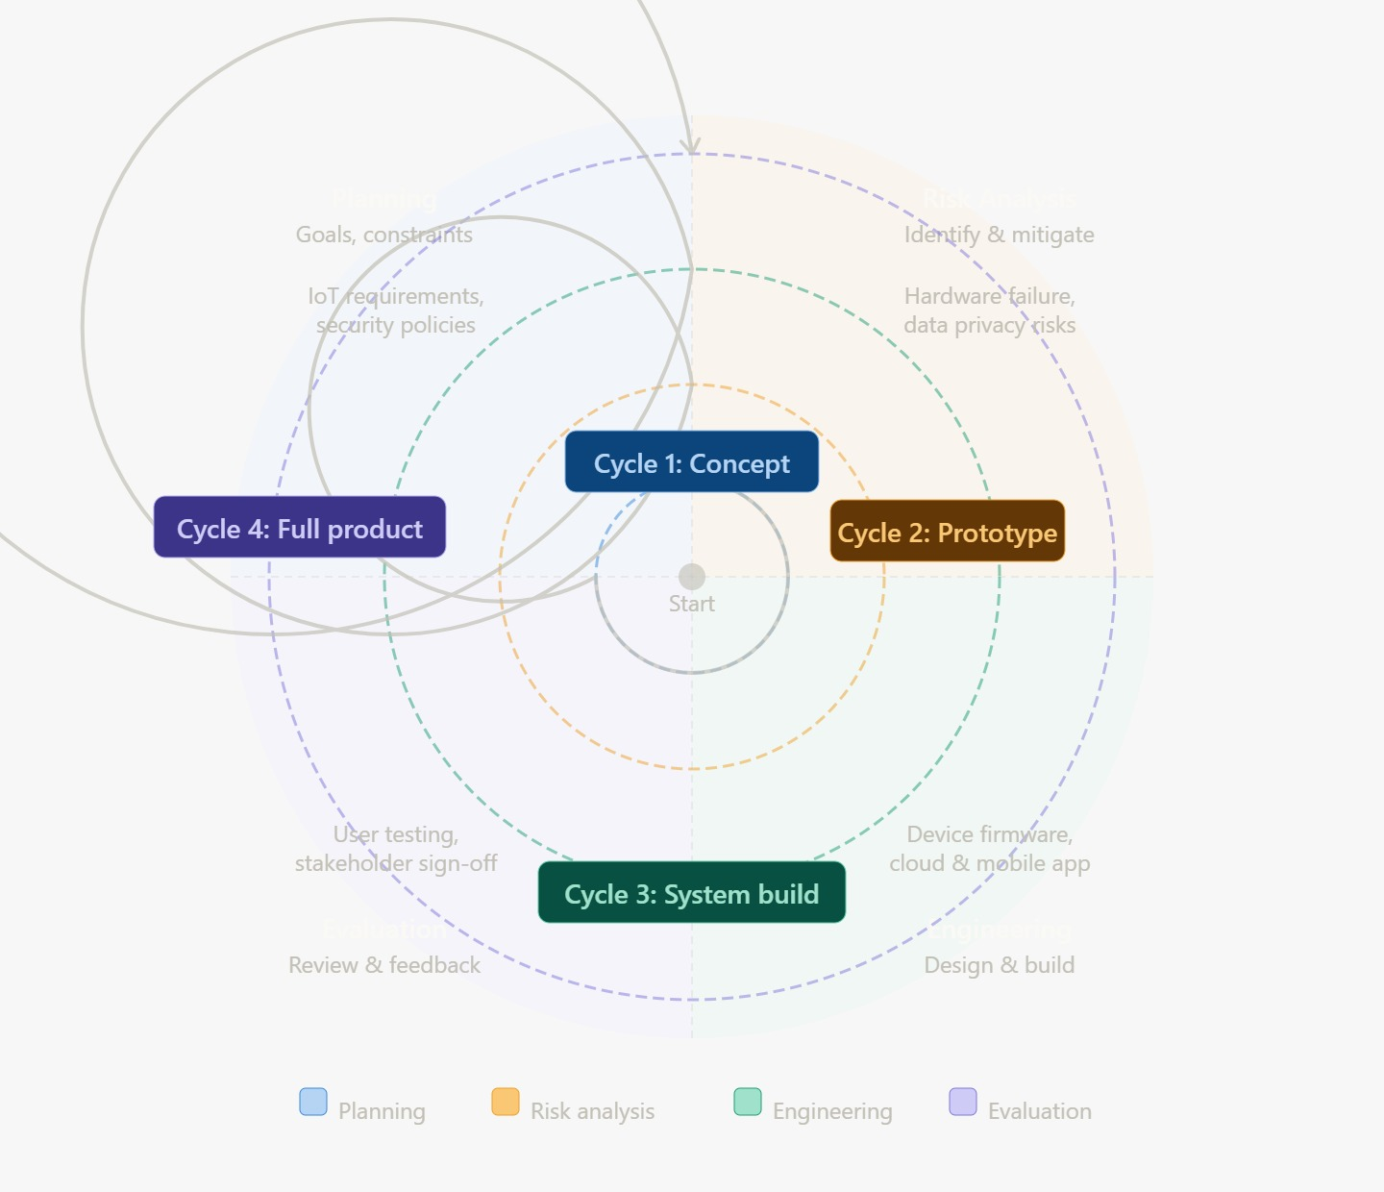
How the Spiral Model flows:
- Each cycle begins with Planning — identifying goals, constraints, and requirements for that phase.
- Risk Analysis follows — all technical, security, and operational risks are identified and mitigation strategies are defined.
- Engineering builds the increment — actual design, coding, and testing happens here.
- Evaluation closes the cycle — users and stakeholders review the output, and feedback is fed into the next spiral.
- The process repeats outward (like a spiral) with increasing scope until the complete system is delivered.

6. Conclusion
The Spiral Model is the most suitable SDLC for a Smart Home Automation System because it is a high-risk, high-complexity project with evolving requirements, critical security concerns, and tight hardware-software integration. No other model provides the structured risk analysis at every development cycle that this system demands.
The Spiral Model's four-phase cycle — Planning, Risk Analysis, Engineering, and Evaluation — ensures that every increment of the smart home system is thoroughly reviewed for technical, safety, and security risks before the next layer is built. This makes it the most responsible and effective choice for a system that controls real-world physical environments.

In conclusion, the Spiral Model perfectly balances structure, risk management, and flexibility — making it the most justified and appropriate SDLC model for a Smart Home Automation System.

