

**Manage Warehouse**

* **Faculty: Ho Hoan Kiem**
* **Batch:**
* **Team Member:**
  + - * **Đinh Quốc Hậu**
      * **Mai Tân Chinh**

**Ho Chi Minh City, Sep 10 2012**

Table of Contents

1. Review 1

* **Problem Definition..…………………………………………………………………………………01**
* **Customer Request Specification……………………………………………………………… 02**

1. Review 2

* ***Use Case Diagram* 04**
* ***Class Diagram* 15**
* ***Sequence Diagram* 16**
* ***ERD* 18**
* ***Entity Description* 19**
* ***Table Relationship Diagram* 26**

1. Review 3

* Interface Design………………………………………………………………………………..... 27
* Site Map……………………………………………………………………………………………… 51
* Report ………………………………………………………………………………………………..53
* Tasksheet……………………………………………………………………………………………. 56

REVIEW 1

Problem Definition

1. **The Object Of The Project**

This project aims to create a convenient store management system with small and medium scale. This will only be accessible to store owners with a unique id and password. This system provides the following facilities:

* Import goods into the warehouse.
* Exporting goods from warehouse.
* Print retail invoices to customers.
* Manage the amount of goods in stock.
* Goods information management.

Customer Request   
 Specification

1. **Functional Requirements**

Following is a list of functionalities of the system. More functionalities that you find appropriate can be added to this list.

* Shopkeeper must have a valid User Id and password to login to the system.
* If a wrong password is given thrice in succession, that account will be locked and the shopkeeper will not be able to use it. When an invalid password is entered a warning is given to the user that his/her account is going to get locked.
* After the valid user logs in he/she is shown the function screen.
* On selecting the function he/she is taken to a page which shows this function.
* If he/she select the function of importing goods into the warehouse, on the screen there will be lines for him/her to enter the necessary information, such as: product code, name, the number of items in 1 package, the number of packages of goods, prices of 1 package. After entering all information, the system will automatically calculate the total amount of the shipment and click Add to save.
* If he/she chooses the function of managing goods information in warehouse, he/she can edit product information, such as name and retail price of goods and click uUpdate to save it.
* Or when selecting the retail payment function, the retail screen will be displayed with a box to enter product information: code, product number. Click Add to add the product to the payment list and click Payment to issue an invoice. The system will automatically calculate the total amount to be paid save the order code.
* Shopkeeper can review all the goods sold that day and the total amount collected.

# Hardware/ Software Requirements

By adding new technologies such as ASP.NET 3.5, AJAX, Web Service and 3-tier architecture, the web site becomes more interactive with users, security and easily updated.

1. **System Requirement**

* **For Users**
  + **Hardware**
    - CPU: Pentium IV 2.0 GHz or higher
    - RAM: 512 MB or higher
  + **Software**
    - OS: Windows 7/XP Professional/Server 2003…
    - Browser: Internet Explorer 8.0 or higher
* **For Software Developers**
  + **Hardware**
    - CPU: Pentium IV 2.0 GHz or higher
    - RAM: 512 MB or higher
  + **Software**
    - OS: Windows XP Professional/Server 2003…
    - Environment: Microsoft .NET Framework 3.5
    - Database Management System: Microsoft SQL Server 2008
    - IDE: Microsoft Visual Studio 2010

|  |  |  |
| --- | --- | --- |
| **Date: Sep 10, 2012** | **Prepared by Project Group 4**  **Team Leader:** | **Approved by**  **Mr Ho Hoan Kiem** |
| **Signature** |  |  |

* + - Web Server: Internet Information Services (IIS) JSP / Servlets Dev. Kit

REVIEW 2

**USE CASE DIAGRAM**

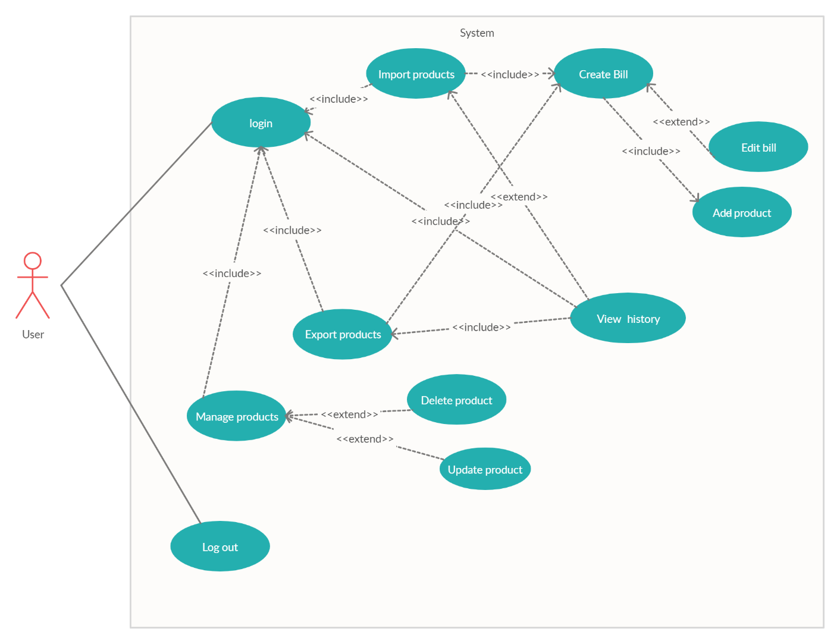

**USE CASE DESCRIPTION**

1. **User:**

User: Owners who buy software and are granted an account to operate the store's trading activities.

1. **Usecase**

|  |  |
| --- | --- |
| **Usecase** | Login |
| **Short Description** | Log in application to use any function of member. |
| **Pre-Conditions** |  |
| **Post-Conditions** |  |
| **Main flow** | _Use inputs the login information :   * Login ID. * Password.   _User clicks on the Login button.  _System check the Login ID and Password.  _If Login ID and Password are invalid, system will notify error “Login Failed”. |
| **Alternative flow(s)** | _If Login ID and Password are invalid, the Login ID field and Password field are blank. |

|  |  |
| --- | --- |
| **Use case** | Import product |
| **Short Description** | Import products into the warehouse. |
| **Pre-Conditions** |  |
| **Post-Conditions** |  |
| **Main flow** | _ Customers enter the product code, the product number in a package, the number of packages, the price of each package and retail price of each product in the input fields.  _ After entering all necessary information, customers press the Add button to add goods to the warehouse. |
| **Alternative flow(s)** | _ If the customer clicks Add when the required input fields are not fully entered or in the wrong format, a warning will be displayed. |

|  |  |
| --- | --- |
| **Usecase** | Export product |
| **Short Description** | Get products out of the warehouse |
| **Pre-Conditions** |  |
| **Post-Conditions** |  |
| **Main flow** | _ Take merchandise out of stock for sale and store history of goods sold.  _ Update the amount of goods left in the warehouse after a day. |
| **Alternative flow(s)** |  |

|  |  |
| --- | --- |
| **Usecase** | Create bill |
| **Short Description** | Create bill payment |
| **Pre-Conditions** |  |
| **Post-Conditions** |  |
| **Main flow** | _The screen displays all the paid products.  _ Customers press the Checkout button to print invoices and save sales history. |
| **Alternative flow(s)** | _ If the number of products to be sold is greater than the number of products that are left in stock, they will be notified on the screen. |

|  |  |
| --- | --- |
| **Usecase** | Manage product |
| **Short Description** | View product in warehouse |
| **Pre-Conditions** |  |
| **Post-Conditions** |  |
| **Main flow** | _User will be able to see information about all the items in stock and their remaining quantity.  _User can search for goods by code. |
| **Alternative flow(s)** |  |

|  |  |
| --- | --- |
| **Usecase** | Update product |
| **Short Description** | Update retail prices |
| **Pre-Conditions** |  |
| **Post-Conditions** |  |
| **Main flow** | _When viewing the remainder of stock, customers can update the retail price of each item if the market value changes. |
| **Alternative flow(s)** |  |

|  |  |
| --- | --- |
| **Usecase** | Delete product |
| **Short Description** | Remove products from the warehouse |
| **Pre-Conditions** |  |
| **Post-Conditions** |  |
| **Main flow** | _In the product management screen, users can press the Delete button to delete any product from the warehouse. |
| **Alternative flow(s)** |  |

|  |  |
| --- | --- |
| **Usecase** | View history |
| **Short Description** | Total revenue |
| **Pre-Conditions** |  |
| **Post-Conditions** |  |
| **Main flow** | _Calculate the total revenue earned from all products sold during the day and display it on the screen. |
| **Alternative flow(s)** |  |

|  |  |
| --- | --- |
| **Usecase** | Add product |
| **Short Description** | Add product to bill |
| **Pre-Conditions** |  |
| **Post-Conditions** |  |
| **Main flow** | _ After user enter the product code and find out the product is in warehouse, enter the number of products to sell.Users press the Add button to add products to the bill. |
| **Alternative flow(s)** |  |

|  |  |
| --- | --- |
| **Usecase** | Edit bill |
| **Short Description** | Modify bill |
| **Pre-Conditions** |  |
| **Post-Conditions** |  |
| **Main flow** | _ Users can edit the list of products that have been added to the invoice, such as deleting products from the invoice. |
| **Alternative flow(s)** |  |

|  |  |
| --- | --- |
| **Usecase** | View payment history |
| **Short Description** | Review the products that have been paid |
| **Pre-Conditions** |  |
| **Post-Conditions** |  |
| **Main flow** | After you have finished adding products to the invoice, users can click the Checkout button to print the invoice and save payment history. |
| **Alternative flow(s)** |  |

|  |  |
| --- | --- |
| **Usecase** | Log out |
| **Short Description** | Log out of the system |
| **Pre-Conditions** |  |
| **Post-Conditions** |  |
| **Main flow** | Back to login screen |
| **Alternative flow(s)** |  |

**CLASS DIAGRAM**

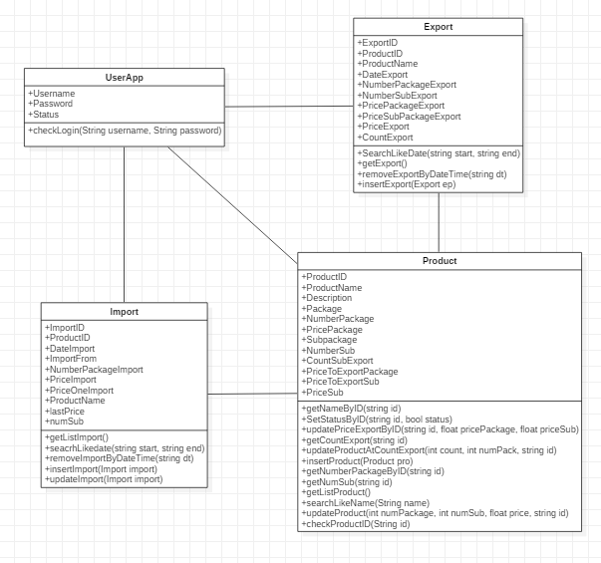

**SEQUENCE DIAGRAM**

**1, login**

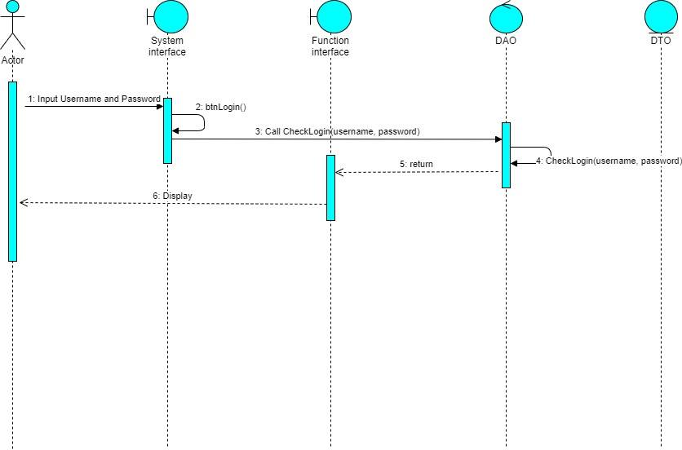

**2, Import**

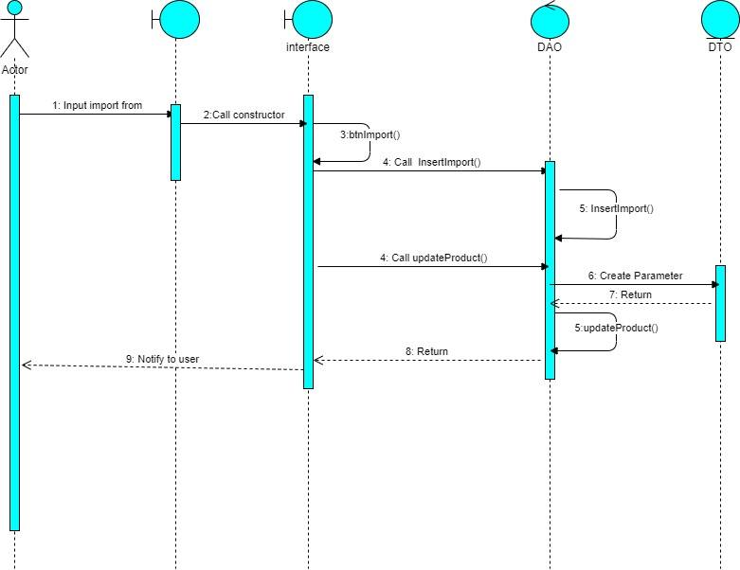

**3, Export**

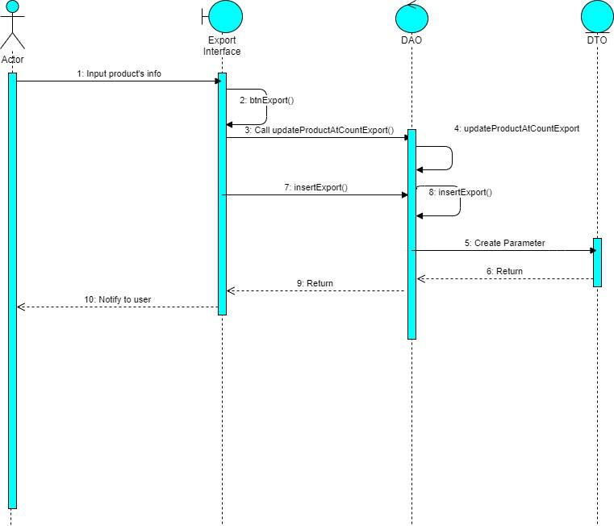

**4, Manage product**

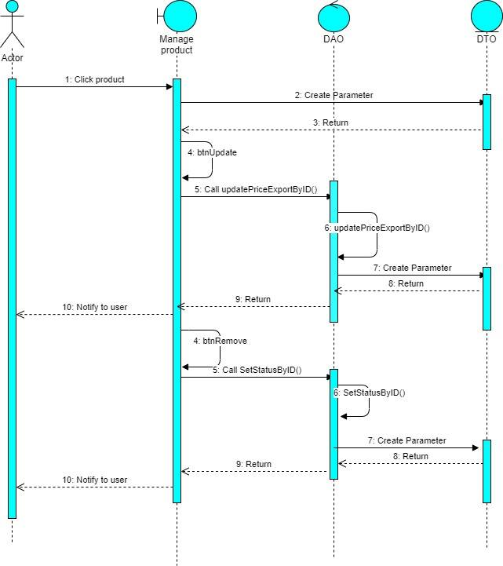**5, View history**

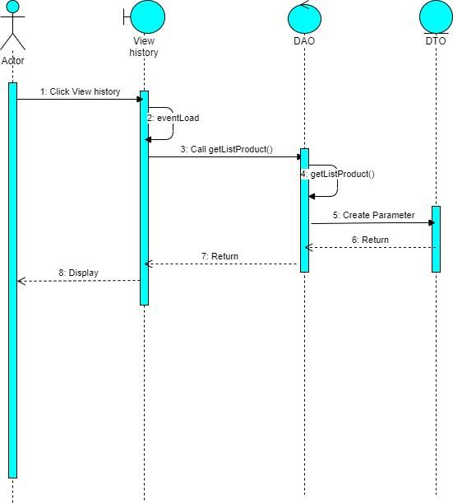**\**

**6, Logout**

**ENTITY RELATIONSHIP DIAGRAM (ERD)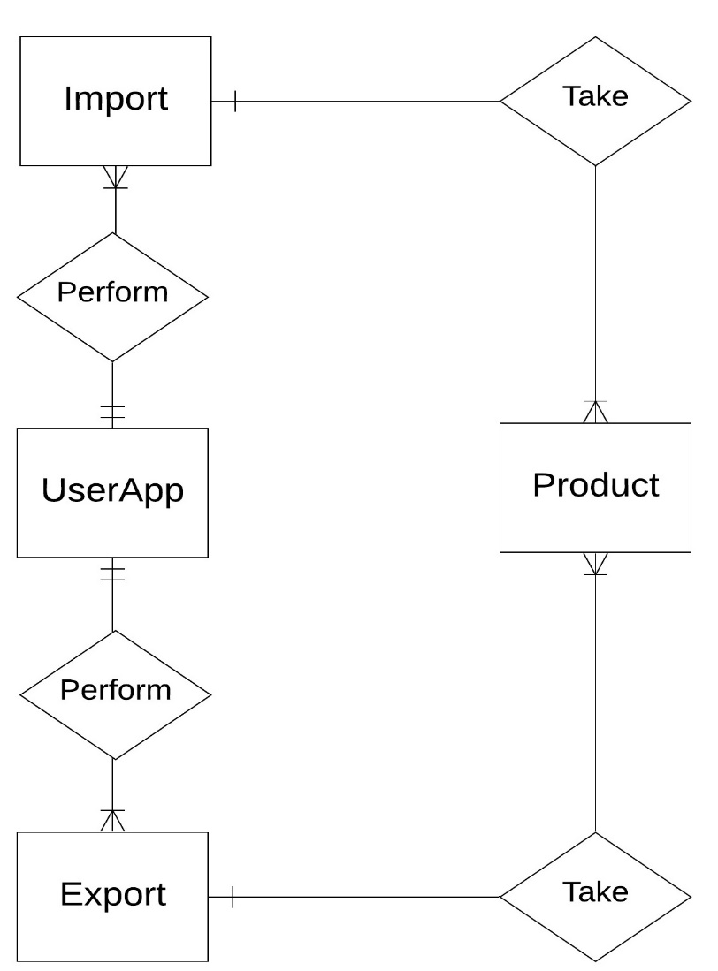 Note:  
  
  
ENTITY DESCRIPTION**

One to  
 many

Entity

Entity Relationship

only one to  
 one or many

**1.UserApp:**

**Account  
Customers**

**2.Product:**

**Product**

**3. Export Product :**

**Export**

**5. Import:**

**Import**

**TABLE DESIGN**

1. **UserApp:**

|  |  |  |  |  |  |
| --- | --- | --- | --- | --- | --- |
| **No** | **Column Name** | **Data Type** | **Size** | **Check** | **Description** |
| 1 | **🗝**Username | Nchar | 50 | Not Null | User ID |
| 2 | Passwords | Nchar | 50 | Null | User’s password |
| 3 | Status | Bit |  | Null | User’s user name |

1. **Product:**

|  |  |  |  |  |  |
| --- | --- | --- | --- | --- | --- |
| **No** | **Column Name** | **Data Type** | **Size** | **Check** | **Description** |
| 1 | **🗝**ProductID | Nchar | 10 | Not Null | Product’s ID |
| 2 | ProductName | Nvarchar | 150 | Null | Product’s name |
| 3 | Description | Nvarchar | 150 | Null | Product’s Description |
| 4 | PackageID | Nchar | 50 | Null | Package’s ID |
| 5 | NumbersPackage | Int |  | Null | Quantity of package |
| 6 | PriceOnePackage | Float |  | Null | Import price |
| 7 | PriceToExportPackage | Float |  | Null | Package’s Price |
| 8 | SubPackage | Nvarchar | 50 | Null | Package’ |
| 9 | NumberSubPackage | Int |  | Null | Quantity of sub in a package |
| 10 | CountSubExport | Int |  | Null | Quantity of sub in a package is sold |
| 11 | PriceToExportSub | Float |  | Null | Retail price |
| 12 | Status | Bit |  | Null | Delete incomplete products from the database |

1. **Export:**

|  |  |  |  |  |  |
| --- | --- | --- | --- | --- | --- |
| **No** | **Column Name** | **Data Type** | **Size** | **Check** | **Description** |
| 1 | ExportID | Nchar | 50 | Null |  |
| 2 | ProductID | Varchar | 30 | Null | Product’s ID |
| 3 | DateExport | Datetime |  | Null | Export date |

1. **Import:**

|  |  |  |  |  |  |
| --- | --- | --- | --- | --- | --- |
| **No** | **Column Name** | **Data Type** | **Size** | **Check** | **Description** |
| 1 | ImportID | Nchar | 50 | Null |  |
| 2 | ProductID | Nchar | 10 | Null | Product’s ID |
| 3 | DateImport | Datetime |  | Null | Import date |
| 4 | ImportFrom | Nchar | 100 | Null | Supplier |
| 5 | NumberPackageImport | Int |  | Null | Quantity of package |

**Note**

**🗝** Primary key

✓ Unique constraint

**TABLE RELATIONSHIP DIAGRAM**

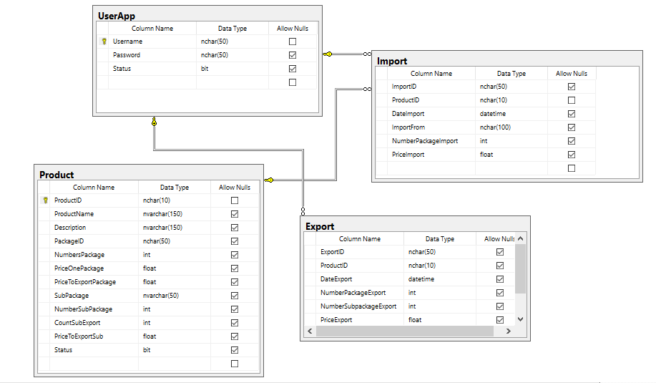

|  |  |  |
| --- | --- | --- |
| **Date: Sep 20, 2012** | **Prepared by Project Group 4**  **Team Leader:** | **Approved by**  **Mr. Ho Hoan Kiem** |
| **Signature** |  |  |

REVIEW 3

**INTERFACE DESIGN**

1. **Login screen**

|  |  |  |  |  |  |
| --- | --- | --- | --- | --- | --- |
| **Name** | **Type** | **Event** | **Validation** | **Description** | **Status** |
| txtUsername | TextBox |  | String, not null | Input Customer’s user name |  |
| txtPassword | TextBox |  | String, not null, | Input Customer’s password |  |
| btnLogin | Button |  | Click | Choose Login |  |

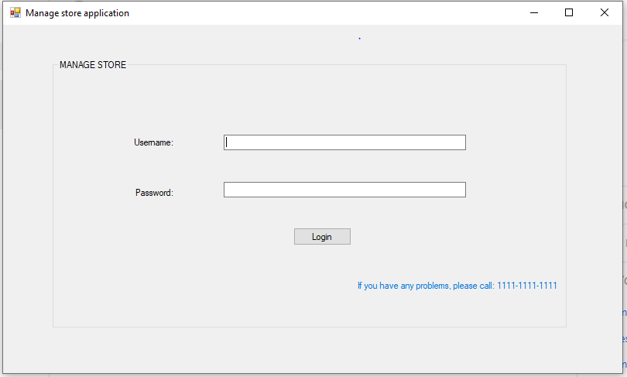

1. **Function Screen:**

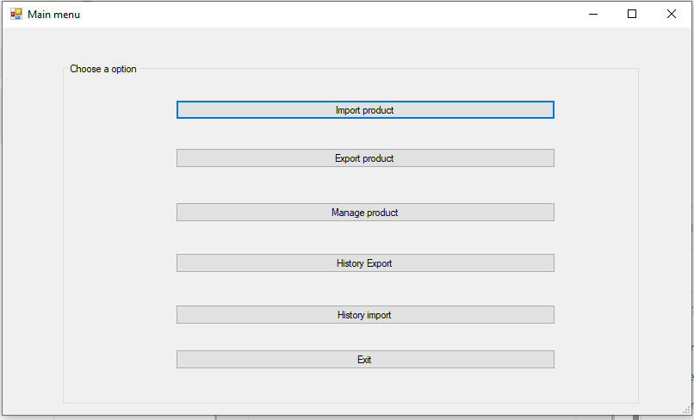

|  |  |  |  |  |
| --- | --- | --- | --- | --- |
| **Name** | **Type** | **Event** | **Description** | **Status** |
| btnImport | Button | Click | Import function |  |
| btnExport | Button | Click | Export function |  |
| btnManage | Button | Click | Manage product function |  |
| btnHistoryExport | Button | Click | View history export function |  |
| btnHistoryImport | Button | Click | View history inport function |  |
| btnExist | Button | Click | Exit program |  |

**3. Import from screen:**

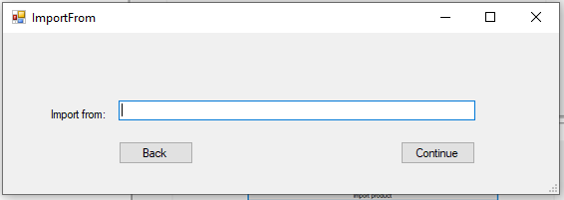

|  |  |  |  |  |  |
| --- | --- | --- | --- | --- | --- |
| **Name** | **Type** | **Event** | **Validation** | **Description** | **Status** |
| txtImportFrom | TextBox | Validating | String, not null | Source of goods |  |
| btnBack | Button | Click |  | Back to the previous screen |  |
| btnContinue | Button | Click |  | Continue to import |  |

**4.Import screen:**

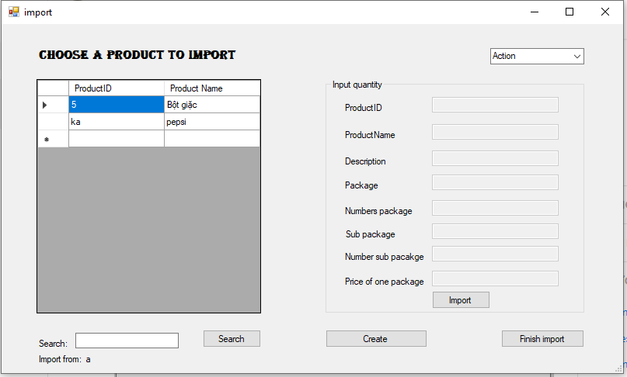

|  |  |  |  |  |  |
| --- | --- | --- | --- | --- | --- |
| **Name** | **Type** | **Event** | **Validation** | **Description** | **Status** |
| dgvListProduct | DataGridView | Click |  | List of products |  |
| cbAction | ComboBox | SelectedIndexChanged |  |  |  |
| txtProductID | TextBox |  | String, not null | Input product’s ID |  |
| txtProductName | TextBox |  | String, not null | Input product’s name |  |
| txtDescription | TextBox |  | String, not null | Input product’s description |  |
| txtPackage | TextBox |  | String, not null | Input product’s package |  |
| txtNumberPacakge | TextBox | Validating | int, not null, greater than 0 | Quantity of package |  |
| txtSubPackage | TextBox |  | String | Name of sub in package |  |
| txtNumberSub | TextBox | Validating | int, not null, greater than 0 | Quantity of sub in a package |  |
| txtPrice | TextBox | Validating | float, not null,greater than 0 | Price of a package |  |
| btnImport | Button | Click |  | Add product into stock |  |
| btnCreate | Button | Click |  | Create products that are not in stock |  |
| btnFinish | Button | Click |  | Finish import |  |
| btnSearch | Button | Click |  | Find product by ID |  |
| txtSearch | TextBox |  |  | Product’s ID need to search |  |

1. **Create product screen:**

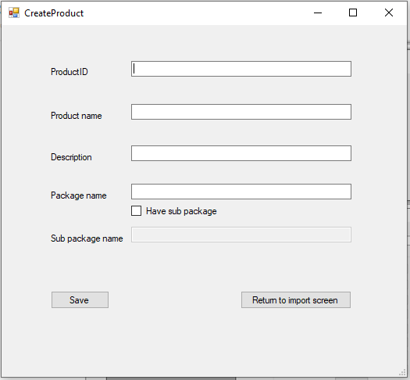

|  |  |  |  |  |  |
| --- | --- | --- | --- | --- | --- |
| **Name** | **Type** | **Event** | **Validation** | **Description** | **Status** |
| txtProductID | TextBox | Validating | String, not null | Input product’s ID |  |
| txtProductName | TextBox | Validating | String, not null, | Input product’s name |  |
| txtDescription | TextBox | Validating | String,not null | Input product’s description |  |
| txtPackage | TextBox | Validating | String,not null | Input product’s package |  |
| txtSubpacakge | TextBox | Validating | String,not null | Name of sub in package |  |
| chCheckSub | CheckBox | Click |  | have sub or not |  |
| btnSave | Button | Click |  | Save |  |
| btnReturn | Button | Click |  | Back to import screen |  |

1. **List Prodcut Inport screen:**

|  |  |  |  |  |  |
| --- | --- | --- | --- | --- | --- |
| **Name** | **Type** | **Event** | **Validation** | **Description** | **Status** |
| dgvSubmit | DataGridView | Click |  | Display all product are imported and get productID |  |
| btnBack | Button | Click |  | Back to import |  |
| btnSubmit | Button | Click |  | Finish import |  |
| btnRemove | Button | Click |  | Remove product |  |

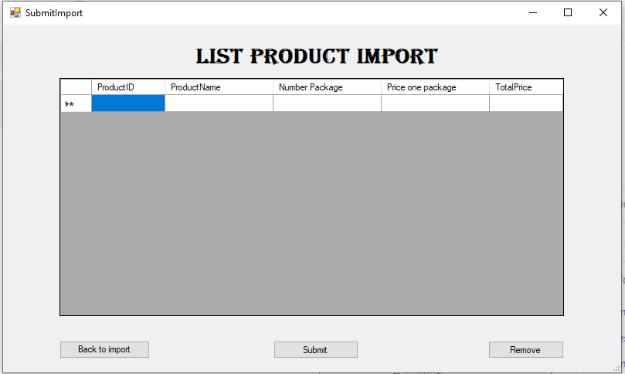

1. **Export Product screen:**

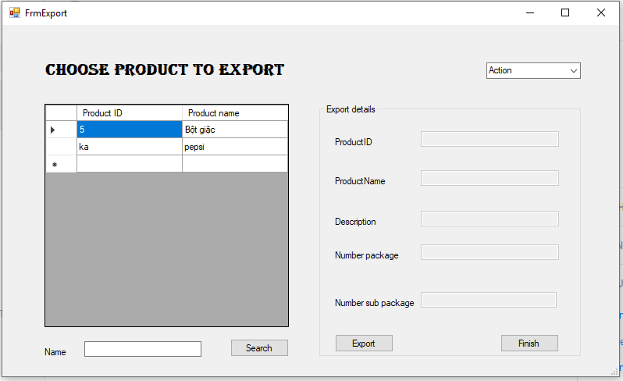

|  |  |  |  |  |  |
| --- | --- | --- | --- | --- | --- |
| **Name** | **Type** | **Event** | **Validation** | **Description** | **Status** |
| dgvExport | DataGridView | Click |  | Display product are exported |  |
| txtSearch | TextBox |  |  | Product’s ID need to search |  |
| btnSearch | Button | Click |  | Search product by ID |  |
| cbAction | ComboBox | SelectedIndexChanged |  | Back to function screen or log out |  |
| txtProductID | TextBox |  |  | Input product’s ID |  |
| txtProductName | TextBox |  |  | Input product’s name |  |
| txtDesCription | TextBox |  |  | Input product’s description |  |
| txtNumberPackage | TextBox | validating | Int, not null, greater than 0 | Quantity of package |  |
| txtNumberSub | TextBox | validating | Int, not null, greater than 0 | Quantity of sub package |  |
| btnExport | Button | Click |  | Export |  |
| btnFinish | Button | Click |  | Finish export |  |

1. **List Product Export screen:**

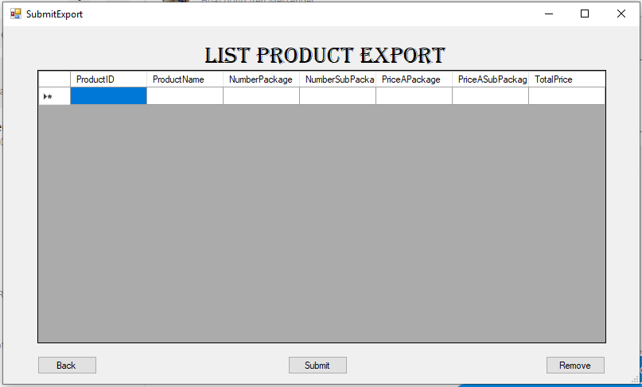

|  |  |  |  |  |  |
| --- | --- | --- | --- | --- | --- |
| **Name** | **Type** | **Event** | **Validation** | **Description** | **Status** |
| dgvSubmitExport | DataGridView | Click |  | Display products are exported and get productID |  |
| btnBack | Button | Click |  | Back to previous screen |  |
| btnSubmit | Button | Click |  | Finish export |  |
| btnRemove | Button | Click |  | Remove product |  |

**9.List product screen:**

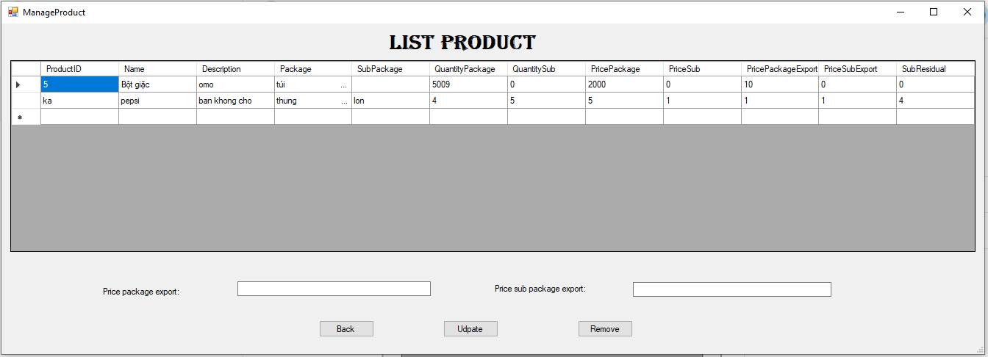

|  |  |  |  |  |  |
| --- | --- | --- | --- | --- | --- |
| **Name** | **Type** | **Event** | **Validation** | **Description** | **Status** |
| dgvView | DataGridView | click |  | Display all product  And get information of product |  |
| lbPrice package export | label |  |  | Display title price package export: |  |
| txtPricePack | TextBox |  | Not null, greater than 0 | Input price package export |  |
| lbPriceSubExport | label |  |  | Display title price sub package export: |  |
| txtPriceSub | TextBox |  | Not null, greater than 0 | Input price sub package export |  |
| btnBack | Button | Click |  | Back to function screen |  |
| btnUpdate | Button | Click |  | Update price export of product.. |  |
| btnRemove | Button | Click |  | Remove product |  |

1. **History export screen:**

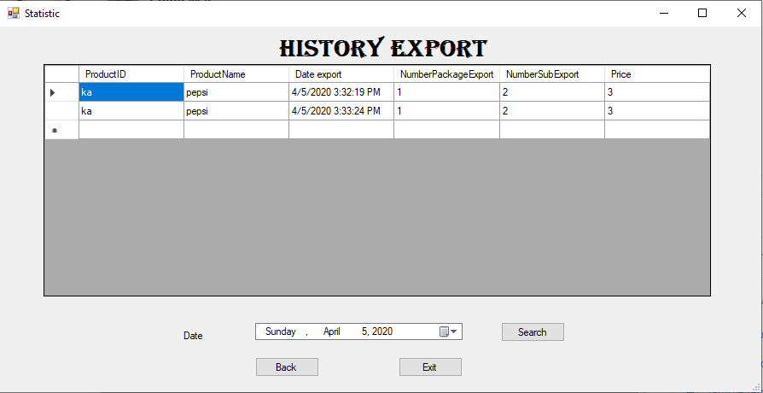

|  |  |  |  |  |  |
| --- | --- | --- | --- | --- | --- |
| **Name** | **Type** | **Event** | **Validation** | **Description** | **Status** |
| dgvHistory | Datagirdview |  |  | Load history export |  |
| lbDate | Label |  |  | Display title to search |  |
| dtSearch | DateTimePicker |  | Date Time | Get date to search |  |
| btnSearch | Button | Click |  | Search export like date |  |
| btnBack | Button | Click |  | Back to function scrren |  |
| btnExit | Button | Click |  | Quit |  |

**11.History import screen:**

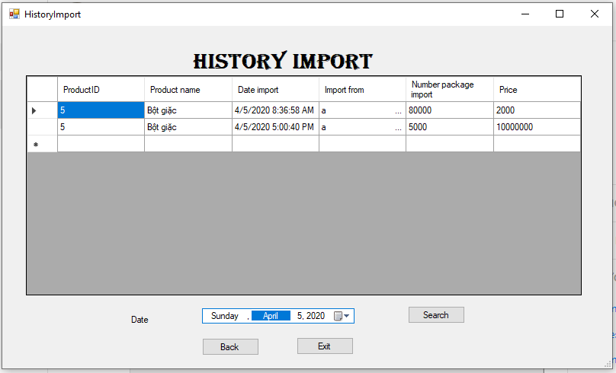

|  |  |  |  |  |  |
| --- | --- | --- | --- | --- | --- |
| **Name** | **Type** | **Event** | **Validation** | **Description** | **Status** |
| dgvHistory | DataGirdView |  |  | Get history import |  |
| lbDate | Label |  |  | Display title search |  |
| dtSeacrh | DateTimePicker |  |  | Get search value |  |
| btnSearch | Button | click |  | Search history import |  |
| btnBack | Button | Click |  | Back to function screen |  |
| btnExit | Button | Click |  | Exist |  |

**TASK SHEET**

|  |  |  |  |  |  |  |
| --- | --- | --- | --- | --- | --- | --- |
| **Project Group FFG** | | **Project Title**  **Laptop Shop Online** | | **Date of Preparation** | | **Activity Plan Prepared by**  **Team** |
| **No** | **Task Title** | | **Planned Start Date** | **Planned Completed Date** | **Team Mate Names** | **Status** |
| 1 | Login | | 04/04/2020 | 05/04/2020 |  |  |
| 2 | Import product | |  |
| 3 | Create product | |  |
| 4 | View history import | |  |
| 5 | Export product | |  |
| 6 | View history import | |  |  |
| 7 | Update product | |  |
| 8 |  | |  |
| 9 |  | |  |
| 10 |  | |  |
| 11 |  | |  |  |
| 12 |  | |  |
| 13 |  | |  |
| 14 |  | |  |
| 15 |  | |  |
| 16 |  | |  |  |
|  |
| 17 |  | |  |
| 18 |  | |  |
| 19 |  | |  |
| 20 |  | |  |  |
| 21 |  | |  |
| 22 |  | |  |
| 23 |  | |  |
| 25 |  | |  |
| 26 |  | |  |
| 27 |  | |  |

|  |  |  |
| --- | --- | --- |
| **Date: Oct 10, 2012** | **Prepared by Project Group 4**  **Team Leader:** | **Approved by**  **Mr. Ho Hoan Kiem** |
| **Signature** |  |  |