## Linearity analysis and Limit of Detection (LOD) and Limit of Quantitation (LOQ)

1. Open the table containing the linearity study and if also the table for LOD & LOQ

## Example Data Table linearity study

Five concentrations of a reference standard by six independent determinations for each concentration covering 80% of the lower specification limits and 120% of the upper specification limit for a two-sided product specification limit.

| **Theoretical Concentration/Dilution** | **Day** | **Analyst** | **Instrument** | **Relative Potency %** |
| --- | --- | --- | --- | --- |
| 150 | D1 | A1 | I2 | 153.6 |
| 50 | D1 | A2 | I2 | 47.1 |
| 150 | D2 | A2 | I1 | 156 |
| 125 | D2 | A1 | I2 | 128.2 |
| 50 | D1 | A1 | I1 | 52 |
| 50 | D1 | A1 | I1 | 47.6 |
| 100 | D2 | A2 | I2 | 97.9 |
| 75 | D2 | A2 | I1 | 76.7 |
| 75 | D1 | A1 | I2 | 79.9 |
| 100 | D1 | A1 | I1 | 99.5 |
| 100 | D1 | A1 | I1 | 99.4 |
| 150 | D1 | A1 | I2 | 153.7 |
| 50 | D2 | A1 | I2 | 41.3 |
| 100 | D2 | A2 | I2 | 99 |
| 150 | D1 | A2 | I1 | 168.9 |
| 125 | D2 | A1 | I1 | 129.6 |
| 125 | D2 | A1 | I1 | 127.8 |
| 150 | D2 | A1 | I2 | 155.5 |
| 75 | D1 | A2 | I2 | 80.1 |
| 50 | D2 | A2 | I1 | 53.9 |
| 100 | D2 | A2 | I2 | 101.7 |
| 75 | D2 | A1 | I2 | 73.4 |
| 150 | D2 | A2 | I1 | 159 |
| 125 | D1 | A2 | I1 | 117.1 |
| 75 | D2 | A1 | I1 | 81.2 |
| 75 | D1 | A2 | I1 | 81.4 |
| 50 | D2 | A2 | I2 | 52.2 |
| 125 | D1 | A2 | I2 | 126.3 |
| 100 | D1 | A1 | I1 | 101.1 |
| 125 | D1 | A2 | I2 | 125.3 |

## Example data table LOD & LOQ

Two concentrations of a reference standard by six independent determinations for each concentration at or near the estimated LOD and LOQ limit.

| **Theoretical Concentration** | **Measurement** | **Theo2** |
| --- | --- | --- |
| 4 | 3.953 | 2 |
| 4 | 4.014 | 2 |
| 4 | 4.000 | 2 |
| 4 | 4.042 | 2 |
| 4 | 3.981 | 2 |
| 4 | 4.028 | 2 |
| 2 | 1.986 | 3 |
| 2 | 1.994 | 3 |
| 2 | 1.996 | 3 |
| 2 | 2.014 | 3 |
| 2 | 1.981 | 3 |
| 2 | 2.019 | 3 |

1. Launch the linearity analysis from the Method Validation menu

## Launch dialog Linearity

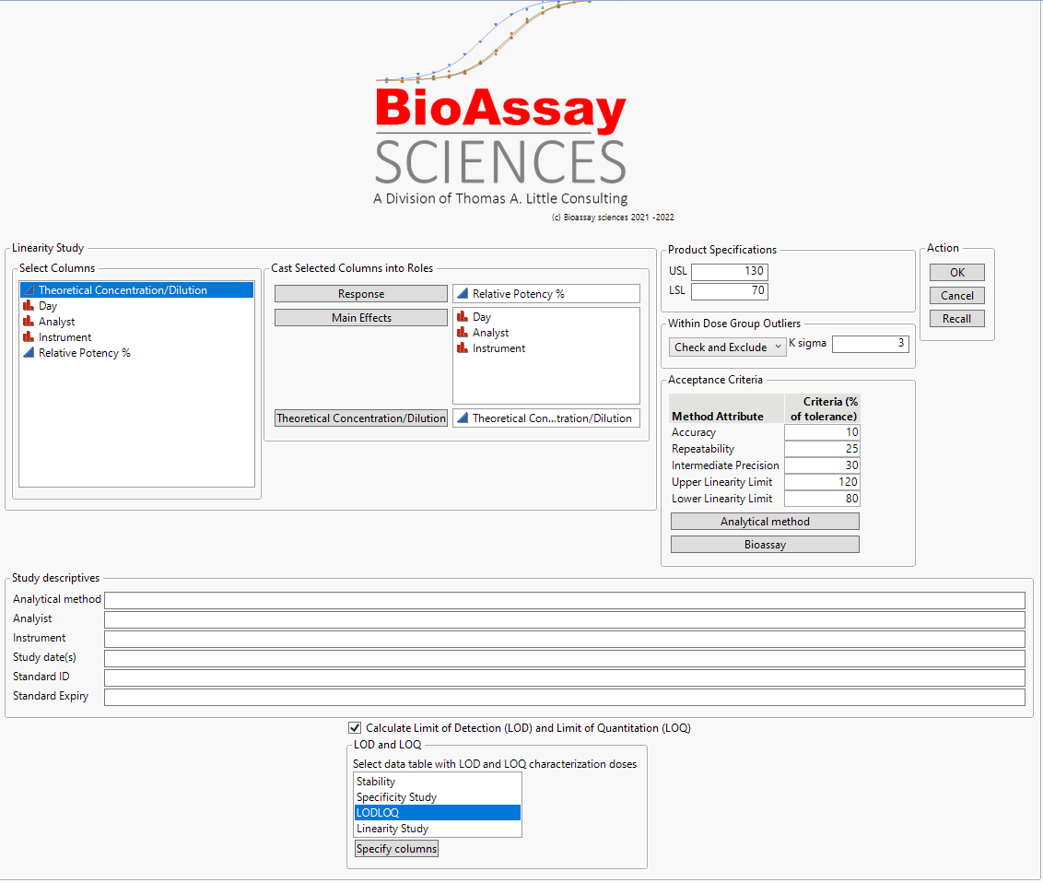

* The response is the measured concentration/potency or other quantitation of the method
* The main effects are the study factors, each in a separate column coded as nominal
* The theoretical concentration or dilution is the 'truth' that we want to see if the method can pick up
* The product specifications in combination with the acceptance criteria set the requirements for the method. Tolerance is USL - LSL
* Within dose group outliers allows you to choose how to handle outlier detection. If 'Detect only' or 'Check and Exclude' is selected, the K sigma value determines the spec for what is flagged as an outlier
* The study descriptives are not used in the analysis but added to the report on the title page

1. To add LOD and LOQ, check the checkbox

Requires the LOD and LOQ table to be opened before running the linearity analysis

1. Select the data table containing the LOD & LOQ study and specify columns

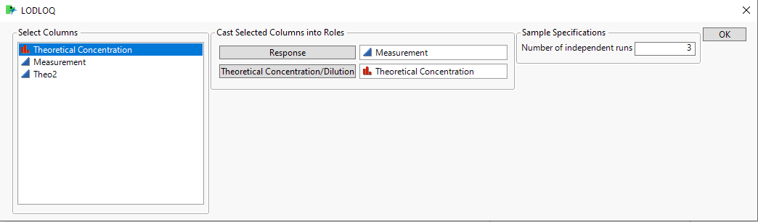

* Response and theoretical concentration/dilution are the same observation as used in the linearity study
* Number of independent runs can be used if the observed response is based on multiple measurements. In this example it is based on 3 repeat measurements from a batch.

1. Press ok to get back to the linearity dialog.
2. Press ok to run the analysis

The report is saved as a journal and a pdf in the same folder as the study data table is located. The file name is formatted as “data table name yyyy.mm.ddThh.mm.ss.(jrn/pdf)”

# Specificity analysis

1. Open the table containing the Specificity study

## Example data table specificity study

Three concentrations of the reference standard for every interfering compound spike in representative concentrations of the interfering compound.

| **Theoretical Concentration/Dilution** | **Relative Potency % Unspiked** | **RP with Media** | **RP with Forced Deg** | **RP with interaction** |
| --- | --- | --- | --- | --- |
| 125 | 128.2 | 131.6 | 133.0 | 160.25 |
| 125 | 129.6 | 133.4 | 135.1 | 162 |
| 125 | 127.8 | 133.8 | 131.3 | 159.75 |
| 125 | 117.1 | . | . | 146.375 |
| 125 | 126.3 | . | . | 157.875 |
| 125 | 125.3 | . | . | 156.625 |
| 100 | 97.9 | 103.0 | 100.0 | 97.9 |
| 100 | 99.5 | 106.1 | 104.4 | 99.5 |
| 100 | 99.4 | 103.1 | 101.9 | 99.4 |
| 100 | 99 | . | . | 99 |
| 100 | 101.7 | . | . | 101.7 |
| 100 | 101.1 | . | . | 101.1 |
| 75 | 76.7 | 81.0 | 79.0 | 57.525 |
| 75 | 79.9 | 85.2 | 83.1 | 59.925 |
| 75 | 80.1 | 83.9 | 82.6 | 60.075 |
| 75 | 73.4 | . | . | 55.05 |
| 75 | 81.2 | . | . | 60.9 |
| 75 | 81.4 | . | . | 61.05 |

1. Launch the specificity analysis from the Method Validation menu

## Launch dialog

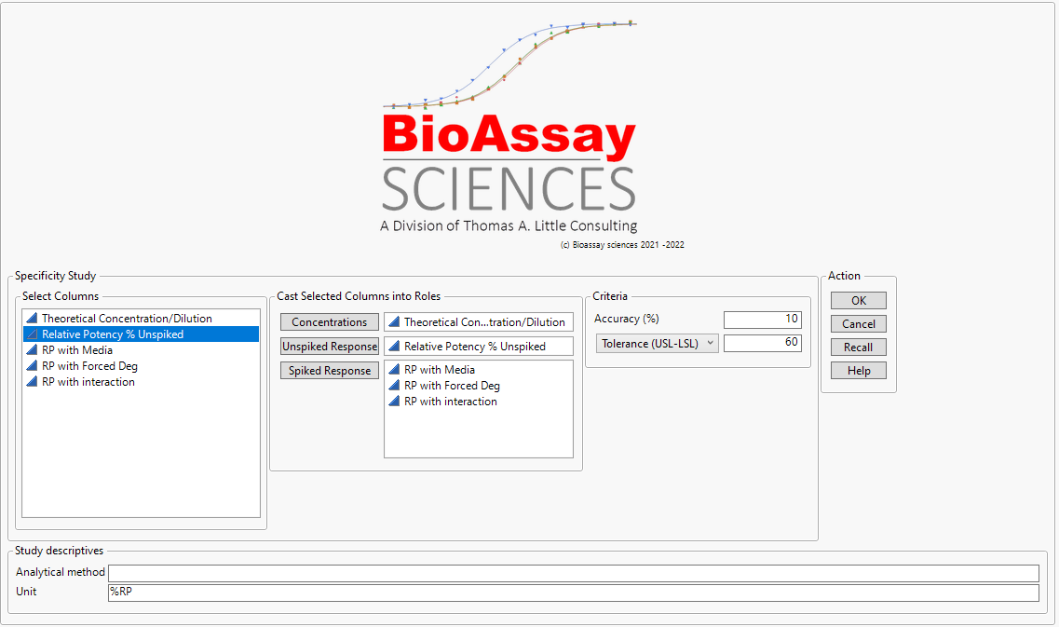

* The concentrations are the concentrations at which the study is done
* The unspiked response is the measurement of the pure material under study
* The spiked responses are the measurements (one per column) of the pure material but changed with materials or methods that need to be validated for their impact on the method
* Accuracy is the percentage of tolerance that is allowable for the spiked material to impact the quantitation
* The study descriptives are not used in the analysis but added to the report on the title page

1. Press ok to run the analysis

The report is saved as a journal and a pdf in the same folder as the study data table is located. The file name is formatted as “data table name yyyy.mm.ddThh.mm.ss.(jrn/pdf)”

# Stability analysis

1. Open the table containing the stability study

## Example data table stability study

One standard concentration under stressed conditions (temperature or pH) at five time points.

| **Time (hours)** | **Condition (C)** | **Impurity (%)** | **Purity** |
| --- | --- | --- | --- |
| 0 | 40 | 2 | 98 |
| 2 | 40 | 2.2 | 97 |
| 6 | 40 | 2.7 | 99 |
| 12 | 40 | 3.5 | 98.5 |
| 24 | 40 | 4.8 | 97.5 |
| 48 | 40 | 5.6 | 98 |

1. Launch the stability analysis from the Method Validation menu

## Launch dialog

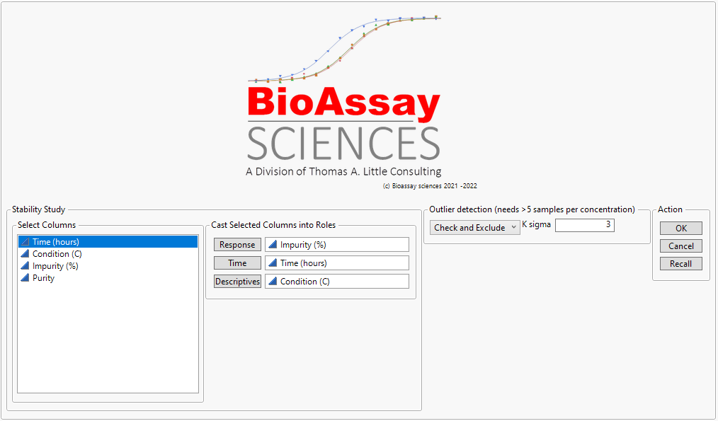

* The response is the measured concentration/potency or other quantitation of the method
* Time is the column that contains the time in units at which the measurements were taken
* Descriptives is a column that contains text that describe the conditions of the study (for example the temperature in degrees C at which the study was conducted)
* Outliers detection allows you to choose how to handle outlier detection. If 'Check and Exclude' is selected, the K sigma value determines the spec for what is flagged as an outlier

1. Press ok to run the analysis

The report is saved as a journal and a pdf in the same folder as the study data table is located. The file name is formatted as “data table name yyyy.mm.ddThh.mm.ss.(jrn/pdf)”