NARRATIVE REPORT ON SEMTOUR
In our recent seminar session, we discussed real-world IT skills that are not always taught inside the classroom. The talk was given by our speaker, Sir Samuel Orias, who shared practical lessons about what really happens in the workplace. The session helped us understand that being good in technical skills is not enough, because companies also look for communication skills, problem-solving abilities, adaptability, and professional behavior.
One of the main topics discussed was communication skills. Sir Orias explained that in a company, it is very important to speak clearly, especially when explaining problems. He compared vague questions and clear questions, and he said that clear questions help solve problems faster. He also reminded us to update our supervisors early before a small issue becomes a big problem. Listening carefully and speaking respectfully to senior staff are also important. Good communication helps build teamwork and avoids misunderstandings. Another important skill is problem-solving. In real jobs, not all instructions are complete or easy to understand. Sometimes employees face unexpected problems. Because of this, we must learn how to think carefully and find solutions on our own. Sir Orias said that companies value workers who do not always depend on others but try their best to solve problems first. This skill is very important in the IT field where challenges happen often.
Sir Orias also talked about adaptability, especially during On-the-Job Training (OJT). He said that OJT students may experience new tools, new systems, new work environments, and new people. There may also be unclear instructions from supervisors. In these situations, we should be patient, ask politely for clarification, and be willing to adjust. He also reminded us to lower our ego, accept corrections, and stay open to learning. The session also highlighted proper behavior in the workplace. Being on time, meeting deadlines, and finishing projects before the due date are very important. We should also show respect for the company hierarchy and act professionally without fear. Sir Orias emphasized that attitude and behavior are just as important as knowledge and skills. Another lesson that stood out was about handling mistakes. The speaker said that everyone makes mistakes at work because no one is perfect. What matters most is how we respond. He shared a simple guide: admit the mistake, explain what happened, fix the problem, and improve so it will not happen again. Being humble and saying sorry when we are wrong shows maturity and professionalism.

Overall, the session taught us that OJT and school activities are not just requirements to pass, but opportunities to prepare for real jobs. We learned that to succeed in the IT field, we need more than technical knowledge. We also need good communication, strong problem-solving skills, adaptability, and a professional attitude. These lessons will help us become more prepared and responsible in our future careers.

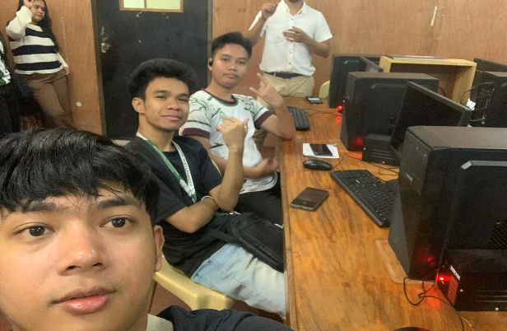
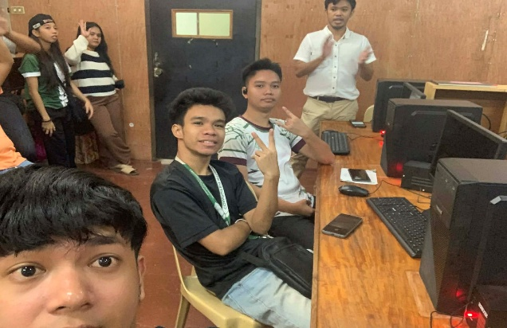

This is the discussion of Mr.Samuel Orias, during the seminar session.

Prepared by:
KENT ZOREL B. ELNAS

