QA/QC Instructions for Item Type – Extended Response

Extended Text: Overview
Extended Text item type requires test takers to respond by entering text (numbers, letters, symbols, etc.) into a response box.
Appearance:
    - Extended Text entry fields (text areas) are multiple lines tall and stand alone
    - The height of the boxes is controlled by authored values in the XML
    - When response is entered the character will fit the available text entry field and a vertical scrollbar appears
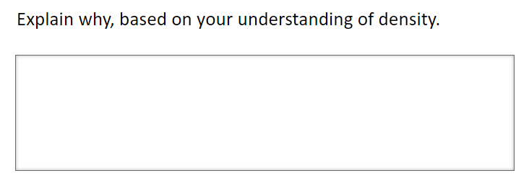
Max Character Limit:
    - You can enter up to 3000 characters in an Extended Text field (including spaces)
    - For math the new limit is set at 1000 characters
    - Letters, numbers, and all special characters are allowed

Extended Text: QC Checklist
 | Test | Steps to Test | Expected Results
1. | Verify that text can be entered into the extended text response box. | Select the extended text response box and then enter text.  - Enter letters, numbers, spaces, and special characters, including those that require the Shift key, from the attached keyboard. For Mathematics assessments, enter text from the attached keyboard and from the Equation Editor.  - Enter text to the end of the response box, with spacing between words/characters.  - Enter more than 5 lines of hard returns.  - For Mathematics assessments, test each button on each tab in the Equation Editor, including embedding templates. For instance, create a fraction that includes fractions, square roots, and operations.  - Enter a run of letters, numbers and special characters without spaces for more than one entire line (width of the response box). | All letters, numbers, and special characters should appear in the response box, including spaces, as entered.  Text should wrap to the next line as it reaches the end of the width of the response box (except for math). If a space is entered prior to the end of a word at the end of the response box, the entire word will wrap to the next line. This will be the case for text entered from either the attached keyboard or the Equation Editor, or a combination of the two.  NOTE: By default, there is not a horizontal/vertical scrollbar.  As text reaches the end of the fifth line or as there is a hard return made on the fifth line, a vertical scrollbar should appear on the right side of the response box as you go to the sixth line. No horizontal scrollbar should appear (except for math as text does not wrap).
2. | Verify max character limit.  NOTE: The standard max character limit is 3,000; however, for math the new limit is set at 1,000 characters. | Select the extended text response box and enter text from either the attached keyboard or the Equation Editor, or a combination of the two.  - Enter a block of text of a known character count. For example, "MMMMMMMMMM WWWWWWWWWW MMMMMMMMMM WWWWWWWWWW MMMMMMMMMM" is 54 characters (spaces included). Then, select this block of text and copy and paste it 19 times (54 x 19 = 1,036 or 56 times (54 x 56 = 3,024).  - Or copy and paste 1,000/3,000 Characters located in the Character Limit Data File.  Confirm that upon entering the maximum allowed characters, you are unable to enter anything further, and that the Max-character Limit dialog box is displayed. | When 1,000/3,000 characters are entered, there should be a dialogue box that appears that says you have reached the limit of the number of characters that you can enter.  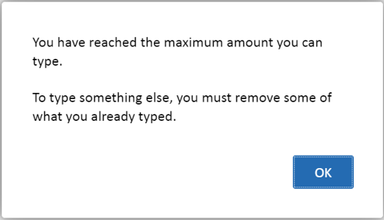
3. | Verify that entered text can be altered and/or cleared. | Select the extended text response box and enter text from either the attached keyboard or the Equation Editor, or a combination of the two. Then, place your cursor anywhere within the response box.  - Edit entered text by using the backspace and delete buttons.  - Enter new text.  - Select one or more words.  - Select delete/backspace.  - Enter new text.  - Select one or more words.  - Select Ctrl C.  - Place your cursor somewhere else within the response box.  - Select Ctrl V. | Deleted text is no longer present, and newly entered text appears in the response box.
4. | Verify that entered text is retained.  Note: This can only be tested in an assembled block. | Select the extended text response box and enter text (numbers, symbols, templates) from either the attached keyboard or the Equation Editor, or a combination of the two. Then navigate to the next item. Then, navigate back to the item.  [Vary your navigation. For instance, go to the next item on some and go to an item that is not the next item (before and after) for others.] | All entered text should appear in the response box as entered.  The item tab should turn grey, and the item should be marked as completed when either numbers or symbols are entered.  NOTE: Empty templates and blank spaces are not considered a valid response. The item should not be marked as completed in the item tab bar.
5. | Verify that a previous version of entered text is NOT retained.  Note: This can only be tested in an assembled block. | Select the extended text response box and enter text (numbers, symbols, templates) from either the attached keyboard or the Equation Editor, or a combination of the two. Then navigate to the next item. (The tab for the item should appear as answered.) Then, navigate back to the item and  - enter new text,  - delete existing text, and  - copy and paste text (using Ctrl C then Ctrl V).  Then, navigate to the next item again.  [Vary your navigation. For instance, go to the next item on some and go to an item that is not the next item (before and after) for others.] | The final version of the text entered should appear in the response box.  The tab for the item in which the answer was edited should still show as answered, unless all the text in the response box was deleted.  If text was entered in the response box for the item, the item should not appear on the Block End Review tab.  If all the text in the response box was deleted for the item, the item should appear as not answered on the Block End Review tab.
6. | Verify copy/paste functionality. | Copy any item text and paste it into the extended text response box. | Note that copy/paste of item text is allowed.  For reading, you should not be allowed to copy/paste passage content.

