Paul Engine Architechture

Abstract

Architecture of a Simple Game Engine, with Software Rendering. Everything is implemented from scratch and libraries are only used as helpers for crossplatform compatibility.

Goals
The main goal is to learn and architecht a software product from scratch.

1) Requirements

Functional Requirements
- Ability to Create Single Player Games.
- Scripting:
Python, Lua
- Physics Engine:
Particle, Collision detection & resolution, RigidBody & angular Movement.
- Graphics Engine:
3D Rendering, Load OBJ Files from blender.
- Core Engine:
Entity Component System Implementation.
- GUI:
Debugging Utilities, LevelEditor.
- Logging:
Logging Engine For debugging.

Non-Functional Requirements

- Performance:
Throughput: 60FPS
Latency: 16ms
Resolution: 1920x1080p
- Load:
Rendering: 1000 triangles per second,
10 meshes on screen with no FPS drop
- DataVolume:
Memory: 4GB RAM max
- Concurrent Users:
total users: 1
- SLA:
downtime: 1minute of downtime per hour
- Target Platform:
Linux Ubuntu

Quality *-ilities

- Scalability: The app only has one user so no need to scale.

- Testablitly: Manual Testing.

- Extensibility: The first Iteration will not implement physics but must be modular enough to allow future extensibility.

- Modularity: the core ECS has to be able to swap physics engine, Backend renderer, and Animation systems without any issue.

- Maintainability: Use Design patterns to maintain code easily.

2) Component Mapping

The Core Engine Handles the Entities, Components & Systems (ex Physics) as well as Rendering. It Then Provides an Interface for The User Interface and another Interface for Game Configuration.

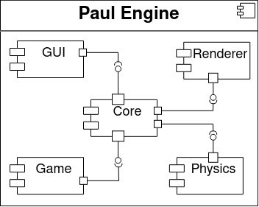
The Game holds the assets like Textures, Meshes etc, and scripts that help program and configure game behaviour.
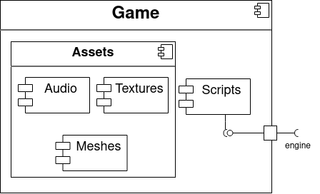

The Renderer uses SDL for Cross platform compatiblitly.

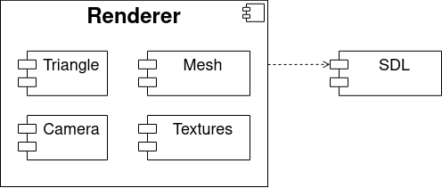

The Physics Engine Uses GLM the openGL Maths library to improve performance.

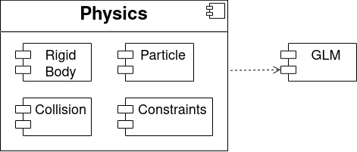

The Core of the Game engine is an Entity Component System with an entity manager (registry).

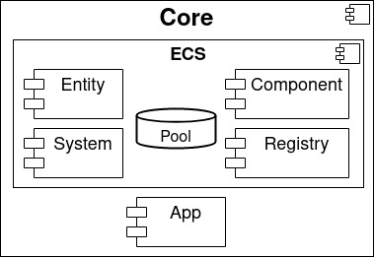

3) Tech Stack

The tech stack of this project is as follows

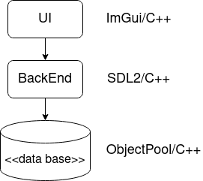

We use ImGui (Imediate Mode GUI) for the front end, SDL2 for crossplatform Compatibility, and a n ObjectPool design pattern to store data in the RAM.

4) Architechture Design

Dependencies
sol, lua, pybind11, SDL, SPDLog, Imgui, asio networking

Renderer Architechture
The renderer provides the interface IRenderer to the core to abstract the core form the implementation specific details of the renderer.

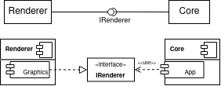

Engine Layers

Window/Editor
every layer in the engine will be an event listener to the editor

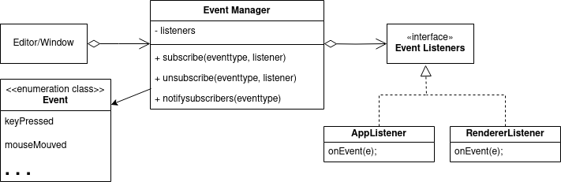

asdf

Core Architechture

Entity Component System

