a. The Inspector panel was the least familiar to me at first. I worked out what it does by selecting different nodes and checking the properties shown in the Inspector. I also experimented with changing some of the properties to understand how they affected the node.
b. I ran into a Git ownership and push issue while setting up the repository. Git detected that the repository was owned by a different Windows user or administrator account, so I added the project folder as a safe directory. I also had a push rejected because the GitHub repository already contained a commit. I resolved it by fixing the safe-directory issue and synchronizing/pushing the local project to the GitHub repository.
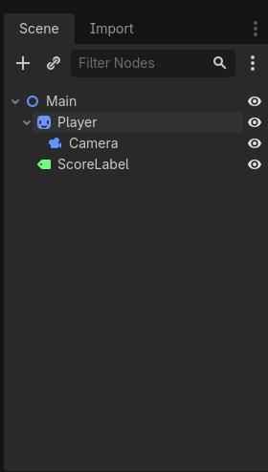
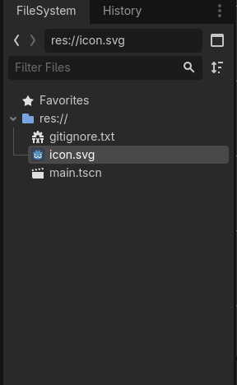
c. A node is an individual object or building block in Godot, such as a camera, light, player, or sprite. A scene is a collection of nodes saved together that can represent part or all of a game. The scene tree is the hierarchy that shows how those nodes are organized, with parent and child relationships.

