**Appendix 1 Readme Instruction**

1. In VSCode the following file structure each file will contain the following which is available in GitHub. Which can be found here:

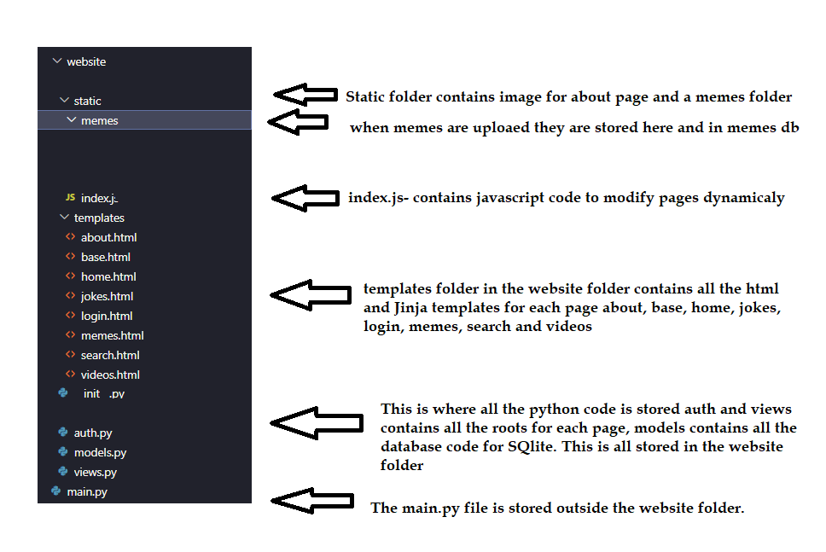

**Figure 1**

1. In VSCode in the terminal type python **main.py** as shown in figure 2

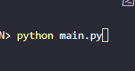

**Figure 2**

1. This will run the application and give the local URL for the application as highlighted in figure 3. Hold CTRL and left click on the URL to launch the application locally.

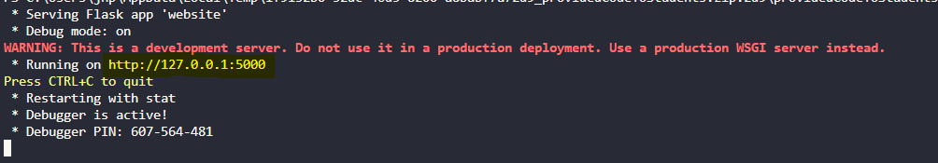

**Figure 3**