**How to deactivate a customers key**

1. Choose Client Configuration for Svc from the right hand panel

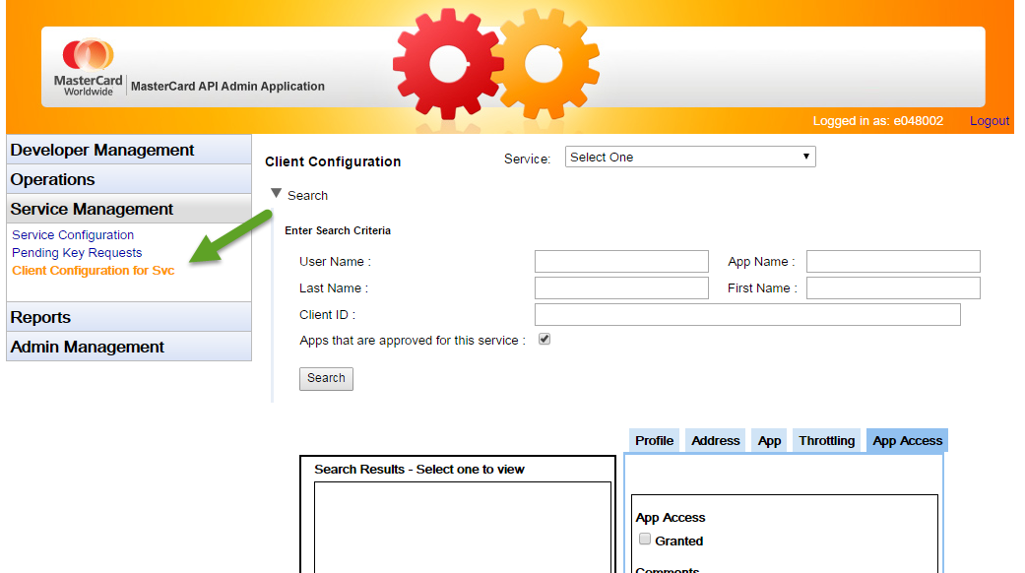

1. Select the service that you would like to remove a user from. You can search for a user using any available criteria. Make sure that the “Apps that are approved for this service” box is checked.

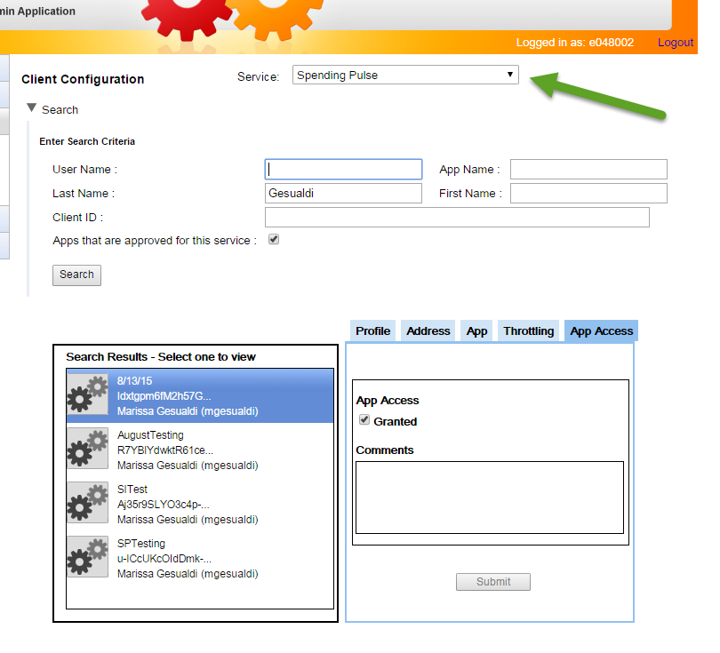

1. Once you have found the user you would like to deactivate, uncheck the “granted” box and click Submit.

