Visual Studio Standards

Before beginning any application you should have certain standards in place. These include programming standards as well as development environment standards. By using good development standards, all programmers will know what is expected of them and how to create new applications from scratch. In addition, these standards help developers move from one project to another without having to learn how different programmers created a particular application.

The standards contained within this document are meant to be customized by you and your team. It does not matter what standards you adopt as long as everyone in your shop is consistent with one another.

## Source Code Control

Use it! You will find that not only will it help you with the versioning of your changes, but makes it easy for a new developer to get the project to work on. The best way to start a new application is to have a single developer (typically the lead programmer for the project) create a new project on their machine. The lead programmer will then proceed to create the appropriate folders for the UI they are building (WPF, MVC, Angular, etc.) for the application. Once the majority of the project is created with forms, pages, html, etc. and the lead is ready to start assigning work to the rest of the team, he/she checks in the project to your source control system such as TFS. Each team member may now retrieve the new project from one location and it will automatically be created correctly on their computer.

### Source Code Control for the Single Developer

Obviously source code control is essential for multi-developer projects, but you will also find that even for a single-developer project it can be a great productivity enhancer. It helps you keep track of what you have worked on and when, and helps you maintain a backup of all the code on another machine (assuming you install the source code control database on another machine). It also helps you roll back to a previous version of the code that you checked in. It takes a little more discipline to use it when you are working alone, but you will find the benefits far outweigh the disadvantages. It is highly recommended that you use a cloud-based source control system as that provides you with an automatic backup system for your projects.

## Visual Studio Install

When installing Visual Studio, select the C# development environment settings. If you have already installed Visual Studio, you can reset this by going to Tools | Import and Export Settings… | Select **Reset all settings** from the first dialog as shown below:

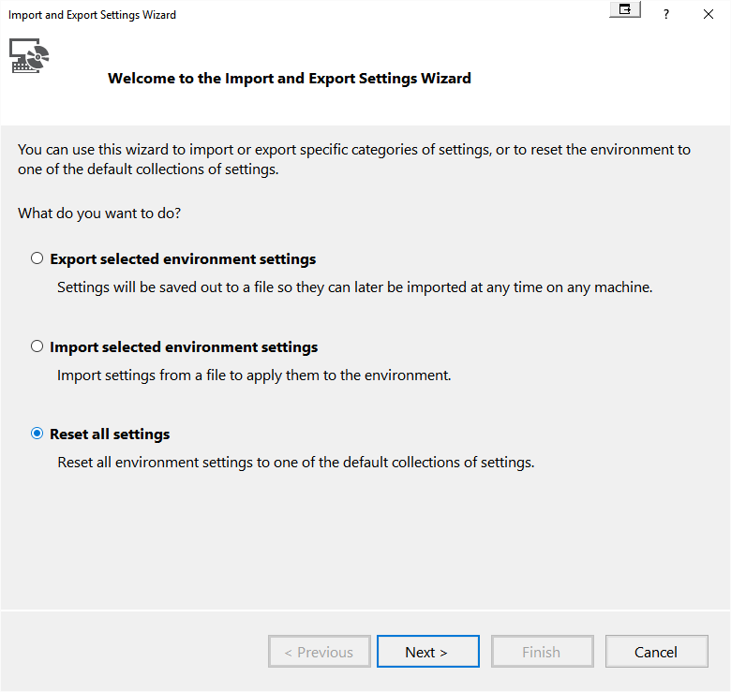

Figure . Reset all settings

Click the Next button

You should save your current settings in case you wish to go back.

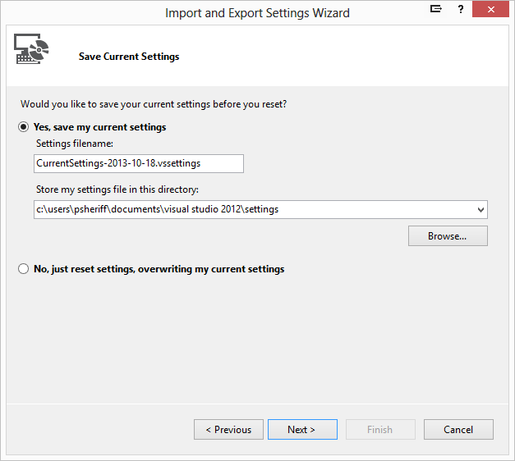

Figure . Save all your old settings (just in case)

Click Next

Choose the **Visual C# Development Settings** from the next list.

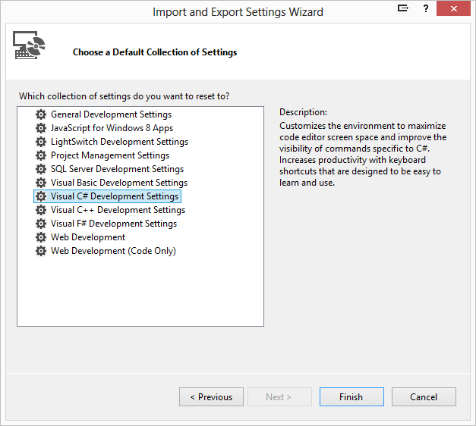

Figure . Select Visual C# Development Settings

## Setting Visual Studio Options

Visual Studio includes many options that define the behavior of the environment and the features in new projects. Before you can begin coding, each member of your team needs to set up Visual Studio with the same options. The following sections highlight some settings within the Options dialog box that you will want to consider setting for each developer. (Use the Tools | Options menu item to display this dialog box.)

**NOTE**: Sometimes the options presented below change from one version of Visual Studio to another, so use the following as a guideline.

### Projects and Solutions | General

Set the **Visual Studio projects location** property to the location where you will be creating all your Visual Studio projects, for example **C:\QTCProjects**. By having each developer put their projects in the same location makes it easier if someone is out of the office and someone else needs to go into their project to check in a file that they forgot.

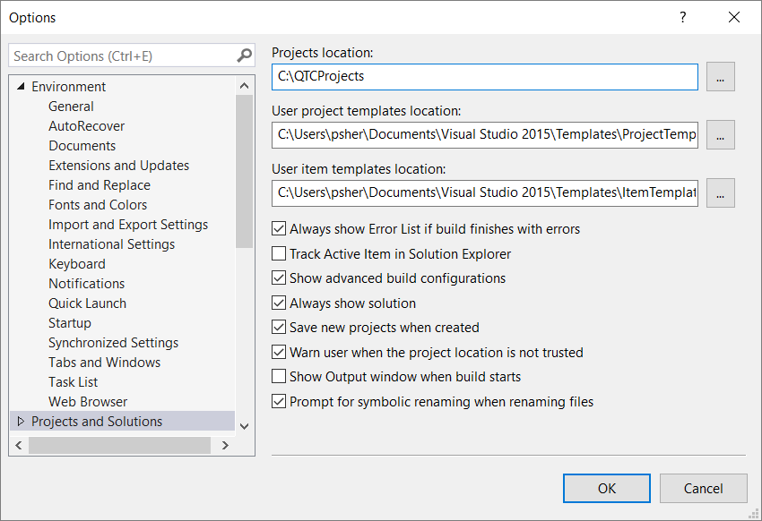

Figure . Environment | Projects and Solutions | General

### Text Editor | All Languages | General

You should check the Line Numbers option as it makes it easier when working with another developer to call out a line number as opposed to saying “the line that starts with…”.

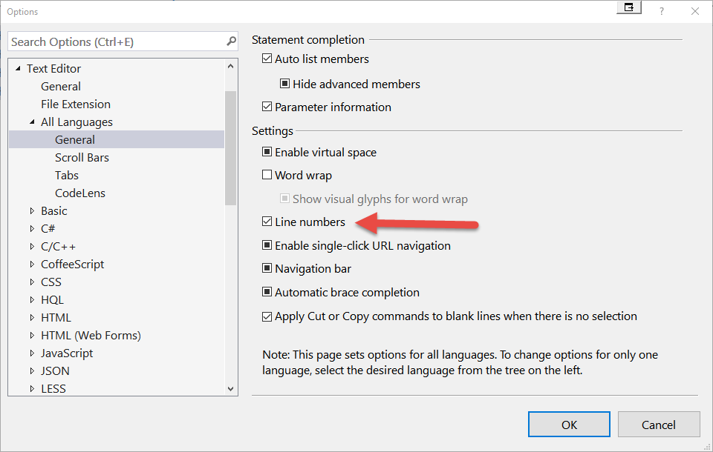

Figure . All Languages | General

### Text Editor | All Languages | Tabs

This tab is very important that all programmers in your group set consistently. If you don't and someone checks out a file and reformats the code according to their settings, then upon check in, the history of that file will show that all lines changed. This makes it very difficult to track what changed from one version of to another.

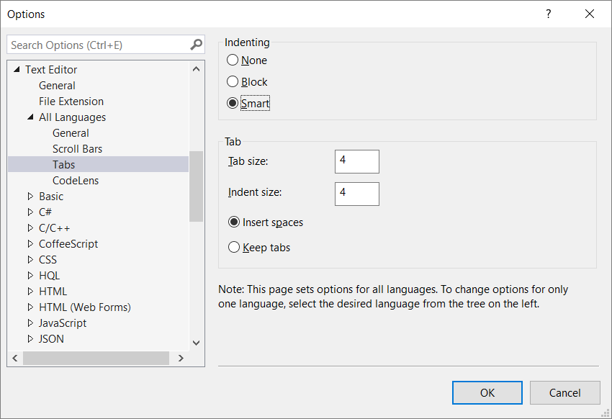

Figure . All Languages | Tabs

### Text Editor | C# | Advanced

Make sure the Place ‘System’ directives first when sorting usings is all set consistently.

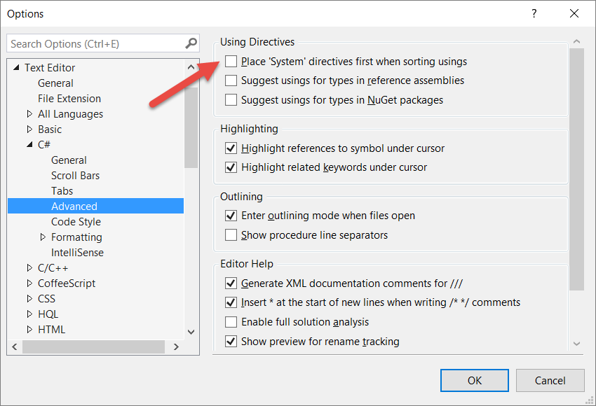

Figure . C# | Advanced

### Text Editor | C# | Formatting | Indentation

Make sure all items on this tab are consistent.

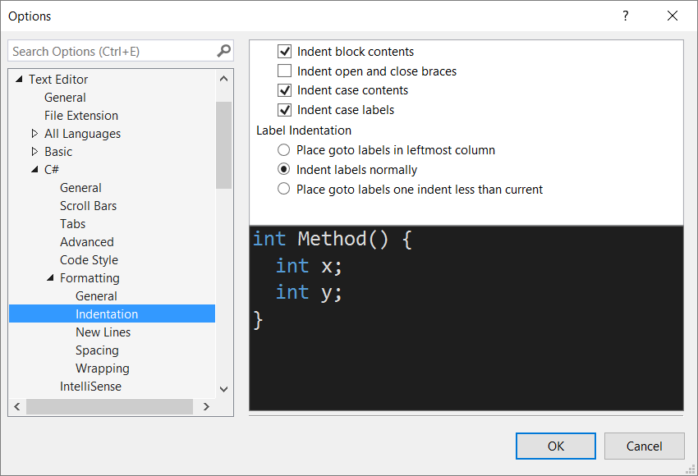

Figure . C# | Formatting | Indentation

### Text Editor | C# | Formatting | New Lines

Make sure all items on this tab are consistent.

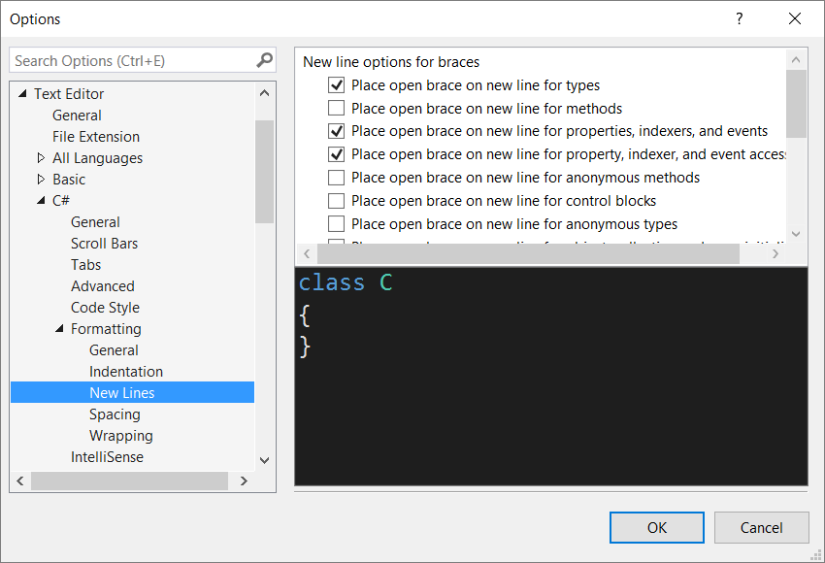

Figure . C# | Formatting | New Lines

### Text Editor | C# | Formatting | Spacing

Make sure all items on this tab are consistent.

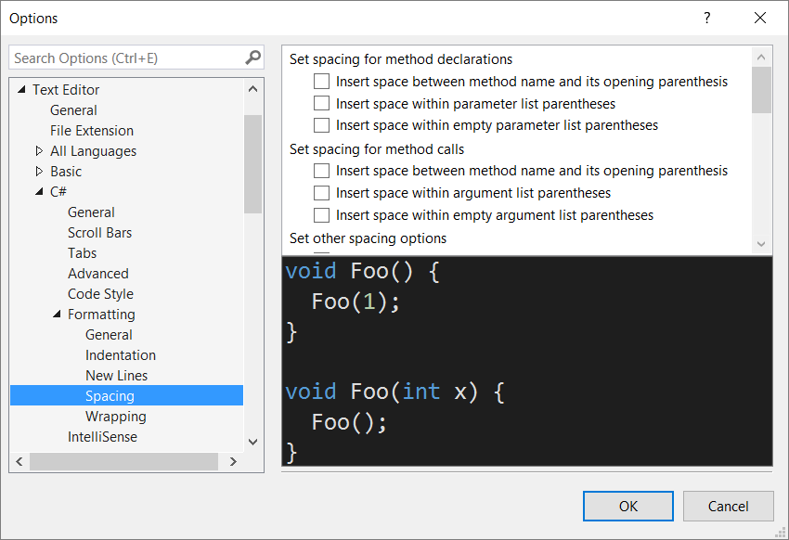

Figure . C# | Formatting | Spacing

### Text Editor | C# | Formatting | Spacing

Make sure all items on this tab are consistent.

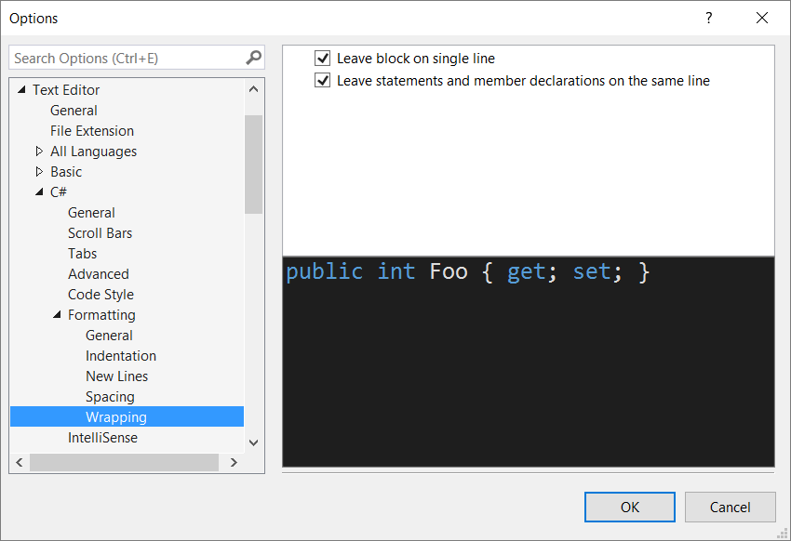

Figure . C# | Formatting | Wrapping

### Text Editor | JavaScript | Formatting | New LInes

Make sure all items on this tab are consistent.

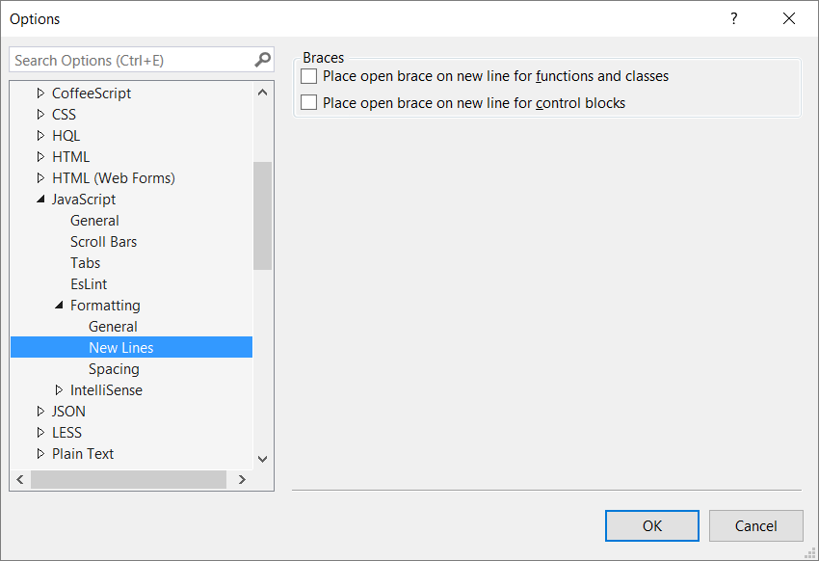

Figure . JavaScript | Formatting | New Lines

### Text Editor | JavaScript | Formatting | Spacing

Make sure all items on this tab are consistent.

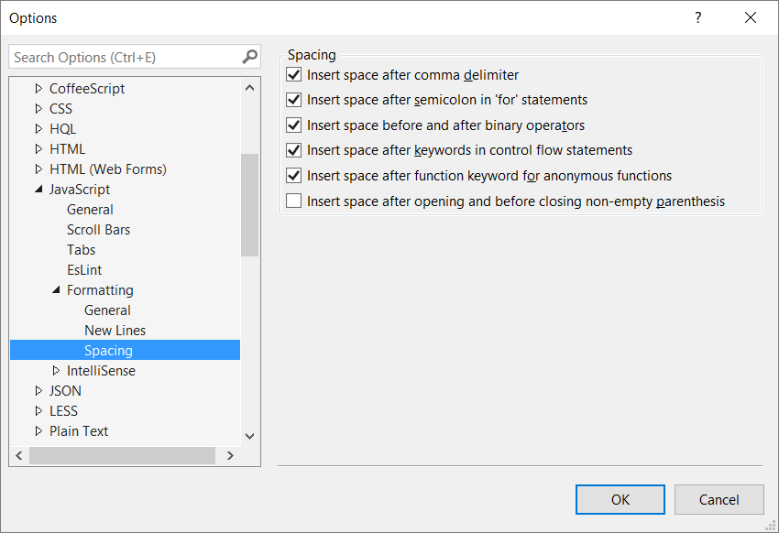

Figure . JavaScript | Formatting | Spacing

### Text Editor | TypeScript | Formatting | New Lines

Make sure all items on this tab are consistent.

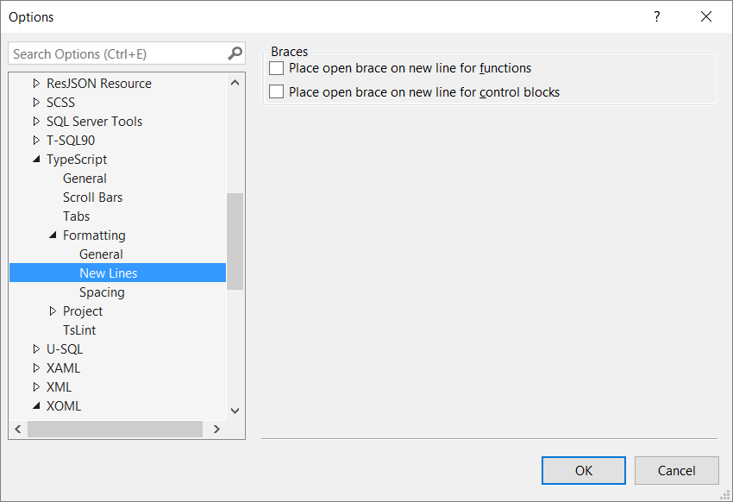

Figure . TypeScript | Formatting | New Lines

### Text Editor | TypeScript | Formatting | Spacing

Make sure all items on this tab are consistent.

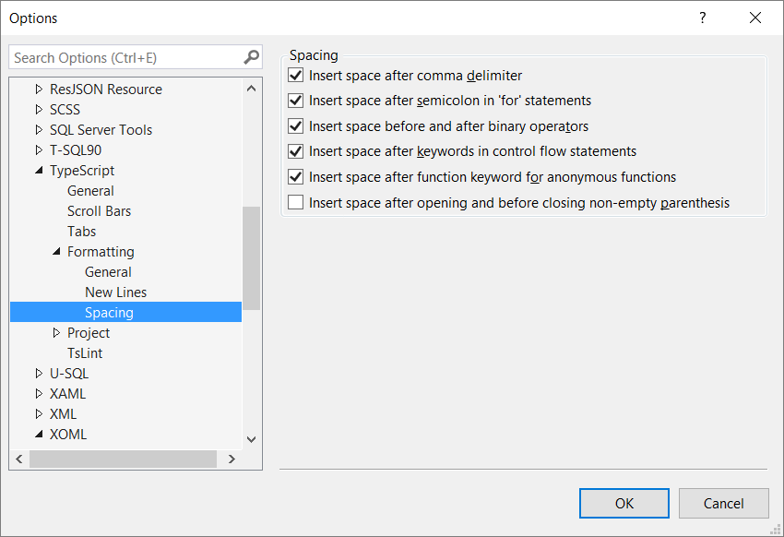

Figure . TypeScript | Formatting | Spacing

### Text Editor | XAML | Formatting | Spacing

Make your XAML more readable by positioning each attribute on a separate line.

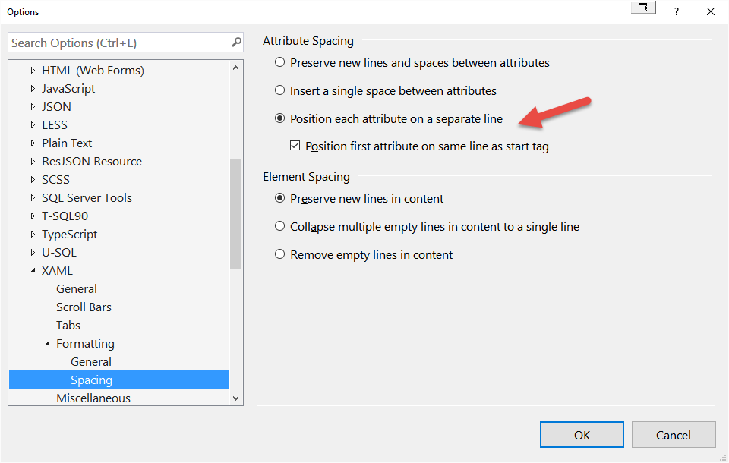

Figure . XAML | Formatting | Spacing

### Text Editor | XML | Formatting

Make your XML more readable by positioning each attribute on a separate line and remove empty lines in your content.

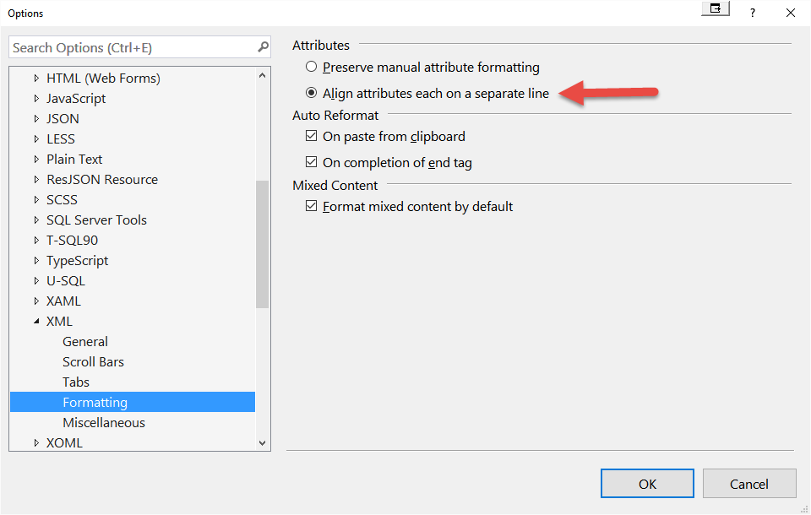

Figure . XML | Formatting

## Structuring your Projects

There are generally four types of classes for any given application you create.

* Classes that can be re-used in any application. We call these **Generic Classes**.
* Classes that are used in only one type of application; ie.MVC, Web Forms, WPF, Windows Forms, etc. We call these **UI Specific Classes**.
* Classes that are re-used only within one application. We call these **Application Specific Classes**.
* Classes that are only used once within an application. We call these **Application Classes**.

As such, you need to design a folder structure on your hard drive that reflects this type of application framework.

### Generic Components

You should always have your own application framework (like our PDSC .NET Productivity Framework) where you keep all the generic components you use for all of your applications. All of these components/classes should be grouped logically into DLLs according to their function. For example, all classes that work with files you might put into a File DLL and a File Folder. All classes that are used for WPF, you might put into a WPFLibrary DLL and folder. Figure 18 shows an example of a generic set of class library projects. These are from the PDSC .NET Productivity Framework. This is only a small portion of the various libraries that we have that we can use across many applications.

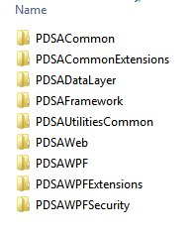

Figure : Example of a Generic Framework Structure

Summary

This chapter introduced you to a standard configuration for your development computers as well as some basic information about Solution and C# Project files. Setting up your environment is very important if you want to get off to a good start developing a .NET application. In this chapter you learned about the various settings that should be consistent among the developers in your shop.