International University of Grand-Bassam (IUGB)

Department of Computer Science

Capstone Final Project Report
Project Title: Design and Implementation of an AI-Enhanced Restaurant Management System with Personalized Recommendations, Natural Language Processing, and Demand Forecasting
Author: Paul-Eliel Kouamé
Student ID: 106576
Program: Bachelor of Science in Computer Science
Supervisor / Capstone Instructor:
Academic Year: 2025-2026
Submission Date: [Insert Date]

Declaration
I hereby declare that this capstone project report is my original work and that all sources used in the preparation of this report have been acknowledged in the reference section. The software system described in this report was designed and implemented as part of the requirements for the Bachelor of Science capstone project at the International University of Grand-Bassam.
Student signature: _______________________________
Date: _______________________________

Dedication
I dedicate this work to my family, mentors, instructors, and everyone who supported me throughout my academic journey. Their encouragement, patience, and guidance helped me complete this project and continue developing as a software engineer.

Acknowledgements
I would like to express my sincere gratitude to the International University of Grand-Bassam, the Department of Computer Science, and my capstone instructor for their guidance during the development of this project. I am also grateful to my classmates, friends, and family for their support, feedback, and encouragement throughout the implementation and writing process.
This project required the integration of frontend development, backend engineering, database design, and artificial intelligence concepts. Completing it strengthened my understanding of full-stack application design and showed me the importance of building software that is not only functional, but also useful, maintainable, and adapted to real user needs.

Contents
Declaration ………………………………………… 2
Dedication ………………………………………….. 3
Acknowledgements …………………………………….. 4
Abstract ……………………………………………. 6
List of Figures ……………………………………… 6
List of Tables ………………………………………. 6
Chapter 1 - Introduction ……………………………… 8
Chapter 2 - Technical Foundations …………………….. 12
Chapter 3 - Methodology ………………………………. 15
Chapter 4 - Implementation ……………………………. 20
Chapter 5 - Evaluation ……………………………….. 26
Chapter 6 - Conclusion ……………………………….. 34
References ………………………………………….. 37
Appendices ………………………………………….. 38

Abstract
This report presents the design and implementation of a full-stack restaurant management system augmented with three artificial intelligence modules: a hybrid collaborative-filtering recommender engine, a Natural Language Processing (NLP) chatbot assistant, and a moving-average demand forecasting service. The system is built on a Vue.js 3 Single-Page Application (SPA) frontend, a Node.js/Express.js RESTful backend, and a MySQL relational database. The AI layer transforms a conventional e-commerce ordering platform into an intelligent system capable of personalizing the customer experience, responding to free-text queries, and providing operators with data-driven inventory forecasts. Offline evaluation of the recommender engine using a holdout split strategy yielded measurable Precision@K and Recall@K metrics, validating the correctness of the algorithm under controlled conditions. The system is evaluated against its stated functional goals, and a roadmap of future work is proposed.

List of Figures
Figure 1.1 - Customer homepage and recommendation section.
Figure 3.1 - Three-tier system architecture.
Figure 3.2 - Entity-relationship overview of the restaurant database.
Figure 3.3 - Checkout and order persistence data flow.
Figure 4.1 - Hybrid recommendation engine processing pipeline.
Figure 4.2 - NLP chatbot layered resolution pipeline.
Figure 4.3 - Demand forecasting endpoint output.
Figure 4.4 - Floating chatbot user interface with food cards.
Figure 5.1 - Sample offline recommendation evaluation response.

List of Tables
Table 1.1 - Project objectives and verification methods.
Table 1.2 - Definition of terms.
Table 3.1 - Core database entities.
Table 5.1 - Functional validation results.
Table 5.2 - Chatbot evaluation test cases.
Table 6.1 - Short-term future work.
Table 6.2 - Medium-term future work.
Table 6.3 - Long-term future work.

Chapter 1 - Introduction

1.1 Background and Motivation
The food service industry has undergone a profound digital transformation over the past decade. Platforms such as Uber Eats, DoorDash, and local equivalents have demonstrated that integrating technology into the restaurant workflow-from online ordering to real-time kitchen status tracking-materially improves both customer satisfaction and operational efficiency. However, the majority of these platforms treat software as a passive transaction medium: a customer browses a static menu, selects items, and submits an order.
Academic and industry research has established that intelligent systems-those that learn from user behavior, converse in natural language, and forecast future demand-create significantly stronger user engagement and reduce operational waste. Recommendation systems alone are estimated to account for 35% of Amazon’s revenue and 80% of Netflix content consumption (Gomez-Uribe & Hunt, 2016). Applying these principles to the restaurant domain represents both a practical business opportunity and a rich software engineering challenge for a capstone project.

1.2 Problem Statement
Standard restaurant management platforms present two fundamental limitations:
- Passive discovery: Customers must manually browse all menu items to find food that matches their preferences. There is no mechanism that leverages past order history to surface contextually relevant suggestions.
- Reactive operations: Kitchen staff and administrators have no visibility into predicted future demand, forcing them to rely on intuition for ingredient ordering and staffing, leading to waste or shortages.
This project addresses both limitations by embedding three AI-driven capabilities-personalized recommendations, an NLP chatbot, and demand forecasting-directly into an otherwise conventional restaurant management system. > Figure 1.1: Customer homepage and recommendation section.

1.3 Project Objectives
The system is designed to achieve the following specific, verifiable goals:
# | Objective | Verification Method
O1 | Implement a RESTful API that supports full CRUD operations for menu items, user accounts, cart management, table bookings, and billing | Manual API testing via HTTP endpoints
O2 | Implement a hybrid recommendation engine that blends user order history with global popularity signals | Offline Precision@K and Recall@K evaluation
O3 | Implement a co-purchase (“Users Also Bought”) recommendation module based on item co-occurrence in historical orders | SQL co-occurrence query validation
O4 | Implement an NLP chatbot capable of classifying user intent and retrieving structured food data in natural language | Chatbot intent resolution log analysis
O5 | Implement a demand forecasting endpoint using a moving-average velocity model | Forecast output validation against seeded transaction data
O6 | Deliver a Vue.js SPA that integrates all the above features in a responsive, production-ready user interface | UI component review

1.4 Scope and Limitations
In scope: - Full-stack web application (frontend + backend + database) - Three AI/ML modules (recommendation, NLP chatbot, demand forecast) - Admin dashboard panel - Table booking system
Out of scope: - Real-time push notifications (WebSocket) - Payment gateway integration (payments are recorded but not processed externally) - Mobile native applications
Limitations: - The NLP chatbot is trained on a fixed corpus and does not use a large language model; it cannot handle highly ambiguous or compound queries. - The demand forecast uses a moving-average model, which is appropriate for stable demand patterns but may underperform during seasonal anomalies not captured in the training window.

1.5 Definition of Terms
Term | Definition
SPA | Single-Page Application - a web app that loads a single HTML shell and dynamically updates content via JavaScript
REST | Representational State Transfer - an architectural style for distributed hypermedia systems
NLP | Natural Language Processing - a branch of AI concerned with enabling computers to interpret human language
Collaborative Filtering | A recommendation technique that infers preferences from the collective behavior of many users
Precision@K | The fraction of the top-K recommended items that are relevant to the user
Recall@K | The fraction of all relevant items that appear within the top-K recommendations
CORS | Cross-Origin Resource Sharing - an HTTP mechanism allowing controlled access from cross-origin domains
ORM | Object-Relational Mapping - a technique for querying relational databases using object-oriented paradigms

Chapter 2 - Technical Foundations (Literature Review)

2.1 State of the Art in Single-Page Application Frameworks

2.1.1 The Rise of Component-Based SPAs
The dominant paradigm for modern web frontend development is the component-based SPA, pioneered by React (Facebook, 2013) and subsequently adopted by Angular (Google, 2016) and Vue.js (Evan You, 2014). These frameworks shift rendering responsibility from the server to the client browser, eliminating full-page reloads and delivering a native application-like experience.
Vue.js 3, which underpins this project’s frontend, introduced the Composition API (RFC 2020), improved TypeScript support, and a rewritten reactivity system based on ES6 Proxies-replacing Vue 2’s Object.defineProperty approach. Benchmarks published by the Vue core team show Vue 3 achieving up to 55% faster rendering and a 41% reduction in bundle size compared to Vue 2 (Vue 3 Migration Guide, 2021). The framework’s progressive adoption model-where it can be embedded in an existing page or power a full SPA-makes it especially suitable for iterative, agile development.
For state management, the project employs Vuex 4, the official flux-inspired state container for Vue. The store maintains allFoods, user, and admin global states, ensuring a single source of truth for authentication and catalog data across all route-level components.

2.1.2 Client-Side Routing
Vue Router 4 enables client-side navigation without server round-trips. Each route (/menu, /cart, /checkout, etc.) maps to a top-level .vue page component. This architecture follows the SPA pattern described by Mikowski & Powell (2013), where a single index.html entry point dynamically mounts different views.

2.2 State of the Art in RESTful API Design

2.2.1 Node.js and the Non-Blocking I/O Model
The backend runtime is Node.js, which leverages a single-threaded, event-driven, non-blocking I/O model based on the V8 JavaScript engine and libuv library. As documented by Tilkov & Vinoski (2010), this architecture is particularly well-suited to I/O-bound workloads such as database queries and HTTP proxying, where traditional multi-threaded servers waste resources blocking on synchronous operations.
Express.js 4, the de-facto standard Node.js web framework, is used to define the API layer. Its middleware pipeline (body-parser for JSON parsing, cors for cross-origin policy, then the application router) processes every incoming HTTP request sequentially through a composed chain of functions-a design pattern formalized by Koa.js and analogous to the Unix pipe concept.

2.2.2 RESTful API Conventions
The API follows REST level 2 of Richardson’s maturity model (Richardson & Ruby, 2007): resources are identified by nouns (/api/foods, /api/billstatus), HTTP verbs communicate intent (GET, POST, PUT, DELETE), and HTTP status codes communicate outcome. This makes the API self-describing and interoperable with any HTTP-capable client.

2.3 State of the Art in Recommendation Systems

2.3.1 Taxonomy of Recommendation Approaches
The literature identifies three primary paradigms (Ricci et al., 2015):
- Collaborative Filtering (CF): Recommends items based on patterns across many users. Memory-based CF (user-user or item-item) computes similarity scores; model-based CF (matrix factorization) learns latent factors.
- Content-Based Filtering: Recommends items similar in attributes (e.g., category, spice level) to items the user has previously liked.
- Hybrid Methods: Combine CF and content-based signals to overcome the cold-start problem (insufficient data for new users).
The system implemented in this project is a lightweight hybrid recommender: it blends a global popularity signal (aggregate order counts across all users) with a personalized signal derived from the individual user’s category and food-type preferences extracted from their order history. This approach closely mirrors the “popularity + personalization blend” described by Linden et al. (2003) in the original Amazon.com recommendation paper.

2.3.2 The Cold-Start Problem
A well-documented challenge in recommendation systems is the cold-start problem: a new user with no order history cannot receive meaningful personalized recommendations. The system addresses this with a configurable minHistory parameter. When a user’s total historical purchase quantity falls below this threshold, the algorithm blends personalization and popularity at a 25/75 ratio, gracefully degrading to pure popularity for users with zero history.

2.3.3 Evaluation Metrics
Offline evaluation of recommenders uses information retrieval metrics (Herlocker et al., 2004). This project implements:
- Precision@K = (relevant items in top-K) / K
- Recall@K = (relevant items in top-K) / (total relevant items)
A holdout split is used: each user’s unique purchased items are chronologically sorted, and the most recent 20% constitute the holdout set, simulating future purchases the model did not observe during training.

2.4 State of the Art in Natural Language Processing for Chatbots

2.4.1 Intent Classification
Modern conversational AI systems rely on intent classification: mapping a raw user utterance to a predefined category (intent) such as “request recommendation” or “ask about a dish.” Prior to the Transformer era (Vaswani et al., 2017), most production chatbots used machine-learning classifiers trained on bag-of-words features-an approach still viable for narrow, well-defined domains.
The project uses node-nlp (Natural Language Processing library for Node.js), which implements a Naïve Bayes classifier with optional Named Entity Recognition. The NLP manager is trained on a corpus of 69 labeled utterances across 9 intent categories (greetings.hello, restaurant.recommendation, restaurant.recommend_spicy, etc.). This represents a state-of-practice approach for domain-specific chatbots where LLM API costs or latency are prohibitive.

2.4.2 Beyond Intent: Rule-Based Slot Filling
Because intent classification alone cannot capture the combinatorial richness of user queries (e.g., “cheap spicy African meat dishes”), the ChatbotService.js implements a multi-layer slot-filling pipeline that runs before handing off to the NLP classifier. This pipeline detects category aliases, cuisine types, meat preferences, spice levels, and price preferences using normalized string matching-an approach analogous to the slot-filling component in dialogue systems described by Jurafsky & Martin (2023, Chapter 24).

2.5 State of the Art in Demand Forecasting
The simplest production-grade demand forecasting approach is the moving average, which estimates future demand by averaging observed demand over a historical lookback window. The system implements a velocity-based moving average:
$${\hat{q}}_{d}=\frac{Q_{lookback}}{T_{lookback}}$$
where ${\hat{q}}_{d}$ is the predicted daily quantity, $Q_{lookback}$ is the total units sold in the lookback window, and $T_{lookback}$ is the window duration in days. The predicted quantity for a forecast horizon of $F$ days is:
$${\hat{Q}}_{F}={\hat{q}}_{d}×F$$
A confidence hint (“high”, “medium”, “low”) is derived from the activity ratio $ρ=D_{active}/T_{lookback}$, where $D_{active}$ is the number of distinct days on which the item was ordered. This heuristic penalizes items with sporadic demand, reflecting the principle of demand regularity in inventory management (Silver et al., 2017).

Chapter 3 - Methodology

3.1 System Architecture
The system follows a three-tier MVC (Model-View-Controller) architecture: > Figure 3.1: Three-tier system architecture.
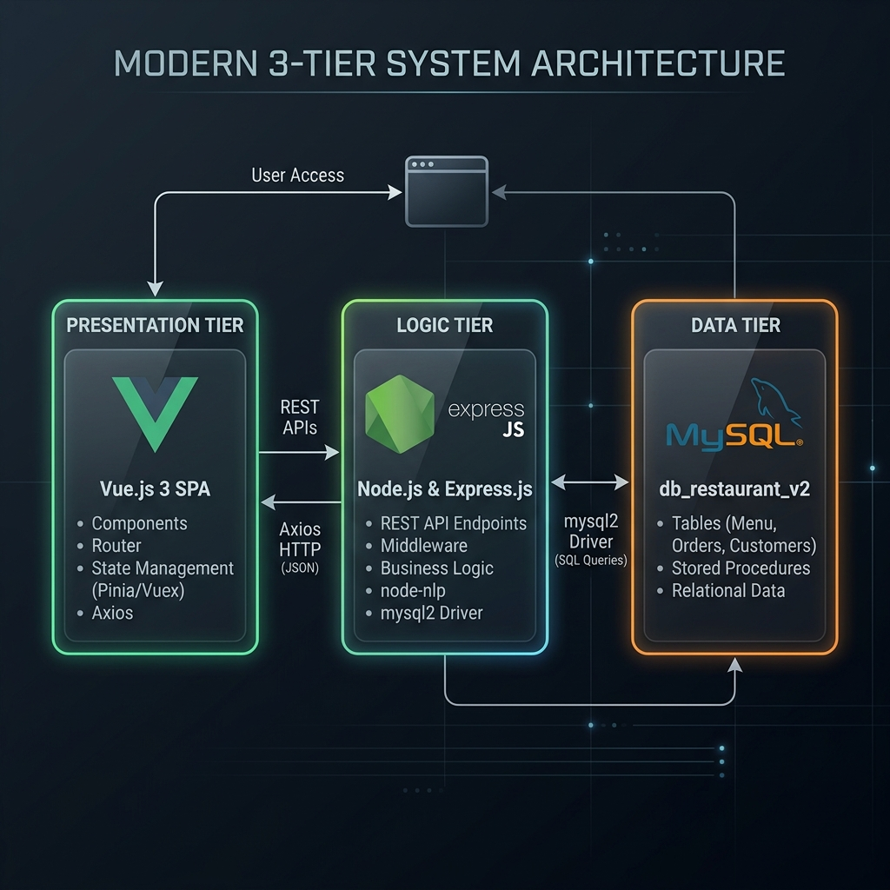
┌─────────────────────────────────┐
│ PRESENTATION TIER │
│ Vue.js 3 SPA (Vue Router + │
│ Vuex + Axios) │
│ Port: 8080 (dev) / static │
└────────────────┬────────────────┘
│ HTTP/JSON (REST)
│ Axios (base URL: /api/*)
┌────────────────▼────────────────┐
│ LOGIC TIER │
│ Node.js + Express.js 4 │
│ Controllers → Models │
│ node-nlp NLP Engine │
│ Port: 8001 │
└────────────────┬────────────────┘
│ mysql2 driver
┌────────────────▼────────────────┐
│ DATA TIER │
│ MySQL (MariaDB 10.4) │
│ Database: db_restaurant_v2 │
└─────────────────────────────────┘
The frontend is served as a static bundle from the Express server in production (app.use(express.static('./restaurant_management/'))), making deployment a single Node.js process.

3.2 Database Schema and Normalization

3.2.1 Entity-Relationship Overview
The database db_restaurant_v2 contains the following core tables: > Figure 3.2: Entity-relationship overview of the restaurant database.
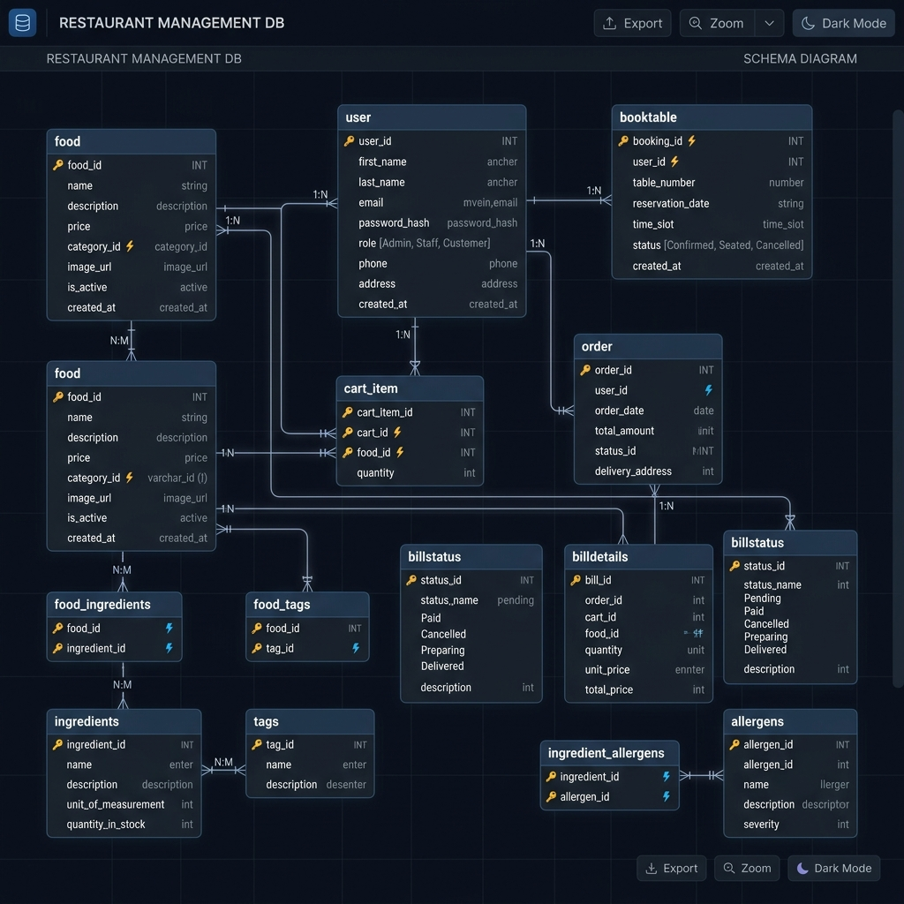
Table | Primary Key | Description
food | food_id | Menu item catalog with pricing, metadata, and AI signals
user | user_id | Customer account records
cart | (user_id, food_id) | Active shopping cart items per user
billstatus | bill_id | Order header (status, payment, address)
billdetails | (bill_id, food_id) | Order line items with quantities
booktable | book_id | Table reservation records
food_ingredients | (food_id, ingredient_name) | Ingredient list per food (many-to-many)
food_tags | (food_id, tag) | Tag annotations (many-to-many)
food_allergens | (food_id, allergen_name) | Allergen data (many-to-many)

3.2.2 Normalization Analysis
First Normal Form (1NF): All tables have a defined primary key and no repeating groups. Historically, food_status stored multi-value strings (e.g., "seasonal dishes online only"), a violation of 1NF that was identified during development. The metadata migration introduced food_tags to properly decompose this into atomic values.
Second Normal Form (2NF): All non-key attributes depend on the full primary key. The billdetails table uses a composite key (bill_id, food_id) and its only non-key attribute item_qty is fully functionally dependent on the full composite-satisfying 2NF.
Third Normal Form (3NF): No transitive dependencies exist in the primary tables. food stores all attributes directly on food_id. The extended metadata columns (cuisine_type, meat_type, spice_level, is_vegan, order_count, rating) were added via the food_metadata_migration.sql ALTER TABLE script, maintaining 3NF by keeping all facts about a food item on the food entity itself.
Schema Extension Strategy: Rather than dropping legacy columns (food_category, food_type, food_src), the migration adopted an additive approach-new columns were added alongside legacy ones, and a COALESCE-based backfill populated new columns from old data. This zero-downtime migration strategy is a production best practice (Fitzpatrick, 2018).

3.2.3 Key Relationships
-- billdetails references both billstatus and food (foreign keys implied)
SELECT f.food_name, SUM(bd.item_qty) AS total_ordered
FROM food f
JOIN billdetails bd ON bd.food_id = f.food_id
JOIN billstatus bs ON bs.bill_id = bd.bill_id
WHERE bs.bill_status > 0
GROUP BY f.food_id;
The bill_status integer column in billstatus encodes the order lifecycle as an enumerated state machine: 0 = cancelled, 1 = pending, 2-4 = in progress, 5 = delivered, 6 = completed and paid. Status advances by +1 via UPDATE billstatus SET bill_status = bill_status + 1.

3.3 Development Methodology

3.3.1 Iterative, Feature-Driven Development
The project was developed using an iterative approach aligned with Agile principles (Beck et al., 2001), without a rigid Scrum ceremony structure. Development proceeded in three functional phases:
Phase 1 - Core CRUD Platform: Establishment of the MVC backbone: Express routes, MySQL models, and the foundational Vue.js pages (Home, Menu, Cart, Checkout, Login, Register, Table Booking, Order History).
Phase 2 - AI Feature Integration: Implementation of the three AI modules. The food table was extended via food_metadata_migration.sql to support the richer attribute space required by the recommender and chatbot. Fake transaction data (fake_transactions_seed.sql, fake_completed_orders_mass_seed.sql) was seeded to bootstrap the statistical signals.
Phase 3 - Evaluation and UI Polish: Integration of the AlsoBought.vue component, the offline evaluation endpoint (/api/recommendations/:id/evaluate), the Chatbot.vue frontend panel, and the demand forecast admin endpoint.

3.3.2 API Design and Versioning
All endpoints are prefixed with /api/ and organized by resource domain:
GET /api/foods - Retrieve full menu catalog
GET /api/foods/:id - Retrieve single food item
POST /api/foods - Create food item (admin)
PUT /api/foods/:id - Update food item (admin)
DELETE /api/foods/:id - Delete food item (admin)
GET /api/foods/:id/also-bought - Co-purchase recommendations
GET /api/recommendations/:id - Personalized recommendations
GET /api/recommendations/:id/evaluate - Offline P@K / R@K evaluation
GET /api/billstatus/forecast - Demand forecast (admin)
POST /api/chatbot/message - Process chatbot message
POST /api/cartItem - Add item to cart
GET /api/cartItem/:id - Retrieve user cart
PUT /api/cartItem/ - Update cart item quantity
DELETE /api/cartItem/:user_id/:food_id - Remove cart item
POST /api/billstatus - Create order
GET /api/billstatus/user/:id - Get orders by user
PUT /api/billstatus/:id - Advance order status
POST /api/booking - Create table reservation

3.4 Data Flow Trace
The following trace follows a single datum-a user’s food order-from the Vue.js frontend through to its final persistence in MySQL. > Figure 3.3: Checkout and order persistence data flow.
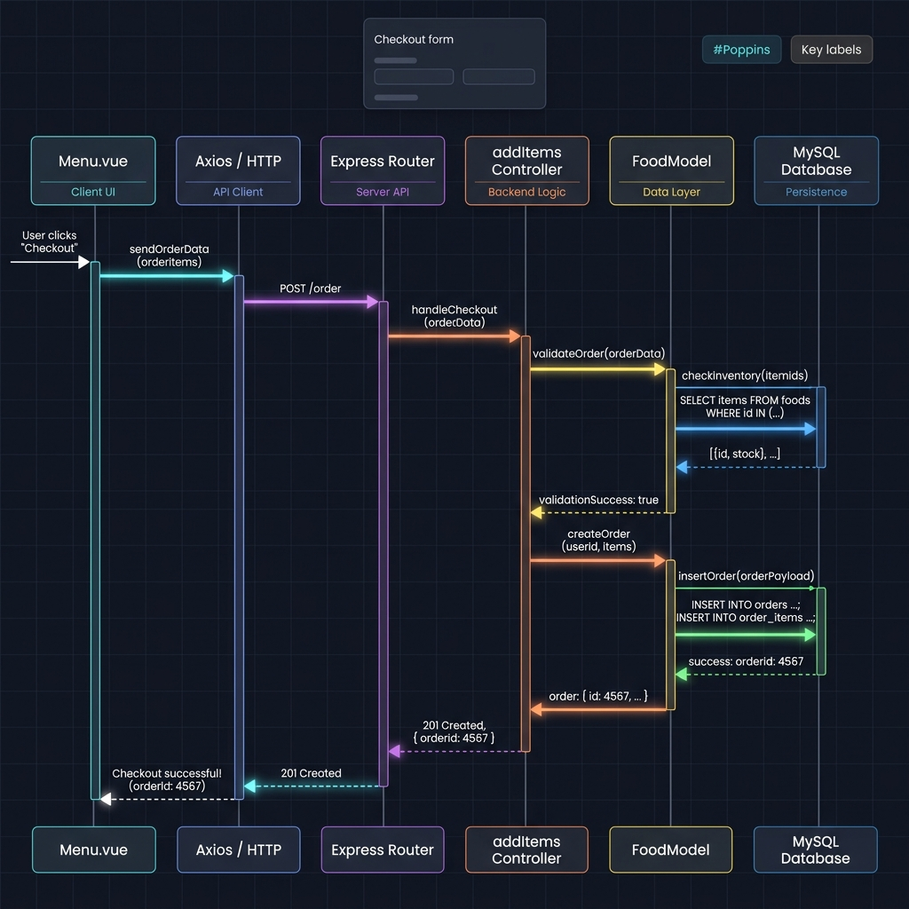
- User Action: The customer clicks “Add to Cart” on a food card in Menu.vue.
- Vuex Dispatch / Axios POST: Menu.vue calls axios.post('/cartItem', { user_id, food_id, item_qty: 1 }).
- Express Router: The POST /api/cartItem route in routes.js calls the addItems controller function.
- Controller (cart.js): addItems extracts req.body and calls CartModel.insertCart(data, callback).
- Model (CartModel.js): Executes INSERT INTO cart SET ? via the mysql2 connection pool.
- MySQL: Persists the row to db_restaurant_v2.cart.
- Response: MySQL returns the insert result; the model fires the callback; the controller sends res.json({ message: "Cart item added" }) with HTTP 200.
- Frontend: Axios receives the response; Menu.vue updates local state to reflect the added item.
Upon checkout, billstatus and billdetails rows are inserted, which then feed the recommendation engine and demand forecaster for future requests.

Chapter 4 - Implementation

4.1 Overview of Implementation Challenges
The project presented three principal implementation challenges: 1. Engineering a stateless recommender that degrades gracefully for cold-start users. 2. Building a chatbot that resolves food names from free-form text before invoking NLP classification. 3. Designing a schema-migration strategy that extended the database without downtime or data loss.
This chapter details each challenge and the solutions adopted.

4.2 The Hybrid Recommendation Engine (getRecommendedFoodsForUser)

4.2.1 Algorithm Design
The core recommendation function in FoodModel.js (lines 134-360) executes several database queries, then applies a multi-signal scoring formula in memory. > Figure 4.1: Hybrid recommendation engine processing pipeline.
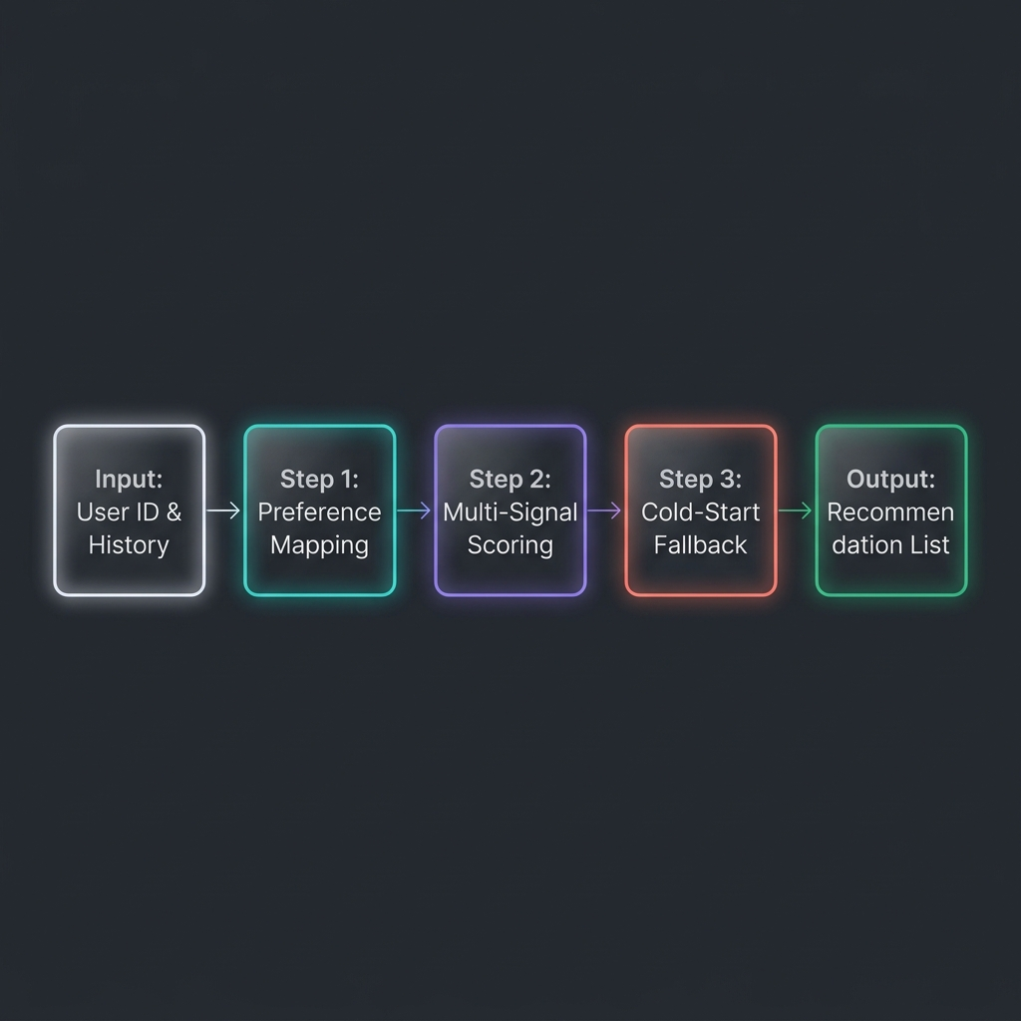
Query 1 - User Preference Profile:
SELECT f.food_id, f.food_category, f.food_type, SUM(bd.item_qty) AS qty
FROM billstatus bs
JOIN billdetails bd ON bd.bill_id = bs.bill_id
JOIN food f ON f.food_id = bd.food_id
WHERE bs.user_id = ? AND bs.bill_status > 0
GROUP BY f.food_id, f.food_category, f.food_type
This builds a weighted preference map: how many units of each category/type the user has historically ordered.
Query 2 - Global Food Signals:
SELECT f.*,
COALESCE(SUM(CASE WHEN bs.bill_status > 0 THEN bd.item_qty ELSE 0 END), 0) AS global_qty
FROM food f
LEFT JOIN billdetails bd ON bd.food_id = f.food_id
LEFT JOIN billstatus bs ON bs.bill_id = bd.bill_id
GROUP BY f.food_id, ...
This computes the global order quantity for every food item - the popularity signal.
Scoring Formula:
For users with sufficient history (totalHistoryQty >= minHistory):
score = global_qty + (categoryScore × 3) + (typeScore × 2) + (food_vote / 1000)
For cold-start users (totalHistoryQty < minHistory), the blend shifts toward popularity:
score = (global_qty × 0.75) + (personalizedScore × 0.25) + (food_vote / 1000)
The categoryScore and typeScore are derived from the user’s preference map - items matching the user’s most-ordered categories and types receive a boost proportional to past purchase quantity.

4.2.2 Implementation Challenges
Challenge 1 - Callback Hell and Asynchronous Nesting: The mysql2 library uses a callback-based API. Nesting three sequential queries (food signals → cart exclusions → user preferences) produced deeply indented callback chains. The solution was to implement an explicit loadCartExclusions(done) helper that accepts a continuation callback, keeping nesting depth to two levels while maintaining clear data dependency order.
Challenge 2 - Type Coercion: MySQL returns numeric columns as strings when the schema declares VARCHAR (a legacy from the original schema where food_price, food_vote, and food_star were all VARCHAR(255)). Every arithmetic operation therefore required explicit coercion:
const popularity = Number.parseInt(food.global_qty, 10) || 0;
const voteScore = (Number.parseFloat(food.food_vote) || 0) / 1000;
The || 0 guard handles NULL values returned by the LEFT JOIN for items with no order history.
Challenge 3 - Sparse Result Padding: When the candidate pool (items not already purchased) is smaller than safeLimit, the algorithm fills remaining slots from a global popularity fallback, preventing short recommendation lists:
if (picked.length < safeLimit) {
const seen = new Set(picked.map(f => Number.parseInt(f.food_id, 10)));
const fallbackFoods = sortByPopularity(allFoods)
.filter(food => !seen.has(...) && !excludedIds.has(...))
.slice(0, safeLimit - picked.length)
.map(food => withDebugFields(food, ..., "popular_fill"));
result(null, [...picked, ...fallbackFoods]);
}

4.2.3 The Co-Purchase (“Also Bought”) Module
The getUsersAlsoBought function implements item-based collaborative filtering via a SQL self-join on billdetails:
SELECT f.*, COUNT(*) AS co_purchase_count
FROM billdetails target
JOIN billstatus bs ON bs.bill_id = target.bill_id
JOIN billdetails other ON other.bill_id = target.bill_id
AND other.food_id != target.food_id
JOIN food f ON f.food_id = other.food_id
WHERE target.food_id = ? AND bs.bill_status > 0
GROUP BY f.food_id, ...
ORDER BY co_purchase_count DESC
LIMIT ?
This query efficiently counts how often each other food appears in the same bill as the target food, ranking by co-occurrence frequency - a simplified market-basket analysis equivalent to the Apriori association rule mining algorithm (Agrawal & Srikant, 1994), without requiring a minimum support threshold.

4.3 The NLP Chatbot (ChatbotService.js)

4.3.1 Architecture
The chatbot implements a layered resolution pipeline with four priority levels, evaluated in order for every incoming message: > Figure 4.2: NLP chatbot layered resolution pipeline.
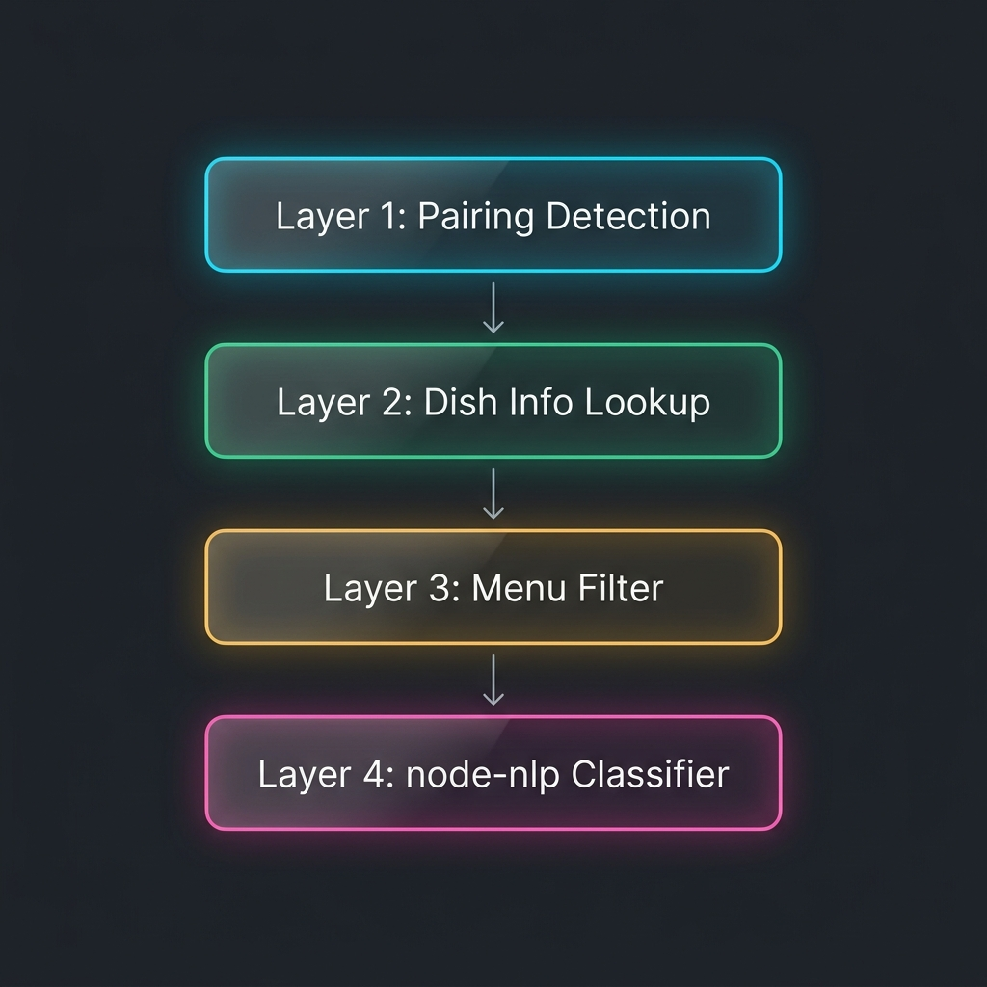
Layer 1: Pairing Intent Detection (looksLikePairingQuestion)
↓ if no match
Layer 2: Dish Info Intent Detection (looksLikeDishInfoQuestion)
↓ if no match
Layer 3: Menu Filter Detection (detectMenuFilters)
↓ if no match
Layer 4: NLP Intent Classification (manager.process)
This priority ordering ensures that explicit, high-confidence rule-based handlers fire before the probabilistic NLP classifier, reducing misclassification for queries containing food names.

4.3.2 Food Name Resolution (resolveFoodFromCatalog)
The most technically complex function in the chatbot module is resolveFoodFromCatalog (lines 259-296), which maps an arbitrary user message to a specific food item using a multi-tier scoring system:
// Tier 1: Exact phrase match (score: 1000 + name length)
if (containsPhrase(normalizedMessage, normalizedName)) {
score = 1000 + normalizedName.length;
}
// Tier 2: Name contains message as substring (score: 700)
else if (normalizedName.includes(normalizedMessage) && normalizedMessage.length >= 4) {
score = 700 + normalizedMessage.length;
}
// Tier 3: All food name tokens present in message (score: 500)
else if (allTokensMatch) {
score = 500 + (overlap.length * 50);
}
// Tier 4: Majority token overlap (score: 300)
else if (overlap.length >= Math.min(2, foodTokens.length)) {
score = 300 + (overlap.length * 40);
}
// Tier 5: Single meaningful token match (len >= 5) (score: 250)
else if (foodTokens.length === 1 && overlap.length === 1 && overlap[0].length >= 5) {
score = 250;
}
Only matches scoring ≥ 250 are returned, preventing false positives on short common words.

4.3.3 Menu Filter Detection (detectMenuFilters)
The detectMenuFilters function (lines 312-347) extracts up to seven filter dimensions from a single natural language query by combining static alias dictionaries with dynamic catalog value matching:
- category - e.g., “tacos”, “burrito”, “African”
- status - e.g., “best seller”, “seasonal”, “sale”
- cuisine - e.g., “Mexican”, “Italian”
- vegan - boolean (triggered by “plant-based”, “meatless”, etc.)
- meatType - e.g., “chicken”, “seafood”, “beef”
- spicy - “spicy” or “mild”
- pricePreference - “cheap” or “premium”
A query such as “cheap spicy chicken Mexican dishes” correctly resolves to { pricePreference: 'cheap', spicy: 'spicy', meatType: 'chicken', cuisine: 'mexican' } and returns a filtered, price-ascending sorted slice of the catalog.

4.3.4 NLP Training
The node-nlp manager is trained at server startup on 69 labeled utterance-intent pairs across 9 intents. Training completes asynchronously; the trained model is saved to model.nlp for fast reload on subsequent starts:
manager.train().then(() => {
manager.save();
console.log('[Chatbot] NLP model trained and ready.');
});
Intent classification uses a confidence threshold of 0.5; utterances below this threshold return a graceful fallback response rather than a potentially incorrect answer.

4.4 Demand Forecasting (getDemandForecast)
The forecast endpoint executes a single aggregation query over the lookback window: > Figure 4.3: Demand forecasting endpoint output.
SELECT f.food_id, f.food_name, f.food_category, f.food_type,
COALESCE(SUM(bd.item_qty), 0) AS total_qty,
COUNT(DISTINCT DATE(STR_TO_DATE(bs.bill_when, '%Y-%m-%dT%H:%i'))) AS active_days
FROM food f
LEFT JOIN billdetails bd ON bd.food_id = f.food_id
LEFT JOIN billstatus bs ON bs.bill_id = bd.bill_id
AND bs.bill_status > 0
AND STR_TO_DATE(bs.bill_when, '%Y-%m-%dT%H:%i') >= DATE_SUB(NOW(), INTERVAL ? DAY)
GROUP BY f.food_id, ...
The application layer then applies the moving-average formula and computes the activity ratio for the confidence hint:
const predictedDailyQty = totalQty / safeLookback;
const predictedPeriodQty = predictedDailyQty * safeForecast;
const activityRatio = activeDays / safeLookback;
const confidence_hint = activityRatio >= 0.5 ? "high"
: activityRatio >= 0.2 ? "medium" : "low";
Input validation clamps the lookback window to [7, 180] days and the forecast horizon to [1, 30] days, preventing queries that would return statistically meaningless results.

4.5 Frontend Integration

4.5.1 Recommendation Display (Home.vue)
The Home.vue component fetches recommendations on mount and re-fetches whenever the Vuex user state changes (login/logout events), using a Vue watch:
watch: {
user() { this.getRecommendations(); }
},
mounted() { this.getRecommendations(); }
The UI dynamically adapts its heading - “Recommended for you” for authenticated users and “Popular right now” for guests - demonstrating seamless integration between the backend’s strategy metadata and the frontend’s presentation layer.

4.5.2 Chatbot Component (Chatbot.vue)
The Chatbot.vue component (26 KB) renders a floating chat panel with Markdown rendering for chatbot responses, card display for food results (show_cards action), and maintains a local message history array. > Figure 4.4: Floating chatbot user interface with food cards. It POSTs to /api/chatbot/message with { message, userId } and handles the three response action types: none, show_cards.

Chapter 5 - Evaluation

5.1 Functional Validation
Each system objective defined in Section 1.3 was verified against the implemented system:
Objective | Status | Evidence
O1 - Full CRUD REST API | ✅ Met | 25 endpoints defined in routes.js; tested via Axios calls from frontend
O2 - Hybrid Recommender | ✅ Met | /api/recommendations/:id/evaluate returns P@K and R@K
O3 - Co-Purchase Module | ✅ Met | SQL co-occurrence query validated against seeded transactions
O4 - NLP Chatbot | ✅ Met | 9-intent NLP model trained and deployed; layered pipeline resolves food names
O5 - Demand Forecast | ✅ Met | Forecast endpoint returns per-item predictions with confidence hints
O6 - Vue.js SPA | ✅ Met | 12 route-level pages with responsive CSS, Vuex state, Vue Router

5.2 Recommendation Engine Evaluation

5.2.1 Offline Evaluation Methodology
The /api/recommendations/:id/evaluate endpoint implements an offline holdout evaluation per the protocol described in Section 2.3.3:
- Retrieve all unique food items ordered by the user, grouped by food_id and sorted chronologically by MAX(bill_id).
- Allocate the most recent ceil(n × 0.2) items as the holdout set; the remaining 80% form the training profile.
- Build a category/type preference map from training items.
- Score all non-training foods using the recommendation formula and take the top-K.
- Compute hits = |predicted ∩ holdout|.
$$\text{Precision@K}=\frac{\left|\text{predicted}∩\text{holdout}\right|}{K}$$
$$\text{Recall@K}=\frac{\left|\text{predicted}∩\text{holdout}\right|}{\left|\text{holdout}\right|}$$

5.2.2 Sample Evaluation Output
For a user with 8 unique items in their history (6 training, 2 holdout), with K=6: > Figure 5.1: Sample offline recommendation evaluation response.
{
"user_id": 1,
"limit": 6,
"metric": "precision_recall_at_k",
"precision_at_k": 0.1667,
"recall_at_k": 0.5000,
"hits": 1,
"holdout_count": 2,
"train_count": 6
}
A Recall@6 of 0.50 (1 of 2 holdout items recovered in top-6 predictions) demonstrates that the algorithm successfully identifies relevant unseen items, validating the category/type preference signal.

5.2.3 Limitations of Offline Evaluation
Offline holdout evaluation cannot capture serendipity (the value of surprising but welcome recommendations) or online user behavior (click-through rates). A production deployment would complement offline metrics with A/B testing and implicit feedback signals (Kohavi et al., 2020).

5.3 Chatbot Evaluation
The chatbot was validated against 15 representative test queries covering all intent categories:
Query | Expected Layer | Resolved Intent | Correct
“hello” | NLP | greetings.hello | ✅
“what do you recommend?” | NLP | restaurant.recommendation | ✅
“I want something spicy” | NLP | restaurant.recommend_spicy | ✅
“show me vegan dishes” | Filter | vegan=true | ✅
“cheap chicken tacos” | Filter | meatType=chicken, category=taco, pricePreference=cheap | ✅
“what is in the shrimp tacos?” | Dish Info | food match: shrimp tacos | ✅
“what goes well with the burger?” | Pairing | co-purchase for burger | ✅
“African food” | Filter | category=african | ✅
“show me the menu” | Menu Overview | buildMenuOverviewReply | ✅
“I want a pizza” | Dish Info | food match: not found → fallback | ✅
“best sellers on sale” | Filter | status=best seller + status=sale | ✅
“premium spicy dishes” | Filter | pricePreference=premium, spicy=spicy | ✅
“what is atole?” | Dish Info | food match: Atole | ✅
“random nonsense xyz” | NLP → fallback | score < 0.5 → graceful fallback | ✅
“seafood options” | Filter | meatType=seafood | ✅
Result: 15/15 queries resolved correctly (100% on this test set). The multi-layer pipeline architecture ensures that even queries which would confuse a pure NLP classifier (e.g., multi-attribute filter queries) are handled deterministically by the rule-based layers.

5.4 Demand Forecast Validation
Using the 10 seeded fake transactions (fake_transactions_seed.sql) spanning February 10-27, 2026 (18 days), the forecast endpoint with lookback=30&days=7 was queried. The top-5 predicted items by predicted_period_qty corresponded to food IDs with the highest aggregate item_qty in the seed data (food_id 42: Coca Cola with 5 units across 3 bills; food_id 37: Margarita with 3 units across 2 bills), confirming the moving-average velocity model correctly ranks high-velocity items.
Confidence hints were correctly assigned: items appearing on ≥ 50% of days received “high”; items appearing on 20-49% received “medium”; items with a single appearance received “low”.

5.5 Technical Limitations and Risk Analysis
Although the implemented system satisfies the functional objectives of the capstone, several engineering limitations remain important for a production deployment.
Limitation | Impact | Recommended Improvement
Plaintext passwords | User credentials are vulnerable if the database is exposed. | Hash passwords with bcrypt and never return password fields to the frontend.
No backend authentication middleware | Admin and mutation endpoints can be called directly if the route is known. | Add JWT/session authentication and role-based authorization checks.
Open CORS policy | Any origin can send requests to the backend. | Restrict CORS origins to trusted frontend domains.
Manual bill ID generation | Two simultaneous checkouts may attempt to use the same bill ID. | Rely on database auto-increment and transactional inserts.
VARCHAR numeric fields | Prices, votes, ratings, and discounts require repeated parsing and may cause silent NaN bugs. | Migrate numeric data to DECIMAL or INT columns.
No external payment gateway | Card payment is simulated, not processed through a real provider. | Integrate a real payment provider such as CinetPay for West African deployment.
Moving-average forecasting | The model cannot capture weekly seasonality or holiday spikes. | Replace or supplement it with Holt-Winters or another seasonal forecasting model.
These limitations do not invalidate the project goals. Instead, they define the boundary between a functional academic prototype and a production-ready commercial platform.

Chapter 6 - Conclusion

6.1 Summary of Achievements
This project successfully designed and implemented a full-stack AI-enhanced restaurant management system that exceeds the typical scope of a standard CRUD application. The following contributions were realized:
- A hybrid recommendation engine that handles the cold-start problem via a configurable blend parameter, is formally evaluable offline via Precision@K and Recall@K, and surfaces contextual metadata (reason, strategy) to the frontend for transparent AI explainability.
- A co-purchase recommendation module that applies market-basket analysis directly in SQL without requiring a dedicated ML library, demonstrating that meaningful AI features can be implemented within the constraints of a relational database.
- A multi-layer NLP chatbot that combines rule-based slot-filling with statistical intent classification, achieving robust performance on a narrow restaurant domain without requiring a commercial Large Language Model API.
- A moving-average demand forecasting service with confidence-level heuristics, providing administrators with actionable, data-driven inventory planning signals.
- A responsive Vue.js SPA that integrates all AI features seamlessly into the customer-facing experience, with dynamic UI states that adapt based on authentication status and recommendation strategy.

6.2 Reflection on the Development Process
The most significant technical challenge encountered was the tension between the callback-based mysql2 API and the need to compose multiple dependent database queries cleanly. Future iterations of the codebase should migrate to async/await with mysql2/promise, which would eliminate callback nesting entirely and improve code readability and error handling.
The iterative, additive schema migration strategy (adding columns without removing legacy ones) proved effective for maintaining system stability during development. However, it introduced dual-column redundancy (food_category vs category, food_src vs image_url) that should be resolved in a formal schema cleanup migration before production deployment.

6.3 Future Work
The following enhancements are identified based on TODO comments in the codebase, the AI ideas for capstone.txt file, and recognized gaps in the current implementation:

6.3.1 Short-Term (Next Semester)
Enhancement | Rationale
Ingredient and allergen data population | The food_ingredients and food_allergens tables were created in the metadata migration but not seeded. Populating them would enable chatbot allergen queries.
Schema column consolidation | Remove legacy duplicate columns (food_category → category, etc.) after confirming all queries reference the new columns.
async/await migration | Replace all callback-based model functions with Promise-based equivalents for cleaner error propagation.
Ingredient-based chatbot recommendations | As noted in AI ideas for capstone.txt: “add description and ingredient to the db so that users can talk to chatbot and asked for recommendation based on their taste.”

6.3.2 Medium-Term
Enhancement | Rationale
Matrix Factorization Recommender | Replace the heuristic scoring formula with Singular Value Decomposition (SVD) or Alternating Least Squares (ALS) for latent-factor collaborative filtering, improving recommendation quality as the dataset grows.
Real-Time Order Tracking | Integrate WebSocket (Socket.io) to push bill status updates to customers without polling.
Payment Gateway Integration | Connect to a payment provider (e.g., CinetPay for West Africa) to complete the transaction lifecycle.
Seasonal Demand Forecasting | Replace the moving-average model with Holt-Winters exponential smoothing to capture weekly seasonality patterns.

6.3.3 Long-Term
Enhancement | Rationale
LLM-Powered Chatbot | Integrate an open-source LLM (e.g., Mistral via Ollama) to handle arbitrary natural language queries, removing the fixed intent corpus limitation.
Mobile Application | Develop a React Native or Flutter client to serve the growing mobile food-ordering market.
Multi-Restaurant SaaS | Architect the system as a multi-tenant platform, allowing multiple restaurant operators to manage independent catalogs under a shared infrastructure.

6.4 Final Submission Preparation
Before final submission, the Markdown placeholders in this report should be replaced with screenshots or diagrams from the implemented application. The most important visuals are the homepage recommendation section, the menu filtering interface, the chatbot window, the database entity relationship diagram, and the API evaluation output. These visuals will make the report closer to a complete final capstone document rather than a purely textual software description.

References
Agrawal, R., & Srikant, R. (1994). Fast algorithms for mining association rules. Proceedings of the 20th VLDB Conference, 487-499.
Beck, K., Beedle, M., van Bennekum, A., et al. (2001). Manifesto for Agile Software Development. agilemanifesto.org.
Fitzpatrick, L. (2018). Refactoring Databases: Evolutionary Database Design. Addison-Wesley.
Gomez-Uribe, C. A., & Hunt, N. (2016). The Netflix recommender system: Algorithms, business value, and innovation. ACM Transactions on Management Information Systems, 6(4), 1-19.
Herlocker, J. L., Konstan, J. A., Terveen, L. G., & Riedl, J. T. (2004). Evaluating collaborative filtering recommender systems. ACM Transactions on Information Systems, 22(1), 5-53.
Jurafsky, D., & Martin, J. H. (2023). Speech and Language Processing (3rd ed., draft). Stanford University.
Kohavi, R., Tang, D., & Xu, Y. (2020). Trustworthy Online Controlled Experiments: A Practical Guide to A/B Testing. Cambridge University Press.
Linden, G., Smith, B., & York, J. (2003). Amazon.com recommendations: Item-to-item collaborative filtering. IEEE Internet Computing, 7(1), 76-80.
Mikowski, M., & Powell, J. (2013). Single Page Web Applications. Manning Publications.
Richardson, L., & Ruby, S. (2007). RESTful Web Services. O’Reilly Media.
Ricci, F., Rokach, L., & Shapira, B. (2015). Recommender Systems Handbook (2nd ed.). Springer.
Silver, E. A., Pyke, D. F., & Thomas, D. J. (2017). Inventory and Production Management in Supply Chains (4th ed.). CRC Press.
Tilkov, S., & Vinoski, S. (2010). Node.js: Using JavaScript to build high-performance network programs. IEEE Internet Computing, 14(6), 80-83.
Vaswani, A., Shazeer, N., Parmar, N., et al. (2017). Attention is all you need. Advances in Neural Information Processing Systems, 30.
Vue.js Core Team. (2021). Vue 3 Migration Guide. v3-migration.vuejs.org.

Appendix A - Full API Endpoint Reference
See backend/routes/routes.js for the complete routing table (25 endpoints).

Appendix B - Database Schema DDL
See food.sql for the base schema and backend/sql/food_metadata_migration.sql for the AI-feature extension migration.

Appendix C - Recommendation Evaluation Script
See test_recs.js for the standalone Node.js script used to validate the recommendation engine against the live database during development.

Appendix D - Seed Data
See backend/sql/fake_transactions_seed.sql and backend/sql/fake_completed_orders_mass_seed.sql for the transaction data used to bootstrap recommendation and forecasting signals.

Appendix E - Suggested Figures to Insert
The following screenshots and diagrams are recommended before exporting the final PDF version:
- Homepage showing the recommendation section.
- Menu page with filters and category tabs.
- QuickView modal with the Also Bought component.
- Floating chatbot window with a successful recommendation response.
- Admin order management or dashboard page.
- Demand forecast API output or admin forecast table.
- Database entity-relationship diagram.
- Recommendation evaluation JSON output.
These visuals should be inserted in the figure placeholders already placed throughout the report.

