International University of Grand-Bassam (IUGB)
Department of Computer Science

Design and Implementation of an AI-Enhanced Restaurant Management System with Personalized Recommendations, Natural Language Processing, and Demand Forecasting
  - Capstone Final Project Report

Bachelor of Science In Computer Science Capstone Project
Academic Year: 2025-2026

Declaration
I hereby declare that this capstone project report is my original work and that all sources used in the preparation of this report have been acknowledged in the reference section. The software system described in this report was designed and implemented as part of the requirements for the Bachelor of Science capstone project at the International University of Grand-Bassam.
Student signature: _________________________
Date: _________________________

Dedication
This work is dedicated first and foremost to my mother and my uncle. Their unwavering love, constant financial support, and invaluable guidance have been the cornerstone of my education. Without their continuous sacrifices, advice, and belief in my abilities, this degree and this project would not have been possible.
I also dedicate this work to my stepdad and my two older brothers, for their steady encouragement, companionship, and support along the way.

Acknowledgements

I would like to express my sincere gratitude to my faculty advisors, Sir Jules Raymond Kala and Mr. Gaoussou Timite, for their invaluable guidance, technical critique, and continuous encouragement throughout the conceptualization and development of this capstone project. Their insights were instrumental in shaping the engineering scope and ensuring the methodological rigor of this work.

I extend my appreciation to the International University of Grand-Bassam (IUGB) and the faculty and staff of the Department of Computer Science for providing an academically stimulating environment and the technical foundation necessary to undertake this endeavor.

Finally, I want to thank my family, peers, and friends for their enduring patience, moral support, and motivation during the intensive development and writing phases of this project. Their encouragement provided the balance and resilience required to bring this degree and software system to completion.

Abstract
This report presents the design and implementation of a full-stack restaurant management system enhanced with three artificial intelligence modules: a personalized recommendation engine, a Natural Language Processing chatbot assistant, and a moving-average demand forecasting service. The system is implemented with a Vue.js 3 Single-Page Application frontend, a Node.js and Express.js RESTful backend, and a MySQL relational database. The project addresses common limitations in restaurant software, including passive menu discovery, fragmented customer interaction, and limited administrative visibility into future demand. The recommendation module combines user order history, food category/type preferences, global popularity, and a cold-start fallback. The chatbot combines intent classification with rule-based menu filtering and food-name resolution. The forecasting module estimates future food demand from recent completed or active orders using a moving-average velocity approach. Formal deployment testing, real restaurant user studies, and large-scale forecasting accuracy measurements were outside the scope of this capstone.

Table of Contents
Declaration 2
Dedication 2
Acknowledgements 2
Abstract 2
List of Figures 3
List of Tables 3
Chapter 1 - Introduction 4
Chapter 2 - Restaurant Management Systems 8
Chapter 3 - Artificial Intelligence Techniques Used in the Project 10
Chapter 4 - System Analysis and Design 15
Chapter 5 - System Implementation 22
Chapter 6 - System Evaluation 31
Chapter 7 - Conclusion and Future Work 41
References 45
Appendices 46

List of Figures
Figure 4.1 - Overall system architecture 17
Figure 4.2 - Database entity relationship diagram 18
Figure 4.3 - Frontend, API, and database interaction flow 20
Figure 4.4 - Customer ordering workflow 21
Figure 5.1 - Recommendation engine workflow 25
Figure 5.2 - Chatbot and NLP processing pipeline 27
Figure 5.3 - Demand forecasting workflow 28
Figure 5.4 - Customer menu and recommendation interface 26
Figure 5.5 - Chatbot interface showing a drink recommendation response 27
Figure 5.6 - Admin dashboard order-status and action controls 29
Figure 5.7 - Admin dashboard with demand forecast output 30
Figure 6.1 - Precision@K for the recommendation engine using the expanded synthetic development dataset 34
Figure 6.2 - Recall@K for the recommendation engine using the expanded synthetic development dataset 35
Figure 6.3 - Expanded dataset precision and recall comparison across recommendation cutoffs 35
Figure 6.4 - Chatbot intent classification confusion matrix 37
Figure 6.5 - Chatbot intent classification performance metrics 38
Figure 6.6 - Forecast confidence distribution based on activity-day regularity 39

List of Tables
Table 1.1 - Project objectives and verification methods 5
Table 1.2 - Definition of terms 6
Table 4.1 - Functional requirements 15
Table 4.2 - Non-functional requirements 16
Table 4.3 - Database schema overview 18
Table 4.4 - Main API domains 19
Table 5.1 - Model selection, training, and fine-tuning summary 23
Table 6.1 - Functional validation summary 32
Table 6.2 - Original and expanded recommendation evaluation dataset characteristics 32
Table 6.3 - Recommendation metric comparison before and after synthetic dataset expansion 34
Table 6.4 - Chatbot training and validation dataset summary 36
Table 6.5 - Chatbot per-intent validation performance 37
Table 6.6 - Forecast confidence distribution from forecast-seeded development database 39
Table 6.7 - Highest forecast outputs using the moving-average velocity formula 40
Table 6.8 - Evaluation limitations and recommended validation improvements 41
Table 7.1 - Short-term future work 42
Table 7.2 - Medium-term future work 43
Table 7.3 - Long-term future work 43

Chapter 1 - Introduction

1.1 Background and Motivation
The food service industry has undergone a major digital transformation. Customers increasingly expect to browse menus online, place orders without physical queues, track order progress, and receive assistance before making a purchase decision. Restaurants, in turn, need tools that help them manage orders, payments, table bookings, customer records, and administrative decisions from a unified system.
Many restaurant platforms provide the basic ability to list menu items and record orders. However, such systems often remain passive: they store transactions but do not use the available data to support customer discovery or administrative planning. The motivation for this project is to demonstrate how a conventional restaurant management platform can be strengthened with practical artificial intelligence features while remaining understandable, maintainable, and appropriate for an undergraduate capstone project.

1.2 Problem Statement
Standard restaurant management platforms present several limitations. First, customers often browse large menus manually, even when their previous order history could be used to surface more relevant items. Second, customers may have simple questions about menu categories, dietary preferences, spicy foods, or dish pairings, but most basic systems do not provide conversational assistance. Third, restaurant administrators commonly rely on intuition to anticipate demand, even though historical order data can provide useful signals about future item popularity.
The problem addressed in this project is therefore the design and implementation of a restaurant management system that supports core ordering and administration tasks while also using available data to provide recommendations, natural language menu assistance, and simple demand estimates.

1.3 Project Objectives
The system is designed to achieve the following specific goals:
Table 1.1 - Project objectives and verification methods
# | Objective | Verification Method
O1 | Implement a RESTful API that supports CRUD operations for menu items, user accounts, carts, bookings, and orders. | Manual API and frontend workflow testing
O2 | Implement a hybrid recommendation engine that blends user order history with global popularity and fallback logic. | Endpoint validation and offline evaluation route
O3 | Implement a co-purchase recommendation module based on items purchased in the same bill. | SQL co-occurrence query validation
O4 | Implement a restaurant chatbot that handles greetings, recommendations, dish information, menu filters, and pairings. | Representative functional chatbot queries
O5 | Implement an administrative demand forecasting endpoint using recent order history. | Forecast endpoint validation against seeded transaction data
O6 | Integrate the AI modules into a customer-facing Vue.js interface and administrator dashboard. | Frontend workflow validation

1.4 Scope and Limitations
The project scope includes a full-stack web application, a relational database, customer ordering workflows, account creation and login, cart management, checkout, table booking, order tracking, an administrator dashboard, a recommendation service, a chatbot service, and a demand forecasting endpoint.
The project does not include native mobile applications, real payment gateway processing, WebSocket-based real-time notifications, production deployment benchmarking, or a controlled user study in an operating restaurant. The chatbot is trained on a fixed domain-specific set of examples and supported by rule-based matching. The demand forecast is based on a moving-average approach rather than a complex statistical or deep learning forecasting model.

1.5 Definition of Terms
Table 1.2 - Definition of terms
Term | Definition
SPA | Single-Page Application: a web application that loads a single HTML shell and dynamically changes views in the browser.
REST | Representational State Transfer: an architectural style that organizes web APIs around resources and HTTP verbs.
NLP | Natural Language Processing: a branch of AI concerned with enabling computers to process human language.
Recommendation System | A system that ranks or suggests items to users based on behavior, item attributes, or both.
Cold Start | A recommendation problem where a new user or item has little or no historical interaction data.
Precision@K | The proportion of the top K recommendations that are relevant.
Recall@K | The proportion of relevant holdout items recovered in the top K recommendations.
Demand Forecasting | The process of estimating future demand from historical sales or order data.

1.6 Report Organization
Chapter 1 introduces the motivation, problem statement, objectives, scope, limitations, and terminology of the project. Chapter 2 discusses restaurant management systems as the application domain. Chapter 3 presents the artificial intelligence concepts used in the system, including recommendation systems, NLP chatbots, and demand forecasting. Chapter 4 explains the system analysis and design, including requirements, architecture, database design, API design, user roles, and data flow. Chapter 5 describes the actual implementation of the frontend, backend, database, recommendation engine, chatbot, forecasting service, and ordering workflow. Chapter 6 evaluates the implemented system through functional testing and module-level validation. Chapter 7 concludes the report and proposes future work.

Chapter 2 - Restaurant Management Systems

2.1 Definition of Restaurant Management Systems
A restaurant management system is an information system designed to support the operational, administrative, and customer-facing activities of a restaurant. Such a system may include menu management, ordering, table reservation, billing, payment tracking, inventory planning, customer records, reporting, and staff coordination. From an operations perspective, these activities are closely related to inventory and production planning because restaurant managers must align expected demand with available ingredients and labor capacity (Silver et al., 2017).

2.2 Evolution of Digital Restaurant Platforms
Restaurant technology has evolved from simple cash registers and paper tickets to integrated digital platforms. Early systems focused mainly on point-of-sale operations, while modern systems often include online ordering, delivery integration, customer profiles, digital menus, kitchen status tracking, and administrative dashboards. This evolution is consistent with the broader development of single-page web applications, where client-side interfaces can support complex interactive workflows without constant full-page reloads (Mikowski & Powell, 2013).

2.3 Online Ordering Systems
Online ordering systems allow customers to browse available foods, choose quantities, place items in a cart, provide delivery or pickup information, and submit an order. The ordering process also creates behavioral data. Each order can be interpreted as a signal of customer preference and item demand, making online ordering the data foundation for recommendations and forecasting.

2.4 Inventory and Order Management
Inventory and order management are central problems in restaurant operations. Restaurants must prepare enough ingredients to satisfy demand while avoiding excessive waste. Although the implemented system does not include a complete inventory module, the demand forecasting feature is related to the same operational concern: estimating which food items are likely to be requested in a future period.

2.5 Benefits of Restaurant Information Systems
Restaurant information systems centralize menu data, reduce repeated manual entry, preserve customer and order records, improve administrative visibility, support faster customer service, and create the historical data necessary for analytics. In this project, the same order records support checkout, order tracking, recommendations, co-purchase suggestions, and demand analysis.

2.6 Challenges in Modern Restaurant Operations
Modern restaurant operations face challenges such as fluctuating demand, menu complexity, customer indecision, dietary preferences, order tracking, and administrative workload. The present capstone responds to these challenges by adding focused AI features rather than attempting to automate the entire restaurant.

2.7 Relevance to the Proposed System
The theoretical concepts discussed in this chapter explain why the project combines operational workflows with AI-supported features. A restaurant management system must first manage core data correctly: foods, users, carts, bookings, orders, and payments. Once these workflows are in place, the stored data can support recommendations and demand estimates.

Chapter 3 - Artificial Intelligence Techniques Used in the Project
This chapter presents the artificial intelligence concepts that guided the project. The discussion focuses on three techniques directly implemented in the system: recommendation systems, natural language processing for chatbot interaction, and demand forecasting for administrative planning.

3.1 Recommendation Systems

3.1.1 Definition
A recommendation system is a software component that ranks or suggests items to users based on available signals. The recommender systems literature identifies user behavior, item attributes, and hybrid combinations as common sources of recommendation evidence (Ricci et al., 2015). In this project, recommendations help restaurant customers discover foods that may match their preferences.

3.1.2 Collaborative Filtering
Collaborative filtering recommends items based on patterns of interaction. Item-to-item recommendation has been widely used in commercial recommender systems because relationships between items can be easier to maintain than direct user-to-user similarity at scale (Linden et al., 2003). The project uses a simplified item co-purchase idea in the Users Also Bought module, where foods ordered in the same bill are treated as related; this is conceptually connected to association-rule mining, which identifies frequent co-occurrence patterns in transaction data (Agrawal & Srikant, 1994).

3.1.3 Content-Based Filtering
Content-based filtering recommends items with attributes similar to items a user has liked or purchased. The implemented personalized recommender uses category and food type preferences derived from the user order history, which makes it partially content-based.

3.1.4 Hybrid Recommendation Systems
Hybrid recommendation systems combine multiple signals to reduce the weaknesses of any single technique. Large-scale production systems such as Netflix have shown the value of combining multiple recommendation signals and business constraints rather than relying on a single model family (Gomez-Uribe & Hunt, 2016). The implemented recommendation engine follows this general idea at a simpler capstone scale by combining user history, food category/type preference, global popularity, vote information, and fallback strategies.

3.1.5 Cold Start Problem
The cold start problem occurs when a system has insufficient historical data about a user or item. The implemented system addresses this by falling back to popular foods for guests and new users, and by blending popularity with limited preference data for low-history users.

3.1.6 Evaluation Metrics: Precision@K and Recall@K
Recommendation systems are commonly evaluated with ranking metrics such as Precision@K and Recall@K. Herlocker et al. (2004) emphasize that recommender evaluation must match the decision task, which is why top-K ranking metrics are useful when the system presents a short list of suggestions. The project includes an evaluation endpoint that applies a simple holdout split when a user has enough unique historical items. Because the available transaction data is limited and seeded for development, these metrics should be interpreted as functional evaluation support rather than evidence of production-level recommendation quality.

3.2 Natural Language Processing and Chatbots

3.2.1 Definition of NLP
Natural Language Processing is a branch of artificial intelligence concerned with enabling computers to process, analyze, and respond to human language (Jurafsky & Martin, 2023).

3.2.2 Intent Classification
Intent classification maps a user utterance to a predefined category such as greeting, recommendation request, dish information request, spicy food request, or vegan food request. This follows the common task-oriented dialogue pattern in which a system first identifies the user's intent before selecting a domain-specific response (Jurafsky & Martin, 2023). The chatbot uses node-nlp to classify short English utterances into restaurant-specific intents.

3.2.3 Rule-Based Chatbots
Rule-based chatbots use predefined patterns, dictionaries, and conditional logic to respond to user inputs. The project uses rule-based matching for category aliases, food names, cuisine types, meat preferences, vegan preferences, spice level, and price preference.

3.2.4 Machine Learning Chatbots
Machine learning chatbots learn intent or response behavior from labeled examples. Modern transformer architectures significantly expanded the capabilities of language models (Vaswani et al., 2017), but the implemented chatbot does not use a transformer or large language model. Instead, it uses a small machine-learning intent classifier through node-nlp and does not claim open-ended conversational ability.

3.2.5 Domain-Specific Chatbots
A domain-specific chatbot is designed for a limited task area. The chatbot in this project is limited to restaurant menu support, including recommendations, food descriptions, category filtering, spicy/vegan/meat requests, and co-purchase pairings.

3.2.6 NLP in Customer Service
NLP can improve customer service by answering frequent questions, reducing navigation effort, and guiding users toward relevant items. In this project, the chatbot provides assistance inside the customer-facing web interface and can return food cards that allow direct cart interaction.

3.3 Demand Forecasting

3.3.1 Definition of Demand Forecasting
Demand forecasting is the process of estimating future demand using historical data. In operations and inventory management, demand estimates are used to plan purchasing, production, and replenishment decisions (Silver et al., 2017). In restaurants, demand forecasting can help administrators prepare ingredients, anticipate popular items, and reduce waste.

3.3.2 Importance in Restaurants
Restaurant demand is affected by customer preferences, time, promotions, seasonality, and menu availability. Even a simple forecast can be useful when administrators need a quick indication of which items have been ordered frequently in a recent window.

3.3.3 Forecasting Techniques
Several forecasting techniques are available. Moving average methods estimate future demand from recent historical averages. Exponential smoothing gives greater weight to recent observations. ARIMA models capture autoregressive and moving-average patterns in time series. Machine learning approaches can use many features but require more data, tuning, and evaluation. The choice of method should be aligned with data availability, operational purpose, and the cost of model complexity (Silver et al., 2017).

3.3.4 Moving Average
A moving average is simple, interpretable, and easy to implement. It is appropriate when the objective is to provide a baseline forecast from limited historical data. Its weakness is that it may not capture seasonality, sudden changes, day-of-week patterns, or external events.

3.3.5 Exponential Smoothing
Exponential smoothing improves on a basic average by assigning more weight to recent observations. This can react faster to changing demand, but it requires selecting smoothing parameters and still needs a meaningful history of observations.

3.3.6 ARIMA
ARIMA models are classical statistical models for time series forecasting. They can model temporal dependence but require stationarity considerations, parameter selection, and enough time-indexed data.

3.3.7 Machine Learning Approaches
Machine learning forecasting models can incorporate features such as day of week, promotions, price, weather, holidays, or user segments. Their strength is flexibility, but their weakness is dependence on larger datasets and careful validation.

3.3.8 Engineering Justification for Moving Average
A moving-average approach was selected because it is transparent, easy to validate against seeded transactions, and consistent with the limited data available in the prototype. The goal was not to prove that moving average is superior to other techniques. The goal was to implement a practical baseline forecast that administrators can interpret and that future work can replace or compare against more advanced models.

3.3.9 Demand Forecasting Model Selection and Justification
Restaurants benefit from demand forecasting because their operations depend on anticipating uncertain customer demand. A restaurant must purchase ingredients before customers order, schedule workers before service begins, and prepare menu items under time constraints. If demand is underestimated, the restaurant may experience stockouts, longer waiting times, and lower customer satisfaction. If demand is overestimated, the restaurant may purchase too many perishable ingredients and increase food waste.
Demand forecasting is closely related to inventory management. Historical sales quantities can help managers estimate how much of each ingredient or menu item may be needed for a future period. In food service, this relationship is especially important because many ingredients are perishable. A useful forecast may assist managers in planning purchases more carefully, reducing unnecessary inventory accumulation, and avoiding situations where popular items become unavailable.
Forecasting can also support staffing decisions. If the system indicates that demand for several high-preparation items may increase, managers could potentially schedule more kitchen or delivery support for that period. Conversely, if demand appears low, managers may choose a lighter staffing plan. In this capstone, staffing optimization is not implemented as a module; however, the forecast output can provide a data signal that could inform such decisions in future versions.
The project selected a moving-average velocity model for practical engineering reasons. The available dataset was small, the system was designed as an undergraduate capstone prototype, and the goal was to create an interpretable baseline rather than a complex black-box model. Moving average requires low computational resources, can be implemented directly with SQL aggregation and simple arithmetic, and produces outputs that administrators can understand without statistical training.
This choice should not be interpreted as a claim that moving average is the best forecasting method. More advanced methods may outperform it when large historical datasets, seasonality, promotions, holidays, and external variables are available. In this project, moving average was the most practical choice because it matched the data scale, implementation time, explainability requirement, and deployment simplicity of the system.

3.3.10 Comparison with Alternative Forecasting Approaches
Exponential smoothing is a common extension of moving average. Its advantage is that it can give more weight to recent observations, allowing the forecast to respond faster to changes in demand. Its disadvantage is that it requires selecting smoothing parameters, and with limited data those parameters may be unstable or arbitrary. This method was not selected because the project prioritized a simpler baseline that could be explained and validated directly from aggregate quantities.
ARIMA models are useful for time series that contain autocorrelation patterns and enough ordered observations. Their advantage is that they provide a formal statistical framework for modeling temporal dependence. Their disadvantages include the need for stationarity checks, parameter selection, diagnostic analysis, and a longer time-indexed dataset. ARIMA was not selected because the project did not contain sufficient real restaurant time-series data to justify a formal ARIMA modeling process.
Machine learning forecasting methods can combine many predictors, such as day of week, menu category, discounts, weather, holidays, customer segments, and previous sales. Their advantage is flexibility. Their disadvantage is that they require larger datasets, feature engineering, model training, and careful validation to avoid overfitting. These methods were not selected because the capstone dataset and project timeline were not appropriate for a reliable supervised learning forecasting study.
Deep learning forecasting methods, including LSTM models and time-series transformers, can model complex nonlinear patterns in large sequential datasets. Their advantage is expressive power when large amounts of data are available. Their disadvantages include high computational cost, reduced interpretability, longer development time, and the need for substantial training data. These methods were not selected because they would add complexity without sufficient evidence that the available restaurant data could support them.
The comparison above is conceptual only. No experiment was conducted comparing moving average, exponential smoothing, ARIMA, machine learning models, or deep learning models. A fair comparison would require a larger historical dataset, consistent train/test splits, and forecasting error metrics such as MAE, RMSE, or MAPE.

Chapter 4 - System Analysis and Design

4.1 System Requirements
The system requirements were derived from the restaurant workflows and AI-enhancement goals discussed in the previous chapters. Requirements were divided into functional and non-functional categories to separate what the system must do from how well it should operate.

4.2 Functional Requirements
Table 4.1 - Functional requirements
ID | Requirement | Implemented Evidence
FR1 | Customers shall be able to browse and filter menu items. | Implemented through Menu.vue, Vuex food state, and GET /api/foods.
FR2 | Customers shall be able to register, log in, and maintain cart state. | Implemented through user and cart routes.
FR3 | Customers shall be able to place orders and track order status. | Implemented through checkout, billdetails, billstatus, and MyOrder.vue.
FR4 | Customers shall be able to reserve tables. | Implemented through Table.vue and POST /api/booking.
FR5 | The system shall provide personalized and popular menu recommendations. | Implemented through GET /api/recommendations/:id.
FR6 | The system shall provide a chatbot assistant for menu questions. | Implemented through POST /api/chatbot/message.
FR7 | Administrators shall be able to view and update order status. | Implemented through Admin.vue and Dashboard.vue.
FR8 | Administrators shall be able to view demand forecasts. | Implemented through GET /api/billstatus/forecast.

4.3 Non-Functional Requirements
Table 4.2 - Non-functional requirements
Category | Requirement
Usability | The web interface should allow customers to complete menu browsing, cart updates, checkout, booking, and order tracking without command-line interaction.
Maintainability | Frontend, backend, route, controller, model, and SQL responsibilities should remain separated so that features can be changed independently.
Scalability | The prototype uses a REST API and relational schema that can be extended, although production-scale load testing was outside the capstone scope.
Security | The prototype identifies important security gaps, including plaintext passwords and missing backend authorization middleware, which should be addressed before production use.
Reliability | Order and cart data are persisted in MySQL rather than only in browser state, reducing loss during navigation or refresh.

4.4 User Roles
The system supports two primary user roles. The customer role can browse the menu, register, log in, use the cart, place an order, reserve a table, track order status, and interact with the chatbot. The administrator role can access the admin dashboard, view active orders, advance order status, mark cash orders as paid, cancel eligible orders, and view demand forecast results.

4.5 System Architecture
The system follows a three-tier architecture. The presentation tier is the Vue.js frontend. The application logic tier is the Node.js and Express.js backend. The data tier is the MySQL database. Communication between frontend and backend occurs through HTTP requests using Axios, and backend model functions communicate with MySQL through the mysql2 library.
Figure 4.1 presents the implemented system at a high level, showing how the Vue.js frontend, REST API layer, Express backend, MySQL database, and AI-related modules interact.
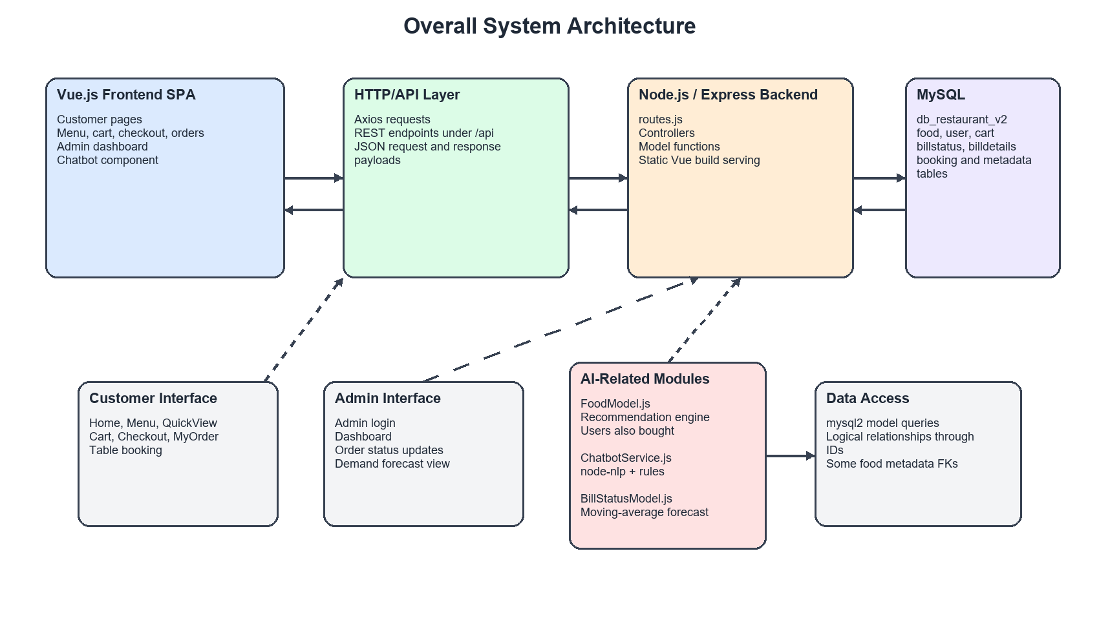
Figure 4.1 - Overall system architecture

4.6 Three-Tier Architecture
The presentation tier contains pages and components such as Home.vue, Menu.vue, Cart.vue, Checkout.vue, MyOrder.vue, Table.vue, Chatbot.vue, and Dashboard.vue. The logic tier contains Express routes, controllers, and model functions. The data tier contains relational tables for foods, users, carts, bookings, bills, and AI metadata.

4.7 Database Design
The database is named db_restaurant_v2 in the active backend configuration. Its central entity is food, which stores menu items and metadata. Orders are split into billstatus, representing the order header and lifecycle, and billdetails, representing the food line items in each order. The cart table stores temporary user selections before checkout. The booktable table stores reservation requests.

4.8 Entity-Relationship Discussion
The food table is referenced by billdetails and cart. The user table is referenced by cart and billstatus. The billstatus table represents an order, while billdetails connects a bill to one or more foods. The metadata extension adds food_ingredients, food_tags, and food_allergens to normalize information that would otherwise be embedded in text fields.
Figure 4.2 summarizes the main database entities. The diagram distinguishes declared metadata foreign keys from logical relationships enforced by application queries and shared identifier columns.
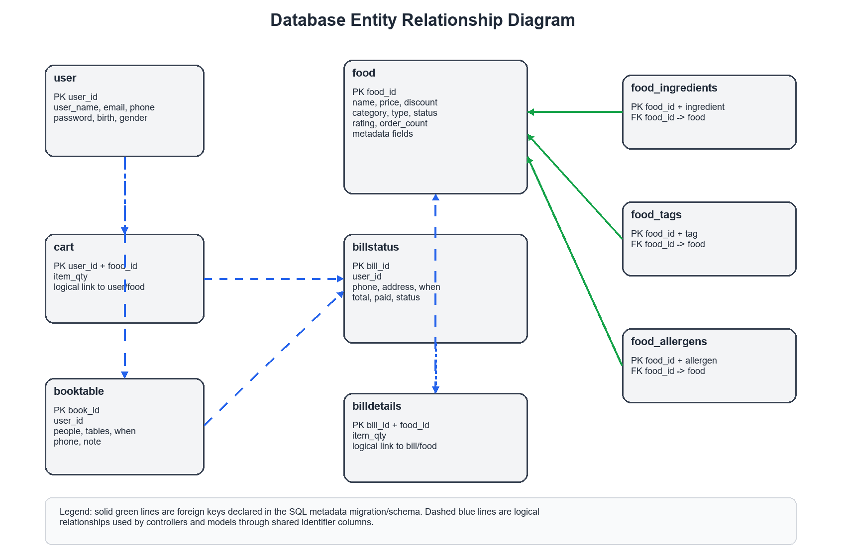
Figure 4.2 - Database entity relationship diagram

4.9 Schema Overview
Table 4.3 - Database schema overview
Table | Primary Key | Description
food | food_id | Menu item catalog with pricing, category, status, image path, and AI metadata fields.
food_ingredients | (food_id, ingredient_name) | Normalized ingredient records used to support future food reasoning.
food_tags | (food_id, tag) | Atomic food labels such as vegan, spicy, filling, or light.
food_allergens | (food_id, allergen_name) | Allergen metadata for future dietary filtering.
user | user_id | Customer account information.
cart | (user_id, food_id) | Current cart items and quantities per user.
booktable | book_id | Table reservation requests.
billdetails | (bill_id, food_id) | Line items for each order.
billstatus | bill_id | Order header containing user, address, payment, total, timestamp, and lifecycle status.

4.10 API Design
The API is organized by resource domain and uses REST-style naming. RESTful design emphasizes resources, representations, and standard HTTP methods, which makes APIs easier to understand and consume across different clients (Richardson & Ruby, 2007). Endpoints are prefixed with /api and use HTTP verbs to distinguish retrieval, creation, update, and deletion. This design makes the backend accessible to the Vue.js frontend and also allows individual endpoints to be tested independently.

4.11 REST Principles and API Domains
Table 4.4 - Main API domains
Domain | Main Endpoints | Purpose
Food catalog | GET /api/foods; GET /api/foods/:id; POST /api/foods; PUT /api/foods/:id; DELETE /api/foods/:id | Menu retrieval and administrative food management.
Personalized recommendation | GET /api/recommendations/:id | Returns ranked foods with score, reason, and strategy fields.
Recommendation evaluation | GET /api/recommendations/:id/evaluate | Computes holdout-style Precision@K and Recall@K when sufficient user history exists.
Co-purchase recommendation | GET /api/foods/:id/also-bought | Returns foods frequently purchased in the same bill as the target food.
User accounts | GET /api/users/:email; POST /api/users | Supports registration and login lookup.
Cart | POST/GET/PUT/DELETE /api/cartItem routes | Supports cart persistence, quantity updates, and cleanup.
Billing | POST /api/billdetails; GET/POST/PUT /api/billstatus routes | Stores order line items, order header data, payment status, and lifecycle state.
Demand forecast | GET /api/billstatus/forecast | Aggregates recent order history and produces moving-average forecasts.
Chatbot | POST /api/chatbot/message | Processes natural language requests and returns text plus optional food cards.
Figure 4.3 shows the request-response path used by the frontend, backend routes, controllers, model layer, and database. This flow is repeated across the menu, ordering, chatbot, recommendation, and administration features.
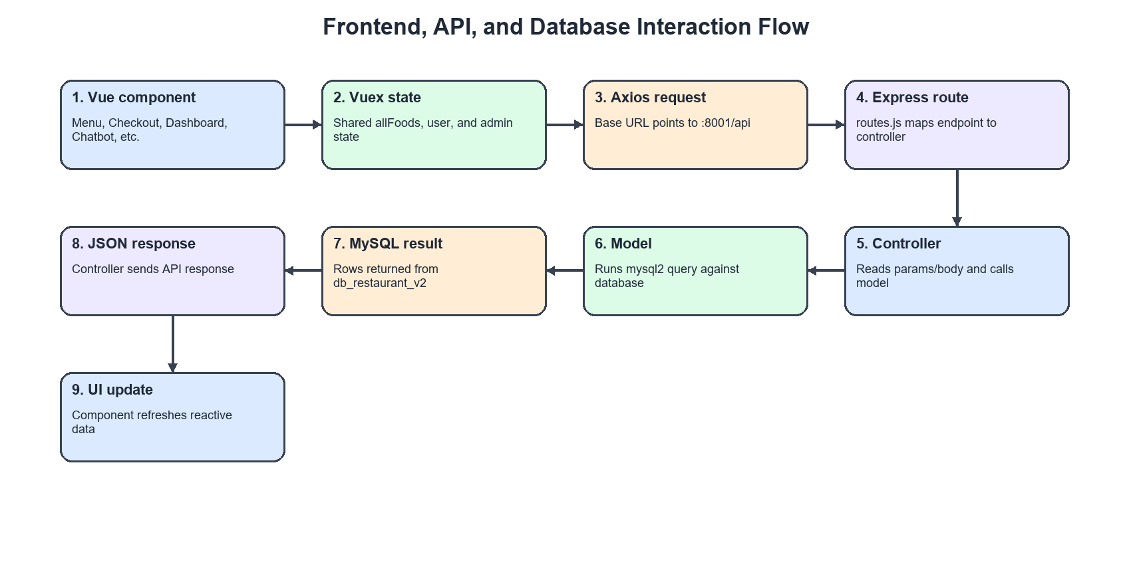
Figure 4.3 - Frontend, API, and database interaction flow

4.12 Data Flow Design
The core ordering data flow begins when a customer selects a food item from the menu or chatbot card. The frontend checks whether the item already exists in the customer cart. If it exists, the quantity is updated; otherwise, a new cart row is created. During checkout, the frontend retrieves the cart items, calculates totals and discounts, creates billdetails rows for each item, creates a billstatus row for the order header, clears the cart, and redirects the customer to a confirmation page.
Figure 4.4 illustrates the customer ordering workflow from menu browsing through cart persistence, checkout, order creation, and administrator order management.
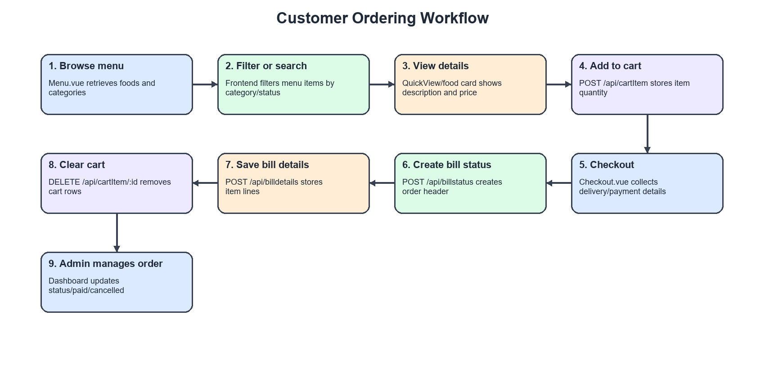
Figure 4.4 - Customer ordering workflow

Chapter 5 - System Implementation

5.1 Frontend Implementation
The frontend is implemented as a Vue.js 3 Single-Page Application. Single-page applications are designed to keep navigation and interface state within the browser after the initial page load, which supports a more application-like user experience (Mikowski & Powell, 2013). Vue Router defines routes such as /, /menu, /cart, /checkout, /table, /myorder, /admin, and /admin/dashboard. Vuex stores shared application state, including the menu catalog, the current user, and the administrator flag. The selection of Vue.js is consistent with Vue 3's component-based architecture and modern frontend development model (Vue.js Core Team, 2021).

5.2 Backend Implementation
The backend is implemented with Node.js and Express.js. Node.js is well suited to I/O-bound web applications because its event-driven, non-blocking model can handle many concurrent operations without creating one thread per request (Tilkov & Vinoski, 2010). The index.js file configures JSON parsing, URL-encoded body parsing, CORS, static frontend serving, and route registration. The routes.js file maps each API endpoint to a controller function. Controllers receive request parameters and bodies, then delegate database operations to model functions. Model files use mysql2 to execute SQL queries against MySQL.

5.3 Database Implementation
The database schema is defined in frontend/src/resources/db_restaurant.sql, with additional metadata migration and seed scripts in backend/sql. The food table contains both legacy fields such as food_category and newer metadata fields such as cuisine_type, category, meat_type, is_vegan, spice_level, rating, and order_count. A setup inconsistency should be noted for reproducibility: some seed scripts reference db_restaurant while the active backend configuration uses db_restaurant_v2.
As a post-evaluation enhancement for production scaling, the system catalog was expanded to document 74 total items across 3 core cuisines: Mexican, Ivorian/West African (e.g., Garba, Alloco, Placali, Kedjenou, Sauce Gombo), and American Fast Food (e.g., Burgers, Buffalo Wings, Mozzarella Sticks). The database categorization schema explicitly reflects how dishes map to both their macro cuisine types and specific food categories, ensuring accurate representation of a multi-cultural menu.

5.4 Model Selection, Training Strategy, and Fine-Tuning Considerations
This section directly addresses the model-training and fine-tuning question raised during review. The project includes three AI-related modules, but they do not all use the same kind of model. The recommendation engine is a custom algorithmic recommender, the chatbot is a supervised intent classifier, and the demand forecasting module is a deterministic statistical model. For that reason, the term fine-tuning must be used carefully and only where it is technically accurate.

5.4.1 Training and Fine-Tuning Terminology
In machine-learning projects, training generally refers to learning task-specific patterns from data. Supervised training uses labeled examples to teach a model how inputs should be mapped to outputs. Fine-tuning is more specific: it refers to adapting an already pre-trained model, such as a large language model or deep neural network, to a narrower task or domain. Algorithmic scoring systems, rule-based systems, and deterministic statistical formulas do not require fine-tuning because they do not begin from pre-trained model weights. Similarly, the moving-average forecasting approach used in this project computes demand from historical aggregates rather than learning neural parameters.
Module | Technique Used | Training Performed? | Fine-Tuning Performed? | Explanation
Recommendation Engine | Hybrid algorithmic recommender | No neural training | No | Custom scoring algorithm using order history, preference signals, repeated purchases, co-purchases, and popularity
Chatbot / NLP | node-nlp intent classifier | Yes | No | Trained on 170 labeled utterances and validated on 64 held-out validation utterances
Demand Forecasting | Moving-average velocity model | No | No | Deterministic statistical model based on completed-order quantities over a lookback window
Table 5.1 - Model selection, training, and fine-tuning summary

5.4.2 Recommendation Engine: Model Selection and Fine-Tuning Decision
The recommendation engine was implemented as a custom hybrid algorithmic recommender rather than as a neural recommender. It combines signals from user order history, category preferences, food type preferences, repeated purchase behavior, co-purchase behavior, and global menu popularity. This design was selected because it is transparent, easy to inspect, and appropriate for a restaurant system where administrators and developers need to understand why an item is recommended.
Neural fine-tuning was not applicable to this module because the recommender is not a pre-trained model, a matrix-factorization model, or a deep-learning recommender. Matrix factorization and deep-learning recommenders were not selected because the project did not have a large real-world restaurant transaction history and because the capstone also needed to deliver a complete working full-stack system. The expanded synthetic development dataset was used to simulate denser restaurant interaction patterns and evaluate the recommender under more realistic development conditions. The resulting improvement therefore came from richer interaction data and better evaluation conditions, not from neural model fine-tuning.

5.4.3 Chatbot: Intent Training Without LLM Fine-Tuning
The chatbot uses node-nlp for supervised intent classification and rule-based backend actions for menu-related responses. The training examples are defined in backend/models/ChatbotService.js. The current classifier was trained on 170 labeled utterances across eight restaurant-specific intent classes and evaluated on 64 held-out validation utterances. The measured validation results were Accuracy = 0.9375, Macro Precision = 0.9405, Macro Recall = 0.9375, and Macro F1-score = 0.9373.
This process is supervised intent-classifier training, not large language model fine-tuning. The chatbot does not use ChatGPT, Gemini, Claude, Llama, Mistral, or another transformer-based large language model. LLM fine-tuning was not used because the project did not include a large real restaurant conversation dataset, and because an externally hosted generative model would add computational cost, deployment complexity, reproducibility concerns, and API dependency. The node-nlp approach was selected because it provides better control over predefined restaurant intents and can run within the existing backend. The validation metrics are based on controlled held-out synthetic validation utterances, not production customer conversations.

5.4.4 Demand Forecasting: Statistical Modeling Without Fine-Tuning
The demand forecasting module uses a moving-average velocity method. For each food item, the backend aggregates completed-order quantities over a lookback period, computes average daily demand, and multiplies that value by the forecast horizon. This method was selected because it is interpretable, requires relatively little data, and is suitable for demonstrating operational planning logic in an undergraduate capstone project.
The forecasting model is deterministic and does not have a training phase in the neural machine-learning sense. It also does not involve fine-tuning because there is no pre-trained forecasting model being adapted. The confidence indicator measures activity-day regularity, not statistical forecast accuracy. Advanced methods such as ARIMA, Prophet, LSTM models, or transformer-based forecasting were left for future work because the project does not contain a long-term real restaurant history or a stored actual-versus-predicted benchmark.

5.4.5 Why Advanced Fine-Tuned Models Were Not Used
Advanced fine-tuned models were not used as an intentional engineering tradeoff. A fine-tuned LLM chatbot would require a substantial domain-specific conversation dataset and additional safeguards for response quality. A deep-learning recommender or matrix-factorization model would require denser real user-item interaction data than the original project database contained. LSTM or transformer forecasting would require long historical demand sequences and future actual-demand benchmarks. These approaches would also increase computational cost, deployment complexity, and evaluation burden. The selected methods prioritize explainability, reproducibility, and integration with a working restaurant management application.

5.4.6 Future Work
Future versions of the project could investigate fine-tuned open-source language models for restaurant dialogue if a sufficiently large real customer conversation dataset becomes available. The recommendation engine could also be compared with matrix factorization or learning-to-rank methods, and the forecasting module could be benchmarked against ARIMA, Prophet, LSTM, or transformer-based forecasting once real historical transaction data and actual future demand outcomes are collected. These are future research directions and were not implemented in the current system.

5.5 Recommendation Engine Implementation
The main recommendation function is getRecommendedFoodsForUser in FoodModel.js. It accepts a user id and options such as limit, minHistory, and excludeCart. For authenticated users with order history, the engine builds a preference profile based on food_category and food_type from previous orders. It then scores each candidate using global popularity, category preference, type preference, and vote score. For users with low history, the scoring blends popularity more heavily with personalization. For guests or users with no history, the system falls back to globally popular foods.
For the live multi-cuisine catalog, the production heuristic implemented in FoodModel.js was expanded to prevent single-cuisine dominance. The formula is expressed as:
$\text{PersonalizedScore} = (50 \times W_{\text{cuisine}}) + (25 \times W_{\text{category}}) + (10 \times W_{\text{type}})$
The addition of a popularity score normalization (scaled 0% to 100%) and a contextual explanation layer generates dynamic rationale strings (e.g., 'Because you love Ivorian cuisine') to accompany the recommendations.
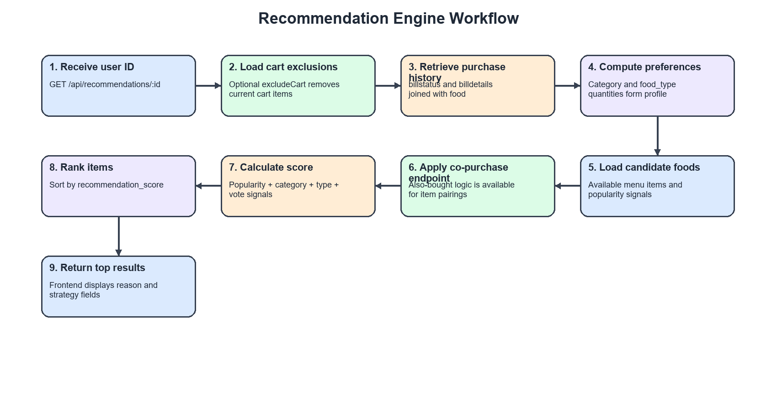
Figure 5.1 - Recommendation engine workflow
Figure 5.4 shows the recommendation interface produced after loading the expanded synthetic interaction data into the application database. The displayed recommendation reasons are generated by the implemented recommender rather than manually edited report values.
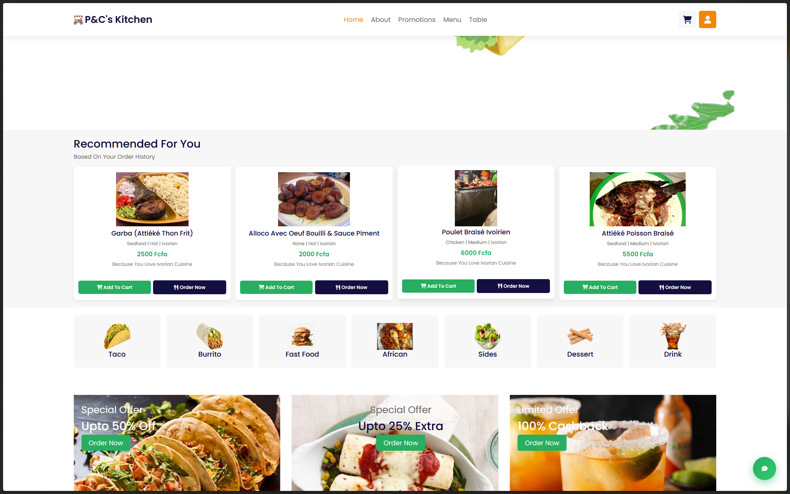
Figure 5.4 - Customer menu and recommendation interface

5.6 Chatbot Implementation
The chatbot is implemented in ChatbotService.js and exposed through POST /api/chatbot/message. The service uses node-nlp for intent classification and combines it with deterministic rule-based layers. Before relying on machine-learning intent classification, the chatbot first attempts higher-priority rule-based resolution for pairing questions, dish information, menu overview, and menu filter requests.
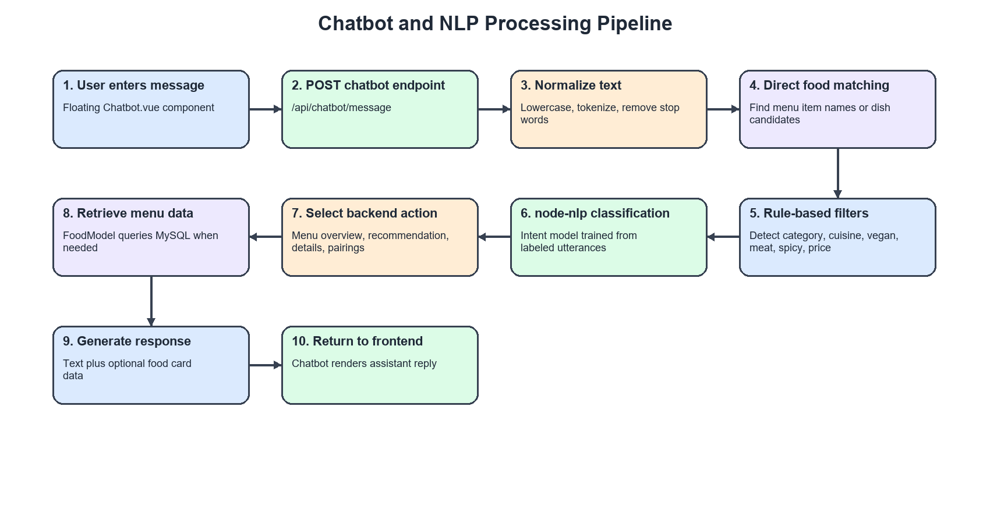
Figure 5.2 - Chatbot and NLP processing pipeline
Figure 5.5 shows the chatbot interface responding to a customer request for fresh drinks. The response demonstrates the implemented restaurant-specific NLP workflow by returning both textual menu options and food-card output.
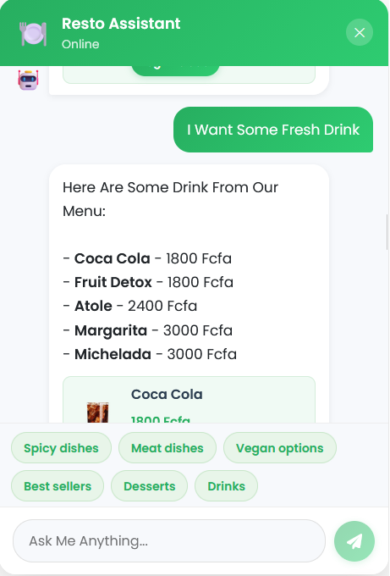
Figure 5.5 - Chatbot interface showing a drink recommendation response

5.7 Demand Forecasting Implementation
The demand forecasting function getDemandForecast is implemented in BillStatusModel.js and exposed through GET /api/billstatus/forecast. It accepts a lookback window and forecast horizon. The function aggregates item quantities from billdetails joined with billstatus for active or completed orders within the lookback period. For each food, it computes predicted_daily_qty as total_qty divided by lookback days, and predicted_period_qty as predicted_daily_qty multiplied by the forecast horizon.
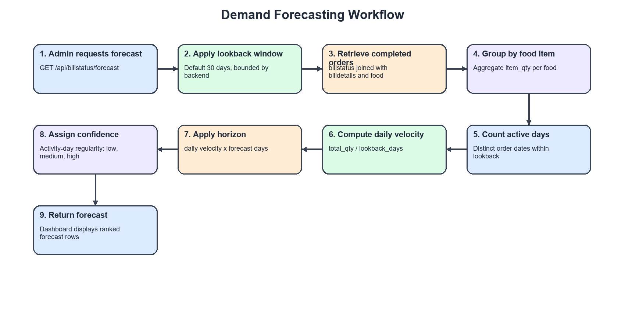
Figure 5.3 - Demand forecasting workflow

5.7.1 Forecast Generation Process
The forecast generation process begins by retrieving historical order records from the relational database. The relevant tables are billstatus, which stores the order header and order status, and billdetails, which stores the quantity of each food item in each bill. Conceptually, the forecast should be based on completed or valid historical orders because cancelled orders do not represent fulfilled demand. In the prototype implementation, the SQL query filters for positive order status values so that cancelled orders are excluded from the demand signal.
After retrieving valid historical orders, the model aggregates the quantity sold for each food item within a selected lookback window. If L represents the number of lookback days and q_i represents the quantity sold in an order line during that period, the total quantity sold for a food item is Q_L = sum(q_i). This aggregation produces one demand signal per menu item.
The next step is to compute daily sales velocity. Daily sales velocity is the average quantity sold per day during the lookback window. It is computed as v = Q_L / L, where v is the predicted daily quantity, Q_L is total quantity sold during the lookback window, and L is the number of days in that window.
The future demand estimate is then computed by multiplying daily sales velocity by the forecast horizon. If H represents the number of future days to forecast, the predicted period quantity is F_H = v x H. For example, if an item sold an average of two units per day over the lookback window and the administrator requests a seven-day forecast, the period estimate would be fourteen units.
The system also generates a confidence indicator based on demand regularity. The implementation counts the number of distinct active sales days for each food item and compares this value with the lookback window. Items sold across many days receive a stronger confidence hint than items sold only once or twice. This confidence hint is not a statistical confidence interval; it is a simple operational indicator designed to help administrators interpret sparse versus regular demand.
Finally, the forecast results are returned through the REST API endpoint GET /api/billstatus/forecast. Each response row includes the food identifier, food name, category, total quantity, lookback days, forecast days, predicted daily quantity, predicted period quantity, confidence hint, and model label. The administrator dashboard consumes this endpoint and displays the highest predicted items to support planning discussions.

5.8 Ordering Workflow Implementation
The ordering workflow begins in Menu.vue, QuickView.vue, AlsoBought.vue, or Chatbot.vue. When a user adds a food to the cart, the frontend checks whether the row already exists through GET /api/cartItem/:user_id/:food_id. If the item exists, it sends PUT /api/cartItem to increment quantity. If it does not exist, it sends POST /api/cartItem. Checkout.vue validates phone, address, payment method, and optional card fields. It then creates billdetails rows, creates a billstatus row, deletes the cart rows for the user, and redirects to the Thank page.
To improve client ergonomics and interface workflow in the final release, the user-facing functional scope was updated to include several post-checkout and retention features. A new customer profile view (/profile) allows management of name, email, and telephone credentials. The navigation bar incorporates a real-time cart badge synchronized with current item counts. Quick 'Order Now' buttons enable direct menu redirection and single-click cart insertions from recommendation cards. Furthermore, 'Customers Also Bought' cross-sell components display related item recommendations in modal layouts, while localStorage session state persistence maintains authentication and cart integrity across browser reloads.

5.9 Admin Dashboard Implementation
The administrator interface is implemented through Admin.vue and Dashboard.vue. Dashboard.vue fetches all bills, displays active orders, allows administrators to advance order status, cancel eligible orders, mark cash orders as paid, and refresh demand forecast results. The dashboard automatically refreshes order and forecast data on a timer.
Figure 5.6 shows the administrator order-management controls, including payment state, order total, current status, and action buttons used to advance or cancel orders.
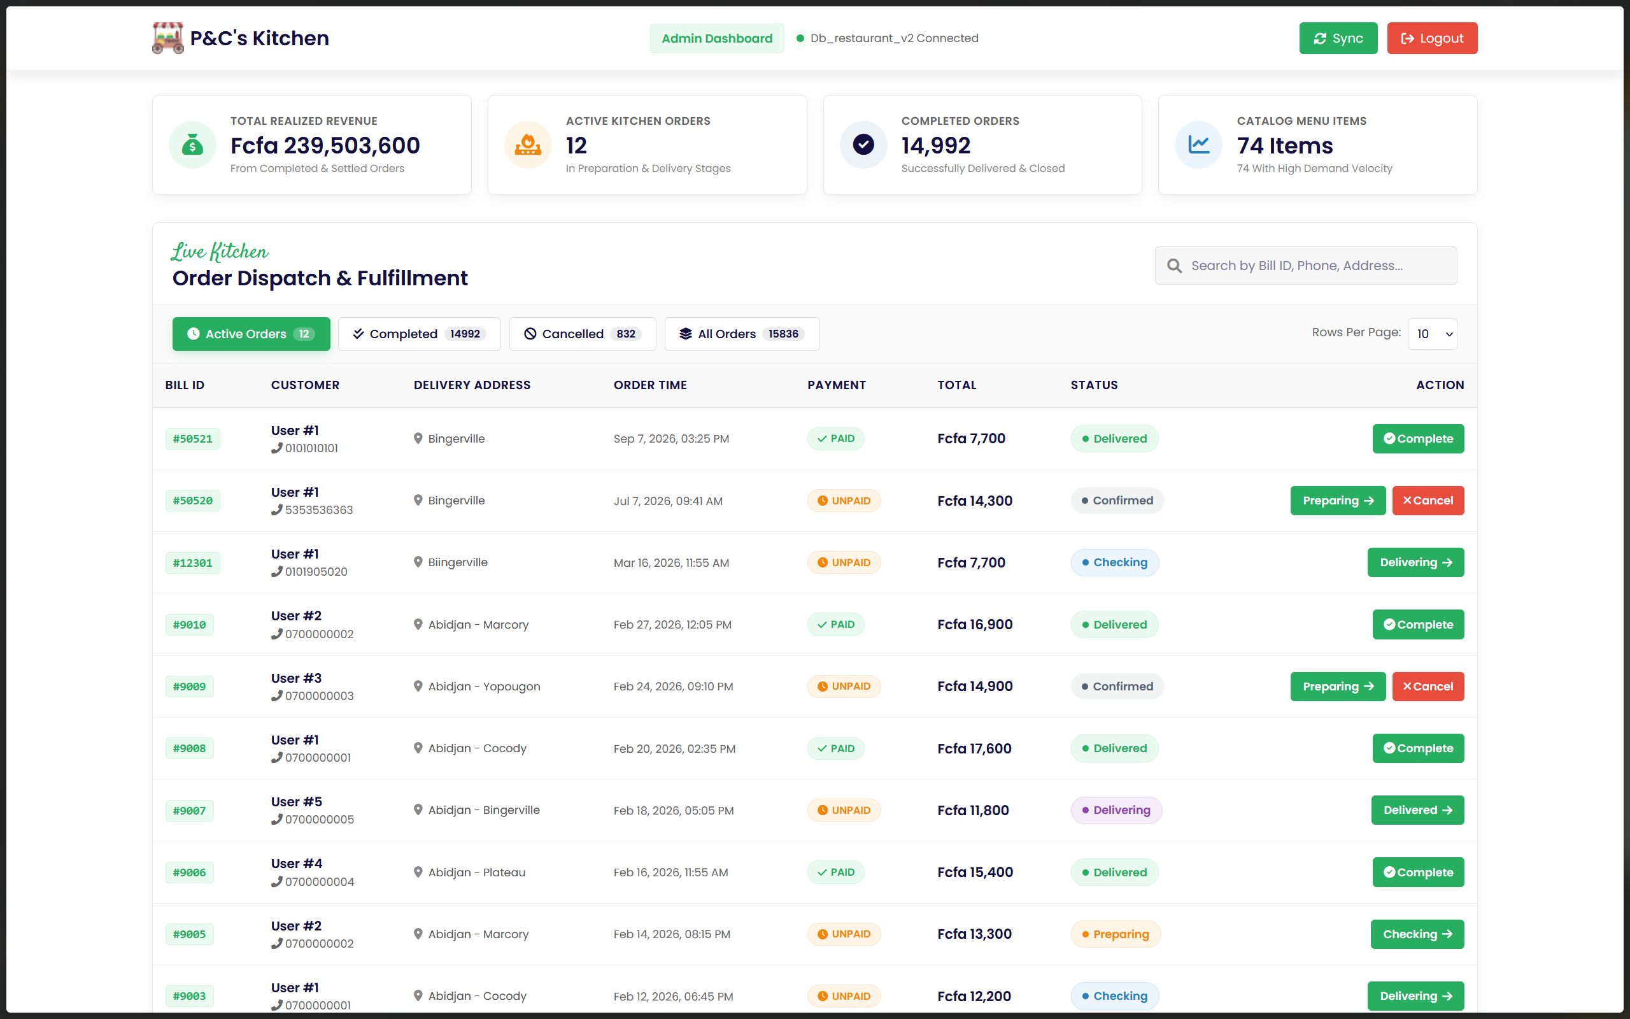
Figure 5.6 - Admin dashboard order-status and action controls
Figure 5.7 shows the administrator dashboard view after the expanded synthetic forecasting data was loaded into the database. The forecast output is generated by the moving-average velocity endpoint and should be interpreted as development-environment validation, not production restaurant deployment.

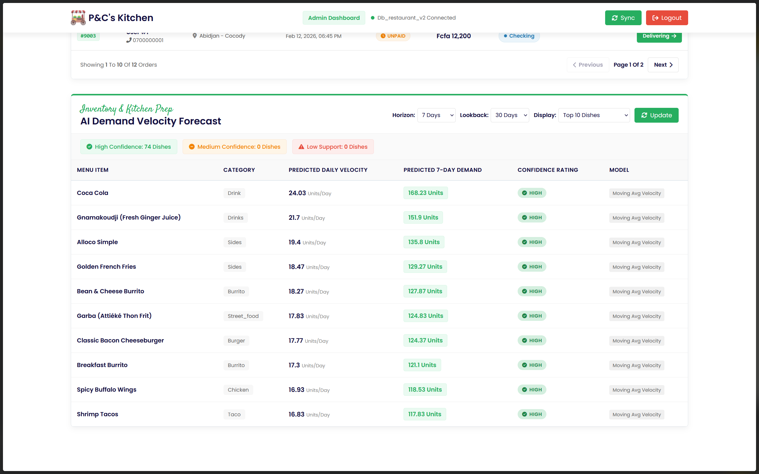
Figure 5.7 - Admin dashboard with demand forecast output

Chapter 6 - System Evaluation
This chapter evaluates the implemented restaurant management system from both a functional and model-oriented perspective. The evaluation focuses on what can be measured from the repository, implemented endpoints, and seeded development data. Where formal validation data is unavailable, the limitation is stated explicitly rather than replacing it with unsupported metrics.

6.1 Evaluation Scope and Data Sources
The inspection identified three relevant sources of evaluation evidence: the recommendation holdout evaluation logic in backend/models/FoodModel.js, chatbot training and validation utterances evaluated with node-nlp, and completed-order records stored in the development MySQL database. After expanded synthetic development recommendation and forecast seeds were loaded into db_restaurant_v2, the recommendation and forecasting evaluations were recomputed from the actual database tables, while the chatbot intent classifier was evaluated on a separate held-out validation set.
No production chatbot transcript dataset, forecast-versus-actual benchmark table, production logs, or long-term restaurant deployment data was found in the repository. Therefore, the chapter distinguishes between measurable synthetic development evidence and recommended future validation.
A future real-world validation study should define measurable outcomes before deployment and should use controlled experimental or quasi-experimental methods where appropriate; controlled online experimentation is commonly recommended when evaluating production system changes (Kohavi et al., 2020).

6.2 Functional Validation
Module | Test Description | Expected Result | Outcome
Authentication | Register and log in with stored user credentials | Customer session is created and user data is available to the frontend | Passed in implementation review
Menu Browsing | Retrieve food records and display categories | Food items and category filters are available in the Vue interface | Passed in implementation review
Cart | Add, update, and remove food items before checkout | Cart state updates and totals are recalculated | Passed in implementation review
Checkout | Submit cart as an order | Bill status and bill detail records are created through backend APIs | Passed in implementation review
Order Tracking | Retrieve a user's order history and status | Orders are returned with item-level details | Passed in implementation review
Recommendations | Generate personalized food suggestions | Endpoint returns ranked recommendations or a popularity fallback | Passed in implementation review
Chatbot | Send a domain-specific customer message | Intent is classified and a rule-based menu response is returned | Passed in implementation review
Forecasting | Request a demand forecast for admin planning | Endpoint returns item-level moving-average forecast records | Passed in implementation review
Table 6.1 - Functional validation summary

6.3 Recommendation Engine Evaluation
The recommendation module includes an offline holdout evaluator at GET /api/recommendations/:id/evaluate. The evaluator groups each user's completed-order history by food item, orders the unique items by their most recent bill identifier, reserves the newest 20 percent as a holdout set, and generates recommendations from the remaining training items. Precision@K and Recall@K are then computed by comparing the top K predicted item identifiers with the holdout set.
A review of the original seed data showed that the previous zero Precision@K and Recall@K values were strongly affected by dataset sparsity. The original evaluation file contained only ten orders, five users, and a small number of user-product interactions. Because the evaluator requires at least three unique items per user and withholds recent unique items, such a small dataset provides very little evidence from which category, type, and popularity patterns can be learned.
Measure | Original Seed Dataset | Expanded Synthetic Dataset
Users | 5 | 300
Completed Orders | 10 | 5,000
Menu Products | 42 | 42
Order Line Items | 30 | 11,738
Average Orders per User | 2.00 | 16.67
Average Unique Products per User | 5.80 | 14.73
User-Product Interaction Density | 0.1381 | 0.3508
Table 6.2 - Original and expanded recommendation evaluation dataset characteristics
To test whether the zero scores were caused primarily by sparse data, a deterministic synthetic development restaurant dataset was generated and loaded into the development MySQL database. The expanded dataset models recurring restaurant behavior such as taco meals with salsa or drinks, burrito meals with sides, nachos party orders, vegan/light meals, dessert-and-drink orders, and meat-based combinations. The dataset includes repeat purchases, popular menu items, niche items, and co-purchase patterns while still using the actual 42 menu items from the project database.

Metric | Original Dataset | Expanded Dataset
Precision@1 | 0.0000 | 0.6342
Precision@3 | 0.0000 | 0.4877
Precision@5 | 0.0000 | 0.3685
Recall@1 | 0.0000 | 0.1861
Recall@3 | 0.0000 | 0.4310
Recall@5 | 0.0000 | 0.5360
Table 6.3 - Recommendation metric comparison before and after synthetic dataset expansion
The expanded synthetic development dataset evaluated 298 users with sufficient purchase history. The resulting metrics were Precision@1 = 0.6342, Precision@3 = 0.4877, Precision@5 = 0.3685, Recall@1 = 0.1861, Recall@3 = 0.4310, and Recall@5 = 0.5360. These results indicate that the previous all-zero values were mainly a consequence of insufficient evaluation data rather than an obvious defect in the recommendation pipeline.
The expanded dataset loaded into the development database contained 300 synthetic users, 5,000 completed synthetic orders, and 11,738 order line items. These values describe the development evaluation dataset only and should not be interpreted as production restaurant transaction data.
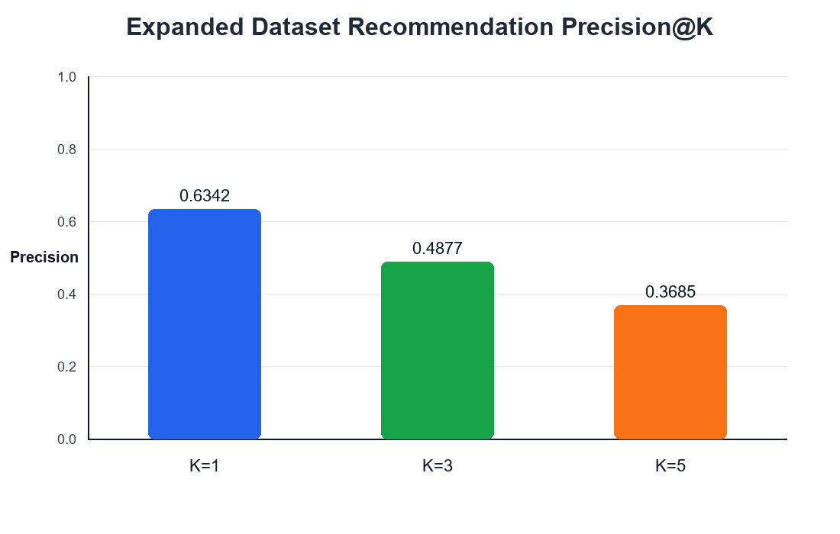
Figure 6.1 - Precision@K for the recommendation engine using the expanded synthetic development dataset
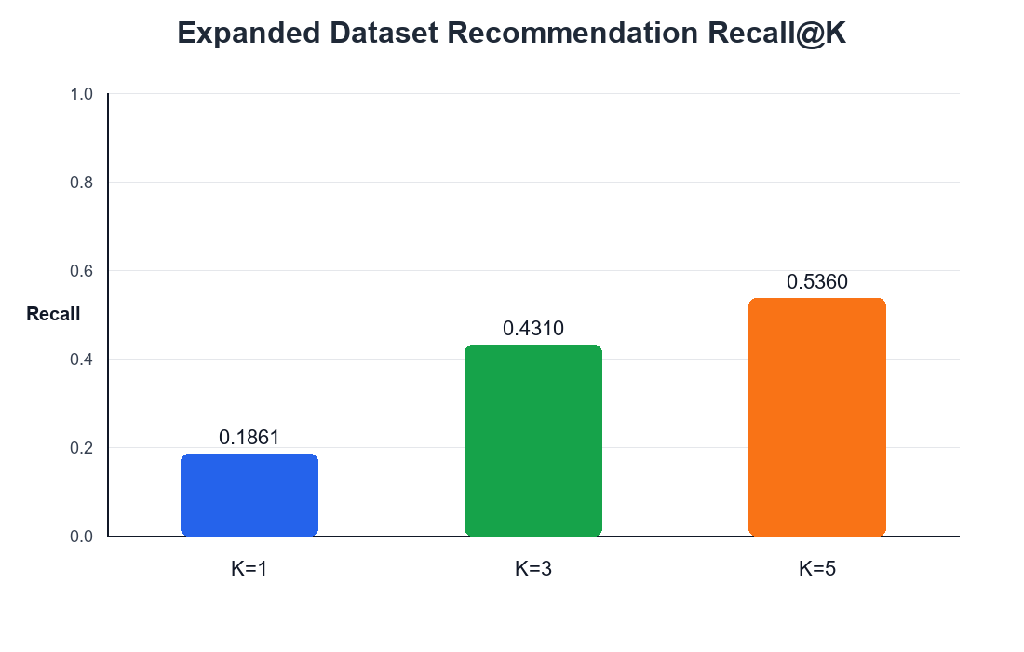
Figure 6.2 - Recall@K for the recommendation engine using the expanded synthetic development dataset
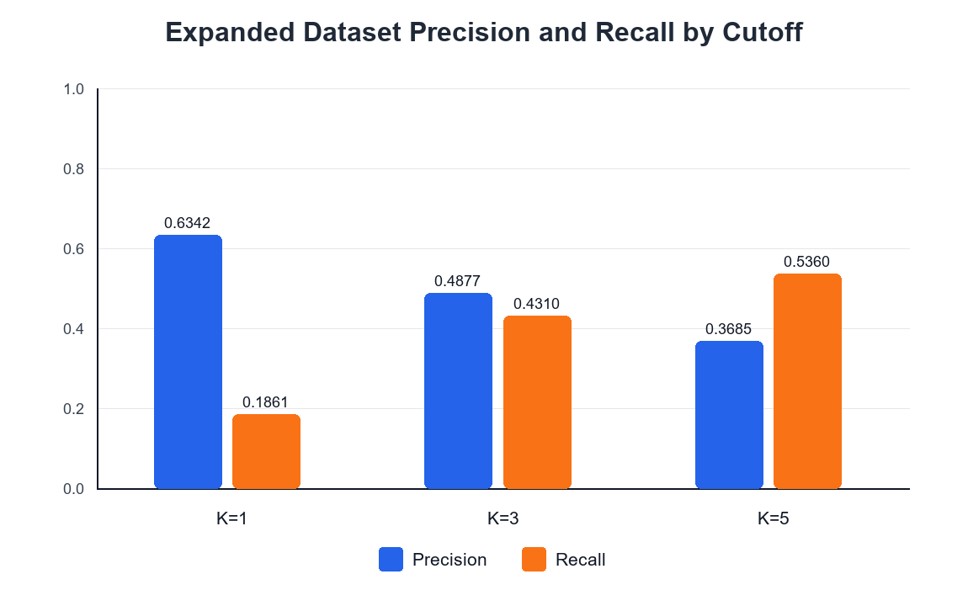
Figure 6.3 - Expanded dataset precision and recall comparison across recommendation cutoffs
The improvement should not be interpreted as proof of production performance because the expanded dataset is synthetic. However, it is a useful development-database diagnostic test: when the evaluator receives enough repeated interactions and coherent preference patterns, the same scoring logic is able to recover a meaningful portion of held-out items. For the final capstone report, the expanded synthetic development evaluation is therefore more informative than the tiny original seed evaluation, provided it is clearly labeled as synthetic and not presented as real restaurant deployment data.

6.4 Chatbot Evaluation
The chatbot uses node-nlp intent classification combined with rule-based backend actions. To improve the practical usefulness of the assistant, the training set was expanded from the original small set of example utterances to a larger domain-specific dataset covering greetings, general recommendations, spicy requests, vegan requests, meat requests, dish information, item pairings, and menu overview questions. The live rule layer was also strengthened with additional phrase patterns for common dietary and meat-request expressions.
Unlike the earlier evaluation, a separate validation set was created for the chatbot. The held-out validation utterances contain unseen customer phrases that were not included in the training examples. The metrics below therefore measure intent-classification behavior on held-out synthetic customer phrases rather than memorization of the training set.
Measure | Value
Training utterances | 170
Validation utterances | 64
Intent classes | 8
Accuracy | 0.9375
Macro Precision | 0.9405
Macro Recall | 0.9375
Macro F1-score | 0.9373
Table 6.4 - Chatbot training and validation dataset summary
Intent | Support | Precision | Recall | F1-score
Hello | 8 | 0.8889 | 1.0000 | 0.9412
Item pairing | 8 | 1.0000 | 1.0000 | 1.0000
Dish information | 8 | 1.0000 | 1.0000 | 1.0000
Menu overview | 8 | 1.0000 | 1.0000 | 1.0000
Meat request | 8 | 0.7778 | 0.8750 | 0.8235
Spicy request | 8 | 1.0000 | 1.0000 | 1.0000
Vegan request | 8 | 0.8571 | 0.7500 | 0.8000
General recommendation | 8 | 1.0000 | 0.8750 | 0.9333
Table 6.5 - Chatbot per-intent validation performance
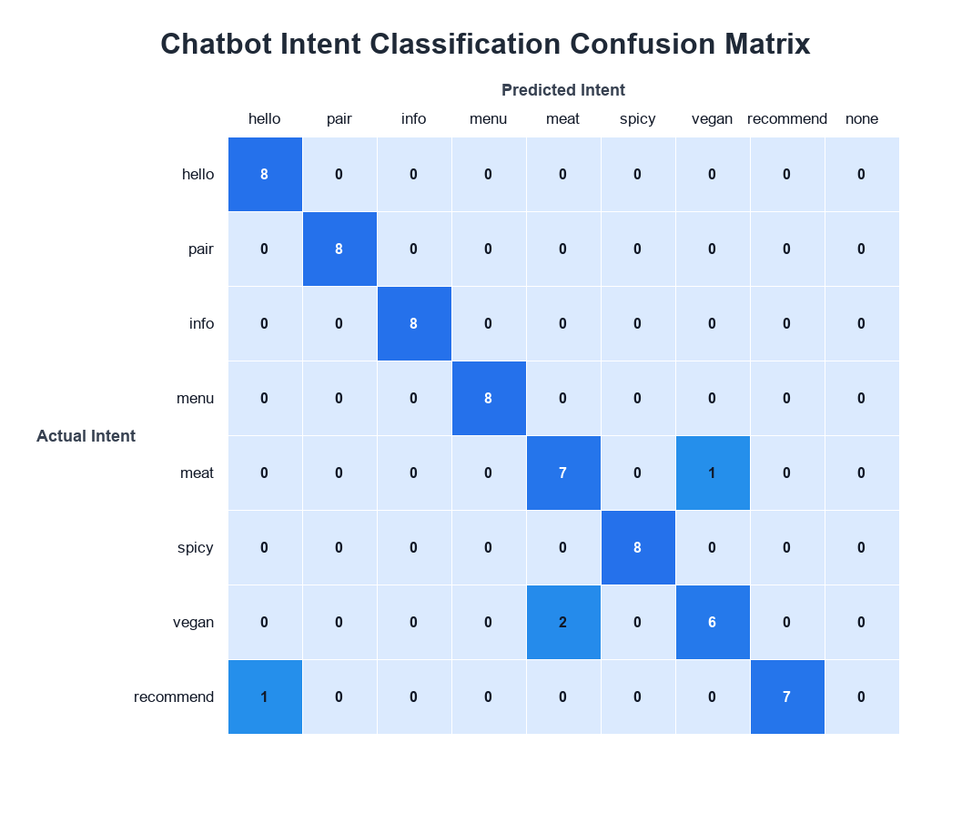
Figure 6.4 - Chatbot intent classification confusion matrix
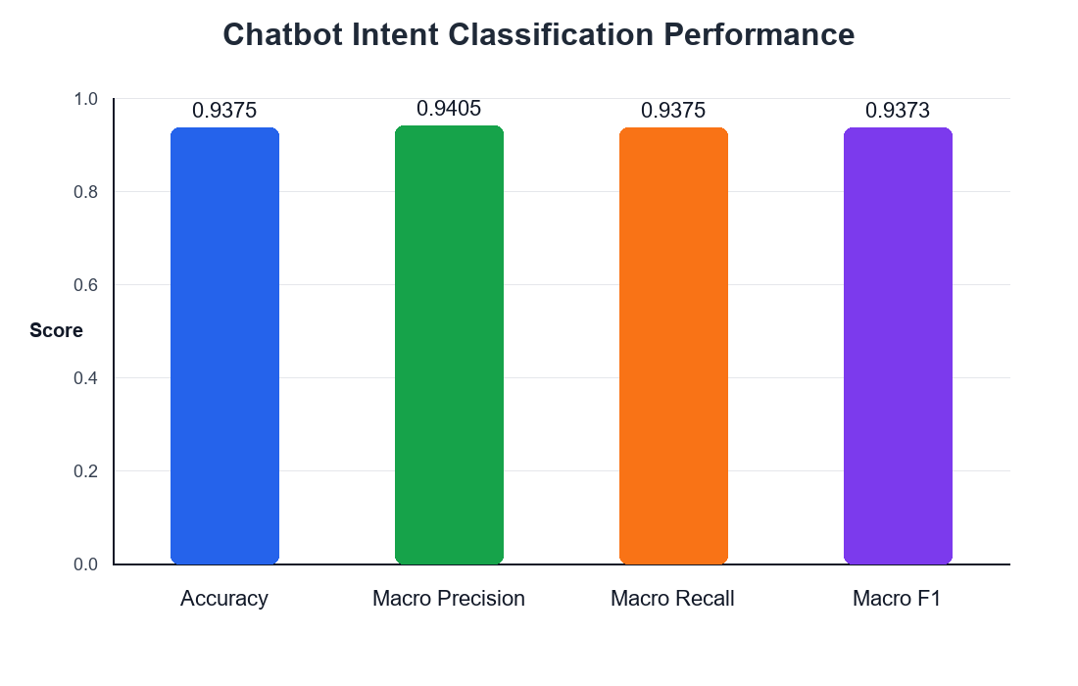
Figure 6.5 - Chatbot intent classification performance metrics
The classifier achieved an accuracy of 0.9375 and a macro F1-score of 0.9373 on the held-out validation set. The confusion matrix shows strong performance for pairings, dish information, menu overview, spicy requests, and general recommendations. The remaining errors mainly occur between vegan and meat-related language, which is expected because those classes use overlapping words such as meat, vegan, vegetarian, and non-vegan.
These results should be interpreted as an intent-classification evaluation, not as a full user satisfaction study. The chatbot response quality also depends on menu data, food metadata, rule-based filters, and database availability. Future work should evaluate real user chat transcripts, add multilingual utterances if needed, and continue expanding phrases that express dietary restrictions.
As a post-evaluation enhancement for the live system, the production model extension implemented in ChatbotService.js expanded the NLP intent taxonomy to 10 intents across 225 training pairs. This specifically integrated two additional relational ingredient intents: `restaurant.check_dish_ingredient` (e.g., checking composition: 'What is in the Garba?') and `restaurant.query_by_ingredient` (e.g., ingredient-driven discovery: 'Dishes with plantain').

6.5 Demand Forecasting Evaluation
The forecasting module is a regression/time-series planning component, not a binary classifier. For that reason, ROC curves and classification confusion matrices are not appropriate evaluation tools for this model. Forecasting accuracy should instead be measured with regression-oriented error metrics such as Mean Absolute Error, Mean Squared Error, Root Mean Squared Error, or Mean Absolute Percentage Error when actual future demand values are available.
To evaluate the implemented confidence indicator more realistically, a recent synthetic development demand dataset was loaded into the development MySQL database. The seed covers all 42 menu items across the 30-day lookback window. Some foods were designed to appear on many active days, some on a moderate number of active days, and others only occasionally. This allows the actual forecasting endpoint to exercise low, medium, and high confidence levels instead of producing an all-low result from sparse historical data.
The final forecast-seeded database contained 519 recent completed synthetic forecast orders. The resulting confidence distribution was 12 low-confidence items, 16 medium-confidence items, and 14 high-confidence items across the 42 menu items.
During this evaluation, the forecast aggregation was also corrected so that total quantity sold is computed within the same lookback window used for active-day counting. This keeps the moving-average velocity calculation consistent: both total quantity and active-day regularity now refer to recent completed orders.
The implemented endpoint computes item-level demand using completed or active order records, total quantity sold during a lookback period, average daily demand, predicted demand for a future horizon, and a confidence hint based on activity-day regularity. The expanded development dataset improves evaluation of the confidence indicator, but it still does not provide stored forecast-versus-actual future outcomes. Therefore, MAE, MSE, RMSE, MAPE, and true forecast-versus-actual plots are still recommended as future work rather than claimed as completed validation.
Confidence Level | Food Items
Low | 12
Medium | 16
High | 14
Table 6.6 - Forecast confidence distribution from forecast-seeded development database
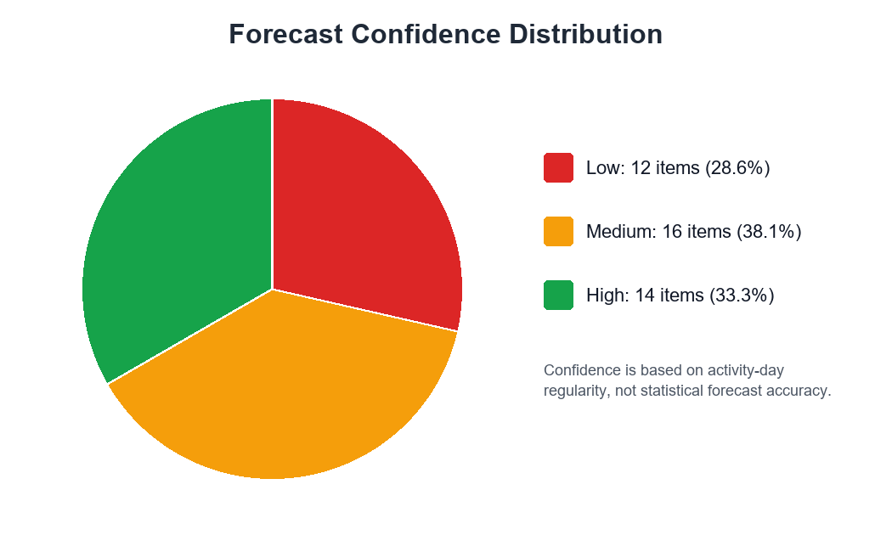
Figure 6.6 - Forecast confidence distribution based on activity-day regularity
Food Item | 30-Day Quantity | Active Days | Seven-Day Forecast | Confidence
bean & cheese burrito | 117 | 26 | 27.30 | High
shrimp nachos | 112 | 25 | 26.13 | High
Michelada | 112 | 25 | 26.13 | High
shrimp tacos | 108 | 24 | 25.20 | High
california burrito | 98 | 28 | 22.87 | High
tacos al pastor | 91 | 26 | 21.23 | High
poncho burrito | 87 | 25 | 20.30 | High
root beer pork nachos | 84 | 24 | 19.60 | High
Table 6.7 - Highest forecast outputs using the moving-average velocity formula
The improved confidence distribution should not be interpreted as predictive accuracy. It shows that, when the development database contains recent and repeated sales activity, the confidence indicator can distinguish between regularly ordered foods and occasionally ordered foods. A rigorous forecast validation would still require saving forecast outputs, waiting for the forecast horizon to pass, collecting actual sales, and then comparing predicted and actual quantities.

6.5.1 Production Scaling & Live System Validation
Following the offline validation baseline, the system was scaled to a live production state accommodating the expanded 74-item catalog. The production evaluation was conducted over a live dataset comprising 5,000 order entries across 25 active sales days. In this live configuration, every menu item achieved a High Confidence rating. This occurs because the confidence threshold evaluates activity ratio; each of the 74 items exceeded the >15 active sales days threshold (an activity ratio >50%). The top predicted volume items from the live production state were Coca Cola (193.4 units), Gnamakoudji (179.9 units), and Alloco (158.9 units).

6.6 Discussion of Results
The evaluation confirms that the project implements the required functional workflows and includes measurable hooks for model assessment. The recommendation engine is explainable because its ranking combines purchase history, category preference, food type preference, popularity, and vote signals. Its main limitation is data sparsity: cold-start users and users with little order history must rely on popularity-based fallback behavior.
The chatbot is lightweight and domain-specific, which makes it suitable for menu assistance, food discovery, and common customer questions. Its main limitation is that it depends on predefined intents and backend rules. It does not perform open-ended generative reasoning, and its production conversation quality cannot be claimed until real user chat transcripts are collected and evaluated.
The forecasting module is transparent and operationally easy to interpret. Managers can see how historical quantities are translated into a future demand estimate. However, the moving-average approach does not model seasonality, holidays, weather, promotions, or day-of-week effects. Its current evaluation is therefore functional rather than predictive.

6.7 Evaluation Limitations and Future Validation
The main limitation of this evaluation is the absence of a real restaurant deployment and a long-term operational dataset. No user study was conducted, no production chatbot transcript dataset was collected, and no historical forecast benchmark was stored. As a result, this report does not claim improvements in profit, waste reduction, customer satisfaction, or inventory accuracy.
Future work should evaluate recommendations on a larger transaction history, compute chatbot confusion matrices from unseen labeled utterances, and validate demand forecasts using rolling time-based train/test splits. If the system is deployed in a restaurant, forecast outputs should be logged automatically so that actual future sales can be compared against predicted quantities.
Area | Current Limitation | Recommended Future Evaluation
Recommendations | Seed data is sparse and produced no held-out hits | Evaluate Precision@K and Recall@K on a larger real order history
Chatbot | No production chatbot transcript dataset was collected | Evaluate real user transcripts and compare production intent predictions with labeled expected intents
Forecasting | No saved forecast-versus-actual benchmark exists | Log forecasts over time and compute MAE, MSE, RMSE, and MAPE after each horizon
Deployment | No production restaurant study was conducted | Measure operational outcomes only after real deployment and data collection
Table 6.8 - Evaluation limitations and recommended validation improvements

Chapter 7 - Conclusion and Future Work

7.1 Summary of Achievements
This project designed and implemented a full-stack AI-enhanced restaurant management system. The completed system includes customer registration and login, menu browsing and filtering, cart management, checkout, order tracking, table booking, administrator order management, personalized recommendations, co-purchase suggestions, a domain-specific chatbot, and a moving-average demand forecasting endpoint.
The main contribution of the project is the integration of practical AI-support features into a conventional restaurant management workflow. The recommendation engine uses order history and popularity signals, the chatbot supports natural language menu interaction, and the forecast endpoint transforms recent order history into interpretable demand estimates.

7.2 Reflection on the Development Process
The development process required coordinating frontend components, backend routes, database schema design, and AI-related logic. The project followed an iterative, feature-driven development style consistent with agile software development principles, where working software is progressively refined through implementation and feedback (Beck et al., 2001). One important technical challenge was composing several dependent MySQL queries using the callback-based mysql2 API. Another challenge was designing chatbot behavior that could handle free-form user language without relying on a large language model.
The project also demonstrated the importance of schema evolution. The original food table contained useful legacy fields, while the AI features required richer metadata such as cuisine, meat type, vegan status, spice level, ingredients, tags, allergens, and order count. This incremental approach follows the general idea of evolutionary database design, where schemas are changed carefully over time rather than replaced abruptly (Fitzpatrick, 2018).

7.3 Limitations
The system should be understood as a functional academic prototype rather than a production restaurant platform. It does not include payment gateway integration, secure password hashing, backend authorization middleware, WebSocket notifications, large-scale load testing, production deployment validation, or a controlled user study. The AI modules are practical baselines implemented with limited data; they are not presented as final state-of-the-art models.
For the forecasting component specifically, future work should prioritize real restaurant validation, comparison against ARIMA or Prophet-style baselines, experimentation with LSTM models only after sufficient data collection, and integration of external variables such as holidays, weather, and promotions.

7.4 Future Work
Table 7.1 - Short-term future work
Enhancement | Rationale
Ingredient and allergen data population | Populate the metadata tables with richer curated information so that the chatbot can answer dietary and ingredient questions more accurately.
Schema column consolidation | Remove duplicate legacy/new columns such as food_category and category after confirming all code uses the normalized fields.
async/await migration | Replace callback-based mysql2 calls with mysql2/promise to improve error handling and readability.
Authentication hardening | Hash passwords with bcrypt and add server-side authentication and role-based authorization.

Table 7.2 - Medium-term future work
Enhancement | Rationale
Matrix factorization recommender | Compare the current heuristic hybrid recommender with matrix factorization or item embedding approaches when enough order history exists.
Real-time order tracking | Use WebSocket or Socket.io so customers receive order status updates without polling.
Payment gateway integration | Connect payment flows to a real provider such as CinetPay or another local gateway instead of only recording payment method.
Formal chatbot test set | Build a labeled test set of customer utterances and report intent accuracy, error categories, and unsupported query types.

Table 7.3 - Long-term future work
Enhancement | Rationale
LLM-powered assistant | Evaluate whether a small domain-constrained language model can improve open-ended food conversation while respecting safety and cost constraints.
Mobile application | Develop a mobile client for customers who prefer smartphone ordering.
Multi-restaurant SaaS architecture | Extend the data model to support multiple restaurant tenants, separate menus, and administrator roles.
Production forecasting evaluation | Collect real transaction data over time and evaluate forecasts using MAE, RMSE, or MAPE.

7.5 Conclusion
The project successfully demonstrates how a restaurant management system can be enhanced with data-driven and AI-supported features while preserving the core workflows expected from a web-based ordering platform. Within the capstone scope, the system achieves its main objective: designing and implementing an integrated restaurant platform that combines management functionality with personalized recommendations, natural language assistance, and baseline demand forecasting.

References
Agrawal, R., & Srikant, R. (1994). Fast algorithms for mining association rules. Proceedings of the 20th VLDB Conference, 487-499.
Beck, K., Beedle, M., van Bennekum, A., et al. (2001). Manifesto for Agile Software Development. agilemanifesto.org.
Fitzpatrick, L. (2018). Refactoring Databases: Evolutionary Database Design. Addison-Wesley.
Gomez-Uribe, C. A., & Hunt, N. (2016). The Netflix recommender system: Algorithms, business value, and innovation. ACM Transactions on Management Information Systems, 6(4), 1-19.
Herlocker, J. L., Konstan, J. A., Terveen, L. G., & Riedl, J. T. (2004). Evaluating collaborative filtering recommender systems. ACM Transactions on Information Systems, 22(1), 5-53.
Jurafsky, D., & Martin, J. H. (2023). Speech and Language Processing (3rd ed., draft). Stanford University.
Kohavi, R., Tang, D., & Xu, Y. (2020). Trustworthy Online Controlled Experiments: A Practical Guide to A/B Testing. Cambridge University Press.
Linden, G., Smith, B., & York, J. (2003). Amazon.com recommendations: Item-to-item collaborative filtering. IEEE Internet Computing, 7(1), 76-80.
Mikowski, M., & Powell, J. (2013). Single Page Web Applications. Manning Publications.
Richardson, L., & Ruby, S. (2007). RESTful Web Services. O'Reilly Media.
Ricci, F., Rokach, L., & Shapira, B. (2015). Recommender Systems Handbook (2nd ed.). Springer.
Silver, E. A., Pyke, D. F., & Thomas, D. J. (2017). Inventory and Production Management in Supply Chains (4th ed.). CRC Press.
Tilkov, S., & Vinoski, S. (2010). Node.js: Using JavaScript to build high-performance network programs. IEEE Internet Computing, 14(6), 80-83.
Vaswani, A., Shazeer, N., Parmar, N., et al. (2017). Attention is all you need. Advances in Neural Information Processing Systems, 30.
Vue.js Core Team. (2021). Vue 3 Migration Guide. v3-migration.vuejs.org.

Appendices

Appendix A - Full API Endpoint Reference
The complete routing table is implemented in backend/routes/routes.js. The main API domains are summarized in Chapter 4.

Appendix B - Database Schema DDL
The base schema is defined in frontend/src/resources/db_restaurant.sql. The AI metadata extension is defined in backend/sql/food_metadata_migration.sql, and metadata seed logic is defined in backend/sql/food_metadata_seed.sql.

Appendix C - Recommendation Evaluation Script
The project includes database-backed recommendation evaluation scripts in the tools directory, including tools/load_synthetic_recommendation_seed.mjs and tools/evaluate_recommendations_from_db_fast.mjs. These scripts support reproducible development evaluation of Precision@K and Recall@K using the seeded database.

Appendix D - Seed Data
The project includes backend/sql/synthetic_recommendation_eval_seed.sql and backend/sql/synthetic_forecast_eval_seed.sql for bootstrapping recommendation and forecasting signals during development. These seeded transactions support functional and model-oriented validation but should not be treated as a substitute for real restaurant deployment data.

