Title: Reproducible Research: Peer Assessment Two

Dr Paul Fergus

24/10/2014

## Summary

It is common knowledge that stroms and severe weather conditions have a serious impact on public health and the economy. There is a general consensus that the utilisation of data will help to inform and prioritise decisions about if and when they could occur, including estimates of potential fatalities, injury and damage to proporty. This report draws the readers attention to this fact and presents quantitative evidence based on a storm database collected from the U.S. Oceanic and Atmospheric Administration (NOAA) from 1950-2011.

## Synopsis

The results in this report present us with some interesting results. From the first set of results we find that tornados have accounted for the number of deaths since recordings began in 1950, with 5633 recorded fatalities. This was followed by excessive heat wih 1903 recordings and the lowest end of the scale 224 of deaths caused by Avalanche. In terms of injury again we find that tornados account for most recorded insidences with 91346 recordings since 1950. At the lower end of the top ten events we are interesed in in this report we find that 1361 injuries were recorded. Looking at the economic burden severe weather conditions has on the economy we find that floods account for the main cause of damage to property at a total cost of 115 billion since 1950 with hurricane/typhoon, and storm surge accounding for 58 billion and 31 billion respectively. (the results here are problematic because of duplication in the records). In terms of the costs cuased by damage to crops we find that river floods and ice storms acount for the most economic costs, costing 5, 5, and 1.5 billion respectively.

### Load Libraries and Perform Initial Setup

#Load Libraries  
library(ggplot2)  
library(plyr)  
#This allows the reader to examine the software environment  
sessionInfo()

## R version 3.0.2 (2013-09-25)  
## Platform: x86_64-pc-linux-gnu (64-bit)  
##   
## locale:  
## [1] LC_CTYPE=en_GB.UTF-8 LC_NUMERIC=C   
## [3] LC_TIME=en_GB.UTF-8 LC_COLLATE=en_GB.UTF-8   
## [5] LC_MONETARY=en_GB.UTF-8 LC_MESSAGES=en_GB.UTF-8   
## [7] LC_PAPER=en_GB.UTF-8 LC_NAME=C   
## [9] LC_ADDRESS=C LC_TELEPHONE=C   
## [11] LC_MEASUREMENT=en_GB.UTF-8 LC_IDENTIFICATION=C   
##   
## attached base packages:  
## [1] stats graphics grDevices utils datasets methods base   
##   
## other attached packages:  
## [1] plyr_1.8.1 ggplot2_1.0.0  
##   
## loaded via a namespace (and not attached):  
## [1] colorspace_1.2-4 digest_0.6.4 evaluate_0.5.5 formatR_1.0   
## [5] grid_3.0.2 gtable_0.1.2 htmltools_0.2.6 knitr_1.7   
## [9] MASS_7.3-29 munsell_0.4.2 proto_0.3-10 Rcpp_0.11.2   
## [13] reshape2_1.4 rmarkdown_0.2.68 scales_0.2.4 stringr_0.6.2   
## [17] tools_3.0.2 yaml_2.1.13

### Load Data

if(!file.exists("./data/repdata-data-StormData.csv")){  
 dataset <- read.table(  
 bzfile("./data/repdata-data-StormData.csv.bz2",   
 "repdata-data-StormData.csv"), sep=",", header=T, na.string="NA")  
}

### Check that we have data

At this stage we just want to check that we have loaded some data.

head(dataset, n=1)

## STATE__ BGN_DATE BGN_TIME TIME_ZONE COUNTY COUNTYNAME STATE  
## 1 1 4/18/1950 0:00:00 0130 CST 97 MOBILE AL  
## EVTYPE BGN_RANGE BGN_AZI BGN_LOCATI END_DATE END_TIME COUNTY_END  
## 1 TORNADO 0 0  
## COUNTYENDN END_RANGE END_AZI END_LOCATI LENGTH WIDTH F MAG FATALITIES  
## 1 NA 0 14 100 3 0 0  
## INJURIES PROPDMG PROPDMGEXP CROPDMG CROPDMGEXP WFO STATEOFFIC ZONENAMES  
## 1 15 25 K 0   
## LATITUDE LONGITUDE LATITUDE_E LONGITUDE_ REMARKS REFNUM  
## 1 3040 8812 3051 8806 1

## Data Preprocessing

I left completing this assignment far too late. I would have liked to have cleaned the data more than I have. In particular, the final set of results caused problems becuase of dupiliate EVTYPE data values- please see the numeric values - I should have dealt with these values in the preprocessing stage, but have not due to time constraints.

What has been done is to convert the alpha values that represent thousands, millions and billions,into numerical equivalents so that we can calculate the property and crop damage. For this project I have capped the number of events that we are interested in to the top ten as these account for most of the damage and costs.

During this stage we also work out which weather event causes the most loss of life and injury and which of the weather events recorded has the most significant ecomonic impact on property and crops

#PROPDMGEXP  
#Convert the exponential to a numeric value that we can work with.  
dataset$PROPDMGEXP <- as.character(dataset$PROPDMGEXP)

## Warning: closing unused connection 5  
## (./data/repdata-data-StormData.csv.bz2)

dataset$PROPDMGEXP[grep("K", dataset$PROPDMGEXP)] <- "1000"  
dataset$PROPDMGEXP[grep("k", dataset$PROPDMGEXP)] <- "1000"  
dataset$PROPDMGEXP[grep("M", dataset$PROPDMGEXP)] <- "1000000"  
dataset$PROPDMGEXP[grep("m", dataset$PROPDMGEXP)] <- "1000000"  
dataset$PROPDMGEXP[grep("B", dataset$PROPDMGEXP)] <- "1000000000"  
dataset$PROPDMGEXP[grep("b", dataset$PROPDMGEXP)] <- "1000000000"  
#Set all other characters to 1 - we consider this to be noise in the data.  
to.be.one <- dataset$PROPDMGEXP %in% c("1000", "1000000", "1000000000") == F  
dataset$PROPDMGEXP[to.be.one == TRUE] <- "1"  
#Change the variable to numeric so that we can perform the calculations  
dataset$PROPDMGEXP <- as.numeric(dataset$PROPDMGEXP)  
  
#CROPDMGEXP  
#Convert the exponential to a numeric value that we can work with.  
dataset$CROPDMGEXP <- as.character(dataset$CROPDMGEXP)  
dataset$CROPDMGEXP[grep("K", dataset$CROPDMGEXP)] <- "1000"  
dataset$CROPDMGEXP[grep("k", dataset$CROPDMGEXP)] <- "1000"  
dataset$CROPDMGEXP[grep("M", dataset$CROPDMGEXP)] <- "1000000"  
dataset$CROPDMGEXP[grep("m", dataset$CROPDMGEXP)] <- "1000000"  
dataset$CROPDMGEXP[grep("B", dataset$CROPDMGEXP)] <- "1000000000"  
dataset$CROPDMGEXP[grep("b", dataset$CROPDMGEXP)] <- "1000000000"  
#Set all other characters to 1 - we consider this to be noise in the data.  
to.be.one <- dataset$CROPDMGEXP %in% c("1000", "1000000", "1000000000") == F  
dataset$CROPDMGEXP[to.be.one == TRUE] <- "1"  
#Change the variable to numeric so that we can perform the calculations  
dataset$CROPDMGEXP <- as.numeric(dataset$CROPDMGEXP)  
  
#Calculate the costs  
dataset$prop.damage <- dataset$PROPDMG * dataset$PROPDMGEXP  
dataset$crop.damage <- dataset$CROPDMG * dataset$CROPDMGEXP  
  
#Extract the top 10 most   
top.ten.prop <- head(dataset[order(dataset$prop.damage, decreasing=TRUE),], 10)  
top.ten.crop <- head(dataset[order(dataset$crop.damage, decreasing=TRUE),], 10)  
  
#First of all summerise all the fatalities and injuries for all of the event types in the dataset.  
casulties <- ddply(dataset, .(EVTYPE), summarize,   
 fatalities = sum(FATALITIES),  
 injuries = sum(INJURIES))  
  
#Get the top 10 event types that cause fatality.  
top.ten.fatalities <- head(casulties[order(casulties$fatalities, decreasing=TRUE), ], 10)  
  
#Get the top 10 event types that cause fatality.  
top.ten.injuries <- head(casulties[order(casulties$injuries, decreasing=TRUE), ], 10)

## Results

### Question One: Across the United States, which types of events (as indicated in the EVTYPE variable) are most harmful with respect to population health

We are not interested in every event type, only the ones that cause the most harm. For the purposes of this study we are only interested in the top 10 Event Types that cause the most harm to the poluation (although this could be changed to suite specific needs).

#### The results below show the top ten number of fatalities and injuries categorised by event type

##Top 10 Events that Caused the Highest Number of Deaths  
#Plot top ten fatalities by event type  
library(ggplot2)  
ggplot(top.ten.fatalities, aes(EVTYPE, fatalities, fill=fatalities)) +  
 geom_bar(stat="identity") + coord_flip() +   
 stat_summary(fun.y = median, geom="bar") +  
 labs(x="Event Type", y="Number of Deaths (1950-2011)",   
 title="Events that Cause the Highest Number of Deaths\n in the United States (1950-2011)")

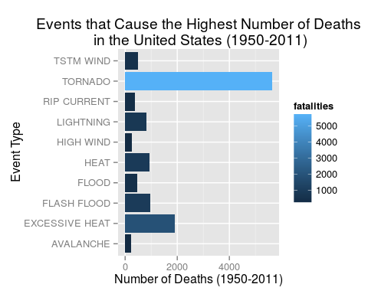

#Display the top 10 fatalities  
top.ten.fatalities[,c("EVTYPE", "fatalities")]

## EVTYPE fatalities  
## 830 TORNADO 5633  
## 123 EXCESSIVE HEAT 1903  
## 147 FLASH FLOOD 978  
## 269 HEAT 937  
## 452 LIGHTNING 816  
## 854 TSTM WIND 504  
## 164 FLOOD 470  
## 581 RIP CURRENT 368  
## 354 HIGH WIND 248  
## 11 AVALANCHE 224

##Top 10 Events that Caused the Highest Number of Injuries  
#Plot top ten injuries by event type  
ggplot(top.ten.injuries, aes(EVTYPE, injuries, fill=injuries)) +  
 geom_bar(stat="identity") + coord_flip() +   
 stat_summary(fun.y = median, geom="bar") +  
 labs(x="Event Type", y="Number of Injuries (1950-2011)",   
 title="Events that Cause the Highest Number of Injuries \n in the United States (1950-2011)")

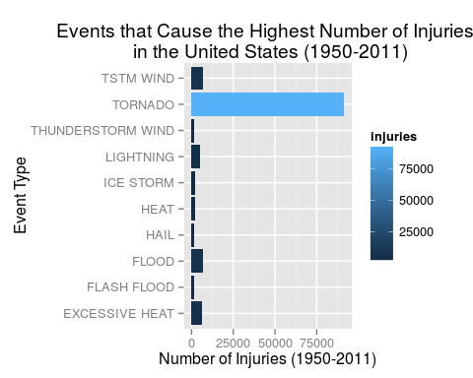

#Display the top 10 fatalities  
top.ten.injuries[,c("EVTYPE", "injuries")]

## EVTYPE injuries  
## 830 TORNADO 91346  
## 854 TSTM WIND 6957  
## 164 FLOOD 6789  
## 123 EXCESSIVE HEAT 6525  
## 452 LIGHTNING 5230  
## 269 HEAT 2100  
## 424 ICE STORM 1975  
## 147 FLASH FLOOD 1777  
## 759 THUNDERSTORM WIND 1488  
## 238 HAIL 1361

### Question Two: Across the United States, which types of events have the greatest economic consequences?

As with question one we are not interested in every event type, only the ones that have the greatest economical costs. For the purposes of this study we are only interested in the top 10 Event Types that cost the economoy the most (although this could be changed to suite specific needs).

#### The results below show the top ten highest economical costs for prop and crop for the severest weather categorised by event type.

#Plot the top 10 economoic prop damages  
ggplot(top.ten.prop, aes(EVTYPE, prop.damage)) +  
 geom_bar(stat="identity") +   
 stat_summary(fun.y = median, geom="bar") +  
 labs(x="Event Type", y="Cost of Property Damage (in Billions)",   
 title="Events that Cause the Highest Property Damage Costs \n in the United States (1950-2011)") +  
 theme(axis.text.x = element_text(angle = 45, hjust = 1))

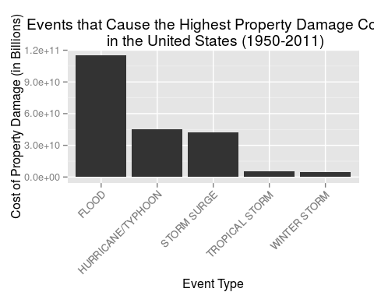

#Display the top 10 prop damage  
top.ten.prop[,c("EVTYPE", "prop.damage")]

## EVTYPE prop.damage  
## 605953 FLOOD 1.150e+11  
## 577676 STORM SURGE 3.130e+10  
## 577675 HURRICANE/TYPHOON 1.693e+10  
## 581535 STORM SURGE 1.126e+10  
## 569308 HURRICANE/TYPHOON 1.000e+10  
## 581533 HURRICANE/TYPHOON 7.350e+09  
## 581537 HURRICANE/TYPHOON 5.880e+09  
## 529351 HURRICANE/TYPHOON 5.420e+09  
## 443782 TROPICAL STORM 5.150e+09  
## 187564 WINTER STORM 5.000e+09

#Plot the top 10 economoic crop damages  
ggplot(top.ten.crop, aes(EVTYPE, crop.damage)) +  
 geom_bar(stat="identity") +  
 stat_summary(fun.y = median, geom="bar") +  
 labs(x="Event Type", y="Cost of Crop Damage (in Billions)",   
 title="Events that Cause the Highest Crop Damage Costs \n in the United States (1950-2011)") +  
 theme(axis.text.x = element_text(angle = 45, hjust = 1))

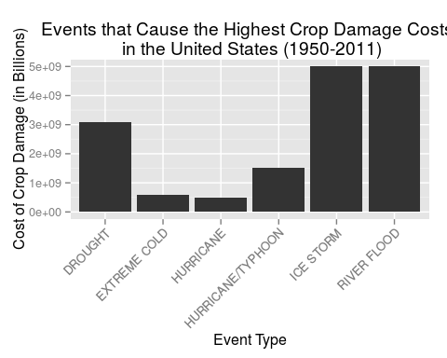

#Display the top 10 crop damage  
top.ten.crop[,c("EVTYPE", "crop.damage")]

## EVTYPE crop.damage  
## 198389 RIVER FLOOD 5000000000  
## 211900 ICE STORM 5000000000  
## 581537 HURRICANE/TYPHOON 1510000000  
## 639347 DROUGHT 1000000000  
## 312986 EXTREME COLD 596000000  
## 422676 DROUGHT 578850000  
## 410175 DROUGHT 515000000  
## 199733 DROUGHT 500000000  
## 337008 DROUGHT 500000000  
## 366694 HURRICANE 500000000