# Lab1

## Running Caesar Cipher

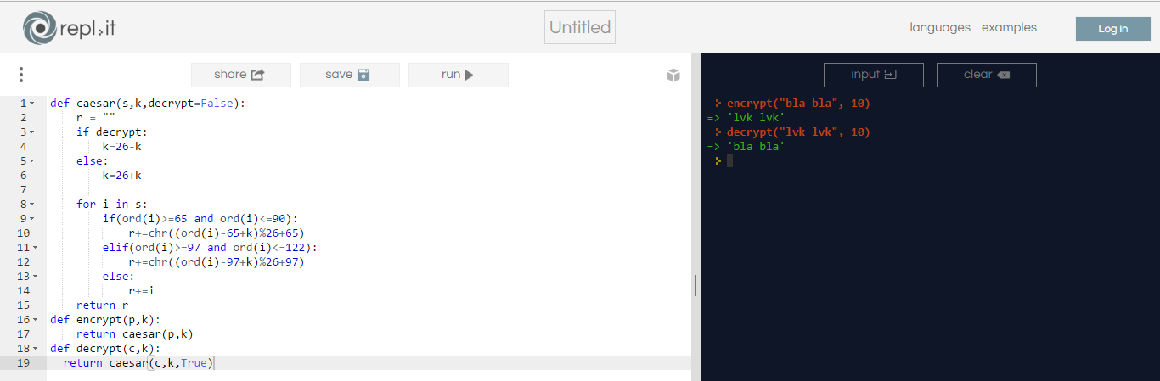

## Checking Output

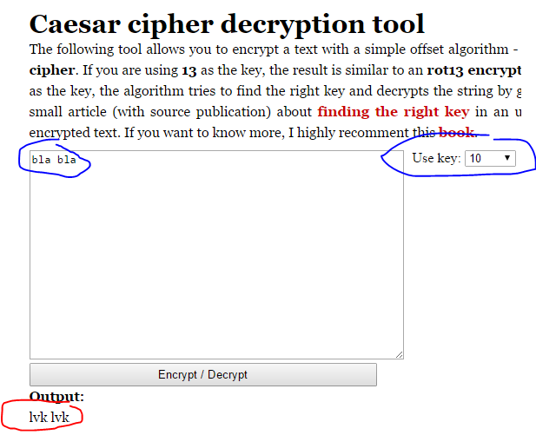

## Running Rail Fence Cipher

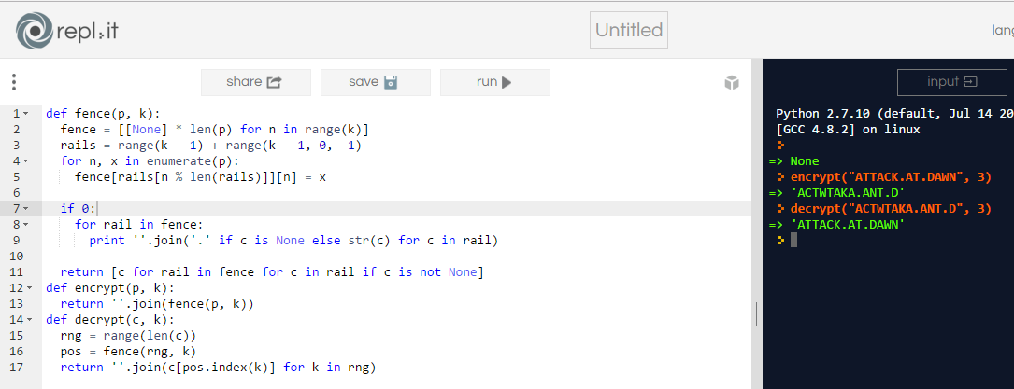

## Checking Output

