# Lab 2

## Running encrypt on Caesar Cipher

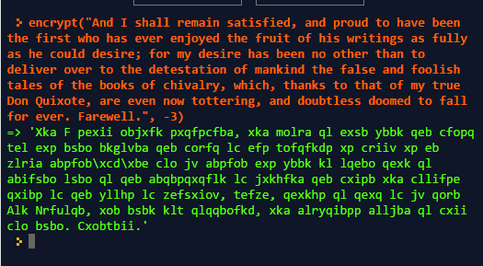

## Solved Decrypt

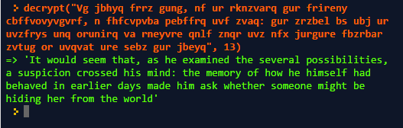

**Solution**: Brute Force is possible for Caesar Ciphers.

## Running Vigenere Cipher

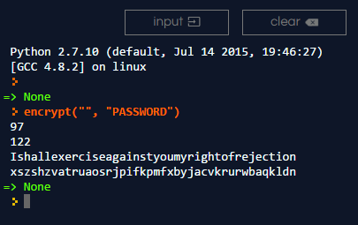

## Intended Output Check

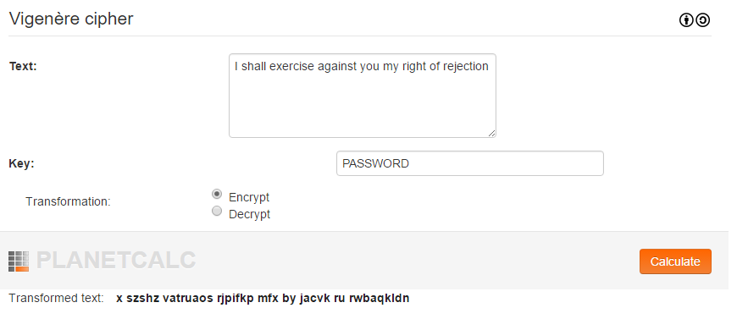

## Vigenere Decrypt

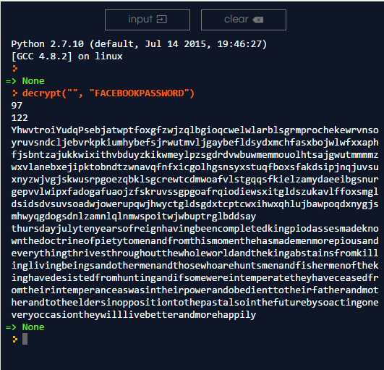

I used the known words of Thursday and the idea of the second word to be a month as the cipher text contained : Yhwvtroi, 28 Yudq 2016. Knowing the first word to be Thursday and the second to be a 4 letter month.