# HTTP Endpoints

# Paul Good C12397836

## Question 1

### Install Node JS

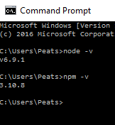

## Question 2

### Start Express



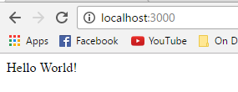

## Question 3

### Install Postgres

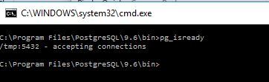

## Question 4

### Load Sample database and inspect schema using psql

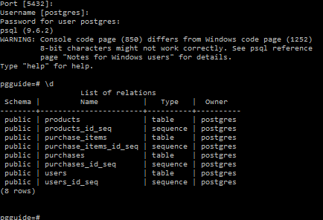

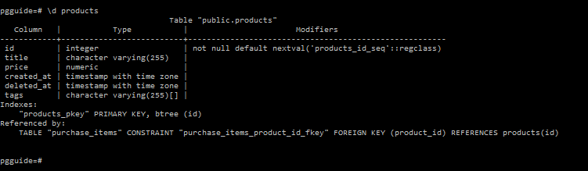

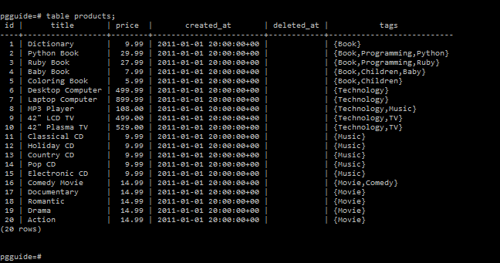

## Question 5

### Install Massive JS and follow the tutorial. Access the sample database from step 4 and allow CRUD operations



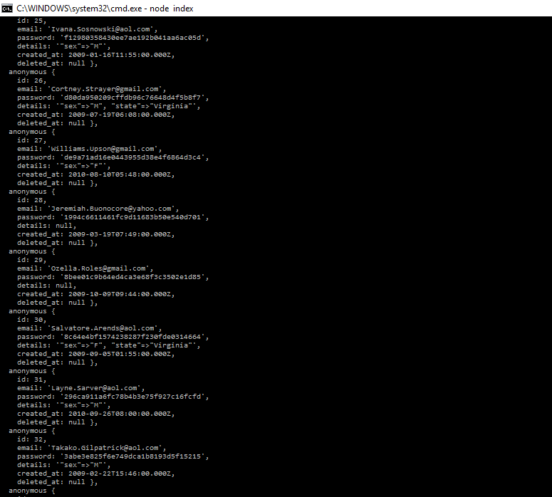



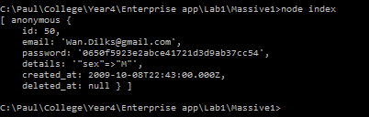

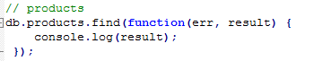

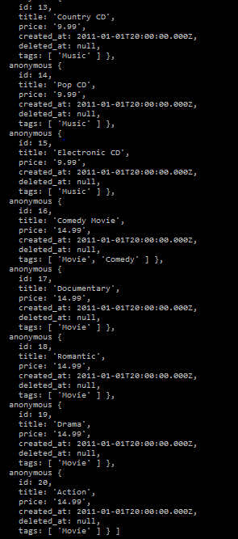



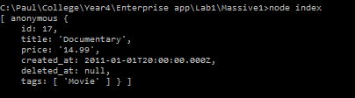

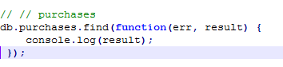

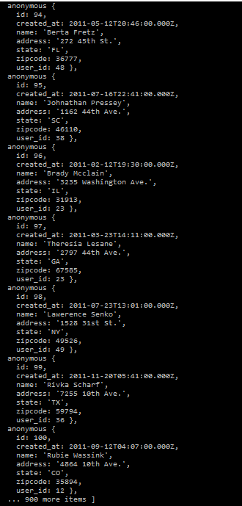

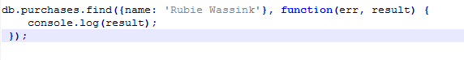

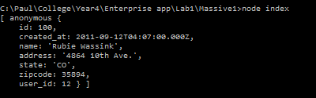

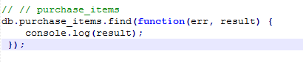

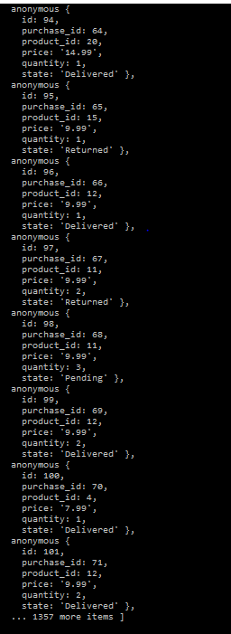



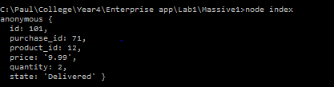

## Question 6

### Using Node Express and Massive create following HTTP API endpoints

