# HTTP Endpoints

# Paul Good C12397836

Table of Contents

HTTP Endpoints 1

Paul Good C12397836 1

Question 1 1

Products by name 1

Malformed Query 2

Question 2 2

Parameterised Query 2

Using a stored procedure using SQL or PLPGSQL whichever you prefer 2

Show attack does nothing now: 3

Question 3 4

New Express project using Sequelize ORM 4

Wire it up to new Postgres database 4

Build schema for courts 5

Question 4 6

Populate database 6

Question 5 9

Build RESTful API 9

## Question 1

### Products by name

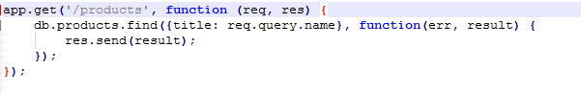



### Malformed Query

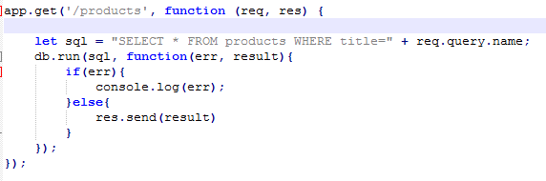

Use SQL injection :

[http://localhost:8080/products?name=’anything](http://localhost:8080/products?name='anything)’ OR ‘x’=’x’; DROP TABLE products CASCADE;

## Question 2

### Parameterised Query

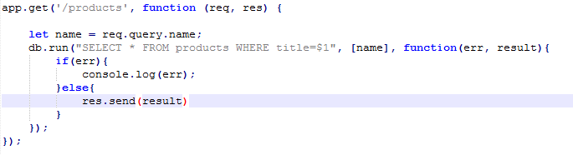

### Using a stored procedure using SQL or PLPGSQL whichever you prefer

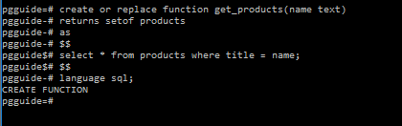

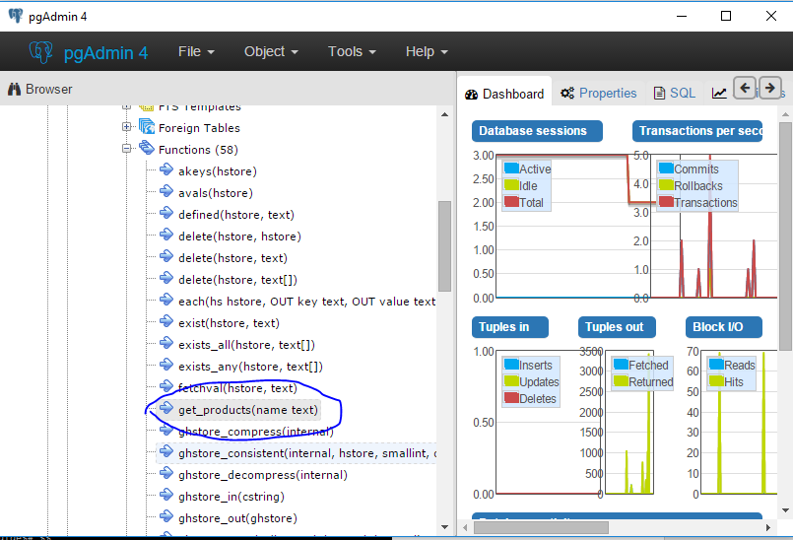

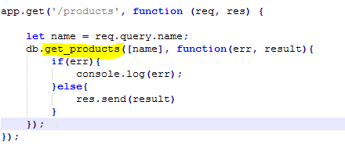

### Show attack does nothing now:

#### Empty result/request.

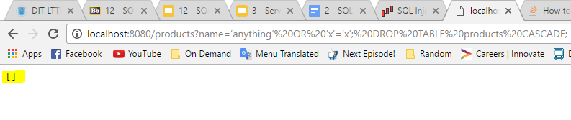

## Question 3

### New Express project using Sequelize ORM

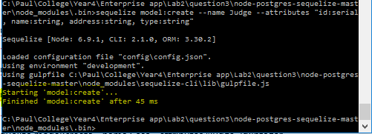

### Wire it up to new Postgres database

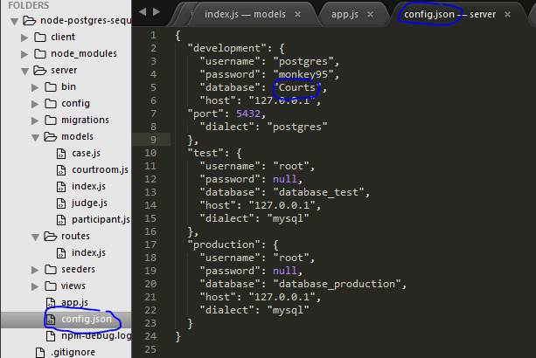

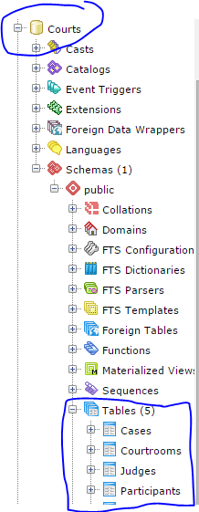

### Build schema for courts

#### After sequelize init from server folder:

* ..\node_modules\.bin\sequelize model:create --name Judge --attributes "id:serial, name:string, address:string, type:string"
* ..\node_modules\.bin\sequelize model:create --name Courtroom --attributes "id:serial, number:string”
* ..\node_modules\.bin\sequelize model:create --name Participant --attributes "id:serial, name:string, address:string, type:string”
* ..\node_modules\.bin\sequelize model:create --name Case --attributes "judge_id:integer, courtroom_id:integer, claimant_id:integer, respondent_id:integer, start_date:date, duration:interval, result:Boolean”

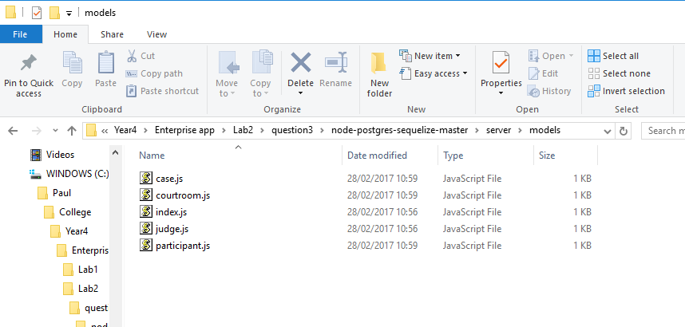

## Question 4

### Populate database

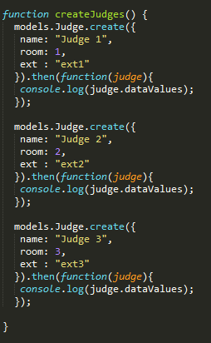

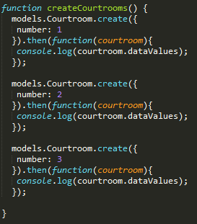

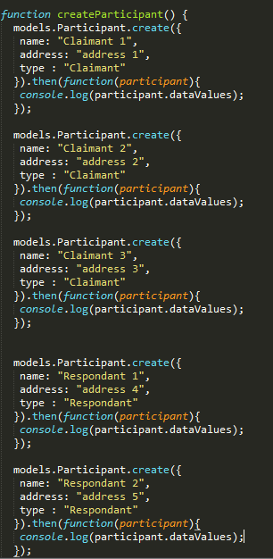

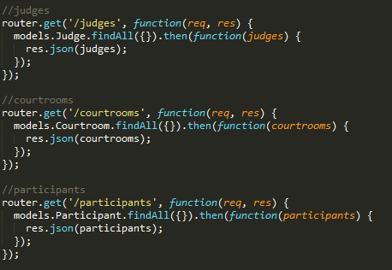

## Question 5

### Build RESTful API

#### Judges

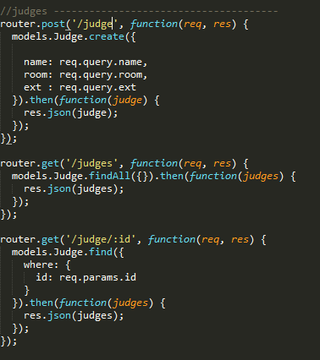

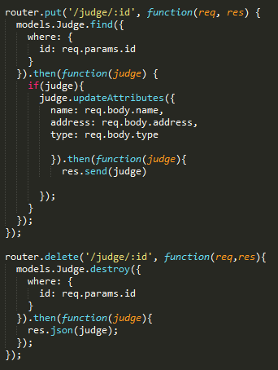

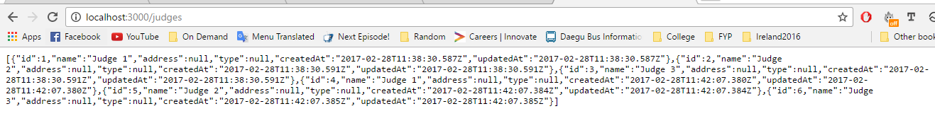

#### Courtrooms

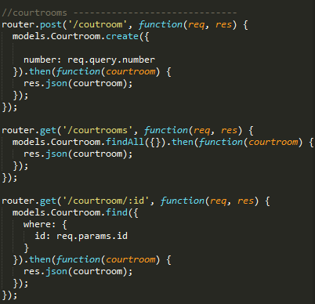

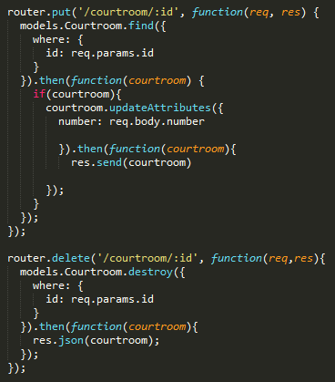

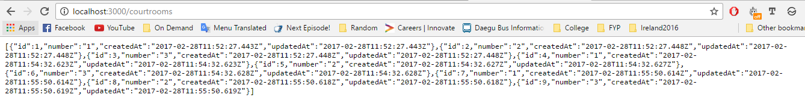

#### Participants

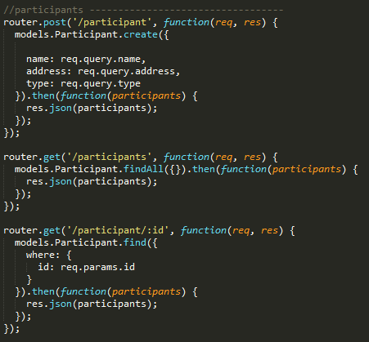

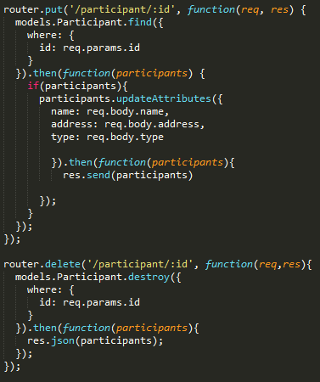

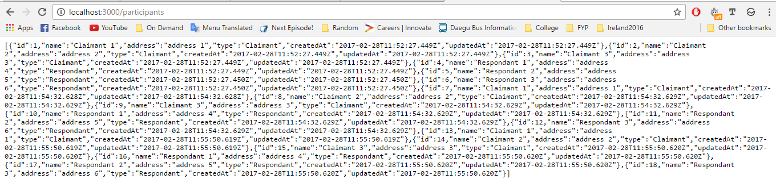

#### Cases

