**Гресько Павел Николаевич 6132-010402D**

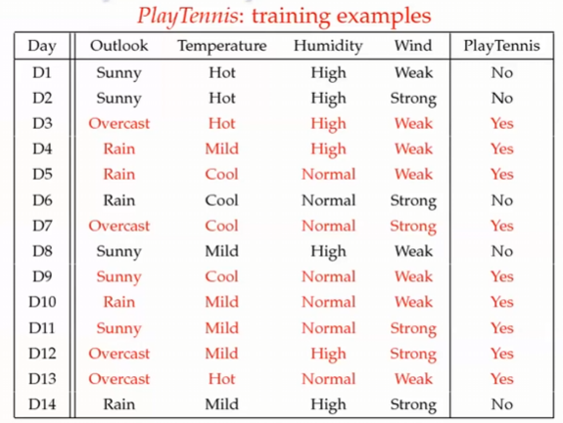

**Вариант: "Overcast", "Cool", "High", "Weak"**

P(Outlook=Overcast|Play=Yes) = 4/9

P(Temperature=Cool|Play=Yes) = 3/9

P(Huminity=High|Play=Yes) = 3/9

P(Wind=Weak|Play=Yes) = 6/9

P(Play=Yes) = 9/14

P(Outlook=Overcast|Play=No) = 0/5 – вырожденный случай

P(Temperature=Cool|Play=No) = 1/5

P(Huminity=High|Play=No) = 4/5

P(Wind=Weak|Play=No) = 2/5

(Play=No) = 5/14

**Из-за вырожденного случая применим сглаживание Лапласа:**

P(Outlook=Overcast|Play=Yes) = 5/11

P(Temperature=Cool|Play=Yes) = 4/11

P(Huminity=High|Play=Yes) = 4/11

P(Wind=Weak|Play=Yes) = 7/11

P(Play=Yes) = 10/16

P(Outlook=Overcast|Play=No) = 1/7 – вырожденный случай

P(Temperature=Cool|Play=No) = 2/7

P(Huminity=High|Play=No) = 5/7

P(Wind=Weak|Play=No) = 3/7

(Play=No) = 6/16

P(*Yes*|**x**) ≈ [P(Overcast|Y*es*)P(*Cool*|*Yes*)P(*High*|Y*es*)P(Weak|*Yes*)]P(Play=*Yes*) = **0,024**

P(*No*|**x**) ≈ [P(Overcast|N*o*)P(*Cool*|N*o*)P(*High*|*No*)P(Weak|*No*)]P(Play=*No*) = **0,005**

**Решение: “Yes”**