Intent Compression Architecture
A Clarification-First Control Layer for Reliable LLM Systems
Engineering design proposal
Author | Paul Maddison
Short name | ICA
Canonical artifacts | README.md, architecture diagram, proposal DOCX/PDF, evaluation scaffold

Executive summary. ICA is a pre-generation control layer that decides whether clarification is worth the cost before the model commits to an answer. It treats ambiguity as uncertainty over latent user intent, estimates expected utility over possible clarification replies, and routes the request to direct answer, clarifier, premise-check, or refusal/redirect as appropriate.
1. Architecture overview
A common failure mode in LLM systems is unresolved ambiguity. Users often ask questions that admit multiple plausible interpretations, while the system is optimized to answer immediately. The result is a broad first answer, a user correction, and an unnecessary second pass.
ICA inserts a control layer between user input and final generation. The layer estimates likely intent hypotheses, scores ambiguity and risk, and decides whether clarification improves the expected outcome enough to justify the extra turn.
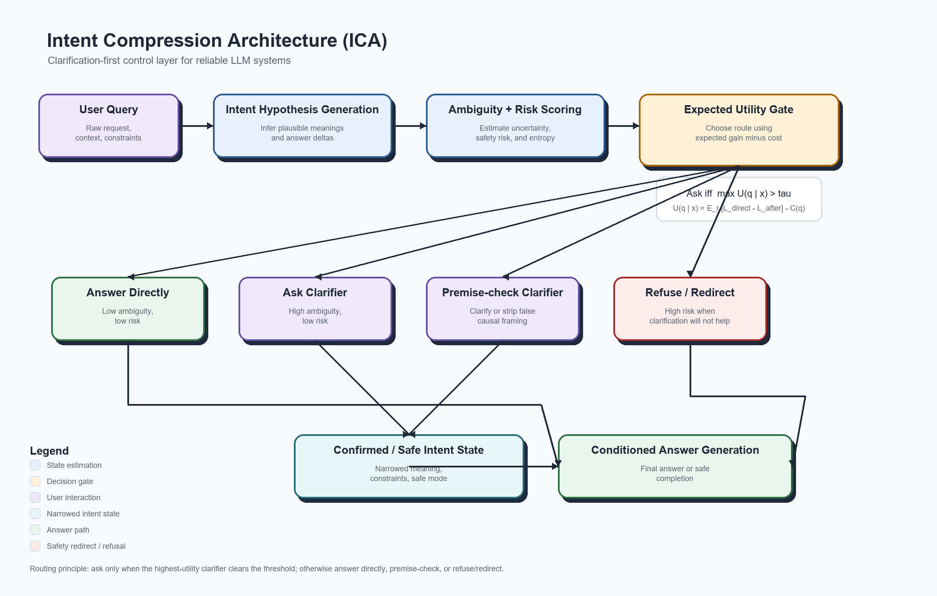
Figure 1. ICA control flow with expected-utility routing and embedded legend.
2. Core decision policy
Minimal rule: ask a clarifying question only when expected improvement in answer quality or safety exceeds the cost of another turn.
U(q | x) = E_r [L_direct(x) - L_after(x, q, r)] - C(q)
Ask iff max_q U(q | x) > tau_domain
This formulation makes the unknown user reply explicit by taking an expectation over possible clarification responses. The domain threshold allows the same architecture to be tuned differently for coding, medical, legal, finance, or customer-support use cases.
3. Compression interpretation
ICA treats ambiguity as entropy over possible user intents. Before clarification, the system reasons over H(I | x). After clarification q and user reply r, the system reasons over H(I | x, q, r). The expected value of clarification is the reduction in intent entropy, tempered by interaction cost.
This is why the term intent compression is mathematically defensible: the controller narrows the intent distribution before generation rather than letting the answering model hedge across multiple meanings.
4. Routing policy
Ambiguity | Risk | Default action | Operational note
Low | Low | Answer directly | No clarification needed.
High | Low | Ask one high-value clarifier | Clarify only if the best question clears the threshold.
Low | High | Direct safe completion, premise-check, or refuse/redirect | Do not ask the user to reconfirm harmful intent if the safe response would not change.
High | High | Strict clarification, constrained answer, or refuse/redirect | High uncertainty plus high downside requires tighter control.
A practical implication is that clarification is not always the right response to risk. Sometimes the cleanest and safest route is a direct refusal with a helpful redirect.

5. Implementation contract
The control layer should emit a structured decision object rather than a free-form paragraph. This proposal includes a JSON schema and reference example in spec/clarifier_output.schema.json and spec/clarifier_output.example.json.
{
"ambiguity_score": 0.74,
"risk_score": 0.22,
"decision": "ask_clarifier",
"clarifying_question": "When you say propaganda, do you mean persuasive political advocacy, coordinated deceptive messaging, or something else?",
"answer_constraints": ["avoid loaded framing", "define terms before conclusion"]
}
6. Evaluation package
The largest remaining credibility gap for ICA is empirical evidence. To address that, the repository now includes a benchmark prompt set, an evaluation protocol, and a sample reporting format.
Artifact | Purpose
examples/ambiguous_prompts.csv | Starter prompt set covering low-risk ambiguity, high-risk ambiguity, and premise-risk cases.
eval/README.md | Protocol, scoring rubric, success criteria, and counter-metrics.
eval/sample_results.md | Template for benchmark reporting without fabricating results.
Key primary metrics include total tokens per resolved task, retry count, latency to correct answer, human-rated correctness, clarity, and premise handling. Key counter-metrics include over-clarification rate, unnecessary clarification rate, false direct-answer rate, false refusal rate, and clarification bias.
7. Deployment guidance
ICA is most useful when deployed as a policy layer around an existing model stack. The orchestration logic should be explicit and testable, while uncertainty is isolated to model outputs and external-system calls such as retrieval, APIs, or mutable external state.
The controller should log ambiguity score, risk score, candidate clarifiers, expected utility estimates, final route, and user reply when applicable. Those traces are the data needed to improve the control layer over time.
8. Conclusion
ICA is a credible architecture pattern because it defines a control-layer problem that engineers can implement: infer intent hypotheses, quantify ambiguity, route by expected utility, narrow intent before generation when doing so is worth the cost, and build systems that are more precise, more reliable, easier to defend, and often cheaper to operate on ambiguous tasks.
Appendix A. Starter benchmark pack
The repository includes a lightweight evaluation package so the proposal can move from theory to early evidence without requiring a large research program.
Artifact | Use
examples/ambiguous_prompts.csv | Seed prompt set covering coding, planning, legal, medical, finance, public reasoning, and safety-sensitive ambiguity.
eval/README.md | Evaluation procedure, rating rubric, success criteria, and counter-metrics.
eval/sample_results.md | Reporting format for summary metrics and per-prompt comparisons.
Recommended next move: run a 25-prompt pilot benchmark, publish the results using the template, and update the controller threshold and routing rules based on observed over-clarification, false direct-answer, and false-refusal rates.

